What is an Electrochemical Cell?
An electrochemical cell is a device used to separate the reactants in a chemical reaction so that the electrons are transferred from one reactant to via an external circuit rather than by directly mixing the reactants. In a galvanic or self-driven, cell the chemical reaction proceeds spontaneously, causing current to flow in the external circuit- net result is the conversion of the energy of a chemical reaction into electrical energy.
In an electrolytic, or driven, electrochemical cell, the process can be reversed. In this case, current can be forced to flow through a cell by using external power source, such as a battery or direct current (DC) power supply. This process, called electrolysis, can create new chemical substances that have greater chemical energy than the reactants, thereby "storing" energy which on demand, can convert chemical energy back into electrical energy.
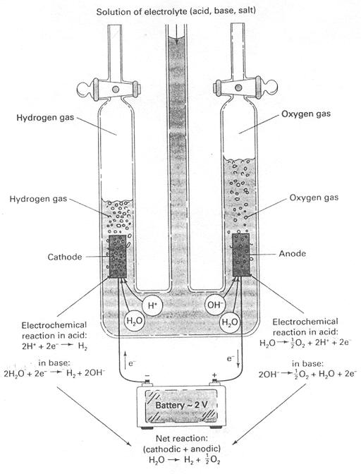
Figure 1 Production of hydrogen by electrolysis of water in an electrolytic (driven) cell
The electrolysis of water by means of a driven cell shown in Figure 1. The chemical energy that is stored in the electrolysis products (hydrogen and oxygen gases) can be directly converted into electrical energy by using a self-driven fuel cell1 shown in Figure 2.
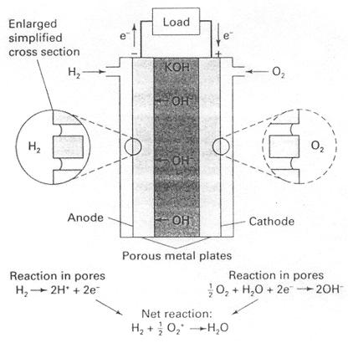
Figure 2 A scheme for obtaining electrical energy from a galvanic (self-driven) hydrogen-oxygen fuel cell. The net chemical reaction in the cell is equivalent to the combustion of hydrogen
Processes that use electrolysis include chlorine from brine (NaCl) solution and aluminum from alumina 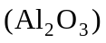 dissolved in molten cryolite 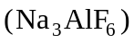, although very high temperatures are required. Here, the driven cells are used as "substance-producing" devices and can also be used in electroplating, in which a thin metal layer is plated out on a conducting substrate, and in the passivation of metals (like aluminum) to produce a thin layer of oxide that provides a protective (and decorative) coating.

Faraday's Laws and Electrolysis
Faraday's laws state:
- The amount of chemical change produced is proportional to the total amount of charge passed through the cell.
- The passage of a mole of electric charge produces an equivalent of chemical change. An equivalent of chemical change is equal to a mole of chemical change divided by the number of electrons transferred per mole of chemical change.
The amount of electric charge is expressed in coulombs, and can be determined experimentally by measuring the electric current (flow of charge). The current is measured in units of amperes: One ampere is equal to a charge flow of one coulomb per second. If the current is constant, the total charge transferred is equal to the current multiplied by the time in seconds:
coulombs = amperes (or coulombs/seconds) x seconds (1)
When a mole of silver (107.87 g) is deposited at a cathode, the half-cell equation
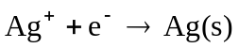 (2)

Indicates that an Avogadro's number 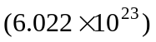 of individual silver ions must be reduced the same number of electrons - "a mole of electrons". The charge on a mole of electrons is
coulombs/electron = 96,485 coulombs (3)
which is called a faraday and given the symbol F. When copper is plated out at the cathode, the half-cell equation
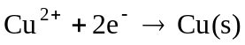 (4)
Shows that 1 mol of electrons (1 faraday) will produce only 1/2 mol of copper (63.54/2 = 31.77g).
To summarize, when 1 faraday (96,485 coulombs of charge) is passed through a cell, chemical change equivalent to transfer of 1 mole of electrons (oxidation at the anode and the reduction at the cathode) occurs at each electrode. This quantity of materials is called one electrochemical equivalent.
Only a few electrochemical reactions are known that give a simple, well-defined reaction conforming exactly to Faraday's laws. More often, an electrochemical reaction is complex, yielding several products. This may occur when one electron transfer reaction takes place on the electrode or when the primary products are very reactive in some side reaction.
Electrochemists use the terms current efficiency or yield and define these terms as the percentage of total charge that is effective in producing the desired substance. It as just these effects that made it difficult to discover these laws, which may seem self-evident to students already familiar with atomic theory. But in 1834, modern theories of atomic structure, chemical bonding, or ionization did not exist, nor was anything known about the existence and properties of electrons. These laws, which eluded many who were studying electricity, should be regarded as a lasting tribute to Faraday's ingenuity and careful experimental work.

Electrochemistry and Corrosion
When it is not desired, the dissolution of a metal is called corrosion, and much money and effort are spent in preventing or combating it. A simple example of corrosion is the dissolution of a metal in acid, where the oxidation-reduction processes are those shown in Figure 3.
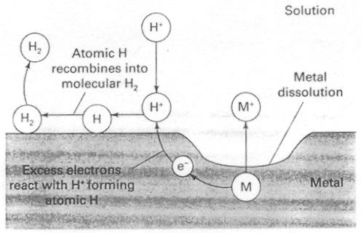
Figure 3 In corrosion, dissolution of the metal liberates electrons. If these electrons can be taken up by some other electrochemical reactions (like 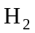 evolution), the metal continues to dissolve.
Corrosion is a common affliction of automobiles in regions with cold climates, where corrosive salts are spread on the roads to melt ice. When a hole or crack in the paint exposes the steel of the auto body, the steel often begins to corrode. This suggests that the corrosion process is primarily electrochemical in nature, two separated half-reactions being mediated by flow of electrons in the steel (see Figure 4). Unless the corroded area is cleaned and repainted, corrosion will continue until the metal is rusted through over a large area.
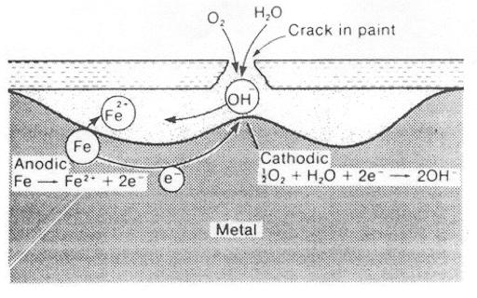
Figure 4 At a crack in the protective paint, corrosion often develops under the paint. It is the (invisible) part of the steel under the paint becomes anodic and dissolves. Electron flow in the metal and ionic flow in the corroded area couple the two half-reactions.

