PreLab Form: Equilibrium Constant of a Complex Ion

(Total 10 Points)
Note: In preparing this report you are free to use references and consult with others. However, you may not copy from other students’ work (including your laboratory partner) or misrepresent your own data (see honor code).
Name(Print then sign): ___________________________________________________
Lab Partner: ____________________________________________________________

Lab Day: ___________________Section: ________TA_________________________
A student mixes 5.00 mL 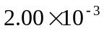 M 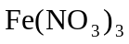 with 5.00 mL M KSCN. She finds that in the equilibrium mixture the concentration of 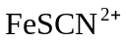 is 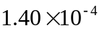 M. Find 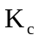 for the reaction .
1. Find the number of moles 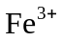 and 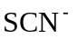 initially present
___________moles
___________ moles
2. How many moles are in the mixture at equilibrium? What is the volume of equilibrium mixture?
___________ mL
___________moles
How many moles of and are used up in making ?
___________ moles
___________moles

3. How many moles of and remain in the solution at equilibrium?
___________ moles
__________moles

4. What are the concentrations of , , and at equilibrium? What is the volume of the equilibrium mixture?

[] = ___________M
[] = __________M
[] = __________M
_________mL

5. What is the value of for the reaction?

= _______________

