Report Form: Properties of Aluminum and Its Compounds
Name___________________________
Lab Section______________________
Note: In preparing this report you are free to use references and consult with others. However, you may not copy from other students' work (except to compile the group data set) or misrepresent your own data.
Part 1: Preparation of an Alum
1. Weight of aluminum sample #1 ____________
Write observations and balanced equations for:
- Aluminum reacts with potassium hydroxide to form soluble tetrahydroxoaluminate ion and hydrogen gas.

- Addition of sulfuric acid forms the precipitate of aluminum hydroxide.

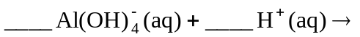
- Additional acid neutralizes the hydroxide to form the clear solution of aluminum (III) ion and water.

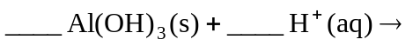
- The Alum precipitates on cooling.

Part II: Percent Yield
- Calculate the percent yield of the reaction forming alum from aluminum metal. (show work)

Your percent yield: ________________
8. Describe the appearance of your crystals.

Part III: Qualitative Analysis of Alum
- Is the solution acidic, basic, or neutral? __________________________

10. What happened when you added 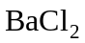?

- Write the equation for the reaction of 1 drop of 0.5 M to the 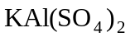 solution.

12. Note the color of the crystals in the flame: ___________________________
Part 4: Acid-Base Properties of Aluminum Compounds
Record your observations and write a balanced chemical equation for the addition of:
13. sodium hydroxide to the aluminum nitrate solution

14. adding more (3 mL) sodium hydroxide solution to tube 1

15. adding 3 mL of 6M HCl solution to tube 2

16. adding 3 mL of 6M 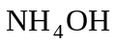 to tube 3

17. Based on your observations in this lab, is aluminum hydroxide acidic, basic, or amphoteric? What other metal hydroxides display the same behavior? (Refer to your textbook.)

