Report Form: ElectroGels - Metal Corrosion, Anodic Protection and the Golden Penny
Note: In preparing this report you are free to use references and consult with others. However, you may not copy from other students’ work (including your laboratory partner) or misrepresent your own data (see honor code).
Name(Print then sign): ___________________________________________________
Lab Day: ___________________Section: ________TA__________________________

Metal Corrosion and Anodic Protection
- In the space below, make annotated sketches of what you observed in the three Petri dishes containing bimetal strips in agar gel. Also summarize your observations in the table below.
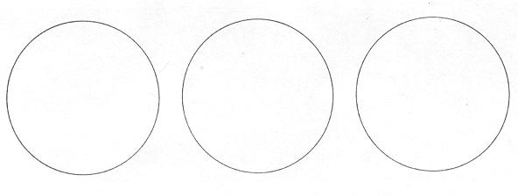
- Summarize your observations on the Petri dishes in the table below:
_____________________ | Phenolphthalein test: Pink color is an indication of 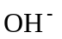 | 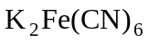 test: Blue color is an indication of 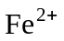 | Describe the formation of any bands of precipitate | Other observations
Cu/Fe | ______________________ | _____________________ | ______________________ | ______________________
Cu/Zn | ______________________ | _____________________ | ______________________ | ______________________
Zn/Fe | ______________________ | _____________________ | ______________________ | ______________________
- Since you used a digital voltmeter to probe the voltages in the three Petri dishes, answer the following questions by filling in the table.
When the probes are inserted 1-2 mm from the metal strips, at about the center of the metal strips:
Do you measure a voltage difference?
If so, what is the magnitude of the voltage and next to which metal is there a region of positive charge?
What is the magnitude of the voltage when the probes are firmly contacting the metal strips?
Write plausible reactions for the formation of positive ions (metal atom oxidation) and negative ions (reduction of water or oxygen).
___________________________ | Magnitude of the voltages difference next to the metals, millivolts | The region of positive charge is next to which metal? | Magnitude of the voltage difference when the probes are contacting the metals
Cu/Fe | ___________________________ | ___________________________ | ___________________________
Cu/Zn | ___________________________ | ___________________________ | ___________________________
Zn/Fe | ___________________________ | ___________________________ | ___________________________
- Ions migrate in an electric field. So if positive ions are formed at the surface of the metal and negative ions at the surface of the other metal, the ions of opposite charge will migrate toward one another under the influence of the electric field created by the charge separation.
How might this explain the formation bands of precipitate?
Describe the color of any bands of precipitate that form.
What would be plausible chemical formulas for the precipitates you observed?

- Did the iron nail connected to the zinc metal strip corrode? What's your hypothesis (in terms of what the atoms are doing) to explain how the iron nail is protected from corrosion by being connected to the zinc metal?

- Did the iron nail connected to the copper strip corrode? What's your hypothesis (in terms of what the atoms are doing) to explain this result? Plumbers use a dielectric union when connecting steel water pipes to a copper pipe plumbing system. The union contains an insulating sleeve to prevent direct electrical contact between the steel and copper pipes. Based on what you observed in the Petri dish, what do you think would happen if you directly connected the steel and copper pipes?

The Golden Penny Experiment

General Observations
- What happens to pennies resting in contact with the 30- mesh zinc on the bottom of the beaker?

- What happens to pennies resting on the bottom of the beaker but not in contact with zinc?

- What happens to a copper penny soldered to copper wire and immersed in solution when the copper wire is not in contact with zinc metal?

- What happens to a penny soldered to copper wire, suspended in solution when the other end of the copper wire is soldered to a strip of zinc metal which is in turn touching the 30-mesh zinc?

- Do you observe the evolution of any gas from the 30-mesh zinc in 1 M NaOH which might come from the following reaction:
?

- Does the zinc powder react with 1 M NaOH to form a gas?

- Is there voltage difference between a strip of zinc metal and the free end of a copper wire soldered to a penny when both the zinc strip and penny are immersed in solution?

- If there is a voltage difference, which is the negative electrode (the electrode source)? The copper wire soldered to the penny? Or the strip of zinc metal?

- If there is a voltage difference, do it remain constant? Or does it change with time?

Consider this
Constructing an hypothesis to explain the whole process: copper to silver to gold color.
- What do you think makes up the silver-colored coating on the penny? Does it behave in any ways similar to zinc metal?

- If we assume the silvered-colored coating is zinc metal, how do you think the atoms of zinc get from the 30-mesh zinc to the copper penny? By diffusing from the zinc metal to the penny? Or through the solution?

- If the zinc that coats the copper penny comes from the solution, is the zinc in solution more likely to be in the form of Zn atoms or 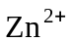 ions? Explain your answer.

- If you analyzed the solution at the end of the experiment, would you expect to find zinc ions (or 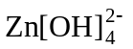 complex ions) in solution? If so, by what chemical (or electrochemical) reaction could they have been formed?

- When the silver-plated pennies are heated on the hot plate, they turn a golden color, which is the color of brass, a copper-zinc alloy. Explain how heating could promote the formation of an alloy and cause a color change from silver to gold.

- Summarize the key observations and your hypothesis for explaining the whole process by which a copper penny acquires a shiny gold color? Hint:Write the half reactions then explain what is happening.

