Pre-Lab: (Total 10 Points)
Hopefully here for the Pre-Lab
Name(Print then sign): ___________________________________________________
Lab Day: ___________________Section: ________TA__________________________
This assignment must be completed individually and turned in to your TA at the beginning of lab. You will not be allowed to begin the lab until you have completed this assignment
1. Fill in the blanks:
Fuel cells are used for direction conversion of the energy of combustion reactions to ______________. A fuel cell is a ______________ in which electricity is generated by a combustion reaction. A fuel cell provides a ______________ voltage that can be used to power motors, lights or any number of electrical appliances.
2. T or F At the anode, oxidation of the fuel takes place.
3. T or F The fuel cell emissions will be nothing but water vapor.
4. T or F The efficiency of fuel cells, chemical-to-electric energy conversion, is approximately 40%.

Review of series and parallel circuits:
In a series circuit, the electrons in the current have to pass through all the components, which are arranged in a line. Consider a typical series circuit in which there are three resistors of value 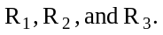
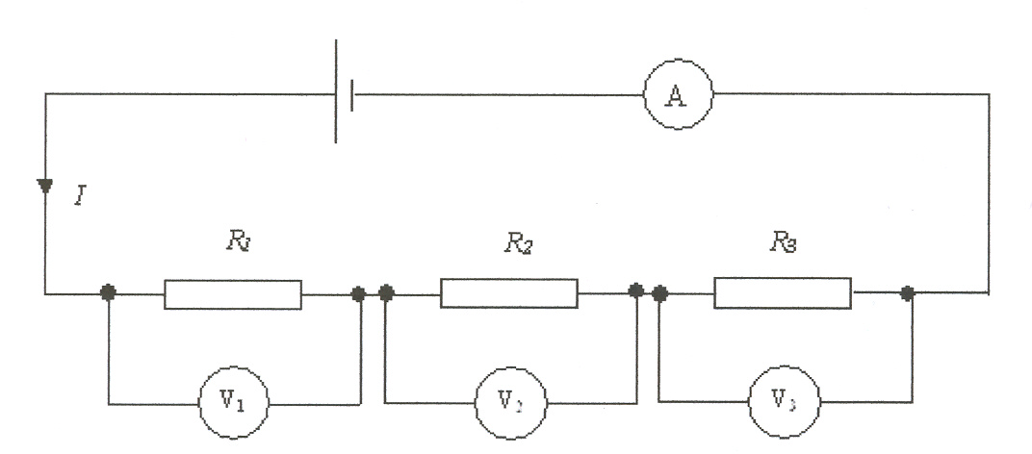
There are two key points about a series circuit:
- The current throughout the circuit is the same.
- The voltages add up to the battery voltage.
Therefore:
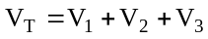

From Ohm’s Law:
- 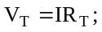
- 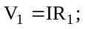
- 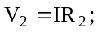
- 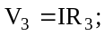
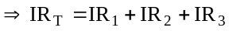
Therefore:
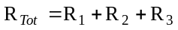
5. In the circuit below, the current is 100 mA.

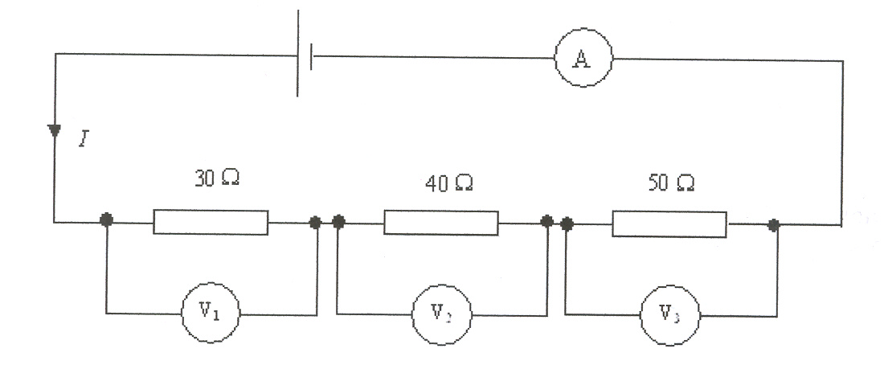
(a) What is the current in each resistor?
(b) What is the voltage across each resistor?
(c) What is the total resistance?
(d) What is the battery voltage?
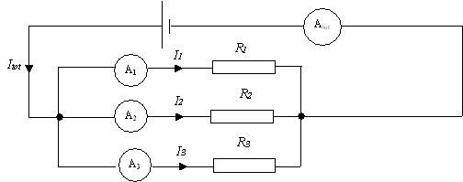
Parallel circuits have their components in parallel branches so that an individual electron can go through one of the branches but not the others. The current splits into the available number of branches.
In this case, the current will split into three. For a parallel circuit:
- The voltage across each branch is the same.
- The currents in each branch add up to the total current.
From this:
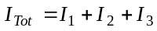
From Ohm’s Law: 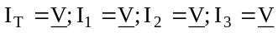
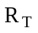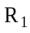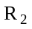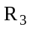
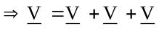
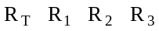
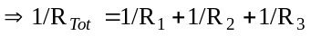
6. This question refers to the circuit below.
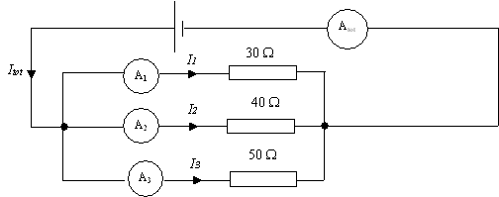
(a) What is the total resistance of the circuit?
(b) What is the current through each resistor?
(c) What is the total current?

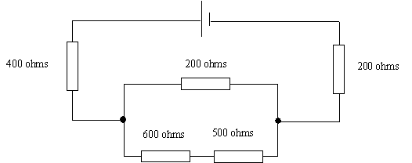
For resistors in both series and parallel, follow these guidelines:
- Work out the total resistance of the parallel combination.
- Work out the total resistance of the circuit by adding your answer in the previous step to the values of the series resistors.
7. What is the single resistor equivalent of this circuit?

