Pre-Lab: Introductory Organic Reactions

(Total 25 Points)
Hopefully here for the Pre-Lab
Name(Print then sign): ___________________________________________________
Lab Day: ___________________Section: ________TA__________________________
This assignment must be completed individually and turned in to your TA at the beginning of lab. You will not be allowed to begin the lab until you have completed this assignment.

For questions 1-4, draw the structural formulae of:
1) 2,2 - dimethylbutane

2) 3-ethyl-2,4-dimethylpentane

3) 2,3,4-trimethylhexane

4) 3-ethyl-2-methylheptane

For questions 5-8, give the names of
5) 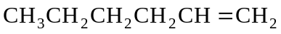

6) 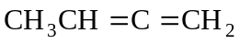

7) 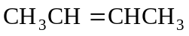

8) 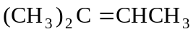

For questions 9-11, give the structural formulae for:
9) hex-3-ene

10) 3-methylhex-1-ene

11) 2,5- dimethylhex-2-ene

For questions 12-14, give the names of:
12) 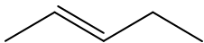

13) 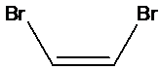

14) 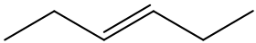

For questions 15-19, give the stuctural formulae of:
15) trans-1,2-dibromoethene

16) trans-1-chloroprop-1-ene

17) cis- hex-2-ene

18) pent-1-yne

19) 3-methylbut-1-yne

For questions 20-25, name the following compounds:
20) 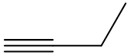

21)

22) 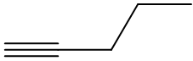

23) 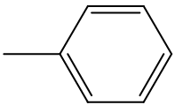

24) 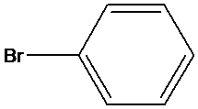

25) 