Report 5: Bonding 07
Hopefully here for the Report Form
Note: In preparing this report you are free to use references and consult with others. However, you may not copy from other students’ work (including your laboratory partner) or misrepresent your own data (see honor code).
Name(Print then sign): ___________________________________________________
Lab Day: ___________________Section: ________TA__________________________

Part I. Predicting bond type through electronegativity differences.
Chemical Formula | Electroneg (1) | Electroneg (2) | Diff Electroneg | Type of bond
KCl

CO

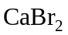

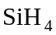

MgS

Part II. Weak and strong electrolytes
Solution Tested | Numerical Output | Electrolyte Strength | Ions Present
0.1 M HCl
0.1 M 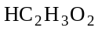
0.1 M 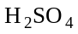
0.1 M NaOH
0.1 M 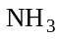
0.1 M 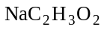
0.1 M NaCl
0.1 M 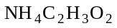
0.1 M 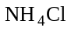
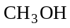
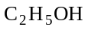
Sucrose
Tap water
1. Why do we use deionized water instead of tap water when making solutions for conductivity measurements?

Part III. Electrolyte strength and reaction rate
2. Time to collect 20 mL of gas using 1 M HCl _______________________. Write the reaction of HCl with 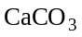.

3. Time to collect 20 mL of gas using 1 M _______________________. Write the reaction of with .

4. Time to collect 20 mL of gas using 0.5 M _________________________.Write the reaction of with .

5. Why does it take different lengths of time to collect 20 mL of gas?

6. Based on the time it took to collect 20 mL of gas, rank the acids in the order of increasing strength.

7. Why did we use 0.5 M instead of 1.0 M ?

Part IV. Chemical reactions
8. Write the chemical reaction for calcium hydroxide with your exhaled breath.

9. Write your observations for the reaction that took place (i.e. appearance, conductivity, etc.)

10. When in separate solutions, aqueous ammonia, (aq) and acetic acid conduct electricity equally well. However, when the two solutions are mixed a substantial increase in electrical conductivity is observed. Explain.

11. Separately, ammonium sulfate and barium hydroxide solutions are very good conductors. When the two solutions are mixed a substantial decrease in conductivity is observed. Rationalize this.

