Report: Organic Reactions
Hopefully here for the Report Form
Note: In preparing this report you are free to use references and consult with others. However, you may not copy from other students’ work (including your laboratory partner) or misrepresent your own data (see honor code).
Name(Print then sign): ___________________________________________________
Lab Day: ___________________Section: ________TA__________________________

Observations:

Synthesis of esters
Reagents | Product | Observations
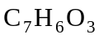(salicylic acid ) + 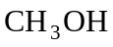
(methyl alcohol)
(1 - octanol ) 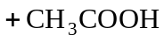 (glacial acetic acid)
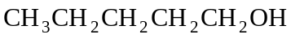
(amyl alcohol) (glacial acetic acid)
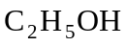 (ethanol) (acetic acid)

Oxidation of an alcohol with acidified potassium dichromate(VI) solution.
Remember to describe what happens and explain the color changes.
What conditions and techniques would favour the oxidation of ethanol to
a. ethanal rather than ethanoic acid.
b. ethanoic acid rather than ethanal?
Add 10 drops of dil. 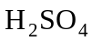 to 5 drops of 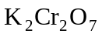 to the following alcohols | Observations: color/smell  Smell cautiously! | Observations: color/smell on warming  Smell cautiously!
Ethanol
Methanol
Propan-2-ol

Oxidation of an alcohol with acidified potassium permanganate (VII) solution
Remember to describe what happens and explain the color changes.
What is your final product?
Add 10 drops of dil. to 5 drops of 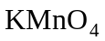 to the following alcohols | Observations: color/smell  Smell cautiously! | Observations: color/smell on warming  Smell cautiously!
Ethanol
Methanol
Propan-2-ol

Saponification of a vegetable oil
Reagent | pH from indicator paper
Your soap
Laundry Detergent
Hand Soap

