PreLab: Acid and Bases to Buffers

(Total 10 Points)
Note: In preparing this report you are free to use references and consult with others. However, you may not copy from other students’ work (including your laboratory partner) or misrepresent your own data (see honor code).
Name(Print then sign): ___________________________________________________
Lab Partner: ____________________________________________________________
Lab Day: ___________________Section: ________TA__________________________

1. Indicate on the following graph where the equivalence point is.

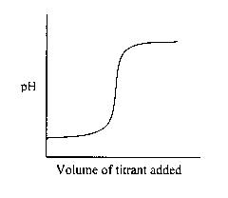

2. Define equivalence point (in terms of what is present in the solution).

3. What is a buffer?

4. Write the Henderson-Hasselbalch equation:

5. What is the buffer system used to control the pH of blood? (HINT: look in your book)

