PreLab: Thermochemistry
(Total 10 Points)
Note: In preparing this report you are free to use references and consult with others. However, you may not copy from other students’ work (including your laboratory partner) or misrepresent your own data (see honor code).
Name(Print then sign): ___________________________________________________
Lab Day: ___________________Section: ________TA__________________________
Lab Partner: ____________________________________________________________
Hold on to your Pre-Lab until the end of your Lab session as you will need it during your Lab.
For calculations on heat transfer, use the equations:
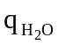 = 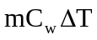
where q = heat in J, m = mass of water in grams, 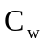 = specific heat of water = 4.18 J/(g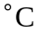), 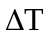 = change in temperature in .

To find the following heats of solution and, in the last question, heat of fusion where 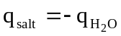:

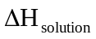 = [ 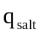 / g of salt][formula weight in grams / 1 mole]

  - Heat of Fusion - Melting of Ice. When 6.4 g of ice was added to 100.0 g of water, there was a temperature drop from 24.31 to 18.86 . Find the values of q for ice and water and then 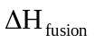. Remember, during the phase change the temperature of the ice does not change.

  - Heat of Solution of Magnesium Sulfate (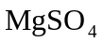). 5.096 g of magnesium sulfate was added to 97.3 g of water and a temperature rise was observed from 24.67 to 31.86 . Hint: find q then 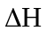, for .

Original (unbalanced) Reaction | Rewritten
(1) 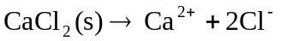
(2) 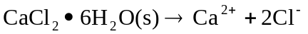
target reaction:
  - You will perform reactions (1) and (2) and use your experimentally determined enthalpy values to calculate for the target reaction. Find the value for the heat of reaction for the rewritten reactions 1 and 2 and compute the heat of reaction for the target reaction.

