Report: Thermochemistry
(Total 80 Points)
On my honor, in preparing this report, I know that I am free to use references and consult with others. Note: In preparing this report you are free to use references and consult with others. However, you may not copy from other students’ work (including your laboratory partner) or misrepresent your own data (see honor code).
Name(Print then sign): ___________________________________________________
Lab Day: ___________________Section: ________TA__________________________
Lab Partner ____________________________________________________________
Demonstrations – include observations and equations
- Balloons

- Thermite

Part I. Reaction of a Strong Acid with a Strong Base
1. Write a balanced chemical equation for this reaction.

2. Calculate both the initial and final number of moles of HCl, NaOH, 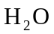 and NaCl involved in the reaction. Hint: Reaction between a strong acid and a strong base goes to completion.

3. Is the reaction exothermic or endothermic? Explain.

Please use this formula for standard deviation calculations:
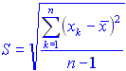
N.B: The following tables will be best completed in an excel workbook and handed in

Individual Data Set
 | DATA |  |  | CALCULATIONS
 | 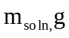 | 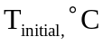 | 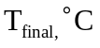 | 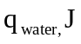 | 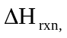 J/g (NaOH) | kJ/mol (NaOH)
Trial 1
Trial 2
AVERAGE
% ERROR (use average)
STD. DEV.

Group Data Set
 | DATA |  |  | CALCULATIONS
 |  |  |  |  | J/g (NaOH) | kJ/mol (NaOH)
Group 1
Trial 1
Group 8
Trial 1
Group 8
Trial 2
AVERAGE
% ERROR (use average)
STD. DEV.

4. Don't forget to include the printouts of your temperature curves!

5. Compare the average and standard deviation of your data with that of the larger set. Which data is more accurate? Which is more precise? Comment. If your result is not what you would expect then explain.

Part II. Enthalpy of Reaction

Individual Data Set (you and your partner)
Dissolution of 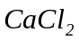 Anhydrous
 | 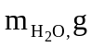 | 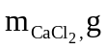 |  |  |  | kJ/mol
Trial 1
Trial 2
AVERAGE
% ERROR
STANDARD DEVIATION

Individual Data Set (you and your partner)
Dissolution of 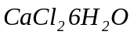
 |  | 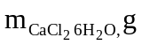 |  |  |  | kJ/mol
Trial 1
Trial 2
AVERAGE
% ERROR
STANDARD DEVIATION

Individual Data Set (you and your partner)
Hess's Law
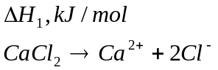 | 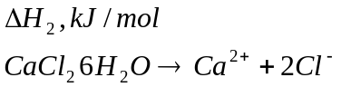 | 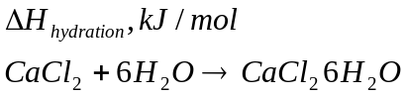
THEORETICAL VALUE
% ERROR
Group Data Set
Hess's Law
THEORETICAL VALUE
% ERROR

Data Analysis
6. Evaluate the possible sources of error in this experiment and specifically how those errors would have affected your 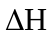values.
Source of Error | Increase or Decrease ΔH? Explain

Part III. Chemistry of Life
- Based on your observations, which compound, magnesium sulfate or ammonium chloride, is used to make cold packs (hot packs)? Explain.

- Explain whether the two reactions are endothermic or exothermic: (1) ammonium chloride and water (2) magnesium sulfate and water.

- What sign will have for the two reactions: (1) ammonium chloride and water (2) magnesium sulfate and water?

