Report 3: Colorful Copper

Note: In preparing this report you are free to use references and consult with others. However, you may not copy from other students’ work (including your laboratory partner) or misrepresent your own data (see honor code).
Name(Print then sign): ___________________________________________________
Lab Day: ___________________Section: ________TA__________________________
1. Initial mass of copper _______

2. Mass of copper and beaker _______

3. Mass of evaporating beaker _______

4. Mass of recovered copper ______

5. Percent yield (show calculations) ______

6. Complete and balance the equation and describe what you observed:

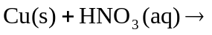

7. Complete and balance the equation and describe what you observed:

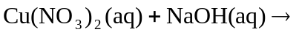

8. Complete and balance the equation and describe what you observed:

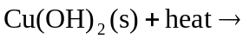

9. What are you removing by this washing?

10. What copper compound is present in the beaker?

11. Describe the reaction 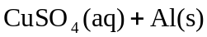
12. What is present in solution?

13. What is the gas?

14. How do you know?

15. What are you removing by washing?

16. What color is your copper sample? Is it uniform in appearance?

17. Suggest at least two possible sources of error in this experiment.

