title
Analog Synthesis with LabVIEW

Objective
This project will give you the opportunity to begin designing sounds in LabVIEW. You will create two subVIs: one to implement an ADSR-style envelope generator and the other to create a multi-voice sound source. You will then create a top-level application VI to render a simple musical composition as an audio file.

Prerequisite Modules
If you have not done so already, please study the pre-requisite modules, Analog Synthesis Modules [LINK TO THE MODULE]. If you are relatively new to LabVIEW, consider taking the course LabVIEW Techniques for Audio Signal Processing [LINK TO THE MODULE], which provides all of the foundation you need in order to complete this mini-project activity, including working with arrays, creating subVIs, playing an array to the soundcard, and saving an array as a .wav sound file.

Deliverables
- All LabVIEW code that you develop (block diagrams and front panels)
- All generated sounds in .wav format
- Any plots or diagrams requested
- Summary write-up of your results

Part 1: ADSR Envelope
Create the subVI <term>ADSR.vi</term> to generate the ADSR-style envelope specified below (ADSR = Attack-Decay-Sustain-Release):
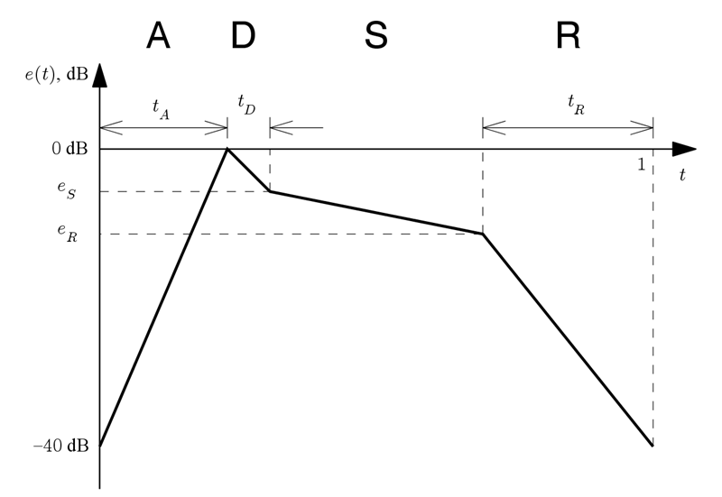
The envelope shape is defined over a normalized time interval of 0 to 1; the envelope will stretch or compress to match the actual duration requested. The three time intervals are likewise expressed in normalized units, so an attack duration (tA) of 0.2 indicates that the attack time is 20% of the entire envelope duration. The envelope values range from 0 dB (full sound intensity) to -40 dB (close to silence). Once you have defined the envelope shape in terms of straight-line segments, you can create the envelope amplitude waveform by undoing the decibels operation; recall that an amplitude “A” expressed in dB is 20 log10(A).

The subVI requires the following controls as input parameters (units specified in brackets):
- <term>duration [s] </term> – total duration of envelope
- <term>fs [Hz] </term> – system-wide sampling frequency
- <term>t values</term> – three-value array containing attack (A) interval, decay (D) interval, release (R) interval. All three values are in the range 0 to 1, so the intervals are to be treated as fractions of the total duration of the envelope. For example, A=0.3 indicates the attack interval is 30% of the envelope’s duration.
- <term>e values</term> – two-value array containing the envelope value at the beginning of the sustain interval (eS in the diagram above) and the envelope value at the beginning of the release interval (eR).

The subVI requires the single indicator (output) <term>envelope</term>, an array with values in the range 0 to 1.

Show that your ADSR VI functions properly by plotting the envelope for at least two distinct cases. Plot both the dB form of the envelope and as well as its non-dB form.

The following screencast video provides coding tips and other suggestions to help you develop your subVI.

[video: asyn_MP-compose-part1]

Part 2: Sound Generator
Make a subVI called <term>SoundGen.vi</term> that combines a signal source with the ADSR envelope generator. Use a <term>case structure</term> with <term>enumerated data type</term> control an that will allow you to choose one of several different “voices” or “instruments;” the case structure will then define the ADSR input parameters and choose the type of signal source (or noise source for a percussive-type instrument).

The subVI requires the following controls as input parameters (units specified in brackets):
- <term>duration [s] </term> – total duration of note
- <term>fs [Hz] </term> – system-wide sampling frequency
- <term>fref [Hz] </term> – reference frequency
- <term>note </term> – note frequency as described by an integer value that denotes the number of semitone intervals from the reference frequency; <term>note </term> can be a negative, zero, or positive value
- <term>instrument </term> – enumerated data type with values of your choice; your SoundGen.vi should have at least three different tone-type sounds and at least two different percussive-type sounds. Use a variety of envelope shapes.

If the discussion in Item 4 for the <term>note </term> control seems mysterious, review the module [INSERT NAME AND MODULE LINK] to learn how to calculate the frequency of a semitone interval using <term>equal temperament</term>.

Show that your sound generator VI functions properly by developing a top-level VI that plays a chromatic scale. Vary the duration of the notes. Plot the waveform to ensure that the envelope shape makes sense. Save your generated sound to a .wav file to be included with your deliverables.

The following screencast video provides coding tips and other suggestions to help you develop your subVI.

[video: asyn_MP-compose-part2]

Part 3: Multi-Voice Composition
Compose a simple piece of music using analog synthesis techniques of your choice. Better compositions will include variety, e.g., different envelope parameters at different times, multiple channels (chords), stereo, percussive sounds, etc. Write a paragraph or two that describes your compositional technique. Better compositions will be click-free, i.e., joining the notes together does not produce any pops or clicks.

Hints: [LIST NAME]
- You may wish to use a familiar melody (remember, you’ve got an equation that converts a note from the equal-tempered scale into frequency), or you may want to use a musical “experiment” based on an algorithm as the basis for your composition.

- Operate the multiple instances of <term>SoundGen.vi</term> in parallel (each with a different instrument setting) and add their outputs together.

- Import multiple spreadsheets to define your note lists (use “File IO | Read Spreadsheet”). Spreadsheets are the easiest way to hand-edit the contents of arrays

- Remember to normalize your finished output before saving it to a .wav file! Use <term>QuickScale</term> (“Signal Processing | Signal Operation | Quick Scale”) for this purpose.

- View your finished composition as a waveform plot. Confirm the envelope shapes make sense, and that the waveform is symmetrical about the zero axis (it should not contain any constant offset).

Alternative Part 3: Multi-Voice Composition using MIDI File
The overall objectives of this alternative Part 3 are the same as described above, but the technical approach is different.

Go to [NAME OF MODULE; CNX LINK] to learn all about <term>MIDI_Render.vi</term>, an application VI that reads a standard MIDI file (.mid format) and renders it to an audio file (.wav format) using “instrument” subVIs of your own design. You have already done all of the work necessary to create your own instruments, and it is a simple matter to place them inside a standard subVI wrapper the MIDI_Render can use.

[video: asyn_MP-compose-midi]

The MIDI_Render application is available in this .zip archive: MIDI_Render.zip. Right-click and choose “Save As” to download the .zip file, unpack the archive into its own folder, and double-click “MIDI_Render.vi” to start the application.

