Overview
Arrays are a fundamental data type for signal processing. LabVIEW offers a complete set of techniques to create and manipulate arrays, and to perform mathematical and signal processing operations on arrays. This module will acquaint you with the basic techniques for working with arrays.

Creating Arrays
The following video screencast describes how to create arrays on the front panel and on the block diagram. The elements of an array can be edited and modified directly, a suitable technique when the array is relatively small.
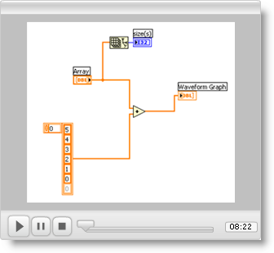

Manipulating Arrays
The next video screencast explains essential array manipulations for signal processing tasks, including: determining the dimensions of an array, retrieving individual elements, rows, columns, or other subarrays, appending (concatenating) arrays, and reshaping arrays.
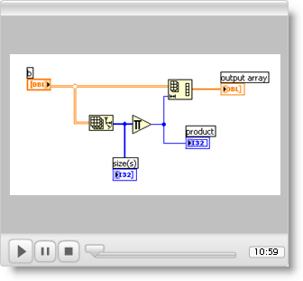

Mathematical Operations with Arrays
Signal processing operations commonly operate on all of the array elements at once. For example, adding a scalar constant to an array implies a loop operation in which the constant is added to each element of the array.

The following screencast video describes several techniques for performing mathematical operations on arrays. Important side effects (such as what happens when two arrays of different lengths are added together) are discussed. The Ramp Pattern subVI is also described as a method to create a time basis for mathematical functions such as the exponential.
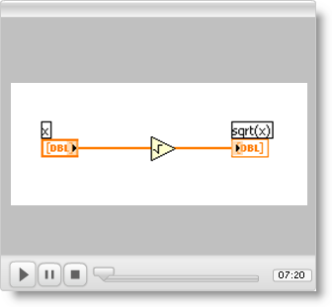

Arrays and Spreadsheets
Spreadsheets are often used as a data storage mechanism by other applications. The next screencast video shows you how to retrieve an array from a comma-separated-values (CSV-format) spreadsheet, and how to create your own CSV-format spreadsheet from an existing array within LabVIEW.
