Overview
Welcome to the exciting world of LabVIEW for audio and signal processing applications! This module contains four screencast videos, meaning that the videos were captured directly from my computer screen. As I operate the LabVIEW software, I explain each step and discuss what is going on. After you watch each of the four videos, you will have a good idea of some fundamental LabVIEW concepts, including:
- Front panel and block diagram programming paradigm
- Dataflow paradigm
- Data types
- Debugging techniques

A Bit of History
In 1986 National Instruments Corporation released the first version of LabVIEW (Laboratory Virtual Instrument Engineering Workbench), which was designed to help engineers use a computer (the Apple Macintosh) to control and gather data from electronic instrumentation (voltmeters, oscilloscopes, and the like) all interconnected by the standard General Purpose Instrumentation Bus, or GP-IB. From its inception, LabVIEW programming was graphical in nature. Instead of writing a text file and compiling it to an executable, you connect various elements such as controls, indicators, nodes and subVIs together with wires, and in this way create a block diagram. The controls and indicators reside on the front panel, which looks just a traditional electronic instrument, i.e., it can have knobs, sliders, buttons, and display panels. The complete application is called a virtual instrument, or VI for short.

LabVIEW has since evolved into a complete programming environment; anything that you can imagine can probably be implemented in LabVIEW. Recent versions of LabVIEW have added a full suite of tools for doing signal processing, and since soundcard operations are provided, it becomes natural to develop audio signal processing applications in LabVIEW.

LabVIEW’s interactive front panel offers a unique opportunity to explore signal processing concepts in real time. As you work your way through other modules in this series, you will learn how to implement your own applications whose user interface consists of knobs, sliders and switches that can adjust processing parameters while you listen to the results.

Your First Virtual Instrument (VI)
Watch the following screencast video to learn how to connect front panel controls and indicators together. You will also learn how to use the While Loop structure to make your VI operate continuously until you press a “STOP” button on the front panel.
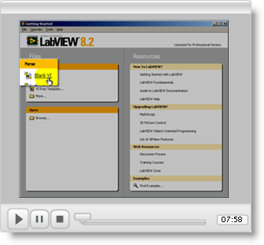

The Dataflow Concept
The notion of LabVIEW’s dataflow programming paradigm must be grasped immediately in order for you to make forward progress learning about LabVIEW and creating your own applications. Dataflow programming means that valid data must be present at all of the input terminals on a node (or subVI) before that node (or subVI) will produce valid data on its output terminals. Moreover, the node (or subVI) does not continually process its inputs data unless it is embedded in some sort of looping structure.

Click on the following animation of the dataflow concept to watch a screencast video that explains and further explores the dataflow programming concept.
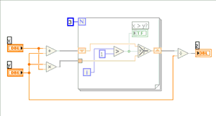

Data Types
LabVIEW supports a broad range of data types, including numeric, Boolean, and string. The following screencast video will acquaint you with the floating point and integer styles of numeric data type, as well as the Boolean data type. The screencast explains the significance of the coercion indicator -- the red dot that flags a mismatch on data types applied to the input of a node or subVI -- as well as data type conversion nodes that you can use to intentionally convert a value from one data type to another.
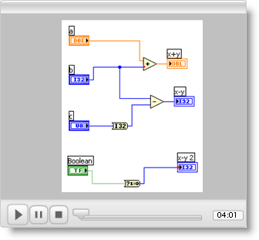

Broken Wires
Broken wires indicate an error that must be corrected before your VI will run. Broken wires result from a number of causes, and it is important to be able to understand why the wire is broken and how to correct the situation. The following screencast describes broken wires in detail.
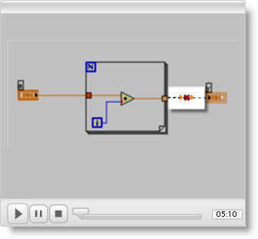

Debugging Techniques
As you begin learning LabVIEW so that you can develop your own VIs, you will find the debugging techniques described by the next screencast video to be help. Topics include adding additional indicators, using the Highlight Execution feature, using the Retain Wire Values feature, single-stepping, viewing wire values using probes, and creating breakpoints to pause execution when new data is available on a wire.
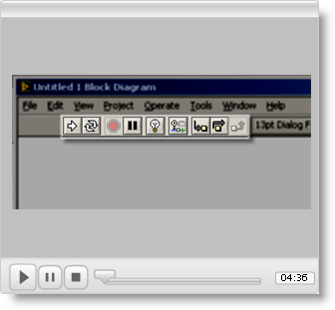

For Further Study
If you are new to LabVIEW, I recommend the excellent text by Robert H. Bishop, Learning with LabVIEW 8 (Pearson Prentice Hall, 2007, ISBN 0-13-239025-6). With this text you can learn basic LabVIEW programming techniques and get a better idea of everything that LabVIEW has to offer.

Once you have developed some skill with LabVIEW, consider Peter A. Blume’s text, The LabVIEW Style Book (Prentice Hall 2007, ISBN 0-13-145835-3). This text covers a wide variety of techniques that will help you to develop robust and well-designed LabVIEW applications.

Don’t forget to check out the on-line documentation that is part of your LabVIEW product installation.

Visit the National Instruments website, including their Academic page and the NI Developer Zone.

