Signals and Systems

Homework Assignment #2

Problem 1. Let x[n] and h[n] represent the signals shown in the following plots.

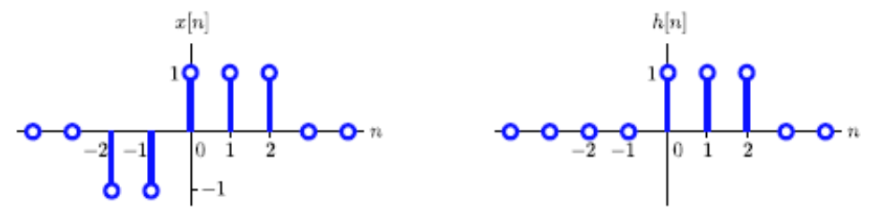

Both signals are zero outside the indicated range of n.
a. Sketch x[n] * h[n].
b. Sketch x[n - 1] * h[n].
c. Sketch (x[n] - x[n - 1]) * h[n].
d. Sketch the “step response” s[n] of h[n], which is defined as s[n] = u[n] * h[n].

Problem 2. Let x(t) and h(t) represent the signals shown in the following plots.

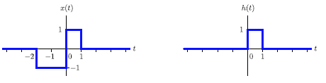
Both signals are zero outside the indicated range of t.
a. Sketch x(t) * h(t).
b. Sketch x(t - 1) * h(t).
c. Sketch (x(t) - x(t - 1)) * h(t).

Problem 3.
a. Determine an expression for y₁(t) = u(t) * e^{-t}u(t). Sketch your result.
b. Determine an expression for y₂(t) = e^{-t}u(t) * e^{-2t}u(t). Sketch your result.
c. Determine an expression for y₃(t) = e^{-t}u(t) * e^{-t}u(t). Sketch your result.

Problem 4.
a. Determine an expression for y₁[n] = u[n] * 0.5^{n}u[n]. Sketch your result.
b. Determine an expression for y₂[n] = 0.7^{n}u[n] * 0.8^{n}u[n]. Sketch your result.
c. Determine an expression for y₃[n] = 0.7^{n}u[n] * 0.7^{n}u[n]. Sketch your result.

