Signals and Systems

Solutions to Homework Assignment #1

Problem 1.
- Set t = 0. Then y₁(0) = x(−1). Set t = 1. Then y₁(1) = x(0). Set t = 2. Then y₁(2) = x(1). These examples make it clear that y₁(t) looks like a delayed version of x(t).
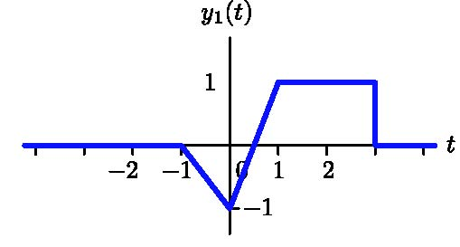
- Set t = 0. Then y₂(0) = x(2). Set t = 1. Then y₂(1) = x(4). Set t = −2. Then y₂(−2) = x(−2). Thus y₂(t) is a version of x(t) that is compressed by a factor of 2 about the point t = −2.
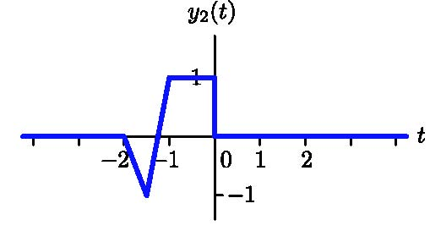
- Set t = 0. Then y₃(0) = x(1). Set t = 1. Then y₃(1) = x(0). Set t =1/2. Then y₃(1/2) = x(1/2). Thus y₃(t)is version of x(t) that is ﬂipped about the point t =1/2.
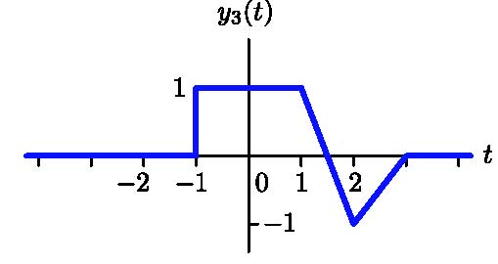
- Let x(t) = x_{e}(t) + x_{o}(t). Then x(−t) = x_{e}(−t) + x_{o}(−t). By the deﬁnitions of even and odd, it follows that x(−t) = x_{e}(t) − x_{o}(t). Add this to the ﬁrst equation to get x(t) + x(−t) = 2x_{e}(t). Thus

x_{e}(t) = ½ (x(t) + x(−t))
is uniquely determined by x(t). The function x_{e}(t) is plotted below.
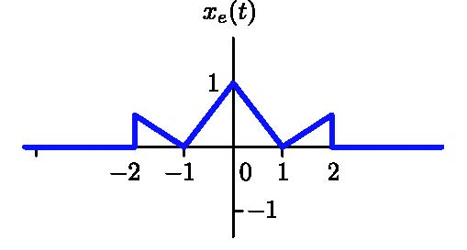
- Set t = (-2 – b)/a. Then y₄((-2-b)/a) = x(−2). Set t = (2 – b)/a. Then y₄((2-b)/a) = x(2). If a > 0 then y₄(t) has the following shape.
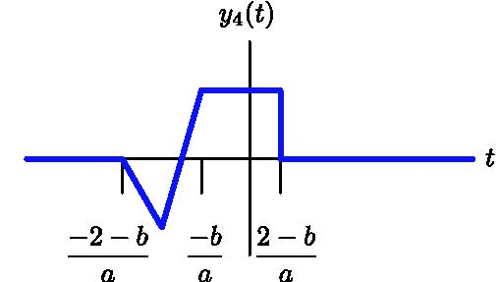
In order for y₄(t) to be causal,
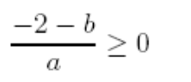
which implies that b ≤ −2. If a < 0, then the signal is ﬂipped, as illustrated below.
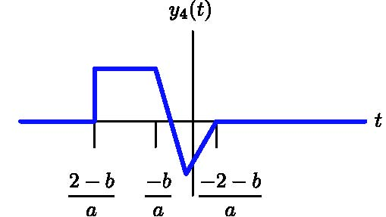
Now
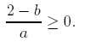
Since a < 0, this implies that 2 − b ≤ 0 and therefore b ≥ 2.
If a =0, then y(t) = x(b), which will be causal if b > 2 or b < −2 or b = −1/2.
In summary, a can take on any value. If a > 0 then b must be less than or equal to −2. If a < 0 then b must be greater than or equal to 2. If a = 0 then b must be less than −2 or greater than 2 or equal to −1/2.

Problem 2.
- If n = 0 then y₁[0] = x[−1]. If n = 1 then y₁[1] = x[0]. Thus y₁[n] is a delayed version of x[n] as illustrated below.
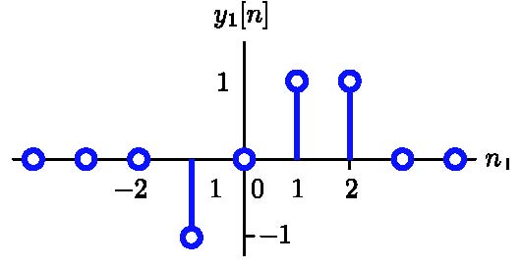
- If n = 0 then y₂[0] = x[2]. If n = 1 then y₂[1] = x[4]. Thus, values of x[n] at even indices are compressed into successive samples of y₄[n], as shown below.
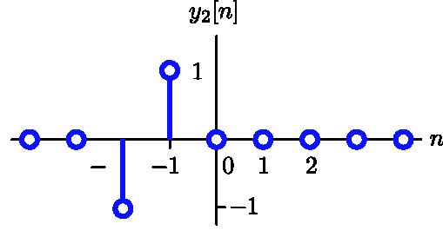
- Let x[n] = x_{e}[n] + x_{o}[n]. Then x[−n] = x_{e}[−n] + x_{o}[−n]. By the deﬁnitions of even and odd, it follows that x[−n] = x_{e}[n] − x_{o}[n]. Subtract this to the ﬁrst equation to get x[n] − x[−n] = 2x_{o}[n]. Thus
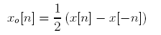
is uniquely determined by x[n]. The function x_{o}[n] is plotted below.
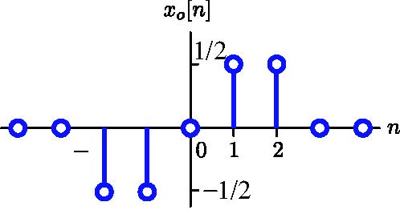
- We must assure that y₃[n] = 0 for n < 0. Since y₃[n] = x[3n + b] it follows that 3n + b must not be equal to −2 or 0 or1for n < 0. Thus, forbidden values of b are b = −2 − 3n, n < 0 or b = 0 − 3n, n < 0 or b = 1− 3n, n < 0. Enumerating, these are b = 1,4,7,10,13,... or b = 3,6,9,12,15,... or b = 4,7,10,13,.... Thus b can be any negative number or zero or 2,5,8,11,14,....
- The value of sin(t)/t at t = 0 can be obtained using l’Hospital’s rule.

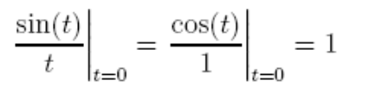
Therefore y₄[0] = 1. For n = ±1, y₄[n] = sin(±π/2)/(±π/2) = 2/π. For n = ±2, y₄[n] = sin(±π)/(±π) = 0. For n = ±3, y₄[n] = sin(±3π/2)/(±3π/2) = −2/(3π). This pattern repeats and assigns no-zero values to all odd indices n and shown in the following ﬁgure.
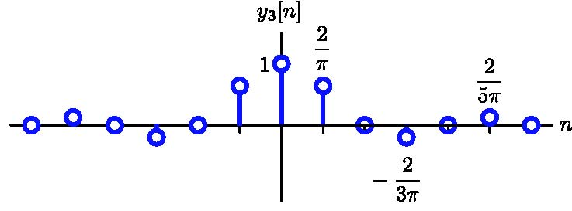
Problem 3. All three statements are true. The ﬁrst function is periodic in period 8 because
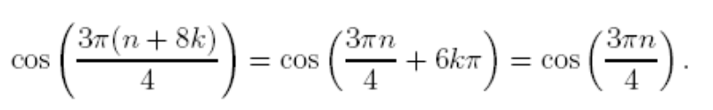
The second function is periodic in period 8 because
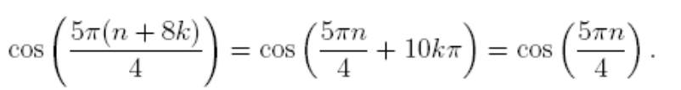
Since the cosine function is even, it follows that
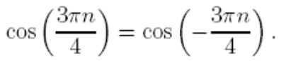
Since the cosine function is periodic in 2π,itfollowsthat
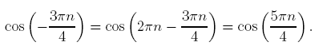
Therefore x₁[n] = x₂[n] for all n.

Problem 4. Sampling generates DT signals
x₁[n] = cos(3n),
x₂[n] = cos(4n), and
x₃[n] = cos(5n).
At ﬁrst glance, it appears that x₁[n] has the lowest discrete frequency and x₃[n] has the highest. However, discrete frequencies are periodic in 2π. Therefore
x₂[n] = cos(4n) = cos(2πn−4n) ≈ cos(2.28n).
x₃[n] = cos(5n) = cos(2πn−5n) ≈ cos(1.28n).
Thus, x₃[n] has the lowest discrete frequency and x₁[n] has the highest.

Problem 5.
- Answer: −∞ < l < ∞ and −∞ < m < ∞. If x₁[n]→ y₁[n] and x₂[n]→ y₂[n] then
αx₁[n] + βx₂[n] → (−2)^{ln} (αx₁[n −m] + βx₂[n −m])
= α(−2)^{ln}x₁[n −m] + β(−2)^{ln}x₂[n −m])
= αy1[n] + βy2[n].
Thus the system is linear for all values of l and m.
- Answer: l = 0 and −∞ < m < ∞. If l ≠ 0 then shifting the signal also multiplies it by (−2)^{ln}. If l = 0 then the multiplier is always 1.
- Answer: −∞ < l < ∞ and 0 ≤ m < ∞. If m < 0, then y[n] depends on inputs that follow n.
- Answer: −∞ < l < ∞ and m = 0. If m ≠ 0, then y[n] depends on inputs at times other than n.
- Answer: l = 0 and −∞ < m < ∞. If l > 0, then the multiplier (−2)^{ln} approaches ±∞ as n → ∞. If l < 0, then the multiplier (−2)^{ln} approaches ±∞ as n → −∞.

