Signals and Systems

Homework Assignment #1

Problem 1. Let x(t) represent the signal shown in the following plot.
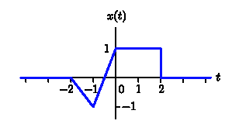

The signal is zero outside the range -2 < t < 2.
a. Sketch y₁(t) = x(t - 1).
b. Sketch y₂(t) = x(2t + 2).
c. Sketch y₃(t) = x(1 - t).
d. Assume that x(t) can be written as the sum of an even part

x_{e}(t) = x_{e}(-t)
and an odd part
x_{o}(t) = -x_{o}(-t):
Prove that x_{e}(t) is unique. Sketch x_{e}(t).
e. Let y₄(t) = x(at + b). Determine all possible pairs of a and b for which y₄(t) is causal.

Problem 2. Let x[n] represent the signal shown in the following plot.

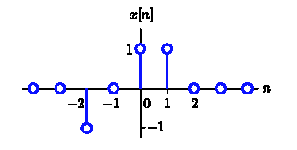

The signal is zero outside the range -2 ≤ n ≤ 1.
a. Sketch y₁[n] = x[n - 1].
b. Sketch y₂[n] = x[2n + 2].
c. Assume that x[n] can be written as the sum of an even part
x_{e}[n] = x_{e}[-n]
and an odd part
x_{o}[n] = -x_{o}[-n]:
Prove that x_{o}[n] is unique. Sketch x_{o}[n].
d. Let y₃[n] = x[3n+b] where b is an integer. Find all values of b for which y₃[n] is causal.
e. Let y₄[n] represent a sampled version of sin(t)/t so that y₄[n] = sin(nT)/(nT) where the sampling interval T = π/2. Sketch y₄[n].

Problem 3. Consider two DT signals:
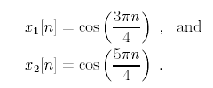

How many of the following statements are true?
- x₁[n] is periodic with a period of 8.
- x₂[n] is periodic with a period of 8.
- x₁[n] = x₂[n].
Briefly explain.

Problem 4. Consider 3 CT signals:
x₁(t) = cos(3000t) ;
x₂(t) = cos(4000t) ; and
x₃(t) = cos(5000t) :
Each of these is sampled to generate three DT signals:
x₁[n] = x₁(nT) ;
x₂[n] = x₂(nT) ; and
x₃[n] = x₃(nT) ;
where T = 0:001. Which of the DT signals has the highest DT frequency? Which of the DT signals has the lowest DT frequency?

Problem 5. Consider a DT system defined by
y[n] = (-2)^{nl}x[n - m]
where l and m are integer constants.
a. Determine all possible values of l and m so that the system is linear.
b. Determine all possible values of l and m so that the system is time invariant.
c. Determine all possible values of l and m so that the system is causal.
d. Determine all possible values of l and m so that the system is memoryless.
e. Determine all possible values of l and m so that the system is BIBO stable.

