Figure 1.3: Interweaving of the historical traditions of biochemistry, cell biology, and genetics.
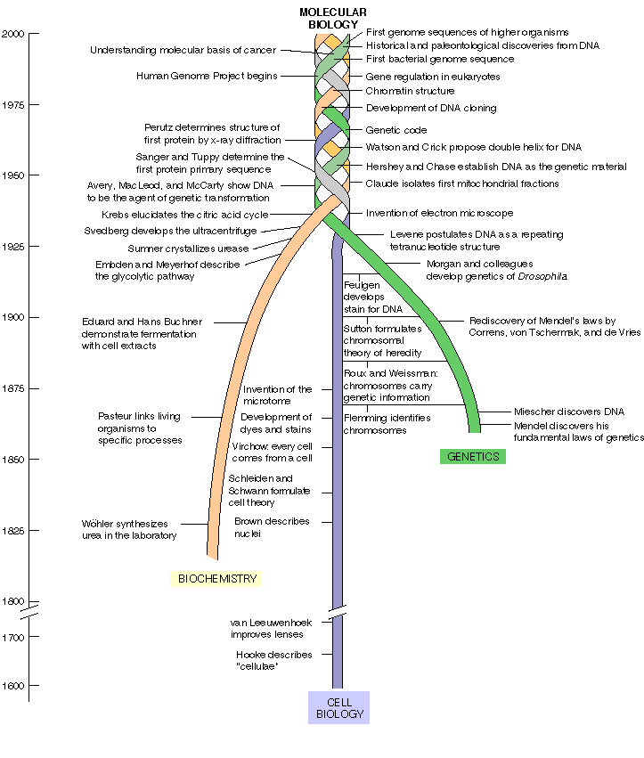
Adapted from W. M. Becker, L. J. Kleinsmith, and J. Hardin, The World of the Cell, 4th ed. (San Francisco, CA: Addison Wesley Longman, 2000). © Addison Wesley Longman, Inc.

