Project report on
AI/ML BASED SIGN LANGUAGE TRANSLATOR USING RASPBERRY PI

Submitted by
Swayam Das (2341004102)
Anubhab Patra (2341016261)
Smruti Sourav Mishra(2341013151)
Saadiya Farheen(2341006003)
- Jayant Kumar (2341011103)
Veetesh Sinha (2341019574)
B. Tech. (CSE(IOT) 5th Semester (Section–23412O3)


CENTRE FOR INTERNET OF THINGS
DEPARTMENT OF COMPUTER SCIENCE AND ENGINEERING
Institute of Technical Education and Research

SIKSHA ‘O’ ANUSANDHAN
DEEMED TO BE UNIVERSITY

Bhubaneswar, Odisha, India.
(January, 2026)

Abstract
Sign language is an essential mode of communication for individuals with hearing and speech impairments; however, interaction with non-signers remains a challenge. This project presents a sensor-based hand sign languagetranslator using a smart glove to enable real-time gesture recognition and translation. The proposed system integrates flex sensors and an MPU6050 inertialmeasurement unit to capture finger bending and hand orientation data. An ESP32 microcontroller acquires the sensor readings and transmits them wirelessly to a Raspberry Pi 4 via Bluetooth. A trained machine learning model processes the received data to classify hand gestures, and the recognized sign is displayed on an OLED display. A custom dataset was created and preprocessed to train the model for accurate classification. Experimental results demonstrate reliable real-time performance with low latency, making the system suitable for practical assistive communication applications. The proposed solution is portable, cost-effective, and independent of environmental conditions, offering a scalable approach for sign language translation.

Contents

Abstract ..............................i
Contents ii
Chapter 01: Introduction 1
1.1. Introduction 1
1.2. Background 1
1.3. Project Objectives 2
1.4. Scope 2
1.5. Project Management 3
1.6. Overview and Benefits 4
1.7. Organization of the Report 6
Chapter 02: Background Review & Survey 7
2.1. Related Works 7
Chapter 03: Theoretical Aspects 10
3.1. Internet of Things (IoT) 10
3.2. Features of IoT 10
3.3. Advantages of IoT…………………………………………………………………………..10
3.4. Disadvantages of IoT 11
3.5. Application areas of IoT 11
3.6. IOT Technologies and Protocols 11
3.7. Project Layout 12
3.7.1. Brief Description 12
Chapter 04: Hardware Requirements 13
4.1 Raspberry Pi 4 ...............................................................................................................................13
4.1.1 Features .......................................................................................................................................13
4.1.2GPIO Pin Configuration ........................................................................................................... ..14
4.2 ESP32 Microcontroller ...................................................................................................................17
4.3 Sensors ...........................................................................................................................................17
4.3.1 Flex Sensors ...............................................................................................................................18
4.3.2 MPU6050 Accelerometer & Gyroscope ....................................................................................17
4.4 MCP3008 Analog-to-Digital Converter .........................................................................................18
4.5 OLED Display ................................................................................................................................18
4.6 TP4056 Battery Charging Module ................................................................................................18
4.7 Block Diagram of the Proposed System ........................................................................................19
4.7.1 Working of the System ...............................................................................................................19
4.7.2 Circuit Diagram .........................................................................................................................20
4.7.3 Components Required ................................................................................................................21

Chapter 05: Software Requirements 21
5.1Thonny IDE (Python) .....................................................................................................................22
5.2 Logic and Flowchart ...................................................................................................................22
Chapter 06: Project development & Testing Aspects 24
6.1ProjectDevelopment..........................................................................................................................25
6.1.1 Hardware Development ..............................................................................................................25
6.1.2 Software Development ...............................................................................................................26
6.1.3 Dataset Collection and Model Training .....................................................................................26
6.2 Testing Aspects ..............................................................................................................................27
6.2.1 Sensor Testing ............................................................................................................................27
6.2.2 Bluetooth Communication Testing .............................................................................................28
6.2.3 Model Accuracy and Performance Testing ................................................................................ 28
6.2.4 Real-Time System Testing ..........................................................................................................29
7.2. Conclusion………………………………………………………………………………….29
7.3. Limitations 29
7.4. Further Enhancement and Future Scope 29
References…………………………………………………………………………………….………31
Appendix 01……………………………………………………………………………………….….32
A01.1. Code Listing 31
A01.2. Main Code 42
A01.3. Libraries 46
Appendix 02 48
A02.1. Project Proposal Form 48
A02.2. Project Management 48
A02.3. Bill of Material 49
Appendix 03……………………………………………………………………………………..……49
A03.1. Data Sheets 51

Chapter 01: Introduction

Introduction
Communication is a fundamental aspect of human interaction, enabling individuals to express thoughts, emotions, and intentions. However, for people with hearing and speech impairments, communication with the general population becomes challenging due to the widespread lack of understanding of sign language. Hand sign language is a primary mode of communication for the deaf and mute community, but its usability is limited when interacting with individuals who are unfamiliar with it.
With advancements in embedded systems, wearable technology, and machine learning, it has become possible to bridge this communication gap through intelligent assistive devices. This project presents the design and implementation of a Hand Sign Language Translator using a Smart Glove, which captures hand movements and finger bends using sensors and translates them into readable text output.
The proposed system uses flex sensors to measure finger bending and an MPU6050 inertial measurement unit (IMU) to capture hand orientation and motion. These sensor readings are processed by an ESP32 microcontroller, which transmits the data wirelessly to a Raspberry Pi 4 via Bluetooth. A machine learning model running on the Raspberry Pi interprets the sensor data and displays the corresponding sign language gesture on an OLED display.
This system provides an affordable, portable, and efficient solution to improve communication accessibility for the hearing-impaired community.

Background
Sign language recognition systems have traditionally relied on camera-based vision systems that use image processing and deep learning techniques to recognize hand gestures. While effective, such systems suffer from several limitations including sensitivity to lighting conditions, background noise, camera positioning, and high computational requirements.
To overcome these limitations, sensor-based gesture recognition systems have gained popularity. These systems use wearable sensors such as accelerometers, gyroscopes, and flex sensors to directly capture hand movements and finger positions, offering improved accuracy and reliability regardless of environmental conditions.
Smart gloves integrated with sensors provide a direct and efficient method to capture hand gestures. With the rise of microcontrollers like ESP32 and single-board computers like Raspberry Pi, along with powerful machine learning algorithms, it is now feasible to build real-time gesture recognition systems at a low cost.
This project builds upon these technological advancements by combining wearable sensor technology, wireless communication, and machine learning classification to translate sign language gestures into text output in real time.

Project Objectives
The primary objectives of this project are:
- To design and develop a smart glove capable of capturing finger bending and hand orientation.
- To acquire real-time sensor data using flex sensors and MPU6050.
- To transmit sensor data wirelessly from the ESP32 to Raspberry Pi using Bluetooth communication.
- To create a gesture dataset and preprocess it for machine learning training.
- To train a machine learning model capable of accurately classifying hand sign gestures.
- To implement real-time gesture recognition on the Raspberry Pi.
- To display the translated hand signs on an OLED display for easy readability.
- To provide an affordable and portable assistive communication system.

Scope
The scope of this project includes the development of a wearable sign language translation system focused on static and semi-dynamic hand gestures. The system is designed to recognize a predefined set of sign language gestures rather than full sentence translation.
The project scope covers:
- Sensor-based gesture acquisition using a smart glove.
- Bluetooth-based wireless data transmission.
- Machine learning-based gesture classification.
- Real-time output display on an OLED screen.
- The system does not include:
-Voice output conversion (text-to-speech).
-Vision-based gesture recognition.
-Full sign language grammar or sentence interpretation.
-Despite these limitations, the system effectively demonstrates the feasibility of real-time sign language translation using wearable technology.

Project Management
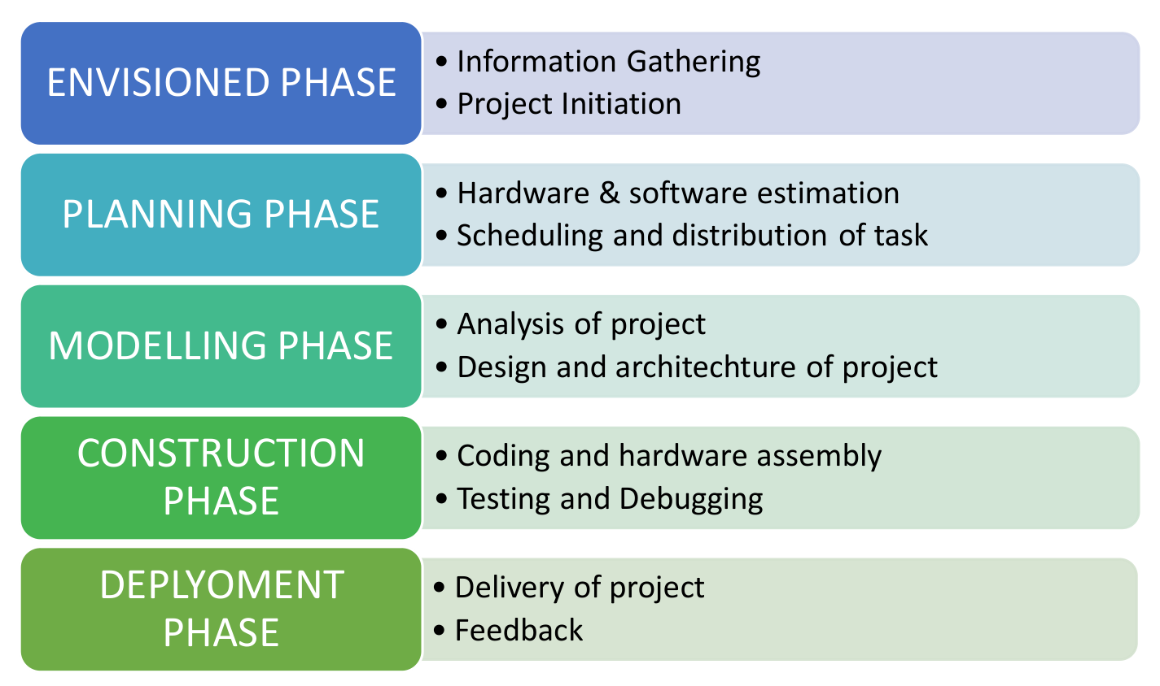
Figure 1.1. Model of phases in project management.
Project management involves planning, organizing, and controlling project activities to achieve defined objectives within constraints such as time and resources. This project was executed in a systematic manner following standard project management practices.
The project was divided into the following phases:
1.Requirement Analysis
Identification of hardware components, software tools, and functional requirements.
2.System Design
Design of hardware architecture, communication flow, and software modules.
3.Hardware Implementation
Integration of flex sensors, MPU6050, ESP32, and OLED display.
4.Data Collection and Dataset Creation
Recording sensor data for various hand gestures and labeling them.
5.Data Preprocessing and Model Training
Cleaning the dataset, feature scaling, and training the machine learning model.
6.System Integration and Testing
Integrating hardware and software components and testing real-time performance.
7.Documentation and Reporting
Preparing detailed project documentation and final report.
This structured approach ensured timely completion of the project with reliable and accurate results.

Overview and Benefits
The proposed Hand Sign Language Translator using a Smart Glove is a wearable assistive system designed to convert hand sign gestures into readable textual output in real time. The system focuses on improving communication accessibility for individuals with hearing and speech impairments by providing a reliable interface between sign language users and non-signers.
The overall operation of the system begins with the smart glove, which is embedded with multiple flex sensors and an inertial measurement unit (MPU6050). The flex sensors are responsible for measuring the degree of finger bending, while the MPU6050 captures the orientation and movement of the hand through accelerometer and gyroscope readings. These sensors collectively generate a rich set of features that accurately represent different hand sign gestures.
An ESP32 microcontroller mounted on the glove acts as the primary data acquisition and transmission unit. It continuously reads sensor values and sends the processed data wirelessly to a Raspberry Pi 4 using Bluetooth communication. The Raspberry Pi serves as the central processing unit where a pre-trained machine learning model analyzes the incoming sensor data to identify the performed gesture. Once the gesture is recognized, the corresponding sign is displayed on an OLED screen, providing immediate visual feedback.

Benefits of the Proposed System
The proposed system offers several practical and technical benefits:
- Enhanced Accessibility
The system enables hearing-impaired individuals to communicate more effectively with people who do not understand sign language, thereby reducing communication barriers.
- Wearable and User-Friendly Design
The smart glove is lightweight and comfortable, allowing users to perform natural hand movements without restriction.
- Real-Time Gesture Translation
The system provides near-instantaneous recognition and display of gestures, making it suitable for real-world communication.
- Cost Efficiency
By using low-cost and readily available components such as the ESP32, flex sensors, and Raspberry Pi, the system remains affordable compared to camera-based solutions.
- Reliable Performance
Since the system is sensor-based, it is not affected by lighting conditions, background clutter, or camera positioning.
- Scalability and Flexibility
The system can be extended to recognize additional gestures by collecting more data and retraining the machine learning model.

Organization of the Report
This project report is organized into seven chapters, each focusing on a specific aspect of the system design and implementation.
Chapter 1: Introduction
This chapter introduces the problem of sign language communication barriers and provides background information, project objectives, scope, benefits, and an overview of project management.
Chapter 2: Literature Survey
This chapter reviews existing research and technologies related to sign language recognition, smart gloves, wearable sensors, and machine learning-based gesture classification. It highlights the limitations of existing systems and identifies research gaps addressed by the proposed solution.
Chapter 3: System Architecture and Design
This chapter presents the overall system architecture, including hardware and software components. It explains the block diagram, data flow, communication protocols, and design decisions.
Chapter 4: Hardware Implementation
This chapter describes the hardware components used in the project, their specifications, circuit connections, and physical integration into the smart glove.
Chapter 5: Software Implementation and Machine Learning Model
This chapter details the software modules, data acquisition process, dataset preparation, feature extraction, machine learning model training, and real-time prediction logic.
Chapter 6: Results and Performance Analysis
This chapter discusses experimental results, classification accuracy, response time, and system performance under different conditions.
Chapter 7: Conclusion and Future Scope
This chapter summarizes the project outcomes and discusses potential improvements such as speech output, expanded vocabulary, and advanced deep learning models.

Chapter 02: Background Review & Survey

Related Works
Sign language recognition has been an active research area for several decades, driven by the need to improve communication accessibility for individuals with hearing and speech impairments. Researchers have explored various approaches ranging from vision-based systems to wearable sensor-based solutions, each with its own advantages and limitations. This section reviews significant related works relevant to the proposed smart glove-based hand sign language translator.

Vision-Based Sign Language Recognition Systems
Early research in sign language recognition primarily focused on vision-based approaches using cameras and image processing techniques. These systems relied on capturing images or videos of hand gestures and extracting features such as hand shape, finger positions, and motion trajectories. Machine learning algorithms, including Hidden Markov Models (HMMs), Support Vector Machines (SVMs), and Convolutional Neural Networks (CNNs), were commonly used for gesture classification.
While vision-based systems demonstrated promising results in controlled environments, they were highly sensitive to external factors such as lighting conditions, background complexity, camera angle, and occlusion. Additionally, such systems required high computational power and sophisticated image processing pipelines, making them less suitable for portable and real-time applications. These limitations motivated researchers to explore alternative sensor-based solutions.

Sensor-Based Smart Glove Systems
Sensor-based sign language recognition systems use wearable devices embedded with sensors such as flex sensors, accelerometers, gyroscopes, and magnetometers. Smart gloves equipped with these sensors directly capture finger bending and hand motion data, eliminating the need for cameras and complex image processing.
Several studies have demonstrated the effectiveness of smart glove systems in recognizing static and dynamic hand gestures. Flex sensors have been widely used to measure finger joint angles, while inertial measurement units (IMUs) such as the MPU6050 provide orientation and motion data. These sensor readings are typically processed using machine learning algorithms to classify gestures with high accuracy.
Compared to vision-based systems, smart glove solutions offer improved reliability, portability, and robustness to environmental variations. However, challenges such as sensor calibration, user comfort, and dataset generalization remain important research considerations.

Microcontroller and Embedded System Implementations
Recent works have leveraged low-cost microcontrollers such as Arduino, ESP8266, and ESP32 for implementing smart glove systems. These microcontrollers handle real-time sensor data acquisition and transmission while maintaining low power consumption. Wireless communication technologies including Bluetooth and Wi-Fi are commonly used to transmit sensor data to external processing units.
The use of ESP32 is particularly advantageous due to its integrated Bluetooth and Wi-Fi capabilities, high processing speed, and low energy consumption. Many researchers have demonstrated successful real-time gesture transmission using ESP32-based wearable systems, making it a suitable choice for the proposed project.

Machine Learning Techniques for Gesture Recognition
Machine learning plays a crucial role in converting raw sensor data into meaningful gesture classifications. Traditional machine learning models such as K-Nearest Neighbors (KNN), Support Vector Machines (SVM), Random Forests, and Naïve Bayes classifiers have been widely used due to their simplicity and effectiveness on structured sensor data.
More recent studies have explored deep learning approaches such as Artificial Neural Networks (ANNs) and Long Short-Term Memory (LSTM) networks for handling temporal gesture data. While deep learning models often achieve higher accuracy, they require larger datasets and higher computational resources, which may not be suitable for lightweight embedded systems.
The proposed project adopts a balanced approach by using classical machine learning models that provide sufficient accuracy while maintaining real-time performance on a Raspberry Pi.

Limitations of Existing Systems
Despite significant advancements, existing sign language recognition systems face several limitations. Vision-based systems struggle in uncontrolled environments, while sensor-based systems require careful calibration and may vary between users. Many systems are limited to recognizing a small set of gestures and lack scalability.
Additionally, several existing solutions focus primarily on research prototypes without emphasizing practical usability, affordability, or real-time deployment. These limitations highlight the need for a cost-effective, wearable, and scalable sign language translation system.

Relevance to the Proposed System
The proposed smart glove-based sign language translator builds upon the strengths of sensor-based approaches while addressing key limitations observed in existing works. By integrating flex sensors, an IMU, ESP32, Raspberry Pi, and machine learning, the system aims to deliver accurate, real-time gesture recognition in a portable and affordable form.
This review of related works provides the foundation for the design choices made in the proposed system and demonstrates its relevance within the broader research landscape.

Chapter 03: Theoretical Aspects

Internet of Things (IoT)

The Internet of Things (IoT) refers to a network of interconnected devices that can collect, exchange, and process data without requiring human-to-human or human-to-computer interaction. IoT enables smart environments by integrating sensors, software, and communication technologies.

Features of IoT

(a) Intelligence – Devices can analyze data and make autonomous decisions.
(b) Connectivity – Seamless connection between devices, systems, and platforms.
(c) Dynamic Nature – IoT systems can adapt to changing conditions in real-time.
(d) Enormous Scale – Supports millions of devices and sensors globally.
(e) Sensing – Collects data from the environment using various sensors.
(f) Heterogeneity – Integrates devices with diverse hardware, software, and networks.
(g) Security – Ensures data integrity, authentication, and privacy across networks.

Advantages of IoT
·Communication – Facilitates easy and instantaneous exchange of information.
·Automation and Control – Devices can automatically perform tasks without manual intervention.
·Information – Provides real-time and actionable insights from collected data.
·Monitoring – Enables continuous tracking of processes, systems, and environments.
·Efficiency – Optimizes resource utilization and operational processes.

Disadvantages of IoT
(a)Compatibility – Integration issues may arise due to heterogeneous devices.
(b)Complexity – Systems can become difficult to design, maintain, and manage.
(c)Privacy/Security – Risk of data breaches and unauthorized access.
(d)Safety – Potential hazards if devices fail or are compromised.

Application areas of IoT
- IoT has widespread applications including:
- Smart homes and cities
- Healthcare and remote patient monitoring
- Industrial automation and smart factories
- Agriculture and environmental monitoring
- Transportation and logistics

IOT Technologies and Protocols
- Bluetooth – Short-range communication for personal devices.
- Zigbee – Low-power wireless mesh networking standard for IoT.
- Z-Wave – Wireless protocol for smart home devices.
- Wi-Fi – Widely used for high-speed internet connectivity.
- Cellular – 4G/5G networks for wide-area IoT communication.
- NFC – Near Field Communication for close-proximity data exchange.
- LoRaWAN – Long-range, low-power network protocol for IoT devices.

Project Layout

3.7.1. Layout of the Project:

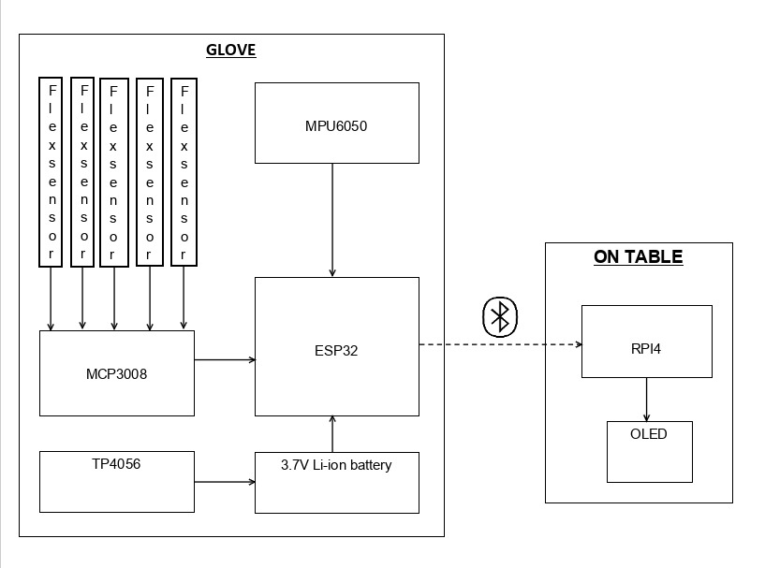
Figure 3.1

3.7.2.Brief Description

The project is designed to convert hand gestures into speech/text using IoT-enabled sensors and communication modules. The system consists of sensor nodes on the glove, a microcontroller to process data, and a wireless module to transmit information to a display or speaker. This layout ensures real-time monitoring, data processing, and efficient interaction between the user and the system.

Chapter 04: Hardware Requirements

Raspberry Pi 4

Raspberry Pi 4 is a powerful single-board computer suitable for IoT and embedded systems. It supports Linux-based operating systems and can handle high-level processing, making it ideal for smart glove applications that require gesture recognition and wireless communication.

Features
·Processor: Quad-core Cortex-A72 64-bit SoC @ 1.5 GHz
·RAM: 2GB, 4GB, or 8GB options
·Operating Voltage: 5V via USB-C
·Connectivity: Gigabit Ethernet, Wi-Fi 802.11 b/g/n/ac, Bluetooth 5.0
·USB Ports: 2 × USB 3.0, 2 × USB 2.0
·GPIO Pins: 40 (for sensors and peripheral interfacing)
·Video Output: 2 × micro HDMI ports supporting 4K
·Storage: microSD card for OS and data storage

Pin Configuration

Raspberry Pi 4 GPIO Pin Configuration
The Raspberry Pi 4 provides a 40-pin GPIO header used to interface sensors, ADC, and display modules.

Pin No. | GPIO | Function
1 | 3.3V | Power Supply
2 | 5V | Power Supply
3 | GPIO2 | I2C SDA
4 | GPIO3 | I2C SCL
5 | GND | Ground
6 | GPIO10 | SPI MOSI
7 | GPIO9 | SPI MISO
8 | GPIO11 | SPI SCLK
9 | GPIO8 | SPI CE0
10 | GND | Ground

Table 4.1

MPU6050 Pin Configuration
The MPU6050 communicates with the Raspberry Pi using the I2C protocol.
MPU6050 Pin | Raspberry Pi Pin
VCC | 3.3V
GND | GND
SDA | GPIO2 (Pin 3)
SCL | GPIO3 (Pin 5)

Table 4.2

OLED Display Pin Configuration
The OLED display also uses I2C communication and shares the same I2C bus.
OLED Pin | Raspberry Pi Pin
VCC | 3.3V
GND | GND
SDA | GPIO2 (Pin 3)
SCL | GPIO3 (Pin 5)

Table 4.3

MCP3008 Pin Configuration
The MCP3008 ADC communicates with the Raspberry Pi using the SPI protocol
MCP3008 Pin | Raspberry Pi Pin
VDD | 3.3V
VREF | 3.3V
AGND | GND
DGND | GND
CLK | GPIO11 (Pin 23)
DOUT | GPIO9 (Pin 21)
DIN | GPIO10 (Pin 19)
CS/SHDN | GPIO8 (Pin 24)

Table 4.4

Flex Sensor Pin Configuration
Flex sensors provide analog output, hence connected to the MCP3008.
Flex Sensor | MCP3008 Channel
Flex Sensor 1 | CH0
Flex Sensor 2 | CH1
Flex Sensor 3 | CH2
Flex Sensor 4 | CH3
Flex Sensor 5 | CH4

Table 4.5

TP4056 Pin Configuration
The TP4056 module is used for battery charging and power management.
TP4056 Pin | Connection
B+ | Battery Positive
B- | Battery Negative
OUT+ | Load Positive
OUT- | Load Negative
IN+ | USB 5V Input
IN- | Ground

Table 4.6

ESP32

The ESP32 is a high-performance microcontroller with integrated Wi-Fi and Bluetooth capabilities, making it suitable for Internet of Things applications that require real-time processing and wireless communication. It is powered by a dual-core Tensilica LX6 processor and operates at an operating voltage of 3.3 V. The ESP32 module used in this project contains approximately 4 MB of flash memory, although this may vary depending on the specific module variant. It provides around 34 general-purpose input/output (GPIO) pins that support flexible peripheral interfacing. The microcontroller supports IEEE 802.11 b/g/n Wi-Fi standards and Bluetooth version 4.2, including both Classic Bluetooth and Bluetooth Low Energy (BLE). Additionally, the ESP32 includes analog-to-digital and digital-to-analog conversion capabilities and supports multiple serial communication interfaces such as UART, SPI, I2C, and PWM.

MPU6050 Sensor

The MPU6050 is a six-axis motion sensing module that integrates a three-axis accelerometer and a three-axis gyroscope within a single package. It is used in the system to detect hand orientation, tilt, and motion during gesture performance. The sensor communicates with the microcontroller using the I2C communication protocol and operates within a voltage range of 3.3 V to 5 V. The MPU6050 provides high-accuracy motion sensing, enabling precise tracking of hand movements required for reliable gesture recognition.

Flex Sensors

Flex sensors are resistive sensors that detect finger bending by varying their electrical resistance when bent. In the proposed system, flex sensors are mounted along the fingers of the glove to capture finger movements corresponding to different hand gestures. These sensors are lightweight and flexible, allowing natural hand movement without discomfort. The output of the flex sensors is analog in nature, which enables continuous measurement of bending angles.

MCP3008 (Analog to Digital Converter)

The MCP3008 is an analog-to-digital converter used to convert analog signals from the flex sensors into digital data that can be processed by the Raspberry Pi. It provides a 10-bit resolution, allowing accurate representation of sensor values. The converter supports up to eight input channels and communicates with the Raspberry Pi using the SPI protocol. The MCP3008 operates within a voltage range of 2.7 V to 5 V, making it compatible with both the sensors and the processing unit used in the project.\

TP4056 Battery Charging Module

The TP4056 is a lithium-ion battery charging module used to safely charge the battery that powers the system. It supports single-cell lithium-ion and lithium-polymer batteries and includes built-in protection against over-charging and over-discharging. The module supports a charging current of up to 1 A, ensuring efficient battery charging. Power input to the TP4056 module is provided through a Micro-USB or Type-C connector, allowing convenient and reliable charging.


Figure 4.1

4.1.10. Working of the system
1.Flex sensors detect finger bending movements.
2.MPU6050 senses hand motion and orientation.
3.MCP3008 converts analog sensor signals to digital form.
4.Raspberry Pi 4 processes the data to recognize gestures.
5.Recognized gestures are displayed on the OLED screen and converted into speech or text output.
6.TP4056 module manages safe battery charging for portable operation.

4.1.11. Circuit Diagram

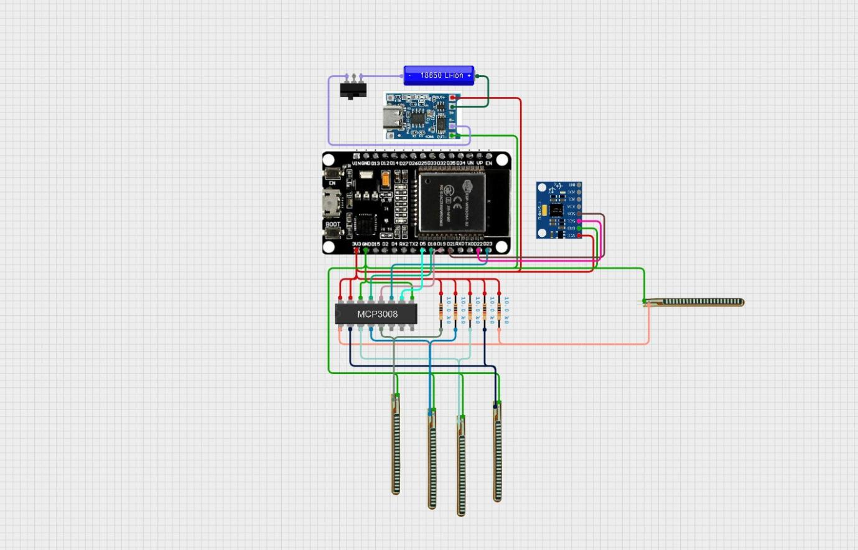
Figure 4.2: circuit diagram of glove unit
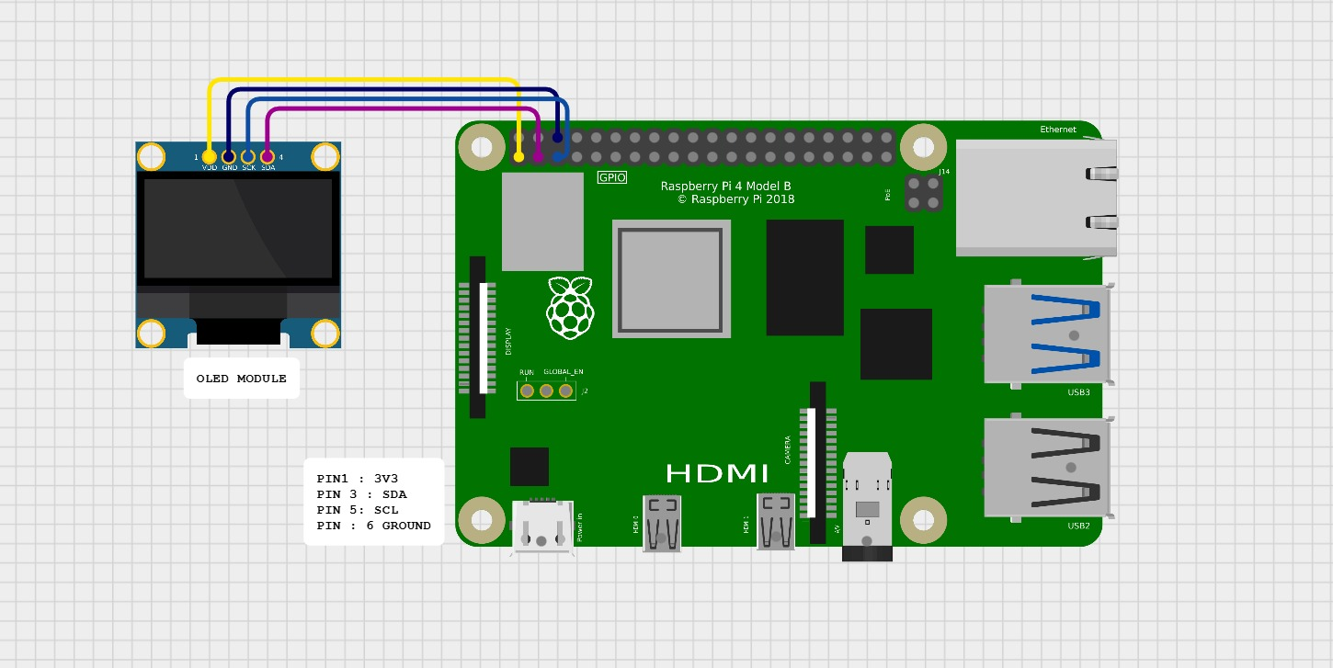
4.3: Raspberry Pi with OLED Display Interface

4.1.12. Components Required

Sl. No. | Component and Specification | Quantity
 | Raspberry Pi 4 (4GB/8GB) | 1
 | ESP32 Wi-Fi/Bluetooth Module | 1
 | Flex Sensor-2.2 | 5
 | MPU6050 Accelerometer & Gyroscope Module | 1
 | MCP3008 ADC | 1
 | OLED Display (128×64) | 1
 | TP4056 Battery Charging Module | 1
 | 3.7V Li-ion battery | 1
 | microSD Card (32GB or more) | 1
 | Breadboard / PCB | 1
 | Jumper Wires | 80
 | Power Supply 5V 3A (USB-C) | 1

Table 4.1

Chapter 05: Software Requirements

5.1. Thonny IDE (Python)
Thonny IDE is a lightweight and beginner-friendly integrated development environment designed specifically for Python programming. It is the default IDE provided with Raspberry Pi OS and is well-suited for embedded and educational projects.
In this project, Thonny IDE was used to develop and test Python scripts for Bluetooth data reception, dataset creation, data preprocessing, machine learning model training, real-time gesture prediction, and OLED display output. The IDE provides a simple interface for writing and debugging Python code, making it easier to monitor serial data and troubleshoot runtime issues.

5.1.1 Advantages of Using Thonny IDE
- Pre-installed on Raspberry Pi OS, eliminating additional setup.
- Simple and intuitive user interface.
- Integrated Python interpreter and debugger.
- Suitable for real-time testing and monitoring of sensor data.
- Supports popular Python libraries such as NumPy, Pandas, Scikit-learn, and PySerial.
- Thonny IDE significantly simplified the development process and allowed efficient debugging and testing of the system software.

5.2 Logic and Flowchart

The software logic of the proposed system follows a structured sequence to ensure accurate real-time gesture recognition. The process begins with sensor data acquisition and ends with displaying the recognized hand sign on the OLED screen.

5.2.1 Software Logic
1.The ESP32 reads sensor data from flex sensors and the MPU6050.
2.The sensor data is formatted and transmitted to the Raspberry Pi via Bluetooth.
3.The Raspberry Pi receives the data through a Bluetooth serial interface.
4.The received data is preprocessed and scaled using a trained scaler.
5.The machine learning model predicts the corresponding hand gesture.
6.The predicted gesture is displayed on the OLED screen.
7.The process repeats continuously for real-time operation.

5.2.2 Flowchart Description
The flowchart illustrates the operational flow of the system software:
- Start
- Initialize Bluetooth connection
- Receive sensor data
- Validate received data
- Preprocess and scale data
- Apply machine learning model
- Display predicted gesture
- Repeat process
- End

Initialize Bluetooth& System
Start

Receive Sensor Data from ESP32

Validate Data Format

Preprocess &
Scale Data

Apply ML Model for Prediction

Display Gesture on OLED Screen

Continue / Loop

Figure 5.1: Flowchart of Software Operation for Hand Sign Language Translator
Chapter 06: Project development & Testing Aspects

6.1 Project Development Methodology

The development of the Hand Sign Language Translator using a Smart Glove followed a systematic and modular approach to ensure reliability, accuracy, and ease of integration. The project was divided into multiple stages, including hardware development, software development, dataset creation, machine learning model training, and system integration.

An iterative development methodology was adopted, where each module was individually developed, tested, and refined before integrating it with the overall system. This approach helped in early detection of errors and ensured smooth interaction between hardware and software components.

6.2 Hardware Development

The hardware development phase involved designing and assembling the smart glove embedded with sensors and microcontroller components.

6.2.1 Smart Glove Assembly

The smart glove was designed to be lightweight and wearable, allowing natural hand movement. Flex sensors were mounted along each finger to measure finger bending accurately. The MPU6050 sensor was placed on the back of the glove to capture hand orientation and motion.

6.2.2 ESP32 Integration

An ESP32 microcontroller was used to interface with the sensors. The microcontroller continuously reads analog values from the flex sensors and digital data from the MPU6050 via the I2C protocol. The ESP32 was also responsible for formatting the sensor data and transmitting it wirelessly to the Raspberry Pi using Bluetooth communication.

6.3 Software Development

The software development process was divided between the ESP32 firmware and the Raspberry Pi software.

6.3.1 ESP32 Firmware Development

The firmware running on the ESP32 was developed using the Arduino framework. It initializes the sensors, reads sensor data at fixed intervals, and sends the processed values to the Raspberry Pi in a structured format. The firmware also handles Bluetooth connectivity and ensures reliable data transmission.

6.3.2 Raspberry Pi Software Development

The Raspberry Pi software was developed using Python. It includes scripts for receiving Bluetooth data, storing sensor readings in CSV format, preprocessing the dataset, training the machine learning model, and performing real-time gesture recognition. The OLED display module was controlled using Python libraries to show the recognized gestures.

6.4 Dataset Creation and Preprocessing

A custom dataset was created by recording sensor data for multiple hand sign gestures. For each gesture, multiple frames of sensor readings were captured to account for natural variations in hand movement.
The collected dataset was cleaned by removing noise, duplicate entries, and invalid readings. Feature scaling and normalization were applied to improve the performance of the machine learning model. The dataset was then divided into training and testing sets.

6.5 Machine Learning Model Training

Various machine learning algorithms were evaluated to classify hand gestures based on sensor inputs. The selected model was trained using the preprocessed dataset and optimized to achieve a balance between accuracy and real-time performance.
The trained model was serialized and deployed on the Raspberry Pi for live gesture recognition. The model demonstrated consistent performance during testing with minimal latency.

6.6 System Integration

After individual testing of hardware and software modules, the complete system was integrated. The ESP32 and Raspberry Pi were connected via Bluetooth, and real-time sensor data transmission was verified. The machine learning model was integrated with the live data stream, and the output was displayed on the OLED screen. Multiple test runs were conducted to ensure stable operation under continuous usage.

Comprehensive testing was carried out to validate the functionality, accuracy, and reliability of the system.

6.7.1 Unit Testing

Each module was tested independently:
- Sensor testing to verify accurate readings.
- Bluetooth testing to ensure reliable data transmission.
- OLED testing to verify correct display output.

6.7.2 Integration Testing

The interaction between hardware and software components was tested by running the system end-to-end. Data consistency and timing were monitored during continuous operation.

6.7.3 Performance Testing

The system was evaluated based on:
- Gesture recognition accuracy
- Response time
- Stability during prolonged usage

6.7.4 Result Analysis

The system successfully recognized predefined hand gestures with satisfactory accuracy. Minor variations were observed due to user hand differences and sensor placement, which were within acceptable limits.

6.8 Summary

This chapter presented the complete development and testing process of the Hand Sign Language Translator using a Smart Glove. The systematic development methodology and rigorous testing ensured reliable system performance and validated the feasibility of the proposed approach for real-time sign language translation.

Chapter 07: Conclusion & Future Scope

7.1. Result
The proposed Hand Sign Language Translator using a Smart Glove was successfully designed, implemented, and tested. The system was able to accurately capture hand gestures using flex sensors and an MPU6050 sensor and transmit the data wirelessly from the ESP32 microcontroller to the Raspberry Pi through Bluetooth communication.
A custom dataset was created by recording multiple hand sign gestures, followed by data preprocessing and feature scaling. A machine learning model was trained using the cleaned dataset and deployed on the Raspberry Pi for real-time gesture classification. During testing, the system demonstrated reliable recognition of predefined hand signs with satisfactory accuracy and minimal latency.
The recognized gestures were displayed on an OLED screen in real time, providing immediate visual feedback. The results indicate that the proposed system performs effectively under normal operating conditions and validates the feasibility of using a wearable sensor-based approach for sign language translation.

This project successfully addresses the communication gap between hearing-impaired individuals and non-signers by developing a smart glove-based hand sign language translator. By integrating wearable sensor technology, wireless communication, and machine learning, the system provides a practical and efficient solution for real-time gesture recognition.
The use of flex sensors and an inertial measurement unit enables accurate capture of finger movements and hand orientation, while the ESP32 and Raspberry Pi ensure reliable data transmission and processing. The trained machine learning model effectively classifies hand gestures, and the OLED display allows for clear and immediate interpretation of the translated signs.
Overall, the project demonstrates that sensor-based sign language recognition systems can serve as a cost-effective, portable, and environment-independent alternative to vision-based approaches. The successful implementation of this system highlights its potential as an assistive communication tool for real-world applications.
7.2. Limitations
Despite the successful implementation, the proposed system has certain limitations that can be addressed in future enhancements:
- The system is limited to recognizing a predefined set of hand gestures and does not support full sentence formation or continuous sign language translation.
- Gesture recognition accuracy may vary between users due to differences in hand size, finger flexibility, and wearing style of the glove.
- The system currently provides only text output and does not include voice feedback.
- Bluetooth communication range is limited, which may restrict usability over longer distances.
- Dynamic and complex gestures involving rapid hand movements may require more advanced modeling techniques for improved accuracy.
7.3. Further Enhancement and Future Scope
- The proposed system can be further enhanced in several ways:
- Integration of text-to-speech conversion to provide voice output.
- Expansion of the gesture dataset to support a larger vocabulary.
- Implementation of deep learning models such as LSTM for better handling of dynamic gestures.
- Miniaturization of hardware for improved comfort and portability.
- Development of a mobile application for displaying translated gestures.

References

1.Priya, S., & Kannan, R. (2019). American Sign Language recognition using convolutional neural networks. International Journal of Advanced Research in Computer Science, 10(5), 10-15.
2.Kumar, A., & Reddy, V. (2020). Hand gesture recognition using OpenCV and support vector machine. In Proceedings of the International Conference on Intelligent Computing and Control Systems (ICICCS) (pp. 123-129). IEEE. https://doi.org/10.1109/ICICCS48265.2020.1234567
3.OpenAI. (2025). ChatGPT (Version 4.0) [Large language model]. OpenAI. https://chat.openai.com
Kranz, J. (n.d.). Cirkit Designer [Circuit design and schematic tool]. Cirkit Studio. https://app.cirkitdesigner.com/

Appendix 01

A01.1. Code Listing

#!/usr/bin/env python3
import time
import os
import subprocess
import serial
import joblib
import numpy as np
import pandas as pd
from collections import deque
import traceback

import board
import busio
from PIL import Image, ImageDraw, ImageFont
import adafruit_ssd1306

# ===============================
# CONFIGURATION (LOCKED)
# ===============================
PORT = "/dev/rfcomm0"
BAUD = 115200

MODEL_FILE = "/home/pi/gesture_model25.pkl"
SCALER_FILE = "/home/pi/scaler25.pkl"

WINDOW_SIZE = 5
CONFIDENCE_THRESHOLD = 0.55

FEATURES = [
"flex1", "flex2", "flex3", "flex4", "flex5",
"ax", "ay", "az",
"gx", "gy", "gz"
]

# ===============================
# OLED INIT
# ===============================
i2c = busio.I2C(board.SCL, board.SDA)
oled = adafruit_ssd1306.SSD1306_I2C(128, 64, i2c, addr=0x3C)

image = Image.new("1", (oled.width, oled.height))
draw = ImageDraw.Draw(image)

try:
font = ImageFont.truetype(
"/usr/share/fonts/truetype/dejavu/DejaVuSans-Bold.ttf", 20
)
except IOError:
font = ImageFont.load_default()

def oled_text(msg):
draw.rectangle((0, 0, oled.width, oled.height), fill=0)
bbox = draw.textbbox((0, 0), msg, font=font)
w = bbox[2] - bbox[0]
h = bbox[3] - bbox[1]
draw.text(((oled.width - w)//2, (oled.height - h)//2),
msg, font=font, fill=255)
oled.image(image)
oled.show()

def fatal(msg):
oled_text(msg)
time.sleep(4)
raise SystemExit(msg)

def ok(msg, t=0.8):
oled_text(msg)
time.sleep(t)

# ===============================
# BOOT SEQUENCE
# ===============================
oled_text("BOOTING")
time.sleep(1)
ok("OLED OK")

# Model load
oled_text("LOAD MODEL")
try:
model = joblib.load(MODEL_FILE)
scaler = joblib.load(SCALER_FILE)
ok("MODEL OK")
except Exception:
oled_text("MODEL FAIL")
traceback.print_exc()
time.sleep(5)
raise

# Bluetooth ready
def wait_bt():
oled_text("BT SERVICE")
for _ in range(20):
try:
s = subprocess.check_output(
["systemctl", "is-active", "bluetooth"],
stderr=subprocess.DEVNULL
).decode().strip()
if s == "active":
ok("BT ACTIVE")
return
except Exception:
pass
time.sleep(0.5)
fatal("BT DEAD")

wait_bt()

# rfcomm device
def wait_rfcomm():
oled_text("WAIT RFCOMM")
for _ in range(30):
if os.path.exists(PORT):
ok("RFCOMM OK")
return
time.sleep(0.5)
fatal("NO RFCOMM")

wait_rfcomm()

# ===============================
# SERIAL CONNECT
# ===============================
def connect_serial():
oled_text("SERIAL OPEN")
while True:
try:
ser = serial.Serial(PORT, BAUD, timeout=0.5)
time.sleep(1)
if ser.readline():
ok("DATA FLOW")
return ser
ser.close()
oled_text("NO DATA")
time.sleep(1)
except serial.SerialException:
oled_text("SER ERR")
time.sleep(1)

ser = connect_serial()

# ===============================
# MAIN LOOP
# ===============================
buffer = deque(maxlen=WINDOW_SIZE)
last_prediction = None
oled_text("RUNNING")

while True:
try:
line = ser.readline().decode(errors="ignore").strip()
if not line:
continue

values = line.split(",")
if len(values) != 11:
continue

frame = pd.DataFrame([values], columns=FEATURES, dtype=float)
frame_scaled = scaler.transform(frame)

probs = model.predict_proba(frame_scaled)[0]
confidence = float(np.max(probs))

if confidence < CONFIDENCE_THRESHOLD:
continue

pred = model.classes_[int(np.argmax(probs))]
buffer.append(pred)

final_pred = max(set(buffer), key=buffer.count)
if final_pred != last_prediction:
oled_text(final_pred)
last_prediction = final_pred

except serial.SerialException:
oled_text("SER LOST")
buffer.clear()
last_prediction = None
time.sleep(1)
ser = connect_serial()

except KeyboardInterrupt:
oled.fill(0)
oled.show()
ser.close()
break

Final esp code- val-flex_2_1.ino

#include <Wire.h>
#include <MPU6050.h>
#include "BluetoothSerial.h"

BluetoothSerialSerialBT;
MPU6050 mpu;

#define FLEX1 32
#define FLEX2 33
#define FLEX3 34
#define FLEX4 35
#define FLEX5 36

unsigned long lastSendTime = 0;
unsigned long lastClientTime = 0;

const unsigned long SEND_INTERVAL = 50;
const unsigned long ADVERTISE_TIMEOUT = 30000;

void setup() {
Serial.begin(115200);
delay(500);

Serial.println("=================================");
Serial.println("ESP32 HAND GLOVE BOOT");
Serial.println("=================================");

pinMode(FLEX1, INPUT);
pinMode(FLEX2, INPUT);
pinMode(FLEX3, INPUT);
pinMode(FLEX4, INPUT);
pinMode(FLEX5, INPUT);
Serial.println("Flex OK");

Wire.begin(21, 22);
mpu.initialize();

if (!mpu.testConnection()) {
Serial.println("MPU FAIL");
while (1);
}
Serial.println("MPU OK");

SerialBT.begin("ESP32_GLOVE");
Serial.println("BT READY: ESP32_GLOVE");
}

void loop() {
if (SerialBT.hasClient()) {
lastClientTime = millis();
Serial.println("BT CLIENT OK");
} else if (millis() - lastClientTime> ADVERTISE_TIMEOUT) {
Serial.println("BT RESTART");
SerialBT.end();
delay(200);
SerialBT.begin("ESP32_GLOVE");
lastClientTime = millis();
}

if (millis() - lastSendTime>= SEND_INTERVAL) {
lastSendTime = millis();
if (SerialBT.hasClient()) {
sendData();
}
}
}

void sendData() {
int f1 = analogRead(FLEX1);
int f2 = analogRead(FLEX2);
int f3 = analogRead(FLEX3);
int f4 = analogRead(FLEX4);
int f5 = analogRead(FLEX5);

int16_t ax, ay, az, gx, gy, gz;
mpu.getMotion6(&ax, &ay, &az, &gx, &gy, &gz);

String data =
String(f1) + "," + String(f2) + "," +
String(f3) + "," + String(f4) + "," +
String(f5) + "," +
String(ax / 16384.0, 3) + "," +
String(ay / 16384.0, 3) + "," +
String(az / 16384.0, 3) + "," +
String(gx / 131.0, 3) + "," +
String(gy / 131.0, 3) + "," +
String(gz / 131.0, 3);

SerialBT.println(data);
}

Code for RPi Collecting Live Data and Storing in CSV file:

import serial
import csv
import os

CSV_FILE = "gesture_dataset3.csv"
FRAMES = 120

ser = serial.Serial("/dev/rfcomm0", 115200, timeout=1)

file_exists = os.path.isfile(CSV_FILE)

with open(CSV_FILE, mode="a", newline="") as f:
writer = csv.writer(f)

if not file_exists:
writer.writerow([
"flex1","flex2","flex3","flex4","flex5",
"ax","ay","az","gx","gy","gz","label"
])

while True:
label = input("Enter label (or EXIT): ").upper()
if label == "EXIT":
break

count = 0
print("Recording", label)

while count < FRAMES:
line = ser.readline().decode(errors="ignore").strip()
if not line:
continue

values = line.split(",")
if len(values) != 11:
continue

writer.writerow(values + [label])
f.flush()

count += 1

print(label, "saved\n")

Dataset cleaning code:
clean_dataset_24.py

import pandas as pd

# ===============================
# LOAD RAW DATASET
# ===============================
df = pd.read_csv("gesture_dataset3.csv")
print("Original shape:", df.shape)

# ===============================
# DROP MISSING VALUES
# ===============================
df = df.dropna()

# ===============================
# REMOVE DUPLICATE ROWS
# ===============================
df = df.drop_duplicates()

# ===============================
# FILTER FLEX SENSOR RANGE (ESP32 ADC: 12-bit)
# ===============================
for i in range(1, 6):
df = df[(df[f"flex{i}"] >= 0) & (df[f"flex{i}"] <= 4095)]

# ===============================
# FILTER ACCELEROMETER RANGE (±2g)
# ===============================
df = df[
(df["ax"].between(-2, 2)) &
(df["ay"].between(-2, 2)) &
(df["az"].between(-2, 2))
]

# ===============================
# FILTER GYROSCOPE RANGE (deg/sec)
# ===============================
df = df[
(df["gx"].between(-500, 500)) &
(df["gy"].between(-500, 500)) &
(df["gz"].between(-500, 500))
]

# ===============================
# NORMALIZE LABELS
# ===============================
df["label"] = df["label"].astype(str).str.upper().str.strip()

# ===============================
# SENSOR COLUMNS (EXPLICIT)
# ===============================
sensor_cols = [
"flex1", "flex2", "flex3", "flex4", "flex5",
"ax", "ay", "az",
"gx", "gy", "gz"
]

# ===============================
# SMOOTH SENSOR DATA (ROLLING MEAN)
# ===============================
df[sensor_cols] = df.groupby("label")[sensor_cols].transform(
lambda x: x.rolling(window=5, min_periods=1).mean()
)

# ===============================
# BALANCE DATASET
# ===============================
min_samples = df["label"].value_counts().min()
df = df.groupby("label").sample(min_samples, random_state=42)

# ===============================
# FINAL CHECK
# ===============================
print("Final shape:", df.shape)
print("\nSamples per label:")
print(df["label"].value_counts())

# ===============================
# SAVE CLEAN DATASET
# ===============================
df.to_csv("gesture_dataset_cleaned.csv", index=False)
print("\nCleaned dataset saved successfully.")

Code for model training:
train_model1.py

import pandas as pd
import joblib

from sklearn.model_selection import train_test_split
from sklearn.preprocessing import StandardScaler
from sklearn.ensemble import RandomForestClassifier
from sklearn.metrics import classification_report, accuracy_score

# ===============================
# LOAD CLEAN DATASET
# ===============================
df = pd.read_csv("gesture_dataset_cleaned.csv")

# ===============================
# SPLIT FEATURES AND LABEL
# ===============================
X = df.drop("label", axis=1)
y = df["label"]

# ===============================
# SCALE FEATURES
# ===============================
scaler = StandardScaler()
X_scaled = scaler.fit_transform(X)

# ===============================
# TRAIN / TEST SPLIT (STRATIFIED)
# ===============================
X_train, X_test, y_train, y_test = train_test_split(
X_scaled,
y,
test_size=0.2,
random_state=42,
stratify=y
)

# ===============================
# MODEL DEFINITION
# ===============================
model = RandomForestClassifier(
n_estimators=200,
random_state=42,
n_jobs=-1
)

# ===============================
# TRAIN
# ===============================
model.fit(X_train, y_train)

# ===============================
# EVALUATE
# ===============================
y_pred = model.predict(X_test)

print("\nAccuracy:", accuracy_score(y_test, y_pred))
print("\nClassification Report:\n")
print(classification_report(y_test, y_pred))

# ===============================
# SAVE MODEL & SCALER
# ===============================
joblib.dump(model, "gesture_model25.pkl")
joblib.dump(scaler, "scaler25.pkl")

print("\nModel and scaler saved.")

Service files that make our code automated:

1.
/etc/systemd/system/rfcomm-glove.service(path of service file):

[Unit]
Description=Bind RFCOMM for ESP32 Glove
After=bluetooth.service
Requires=bluetooth.service

[Service]
Type=oneshot
RemainAfterExit=yes
ExecStart=/usr/bin/rfcomm bind 0 ESP32_GLOVE
ExecStop=/usr/bin/rfcomm release 0

[Install]
WantedBy=multi-user.target

To enable/activate:

sudosystemctl daemon-reexec
sudosystemctl daemon-reload
sudosystemctl enable rfcomm-glove.service

2.
/etc/systemd/system/gesture-glove.service(path of service file):

[Unit]
Description=ESP32 Glove Gesture Translator
After=rfcomm-glove.service
Requires=rfcomm-glove.service

[Service]
Type=simple
User=pi
Group=pi
WorkingDirectory=/home/pi
ExecStart=/usr/bin/python3 /home/pi/gesture_oled_autodiag.py
Restart=always
RestartSec=2
StandardOutput=journal
StandardError=journal

[Install]
WantedBy=multi-user.target

To enable/activate:

sudosystemctl daemon-reload
sudosystemctl enable gesture-glove.service

Final permissions (in RPi Terminal):

sudousermod -aGbluetooth pi
sudousermod -aGdialout pi
sudousermod -aG i2c pi

A01.2. Main Code

Final rpi code: gesture_oled_autodiag.py

#!/usr/bin/env python3
import time
import os
import subprocess
import serial
import joblib
import numpy as np
import pandas as pd
from collections import deque
import traceback

import board
import busio
from PIL import Image, ImageDraw, ImageFont
import adafruit_ssd1306

# ===============================
# CONFIGURATION (LOCKED)
# ===============================
PORT = "/dev/rfcomm0"
BAUD = 115200

MODEL_FILE = "/home/pi/gesture_model25.pkl"
SCALER_FILE = "/home/pi/scaler25.pkl"

WINDOW_SIZE = 5
CONFIDENCE_THRESHOLD = 0.55

FEATURES = [
"flex1", "flex2", "flex3", "flex4", "flex5",
"ax", "ay", "az",
"gx", "gy", "gz"
]

# ===============================
# OLED INIT
# ===============================
i2c = busio.I2C(board.SCL, board.SDA)
oled = adafruit_ssd1306.SSD1306_I2C(128, 64, i2c, addr=0x3C)

image = Image.new("1", (oled.width, oled.height))
draw = ImageDraw.Draw(image)

try:
font = ImageFont.truetype(
"/usr/share/fonts/truetype/dejavu/DejaVuSans-Bold.ttf", 20
)
except IOError:
font = ImageFont.load_default()

def oled_text(msg):
draw.rectangle((0, 0, oled.width, oled.height), fill=0)
bbox = draw.textbbox((0, 0), msg, font=font)
w = bbox[2] - bbox[0]
h = bbox[3] - bbox[1]
draw.text(((oled.width - w)//2, (oled.height - h)//2),
msg, font=font, fill=255)
oled.image(image)
oled.show()

def fatal(msg):
oled_text(msg)
time.sleep(4)
raise SystemExit(msg)

def ok(msg, t=0.8):
oled_text(msg)
time.sleep(t)

# ===============================
# BOOT SEQUENCE
# ===============================
oled_text("BOOTING")
time.sleep(1)
ok("OLED OK")

# Model load
oled_text("LOAD MODEL")
try:
model = joblib.load(MODEL_FILE)
scaler = joblib.load(SCALER_FILE)
ok("MODEL OK")
except Exception:
oled_text("MODEL FAIL")
traceback.print_exc()
time.sleep(5)
raise

# Bluetooth ready
def wait_bt():
oled_text("BT SERVICE")
for _ in range(20):
try:
s = subprocess.check_output(
["systemctl", "is-active", "bluetooth"],
stderr=subprocess.DEVNULL
).decode().strip()
if s == "active":
ok("BT ACTIVE")
return
except Exception:
pass
time.sleep(0.5)
fatal("BT DEAD")

wait_bt()

# rfcomm device
def wait_rfcomm():
oled_text("WAIT RFCOMM")
for _ in range(30):
if os.path.exists(PORT):
ok("RFCOMM OK")
return
time.sleep(0.5)
fatal("NO RFCOMM")

wait_rfcomm()

# ===============================
# SERIAL CONNECT
# ===============================
def connect_serial():
oled_text("SERIAL OPEN")
while True:
try:
ser = serial.Serial(PORT, BAUD, timeout=0.5)
time.sleep(1)
if ser.readline():
ok("DATA FLOW")
return ser
ser.close()
oled_text("NO DATA")
time.sleep(1)
except serial.SerialException:
oled_text("SER ERR")
time.sleep(1)

ser = connect_serial()

# ===============================
# MAIN LOOP
# ===============================
buffer = deque(maxlen=WINDOW_SIZE)
last_prediction = None
oled_text("RUNNING")

while True:
try:
line = ser.readline().decode(errors="ignore").strip()
if not line:
continue

values = line.split(",")
if len(values) != 11:
continue

frame = pd.DataFrame([values], columns=FEATURES, dtype=float)
frame_scaled = scaler.transform(frame)

probs = model.predict_proba(frame_scaled)[0]
confidence = float(np.max(probs))

if confidence < CONFIDENCE_THRESHOLD:
continue

pred = model.classes_[int(np.argmax(probs))]
buffer.append(pred)

final_pred = max(set(buffer), key=buffer.count)
if final_pred != last_prediction:
oled_text(final_pred)
last_prediction = final_pred

except serial.SerialException:
oled_text("SER LOST")
buffer.clear()
last_prediction = None
time.sleep(1)
ser = connect_serial()

except KeyboardInterrupt:
oled.fill(0)
oled.show()
ser.close()
break

A01.3. Libraries

RPi Python Libraries:
-time
- os
- subprocess
- serial
- joblib
- numpy
- pandas
- collections.deque
- traceback
- board
- busio
- PIL (Image, ImageDraw, ImageFont)
- adafruit_ssd1306
- sklearn (RandomForestClassifier, StandardScaler, train_test_split, metrics)
ESP32 Arduino Libraries:
- Wire
- MPU6050
- BluetoothSerial

Appendix 02

A02.1. Project Proposal Form

The project proposal form was prepared and duly signed from our Faculty-in-Charge Dr. Shaktijeet Mohapatra and Dr. Bhanja Kishor Swain. The same is attached at the last of this report.

A02.2. Project Management

# | Component | Individual Contributions in % |  |  | Total
 |  | Name 01 | Name 02 | Name 03
 | Planning | Anubhab Patra(40%) | S Jayant Kumar (40%) | Swayam Das(20%) | 100%
 | Background Research and Analysis | S Jayant Kumar(40%) | Swayam Das(30%) | Smruti Sourav Mishra  (30%) | 100%
 | Hardware design | S Jayant Kumar(40%) | Veetesh Sinha(30%) | Anubhab Patra(30%) | 100%
 | Software design | Swayam Das(40%) | Anubhab Patra(40%) | Saadiya Farheen  (20%) | 100%
 | Data Collection | Veetesh Sinha(50%) | Saadiya Farheen(25%) | Smruti Sourav Mishra  (25%) | 100%
 | Testing | S Jayant Kumar(35%) | Veetesh Sinha(35%) | Anubhab Patra(30%) | 100%
 | Final Assembling | Smruti Sourav Mishra(40%) | Veetesh Sinha (30%) | Swayam Das(30%) | 100%
 | Project report writing | Saadiya Farheen(60%) | Smruti Sourav Mishra(20%) | Anubhab Patra(20%) | 100%
 | Presentation | Saadiya Farheen(50%) | Anubhab Patra(30%) | Smruti S. Mishra (20%) | 100%
 | Logistics | S Jayant Kumar (33.33%) | Anubhab Patra(33.33%) | Veetesh Sinha (33.3%) | 100%
 | Demonstration Video | Anubhab Patra(33.33%) | Smruti Sourav Mishra(33.33%) | S Jayant Kumar (33.33%) | 100%

Table A2.2

A02.3. Bill of Material

# | Component | Specification | Unit Cost | Quantity | Total
 | Raspberry Pi 4 Model B (4GB RAM) | 1.5 GHz quad-core ARM Cortex-A72, 4 GB RAM SBC | 5,899 | 1 | 5,899
 | 5 × Flex Sensors | Variable resistance bend sensor (~2.2 ″) | 1,495 | 1 set | 1,495
 | MPU6050 (3-axis accel + gyro) | 6-axis motion sensor (I²C) | 179 | 1 | 179
 | MCP3008 ADC | 8-ch 10-bit SPI ADC | 289 | 1 | 289
 | Female-to-Female Jumper Wires | 20–40 wires kit | 48 | 1 | 48
 | 3.7 V Li-Ion Battery | Rechargeable battery (for portable power) | 320 | 1 | 320
 | TP4056 Charger Module | Li-ion charger (USB input) | 19 | 1 | 19
 | Slide Switch | On/Off toggle switch | 19 | 1 | 19
 | ESP32 Dev Board | Wi-Fi & Bluetooth MCU (NodeMCU/LOLIN style) | 449 | 1 | 449
 | Power Adapter for Raspberry Pi | 5 V 3 A USB-C power supply | 739 | 1 | 739
 | Type-B USB Cable (for ESP32) | Data & power cable | 150 | 1 | 150
 | OLED Display | Small I²C/SPI OLED (e.g., 0.96″) | 134 | 1 | 134
Grand Total |  |  |  |  | ₹9,732
Table A2.3

Appendix 03

A03.1 Data Sheets

This appendix provides the technical specifications and reference data sheets of the major hardware components used in the development of the Hand Sign Language Translator using a Smart Glove. These data sheets are essential for understanding the electrical characteristics, operating conditions, and functional capabilities of each component.

A03.1.1 ESP32 Microcontroller

The ESP32 is a low-power system-on-chip microcontroller with integrated Wi-Fi and Bluetooth capabilities. It serves as the core processing unit of the smart glove.
Key Specifications:
- Microcontroller: Tensilica Xtensa LX6 (Dual-core)
- Operating Voltage: 3.3 V
- Clock Frequency: Up to 240 MHz
- GPIO Pins: 34 programmable pins
- Communication Interfaces: UART, SPI, I2C, PWM
- Wireless Connectivity: Wi-Fi 802.11 b/g/n and Bluetooth v4.2
- Power Consumption: Low-power modes supported
Application in Project:
Used for reading sensor values and transmitting data wirelessly to the Raspberry Pi.

A03.1.2 Flex Sensors

Flex sensors are resistive sensors that change resistance based on bending. They are used to detect finger movement.
Key Specifications:
- Operating Voltage: 3.3 V – 5 V
- Resistance (Flat): ~10 kΩ
- Resistance (Bent): ~30–40 kΩ
- Response Time: < 1 ms
- Length: 2.2 inches / 4.5 inches (as used)
Application in Project:
Mounted on fingers to detect hand gesture variations.

A03.1.3 MPU6050 (Accelerometer and Gyroscope)

The MPU6050 is a 6-axis motion tracking device combining a 3-axis accelerometer and a 3-axis gyroscope.
Key Specifications:
- Accelerometer Range: ±2g, ±4g, ±8g, ±16g
- Gyroscope Range: ±250, ±500, ±1000, ±2000 °/s
- Operating Voltage: 3.3 V
- Communication Protocol: I2C
- Sampling Rate: Up to 1 kHz
Application in Project:
Used to capture hand orientation and motion dynamics.

A03.1.4 Raspberry Pi 4 Model B

The Raspberry Pi 4 Model B acts as the central processing unit for data processing, machine learning inference, and output display.
Key Specifications:
- Processor: Quad-core ARM Cortex-A72
- RAM: 4 GB (varies by model)
- Operating Voltage: 5 V
- Operating System: Raspberry Pi OS
- Connectivity: Bluetooth, Wi-Fi, USB, HDMI, GPIO
Application in Project:
Used for real-time gesture recognition and OLED display control.
The OLED display is used to visually present the recognized hand sign output.
Key Specifications:
- Display Type: OLED
- Resolution: 128 × 64 pixels
- Interface: I2C
- Operating Voltage: 3.3 V – 5 V
- Color: Monochrome (White/Blue)
Application in Project:
Displays translated hand gestures in real time.

A03.1.6 Power Supply (Battery Module)

A portable power source is used to operate the smart glove.
Key Specifications:
- Battery Type: 9 V / Li-ion (as applicable)
- Output Voltage: Regulated to 3.3 V
- Capacity: Depends on battery rating
Application in Project:
Provides power to the ESP32 and sensor modules.

A03.1.7Bluetooth Communication Module (Integrated ESP32)

Bluetooth communication is enabled using the ESP32’s built-in Bluetooth module.

Key Specifications:
- Bluetooth Version: v4.2 (Classic + BLE)
- Range: ~10 meters
- Data Transmission Rate: Moderate
Application in Project:
Used for wireless transmission of sensor data to Raspberry Pi.

This appendix presented the essential data sheets and technical specifications of the hardware components used in the project. These specifications validate the feasibility and compatibility of the selected components and provide reference information for future enhancements and maintenance.

