How to transfter files between vmware centOS and host Windows

1. Share a folder in host Windows, for example, WebEditorApp
2. 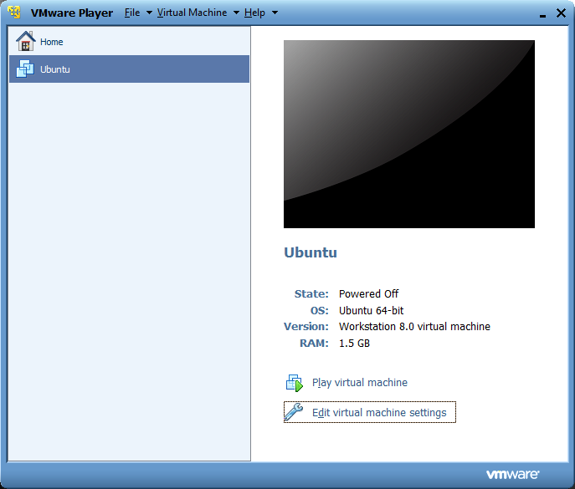
3. 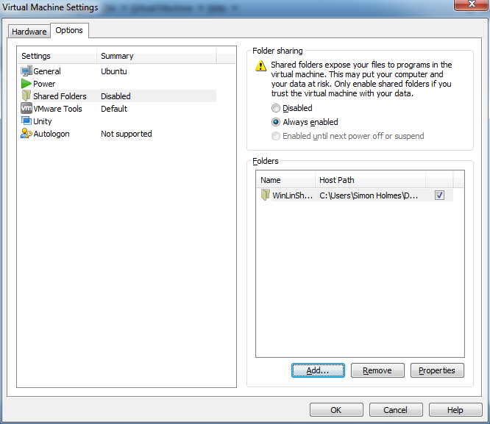
4. Shared folders in centOS appear in the location /mnt/hgfs but you probably won’t be able to see it
5. yum install open-vm-tools
6. Type vmware-hgfsclient to see current shared folder, for example, WebEditorApp
7. Add /mnt/hgfs folder: sudo mkdir /mnt/hgfs
8. Mount host:/WebEditorApp to /mnt/hgfs as below:

sudo vmhgfs-fuse .host:/WebEditorApp /mnt/hgfs -o allow_other

if has mounted already and needs to be re-mounted, use

sudo vmhgfs-fuse .host:/WebEditorApp /mnt/hgfs -o allow_other,nonempty

1. You can see files in /mnt/hgfs
2. If want to mount this folder after every reboot automatically, add below line to /etc/fstab:

.host:/WebEditorApp /mnt/hgfs vmhgfs defaults 0 0

配置共享文件夹脚本

#!/bin/sh

cd /

vmhgfs-fuse .host:/WebEditorApp /mnt/hgfs -o allow_other

vmware-hgfsclient

~