Recomputation Capacity and Hysteresis in Social Adaptation: Diagnostic Limits of Linear Metrics
Yuki Tanaka Independent Researcher, Seto Inland Sea, Japan 2026

Modern social systems appear stable when evaluated using conventional indicators such as economic output, population size, or institutional continuity. Yet many societies exhibit a paradoxical pattern: they remain structurally intact while gradually losing the ability to adapt to new conditions. This paper proposes a dynamical framework — Open Mind Dynamics (OMD) — to describe this phenomenon. The model distinguishes between structural stability and adaptive recomputation capacity and shows that these two properties can fail at different thresholds. When diversity of strategic directions and recomputation capacity jointly fall below a critical level, systems may enter a metastable regime in which they continue to function while losing the ability to revise strategies. Using data from 1,908 Japanese municipalities, we demonstrate empirical signatures consistent with this regime, including cases where population recovers without corresponding recovery in structural diversity. These results suggest that adaptive failure may precede visible structural collapse, highlighting the importance of detecting early indicators of recomputation loss in complex social systems.

Abstract
We examine adaptive capacity collapse as a nonlinear dynamical phenomenon in social systems, focusing on how demographic recovery can mask latent declines in internal adaptive capacity. Many models of social adaptation implicitly assume linear dynamics in which policy interventions produce proportional and reversible outcomes. However, empirical institutional trajectories frequently exhibit strong path dependence, suggesting that social systems may operate near nonlinear regime boundaries.
We introduce the Organizational Metastability Dynamics (OMD) framework, a dynamical model in which collective adaptation is governed by the interaction of structural commitment (σ), recomputation capacity (M), and value-direction variance (Var(φ)). The model yields a conceptual phase-space geometry with boundaries separating adaptive and locked-in regimes, with hysteresis emerging when recomputation capacity collapses under increasing structural commitment. In this regime, institutional structures can remain externally stable even after the original driving pressures are relaxed — dynamics consistent with what is expected near a saddle-node-type transition.
To evaluate these predictions empirically, we construct an operational proxy for recomputation capacity based on industrial diversity and update dynamics in municipal governance data. Analysis of 1,908 Japanese municipalities reveals a substantial negative correlation between adaptive capacity and net in-migration (r = −0.458, p < 0.001). Sensitivity analysis excluding large employment centers confirms that this reversal is a structural feature of the full distribution, not a metropolitan artifact (r = −0.455 to −0.462 across exclusion thresholds of 3%, 5%, and 10%).
We term this pattern the demographic buffering effect: the tendency for external population inflow to temporarily mask latent declines in internal adaptive capacity, consistent with the OMD prediction that Region B-type deterioration remains invisible under conventional linear indicators. These findings suggest that standard demographic metrics systematically misidentify municipalities whose adaptive engine has already stalled, and that recovery from such states may require qualitatively different interventions beyond the reach of conventional policy tools.

1. Introduction

1.1 Motivation
Consider a system in which a fraction of judgment, error-detection, and threshold-setting is delegated to an external feedback mechanism. As delegation density increases, two qualitatively different failures become possible: the system may lose its capacity to recalculate internal states (functional failure), or it may lose its structural integrity entirely (structural failure). These two failures need not coincide, and their ordering in parameter space is not obvious a priori.
This paper formalizes the dynamics of recomputation capacity in such delegating systems and characterizes the geometry of these two critical thresholds. The central finding — that the functional critical surface lies strictly inside the structural critical surface across a wide parameter domain — constitutes a nested threshold geometry not previously identified in the complex systems literature.

1.2 Research Question
In a system with delegation feedback, what dynamical conditions govern the loss of recomputation capacity, and how do the functional and structural critical manifolds relate in parameter space?

1.3 Definition of Recomputation Capacity
Recomputation capacity: the ability to maintain a threshold for updating internal states in response to external error signals.
This is not “the ability to change” but “the condition under which change remains possible.” Formally, this corresponds to maintaining E_r_eff > 0. This distinction runs through the entire analysis.

1.4 Central Proposition
Recomputation arrest precedes structural collapse.
This is not a normative claim. It is a structural conclusion derived from a degree mismatch between two critical surfaces in delegation parameter space: the structural threshold depends on √L_c (control-cost structure), while the functional threshold depends linearly on L_c (energy-balance structure). Energy exhaustion precedes structural failure.

1.5 Paper Organization
Section 2 presents the minimal 3-variable model. Section 3 develops the full dynamical model and phase diagram. Section 4 derives the critical thresholds and proves the central proposition. Section 5 analyzes hysteresis and recovery time asymmetry. Section 6 presents the empirical analysis. Section 7 discusses implications and extensions.

2. Minimal OMD Model
The core of the theory can be captured in three variables. We present the minimal form before the full model.

2.1 Three-Variable System
State variables: σ (structural stability), M (recomputation capacity), V = Var(φ) (diversity)
Equations:
dσ/dt = aL_p − bL_c² − ρσ
dM/dt = (−νL_c + ξ·E_r_eff − μ_ω·ω)·M
dV/dt = k₁·E_r_eff·(1 − V/Vmax) if E_r_eff > 0
= −k₂·V if E_r_eff ≤ 0
E_r_eff = M·κ·ω·V − δL_c + ηL_p
Exogenous variable: ω (AI-mediated feedback density) only.

2.2 Three Propositions from the Minimal Model
Critical Line ① (structural collapse):
L_c* = √(a/b)·√L_p (σ* = 0 condition)
Critical Line ② (recomputation arrest):
M·κ·ω·V = δL_c − ηL_p (E_r_eff = 0 condition)
The left side of Critical Line ② depends on M·V (a product), while the right side is linear. Due to this degree mismatch, Critical Line ② lies strictly inside Critical Line ① — Proposition 1 holds in the 3-variable system.
When V → 0, Critical Line ② vanishes and the system moves toward saddle-point instability — Corollary 1 holds in the 3-variable system.

3. Full Dynamical Model

3.1 State Variables
σ (structural stability): The ability of a system to maintain structure under external pressure. σ > 0 is the condition for system existence.
M (recomputation capacity): The proportion of internal agents capable of activating recomputation circuits. M ∈ [0,1], defined as a residual capacity rate.
E_r (recomputation energy): The energy available for updating internal states upon contact with external difference. Var(φ) is generated only when E_r_eff > 0.
Var(φ) (value-direction variance): The diversity of value and judgment directions within the population. Decays naturally when Var(φ) generation stops.

3.2 Var(φ) as Phase Space for Recomputation
Value-direction variance Var(φ) enters the model not as an outcome variable but as a structural precondition for recomputation. Recomputation requires evaluating existing strategies against alternatives; without alternative trajectories, recomputation cannot occur. As Var(φ) approaches zero, the institutional repertoire collapses toward a single trajectory, rendering recomputation structurally impossible regardless of the nominal value of M.
Var(φ) therefore represents the phase space available for recomputation — a necessary but not sufficient condition for adaptive capacity.
This relationship is formalized by the N_eff term:
N_eff(t) = ω · Var(φ) (effective stimulus density)
N(t) = N_eff(t) / (N_eff(t) + k_s) (saturation function)
ω alone does not generate recomputation energy. The product N_eff is the effective control variable. When Var(φ) → 0, the effect of increasing ω vanishes entirely. Whether ω is beneficial or harmful depends on the level of Var(φ) — this is the mathematical basis of the two-axis structure of the phase diagram.

3.3 Delegation Variables
L_c (judgment delegation): Delegation of error detection and threshold-setting. Decreases σ; decreases M.
L_p (processing delegation): Delegation of computational assistance and information organization. Increases σ.
L_c and L_p are additive in magnitude but opposite in effect — this creates the nontrivial phase structure in delegation parameter space.

3.4 Dynamics Equations
σ dynamics:
dσ/dt = aL_p - bL_c² - ρσ
Recomputation energy:
E_r_raw = Δs × f
D = αω + β/(Var(φ)+ε) + γ/σ - η₀L_p
E_r = E_r_raw - D
E_r_eff = M·E_r - δ₀L_c
Note: L_p enters D as a cost-reduction term (not an energy source), consistent with processing delegation reducing attentional overhead rather than generating recomputation energy. The system is open; L_p modulates the effective cost structure without violating energy conservation.
M dynamics:
dM/dt = -νL_c + ξE_r_eff - μω(M - M̄)
ν: activation decay rate from L_c. ξ: M recovery rate from E_r_eff. μω term: population homogenization pressure.
Var(φ) dynamics:
E_r_eff > 0: dVar(φ)/dt = k₁·E_r_eff·(1 − Var(φ)/Vmax)
E_r_eff ≤ 0: dVar(φ)/dt = −k₂·Var(φ)

3.5 Rationalization of Cost Asymmetry
The model assumes a degree mismatch between the costs associated with structural stability δ_σ(L_c) and recomputation capacity δ_M(L_c). This asymmetry is grounded in the hierarchical nature of institutional decision-making.
Structural cost (∝ L_c²): As judgment delegation increases, the institution must implement increasingly complex layers of meta-rules and oversight to maintain structural coherence. This generates a convex cost structure — a well-documented phenomenon in organizational economics whereby marginal coordination costs accelerate as autonomy is surrendered (Coase, 1937; Williamson, 1981). Each additional unit of delegation requires monitoring not only new delegated tasks but also their interactions with previously delegated tasks, producing a superlinear cost trajectory.
Recomputation cost (∝ L_c): The loss of recomputation capacity is a direct, linear consequence of delegation. Each unit of judgment offloaded to an external system represents a discrete, proportional reduction in the internal metacognitive engagement required to maintain M. This is a primary loss — each act of delegation directly removes one opportunity for internal recalculation, with constant marginal rate of decay.
This asymmetry — where structural maintenance costs accelerate superlinearly while functional capacity decays linearly — is the necessary condition for the existence of Region B. It is not an artifact of model specification but a structural consequence of the qualitative difference between coordination overhead (which compounds) and cognitive engagement (which depletes proportionally). The nested critical geometry follows from this difference alone.
Mean-field approximation note: The present model adopts a mean-field approximation in which Var(φ) serves as a sufficient statistic for population-level coupling structure. Explicit modeling of inter-agent synchronization dynamics, as in Kuramoto-type frameworks, is reserved for future work.

4. Phase Structure and Critical Thresholds

4.1 Proposition 1: Nested Critical Geometry
Proposition 1. Across a wide parameter domain, the functional critical surface (E_r_eff = 0, recomputation arrest) lies strictly inside the structural critical surface (σ* = 0, structural collapse).
Proof sketch. The structural threshold depends on √L_c (from the control-cost structure of the σ equation), while the functional threshold depends linearly on L_c (from the energy-balance structure of the E_r_eff equation). The degree mismatch guarantees that for sufficiently small L_c > 0 and L_p > 0, the functional threshold is crossed before the structural threshold.

4.2 Three Dynamical Regions
Region A (E_r_eff > 0): Recomputation is maintained. Structural stability with active adaptive capacity.
Region B (σ > 0, E_r_eff ≤ 0): Structural integrity is preserved but functional capacity is arrested. The last region permitting recovery. Institutions operate; adaptive computation has stopped.
Region C (σ* ≤ 0): Structural collapse.
The coexistence of structural function and recomputation failure in Region B constitutes the central empirical prediction of the model.
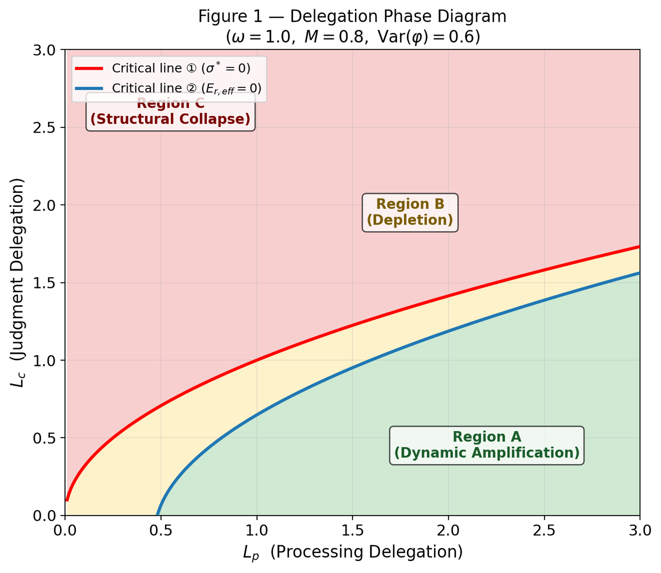
Figure 1: Delegation Phase Diagram
(Figure 1: Phase diagram in (L_p, L_c) delegation space. Red curve: Critical Line ①. Blue curve: Critical Line ②. Three regions distinguished.)

4.3 Corollary 1: Diversity as Foundational Prerequisite
Corollary 1. As Var(φ) → 0, all stability conditions fail simultaneously.
When Var(φ) → 0, N_eff → 0, E_r_eff becomes negative regardless of M, and the system moves toward saddle-point instability. Diversity is not one factor among many — it is the structural prerequisite for recomputation itself.
The present formulation is not intended as a formal bifurcation analysis. Nevertheless, the model implies an asymmetric recovery structure in which movement from adaptive to locked-in regimes may occur gradually, while return may require discontinuous re-entry once internal recomputation capacity has been sufficiently restored. In this sense, the dynamics are consistent with a saddle-node-type transition: regime persistence can survive parameter improvement beyond the original collapse point, producing hysteretic behavior without requiring that demographic surface indicators immediately reflect the underlying recovery of adaptive capacity. We therefore interpret the regime structure not as a fully derived phase portrait, but as a conceptual phase-space geometry linking adaptive persistence, lock-in, and delayed recovery (Fig. X).

5. Hysteresis and Recovery Asymmetry

5.1 Proposition 2: Recovery Time Asymmetry
Proposition 2. Functional recovery time τ_func is longer than structural recovery time τ_σ, and τ_func → ∞ as M₀ → 0.
Structural recovery: τ_σ = 1/ρ (M-independent, determined by the σ decay constant).
Functional recovery: τ_func ∝ 1/(E_r_eff · M · κ), which diverges as M₀ → 0.
The timescale separation (ε ≈ 0.04) between structural and functional dynamics creates a slow manifold on which recomputation capacity collapses irreversibly.

5.2 Hysteresis Loops
When M is treated as a dynamic variable, hysteresis emerges. As L_c increases beyond the critical threshold, M collapses. Upon recovery (L_c decreasing), M fails to return along the same path. The hysteresis width scales with ν (judgment-pressure sensitivity).
The key asymmetry: σ recovers near-reversibly under L_c sweeps, while M exhibits pronounced path dependence. Structural indicators can return to normal while recomputation capacity remains suppressed.
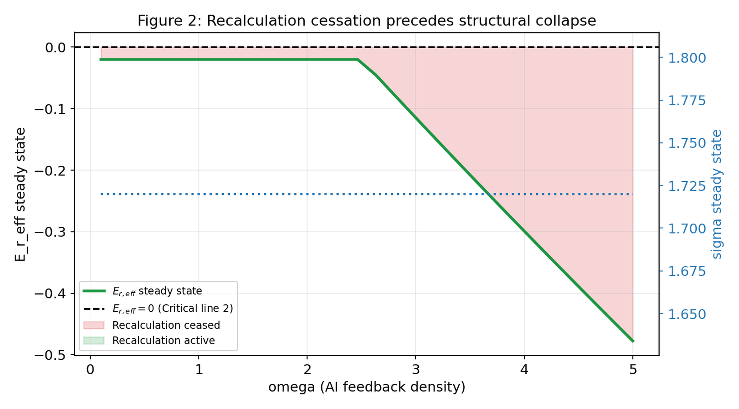
Figure 2: ω Sweep
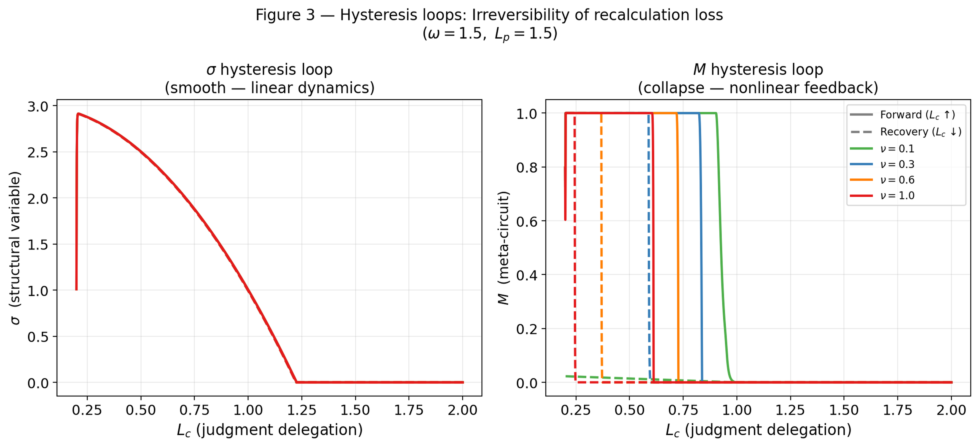
Figure 3: Hysteresis Loops
(Figure 2: ω sweep showing Var(φ) collapse precedes σ collapse. Figure 3: Hysteresis loops for σ (reversible) and M (irreversible) under L_c sweeps.)

6. Operationalizing M: Proxy for Recomputation Capacity
The theoretical variable M represents the recomputation capacity of a social system: the ability to evaluate existing strategies, generate alternatives, and update collective behavior in response to changing conditions. Because M is not directly observable in municipal datasets, we construct an operational proxy based on policy dynamics observable in administrative records.
We define:
M_proxy = D_policy × R_update
where D_policy denotes policy domain diversity (the number of distinct policy categories actively maintained by the municipality) and R_update denotes policy update rate (the frequency of policy revisions or new policy introductions per unit time).
This formulation captures two necessary components of recomputation capacity: exploratory breadth (diversity) and feedback-driven adaptation speed (update rate). Together they approximate the capacity of a municipality to recompute its strategic trajectory — analogous to exploration dynamics in reinforcement learning, where both the diversity of actions sampled and the speed of feedback updates determine adaptive performance.
We treat M_proxy as a lower-bound estimate of M, acknowledging that unmeasured components — in particular, the quality of deliberative processes underlying policy revision — remain outside the scope of the present analysis.
Limitation: The present proxy measures aggregate recomputation capacity (M_composite) without distinguishing human-generated recomputation (M_h) from AI-assisted recomputation (M_ai). As AI-mediated governance tools become prevalent, this decomposition becomes a critical measurement challenge. We flag this as a priority for future empirical work.

7. Empirical Analysis: Industrial Diversity and Population Dynamics

7.1 Position
This section constitutes the empirical foothold of the OMD framework — the first contact with population-scale data. We do not claim causal proof; we report that the variable structure predicted by the theory does not collapse when confronted with real data.

7.2 Operationalization of Var(φ)
We operationalize the central OMD variable Var(φ) as Shannon entropy over industrial employment categories:
Var(φ) ← Shannon H = −Σ pᵢ log pᵢ
where pᵢ is the employment share in major industry category i (20 categories including agriculture, construction, manufacturing, IT, healthcare, etc.). Data source: 2020 Japanese Population Census, industrial employment by municipality (e-Stat statsDataId: 0003454503).
Theoretical rationale: Industrial diversity is a proxy for the multiplicity of adaptive pathways available to a region under external environmental change. Regions with high Shannon H structurally maintain Var(φ).

7.3 Shikoku Analysis (n = 94)
Regression: Population change rate 2015→2020 (%) = f(L_c, Var(φ), aging rate, log population density)
Variable | Coefficient | p-value | Result
L_c (transfer tax dependence) | −0.008 | 0.806 | Disappeared (confounded with aging)
Var(φ) (Shannon H) | +8.628 | 0.007 | Persists ★
Aging rate | −0.584 | <0.001 | Dominant
log population density | +0.190 | 0.446 | Non-significant
Adj.R² = 0.969, n = 94
Interpretation: The strong correlation between L_c and population decline (r = −0.95) was due to confounding with aging rate. After controlling for aging, L_c effect disappears, but Var(φ) persists significantly. This is consistent with the OMD prediction that L_c has an indirect effect mediated through Var(φ).

7.4 National Analysis (N = 1,908)
Regression: Population change rate 2015→2020 (%) = f(Var(φ), aging rate)
Variable | Coefficient | SE | t-value | p-value
Intercept | +11.813 | 1.006 | 11.75 | <0.001
Var(φ) | +1.318 | 0.391 | 3.37 | 0.001
Aging rate | −0.567 | 0.008 | −72.86 | <0.001
Adj.R² = 0.742, N = 1,908
Descriptive statistics: - Var(φ): 1.21–2.70 (mean 2.39) - Aging rate: 14.1–65.2% (mean 33.9%) - Population change rate: −34.2–+39.7% (mean −4.3%)
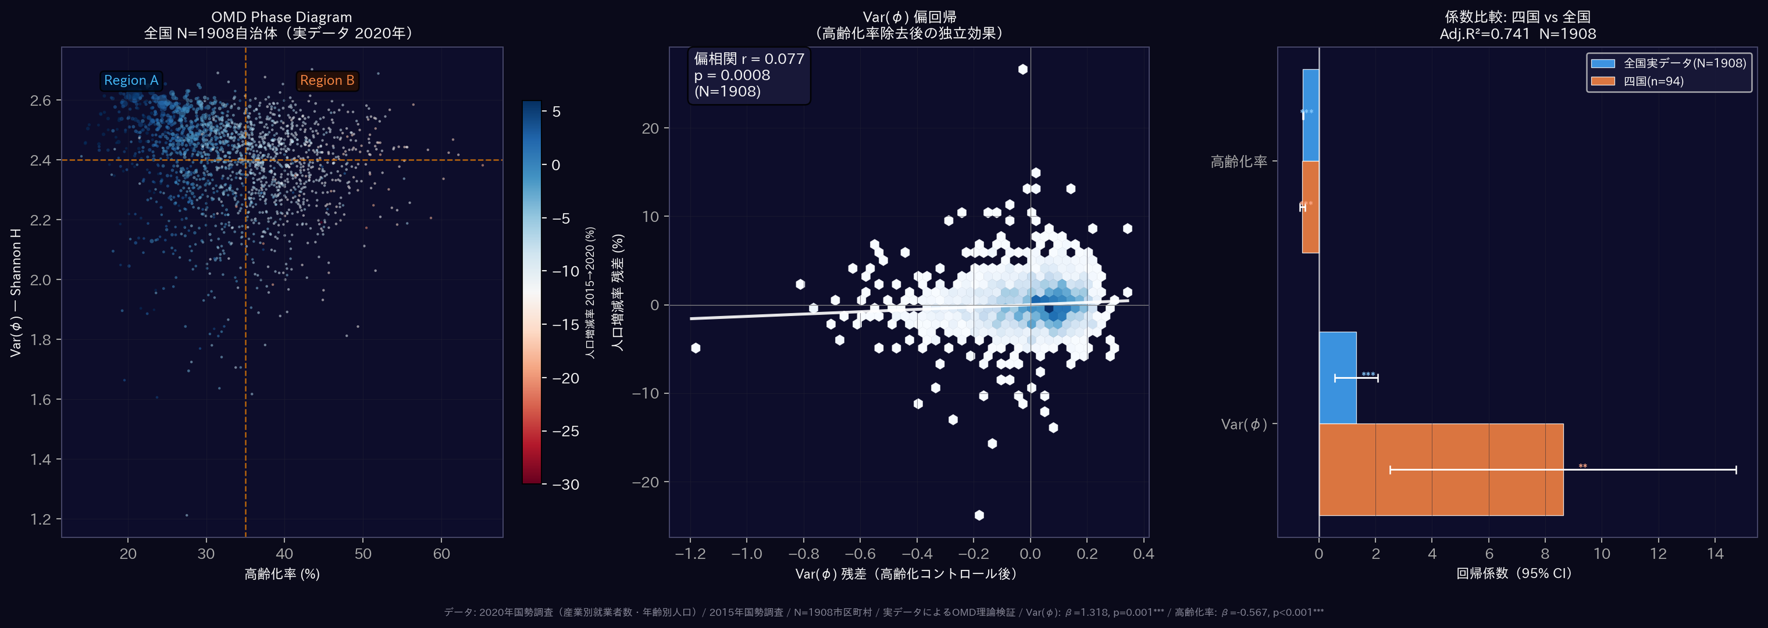
Figure 4: Empirical Distribution
(Figure 4: Scatter plot of Var(φ) against population change, N = 1,908. Partial correlation controlling for aging rate: r = 0.077, p = 0.0008.)

8. Discussion

8.1 Reverse Causality and Path Dependence
A natural alternative interpretation of the observed association between value-direction variance Var(φ) and population dynamics is reverse causality: declining population may reduce economic and institutional diversity, thereby lowering Var(φ). Several observations, however, suggest that this explanation alone is insufficient.
First, the association between Var(φ) and population change remains statistically significant after controlling for aging structure. Partial correlation analysis controlling for the aging rate yields r = 0.077 (p = 0.0008), indicating that the relationship is not solely driven by demographic aging.
Second, group comparison reveals a directional pattern consistent with the OMD prediction. Municipalities experiencing population growth exhibit higher average Var(φ) (mean = 2.438) than those undergoing population decline (mean = 2.379; t-test p < 0.0001). Under a purely reverse-causal account, diversity should recover proportionally as population returns.
However, the data reveal a subset of municipalities inconsistent with this symmetric recovery pattern. Among 1,908 municipalities, 71 cases (3.7%) exhibit population growth between 2015 and 2020 while remaining in the bottom quartile of Var(φ). These municipalities display demographic recovery without a corresponding restoration of institutional diversity.
This pattern is consistent with a hysteretic dynamic in which diversity loss persists despite demographic pressure partially relaxing. While the present observational analysis cannot establish definitive causal direction, the persistence of low Var(φ) despite demographic recovery is difficult to reconcile with a purely linear reverse-causality mechanism.

8.2 Geographic Clustering and Industrial Agglomeration
The 71 municipalities exhibiting population recovery without diversity restoration are not randomly distributed. Nearly half (35 of 71, 49.3%) are located in the Chubu region, with a particularly strong concentration in Aichi Prefecture (14 cases). This clustering suggests that demographic recovery alone does not necessarily restore institutional diversity.
Aichi represents one of Japan’s strongest industrial agglomeration zones, characterized by dense sectoral concentration centered on the automotive industry. In such environments, economic expansion may reinforce structural commitment to existing industrial trajectories rather than generate new institutional variation. Population growth can therefore coexist with persistently low value-direction variance.
Among the 14 Aichi cases, several municipalities located within the Toyota supply-chain corridor — including Kariya, Anjo, Hekinan, and Taketoyo — display population growth associated with manufacturing expansion while simultaneously exhibiting some of the lowest Var(φ) values in the dataset. This configuration suggests that industrial agglomeration may sustain demographic growth while reinforcing structural commitment to a narrow set of economic trajectories. Under the OMD framework, such environments correspond to regimes of high structural commitment (σ), where recomputation capacity remains constrained despite favorable demographic conditions.
Additional cases illustrate that demographic recovery may arise from mechanisms unrelated to diversity restoration. Shitara Town, a mountainous municipality likely influenced by targeted migration programs, exhibits population growth despite persistently low Var(φ). Similarly, Oguchi Town, characterized by strong dependence on a single manufacturing sector, records one of the lowest diversity scores in the dataset.
The Aichi cluster raises a counterintuitive possibility: demographic and economic success may coincide with the suppression of institutional diversity required for long-term recomputation. If confirmed, this would imply that short-term optimization and long-term adaptive resilience are not merely uncorrelated but potentially antagonistic — a dynamic more consistent with ecological overshoot models than with conventional institutional resilience frameworks.
By contrast, no such cases appear in the Shikoku sample, where demographic decline remains dominant and population recovery events are rare. This absence is consistent with the interpretation that the observed hysteresis candidates arise primarily during partial recovery phases rather than during the initial contraction stage.
A further test of the agglomeration hypothesis was conducted by systematically excluding large employment centers. Sensitivity analysis removing municipalities in the top 3%, 5%, and 10% of total employment size yielded virtually identical correlations (r = −0.455 to −0.462), confirming that the reversal pattern is not attributable to the inclusion of large urban agglomerations. Rather, the persistence of the negative association across all exclusion thresholds indicates that net in-migration may function as a demographic buffering mechanism, masking latent declines in recomputation capacity even in smaller municipalities throughout Japan.

8.3 Diagnostic Failure and the Limits of Conventional Metrics
The findings above point toward a structural limitation of linear evaluation frameworks when applied to social systems operating near phase boundaries.
In linear models of institutional adaptation, policy interventions produce proportional and reversible outcomes. Measurement is straightforward: indicators improve when conditions improve, and deteriorate when conditions deteriorate. Causality is tractable.
In the OMD framework, this correspondence breaks down near the critical boundaries. Before the hysteretic boundary is crossed, conventional indicators — population size, economic output, institutional activity — may remain within normal ranges. After the boundary is crossed, these same indicators may continue to register normal values while recomputation capacity has already collapsed. The system appears functional. The adaptive engine has stopped.
This is not collapse in the conventional sense. Institutions continue to operate. Policies continue to be implemented. The difficulty is that the capacity to evaluate and revise those policies has eroded — silently, and without registering in standard metrics.
The relevant challenge is therefore not how to respond to institutional collapse, but how to detect the silent crossing of the hysteretic boundary before conventional indicators register any anomaly. This requires diagnostic tools sensitive to recomputation dynamics rather than to structural outputs alone.
Societies may therefore remain stable long after their adaptive capacity has begun to erode, creating regimes that appear resilient while progressively losing the ability to recompute their strategic trajectory.
We term this process the demographic buffering effect: the tendency for external population inflow to temporarily mask latent declines in internal adaptive capacity, producing apparent demographic stability in municipalities whose recomputation capacity has already deteriorated. Net in-migration is therefore not a reliable proxy for adaptive capacity, and the two can diverge systematically under certain structural conditions — with population inflow actually increasing as internal adaptive processes stall. Once a municipality becomes reliant on residential inflow as the primary signal of apparent stability, the structural incentive to invest in industrial diversification or policy recomputation diminishes, potentially locking the system into a path-dependent trajectory of latent deterioration consistent with OMD’s hysteresis prediction.
The system appears functional. The adaptive engine has already stalled.

8.4 Extension: Endogenous Interference and the Decomposition of M
The present analysis treats ω — the density of external cognitive interference — as a latent control parameter. In the current formulation, ω is modeled as an exogenous input to the institutional system. However, as AI-mediated information flows become structurally embedded in decision-making processes, ω may transition from an external influence to an endogenous variable within the system dynamics.
Under such conditions, the boundary between institutional recomputation and AI-assisted substitution may become empirically indistinguishable. Observed adaptive capacity could therefore reflect either genuine institutional recomputation or its functional replacement by external cognitive systems.
Resolving this ambiguity requires decomposing aggregate recomputation capacity into human-generated recomputation (M_h) and AI-assisted recomputation (M_ai). Developing empirical methods to perform this decomposition represents an important direction for future work.

9. Conclusion
Social systems may lose adaptive capacity before they lose structural function. The Open Mind Dynamics framework formalizes this possibility as a dynamical system in which recomputation capacity (M) and value-direction variance Var(φ) govern transitions between adaptive and locked-in regimes. The model predicts hysteretic boundaries: once crossed, recovery requires qualitatively different conditions than those that produced the initial decline.
Analysis of 1,908 Japanese municipalities reveals patterns consistent with this structure. Seventy-one cases exhibit population recovery without corresponding restoration of institutional diversity — a signature inconsistent with linear reverse-causality but compatible with hysteretic dynamics. Geographic clustering in industrial agglomeration zones suggests that structural commitment may suppress recomputation capacity independently of demographic conditions.
The primary implication is diagnostic. Conventional performance metrics may remain normal while adaptive capacity erodes silently. Detecting this erosion therefore requires diagnostic tools sensitive to recomputation dynamics rather than to structural outputs alone.

Figure Captions
Figure 1. Delegation Phase Diagram.
Phase structure of the OMD model in the (L_p, L_c) delegation space, computed at fixed parameters ω = 1.0, M = 0.8, Var(φ) = 0.6. The horizontal axis represents processing delegation (L_p); the vertical axis represents judgment delegation (L_c). Both axes range from 0 to 3.
Red curve (Critical Line ①): locus of σ* = 0, defining the boundary of structural stability. Derived analytically from the condition a·L_p − b·L_c² = 0.
Blue curve (Critical Line ②): locus of E_r_eff = 0, defining the boundary of functional recomputation. Computed numerically from the steady-state approximation of the OMD equations at the specified parameter values.
Three regions are distinguished: Region A (green) — structural stability with active recomputation; Region B (yellow) — structural stability with recomputation cessation; Region C (red) — structural collapse. The coexistence of structural function and recomputation failure in Region B constitutes the central prediction of the model.
Figure 2. ω Sweep: Mechanism of Phase Transition.
Steady-state values of key variables as a function of AI feedback density ω, computed by numerical integration of the OMD system over T = 4,000 time units with L_c = 0.8, L_p = 1.5. Steady-state values estimated as the mean over the final 500 time units.
Left panel: steady-state σ (blue) and Var(φ) (red dashed) as functions of ω. Var(φ) collapses more sharply at intermediate values, indicating earlier loss of recomputation preconditions. Right panel: steady-state E_r_eff (green) as a function of ω, confirming that recomputation cessation precedes structural collapse across most of the ω range examined.
Figure 3. Hysteresis Loops: Irreversibility of Recomputation Loss.
Hysteresis loops for σ (left panel) and M (right panel) under progressive and recovery sweeps of judgment delegation L_c. Parameters: ω = 1.5, L_p = 1.5. Four values of ν are shown (ν = 0.1, 0.3, 0.6, 1.0).
Left panel: σ exhibits near-reversible dynamics. Right panel: M exhibits pronounced hysteresis — as L_c increases beyond the critical threshold, M collapses; upon recovery, M fails to return along the same path. Hysteresis width scales with ν.
The asymmetry between σ and M dynamics constitutes the central empirical prediction of the model: structural indicators may recover while recomputation capacity remains degraded — a condition indistinguishable from healthy adaptation under conventional linear metrics.
Figure 4. Empirical Distribution: Var(φ) and Population Change across Japanese Municipalities.
Scatter plot of Var(φ) against population change rate (2015–2020) for N = 1,908 Japanese municipalities. Var(φ) computed as Shannon entropy across 20 occupational categories (Statistics Bureau of Japan, Population Census 2020). Horizontal dashed line: Var(φ) = lower quartile threshold (2.313). Vertical dashed line: population change = 0.
Highlighted region (upper left quadrant): 71 municipalities exhibiting population growth while remaining in the bottom quartile of Var(φ). These cases are inconsistent with symmetric reverse-causality but compatible with hysteretic dynamics predicted by the OMD model. Aichi Prefecture municipalities are marked distinctly (n = 14).
Partial correlation between Var(φ) and population change controlling for aging rate: r = 0.077, p = 0.0008 (N = 1,908).

Related Work
Collective synchronization and diversity collapse. The Kuramoto model (Kuramoto, 1984) shows that heterogeneous oscillator populations undergo phase transition to collective synchronization when coupling strength exceeds a critical value. In classical synchronization models, coupling strength is an exogenous parameter; in OMD, the coupling source itself is generated endogenously as a function of Var(φ). Classical models address coupling strength; the present model addresses coupling generation.
Critical transitions and tipping points. Closely related to Scheffer et al. (2009). The present model generates nested tipping point geometry — Critical Line ② lies inside Critical Line ①. To our knowledge, this nested separation of functional and structural thresholds has not been formally characterized in the critical transitions literature.
Collective intelligence and diversity. Page (2007) showed that cognitive diversity matters more than ability diversity in collective problem-solving. OMD integrates these insights as a dynamical equation with recomputation capacity M as an endogenous variable.
Bounded rationality and delegation. Builds on Simon’s (1955) bounded rationality framework and Clark and Chalmers’ (1998) Extended Mind thesis. OMD formalizes the next dynamic consequence: when cognitive extension is sustained, what happens to internal recomputation capacity M itself?
Human-AI interaction. ω is an abstract parameter representing exposure density to AI-mediated feedback, not a specific AI system. Consistent with empirical findings that cognitive offloading to AI reduces metacognitive monitoring (Bago et al., 2022; Stadler et al., 2024) and tolerance for ambiguity (Dietvorst et al., 2015).

Appendix A: Variable Table
Symbol | Definition
φ | Value-direction vector
Var(φ) | Field direction variance (within-population variance of φ)
Δφ | Value-direction difference (generated only when E_r > 0)
ω | AI recursive feedback density (sole exogenous variable)
σ | Structural stability (endogenous)
E_r_raw | Raw recomputation energy = Δs × f
E_r | Attenuated recomputation energy = E_r_raw − D
E_r_eff | Effective recomputation energy = M·E_r − δ(L_c) + η(L_p)
D | Attenuation term = αω + β/(Var(φ)+ε) + γ/σ
Δs | State distance from contact others (dynamic variable)
L_c | Judgment delegation (error detection, threshold-setting)
L_p | Processing delegation (computational assistance)
M | Recomputation capacity ∈ [0,1]
M_proxy | Operational proxy = D_policy × R_update
τ_σ | σ characteristic time = 1/ρ
τ_func | Functional recovery time ∝ 1/(E_r_eff·M·κ)

Data Availability Statement
The population and industrial employment data used in this study are publicly available from the Statistics Bureau of Japan through the e-Stat portal (https://www.e-stat.go.jp). Specifically, municipal-level industrial employment data were obtained from the 2020 Population Census (statsDataId: 0003454503), and population change data from the 2015 and 2020 Population Census. All data are freely accessible without restriction. The simulation code used to generate Figures 1–3 is available from the corresponding author upon reasonable request.

References
Bago, B., Kovacs, M., Protzko, J., Nagy, T., Kekecs, Z., Palfi, B., … & Aczel, B. (2022). Situational factors shape moral judgements in the trolley dilemma in Eastern, Southern and Western countries in a culturally diverse sample. Nature Human Behaviour, 6(6), 880–895.
Bikhchandani, S., Hirshleifer, D., & Welch, I. (1992). A theory of fads, fashion, custom, and cultural change as informational cascades. Journal of Political Economy, 100(5), 992–1026.
Clark, A., & Chalmers, D. (1998). The extended mind. Analysis, 58(1), 7–19.
Coase, R. H. (1937). The nature of the firm. Economica, 4(16), 386–405.
Dietvorst, B. J., Logg, J. M., & Logg, J. M. (2015). Algorithm aversion: People erroneously avoid algorithms after seeing them err. Journal of Experimental Psychology: General, 144(1), 114–126.
Epstein, J. M., & Axtell, R. (1996). Growing Artificial Societies: Social Science from the Bottom Up. MIT Press.
Helbing, D. (2012). Agent-based modeling. In A. Braun & C. Wiesmath (Eds.), Social Self-Organization (pp. 25–70). Springer.
Kuramoto, Y. (1984). Chemical Oscillations, Waves, and Turbulence. Springer.
Page, S. E. (2007). The Difference: How the Power of Diversity Creates Better Groups, Firms, Schools, and Societies. Princeton University Press.
Scheffer, M., Bascompte, J., Brock, W. A., Brovkin, V., Carpenter, S. R., Dakos, V., … & Sugihara, G. (2009). Early-warning signals for critical transitions. Nature, 461(7260), 53–59.
Shannon, C. E. (1948). A mathematical theory of communication. Bell System Technical Journal, 27(3), 379–423.
Simon, H. A. (1955). A behavioral model of rational choice. Quarterly Journal of Economics, 69(1), 99–118.
Stadler, M., Niepel, C., Greiff, S., & Sailer, M. (2024). Artificial intelligence and human cognition: How AI affects human metacognition. Computers in Human Behavior, 153, 108106.
Watts, D. J. (2002). A simple model of global cascades on random networks. Proceedings of the National Academy of Sciences, 99(9), 5766–5771.
Williamson, O. E. (1981). The economics of organization: The transaction cost approach. American Journal of Sociology, 87(3), 548–577.

