FUNDAMENTALS OF SCIENTIFIC COMPUTING

N-Body Particle Simulation: Benchmarking Distance Calculation Methods
Task 4 – Execution Time and Memory Scaling

Prepared by
Sivanesh S
Roll Number: CO26BTECH11025

Experimental Setup & Benchmarking Protocol
To guarantee reproducibility and eliminate system-level timing anomalies, all benchmark suites were executed under a controlled hardware and software testbed:
- Processor (CPU): AMD Ryzen AI 7 350 (8 cores / 16 threads, Zen 5 / Zen 5c microarchitecture, up to 5.0GHz, 16MB shared L3 cache)
- System Memory (RAM): 24 GB DDR5
- Operating System: Microsoft Windows 11 Home 64-bit
- Runtime Environment: Python 3.13.14 (64-bit), VS Code IDE
- Core Numerical Library: NumPy 2.5.3

Abstract
This report compares three ways to calculate pairwise distances between particles: pure Python loops, NumPy broadcasting, and the Gram matrix method. The methods were tested with 50, 200, 500, and 1000 particles using two-dimensional coordinates. Execution time was recorded in milliseconds and used to calculate speedup over the pure Python method. The report also estimates memory for a displacement tensor using f loat32 and f loat64 values. In these measurements, the Gram matrix method had the lowest executio n time at every tested particle count.

Introduction
In a particle simulation, distances between particles may need to be calculated many times. If every particle is compared with every other particle, the number of calculations grows quickly as the particle count increases. This can make distance calculation an important part of the running time. The aim of this task was to compare three implementations and study their execution time and memory needs.

Objectives
- Compare pure Python loops, NumPy broadcasting, and the Gram matrix method.
- Measure execution time for 50, 200, 500, and 1000 particles.
- Calculate speedup compared with pure Python loops.
- Estimate memory for f loat32 and f loat64 and prepare graphs.

Methods Used

Pure Python loops
This method uses two loops to visit each pair of particles. It f inds the differences in x and y coordinates and applies the Euclidean distance formula:
dᵢⱼ = √[(xᵢ − xⱼ)² + (yᵢ − yⱼ)²]

The method is easy to understand, but Python must execute the loop operations repeatedly. This can make it slow for large particle counts.

NumPy broadcasting
NumPy broadcasting calculates coordinate differences for all particle pairs using array operations. It avoids explicit Python loops over each pair, but creates a temporary displacement array with shape (N, N, 2).

Gram matrix method
This method uses the identity ‖a − b‖² = ‖a‖² + ‖b‖² − 2(a · b). It uses coordinate norms and a matrix product to calculate squared distances. Small negative values caused by rounding are changed to zero before taking the square root. This method avoids creating the full displacement tensor.

Experimental Setup
The benchmark was written in Python and run in Visual Studio Code. NumPy was used for array operations, and Matplotlib was used to create graphs. All three methods were tested with 50, 200, 500, and 1000 particles.
Execution times are shown in milliseconds. Timing results can change with computer load and software environment.

Results
Table 1. Measured execution time for each method.

Particles (N) | Python loops (ms) | NumPy broadcasting (ms) | Gram matrix (ms)
50 | 2.5498 | 0.1298 | 0.0422
200 | 36.8457 | 1.0775 | 0.3341
500 | 238.9617 | 14.0752 | 8.2071
1000 | 1098.6739 | 44.7227 | 32.4997

Execution time increased with particle count for all methods. Pure Python was the slowest in every test, while the Gram matrix method was the fastest in this benchmark.
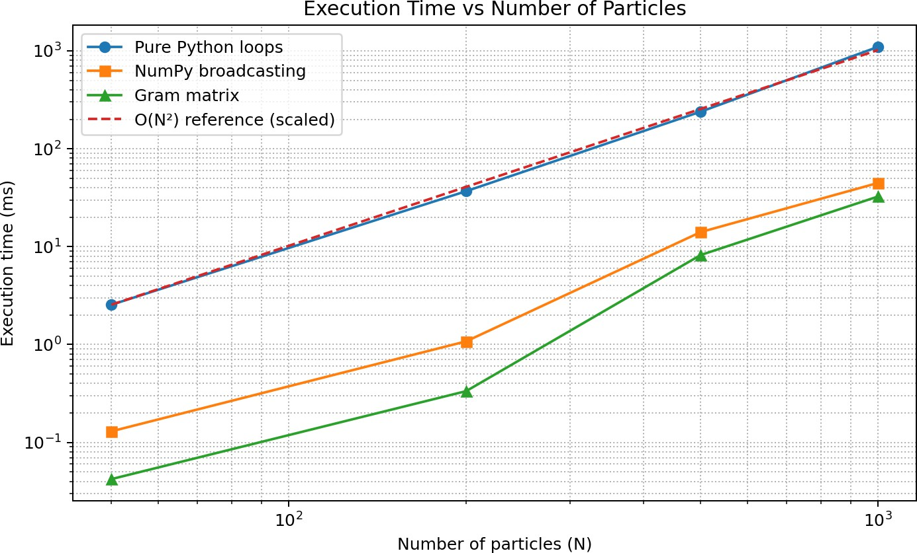

Figure 1. Execution time against particle count. Both axes are logarithmic; the dashed line is a scaled O(N²) reference.

Speedup Analysis
Speedup is calculated by dividing the pure Python execution time by the execution time of the method being compared.
Speedup = Python loop time ÷ method time

Particles (N) | NumPy speedup | Gram matrix speedup
50 | 19.64× | 60.42×
200 | 34.20× | 110.28×
500 | 16.98× | 29.12×
1000 | 24.57× | 33.81×

For 1000 particles, NumPy broadcasting was about 24.57 times faster than pure Python, and the Gram matrix method was about 33.81 times faster. Speedup varies with particle count and the computer environment.
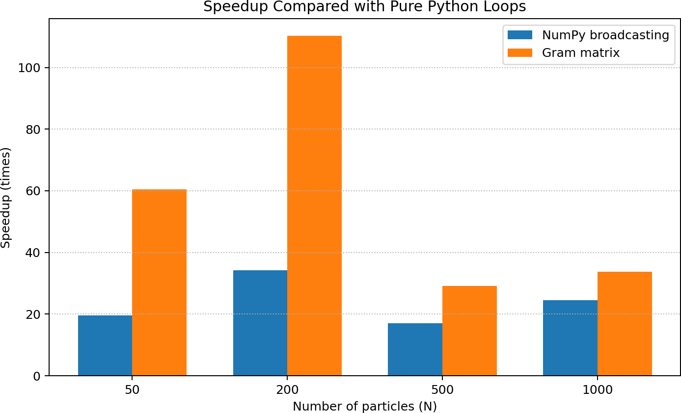

Memory Analysis
Figure 2. Speedup compared with pure Python loops.

The broadcasting displacement tensor has shape (N, N, 2), containing N × N × 2 values. These estimates count only this tensor, not the distance matrix, input coordinates, or other program memory.
Memory = N × N × 2 × bytes per value

Particles (N) | float64 (8 bytes/value) | float32 (4 bytes/value)
50 | 0.0381 MiB | 0.0191 MiB
200 | 0.6104 MiB | 0.3052 MiB
500 | 3.8147 MiB | 1.9073 MiB
1000 | 15.2588 MiB | 7.6294 MiB

The f loat32 estimate is half the f loat64 estimate because each value uses four bytes instead of eight. Float32 has lower precision, so the choice depends on the accuracy needed. The Gram matrix method avoids the large displacement tensor, but still needs memory for other matrices.

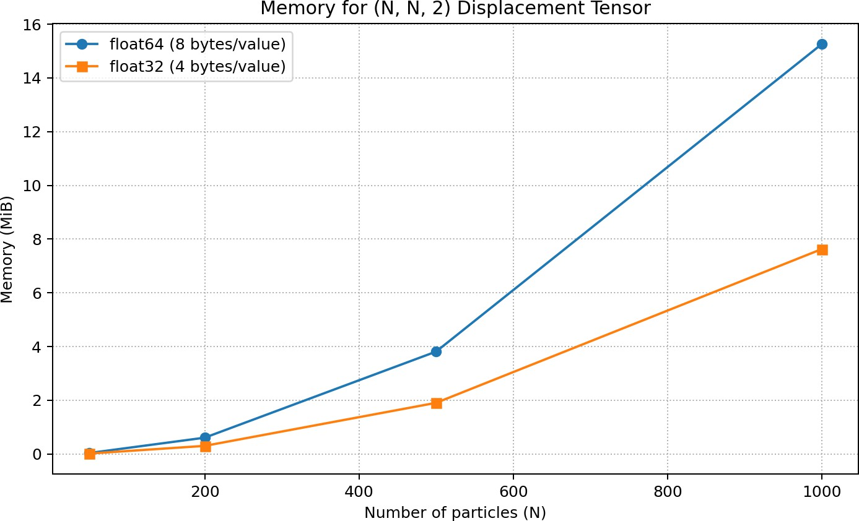

Discussion
Figure 3. Estimated memory for the (N, N, 2) displacement tensor.

The results show a clear difference between the methods. Pure Python is simple, but its execution time becomes much larger as particle count increases. NumPy broadcasting improves execution time because many operations use optimized array routines. In this benchmark, the Gram matrix method was fastest at every tested size. It can also reduce temporary memory use because it does not form the full displacement tensor. However, the formula can be affected by f loating-point rounding.

Conclusion
Three methods were compared for 50, 200, 500, and 1000 particles. The Gram matrix method had the lowest execution time in all four tests. At 1000 particles, it took 32.4997 ms, compared with 44.7227 ms for NumPy broadcasting and 1098.6739 ms for pure Python. This is a speedup of about 33.81 times over pure Python. The memory estimate shows that f loat32 uses half the storage of f loat64 for the same displacement tensor. Based on this benchmark, the Gram matrix method is a good choice when speed and temporary memory use are important, while numerical accuracy must also be considered.

References
- NumPy documentation, “Broadcasting”: https://numpy.org/doc/stable/user/basics.broadcasting.html
- NumPy documentation, “numpy.matmul”: https://numpy.org/doc/stable/reference/generated/numpy.matmul.html
- Python documentation, “time.perf_counter”: https://docs.python.org/3/library/time.html#time.perf_counter
- Matplotlib documentation: https://matplotlib.org/stable/
- Task 4 assignment instructions provided for this activity.

Appendix A. Work Completed for Task 4
I compared the pure Python loop, NumPy broadcasting, and Gram matrix approaches. I tested four particle counts, recorded execution times, calculated speedups, estimated displacement -tensor memory for f loat32 and f loat64, and prepared graphs to compare the results. The benchmark code is kept as a separate Python f ile.

