 | [Insert School’s own header]

Declaration of Originality Form
This form must be completed and signed and submitted with all assignments.
Please complete the information below (using BLOCK CAPITALS).
Name
Student Number
Course Name
Assignment Number/Name
A link to the University’s Plagiarism and Academic Integrity Code is provided at the end of this form. Please read the Plagiarism and Academic Integrity Code carefully THEN read and sign the declaration below.
I confirm that this assignment is my own work and that I have:
Read and understood the guidance on plagiarism in the Student Handbook, including the University of Glasgow Plagiarism and Academic Integrity Code |  | ☐
Read and understood guidance that is available on generative artificial intelligence (AI)  - by the University;  - by the School;  - in relation to this specific piece of assessment |  | ☐
Clearly referenced, in both the text and the bibliography or references, all sources used in the work |  | ☐
Fully referenced (including page numbers) and used quotation marks for all text quoted from books, journals and online sources, in accordance with the School’s accepted referencing style(s). |  | ☐
Provided the sources for all tables, figures, legends, data, and code that are not my own work |  | ☐
Ensured that I have not made use of any of my own work, or the work of any other student(s) past or present without acknowledgement. This includes work that has been previously, or concurrently, submitted for assessment, either at this or any other educational institution, including school. |  | ☐
Not sought or used the paid services of any external agencies, including plagiarism checkers or proofreading services |  | ☐
Not used any website or software that generates assessment content without clearly acknowledging that I have done so |  | ☐
Ensured that if use of generative AI is permitted in this assessment, I have clearly acknowledged its use, citing the specific tool(s) used (e.g. ChatGPT, Copilot, Bard, DeepSeek) and how they were used |  | ☐
In addition, I understand that any false claim in respect of this work will result in conduct action in accordance with University regulations |  | ☐
DECLARATION:
I am aware of and understand the University’s policy on plagiarism and academic integrity and I certify that this assignment is my own work, except where indicated by referencing, and that I have followed the good academic practices noted above
Signed

The University of Glasgow Plagiarism and Academic Integrity Code
The University of Glasgow Plagiarism and Academic Integrity Code can be found in the University Regulations at https://www.gla.ac.uk/myglasgow/apg/policies/uniregs/regulations2025-26/feesandgeneral/studentsupportandconductmatters/reg32/

If you are still unsure or unclear about what plagiarism is or need advice on how to avoid it,
SEEK HELP NOW!
You can contact any one of the following for assistance:
Lecturer
Course Leader
Dissertation Supervisor
Adviser of Studies
Student Learning Development Service
Remember to also read your Course or Programme Handbook for advice on good academic practice.

Declaration of Contribution
Please replace this text when adding your declaration “Declare which what the members of the team have contributed to and whether there was a problem in sharing the task. A member that has not contributed to this work by overriding this statement fairly will lose marks and other members will see their marks upgraded. If there is no apparent problem, then all team members will be awarded the same marks. For this a separate assessment will require you and your team members to assess your own work and peer assess your teammates. The quality of your reflection will also be assessed.”

- Determine the constraints for EID and regulations in relation to LIS (half a page)
This will require accessing government documentation and farm magazines for references to provide you with the necessary background.
As outlined in Department for Environment, Food & Rural Affairs (Defra), low-frequency (LF) electronic identification (EID) is expected to be introduced in 2027 as part of England’s new cattle traceability service. The existing Cattle Tracing System (CTS) will remain operational until EID is fully implemented. [1] Under the announced plan, calves born from 2027 will be required to carry LF electronic identification tags. These tags will enable cattle to be identified through scanning during movements, removing the need to read and enter tag numbers manually. The improved traceability provided by EID ear tags will strengthen the United Kingdom’s capacity to prevent, detect and respond to animal disease outbreaks, thereby protecting farmers and the rural economy. [2]
EID has four main limitations. First, ear tags may be lost or become unreadable. [3] Second, nearby metal bars or pipes may affect antenna performance, and the read zone should admit only one animal at a time so that a number can be attributed reliably. [4] Third, LF technology has a limited reading range, and the positioning of the reader may affect identification performance. [4] Finally, a Scottish ear-tag research project flags ear tearing as a potential animal-welfare concern. [5]
Regarding regulations relevant to LIS, current requirements stipulate that replacement tags must be ordered and fitted within 28 days of discovering that an official ear tag has been lost or damaged. The affected animal must remain on the premises until the replacement tag has been fitted. [6] Farmers must also maintain records relating to the cattle in their care, including ear-tag information, birth registrations and cattle passports. [7] Any movements of cattle onto or off the premises must be reported to the British Cattle Movement Service (BCMS) within three days. [8] These requirements ensure that cattle identities, origins and life histories are documented, providing essential information for the management of traceability records.

- What are the consequences of misidentification of dairy cows in farm environments (half a page)
This will require understanding the underlying reasons why cows need to be identified and hw the identification affects farm operation and individual cows on a daily basis as well as the LIS system and milk buyer information.
Accurate identification links each dairy cow to its production, health and treatment records, providing a foundation for routine management and reliable traceability. Conversely, the misidentification of dairy cows can lead to management errors and inaccurate traceability information.
First, if milk yield is recorded against the wrong cow, feed allocation and production performance monitoring become unreliable. Farmers may overfeed one cow while overlooking another’s nutritional requirements, resulting in excessive nutrient intake, feed waste and reduced production efficiency. AHDB highlights that individual milk yield records are essential for accurately implementing feeding-to-yield strategies. [9]
Furthermore, identification errors may result in staff treating the wrong animal while delaying care for the affected cow. More seriously, an identification error could allow milk from a cow in an antibiotic withdrawal period to enter the bulk tank. If the batch fails residue testing, it cannot be sold and may require disposal. [10] Inaccurate treatment records also reduce the reliability of information provided to milk buyers, hinder investigations into contaminated batches and potentially disrupt milk supply arrangements between producers and buyers. [10]
Incorrect movement records—for example, recording the movement of cow A under cow B’s identification number—can compromise the accuracy of herd movement information. Such errors may also mislead disease investigations: the current CTS holds statutory cattle movement records, while the planned LIS service aims to improve the data available for bovine tuberculosis control. [11] Defra plans to store statutory cattle birth, movement and death records in a future central database supporting the new LIS cattle service, further demonstrating the importance of accurate cattle identification. [12]
Therefore, farmers should maintain accurate and truthful cattle records and verify any uncertain identities to ensure the reliability of national traceability data.

- Formulating the idea: Answer the following question about the idea? (Take a photo of the A3 sheet or generated with murals – it needs to be legible)
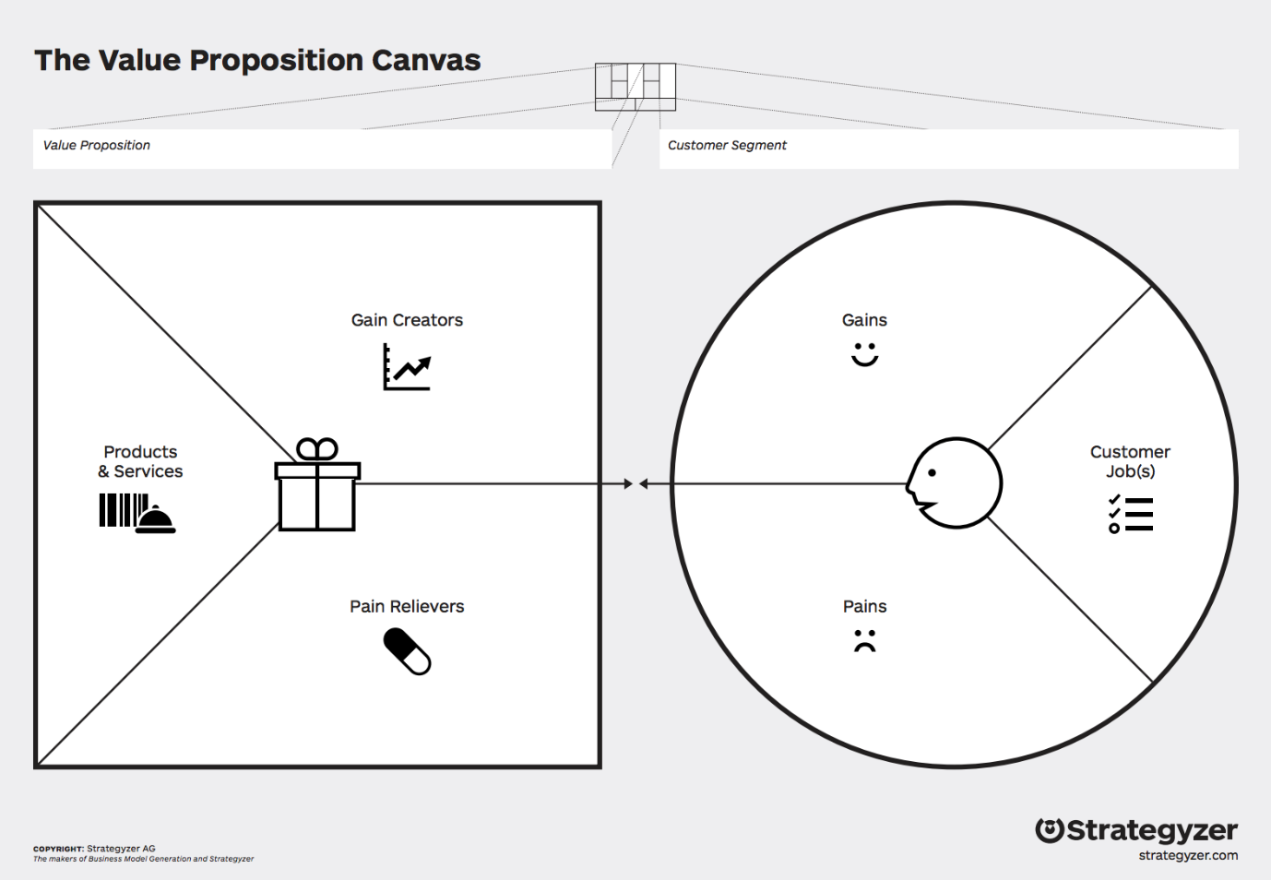

- Identifying group membership and differentiation factors (up to 1 page)
From this analysis, determine the points of parity and the points of difference between your company/product with your selection of competitors one by one.

- More on competition analysis (up to 2 pages)
From this analysis, conduct a porter’s 5 forces, SWOT, PESTEL analysis. Choose at least 2 techniques to analyse the context of your product/service mix. You do not need to show the template diagrams just go through the analysis using the tools. Determine from your analysis what desirable attributes must your product/service mix have to satisfy customers and the differentiation factor from the competition.

- Product/Service Analysis and competition – unique selling point. (1 sentence)
What is the unique selling point of your solution? Based on your analysis what is important to communicate to your customer base?

7
- Fill in the business canvas (A3 sheet or murals generated – it needs to be legible)

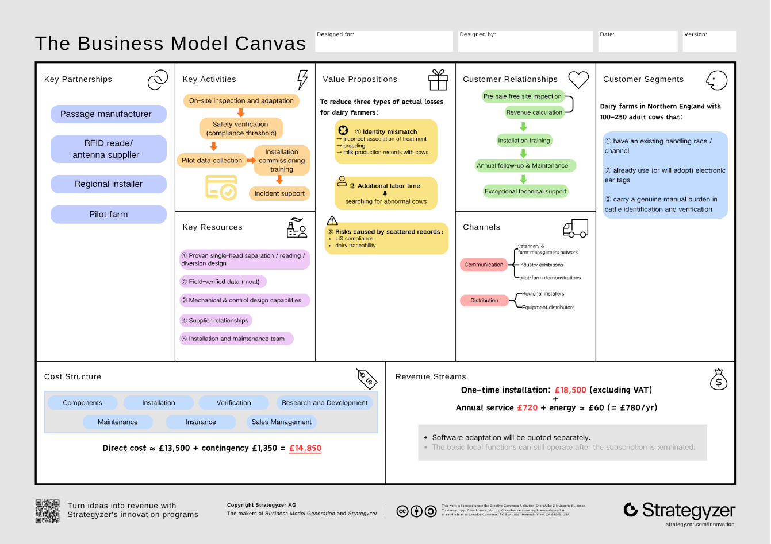
- Critical analysis (up to a page)
8.1 Market size
The target customers are dairy farms in Northern England with an existing handling race, electronic tags and a genuine verification burden. Neither AHDB’s 6,850 Great Britain dairy producers [13] nor Defra’s 1.849 million UK dairy cattle [14] states the Northern England farm count directly.
This report therefore estimates it from Defra's 2024 regional profiles [15]: total farms (agricultural area ÷ average farm size, Table 1.1) multiplied by the dairy share of holdings (Figure 1.7) gives ≈1,240 (North West), ≈406 (Yorkshire & the Humber) and ≈63 (North East), totalling ≈1,700 farms. This is an estimate derived from official data, not a published figure, and carries uncertainty.
8.2 Serviceable share and sales target
Applying the screening criteria (existing race, tags, high verification burden), an assumed 40% are serviceable, giving a serviceable available market (SAM) of ≈680 farms. The 40% is a scenario assumption, not yet validated by customer survey.
Three-year sales of 50 units would represent ≈2.9% of TAM and ≈7.4% of SAM — a sales target, not a market forecast.
8.3 Alignment of desirable attributes with customer needs
Competitive analysis (R5) identified six desirable attributes, each technically grounded and matched to a customer need:
• Reliable identity attribution (mechanical separation + ultrasonic occupancy sensing + LF RFID) — resolves missed reads, double reads and transcription errors
• Clear anomaly classification (two-exit conditional diversion + event records) — resolves difficulty re-locating abnormal cows
• Safe handling (fence-side operation + safety control) — enables safe handling outside the pen
• Local operation — copes with network outages, preserving records
• Ease of maintenance — mitigates maintenance-cost uncertainty
• Quantifiable benefit — makes investment verifiable against economic return
The first two attributes address the brief’s core failure modes (two IDs read at once; complete miss) and form the technical foundation of the value proposition.
8.4 Customer–product fit and necessary adjustment
The segment matches the product’s capability boundary — ID-Coo depends on an existing race, tags and a verification burden — so the criteria reflect genuine fit, not arbitrary choice; small herds, very-low-anomaly farms, or those with mature systems are excluded.
One implementation adjustment remains: per-head isolation may bottleneck throughput and first-time safe separation is unvalidated, so version one uses manual confirmation of single-animal entry, with automation only after validation. This constrains realisation without changing the value proposition. Overall, commercial viability depends on validating safe separation, RFID attribution, exit consistency and net benefit.

- User requirements and justifications (up to 1 page)
Section 8 identifies reliable identity attribution, clear exception outcomes, safe handling, local continuity, maintainability and measurable value as the attributes customers need. The following ten user requirements state the outcomes the product/service must deliver. Each is a MoSCoW Must have. Section 10 describes the proposed design.
UR1: The system must link each passage to the correct cow when a valid electronic identifier is available. A wrong identity can corrupt treatment and herd records, making a reliable attribution is essential to the problem defined in Section 2.
UR2: The system must leave unconfirmed identity unresolved and make the case available for safe staff review, pausing intake if review cannot continue. Tags can be lost or unreadable [3], [6]; a guessed identity would recreate the original record error.
UR3: The system must not record cattle passing together or closely following as one confirmed animal. Otherwise a neighbouring identifier could be attributed to the wrong cow, undermining the identity assurance required in Section 8.
UR4: Staff must be able to operate, stop and take over the process without entering the cattle path. Cattle handling presents injury risks [24], so external control is needed for routine use.
UR5: The system must confirm the exit actually taken and record each passage as one complete, truthful event. A late reading or an incorrect route must not leave an apparently complete but false event record.
UR6: The service must continue essential identity checks and preserve passage and exception records during network outages. Farm handling cannot depend on continuous connectivity, and lost records would prevent later review.
UR7: The service must provide auditable identity, time, exception and route records while distinguishing internal passages from reportable cattle movements. Farmers need usable evidence without mistaking on-farm sorting for a statutory movement [8], [25].
UR8: The service must process 200 cattle within 90 minutes in the pilot, including repeated reads and reviews, without excessive queuing. Otherwise, the checks would delay normal handling; Section 8 identifies per-head processing as a possible bottleneck.
UR9: The system must remain dependable after routine cleaning and allow faults to be recognised and resolved without prolonged downtime in wet, dirty farm conditions. Frequent interruptions would make daily use impractical.
UR10: The installed product and ongoing service must provide a measurable net benefit relative to total ownership cost. Farms need to justify the investment through actual labour savings and operating costs, as Section 8 notes.

- Provide a technical description of the solution e.g. sensor placement, data aggregation, functional block diagram, description of software, interfaces, and pricing to be submitted to your line manager. (up to 4 pages)
10.1 Physical structure
ID-Coo uses a single-file race: holding area → gate G0 → buffer A → gate G1 → detection section B → gate G2. Gate D then directs the cow either back to the herd or, through gate H, into the review pen (Figure 1). Both exits lead forward; D guides rather than pushes the animal.
Version 1 has one buffer and one detection section. More upstream sections would add waiting space, not speed to the read-and-divert cycle, while adding gates and faults. Adjustable alleys are about 526–800 mm wide, with 8 ft and 10 ft modules, indicate a structural envelope [16], [17]. A backing stop may help with reversal but cannot replace the separating gate.
CIGR gives a 650–749 kg Holstein–Friesian cow a withers height of 1.44 m, body length of 1.75 m and chest width of 0.60 m [18]. A field study of 1,054 cows reports a mean withers height of 1.411 m and trunk length of 1.708 m [19]. These guide section length, clear width and antenna height. A farm survey must confirm final dimensions and gate swings; a standard module does not necessarily hold one cow. Other breeds require a fresh dimensional check.
The race requires non-slip drainage, no sharp projections, guarded tracks and hinges, safe head and leg clearances, and continuous exit boundaries [20]. Staff operate from outside; head restraint is optional.
The review pen temporarily holds cows for manual identity checks; it is not for disease isolation. It needs an anti-return entrance, separate handling exit and outside operating space. Gate H closes only after the cow passes. A full pen or blocked branch stops intake.
Capacity follows C ≥ λq × th + Cm (exception rate × handling interval + margin). Because this is an average-load relation, the pen also needs full-pen monitoring. The budget assumes reuse of an existing pen for roughly six cattle. CIGR generally recommends capacity for one parlour side but excepts sorting at the parlour exit. Holding pens should provide water, feed and lying space [18]; the site survey must confirm capacity and facilities.
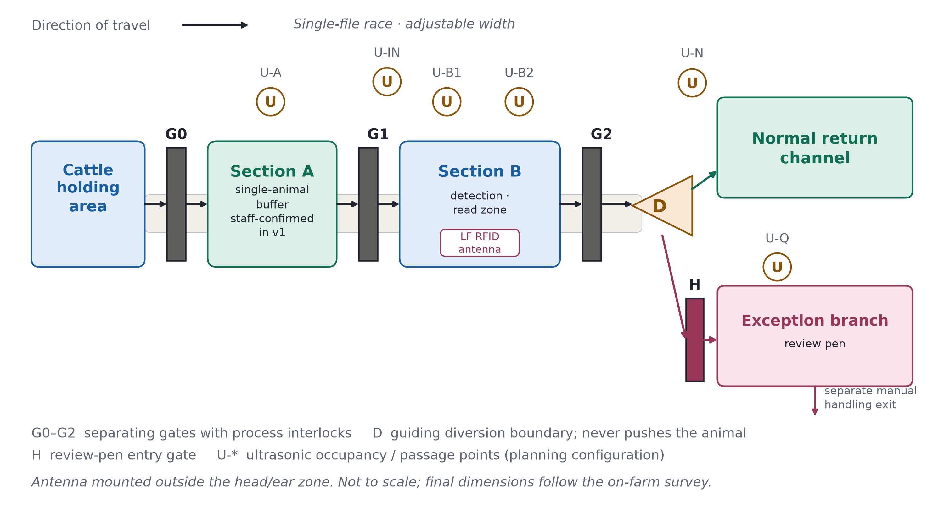
Figure 1 — Race and diversion functional layout
10.2 Sensing equipment and capability boundaries
An LF RFID reader scans LF EID tags where fitted using ISO 11784/11785, HDX and FDX-B. Cattle without an LF EID tag follow manual identity verification or an alternative workflow; an absent read alone does not diagnose tag damage [1]. Tru-Test XRP2/XRP2i is a functional reference; the final reader and antenna position outside B's head-and-ear zone depend on the site survey [4], [21].
Six planned ultrasonic points (U-A, U-IN, U-B1, U-B2, U-N, U-Q) monitor occupancy and passage; top-down mounting is assessed first for U-B1/U-B2. Distance, d = c × Δt / 2, is compared with an empty-race baseline. Each point reports *empty*, *occupied* or *uncertain*. No echo, stale data or a fault means *uncertain*; one echo cannot prove that only one cow is present [22].
Manufacturer-supported staggered transmission will be evaluated to limit crosstalk [23]. Six points are provisional; blind spots at entry or diversion require additional coverage.
An antenna may read a neighbouring tag even when one cow occupies B. The trial must therefore establish read attribution rather than infer it from a closed gate (Section 10.7). Cracked but readable tags and missing non-electronic tags still need visual inspection. (UR1–UR3, UR9)
10.3 Control hardware, electrical and safety
Figure 2 shows functional interfaces, not construction wiring. Voltage, drive rating, cable protection and earthing depend on the chosen equipment and site. The PLC sends motion requests directly to the gate drives. Separately, safety-related control monitors risk-assessed protection devices and can stop or inhibit the drives independently; software and data interfaces cannot bypass it. Site-selected enclosures, connectors and cables must withstand wash-down, ingress and corrosion; operation is checked after routine cleaning. (UR9)
Safety functions and required performance levels follow a site risk assessment using general functional-safety methods; no achieved level is claimed. Mechanical guards and validated obstruction responses protect the gates. Ultrasonic points alone cannot provide anti-pinch protection.
On power loss, hazardous movement stops and each gate holds a defined state; a short backup saves the event and signals the fault. Staff can release cattle from outside. On restart, the controller verifies gate positions and occupancy rather than resuming interrupted motion. Training and inspection follow HSE guidance [24]. (UR4, UR5)
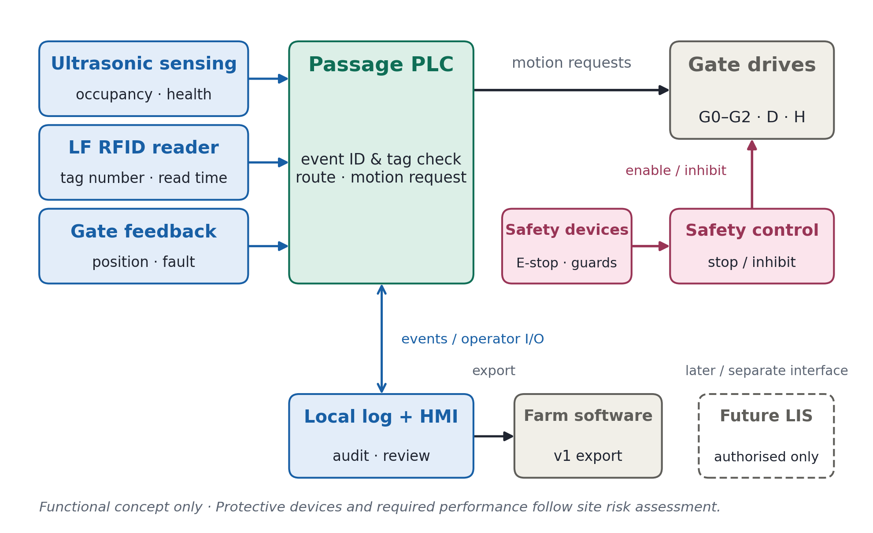
Figure 2 — Functional control, safety and data interfaces
10.4 Control algorithm and diversion logic
A rule-based state machine handles each passage separately; version 1 needs no machine learning. Staff confirm one cow in A, after which the controller admits her to B, reads the tag, sets the exit and confirms the route taken.
Process interlocks keep G0/G1 and G1/G2 from opening together. Scanning requires both B gates closed, a cow in the read zone and no suspected follower. D must be positioned before G2 opens and cannot move while its path is occupied. Sensors and gate feedback confirm exit; a timer alone cannot.
Late reads remain with their original event and cannot redirect the next cow. Process interlocks do not prove safe first entry, so version 1 retains staff confirmation and counts that time in its economics. Automatic entry requires prior validation of separation, anti-pinch protection and exception handling.
An unread cow retains an event ID while in B. Uncertain mechanical state stops automatic diversion; consecutive no-reads trigger reader diagnostics before a whole group can be misdirected. (UR1–UR5)
10.5 Data, software and the farmer interface
Each event records its ID, timing, occupancy and gate state, raw and de-duplicated reads, device status, decision reason, planned and actual exit, operator and edit history.
Event ID and official identity remain separate. If no tag is read, identity stays blank until staff verify it; the original exception and later link remain auditable. If official visual identifiers also fail, staff follow the official procedure rather than invent a number.
The farmer interface distinguishes electronically verified, pending identity review, equipment/race fault and manually resolved. It shows the active event, pen load, open cases and maintenance record, with access-controlled manual actions. A reader fault never appears as a damaged-tag diagnosis. (UR5–UR7)
10.6 LIS and farm-software interface
Version 1 stores records locally and exports them for audit; direct LIS access is not assumed. If specifications and authorisation become available, an adapter will separate internal passages from reportable movements, validate fields, retain submissions and receipts, prevent duplicates, and reconcile after outages [1], [8], [25].
The interface shows locally saved, pending, failed and receipt-confirmed states. Changes to official identity and statutory submissions require human approval. (UR6, UR7)
10.7 Pricing, throughput and validation
The planned installed price is £18,500 excluding VAT and major civil works, plus £720/year service and an assumed £60/year electricity (Section 12). It assumes reuse of the existing race and review pen, while covering sensors, gates and safety equipment. Payback is recalculated using final quotations, service and energy costs, and measured net labour savings. (UR10)
Target throughput is 150 head/hour (about 24 seconds per cow for entry, gates, reading and handling). The trial requires 200 cows in 90 minutes (about 133 head/hour), including retries and reviews. If unmet, the site or flow changes; safety checks do not. (UR8, UR10)
Trials report confirmed-read accuracy against a provisional ≥99.5% target and coverage separately, plus wrong diversions, exceptions, actual versus planned exits, takeovers and net labour time. Repeated passages by one herd are not independent animals; zero observed errors is not zero risk. Safe separation, read attribution and release precede economic validation. (UR1–UR10)

- Sustainable development (up to half a page)
Explain how your solution is built for sustainability by discussingyou’re your design aligns with the dairy roadmap https://www.dairyuk.org/wp-content/uploads/2021/11/Dairy-Roadmap-Climate-Ambition-Final-Version.pdf. Provide technical details in line with your design and critically assess the suitability of your design in line with the principles mentioned (do you need to revise your technical description to align your design to the sustainable development roadmap).

- Affordability (up to half a page)
Justify how much your product/service mix will cost for installation and a recurring service fee. Is that in line with the financial means of your customers? Justify your answer.

References
[1] Department for Environment, Food and Rural Affairs, “Livestock Information Transformation Programme (LITP),” GOV.UK, Jul. 23, 2026. [Online]. Available: https://www.gov.uk/government/publications/livestock-information-transformation-programme-litp/livestock-information-transformation-programme-litp. Accessed: Oct. 15, 2026.
[2] Department for Environment, Food and Rural Affairs, “Electronic ID for cattle mandatory in step forward for UK biosecurity,” GOV.UK, Jun. 2, 2025. [Online]. Available: https://www.gov.uk/government/news/electronic-id-for-cattle-mandatory-in-step-forward-for-uk-biosecurity. Accessed: Oct. 15, 2026.
[3] A. J. Roberts, L. E. Wallace, M. Harbac, and J. A. Paterson, “Case study: Retention and readability of radio frequency identification transponders in beef cows over a 5-year period,” The Professional Animal Scientist, vol. 28, no. 2, pp. 221–226, 2012. [Online]. Available: https://www.ars.usda.gov/ARSUserFiles/30300000/PAS%202012%2028%20221-226.pdf. Accessed: Oct. 15, 2026.
[4] Datamars Limited, XRP2 Panel Reader and Antenna Quickstart Guide, n.d. [Online]. Available: https://us.tru-test.com/resources/xrp2-panel-reader-quickstart-guide-enesptfrde. Accessed: Oct. 15, 2026.
[5] SEFARI, “Sheep and cattle traceability: The impact of environmental and other factors in Scotland on ear tag loss,” research project, n.d. [Online]. Available: https://sefari.scot/research/projects/sheep-and-cattle-traceability-the-impact-of-environmental-other-factors-in. Accessed: Oct. 15, 2026.
[6] British Cattle Movement Service and Rural Payments Agency, “Get new or replacement official ear tags for cattle,” GOV.UK, Nov. 8, 2022. [Online]. Available: https://www.gov.uk/guidance/get-new-or-replacement-official-ear-tags-for-cattle. Accessed: Oct. 15, 2026.
[7] The Cattle Identification Regulations 2007, S.I. 2007/529, United Kingdom. [Online]. Available: https://www.legislation.gov.uk/uksi/2007/529/contents. Accessed: Oct. 15, 2026.
[8] British Cattle Movement Service and Rural Payments Agency, “Record and report cattle movements,” GOV.UK, n.d. [Online]. Available: https://www.gov.uk/guidance/report-and-record-cattle-movements. Accessed: Oct. 15, 2026.
[9] Agriculture and Horticulture Development Board, “How to monitor the performance of a dairy diet,” AHDB, n.d. [Online]. Available: https://ahdb.org.uk/knowledge-library/how-to-monitor-the-performance-of-a-dairy-diet. Accessed: Oct. 15, 2026.
[10] Food Standards Agency, “Information and guidance on the testing of milk for antibiotic residues,” GOV.UK, Jan. 26, 2018. [Online]. Available: https://www.gov.uk/government/publications/milk-hygiene-and-antibiotic-residues/information-and-guidance-on-the-testing-of-milk-for-antibiotic-residues. Accessed: Oct. 15, 2026.
[11] C. Godfray, G. Hewinson, B. Silverman, M. Winter, and J. Wood, Bovine TB Strategy Review Update, Department for Environment, Food and Rural Affairs, 2025. [Online]. Available: https://assets.publishing.service.gov.uk/media/68d563169ce370a7e0a0fcfe/Godfray_bTB_Evidence_Review_Update_2025.pdf. Accessed: Oct. 15, 2026.
[12] Department for Environment, Food and Rural Affairs, “Changes to bovine identification, registration and movement in England: Summary of responses and government response,” GOV.UK, n.d. [Online]. Available: https://www.gov.uk/government/consultations/changes-to-bovine-identification-registration-and-movement-in-england/outcome/summary-of-responses-and-government-response. Accessed: Oct. 15, 2026.
[13] Agriculture and Horticulture Development Board, “GB producer numbers,” AHDB, Jun. 11, 2026. [Online]. Available: https://ahdb.org.uk/dairy/gb-producer-numbers. Accessed: Oct. 15, 2026.
[14] Department for Environment, Food and Rural Affairs, “Livestock populations in the United Kingdom at 1 June 2025,” GOV.UK, 2025. [Online]. Available: https://www.gov.uk/government/statistics/livestock-populations-in-the-united-kingdom/livestock-populations-in-the-united-kingdom-at-1-june-2025. Accessed: Oct. 15, 2026.
[15] Department for Environment, Food and Rural Affairs, “Agricultural facts: England regional profiles,” GOV.UK, Oct. 30, 2025. [Online]. Available: https://www.gov.uk/government/statistics/agricultural-facts-england-regional-profiles. Accessed: Oct. 15, 2026.
[16] Arrowquip, “Easy Flow Elite adjustable cattle alley,” n.d. [Online]. Available: https://arrowquip.com/cattle-equipment/cattle-alleys/easy-flow-alley. Accessed: Oct. 15, 2026.
[17] Arrowquip UK, “Cattle sorting race,” n.d. [Online]. Available: https://arrowquip.co.uk/cattle-equipment/cattle-races/cattle-sorting-races/. Accessed: Oct. 15, 2026.
[18] CIGR Section II Working Group No. 14, The Design of Dairy Cow and Replacement Heifer Housing, 2014. [Online]. Available: https://amsacta.unibo.it/4272/1/Dairy_Housing_report_2015.pdf. Accessed: Oct. 15, 2026.
[19] J. O. L. Cerqueira, J. P. P. Araújo, P. S. Vaz, J. Cantalapiedra, I. Blanco-Penedo, and J. J. R. Niza-Ribeiro, “Relationship between zoometric measurements in Holstein-Friesian cow and cubicle size in dairy farms,” International Journal of Morphology, vol. 31, no. 1, pp. 55–63, 2013, doi: 10.4067/S0717-95022013000100008.
[20] Department for Environment, Food and Rural Affairs, “Code of recommendations for the welfare of livestock: Cattle,” GOV.UK, Jan. 25, 2024. [Online]. Available: https://www.gov.uk/government/publications/code-of-recommendations-for-the-welfare-of-livestock-cattle/code-of-recommendations-for-the-welfare-of-livestock-cattle. Accessed: Oct. 15, 2026.
[21] Tru-Test Datamars, “XRP2 panel reader and antenna,” n.d. [Online]. Available: https://us.tru-test.com/products/eid/xrp2-panel-reader-and-antennas. Accessed: Oct. 15, 2026.
[22] Banner Engineering, “Ultrasonic sensors 101: Answers to your frequently asked questions,” n.d. [Online]. Available: https://www.bannerengineering.com/sg/en/company/expert-insights/ultrasonic-sensors-101.html. Accessed: Oct. 15, 2026.
[23] Pepperl+Fuchs, “Ultrasonic sensor FAQ: Synchronization and common mode,” Jan. 2, 2019. [Online]. Available: https://blog.pepperl-fuchs.com/en/2019/ultrasonic-sensor-faq-synchronization-and-common-mode/. Accessed: Oct. 15, 2026.
[24] Health and Safety Executive, “Livestock,” n.d. [Online]. Available: https://www.hse.gov.uk/agriculture/topics/livestock.htm. Accessed: Oct. 15, 2026.
[25] British Cattle Movement Service and Rural Payments Agency, “Keep a holding register for cattle to record births, movements and deaths,” GOV.UK, Jun. 28, 2023. [Online]. Available: https://www.gov.uk/guidance/keep-a-holding-register-for-cattle. Accessed: Oct. 15, 2026.

