 | [Insert School’s own header]

Declaration of Originality Form
This form must be completed and signed and submitted with all assignments.
Please complete the information below (using BLOCK CAPITALS).
Name
Student Number
Course Name
Assignment Number/Name
A link to the University’s Plagiarism and Academic Integrity Code is provided at the end of this form. Please read the Plagiarism and Academic Integrity Code carefully THEN read and sign the declaration below.
I confirm that this assignment is my own work and that I have:
Read and understood the guidance on plagiarism in the Student Handbook, including the University of Glasgow Plagiarism and Academic Integrity Code |  | ☐
Read and understood guidance that is available on generative artificial intelligence (AI)  - by the University;  - by the School;  - in relation to this specific piece of assessment |  | ☐
Clearly referenced, in both the text and the bibliography or references, all sources used in the work |  | ☐
Fully referenced (including page numbers) and used quotation marks for all text quoted from books, journals and online sources, in accordance with the School’s accepted referencing style(s). |  | ☐
Provided the sources for all tables, figures, legends, data, and code that are not my own work |  | ☐
Ensured that I have not made use of any of my own work, or the work of any other student(s) past or present without acknowledgement. This includes work that has been previously, or concurrently, submitted for assessment, either at this or any other educational institution, including school. |  | ☐
Not sought or used the paid services of any external agencies, including plagiarism checkers or proofreading services |  | ☐
Not used any website or software that generates assessment content without clearly acknowledging that I have done so |  | ☐
Ensured that if use of generative AI is permitted in this assessment, I have clearly acknowledged its use, citing the specific tool(s) used (e.g. ChatGPT, Copilot, Bard, DeepSeek) and how they were used |  | ☐
In addition, I understand that any false claim in respect of this work will result in conduct action in accordance with University regulations |  | ☐
DECLARATION:
I am aware of and understand the University’s policy on plagiarism and academic integrity and I certify that this assignment is my own work, except where indicated by referencing, and that I have followed the good academic practices noted above
Signed

The University of Glasgow Plagiarism and Academic Integrity Code
The University of Glasgow Plagiarism and Academic Integrity Code can be found in the University Regulations at https://www.gla.ac.uk/myglasgow/apg/policies/uniregs/regulations2025-26/feesandgeneral/studentsupportandconductmatters/reg32/

If you are still unsure or unclear about what plagiarism is or need advice on how to avoid it,
SEEK HELP NOW!
You can contact any one of the following for assistance:
Lecturer
Course Leader
Dissertation Supervisor
Adviser of Studies
Student Learning Development Service
Remember to also read your Course or Programme Handbook for advice on good academic practice.

Declaration of Contribution
Please replace this text when adding your declaration “Declare which what the members of the team have contributed to and whether there was a problem in sharing the task. A member that has not contributed to this work by overriding this statement fairly will lose marks and other members will see their marks upgraded. If there is no apparent problem, then all team members will be awarded the same marks. For this a separate assessment will require you and your team members to assess your own work and peer assess your teammates. The quality of your reflection will also be assessed.”

- Determine the constraints for EID and regulations in relation to LIS (half a page)
This will require accessing government documentation and farm magazines for references to provide you with the necessary background.

低频电子身份识别（EID）是由Defra发起，且预计于 2027 年推出，用于新的英格兰新牛只追溯服务。现有的Cattle Tracing System (CTS) 在EID全面推广前继续运行。[1]具体而言，所有新生小牛从2027年起将按要求强制使用低频（LF）技术使用电子识别（EID）。这意味着携带EID耳标的牛不需要通过人工读取和手动输入标签号码，而是在移动时被扫描来得知相关身份信息。牛只携带EID耳标带来的可追溯性将增强英国预防、检测和应对动物疾病爆发的能力，保护农民和农村经济。 [2]
EID 的限制条件主要有以下四项：首先，耳标可能丢失或无法读取。[3]其次，耳标的金属结构和外界金属装置的干扰会影响性能。当多头牛同时接近检测装置会造成误读。[4]然后，低频读取距离有限，安装位置可能会影响读取。[4]最后，有正在进行中的研究表明，牛只的耳标还可能会存在撕裂耳部的现象，涉及动物福利的问题。[5]
LIS 相关的法规方面，现行规定要求在发现官方耳标丢失或损坏后 28 天内订购并安装替换耳标，补装前不得将该牛移出场所。[6]另外，农场主需要对其饲养的牛只的生活状况进行记录，包含耳标、出生登记和牛只护照等内容。[7]若有迁入或者迁出的情况，则必须在3天内向英国牛只运输服务局（BCMS）报告。[8]这些法规保证了牛只的真实身份来源和生长轨迹的记录，为追溯信息的管理提供信息来源。

As outlined in Department for Environment, Food & Rural Affairs (Defra), low-frequency (LF) electronic identification (EID) is expected to be introduced in 2027 as part of England’s new cattle traceability service. The existing Cattle Tracing System (CTS) will remain operational until EID is fully implemented. [1] Specifically, all newborn calves will be required to carry LF electronic identification tags from 2027 onwards. These tags will enable cattle to be identified through scanning during movements, removing the need to read and enter tag numbers manually. The improved traceability provided by EID ear tags will strengthen the United Kingdom’s capacity to prevent, detect and respond to animal disease outbreaks, thereby protecting farmers and the rural economy. [2]
EID has four main limitations. First, ear tags may be lost or become unreadable. [3] Second, metal components in the tags and interference from nearby metal equipment may affect their performance. Reading errors may also occur when multiple cattle approach the reader simultaneously. [4] Third, LF technology has a limited reading range, and the positioning of the reader may affect identification performance. [4] Finally, ongoing research suggests that cattle ear tags may cause tearing of ear tissue, raising concerns regarding animal welfare. [5]
Regarding regulations relevant to LIS, current requirements stipulate that replacement tags must be ordered and fitted within 28 days of discovering that an official ear tag has been lost or damaged. The affected animal must remain on the premises until the replacement tag has been fitted. [6] Farmers must also maintain records relating to the cattle in their care, including ear-tag information, birth registrations and cattle passports. [7] Any movements of cattle onto or off the premises must be reported to the British Cattle Movement Service (BCMS) within three days. [8] These requirements ensure that cattle identities, origins and life histories are documented, providing essential information for the management of traceability records.

[1] https://www.gov.uk/government/publications/livestock-information-transformation-programme-litp/livestock-information-transformation-programme-litp

[2] https://www.gov.uk/government/news/electronic-id-for-cattle-mandatory-in-step-forward-for-uk-biosecurity

[3] https://www.ars.usda.gov/research/publications/publication/?seqNo115=273768

[4] https://sciencesearch.defra.gov.uk/ProjectDetails?ProjectId=21689

[5] https://sefari.scot/research/projects/sheep-and-cattle-traceability-the-impact-of-environmental-other-factors-in

[6] https://www.gov.uk/guidance/get-new-or-replacement-official-ear-tags-for-cattle

[7] https://www.legislation.gov.uk/uksi/2007/529/contents
[8] https://www.gov.uk/guidance/report-and-record-cattle-movements

- What are the consequences of misidentification of dairy cows in farm environments (half a page)
This will require understanding the underlying reasons why cows need to be identified and hw the identification affects farm operation and individual cows on a daily basis as well as the LIS system and milk buyer information.

准确的身份识别可以将每头奶牛与其生产、健康和治疗记录对应起来，为日常管理和可靠追溯提供基础。misidentification of dairy cows则会造成多方面的管理差错和追溯信息失真。首先，如果产奶量被记录到错误的牛只名下，饲料分配和生产表现监测便不再可靠。农场主可能过量饲喂一头牛，同时忽视另一头牛的营养需求，造成营养过剩、饲料浪费并影响生产效率。AHDB 指出，个体产奶记录是准确实施按产奶量饲喂的重要依据。[1] 此外，身份错误还可能导致工作人员对错误的牛实施治疗，同时延误患病牛的护理。更严重的是，正在接受药物治疗的牛的乳汁被错误地混入可销售牛奶，造成抗生素残留的问题，使混合后的整批牛奶损失原本可获得的销售收入，并可能产生额外处置费用。 [2] 不准确的治疗记录还会降低向牛奶收购方提供的信息的可靠性，妨碍污染批次调查，并可能导致生产商与采购方的供奶中断。[2]如果发生了错误转移记录的出现，例如，牛 A 的转移被记录在牛 B 的身份编号下，会造成牛群转移信息不准确。这甚至可能会误导疾病调查，因为保存牛只法定追溯信息的LIS system在牛结核病控制方面至关重要。[3] Defra 计划将牛只法定出生、转移和死亡记录保存在支撑新 LIS 牛只服务的未来中央数据库中，这足以说明准确识别牛只身份的重要性。[4]
综上，农场主在经营养牛场的过程中应当准确、如实记录牛只信息，核实存在疑问的身份，以保证国家追溯数据的可靠性。

Accurate identification links each dairy cow to its production, health and treatment records, providing a foundation for routine management and reliable traceability. Conversely, the misidentification of dairy cows can lead to management errors and inaccurate traceability information.
First, if milk yield is recorded against the wrong cow, feed allocation and production performance monitoring become unreliable. Farmers may overfeed one cow while overlooking another’s nutritional requirements, resulting in excessive nutrient intake, feed waste and reduced production efficiency. AHDB highlights that individual milk yield records are essential for accurately implementing feeding-to-yield strategies. [1]
Furthermore, identification errors may result in staff treating the wrong animal while delaying care for the affected cow. More seriously, milk from a cow undergoing medication may mistakenly enter the saleable milk supply, leading to antibiotic residues. This may result in the loss of sales revenue for the entire mixed batch and additional disposal costs. [2] Inaccurate treatment records also reduce the reliability of information provided to milk buyers, hinder investigations into contaminated batches and potentially disrupt milk supply arrangements between producers and buyers. [2]
Incorrect movement records—for example, recording the movement of cow A under cow B’s identification number—can compromise the accuracy of herd movement information. Such errors may even mislead disease investigations, as the LIS system, which maintains statutory cattle traceability records, plays a crucial role in bovine tuberculosis control. [3] Defra plans to store statutory cattle birth, movement and death records in a future central database supporting the new LIS cattle service, further demonstrating the importance of accurate cattle identification. [4]
Therefore, farmers should maintain accurate and truthful cattle records and verify any uncertain identities to ensure the reliability of national traceability data.

[1] https://ahdb.org.uk/knowledge-library/how-to-monitor-the-performance-of-a-dairy-diet

[2] https://www.gov.uk/government/publications/milk-hygiene-and-antibiotic-residues/information-and-guidance-on-the-testing-of-milk-for-antibiotic-residues

[3]https://assets.publishing.service.gov.uk/media/68d563169ce370a7e0a0fcfe/Godfray_bTB_Evidence_Review_Update_2025.pdf

[4] https://www.gov.uk/government/consultations/changes-to-bovine-identification-registration-and-movement-in-england/outcome/summary-of-responses-and-government-response

- Formulating the idea: Answer the following question about the idea? (Take a photo of the A3 sheet or generated with murals – it needs to be legible)
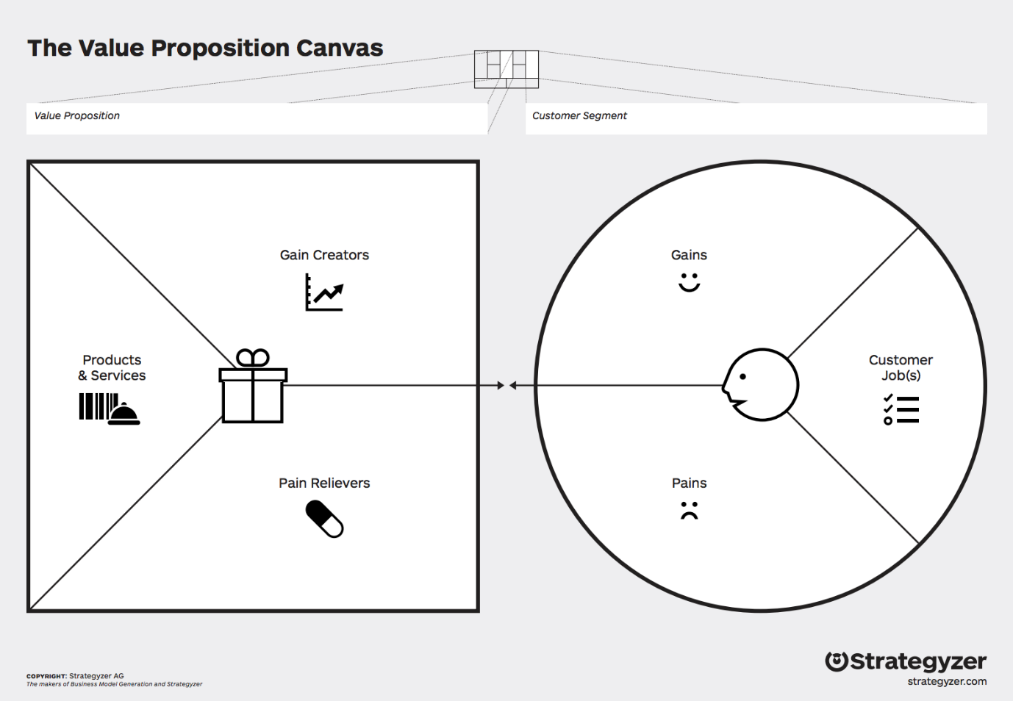

- Identifying group membership and differentiation factors (up to 1 page)
From this analysis, determine the points of parity and the points of difference between your company/product with your selection of competitors one by one.

- More on competition analysis (up to 2 pages)
From this analysis, conduct a porter’s 5 forces, SWOT, PESTEL analysis. Choose at least 2 techniques to analyse the context of your product/service mix. You do not need to show the template diagrams just go through the analysis using the tools. Determine from your analysis what desirable attributes must your product/service mix have to satisfy customers and the differentiation factor from the competition.

- Product/Service Analysis and competition – unique selling point. (1 sentence)
What is the unique selling point of your solution? Based on your analysis what is important to communicate to your customer base?

7
- Fill in the business canvas (A3 sheet or murals generated – it needs to be legible)

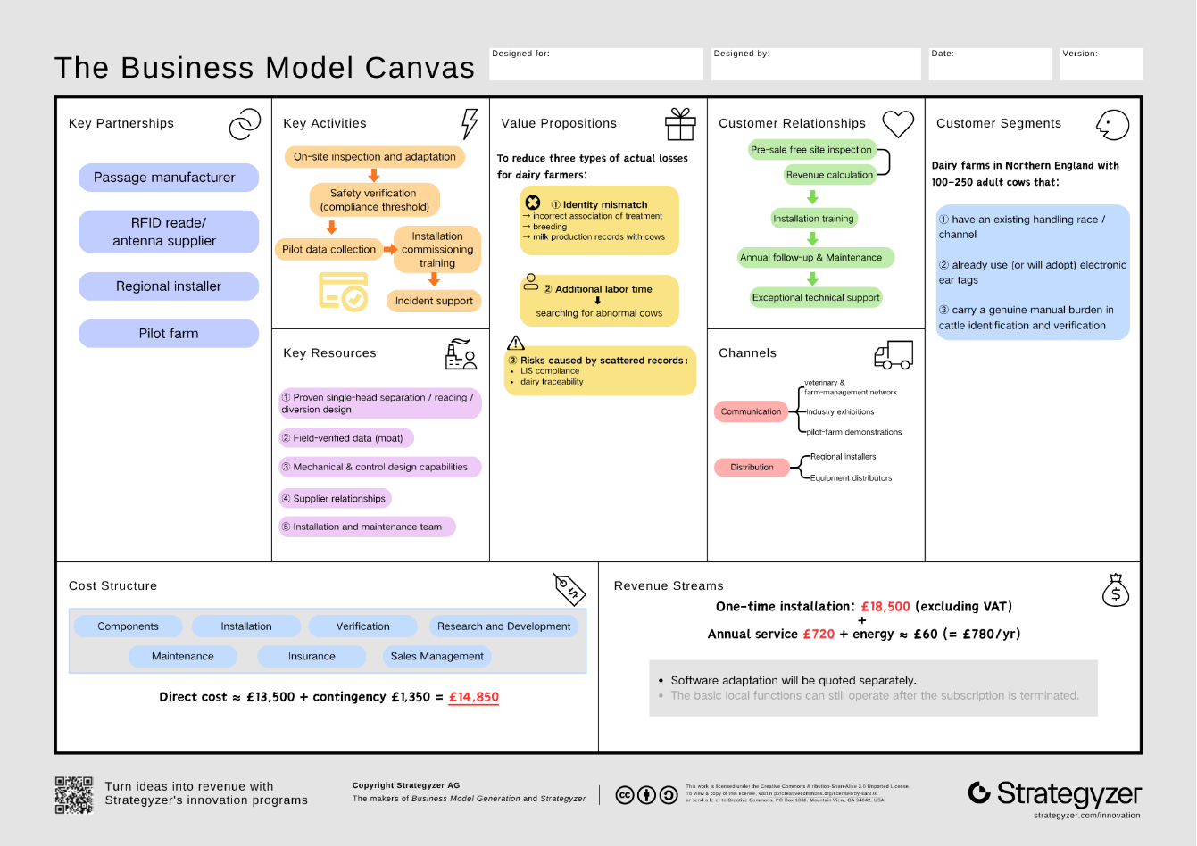
- Critical analysis (up to a page)
8.1 Market size
The target customers are dairy farms in Northern England with an existing handling race, electronic tags and a genuine verification burden. Neither AHDB’s 6,850 Great Britain dairy producers [19] nor Defra’s 1.849 million UK dairy cattle [20] states the Northern England farm count directly.
This report therefore estimates it from Defra 2024 regional data: total farms (agricultural area ÷ average farm size, Table 1.1) multiplied by the dairy share of holdings (Figure 1.7) gives ≈1,240 (North West), ≈406 (Yorkshire & the Humber) and ≈63 (North East), totalling ≈1,700 farms. This is an estimate derived from official data, not a published figure, and carries uncertainty.
8.2 Serviceable share and sales target
Applying the screening criteria (existing race, tags, high verification burden), an assumed 40% are serviceable, giving a serviceable available market (SAM) of ≈680 farms. The 40% is a scenario assumption, not yet validated by customer survey.
Three-year sales of 50 units would represent ≈2.9% of TAM and ≈7.4% of SAM — a sales target, not a market forecast.
8.3 Alignment of desirable attributes with customer needs
Competitive analysis (R5) identified six desirable attributes, each technically grounded and matched to a customer need:
• Reliable identity attribution (mechanical separation + ultrasonic occupancy sensing + LF RFID) — resolves missed reads, double reads and transcription errors
• Clear anomaly classification (two-exit conditional diversion + event records) — resolves difficulty re-locating abnormal cows
• Safe handling (fence-side operation + safety control) — enables safe handling outside the pen
• Local operation — copes with network outages, preserving records
• Ease of maintenance — mitigates maintenance-cost uncertainty
• Quantifiable benefit — makes investment verifiable against economic return
The first two attributes address the brief’s core failure modes (two IDs read at once; complete miss) and form the technical foundation of the value proposition.
8.4 Customer–product fit and necessary adjustment
The segment matches the product’s capability boundary — ID-Coo depends on an existing race, tags and a verification burden — so the criteria reflect genuine fit, not arbitrary choice; small herds, very-low-anomaly farms, or those with mature systems are excluded.
One implementation adjustment remains: per-head isolation may bottleneck throughput and first-time safe separation is unvalidated, so version one uses manual confirmation of single-animal entry, with automation only after validation. This constrains realisation without changing the value proposition. Overall, commercial viability depends on validating safe separation, RFID attribution, exit consistency and net benefit.

- User requirements and justifications (up to 1 page)
Using your product/service mix idea, write down everything your product needs to do. User requirements define what is needed to solve the problem. At this stage, the user requirements outline what the product needs to do, not how the problem will be solved. (up to 10 requirements). Justify the reasoning behind them. This exercise ensures that all user requirements align with solving the problem defined at the beginning. Take each user requirement identified in the previous section, justify why they are needed and help solve the problem. Using the MOSCOW analysis framework insure that all 10 requirements are must have.

- Provide a technical description of the solution e.g. sensor placement, data aggregation, functional block diagram, description of software, interfaces, and pricing to be submitted to your line manager. (up to 4 pages)

10.1 Physical structure
ID-Coo uses a single-file race: holding area → gate G0 → buffer A → gate G1 → detection section B → gate G2. Gate D then directs the cow either back to the herd or, through gate H, into the review pen (Figure 1). Both exits lead forward; D guides rather than pushes the animal.
ID-Coo has one buffer and one detection section. More upstream sections would add waiting space, not speed to the read-and-divert cycle, while adding gates and faults. Adjustable alleys about 526–800 mm wide, with 8 ft and 10 ft modules, indicate a structural envelope [13], [14]. A backing stop may help with reversal but cannot replace the separating gate.
The design starts with adult Holstein–Friesian dimensions: withers height about 1.4 m (CIGR: 1.44 m at 650–749 kg; a 1,054-cow field study: 1.41 m), body length 1.71–1.75 m and chest width about 0.60 m [26], [27]. These guide section length, clear width and antenna height. A farm survey must confirm final dimensions and gate swings; a standard module does not necessarily hold one cow. Other breeds require a fresh dimensional check.
The race requires non-slip drainage, no sharp projections, guarded tracks and hinges, safe head and leg clearances, and continuous exit boundaries [9]. Staff operate from outside; head restraint is optional. (UR8, UR9)
The review pen temporarily holds cows for manual identity checks; it is not for disease isolation. It needs an anti-return entrance, separate handling exit and outside operating space. Gate H closes only after the cow passes. A full pen or blocked branch stops intake.
Capacity follows C ≥ λq × th + Cm (exception rate × handling interval + margin). Because this is an average-load relation, the pen also needs full-pen monitoring. The budget assumes reuse of an existing pen for roughly six cattle. CIGR advises that a sorting pen hold at least one side of the parlour and provide water, feed and lying space [26]; the site survey must confirm this.
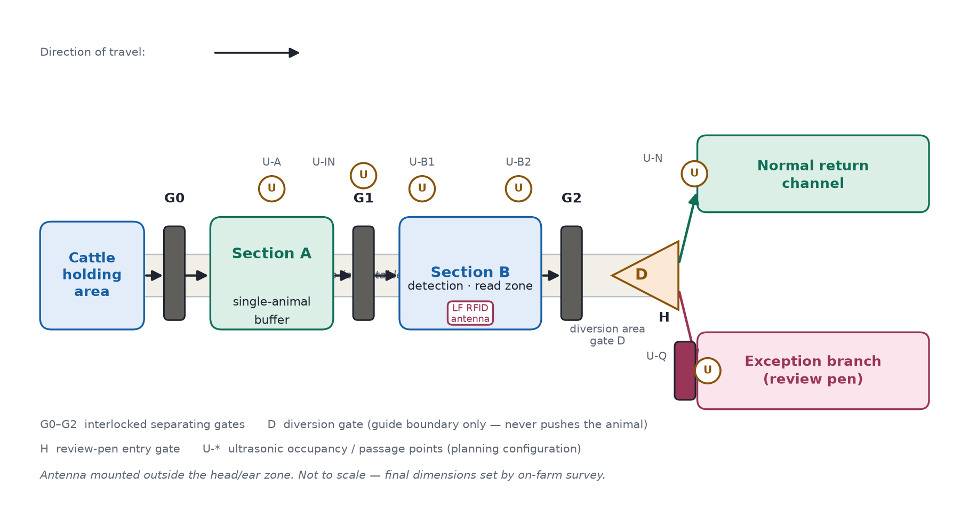Figure 1 — Race and diversion functional layout

10.2 Sensing equipment and capability boundaries
An LF RFID reader scans statutory electronic ear tags using ISO 11784/11785, HDX and FDX-B. Tru-Test XRP2/XRP2i is a functional reference; the final reader and antenna position outside B's head-and-ear zone depend on the site survey [11], [12].
Six planned ultrasonic points (U-A, U-IN, U-B1, U-B2, U-N, U-Q) monitor occupancy and passage; top-down mounting is assessed first for U-B1/U-B2. Distance, d = c × Δt / 2, is compared with an empty-race baseline. Each point reports *empty*, *occupied* or *uncertain*. No echo, stale data or a fault means *uncertain*; one echo cannot prove that only one cow is present [15].
Manufacturer-supported staggered transmission will be evaluated to limit crosstalk [16]. Six points are provisional; blind spots at entry or diversion require additional coverage.
Subsystem | What it contributes | What it cannot establish
Mechanical separation | Creates space for one animal and blocks followers | That the RFID field contains no neighbouring tag
Ultrasonic sensing | Detects occupancy, entry, exit and possible following | Identity or an exact animal count
RFID | Reads an electronic tag number | Tag condition, the cause of a failed read, or that one number means one animal
Gates and diversion | Carry out a confirmed passage and route choice | A diagnosis or an official identity decision
Manual review | Checks tags and reconciles records | Identity by guessing from queue order [3]
An antenna may read a neighbouring tag even when one cow occupies B. The trial must therefore establish read attribution rather than infer it from a closed gate (Section 10.7). Cracked but readable tags and missing non-electronic tags still need visual inspection. (UR1–UR3, UR9)

10.3 Control hardware, electrical and safety
Figure 2 shows functional interfaces, not construction wiring. Voltage, drive rating, cable protection and earthing depend on the chosen equipment and site. The PLC requests gate movement; a separate safety chain alone permits the drive. Software cannot override it.
Safety functions and required performance levels follow a site risk assessment using general functional-safety methods; no achieved level is claimed. Mechanical guards and validated obstruction responses protect the gates. Ultrasonic points alone cannot provide anti-pinch protection.
On power loss, hazardous movement stops and each gate holds a defined state; a short backup saves the event and signals the fault. Staff can release cattle from outside. On restart, the controller verifies gate positions and occupancy rather than resuming interrupted motion. Training and inspection follow HSE guidance [8]. (UR4, UR5)
Interface | Signal or data
Ultrasonic sensors → PLC | Distance, occupancy status, update time and diagnostics
RFID reader → PLC | Tag number, receive time and device status
Gate feedback → PLC | Open, closed, locked and fault states
Safety devices → safety chain | Emergency stop, obstruction and guard status
PLC → drives | Requests to open, close or stop
Data system → farm software | Verified export or authorised interface
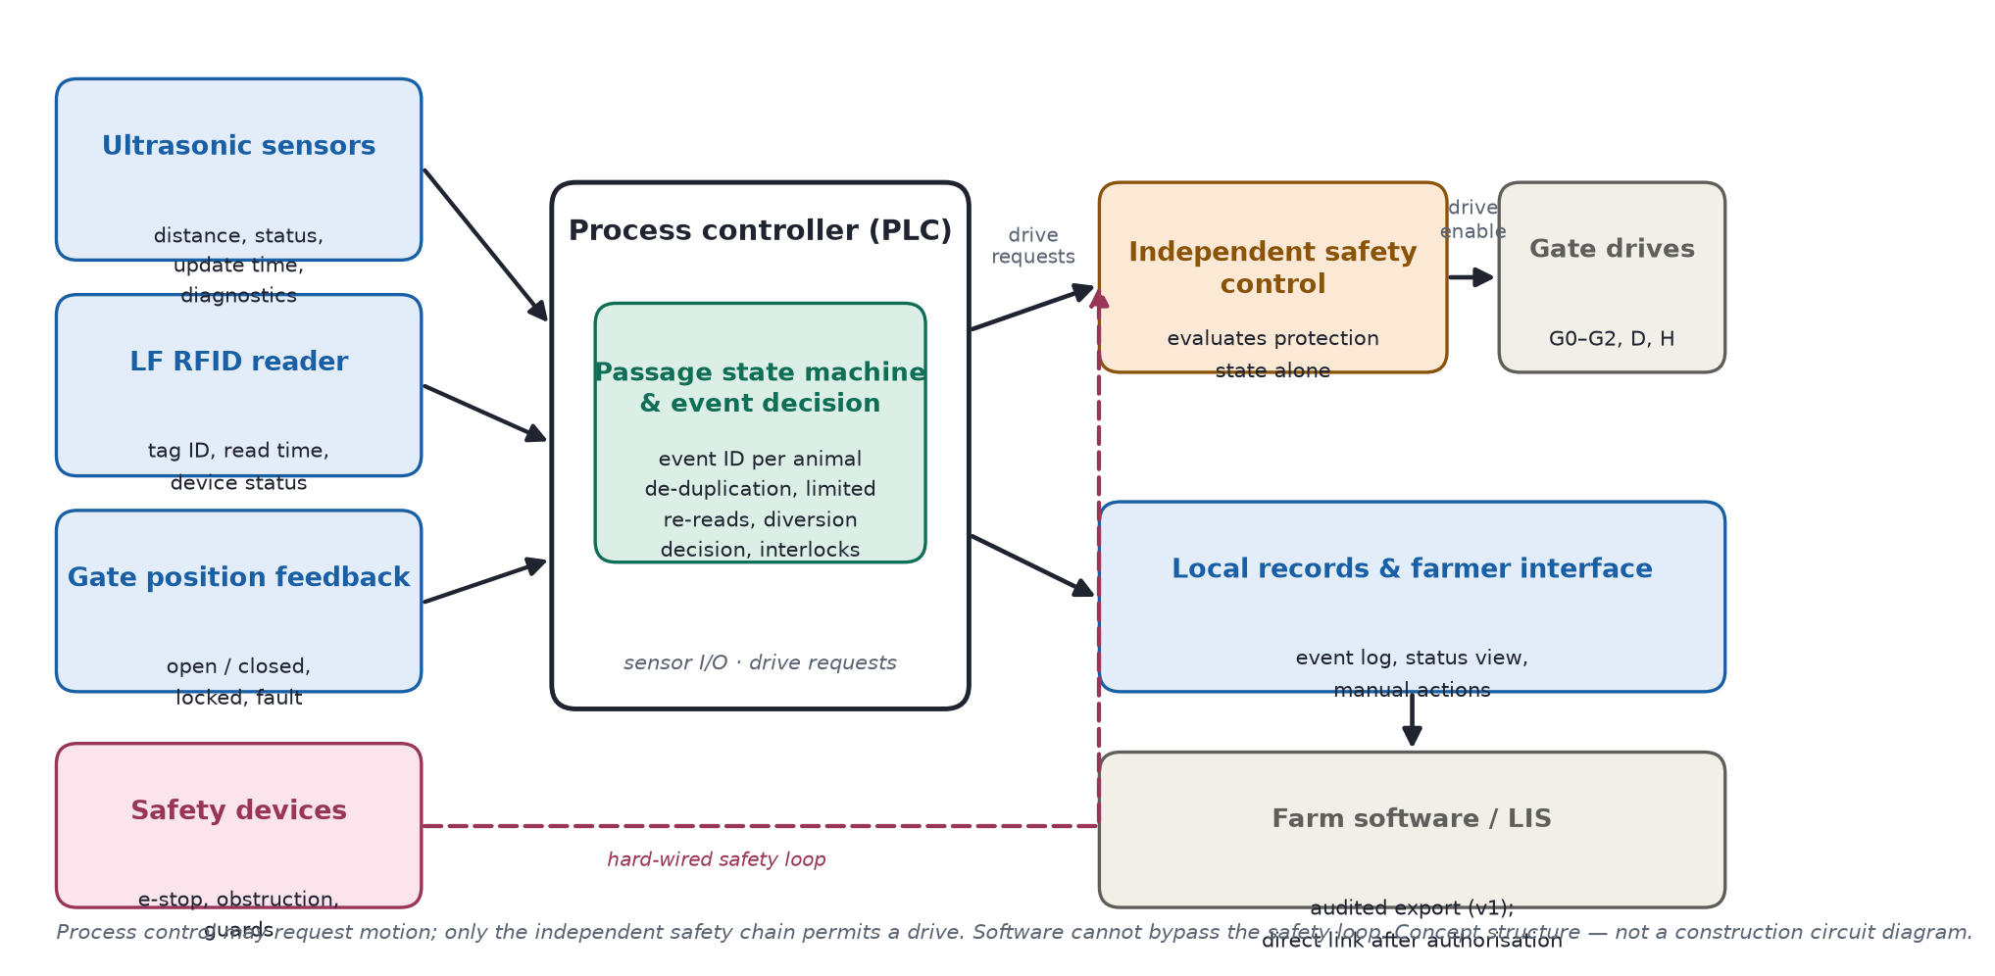Figure 2 — Control and data functional block diagram

10.4 Control algorithm and diversion logic
A rule-based state machine handles each passage separately; Version 1 needs no machine learning. Staff confirm one cow in A, after which the controller admits her to B, reads the tag, sets the exit and confirms the route taken.
State | Main action | Condition for moving on
S0 Self-check | Check devices, protection and gate positions | Start conditions are met
S1 Single buffer | Staff confirm one cow in A | G0 is closed and separation is valid
S2 Entry | Keep G2 closed and open G1 | Cow is fully in B and the gate zone is clear
S3 Isolated scan | Close G1 and begin the read window | G1 and G2 are confirmed closed
S4 Decision | Remove duplicate reads, check attribution and retry within limits | Valid identity or review outcome
S5 Set exit | Check route and position D | Route is available and D is in position
S6 Release | Open G2 while G1 remains closed | Cow has left B
S7 Reset | Confirm actual exit and close gates safely | B and diversion area are clear
SF Fault | Stop intake and prompt staff action | Fault is cleared and staff authorise restart
Interlocks keep G0/G1 and G1/G2 from opening together. Scanning requires both B gates closed, a cow in the read zone and no suspected follower. D must be positioned before G2 opens and cannot move while its path is occupied. Sensors and gate feedback confirm exit; a timer alone cannot.
Late reads remain with their original event and cannot redirect the next cow. Interlocks do not prove safe first entry, so Version 1 retains staff confirmation and counts that time in its economics. Automatic entry requires prior validation of separation, anti-pinch protection and exception handling.
Situation | Response
One cow, one attributable number and no other anomaly | Normal return; tag appearance has not been checked
Cow present, limited retries exhausted and no reader fault | Review branch if available; record reason as “not read”
Several numbers or unclear attribution | Hold in B and retry within limits; unresolved case goes to review
Possible multiple cows, uncertain occupancy or occupied gate zone | Pause for safe re-separation or manual takeover
Reader, ultrasonic or gate fault; blocked branch; full pen | Stop intake; do not label the group as having damaged tags
An unread cow retains an event ID while in B. Uncertain mechanical state stops automatic diversion; consecutive no-reads trigger reader diagnostics before a whole group can be misdirected. (UR1–UR5)

10.5 Data, software and the farmer interface
Each event records its ID, timing, occupancy and gate state, raw and de-duplicated reads, device status, decision reason, planned and actual exit, operator and edit history.
Event ID and official identity remain separate. If no tag is read, identity stays blank until staff verify it; the original exception and later link remain auditable [3]. If official visual identifiers also fail, staff follow the official procedure, and no identity is entered without official confirmation.
The farmer interface distinguishes electronically verified, pending identity review, equipment/race fault and manually resolved. It shows the active event, pen load, open cases and maintenance record, with access-controlled manual actions. A reader fault never appears as a damaged-tag diagnosis. (UR5–UR7)

10.6 LIS and farm-software interface
ID-Coo stores records locally and exports them for audit; direct LIS access is not assumed. If specifications and authorisation become available, an adapter will separate internal passages from reportable movements, validate fields, retain submissions and receipts, prevent duplicates, and reconcile after outages [1], [4], [5].
The interface shows locally saved, pending, failed and receipt-confirmed states. Changes to official identity and statutory submissions require human approval. (UR6, UR7)

10.7 Pricing, throughput and validation
The planned installed price is £18,500 excluding VAT and major civil works, plus £720/year service and an assumed £60/year electricity (Section 12). It assumes reuse of the existing race and review pen, while covering sensors, gates and safety equipment.
Target throughput is 150 head/hour (about 24 seconds per cow for entry, gates, reading and handling). The trial requires 200 cows in 90 minutes (about 133 head/hour), including retries and reviews. If unmet, the site or flow changes; safety checks do not. (UR8, UR10)
Stage | What is tested | Pass condition
Bench | Delayed and duplicate reads, lost communication, conflicting gate states | Correct state transition and event attribution
Without cattle | Simulated occupancy, obstruction, emergency stop and power loss | No hazardous movement without permission
Supervised cattle trial | Animal sizes, bunching, stopping and backing | Safe separation and passage
RF and environment | Neighbouring tags, steelwork, dirt and interference | Valid read zone and occupancy evidence
Tag conditions | Working, dead, missing, cracked but readable, and neighbouring tags | Misses and wrong diversions recorded separately
Farm pilot | Tasks, pen capacity, maintenance and staff time | Acceptable throughput and net benefit
Trials report confirmed-read accuracy and coverage separately, plus wrong diversions, exceptions, actual versus planned exits, takeovers and net labour time. Repeated passages by one herd are not independent animals; zero observed errors is not zero risk. Safe separation, read attribution and release precede economic validation. (UR1–UR10)

- Sustainable development (up to half a page)
Explain how your solution is built for sustainability by discussingyou’re your design aligns with the dairy roadmap https://www.dairyuk.org/wp-content/uploads/2021/11/Dairy-Roadmap-Climate-Ambition-Final-Version.pdf. Provide technical details in line with your design and critically assess the suitability of your design in line with the principles mentioned (do you need to revise your technical description to align your design to the sustainable development roadmap).

- Affordability (up to half a page)
Justify how much your product/service mix will cost for installation and a recurring service fee. Is that in line with the financial means of your customers? Justify your answer.

References (use the IEEE format)
You also need to add a reference section (I would expect an assignment to have between 15-30 references)

