 | [Insert School’s own header]

Declaration of Originality Form
This form must be completed and signed and submitted with all assignments.
Please complete the information below (using BLOCK CAPITALS).
Name
Student Number
Course Name
Assignment Number/Name
A link to the University’s Plagiarism and Academic Integrity Code is provided at the end of this form. Please read the Plagiarism and Academic Integrity Code carefully THEN read and sign the declaration below.
I confirm that this assignment is my own work and that I have:
Read and understood the guidance on plagiarism in the Student Handbook, including the University of Glasgow Plagiarism and Academic Integrity Code |  | ☐
Read and understood guidance that is available on generative artificial intelligence (AI)  - by the University;  - by the School;  - in relation to this specific piece of assessment |  | ☐
Clearly referenced, in both the text and the bibliography or references, all sources used in the work |  | ☐
Fully referenced (including page numbers) and used quotation marks for all text quoted from books, journals and online sources, in accordance with the School’s accepted referencing style(s). |  | ☐
Provided the sources for all tables, figures, legends, data, and code that are not my own work |  | ☐
Ensured that I have not made use of any of my own work, or the work of any other student(s) past or present without acknowledgement. This includes work that has been previously, or concurrently, submitted for assessment, either at this or any other educational institution, including school. |  | ☐
Not sought or used the paid services of any external agencies, including plagiarism checkers or proofreading services |  | ☐
Not used any website or software that generates assessment content without clearly acknowledging that I have done so |  | ☐
Ensured that if use of generative AI is permitted in this assessment, I have clearly acknowledged its use, citing the specific tool(s) used (e.g. ChatGPT, Copilot, Bard, DeepSeek) and how they were used |  | ☐
In addition, I understand that any false claim in respect of this work will result in conduct action in accordance with University regulations |  | ☐
DECLARATION:
I am aware of and understand the University’s policy on plagiarism and academic integrity and I certify that this assignment is my own work, except where indicated by referencing, and that I have followed the good academic practices noted above
Signed

The University of Glasgow Plagiarism and Academic Integrity Code
The University of Glasgow Plagiarism and Academic Integrity Code can be found in the University Regulations at https://www.gla.ac.uk/myglasgow/apg/policies/uniregs/regulations2025-26/feesandgeneral/studentsupportandconductmatters/reg32/

If you are still unsure or unclear about what plagiarism is or need advice on how to avoid it,
SEEK HELP NOW!
You can contact any one of the following for assistance:
Lecturer
Course Leader
Dissertation Supervisor
Adviser of Studies
Student Learning Development Service
Remember to also read your Course or Programme Handbook for advice on good academic practice.

Declaration of Contribution
Please replace this text when adding your declaration “Declare which what the members of the team have contributed to and whether there was a problem in sharing the task. A member that has not contributed to this work by overriding this statement fairly will lose marks and other members will see their marks upgraded. If there is no apparent problem, then all team members will be awarded the same marks. For this a separate assessment will require you and your team members to assess your own work and peer assess your teammates. The quality of your reflection will also be assessed.”
The report was divided into five parts, each carrying 20% of the assessment weighting. Part 1 — Problem and Customer Discovery was assigned to __________, who was responsible for investigating EID constraints and LIS-related regulations, analysing the consequences of dairy cow misidentification, and developing the Value Proposition Canvas based on customer jobs, pains and gains (R1–R3). Part 2 — Differentiation and Positioning was assigned to __________, who was responsible for identifying points of parity and difference relative to competitors, conducting competitive analysis using at least two appropriate tools, and defining the solution’s unique selling point (R4–R6). Part 3 — Business Model and Market Analysis was assigned to __________, who was responsible for developing the Business Model Canvas, estimating market size and the proportion of the market that could reasonably be served, and critically evaluating the alignment between the proposed product/service offering and the target customer segment (R7–R8). Part 4 — Requirements and Technical Design was assigned to __________, who was responsible for defining and justifying user requirements using the MoSCoW framework and preparing the technical description, including sensor placement, system architecture, data flow, algorithms, LIS integration and the farmer’s user interface (R9–R10). Part 5 — Validation and Delivery was assigned to __________, who was responsible for evaluating sustainability against the Dairy Roadmap, assessing installation costs, recurring service fees and affordability, and compiling and checking the references in IEEE format (R11–R13).
- Determine the constraints for EID and regulations in relation to LIS (half a page)
As outlined in Department for Environment, Food & Rural Affairs (Defra), low-frequency (LF) electronic identification (EID) is expected to be introduced in 2027 as part of England’s new cattle traceability service. The existing Cattle Tracing System (CTS) will remain operational until EID is fully implemented [1]. Specifically, all newborn calves will be required to carry LF electronic identification tags from 2027 onwards. These tags will enable cattle to be identified through scanning during movements, removing the need to read and enter tag numbers manually. The improved traceability provided by EID ear tags will strengthen the United Kingdom’s capacity to prevent, detect and respond to animal disease outbreaks, thereby protecting farmers and the rural economy [2].
EID has four main limitations. First, ear tags may be lost or become unreadable [3]. Second, metal components in the tags and interference from nearby metal equipment may affect their performance. Reading errors may also occur when multiple cattle approach the reader simultaneously [4]. Third, LF technology has a limited reading range, and the positioning of the reader may affect identification performance [4]. Finally, ongoing research suggests that cattle ear tags may cause tearing of ear tissue, raising concerns regarding animal welfare [5].
Regarding regulations relevant to Livestock Information Service (LIS), current requirements stipulate that replacement tags must be ordered and fitted within 28 days of discovering that an official ear tag has been lost or damaged [6]. The affected animal must remain on the premises until the replacement tag has been fitted [6]. Farmers must also maintain records relating to the cattle in their care, including ear-tag information, birth registrations and cattle passports [7]. Any movements of cattle onto or off the premises must be reported to the British Cattle Movement Service (BCMS) within three days [8].
These requirements ensure that cattle identities, origins and life histories are documented, providing essential information for the management of traceability records.

- What are the consequences of misidentification of dairy cows in farm environments (half a page)
Accurate identification links each dairy cow to its production, health and treatment records, providing a foundation for routine management and reliable traceability. Conversely, the misidentification of dairy cows can lead to management errors and inaccurate traceability information.
First, if milk yield is recorded against the wrong cow, feed allocation and production performance monitoring become unreliable. Farmers may overfeed one cow while overlooking another’s nutritional requirements, resulting in excessive nutrient intake, feed waste and reduced production efficiency. AHDB highlights that individual milk yield records are essential for accurately implementing feeding-to-yield strategies [9]. Furthermore, identification errors may result in staff treating the wrong animal while delaying care for the affected cow. More seriously, milk from a cow undergoing medication may mistakenly enter the saleable milk supply, leading to antibiotic residues. This may result in the loss of sales revenue for the entire mixed batch and additional disposal costs [10]. Inaccurate treatment records also reduce the reliability of information provided to milk buyers, hinder investigations into contaminated batches and potentially disrupt milk supply arrangements between producers and buyers [10]. Incorrect movement records—for example, recording the movement of cow A under cow B’s identification number—can compromise the accuracy of herd movement information. Such errors may even mislead disease investigations, as the LIS system, which maintains statutory cattle traceability records, plays a crucial role in bovine tuberculosis control [11]. Defra plans to store statutory cattle birth, movement and death records in a future central database supporting the new LIS cattle service, further demonstrating the importance of accurate cattle identification [12].
Therefore, farmers should maintain accurate and truthful cattle records and verify any uncertain identities to ensure the reliability of national traceability data.

- Formulating the idea: Answer the following question about the idea? (Take a photo of the A3 sheet or generated with murals – it needs to be legible)
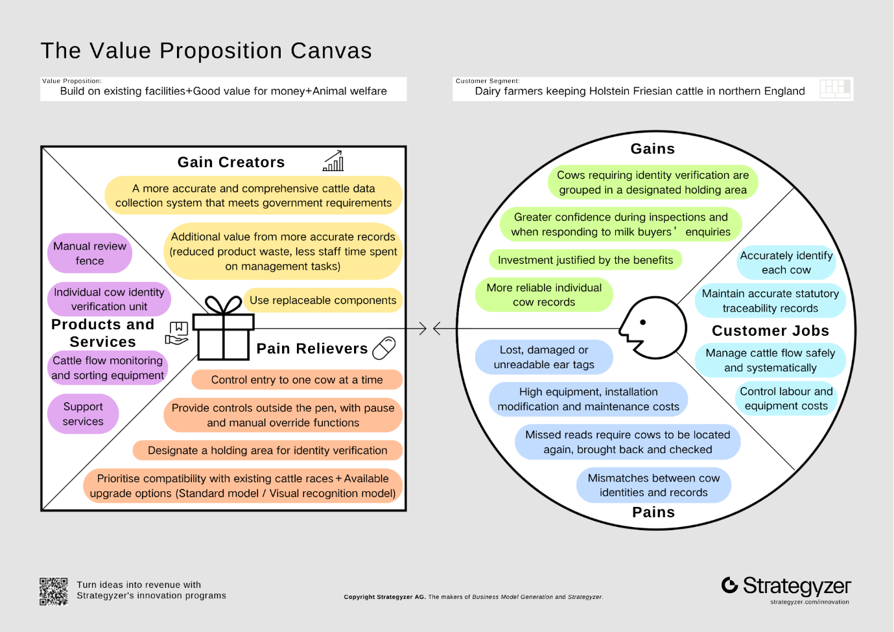

- Identifying group membership and differentiation factors (up to 1 page)
ID-Coo is designed to verify cattle identities and manage failed or uncertain reads on dairy farms with existing handling races. The comparisons below identify shared capabilities (points of parity, POP) and proposed differences (points of difference, POD).
Table 1 ID-Coo and Datamars Dairy Drafter
Comparison | ID-Coo concept | Datamars Dairy Drafter
POP | EID reading, conditional diversion and passage records. | EID-based drafting and confirmation of animals seen/drafted; standalone EID operation. [13]
POD | Links an uncertain passage, blank identity, manual review and confirmed exit under one event ID; this may help reconcile unresolved identities. (Section 10) | Already offers “No ID draft” for unidentified animals. [14] The reviewed sources do not establish an equivalent complete event/change history; this is unknown, not an absent feature.
Table 2 ID-Coo and DeLaval sort gates
Comparison | ID-Coo concept | DeLaval sort gates
POP | Routes animals according to a decision, with manual takeover. | Offers automatic or manual destination selection for groups or exceptions. [15]
POD | Separates no-read, unclear attribution and equipment fault, retaining the event for review; this may prevent treating every failed read as tag damage. (Section 10) | Public description emphasises group/exception routing. Detailed handling of uncertain identity is not established; the Australian page does not confirm UK configurations. [15]
Table 3 ID-Coo and GEA DairyNet Sorting
Comparison | ID-Coo concept | GEA DairyNet Sorting
POP | Rule-based diversion and passage/exit records. | Sorting areas, rule sets, commands and an animal-specific sorting journal. [16]
POD | Version 1 specifies local event storage and audited export without a full herd-management platform; this may suit a focused retrofit. (Section 10) | Sorting requires the Herd module and an active subscription. [16] Offline capability and total installed cost remain unverified.
Reading, diversion and logging are shared capabilities, and diversion of unidentified cows is already offered by competitors [14]. ID-Coo’s proposed difference is a single record linking an uncertain reading, subsequent review and confirmed exit (Section 10).

- More on competition analysis (up to 2 pages)
Porter’s Five Forces
Threat of new entrants — medium. RFID readers, PLCs, sensors, and mechanical gates can be sourced as separate components, so a new firm does not need to invent every part. However, a credible farm system must combine animal handling, safe gate control, correct assignment of RFID readings, installation, training, and after-sales support. The competitor pages show that established suppliers sell an integrated product and support package rather than a reader alone. [13], [15], [16] Version 1 should therefore use an existing race where possible, define operating and safety states clearly, and build a staged validation and service process before expanding into a complete herd-management platform.
Bargaining power of suppliers — medium. The design depends on RFID equipment, antennas, occupancy sensors, gate hardware, drives, safety devices, and a controller. The XRP2 documentation shows that antenna placement, metal, and the single-animal read zone affect performance, while mechanical suppliers define the available race dimensions and gate clearances. [4], [17], [18] Components can be substituted, but changes require reassessment of RFID reading performance, safety and installation. ID-Coo should specify interfaces and operating limits rather than lock the report to an unconfirmed component bill of materials. A second-source plan and site acceptance tests are more useful than an unsupported claim of supplier independence.
Bargaining power of buyers — high. A dairy farm can defer purchase, continue with visual identification, buy a handheld or fixed reader, or select an integrated drafting platform. Datamars, DeLaval, and GEA already present different combinations of sorting, records, integration, and support. [13], [15], [16] A buyer can also compare the proposal with the cost of existing staff time, which makes the planned £18,500 installation plus £720 annual service and £60 energy assumptions sensitive to the farm’s scale and use. ID-Coo must therefore demonstrate measured labour savings against the total cost for a representative farm.
Threat of substitutes — high. Manual visual identification, handheld RFID, fixed RFID, mechanical sorting races, and mature drafting systems can each complete part or all of the customer task. [4], [13], [17], [18] A substitute does not need to match every ID-Coo feature; it only needs to be acceptable for the farm’s volume, risk, and budget. ID-Coo should therefore focus on the narrow outcome of resolving failed or uncertain reads and recording how each case was handled, while remaining compatible with manual takeover and existing handling infrastructure. It should not claim to replace all herd-management functions.
Rivalry among existing competitors — medium to high. Established suppliers already advertise automatic drafting, destination rules, animal-specific journals, and integration or support. [13], [15], [16] Automatic diversion itself is therefore a weak basis for differentiation, and an unreported competitor feature must remain unknown rather than being treated as absent. ID-Coo should compete on the completeness of its records: each passage should remain linked to its identity status, reason for review, operator action and confirmed exit. Any claim of improved performance requires farm trials.
Course knowledge: L03 pp. 7–22 — Porter’s Five Forces; each paragraph follows evidence → judgement → product decision.

原版：
Strengths (internal). ID-Coo separates an event ID from the official identity, preserves raw and de-duplicated reads, records planned and confirmed exits, classifies exceptions, stores locally, and provides controlled manual takeover. These capabilities are specified in R10 rather than inferred from a vendor page. [20]
Weaknesses (internal). The concept has not yet proved automatic first-animal separation, neighbour-read control, throughput, or net labour saving. Staff still confirm single-animal entry in Version 1; ultrasonic sensing cannot prove animal count; and an unresolved identity requires manual review. These limits must be designed into the operating procedure and validation plan, not hidden behind words such as “smart” or “reliable”. [20]
Opportunities (external). Traceability work is becoming more digital, LF electronic identification is already available as a practical farm technology, and farms with an existing race may prefer a bounded retrofit to a complete platform. The R8 draft therefore prioritises reliable identity attribution, clear anomaly classification, safe handling, local operation, maintainability, and quantifiable benefit. [17], [18], [21]
Threats (external). Datamars already documents no-ID drafting; DeLaval and GEA offer established sorting and logging combinations; mature suppliers can bundle hardware, software, installation, and support; and a farm may face cash-flow, maintenance, and training constraints. [13]–[16]
The interaction is decisive. Local records and an explicit review path can use the opportunity for digital traceability, while reuse of the existing race can reduce the scope of a retrofit. Conversely, unvalidated separation and continued manual review amplify the threat from mature integrated systems. The product response is to make exceptions visible, stop intake when the state is unsafe, keep the first version interoperable through audited export, and measure net labour rather than assume it.

修改版：
SWOT
Strengths (internal). ID-Coo separates an event ID from the official identity, preserves raw and de-duplicated reads, records planned and confirmed exits, classifies exceptions, stores records locally, and provides controlled manual takeover. These are proposed design features described in Section 10, not demonstrated performance.
Weaknesses (internal). The concept has not yet proved safe automatic separation at entry, control of neighbouring-tag reads, throughput, or net labour savings. Staff still confirm single-cow entry in Version 1; ultrasonic sensing cannot prove animal count; and an unresolved identity requires manual review. The operating procedure and validation plan must account for these limitations (Section 10).
Opportunities (external). Traceability work is becoming more digital, LF electronic identification is already available as a practical farm technology, and farms with an existing race may prefer a retrofit focused on identity verification to a complete platform. Section 8 therefore prioritises reliable identity attribution, clear anomaly classification, safe handling, local operation, maintainability, and quantifiable benefit. [4], [17]
Threats (external). Datamars already documents no-ID drafting; DeLaval and GEA offer established sorting and logging combinations; mature suppliers can bundle hardware, software, installation, and support; and a farm may face cash-flow, maintenance, and training constraints. [13], [14], [15], [16]
These findings favour a focused retrofit with clear exception handling. Local records and a clear review process suit farms that need better traceability without replacing their handling facilities. However, unvalidated separation and continued manual work make mature integrated systems strong alternatives. Version 1 must therefore record unresolved cases, pause unsafe operation, support auditable export and demonstrate net labour savings.

- Product/Service Analysis and competition – unique selling point. (1 sentence)
What is the unique selling point of your solution? Based on your analysis what is important to communicate to your customer base?

For Northern England Holstein-Friesian dairy farms with an existing handling race, ID-Coo keeps each passage event, its uncertain or verified identity, manual review, and confirmed exit together so that operators can resolve unread, multiple, or uncertain passages without silently assigning an identity, when the system is used with its planned review path and staged validation.
修改版：
For Holstein–Friesian dairy farms in Northern England with an existing handling race, ID-Coo links each passage, its identity checks, any manual review and the confirmed exit in one record, helping staff resolve failed or uncertain reads without guessing the cow’s identity.
7
- Fill in the business canvas (A3 sheet or murals generated – it needs to be legible)

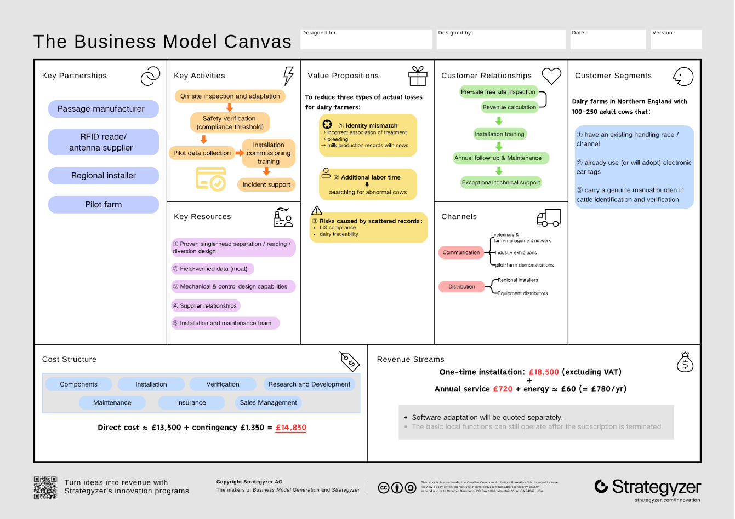
- Critical analysis (up to a page)
8.1 Market size
The target customers are dairy farms in Northern England with an existing handling race, electronic tags and a genuine verification burden. Neither AHDB’s 6,850 Great Britain dairy producers [22] nor Defra’s 1.849 million UK dairy cattle [23] states the Northern England farm count directly.
This report therefore estimates it from Defra 2024 regional data [24]: total farms (agricultural area ÷ average farm size) multiplied by the dairy share of holdings gives ≈1,240 (North West), ≈406 (Yorkshire & the Humber) and ≈63 (North East), totalling ≈1,700 farms. This is an estimate derived from official data, not a published figure, and carries uncertainty.
8.2 Serviceable share and sales target
Applying the screening criteria (existing race, tags, high verification burden), an assumed 40% are serviceable, giving a serviceable available market (SAM) of ≈680 farms. The 40% is a scenario assumption, not yet validated by customer survey.
Three-year sales of 50 units would represent ≈2.9% of TAM and ≈7.4% of SAM — a sales target, not a market forecast.
8.3 Alignment of desirable attributes with customer needs
Six desirable attributes underpin the value proposition, each technically grounded and matched to a customer need:
• Reliable identity attribution (mechanical separation + ultrasonic occupancy sensing + LF RFID) — resolves missed reads, double reads and transcription errors
• Clear anomaly classification (two-exit conditional diversion + event records) — resolves unread, multiple or uncertain passages without silently assigning an identity
• Safe handling (fence-side operation + safety control) — enables safe handling outside the pen
• Local operation — copes with network outages, preserving records
• Maintainability — mitigates maintenance-cost uncertainty
• Quantifiable benefit — makes investment verifiable against economic return
The first two attributes address the brief’s core failure modes (two IDs read at once; complete miss) and form the technical foundation of the value proposition.
8.4 Customer–product fit and necessary adjustment
The segment matches the product’s capability boundary — ID-Coo depends on an existing race, tags and a verification burden — so the criteria reflect genuine fit, not arbitrary choice; small herds, very-low-anomaly farms, or those with mature systems are excluded.
One implementation adjustment remains: per-head isolation may bottleneck throughput and first-time safe separation is unvalidated, so the first version of ID-Coo uses manual confirmation of single-animal entry, with automation only after validation. This limits the level of automation without changing the value proposition. Overall, commercial viability depends on validating safe separation, RFID attribution, exit consistency and net benefit.

- User requirements and justifications (up to 1 page)
Section 8 identifies reliable identity attribution, clear exception outcomes, safe handling, local continuity, maintainability and measurable value as the attributes customers need. The following ten user requirements state the outcomes the product/service must deliver. Each is a MoSCoW Must have. Section 10 describes the proposed design.
UR1: The system must link each passage to the correct cow when a valid electronic identifier is available. A wrong identity can corrupt treatment and herd records, making reliable attribution essential to the problem defined in Section 2.
UR2: The system must never guess an identity. Where an identifier cannot be read or confirmed, the passage must be held as unconfirmed and passed to staff for review, pausing intake if that review cannot be completed safely. Tags can be lost or unreadable [3], [6]; a guess would repeat the very record error this system exists to remove.
UR3: The system must not record cattle passing together or closely following as one confirmed animal. Otherwise a neighbouring identifier could be attributed to the wrong cow, undermining the identity assurance required in Section 8.
UR4: Staff must be able to operate, stop and take over the process without entering the cattle path. Cattle handling presents injury risks [24], so external control is needed for routine use.
UR5: The system must confirm the exit actually taken and record each passage as one complete, truthful event. A late reading or an incorrect route must not leave an apparently complete but false event record.
UR6: The service must continue essential identity checks and preserve passage and exception records during network outages. Farm handling cannot depend on continuous connectivity, and lost records would prevent later review.
UR7: The service must provide auditable identity, time, exception and route records while distinguishing internal passages from reportable cattle movements. Farmers need usable evidence without mistaking on-farm sorting for a statutory movement [8], [25].
UR8: The service must process 200 cattle within 90 minutes in the pilot, including repeated reads and reviews, without excessive queuing. Otherwise the checks would delay normal handling; Section 8 identifies per-head processing as a possible bottleneck.
UR9: The system must remain dependable after routine cleaning and allow faults to be recognised and resolved without prolonged downtime in wet, dirty farm conditions. Frequent interruptions would make daily use impractical.
UR10: The installed product and ongoing service must provide a measurable net benefit relative to total ownership cost. Farms need to justify the investment through actual labour savings and operating costs, as Section 8 notes.

- Provide a technical description of the solution e.g. sensor placement, data aggregation, functional block diagram, description of software, interfaces, and pricing to be submitted to your line manager. (up to 4 pages)
Please ensure that it makes sense and the design is logical. If you use flow diagrams or schematics make sure they follow standard practice. Remember also that it should align with what you have proposed as well as the price point for your technology. Furthermore, it should describe everything from the physical structure in which cows go through to the equipment used, circuit, algorithm, and/or machine learning used as well as interfacing with the LIS and the farmers user interface.

10.1 Physical structure
ID-Coo uses a single-file race: holding area → gate G0 → buffer A → gate G1 → detection section B → gate G2. Gate D then directs the cow either back to the herd or, through gate H, into the review pen (Figure 1). Both exits lead forward; D guides rather than pushes the animal.
ID-Coo has one buffer and one detection section. More upstream sections would add waiting space, not speed to the read-and-divert cycle, while adding gates and faults. Adjustable alleys about 526–800 mm wide, with 8 ft and 10 ft modules, indicate a structural envelope [16], [17]. A backing stop may help with reversal but cannot replace the separating gate.
CIGR gives a 650–749 kg Holstein–Friesian cow a withers height of 1.44 m, body length of 1.75 m and chest width of 0.60 m [18]. A field study of 1,054 cows reports a mean withers height of 1.411 m and trunk length of 1.708 m [19]. These guide section length, clear width and antenna height. A farm survey must confirm final dimensions and gate swings; a standard module does not necessarily hold one cow. Other breeds require a fresh dimensional check.
The race requires non-slip drainage, no sharp projections, guarded tracks and hinges, safe head and leg clearances, and continuous exit boundaries [20]. Staff operate from outside; head restraint is optional. (UR4, UR8, UR9)
The review pen temporarily holds cows for manual identity checks; it is not for disease isolation. It needs an anti-return entrance, separate handling exit and outside operating space. Gate H closes only after the cow passes. A full pen or blocked branch stops intake.
Capacity follows C ≥ λq × th + Cm (exception rate × handling interval + margin). Because this is an average-load relation, the pen also needs full-pen monitoring. The budget assumes reuse of an existing pen for roughly six cattle. CIGR generally recommends capacity for one parlour side but excepts sorting at the parlour exit. Holding pens should provide water, feed and lying space [18]; the site survey must confirm capacity and facilities.
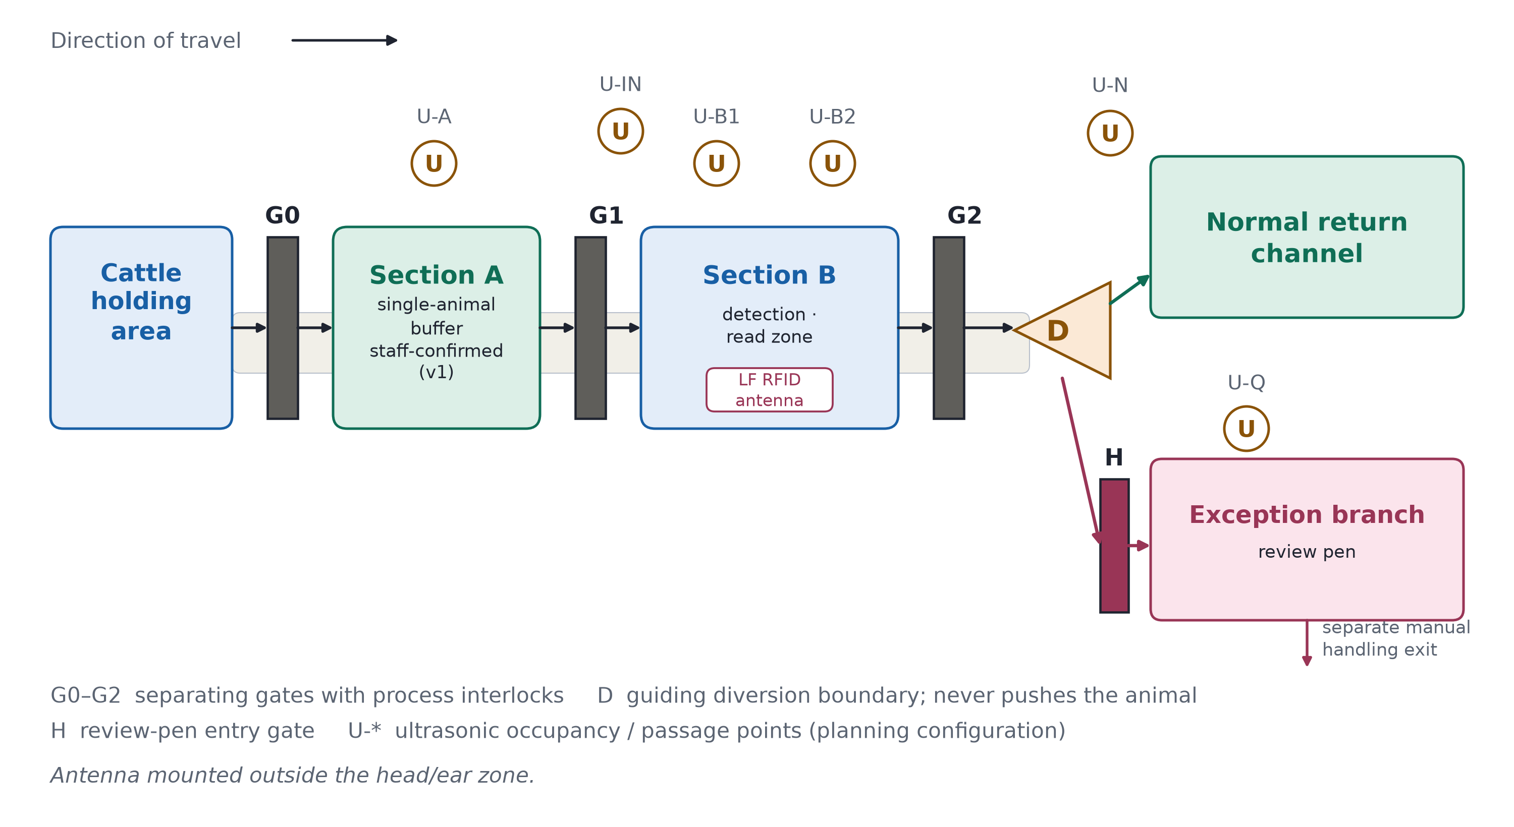
Figure 1 — Race and diversion functional layout

10.2 Sensing equipment and capability boundaries
An LF RFID reader scans LF EID tags where fitted using ISO 11784/11785, HDX and FDX-B. Cattle without an LF EID tag follow manual identity verification or an alternative workflow; an absent read alone does not diagnose tag damage [1]. Tru-Test XRP2/XRP2i is a functional reference; the final reader and antenna position outside B's head-and-ear zone depend on the site survey [4], [21].
Six planned ultrasonic points (U-A, U-IN, U-B1, U-B2, U-N, U-Q) monitor occupancy and passage; top-down mounting is assessed first for U-B1/U-B2. Distance, d = c × Δt / 2, is compared with an empty-race baseline. Each point reports *empty*, *occupied* or *uncertain*. No echo, stale data or a fault means *uncertain*; one echo cannot prove that only one cow is present [22].
Manufacturer-supported staggered transmission will be evaluated to limit crosstalk [23]. Six points are provisional; blind spots at entry or diversion require additional coverage.
An antenna may read a neighbouring tag even when one cow occupies B. The trial must therefore establish read attribution rather than infer it from a closed gate (Section 10.7). Cracked but readable tags and missing non-electronic tags still need visual inspection. (UR1–UR3, UR9)
10.3 Control hardware, electrical and safety
Figure 2 shows functional interfaces, not construction wiring. Voltage, drive rating, cable protection and earthing depend on the chosen equipment and site. The PLC sends motion requests directly to the gate drives. Separately, safety-related control monitors risk-assessed protection devices and can stop or inhibit the drives independently; software and data interfaces cannot bypass it. Site-selected enclosures, connectors and cables must withstand wash-down, ingress and corrosion; operation is checked after routine cleaning. (UR9)
Safety functions and required performance levels follow a site risk assessment using general functional-safety methods; no achieved level is claimed. Mechanical guards and validated obstruction responses protect the gates. Ultrasonic points alone cannot provide anti-pinch protection.
On power loss, hazardous movement stops and each gate holds a defined state; a short backup saves the event and signals the fault. Staff can release cattle from outside. On restart, the controller verifies gate positions and occupancy rather than resuming interrupted motion. Training and inspection follow HSE guidance [24]. (UR4, UR5)
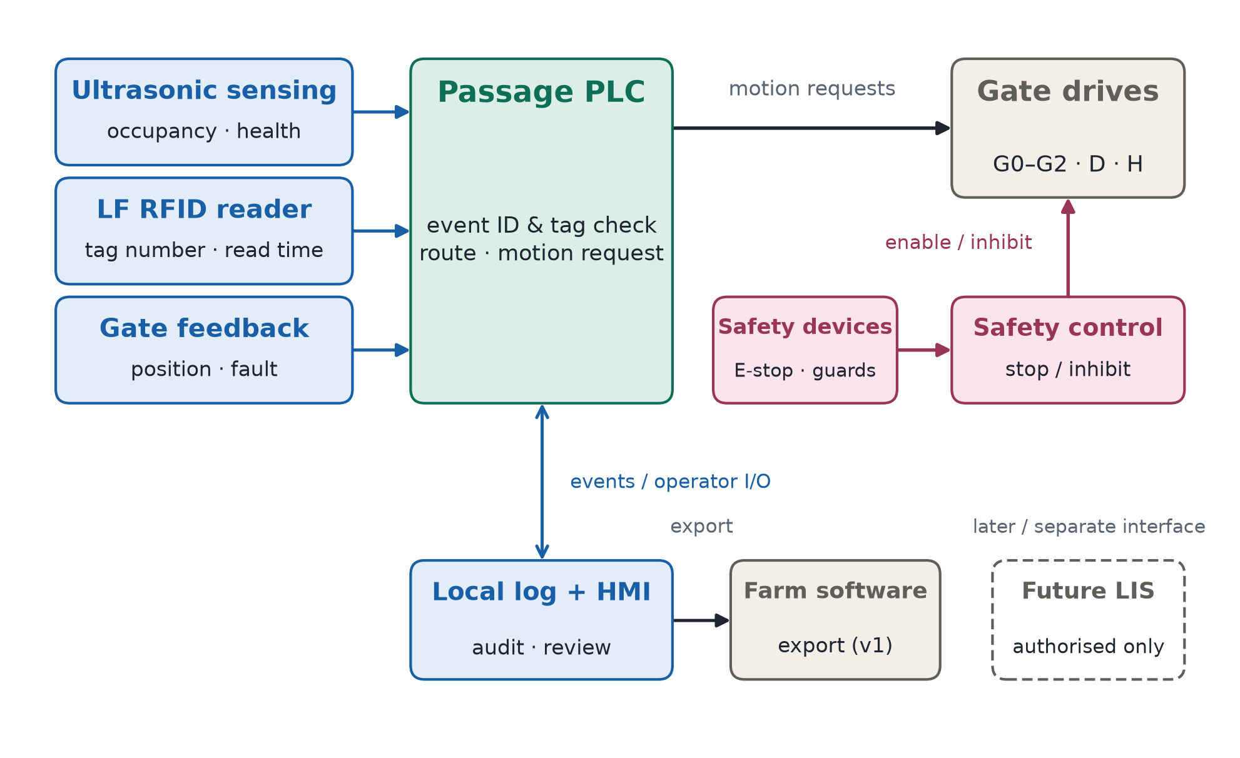
Figure 2 — Functional control, safety and data interfaces
10.4 Control algorithm and diversion logic
A rule-based state machine handles each passage separately; Version 1 needs no machine learning. Staff confirm one cow in A, after which the controller admits her to B, reads the tag, sets the exit and confirms the route taken.
Process interlocks keep G0/G1 and G1/G2 from opening together. Scanning requires both B gates closed, a cow in the read zone and no suspected follower. D must be positioned before G2 opens and cannot move while its path is occupied. Sensors and gate feedback confirm exit; a timer alone cannot.
Late reads remain with their original event and cannot redirect the next cow. Process interlocks do not prove safe first entry, so Version 1 retains staff confirmation and counts that time in its economics. Automatic entry requires prior validation of separation, anti-pinch protection and exception handling.
An unread cow retains an event ID while in B. Uncertain mechanical state stops automatic diversion; consecutive no-reads trigger reader diagnostics before a whole group can be misdirected. (UR1–UR5)
10.5 Data, software and the farmer interface
Each event records its ID, timing, occupancy and gate state, raw and de-duplicated reads, device status, decision reason, planned and actual exit, operator and edit history.
Event ID and official identity remain separate. If no tag is read, identity stays blank until staff verify it; the original exception and later link remain auditable. If official visual identifiers also fail, staff follow the official procedure, and no identity is entered without official confirmation.
The farmer interface distinguishes electronically verified, pending identity review, equipment/race fault and manually resolved. It shows the active event, pen load, open cases and maintenance record, with access-controlled manual actions. A reader fault never appears as a damaged-tag diagnosis. (UR5–UR7)
10.6 LIS and farm-software interface
ID-Coo stores records locally and exports them for audit; direct LIS access is not assumed. If specifications and authorisation become available, an adapter will separate internal passages from reportable movements, validate fields, retain submissions and receipts, prevent duplicates, and reconcile after outages [1], [8], [25].
The interface shows locally saved, pending, failed and receipt-confirmed states. Changes to official identity and statutory submissions require human approval. (UR6, UR7)
10.7 Pricing, throughput and validation
The planned installed price is £18,500 excluding VAT and major civil works, plus £720/year service and an assumed £60/year electricity (Section 12). It assumes reuse of the existing race and review pen, while covering sensors, gates and safety equipment. Payback is recalculated using final quotations, service and energy costs, and measured net labour savings. (UR10)
Target throughput is 150 head/hour (about 24 seconds per cow for entry, gates, reading and handling). The trial requires 200 cows in 90 minutes (about 133 head/hour), including retries and reviews. If unmet, the site or flow changes; safety checks do not. (UR8, UR10)
Trials report confirmed-read accuracy against a provisional ≥99.5% target and coverage separately, plus wrong diversions, exceptions, actual versus planned exits, takeovers and net labour time. Repeated passages by one herd are not independent animals; zero observed errors is not zero risk. Safe separation, read attribution and release precede economic validation. (UR1–UR10)

- Sustainable development (up to half a page)
Explain how your solution is built for sustainability by discussingyou’re your design aligns with the dairy roadmap https://www.dairyuk.org/wp-content/uploads/2021/11/Dairy-Roadmap-Climate-Ambition-Final-Version.pdf. Provide technical details in line with your design and critically assess the suitability of your design in line with the principles mentioned (do you need to revise your technical description to align your design to the sustainable development roadmap).

The Dairy Roadmap calls for evidence-led progress towards net-zero CO₂ and sustained CH₄/N₂O reductions; its 2030 ambitions also prioritise reliable farm-efficiency and animal-welfare data, renewable electricity and waste recovery [23], [26]. ID-Coo supports these objectives through resource-efficient cattle identification, rather than claiming to reduce methane directly. Designed as a retrofit, it retains the farm's existing handling race and EID tags while adding modular LF-RFID, ultrasonic monitoring and gate-control units. Repairable mechanisms and replaceable sensors limit unnecessary equipment disposal.
To strengthen this approach, the specification includes low-standby-power controls, shutdown between handling sessions and metering in kWh per passage; the system can operate using renewable electricity where supplied [26]. Passage records combine the EID read with occupancy signals, gate states and confirmed exit, helping farmers investigate exceptions without repeatedly searching a whole group. Controlled single-cow entry, smooth gate movement, safe release and a dedicated manual-review route also put animal welfare into the operating sequence, reflecting HSE guidance on cattle handling [27] and published research on dairy-cow stress [28]. Together, infrastructure reuse, long-life components, energy monitoring and more traceable handling provide a practical contribution to the Roadmap's environmental and welfare goals.

- Affordability (up to half a page)
Justify how much your product/service mix will cost for installation and a recurring service fee. Is that in line with the financial means of your customers? Justify your answer.

ID-Coo targets Northern England dairy farms that already have a handling race and EID tags but incur labour costs when individual reads are missed or attributed incorrectly. Retrofitting those assets avoids purchasing an entirely new race, while the course stresses balancing robustness, reliability and affordability [29] and assessing value through quality, service and price [30]. The preliminary installed budget is £18,500 excluding VAT and major civil works: £13,500 for race modifications, five gate mechanisms, LF-RFID, six ultrasonic points, PLC/safety controls and setup; £1,350 contingency; and £3,650 for development, warranty and overheads, not realised profit [31]. Allowing £720 per year for servicing and £60 for electricity gives a five-year ownership budget of £22,400.
Defra reports average English dairy Farm Business Income of £153,800 for 2024/25 [22], so installation is about 12.0% of this benchmark. For a more useful business test, AHDB advises including full economic costs [32]. In an illustrative high-use case, saving one net staff-hour each day at £18/hour yields £6,570 annual labour value, or £5,790 after annual charges, corresponding to a 3.20-year simple payback; roughly 41 minutes saved daily would cover the five-year budget. Research on other dairy automation also shows why returns should be assessed for the specific farm [33]. This positions ID-Coo most strongly for farms with frequent verification work, consistent with the course's warning that income alone is an imperfect basis for customer segmentation [34].

References (use the IEEE format)
You also need to add a reference section (I would expect an assignment to have between 15-30 references)
[1] https://www.gov.uk/government/publications/livestock-information-transformation-programme-litp/livestock-information-transformation-programme-litp
[2] https://www.gov.uk/government/news/electronic-id-for-cattle-mandatory-in-step-forward-for-uk-biosecurity
[3] https://www.ars.usda.gov/research/publications/publication/?seqNo115=273768
[4] https://sciencesearch.defra.gov.uk/ProjectDetails?ProjectId=21689
[5] https://sefari.scot/research/projects/sheep-and-cattle-traceability-the-impact-of-environmental-other-factors-in
[6] https://www.gov.uk/guidance/get-new-or-replacement-official-ear-tags-for-cattle
[7] https://www.legislation.gov.uk/uksi/2007/529/contents
[8] https://www.gov.uk/guidance/report-and-record-cattle-movements
[9] https://ahdb.org.uk/knowledge-library/how-to-monitor-the-performance-of-a-dairy-diet
[10] https://www.gov.uk/government/publications/milk-hygiene-and-antibiotic-residues/information-and-guidance-on-the-testing-of-milk-for-antibiotic-residues
[11] https://assets.publishing.service.gov.uk/media/68d563169ce370a7e0a0fcfe/Godfray_bTB_Evidence_Review_Update_2025.pdf
[12] https://www.gov.uk/government/consultations/changes-to-bovine-identification-registration-and-movement-in-england/outcome/summary-of-responses-and-government-response
[13] Datamars Agri UK Ltd., “Dairy Drafter.” Accessed: Oct. 17, 2026. [Online]. Available: https://www.datamars.co.uk/dairy-drafter
[14] ID-Coo project team, “R10 Technical description of the solution,” ID-Coo course project, unpublished internal concept design document, 2026.
[15] Datamars Livestock, “Drafting (sorting) animals with no IDs,” Datamars Livestock Knowledge Base. Accessed: Oct. 17, 2026. [Online]. Available: https://support.livestock.datamars.com/en/articles/11933948-drafting-sorting-animals-with-no-ids
[16] DeLaval, “Sort gates,” DeLaval Australia. Accessed: Oct. 17, 2026. [Online]. Available: https://www.delaval.com/en-au/farm-solutions/milking-essentials/sort-gates/
[17] GEA, “DairyNet Sorting module.” Accessed: Oct. 17, 2026. [Online]. Available: https://www.gea.com/en/products/milking-farming-barn/gea-herd-management/gea-dairynet/module-sorting/
[18] Tru-Test, “XRP2 Panel Reader and Antennas.” Accessed: Oct. 17, 2026. [Online]. Available: https://us.tru-test.com/products/eid/xrp2-panel-reader-and-antennas
[19] Datamars Ltd., “XRP2 Panel Reader and Antenna Quickstart Guide.” Accessed: Oct. 17, 2026. [Online]. Available: https://us.tru-test.com/resources/xrp2-panel-reader-quickstart-guide-enesptfrde
[20] Arrowquip, “Cattle Sorting Race,” Arrowquip UK. Accessed: Oct. 17, 2026. [Online]. Available: https://arrowquip.co.uk/cattle-equipment/cattle-races/cattle-sorting-races/
[21] ID-Coo project team, “Cattle identity verification and exception diversion system for Northern England dairy farms,” unpublished internal course report draft, sec. 8, “Critical analysis,” 2026 (in Chinese).
[22] AHDB, "GB producer numbers," updated 11 June 2026. [Online]. Available: https://ahdb.org.uk/dairy/gb-producer-numbers
[23] Defra, "Livestock populations in the United Kingdom at 1 June 2025." [Online]. Available: https://www.gov.uk/government/statistics/livestock-populations-in-the-united-kingdom/livestock-populations-in-the-united-kingdom-at-1-june-2025
[24] Defra, "Agricultural facts: England regional profiles," 30 Oct. 2025. [Online]. Available: https://www.gov.uk/government/statistics/agricultural-facts-england-regional-profiles
以上是到R8的引用

R11和R12引用：
[22] Department for Environment, Food & Rural Affairs (Defra), “Farm Business Income by farm type in England 2024/25,” GOV.UK, updated Sep. 8, 2026. [Online]. Available: https://www.gov.uk/government/statistics/farm-business-income/farm-business-income-by-farm-type-in-england-202425. [Accessed: Oct. 18, 2026].
[23] Dairy UK, “UK Dairy Roadmap announces historic net zero climate ambition,” Nov. 1, 2021. [Online]. Available: https://www.dairyuk.org/blog/uk-dairy-roadmap-announces-historic-net-zero-climate-ambition/. [Accessed: Oct. 18, 2026].
[26] The Dairy Roadmap, “The Dairy Roadmap,” 2024, pp. 3–4, 7. [Online]. Available: https://dairyroadmap.co.uk/wp-content/uploads/2024/08/17.-Dairy-Roadmap-Overview-2024.pdf. [Accessed: Oct. 18, 2026].
[27] Health and Safety Executive, “Handling and housing cattle,” Agriculture Information Sheet AIS35 (rev. 1), 2012, pp. 1–2. [Online]. Available: https://www.hse.gov.uk/pubns/ais35.pdf. [Accessed: Oct. 18, 2026].
[28] V. Jurkovich, P. Hejel, and L. Kovács, “A review of the effects of stress on dairy cattle behaviour,” Animals, vol. 14, no. 14, art. 2038, 2024, doi: 10.3390/ani14142038. [Online]. Available: https://doi.org/10.3390/ani14142038.
[32] Agriculture and Horticulture Development Board (AHDB), “Trimming costs on your dairy farm.” [Online]. Available: https://ahdb.org.uk/reduce-costs-on-your-dairy-farm. [Accessed: Oct. 18, 2026].
[33] A. H. Adenuga, C. Jack, K. O. Olagunju, and A. Ashfield, “Economic viability of adoption of automated oestrus detection technologies on dairy farms: A review,” Animals, vol. 10, no. 7, art. 1241, 2020, doi: 10.3390/ani10071241. [Online]. Available: https://doi.org/10.3390/ani10071241.

