**Leap Walking**

C. List, D. Neupert

**Abstract**

It is our goal to implement an application, where a character will be controlled by the hand of the user. Two of his fingers are mapped to the legs of the in-game character. We want to find out, if the fingers can be mapped properly to the body and if this interaction technique feels natural to the user. To test our approach, we want to develop a simple jump-and-run-game, where the character, depending on the hand posture, runs, jumps, kicks or ducks.

**Related Work**

Noah Lockwood, Karan Singh (2012) **Motion Editing with Contact Based Hand Performance.** In: SIGGRAPH.

In this research the authors described a system where they used two fingers to pantomime leg movement. The idea was to create full-body animations based on the data they received from a touch-sensitive tabletop when a user “walked with their fingers”.

There are several differences to our idea. We collect the data using a LeapMotion, as so, we not only get the data of the finger tips, but from all the joints in the users hand. This gives us the opportunity to add multiple movements to our application instead of only using the walking movement. Also, instead of only using the data to generate animations, we use it to control a character in a game to find out how natural this interaction method feels to the user.

**Scenario and Methods**

To find out if our interaction technique is valid, we think a game is the best testing-environment. For a start we define four gestures, which are equivalents to four character-movements. The user has to place his hand over the leap motion. His index and middle finger should touch the the “ground” which is represented by a cardboard.

**Walking**

To walk, the user has to lift up one of the “legs” (index or middle finger) slightly.

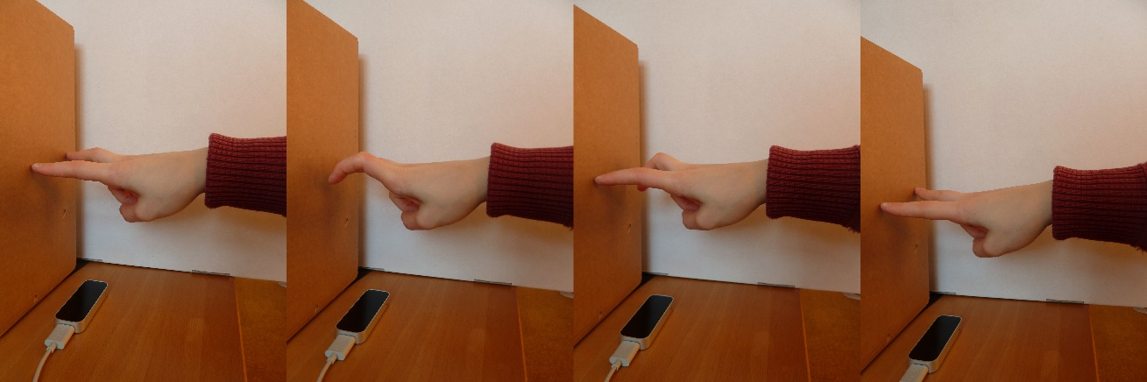

**Curves**

To pass an obstacle on the left or right side, the user has to rotate his hand to rotate the body of the character slightly, while doing the walking gesture.

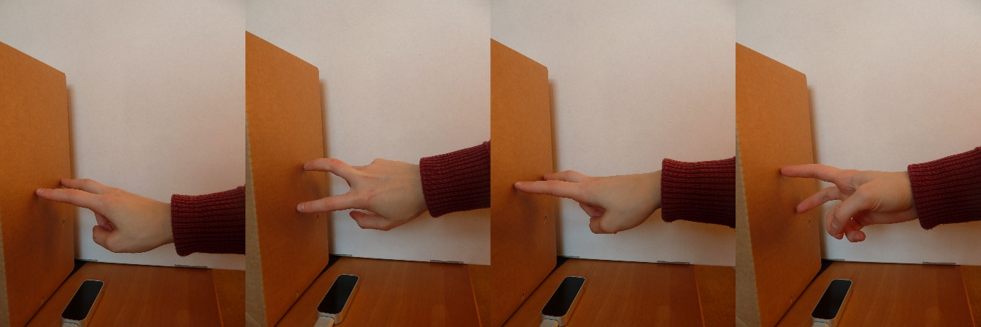

**Jumping**

For jumping the user has to lift up both “legs”, so they don’t touch the “ground” anymore.

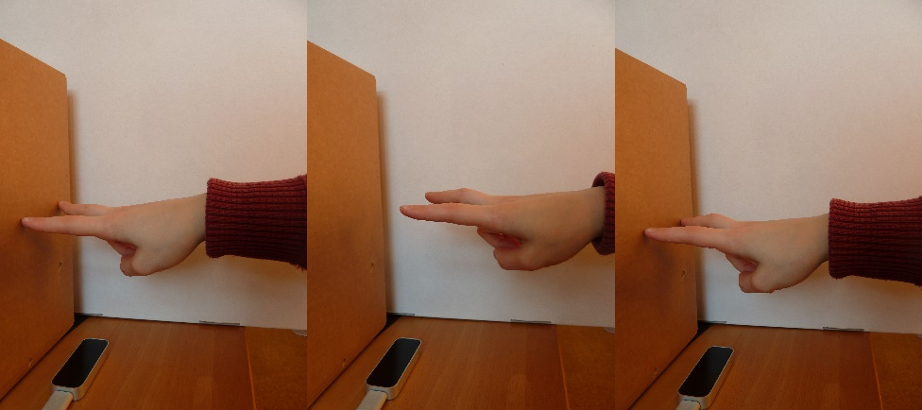

**Ducking**

To evade high obstacles, the character has to duck. To achieve this, the user moves his wrist down to the “ground”.

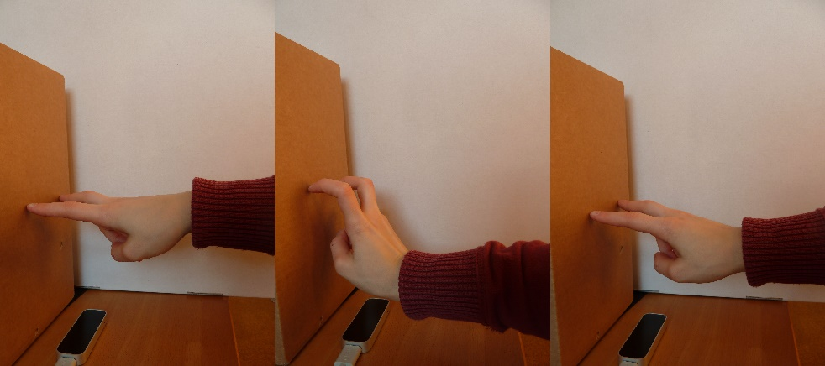

**Technical Requirements**

Detection of the index and middle finger

Recognizing the gesture (finger movement)

Hardware: LeapMotion

Software: Processing, LeapMotionForProcessing by Darius Morawiec

**Timeline**

until 15th December: Testing of possible gestures is complete, first rough prototype

until 10th January: Final prototype is complete

until 15th January: Testing is complete

until 30th January: Presentation and documentation is complete