

**A182**

**STIW2044 MOBILE PROGRAMMING**

**Lab Assignment 1**

**Student:**

GAN LIAN JIE

**Matric:**

255108

**Lecturer:**

Ahmad Hanis Bin Mohd Shabli

Java Class File

MainActivity.java

package com.example.temperature;  
  
import android.support.v7.app.AppCompatActivity;  
import android.os.Bundle;  
import android.view.Menu;  
import android.view.MenuItem;  
import android.view.View;  
import android.widget.Button;  
import android.widget.EditText;  
import android.widget.RadioButton;  
import android.widget.Toast;  
  
public class MainActivity extends AppCompatActivity {  
  
  
  
 @Override  
 protected void onCreate(Bundle savedInstanceState) {  
 super.onCreate(savedInstanceState);  
 setContentView(R.layout.*activity_main*);  
 final EditText temp = (EditText) findViewById(R.id.*temperatureEditText*);  
 final RadioButton CtoF = (RadioButton) findViewById(R.id.*cToFarenheitRB*);  
 final RadioButton CtoK = (RadioButton) findViewById(R.id.*cToKevinRB*);  
 final RadioButton FtoC = (RadioButton) findViewById((R.id.*fToCelsiusRB*));  
 final RadioButton FtoK = (RadioButton) findViewById(R.id.*fToKevinRB*);  
 final RadioButton KtoC = (RadioButton) findViewById(R.id.*kToCelsiusRB*);  
 final RadioButton KtoF = (RadioButton) findViewById(R.id.*kToFarenheitRB*);  
 final Button con = (Button) findViewById(R.id.*convertButton*);  
 final Button re = (Button)findViewById(R.id.*reset*);  
  
  
 con.setOnClickListener(new View.OnClickListener() {  
  
 @Override  
 public void onClick(View v) {  
  
  
 double value = new Double(temp.getText().toString());  
  
  
 if (CtoF.isChecked()){  
 value = UnitConverter.*celsius2Fareheit*(value);}  
 else if (CtoK.isChecked()){  
 value = UnitConverter.*celsius2Kevin*(value);}  
 else if (FtoC.isChecked()){  
 value = UnitConverter.*fareheit2Celsius*(value);}  
 else if (FtoK.isChecked()){  
 value = UnitConverter.*fareheit2Kevin*(value);}  
 else if (KtoC.isChecked()){  
 value = UnitConverter.*kevin2Celcius*(value);}  
 else {  
 value = UnitConverter.*kevin2Fahrenheit*(value);}  
  
 temp.setText(new Double(value).toString());  
 }  
  
 }  
  
 );  
 re.setOnClickListener(new View.OnClickListener() {  
 @Override  
 public void onClick(View v) {  
 if(v.getId() == R.id.*reset*)  
 temp.setText(""); }}  
 );  
 }  
}

UnitConverter.java

package com.example.temperature;  
  
public class UnitConverter {  
 //celsius to fareheit  
 public static double celsius2Fareheit(double f){  
  
 return 32+f*9/5;  
 }  
 //celsius to kevin  
 public static double celsius2Kevin(double c){  
  
 return c+273.15;  
 }  
 //fareheit to celsius  
 public static double fareheit2Celsius(double c){  
  
 return (c-32)*5/9;  
 }  
 //fareheit to kevin  
 public static double fareheit2Kevin(double f){  
  
 return (f-32)*5/9+273.15;  
 }  
 //kevin to celcius  
 public static double kevin2Celcius(double k){  
 return (k-273.15);  
 }  
 //kevin to fahrenheit  
 public static double kevin2Fahrenheit(double k){  
 return (k-273.15)*9/5+32;  
 }  
}

Activity_main.xml and layout blueprint

<?xml version="1.0" encoding="utf-8"?>  
<LinearLayout xmlns:android="http://schemas.android.com/apk/res/android"  
 xmlns:app="http://schemas.android.com/apk/res-auto"  
 xmlns:tools="http://schemas.android.com/tools"  
 android:layout_width="match_parent"  
 android:layout_height="match_parent"  
 android:orientation="vertical"  
 tools:context=".MainActivity" >  
  
 <LinearLayout  
 android:layout_width="match_parent"  
 android:layout_height="59dp"  
 android:orientation="horizontal">  
  
 <EditText  
 android:id="@+id/temperatureEditText"  
 android:layout_width="0dp"  
 android:layout_height="wrap_content"  
 android:layout_weight="1"  
 android:autofillHints=""  
 android:ems="10"  
 android:hint="@string/enter_temperature"  
 android:inputType="numberDecimal" />  
  
 </LinearLayout>  
  
 <RadioGroup  
 android:layout_width="match_parent"  
 android:layout_height="wrap_content">  
  
 <RadioButton  
 android:id="@+id/cToFarenheitRB"  
 android:layout_width="match_parent"  
 android:layout_height="wrap_content"  
 android:layout_weight="1"  
 android:text="@string/from_celsius_to_farenheit" />  
  
 <RadioButton  
 android:id="@+id/cToKevinRB"  
 android:layout_width="match_parent"  
 android:layout_height="wrap_content"  
 android:layout_weight="1"  
 android:text="From Celsius to Kevin" />  
  
 <RadioButton  
 android:id="@+id/fToCelsiusRB"  
 android:layout_width="match_parent"  
 android:layout_height="match_parent"  
 android:layout_weight="1"  
 android:text="@string/from_farenheit_to_celsius" />  
  
 <RadioButton  
 android:id="@+id/fToKevinRB"  
 android:layout_width="match_parent"  
 android:layout_height="wrap_content"  
 android:layout_weight="1"  
 android:text="From Farenheit to Kevin" />  
  
 <RadioButton  
 android:id="@+id/kToCelsiusRB"  
 android:layout_width="match_parent"  
 android:layout_height="wrap_content"  
 android:layout_weight="1"  
 android:text="From Kevin to Celsius" />  
  
 <RadioButton  
 android:id="@+id/kToFarenheitRB"  
 android:layout_width="match_parent"  
 android:layout_height="wrap_content"  
 android:layout_weight="1"  
 android:text="From Kevin to Farenheit" />  
  
 <View  
 android:id="@+id/view"  
 android:layout_width="wrap_content"  
 android:layout_height="8dp"  
 android:layout_weight="1" />  
  
 <LinearLayout  
 android:layout_width="match_parent"  
 android:layout_height="match_parent"  
 android:layout_weight="1"  
 android:orientation="horizontal">  
  
 <Button  
 android:id="@+id/reset"  
 android:layout_width="202dp"  
 android:layout_height="match_parent"  
 android:background="@drawable/custom_button"  
 android:text="RESET"  
 android:textAllCaps="true"  
 android:textColor="#FFFFFF" />  
  
 <Button  
 android:id="@+id/convertButton"  
 android:layout_width="match_parent"  
 android:layout_height="match_parent"  
 android:layout_marginLeft="3dp"  
 android:background="@drawable/custom_button"  
 android:text="CONVERT"  
 android:textAllCaps="false"  
 android:textColor="#FFFFFF" />  
 </LinearLayout>  
  
 </RadioGroup>  
  
</LinearLayo

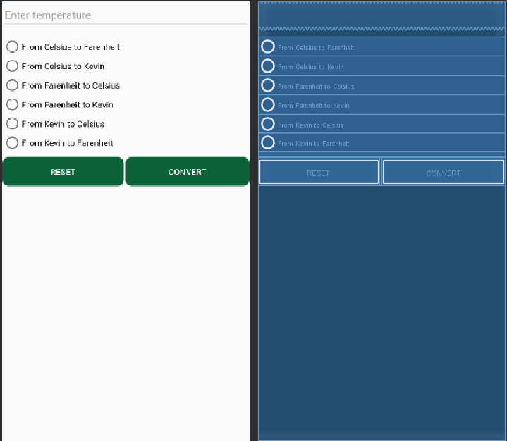

**Interface screenshot that describe input-process-output**

**1)Main Menu of the application**

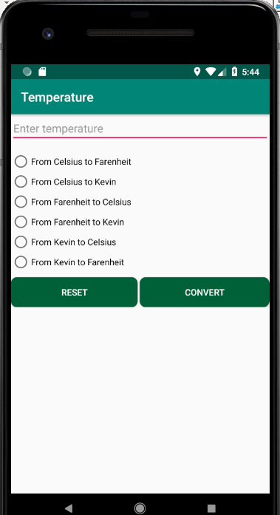

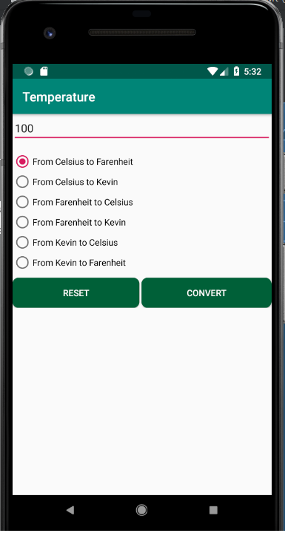**2)Insert a temperature and select the unit that you want to convert.**

**3)After click CONVERT button, the application will convert the number into the text field.**

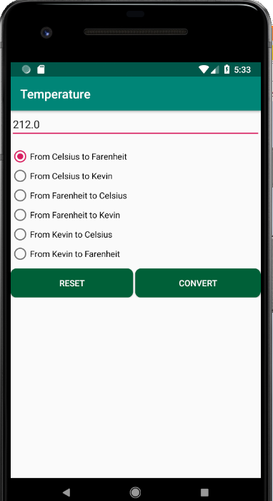

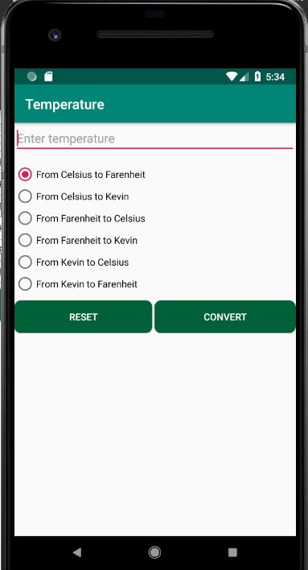**4)After Click RESET buttton, the text field will automatically reset to empty.**

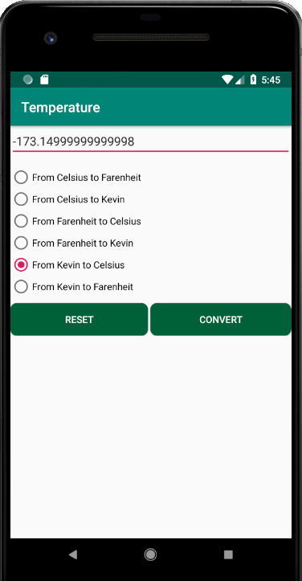**6)Another example of input-process-output**