Freight services UK to Democratic Republic Of the Congo

Shipping to DRC has never been easier, we provide competitive rates for door to port and door to door cargo service to Kinshasa. If you are international student, relocating to DRC or do business in DRC we are here to take care of all your export needs from UK to DRC.

AIRPORT TO AIRPORT
Country | City | Airport Code | +100 kg | +500 kg | +1000 kg | Handling & Documentation
DRC | Kinshasa | FIH | £6/kg | £5.80/kg | £5.60/kg | £50 per shipment
Up-to Kinshasa Airport only
Minimum weight charged is 100 kg
Transit time 3-5 days Variable
Destination charges may apply, such as taxes, airport charges etc...
This is the quickest and cheapest way to ship to DRC by air
We can arrange shipment collections from any UK address, please contact Us

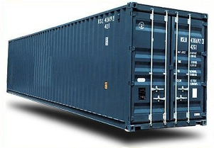 | Full container load to Port of Matadi, send us your requirements and we will revert with quote.  WhatsApp: +447375964786  Email: info@directcargoexpress.com

DRC is about the size of Western Europe, is the largest country in Sub-Saharan Africa (SSA). DRC is endowed with exceptional natural resources, including minerals such as cobalt and copper, hydropower potential, significant arable land, immense biodiversity, and the world’s second-largest rainforest. The population of DRC is 95.89 million and it's capital is Kinshasa.

