
Freight services UK to Ethiopia

Shipping to Ethiopia has never been easier, we provide competitive rates for door to port and door to door cargo service to Addis Ababa. If you are international student, relocating to Ethiopia or do business in Ethiopia we are here to take care of all your export needs from UK to Ethiopia.

AIRPORT TO AIRPORT
Country | City | Airport Code | +100 kg | +500 kg | +1000 kg | Handling & Documentation
Ethiopia | Addis Ababa | ADD | 4.50/kg | 4.25/kg | £4/kg | £50 per shipment
- Up-to Bole Airport only
- Minimum weight charged is 100 kg
- Transit time 3-5 days Variable
- Destination charges may apply, such as taxes, airport charges etc...
- This is the quickest and cheapest way to ship to Ethiopia by air
- We can arrange shipment collections from any UK address, please contact Us

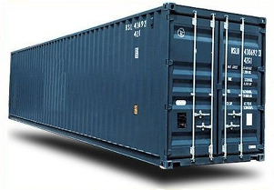 | Full container load to Modjo dry port or port of Djibouti, send us your requirements and we will revert with quote.  WhatsApp: +447375964786  Email: info@directcargoexpress.com

Ethiopia, in the Horn of Africa, is a rugged, landlocked country split by the Great Rift Valley. With archaeological finds dating back more than 3 million years, it’s a place of ancient culture. The population of Ethiopia is 120.3 million and it's capital is Addis Ababa.

