Chapter 4: Alkanes and Cycloalkanes
Organic chemistry questions. Multiple choice first within each textbook section.
Name: ______________________________ Date: ______________

4.1 Introduction to Alkanes
1. What is the general molecular formula of an acyclic alkane with n carbon atoms? [C04M01, Easy]
A) CₙH₂ₙ
B) CₙH₂ₙ₋₂
C) CₙH₂ₙ₊₂
D) CₙHₙ
2. Which compound is a saturated hydrocarbon? [C04M02, Basic]
A)  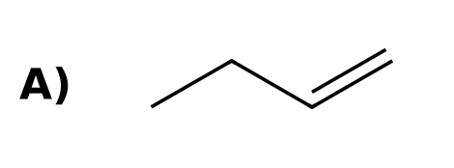 | B)  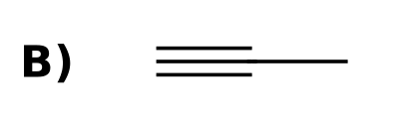
C)  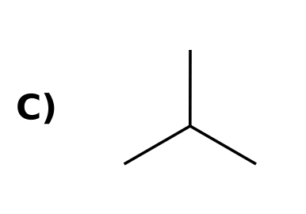 | D)  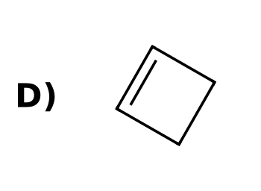
3. Give the molecular formula of the unbranched alkane that has eight carbon atoms. [C04F01, Easy]

4. How many hydrogen atoms does cyclohexane have, and why is this two fewer than hexane? [C04F02, Basic]

4.2 Nomenclature of Alkanes
5. What is the IUPAC parent name for an unbranched chain of six carbon atoms? [C04M03, Easy]
A) Pentane
B) Heptane
C) Hexane
D) Butane
6. What is the parent chain (longest chain) of the compound shown? [C04M04, Basic]
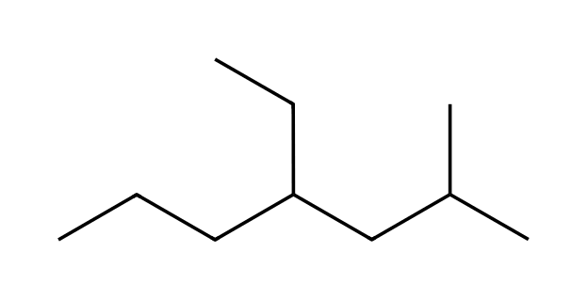
A) Heptane
B) Pentane
C) Octane
D) Hexane
7. What is the IUPAC name of the compound shown? [C04M05, Basic]
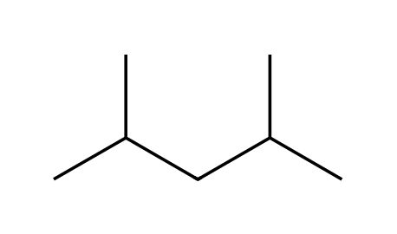
A) 2,4-dimethylpentane
B) 3,5-dimethylpentane
C) 2,4-dimethylbutane
D) 2,4-dimethylhexane
8. What is the IUPAC name of the compound shown? [C04M06, Moderate]
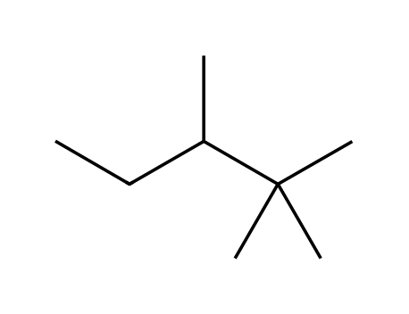
A) 2,2,3-trimethylbutane
B) 2,2,3-trimethylpentane
C) 2,3,3-trimethylpentane
D) 2,2,4-trimethylpentane
9. What is the IUPAC name of the compound shown? [C04M07, Easy]
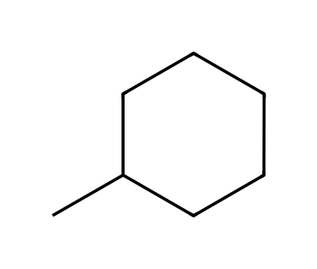
A) ethylcyclohexane
B) methylcyclohexane
C) methylcyclopentane
D) cycloheptane
10. What is the IUPAC name of the compound shown? [C04M08, Basic]
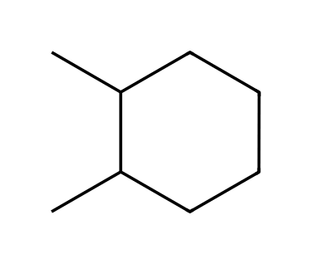
A) 1,3-dimethylcyclohexane
B) 1,4-dimethylcyclohexane
C) 1,1-dimethylcyclohexane
D) 1,2-dimethylcyclohexane
11. What is the IUPAC name of the compound shown? [C04M09, Moderate]
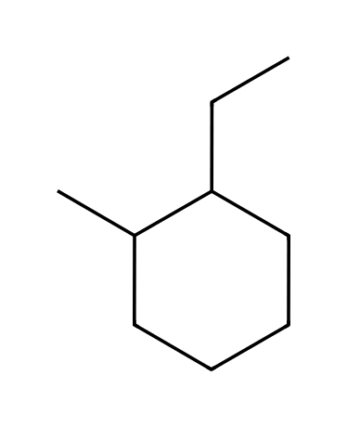
A) 1-ethyl-3-methylcyclohexane
B) 1-ethyl-2-methylcyclohexane
C) 1-ethyl-4-methylcyclohexane
D) 1-ethyl-1-methylcyclohexane
12. Which structure is 4-ethyl-2-methylhexane? [C04M10, Moderate]
A)  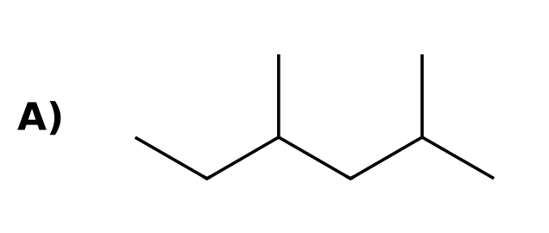 | B)  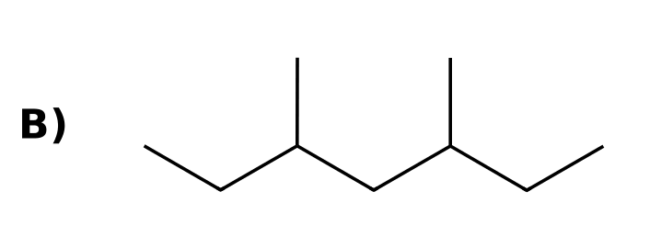
C)  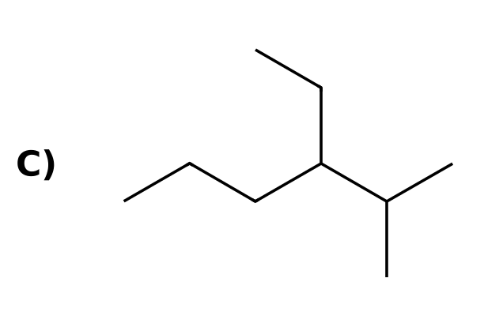 | D)  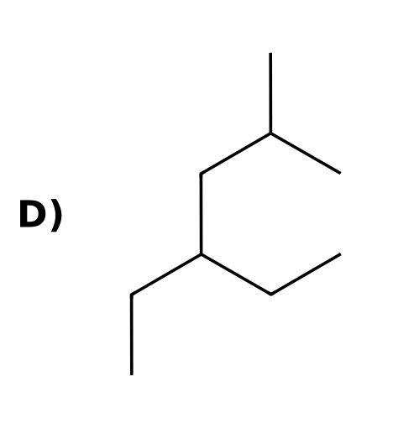
13. Which is the correct IUPAC name for this alkane? [Q31, Easy]
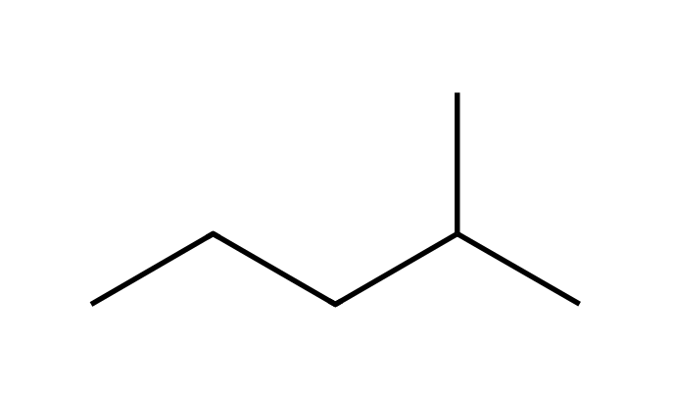
A) 2-methylpentane
B) 4-methylpentane
C) 3-methylpentane
D) 2-ethylbutane
14. Which is the correct IUPAC name for this alkane? [Q32, Easy]
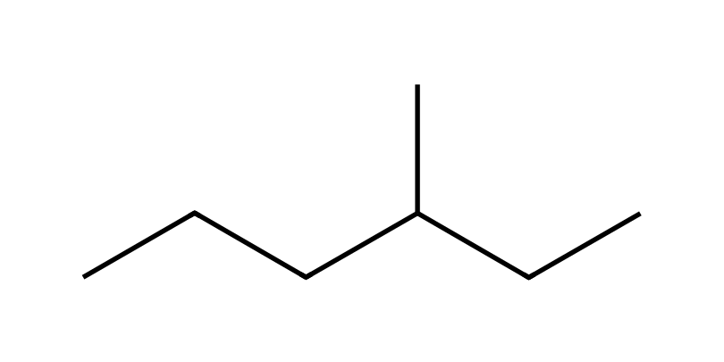
A) 4-methylhexane
B) 2-ethylpentane
C) 3-methylpentane
D) 3-methylhexane
15. Which is the correct IUPAC name for this alkane? [Q33, Easy]
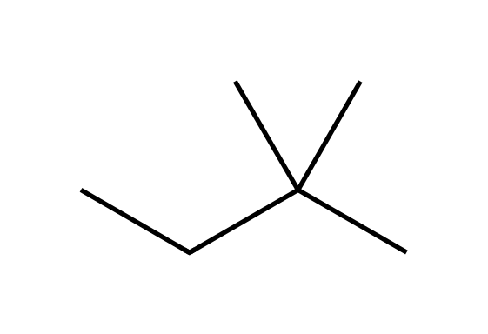
A) 3,3-dimethylbutane
B) 2,2-dimethylbutane
C) 2-ethyl-2-methylpropane
D) 2,2-dimethylpropane
16. Which is the correct IUPAC name for this alkane? [Q34, Easy]
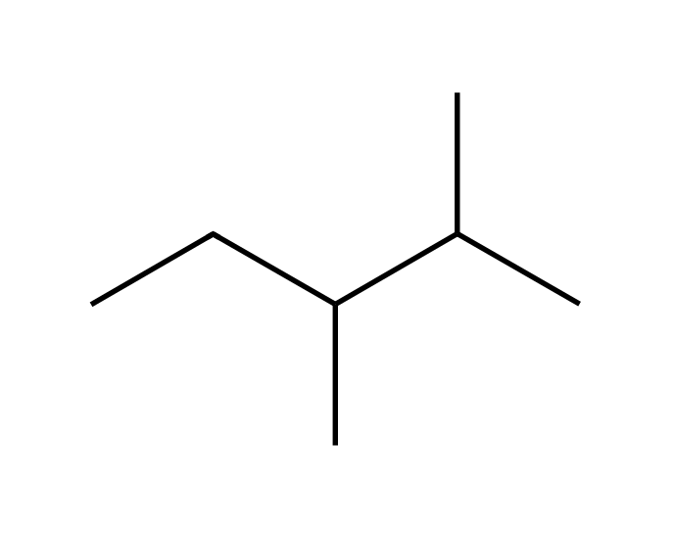
A) 3,4-dimethylpentane
B) 2-methyl-3-methylpentane
C) 2,3-dimethylpentane
D) 2,3-dimethylhexane
17. Which is the correct IUPAC name for this alkane? [Q35, Easy]
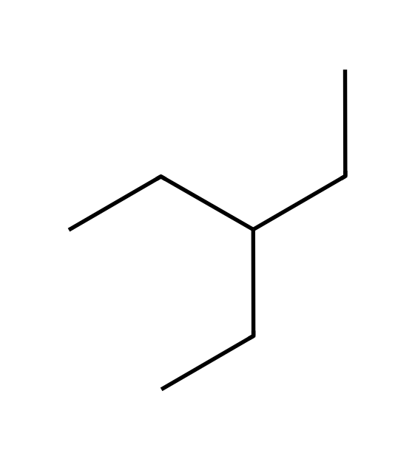
A) 3-methylhexane
B) 3-propylbutane
C) heptane
D) 3-ethylpentane
18. Which is the correct IUPAC name for this alkane? [Q36, Easy]
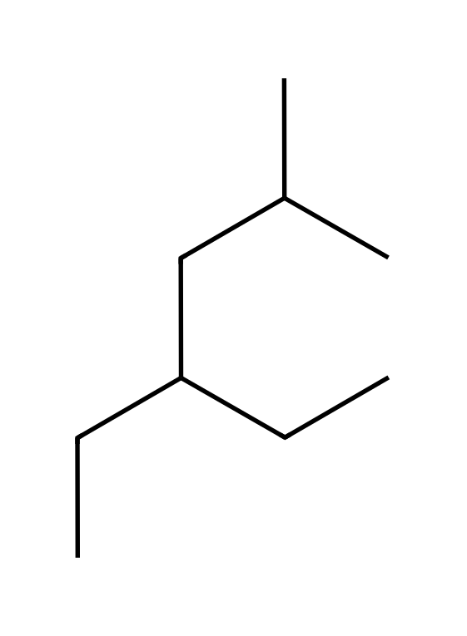
A) 4-ethyl-2-methylhexane
B) 3-ethyl-5-methylhexane
C) 2-methyl-4-ethylhexane
D) 2-ethyl-4-methylhexane
19. Which is the correct IUPAC name for this alkane? [Q37, Easy]
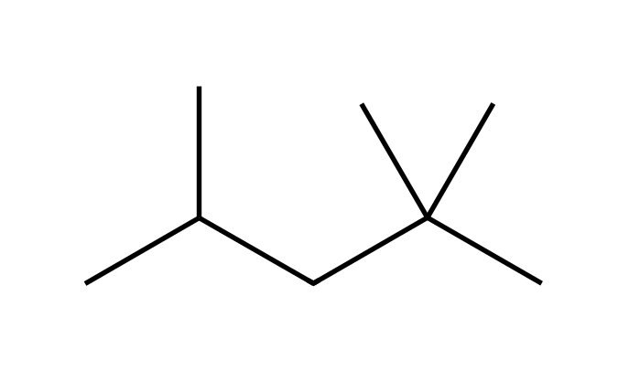
A) 2,4,4-trimethylpentane
B) 2,2,3-trimethylpentane
C) 2,2,4-trimethylpentane
D) 2,2,4-trimethylhexane
20. Which is the correct IUPAC name for this alkane? [Q38, Easy]
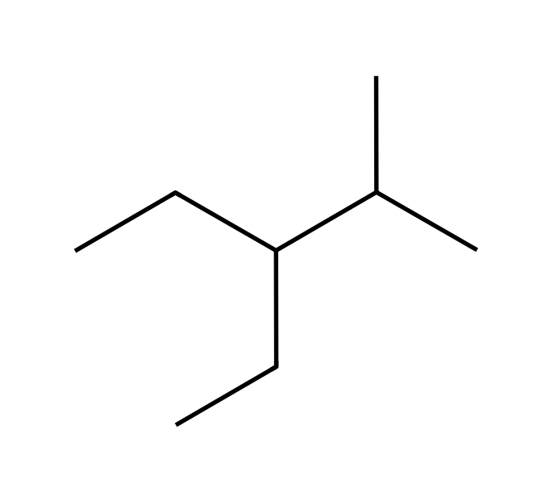
A) 2-methyl-3-ethylpentane
B) 3-ethyl-2-methylpentane
C) 3-ethyl-4-methylpentane
D) 2,3-diethylbutane
21. Which is the correct IUPAC name for this alkane? [Q39, Easy]
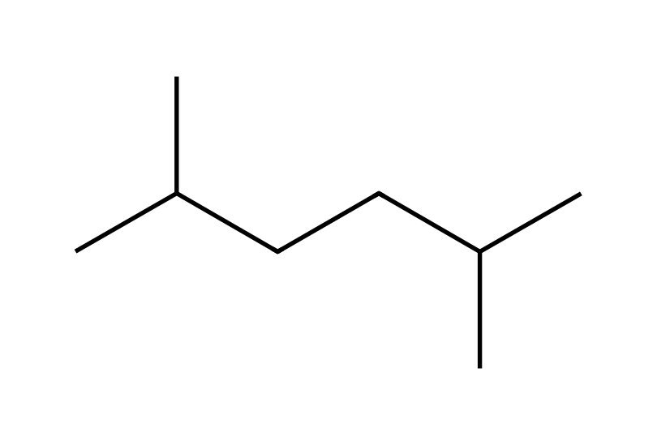
A) 2,5-dimethylhexane
B) 2,4-dimethylhexane
C) 1,1,4-trimethylpentane
D) 2-methyl-5-methylhexane
22. Which structure is 2,3,3-trimethylpentane? [Q40, Basic]
A)  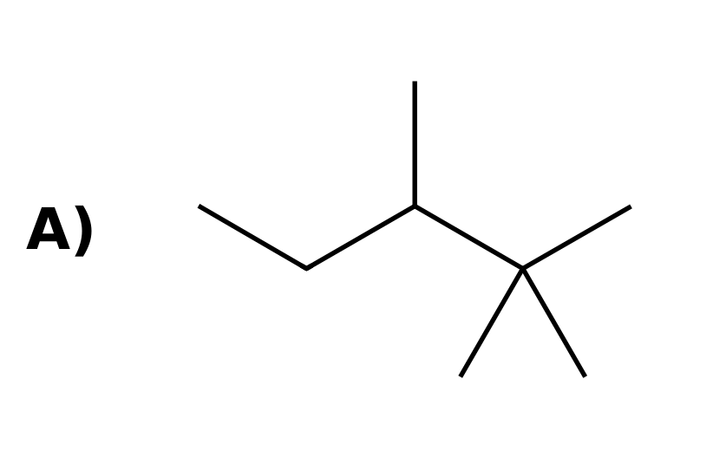 | B)  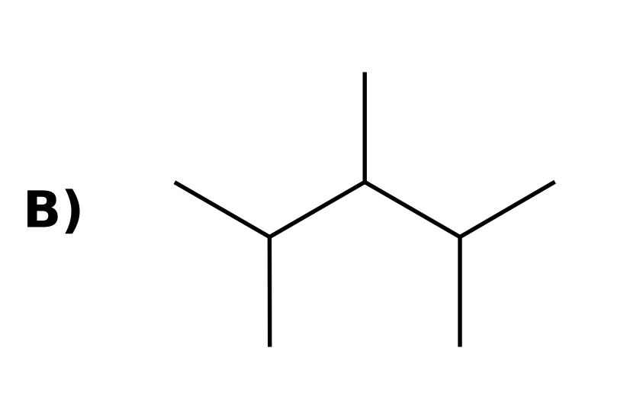
C)  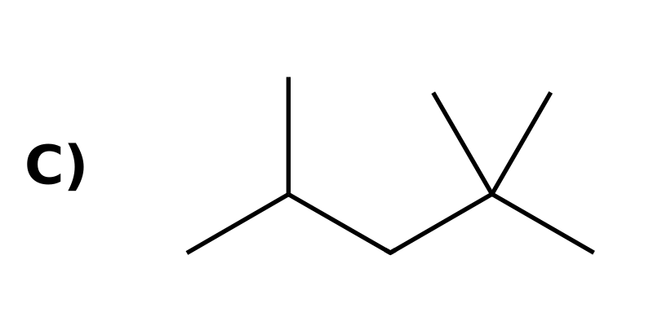 | D)  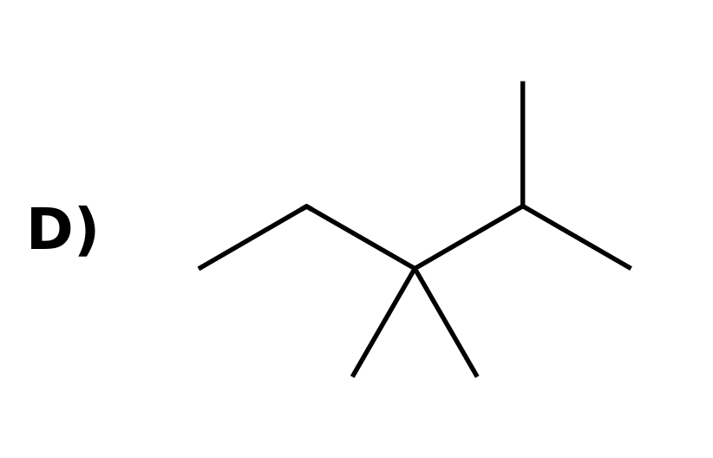
23. Name the straight-chain alkane with seven carbon atoms. [C04F03, Easy]

24. Give the IUPAC name of the compound shown. [C04F04, Basic]
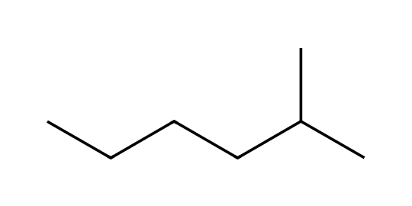

25. Give the IUPAC name of the compound shown. [C04F05, Basic]
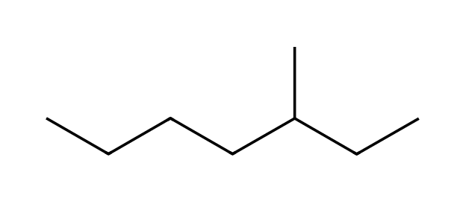

26. Give the IUPAC name of the compound shown. [C04F06, Basic]
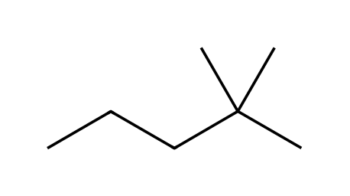

27. Give the IUPAC name of the compound shown. [C04F07, Moderate]
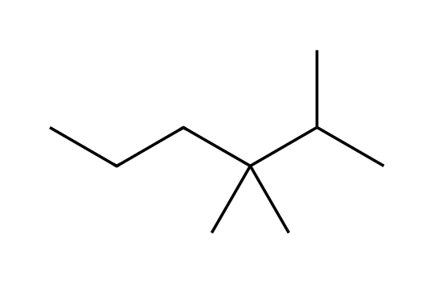

28. Give the IUPAC name of the compound shown. [C04F08, Moderate]
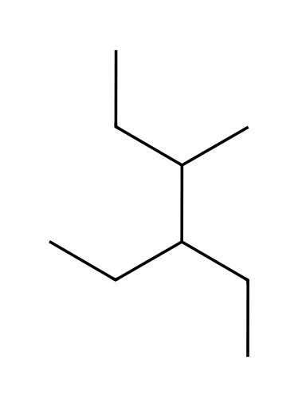

29. Give the IUPAC name of the compound shown. [C04F09, Basic]
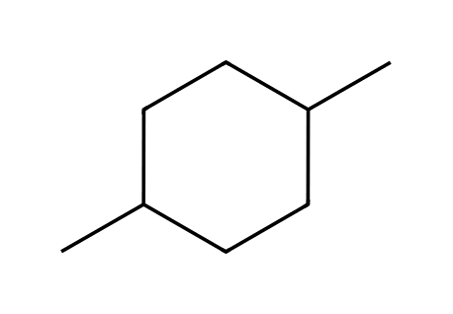

30. Draw 3-ethyl-2,2-dimethylhexane. [C04F10, Moderate]

31. Draw 2,3-dimethylbutane. [C04F11, Basic]

32. What are the names of the substituents -CH(CH₃)₂ and -C(CH₃)₃? [C04F12, Easy]
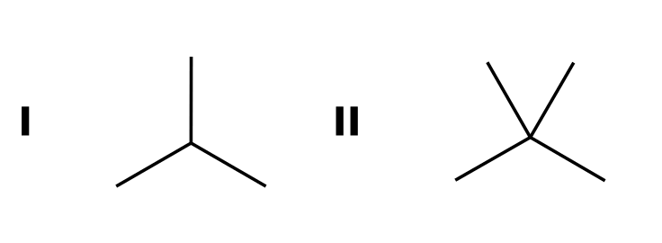

33. A student names the compound shown 2-ethylbutane. Explain the mistake and give the correct name. [C04F13, Moderate]
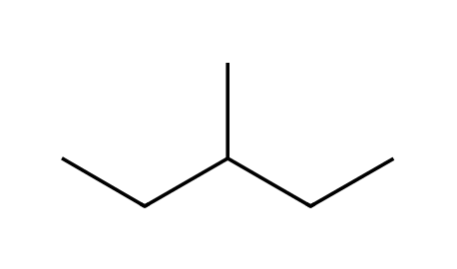

4.3 Constitutional Isomers of Alkanes
34. How many constitutional isomers does pentane (C₅H₁₂) have? [C04M11, Basic]
A) 2
B) 4
C) 5
D) 3
35. Which pair are constitutional isomers? [C04M12, Basic]
A) Propane and butane
B) Ethanol and ethane
C) Cyclohexane and hexane
D) Butane and 2-methylpropane
36. Draw all constitutional isomers of C₅H₁₂ and name them. [C04F14, Basic]

37. Draw all five constitutional isomers of C₆H₁₄. [C04F15, Moderate]

38. Are the two drawings the same compound? Explain. [C04F16, Basic]
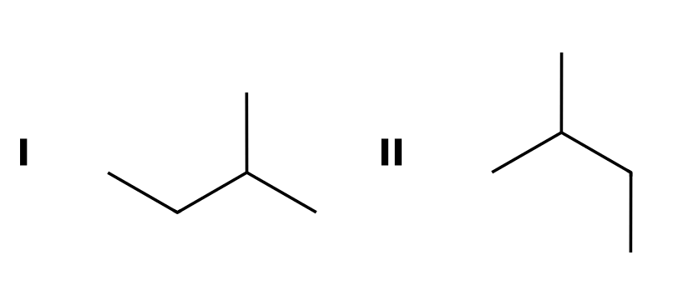

4.4 Relative Stability of Isomeric Alkanes
39. Two isomeric alkanes are burned. The isomer with the smaller heat of combustion is: [C04M13, Basic]
A) Less stable
B) The one with more carbon atoms
C) More stable
D) The one with fewer hydrogen atoms
40. Compared with their unbranched isomers, branched alkanes are generally: [C04M14, Basic]
A) More stable, with lower heats of combustion
B) Less stable, with higher heats of combustion
C) Equal in stability
D) More stable, with higher heats of combustion
41. Define the heat of combustion of an alkane. [C04F17, Easy]

42. Octane and 2,2,3,3-tetramethylbutane are isomers (C₈H₁₈). Which has the smaller heat of combustion? Explain. [C04F18, Moderate]
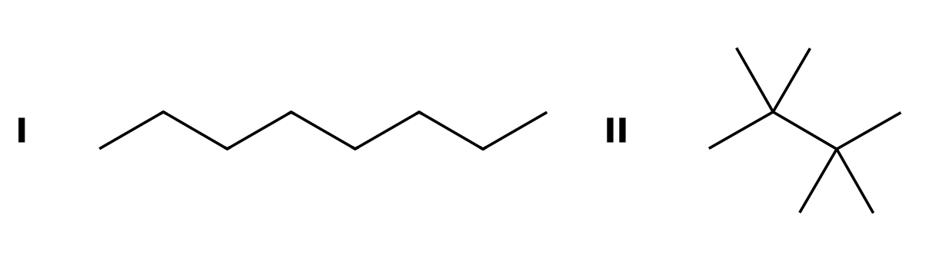

4.5 Sources and Uses of Alkanes
43. What process separates crude oil into fractions? [C04M15, Easy]
A) Cracking
B) Reforming
C) Hydrogenation
D) Fractional distillation
44. Which process converts straight-chain alkanes into branched and aromatic hydrocarbons that reduce knocking? [C04M16, Basic]
A) Cracking
B) Fractional distillation
C) Combustion
D) Reforming
45. Distinguish cracking from reforming. [C04F19, Basic]

46. Why do petroleum fractions come off a distillation tower at different temperatures? [C04F20, Easy]

4.6 Drawing Newman Projections
47. In a Newman projection, what does the circle represent? [C04M17, Easy]
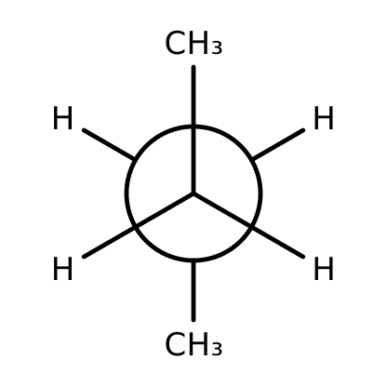
A) The back carbon, with its bonds starting at the circle
B) The front carbon
C) A double bond
D) The center of the molecule
48. What kind of conformation of ethane is shown? [C04M18, Basic]
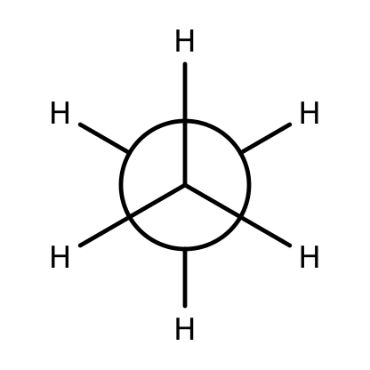
A) Staggered
B) Eclipsed
C) Planar
D) Twist
49. This Newman projection looks down the C2-C3 bond of butane. What is the conformation? [C04M19, Moderate]
A) Anti
B) Gauche
C) Eclipsed
D) Totally eclipsed
50. Draw a staggered Newman projection of ethane. [C04F21, Basic]

51. How do you read a Newman projection? [C04F22, Basic]

52. Draw a staggered Newman projection of propane looking down the C1-C2 bond, with the methyl group of C2 on the back carbon. [C04F23, Moderate]

4.7 Conformational Analysis of Ethane and Propane
53. Which conformation of ethane is lower in energy? [C04M20, Easy]
A) Eclipsed
B) They are equal
C) Staggered
D) It depends on temperature only
54. The energy cost of eclipsing in ethane is called: [C04M21, Basic]
A) Torsional strain
B) Angle strain
C) Steric strain
D) Resonance
55. How does the torsional strain of propane (eclipsed) compare with that of ethane? [C04M22, Moderate]
A) Much smaller
B) Exactly the same
C) Slightly larger, because a C-H bond eclipses a C-CH₃ bond
D) Zero, because propane is branched
56. Sketch the energy diagram for one full 360° rotation about the C-C bond of ethane. How many maxima and minima does it have? [C04F24, Basic]

57. What is the dihedral angle between a front group and the nearest back group in a staggered conformation and in an eclipsed conformation? [C04F25, Basic]

58. Define torsional strain. [C04F26, Basic]

59. Why are all three staggered conformations of ethane equal in energy? [C04F27, Moderate]

4.8 Conformational Analysis of Butane
60. Which Newman projection shows the most stable conformation of butane (looking down the C2-C3 bond)? [C04M23, Basic]
A)  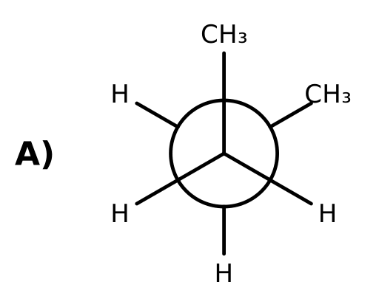 | B)  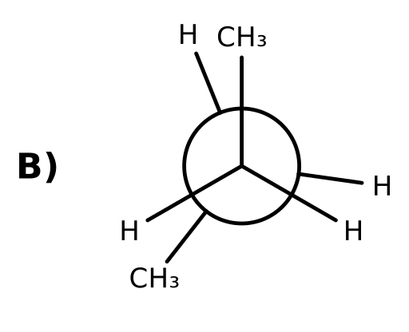
C)  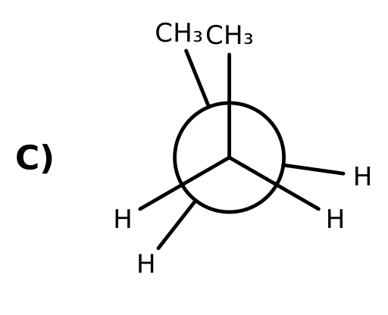 | D)  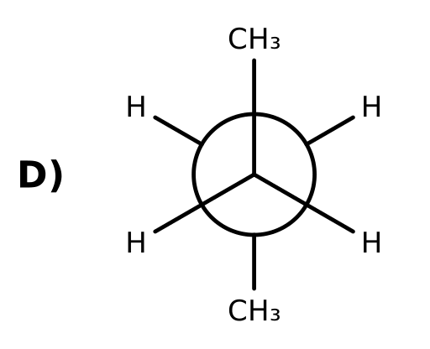
61. Which conformation of butane is the highest in energy? [C04M24, Basic]
A) The anti conformation
B) The gauche conformation
C) The one in which the two CH₃ groups eclipse each other
D) A staggered conformation
62. Why is the gauche conformation of butane higher in energy than the anti conformation? [C04M25, Moderate]
A) Torsional strain from eclipsed bonds
B) Steric strain: the two CH₃ groups are only 60° apart and crowd each other
C) Angle strain at carbon
D) The gauche form has an extra bond
63. Which list orders the butane conformations from lowest to highest energy? [C04M26, Moderate]
A) Gauche < anti < eclipsed < totally eclipsed
B) Anti < gauche < eclipsed (CH₃/H) < totally eclipsed (CH₃/CH₃)
C) Anti < eclipsed < gauche < totally eclipsed
D) Eclipsed < gauche < anti < totally eclipsed
64. Draw the anti conformation of butane as a Newman projection looking down C2-C3. [C04F28, Basic]

65. Draw the gauche conformation of butane as a Newman projection looking down C2-C3. [C04F29, Basic]

66. List the four main conformations of butane from lowest to highest energy and explain the order. [C04F30, Moderate]
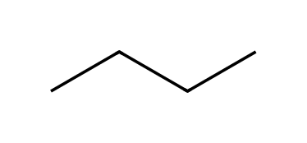

67. What type of strain is present in the gauche conformation but absent in the anti conformation? [C04F31, Moderate]

4.9 Cycloalkanes
68. What is the general formula for a cycloalkane with one ring? [C04M27, Easy]
A) CₙH₂ₙ₊₂
B) CₙH₂ₙ
C) CₙH₂ₙ₋₂
D) CₙHₙ
69. Which ring would have the most angle strain if it were planar? [C04M28, Basic]
A) Cyclopentane
B) Cyclopropane
C) Cyclohexane
D) Cycloheptane
70. Why does cyclopropane suffer from angle strain? [C04F32, Basic]


71. Draw ethylcyclobutane. [C04F33, Easy]

72. A planar cyclohexane would have 120° bond angles. Explain why real cyclohexane is not planar. [C04F34, Moderate]

4.10 Conformations of Cyclohexane
73. Which conformation of cyclohexane is the most stable? [C04M29, Easy]
A) Boat
B) Twist-boat
C) Chair
D) Half-chair
74. Which order of cyclohexane conformations is from lowest to highest energy? [C04M30, Basic]
A) Boat < chair < twist-boat < half-chair
B) Twist-boat < chair < boat < half-chair
C) Chair < boat < twist-boat < half-chair
D) Chair < twist-boat < boat < half-chair
75. The C-C-C bond angles in the chair conformation of cyclohexane are approximately: [C04M31, Basic]
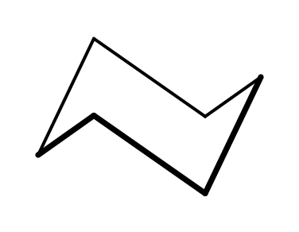
A) 120°
B) 109.5°
C) 90°
D) 60°
76. Explain why the chair conformation has no significant angle or torsional strain. [C04F35, Basic]

77. Why is the boat conformation higher in energy than the chair? [C04F36, Basic]

78. How many axial and how many equatorial hydrogens does the chair of cyclohexane have? [C04F37, Moderate]
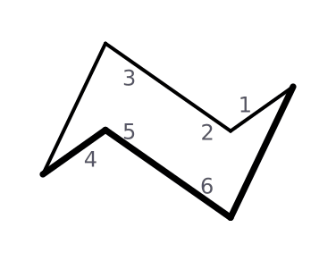

4.11 Drawing Chair Conformations
79. Is the CH₃ group in this chair axial or equatorial? [C04M32, Basic]
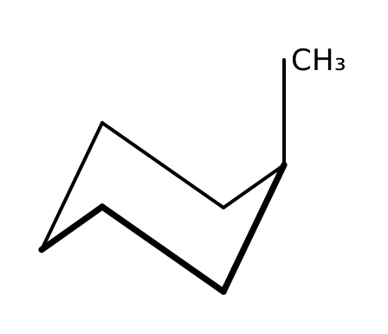
A) Equatorial
B) Planar
C) Gauche
D) Axial
80. Is the chlorine in this chair axial or equatorial? [C04M33, Basic]
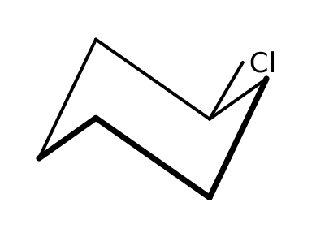
A) Axial
B) Planar
C) Equatorial
D) Eclipsed
81. How can you recognize the axial bonds in a drawing of a chair? [C04F38, Basic]
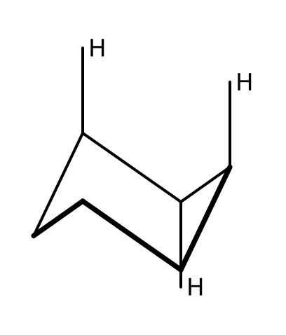

82. Draw the chair that results from a ring flip of the conformation shown. Is the CH₃ now axial or equatorial? [C04F39, Moderate]

83. How do axial bonds on adjacent carbons of a chair point? [C04F40, Basic]

4.12 Monosubstituted Cyclohexane
84. Which chair of methylcyclohexane is more stable? [C04M34, Basic]
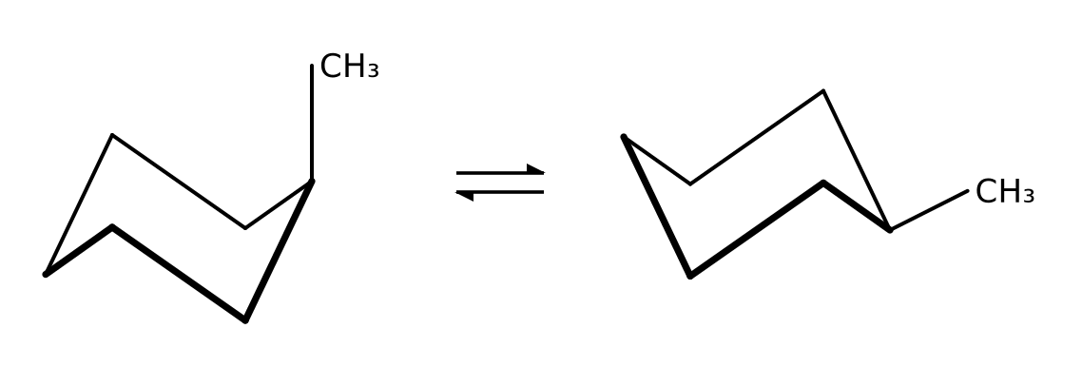
A) The left chair, with CH₃ axial
B) Both are equally stable
C) Neither; the boat is more stable
D) The right chair, with CH₃ equatorial
85. The steric interaction between an axial substituent and the axial hydrogens on carbons 3 and 5 is called: [C04M35, Basic]
A) A 1,3-diaxial interaction
B) A gauche interaction in a chain
C) Angle strain
D) Resonance repulsion
86. Why does a substituent prefer the equatorial position on a cyclohexane chair? [C04F41, Basic]

87. Which has the larger preference for the equatorial position, CH₃ or C(CH₃)₃? Explain. [C04F42, Moderate]

88. In methylcyclohexane, about how much more strained is the axial chair than the equatorial chair, and where does the strain come from? [C04F43, Moderate]

4.13 Disubstituted Cyclohexane
89. Which conformation of cis-1,3-dimethylcyclohexane is more stable? [C04M36, Moderate]
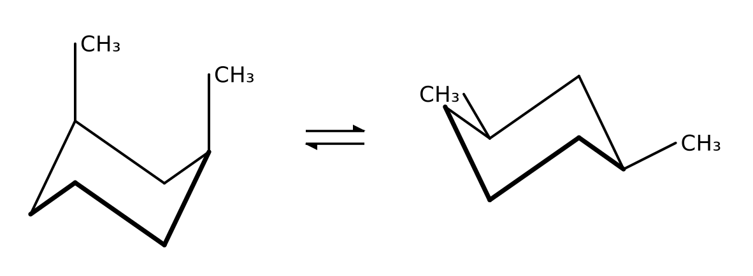
A) The left chair, with both CH₃ groups axial
B) The right chair, with both CH₃ groups equatorial
C) They are equal in energy
D) Neither chair; only the boat exists
90. Which isomer can exist in a chair with both substituents equatorial? [C04M37, Moderate]
A) cis-1,2-Dimethylcyclohexane
B) trans-1,4-Dimethylcyclohexane
C) trans-1,3-Dimethylcyclohexane
D) cis-1,4-Dimethylcyclohexane
91. Draw both chair conformations of trans-1,4-dimethylcyclohexane and state which is more stable. [C04F44, Basic]

92. Describe the two chair conformations of cis-1,2-dimethylcyclohexane. Which is more stable? [C04F45, Moderate]

93. Draw both chairs of cis-1,3-dimethylcyclohexane. Which interaction makes the diaxial chair very unstable? [C04F46, Moderate]

4.14 cis-trans Stereoisomerism
94. In cis-1,2-dimethylcyclohexane the two methyl groups are: [C04M38, Easy]
A) On opposite faces of the ring
B) Both in the plane of the ring
C) On the same face of the ring
D) Bonded to the same carbon
95. Can cis- and trans-1,3-dimethylcyclohexane interconvert by a ring flip? [C04M39, Basic]
A) No; they are different stereoisomers that can only interconvert by breaking bonds
B) Yes, by a ring flip
C) Yes, by rotating a C-C bond
D) Yes, at high temperature without breaking bonds
96. Draw cis- and trans-1,2-dimethylcyclohexane using wedges and dashes. [C04F47, Basic]

97. Why are cis and trans-1,2-dimethylcyclohexane stereoisomers rather than constitutional isomers? [C04F48, Moderate]

4.15 Polycyclic Systems
98. Which prefix is used in the name of a compound that contains two rings sharing atoms? [C04M40, Basic]
A) Bicyclo
B) Dicyclo
C) Bi
D) Cyclo-di
99. Name the bicyclic compound shown (two fused six-membered rings, ten carbons). [C04F49, Moderate]
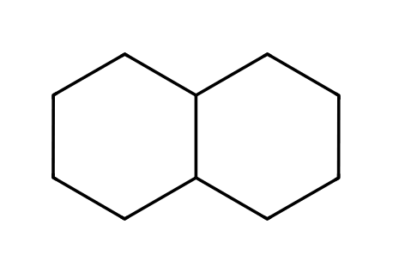

100. How many carbons are in the bicyclic compound bicyclo[2.2.1]heptane, and what does the 1 in the brackets tell you? [C04F50, Basic]

