Chapter 7: Alkyl Halides: Substitution and Elimination: Answer Key
Answers and explanations.
Name: ______________________________ Date: ______________

7.1 Introduction to Substitution and Elimination
1. In a substitution reaction, what happens? [C07M01, Easy]
Answer: C) A leaving group is replaced by another group
Why: Substitution swaps one group for another; elimination forms a π bond.
2. In an elimination reaction of an alkyl halide, what is formed? [C07M02, Easy]
Answer: C) An alkene
Why: The halide and a β hydrogen are lost to form a C=C bond.
3. Which is a good leaving group? [C07M03, Basic]
Answer: D) Br⁻
Why: Good leaving groups are weak bases that are stable on their own.
4. Which is the better leaving group in each pair, and why? (a) Cl⁻ or I⁻ (b) HO⁻ or H₂O (c) CH₃O⁻ or TsO⁻. [P088, Basic]
Answer: (a) I⁻. (b) H₂O. (c) TsO⁻.
Why: Good leaving groups are weak bases, the conjugate bases of strong acids. Iodide is the conjugate base of HI; water is the conjugate base of H₃O⁺; tosylate is the conjugate base of a strong sulfonic acid.
5. Rank 1-chlorobutane, 1-bromobutane and 1-iodobutane by their rate of reaction with NaCN in DMSO, and explain. [P089, Basic]
Answer: 1-iodobutane > 1-bromobutane > 1-chlorobutane.
Why: The rate of SN2 depends on the leaving group: iodide is the weakest base and the best leaving group.

7.2 Nomenclature and Uses of Alkyl Halides
6. What is the IUPAC name of CH₃CH₂CH₂Br? [C07M04, Easy]
Answer: D) 1-Bromopropane
Why: The halogen is a substituent on the three-carbon chain, numbered from the end nearest it.
7. What is the IUPAC name of the compound shown? [C07M05, Basic]
Answer: B) 2-chlorobutane
Why: Number from the end nearest the chlorine.
8. What is the IUPAC name of the compound shown? [C07M06, Moderate]
Answer: D) 2-bromo-4-methylpentane
Why: The longest chain has five carbons; the lowest locants are 2 and 4, with the bromo group named first alphabetically.
9. Classify the alkyl halide 2-bromo-2-methylpropane. [C07M07, Basic]
Answer: C) Tertiary
Why: The carbon bearing the bromine is bonded to three other carbons.
10. Classify the alkyl halide shown. [C07M08, Basic]
Answer: B) Primary
Why: The carbon bearing the halogen is attached to only one other carbon.

7.3 SN2 Reactions
11. What does SN2 stand for? [C07M09, Easy]
Answer: D) Substitution, nucleophilic, bimolecular
Why: The rate depends on two species.
12. The SN2 mechanism proceeds: [C07M10, Easy]
Answer: A) In one concerted step
Why: Bond formation and bond breaking occur at the same time.
13. From which direction does the nucleophile attack in an SN2 reaction? [C07M11, Basic]
Answer: A) From the side opposite the leaving group (back-side attack)
Why: The nucleophile attacks the σ* orbital opposite the leaving group.
14. What is the stereochemical outcome of an SN2 reaction at a chirality center? [C07M12, Basic]
Answer: D) Inversion of configuration
Why: The three other groups flip like an umbrella in the wind.
15. Which substrate reacts fastest by SN2? [C07M13, Basic]
Answer: B) Methyl bromide
Why: Less steric hindrance means faster SN2.
16. Rank the alkyl bromides from fastest to slowest SN2: 1° , 2°, 3°, methyl. [C07M14, Moderate]
Answer: A) Methyl > 1° > 2° > 3°
Why: Steric hindrance slows the back-side attack.
17. The (S)-2-bromobutane shown reacts with NaOH in an SN2 reaction. What is the configuration of the butan-2-ol formed? [C07M15, Moderate]
Answer: C) R
Why: SN2 inverts the configuration; here the priority order is unchanged so the label flips.
18. In the SN2 reaction of 1-bromobutane with NaCN, what is the product? [C07M16, Moderate]
Answer: B) Pentanenitrile
Why: Cyanide replaces bromine, adding one carbon.
19. Which factor does NOT speed up an SN2 reaction? [C07M17, Hard]
Answer: C) Making the substrate more substituted at the reacting carbon
Why: More substituents block the back-side attack.
20. What reagent(s) and solvent would convert iodomethane into ethanenitrile? Name the mechanism and justify your choice with the four factors (substrate, nucleophile, leaving group, solvent). [P001, Easy]
Answer: NaCN in DMSO (SN2).
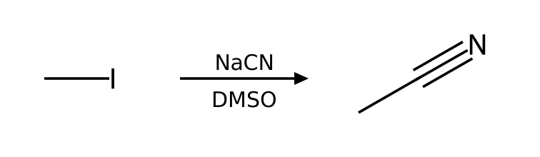
Why: Substrate: methyl alkyl halide; Leaving group: excellent leaving group (I); Nucleophile/base: cyanide is a strong nucleophile and a weak base; Solvent: DMSO is aprotic. These favor SN2.
21. What reagent(s) and solvent would convert bromoethane into azidoethane? Name the mechanism and justify your choice with the four factors (substrate, nucleophile, leaving group, solvent). [P002, Easy]
Answer: NaN₃ in DMF (SN2).
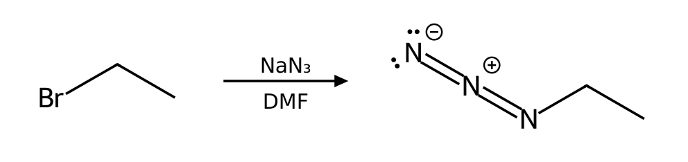
Why: Substrate: primary (1°) alkyl halide; Leaving group: good leaving group (Br); Nucleophile/base: azide is a strong nucleophile and a weak base; Solvent: DMF is aprotic. These favor SN2.
22. What reagent(s) and solvent would convert 1-bromopropane into propane-1-thiol? Name the mechanism and justify your choice with the four factors (substrate, nucleophile, leaving group, solvent). [P003, Easy]
Answer: NaSH in DMSO (SN2).
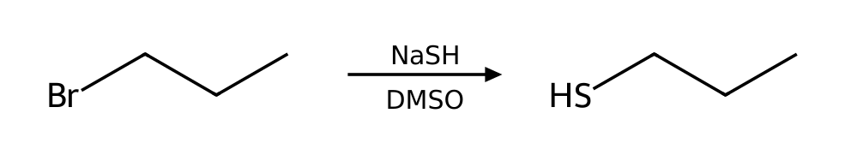
Why: Substrate: primary (1°) alkyl halide; Leaving group: good leaving group (Br); Nucleophile/base: hydrosulfide is a strong nucleophile and a weak base; Solvent: DMSO is aprotic. These favor SN2.
23. What reagent(s) and solvent would convert 2-bromopropane into 2-methylpropanenitrile? Name the mechanism and justify your choice with the four factors (substrate, nucleophile, leaving group, solvent). [P004, Easy]
Answer: NaCN in DMSO (SN2).
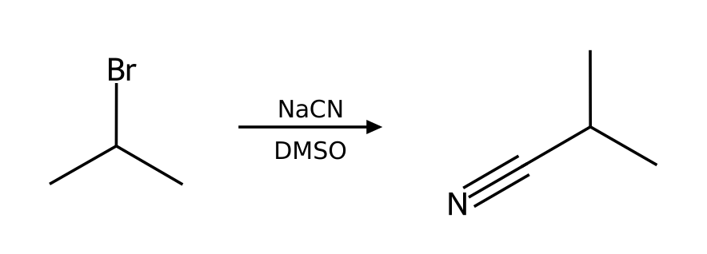
Why: Substrate: secondary (2°) alkyl halide; Leaving group: good leaving group (Br); Nucleophile/base: cyanide is a strong nucleophile and a weak base; Solvent: DMSO is aprotic. These favor SN2.
24. What reagent(s) and solvent would convert 2-bromobutane into butane-2-thiol? Name the mechanism and justify your choice with the four factors (substrate, nucleophile, leaving group, solvent). [P005, Easy]
Answer: NaSH in DMSO (SN2).
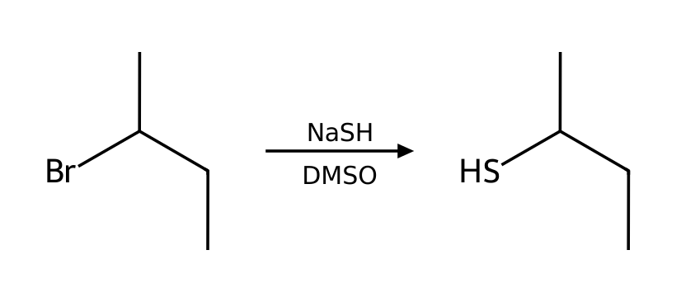
Why: Substrate: secondary (2°) alkyl halide; Leaving group: good leaving group (Br); Nucleophile/base: hydrosulfide is a strong nucleophile and a weak base; Solvent: DMSO is aprotic. These favor SN2.
25. Predict the major organic product of 1-iodobutane with NaCN in CH3CN. State the mechanism and any minor pathway. [P011, Basic]
Answer: pentanenitrile via SN2.
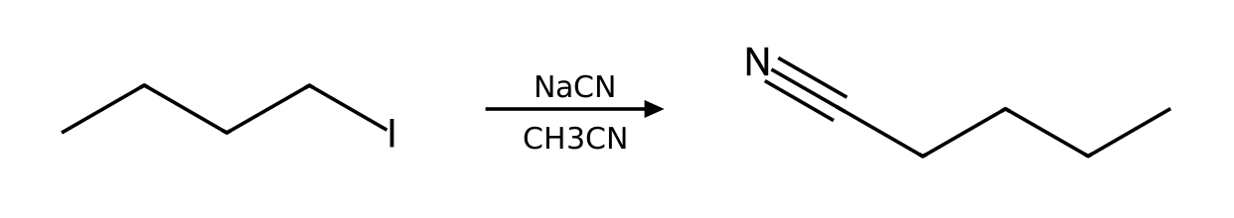
Why: Substrate: primary (1°) alkyl halide; Leaving group: excellent leaving group (I); Nucleophile/base: cyanide is a strong nucleophile and a weak base; Solvent: CH3CN is aprotic. These favor SN2.
26. Predict the major organic product of 1-chlorobutane with NaI in acetone. State the mechanism and any minor pathway. [P012, Basic]
Answer: 1-iodobutane via SN2.
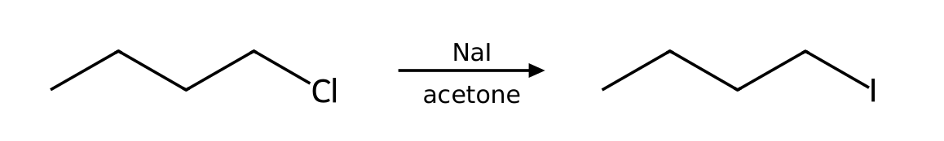
Why: Substrate: primary (1°) alkyl halide; Leaving group: good leaving group (Cl); Nucleophile/base: iodide is a strong nucleophile and a weak base; Solvent: acetone is aprotic. These favor SN2.
27. Predict the major organic product of 1-bromopropane with NaOMe in MeOH. State the mechanism and any minor pathway. [P013, Basic]
Answer: 1-methoxypropane via SN2. Minor: E2 (minor).
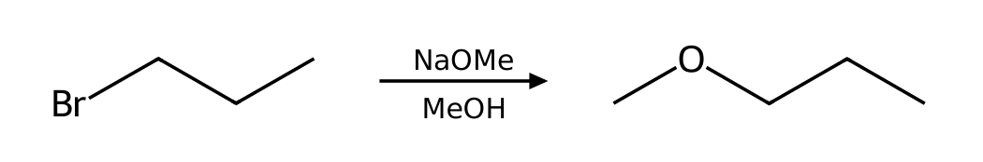
Why: Substrate: primary (1°) alkyl halide; Leaving group: good leaving group (Br); Nucleophile/base: methoxide is a strong nucleophile and a strong base; Solvent: MeOH is protic. These favor SN2. Competing pathway: E2 (minor).
28. Predict the major organic product of 2-iodobutane with NaN₃ in DMF. State the mechanism and any minor pathway. [P014, Basic]
Answer: 2-azidobutane via SN2.
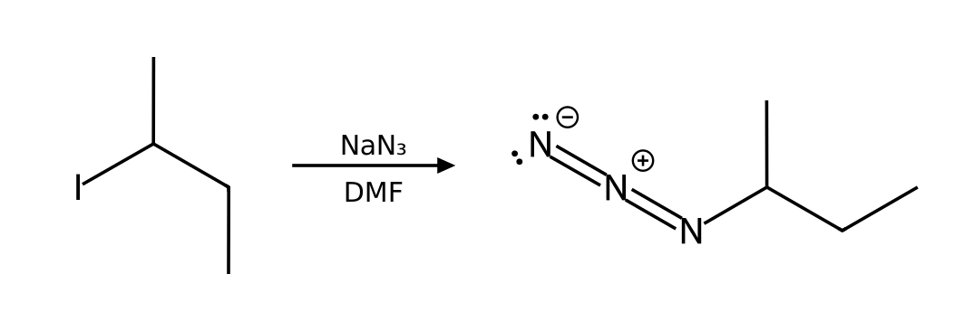
Why: Substrate: secondary (2°) alkyl halide; Leaving group: excellent leaving group (I); Nucleophile/base: azide is a strong nucleophile and a weak base; Solvent: DMF is aprotic. These favor SN2.
29. Predict the major organic product of bromocyclohexane with NaN₃ in DMF. State the mechanism and any minor pathway. [P015, Basic]
Answer: azidocyclohexane via SN2.
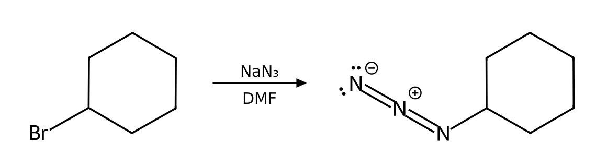
Why: Substrate: secondary (2°) alkyl halide; Leaving group: good leaving group (Br); Nucleophile/base: azide is a strong nucleophile and a weak base; Solvent: DMF is aprotic. These favor SN2.
30. Which mechanism (SN1, SN2, E1 or E2) predominates when bromoethane reacts with NaN₃ in DMF? List the factors that support your answer and give the major product. [P021, Basic]
Answer: SN2. Major product: azidoethane.
Why: Substrate: primary (1°) alkyl halide; Leaving group: good leaving group (Br); Nucleophile/base: azide is a strong nucleophile and a weak base; Solvent: DMF is aprotic. These favor SN2.
31. Which mechanism (SN1, SN2, E1 or E2) predominates when 1-bromobutane reacts with NaOAc in DMF? List the factors that support your answer and give the major product. [P022, Basic]
Answer: SN2. Major product: butyl ethanoate.
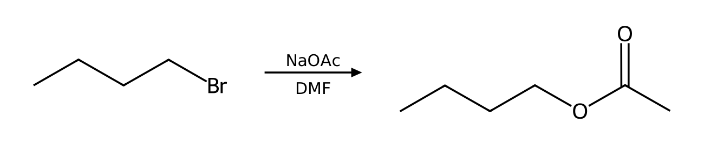
Why: Substrate: primary (1°) alkyl halide; Leaving group: good leaving group (Br); Nucleophile/base: acetate is a weak nucleophile and a weak base; Solvent: DMF is aprotic. These favor SN2.
32. Which mechanism (SN1, SN2, E1 or E2) predominates when 1-chlorobutane reacts with NaI in acetone? List the factors that support your answer and give the major product. [P028, Basic]
Answer: SN2. Major product: 1-iodobutane.
Why: Substrate: primary (1°) alkyl halide; Leaving group: good leaving group (Cl); Nucleophile/base: iodide is a strong nucleophile and a weak base; Solvent: acetone is aprotic. These favor SN2.
33. Draw the product of (S)-2-bromobutane with NaSH in DMSO. Give the configuration (R or S) of the substrate and the product and explain the stereochemical outcome. [P030, Basic]
Answer: (R)-butane-2-thiol: inversion of configuration (S → R).
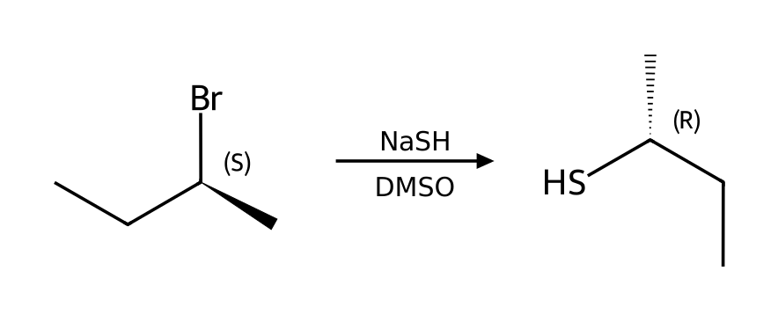
Why: SN2 proceeds by back-side attack, so the α carbon inverts like an umbrella in the wind. Note that the R/S label changes only if the CIP priorities keep the same order; the geometry always inverts. Substrate: secondary (2°) alkyl halide; Leaving group: good leaving group (Br); Nucleophile/base: hydrosulfide is a strong nucleophile and a weak base; Solvent: DMSO is aprotic. These favor SN2.
34. Draw the product of (S)-2-chloropentane with NaCN in DMSO. Give the configuration (R or S) of the substrate and the product and explain the stereochemical outcome. [P031, Basic]
Answer: (R)-2-methylpentanenitrile: inversion of configuration (S → R).
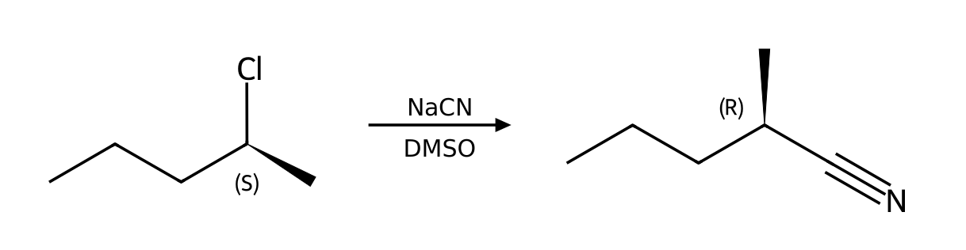
Why: SN2 proceeds by back-side attack, so the α carbon inverts like an umbrella in the wind. Note that the R/S label changes only if the CIP priorities keep the same order; the geometry always inverts. Substrate: secondary (2°) alkyl halide; Leaving group: good leaving group (Cl); Nucleophile/base: cyanide is a strong nucleophile and a weak base; Solvent: DMSO is aprotic. These favor SN2.
35. Draw the product of (R)-3-iodohexane with NaN₃ in DMF. Give the configuration (R or S) of the substrate and the product and explain the stereochemical outcome. [P032, Basic]
Answer: (S)-3-azidohexane: inversion of configuration (R → S).
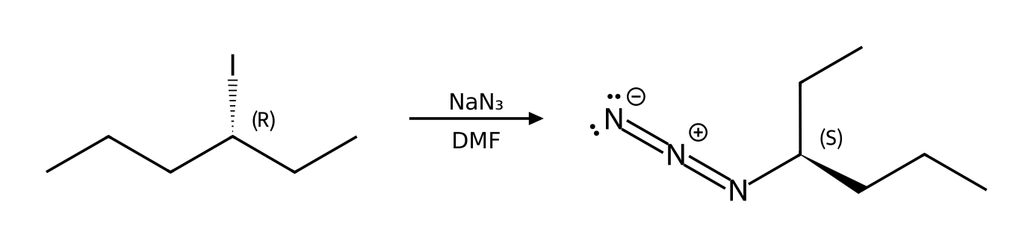
Why: SN2 proceeds by back-side attack, so the α carbon inverts like an umbrella in the wind. Note that the R/S label changes only if the CIP priorities keep the same order; the geometry always inverts. Substrate: secondary (2°) alkyl halide; Leaving group: excellent leaving group (I); Nucleophile/base: azide is a strong nucleophile and a weak base; Solvent: DMF is aprotic. These favor SN2.
36. Draw the product of (R)-2-bromohexane with NaI in acetone. Give the configuration (R or S) of the substrate and the product and explain the stereochemical outcome. [P033, Basic]
Answer: (S)-2-iodohexane: inversion of configuration (R → S).
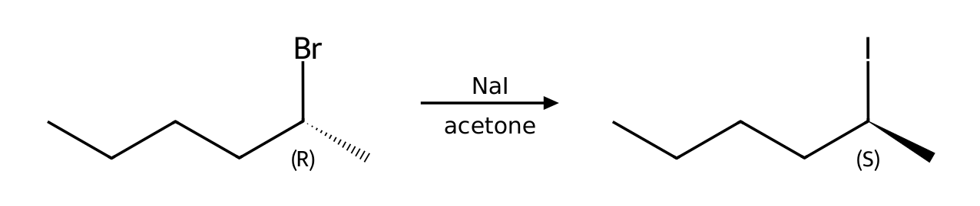
Why: SN2 proceeds by back-side attack, so the α carbon inverts like an umbrella in the wind. Note that the R/S label changes only if the CIP priorities keep the same order; the geometry always inverts. Substrate: secondary (2°) alkyl halide; Leaving group: good leaving group (Br); Nucleophile/base: iodide is a strong nucleophile and a weak base; Solvent: acetone is aprotic. These favor SN2.
37. Describe the complete mechanism (list each step and the curved arrows) for the reaction of bromoethane with NaN₃ in DMF. How many steps are there? [P038, Moderate]
Answer: (1) One concerted step: the nucleophile attacks the α carbon from the back side while the leaving group departs (inversion).
Why: Each ionic mechanism is built from nucleophilic attack, loss of a leaving group, proton transfer and rearrangement. Substrate: primary (1°) alkyl halide; Leaving group: good leaving group (Br); Nucleophile/base: azide is a strong nucleophile and a weak base; Solvent: DMF is aprotic. These favor SN2.
38. Describe the complete mechanism (list each step and the curved arrows) for the reaction of 1-bromopropane with NaOMe in MeOH. How many steps are there? [P039, Moderate]
Answer: (1) One concerted step: the nucleophile attacks the α carbon from the back side while the leaving group departs (inversion).
Why: Each ionic mechanism is built from nucleophilic attack, loss of a leaving group, proton transfer and rearrangement. Substrate: primary (1°) alkyl halide; Leaving group: good leaving group (Br); Nucleophile/base: methoxide is a strong nucleophile and a strong base; Solvent: MeOH is protic. These favor SN2. Competing pathway: E2 (minor).
39. Describe the complete mechanism (list each step and the curved arrows) for the reaction of 2-bromobutane with NaSH in DMSO. How many steps are there? [P043, Moderate]
Answer: (1) One concerted step: the nucleophile attacks the α carbon from the back side while the leaving group departs (inversion).
Why: Each ionic mechanism is built from nucleophilic attack, loss of a leaving group, proton transfer and rearrangement. Substrate: secondary (2°) alkyl halide; Leaving group: good leaving group (Br); Nucleophile/base: hydrosulfide is a strong nucleophile and a weak base; Solvent: DMSO is aprotic. These favor SN2.
40. Describe the complete mechanism (list each step and the curved arrows) for the reaction of 1-bromo-2,2-dimethylpropane with EtOH as the solvent. How many steps are there? [P044, Moderate]
Answer: (1) One concerted step: the nucleophile attacks the α carbon from the back side while the leaving group departs (inversion). (2) Proton transfer: a base removes the proton from the positively charged nucleophile atom.
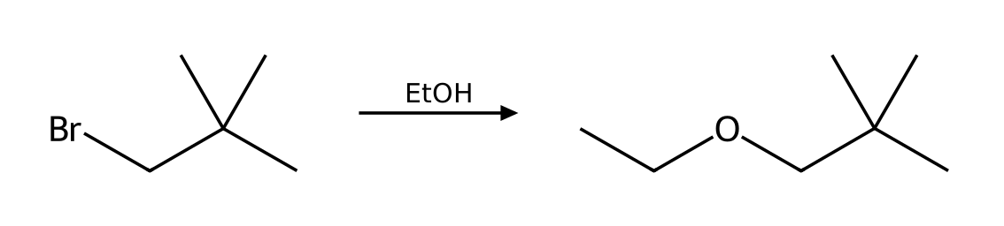
Why: Each ionic mechanism is built from nucleophilic attack, loss of a leaving group, proton transfer and rearrangement. Substrate: primary (1°) alkyl halide; Leaving group: good leaving group (Br); Nucleophile/base: ethanol is a weak nucleophile and a weak base; Solvent: EtOH is protic. These favor SN2. Competing pathway: none significant (slow solvolysis).
41. Treatment of 4-bromobutan-1-ol with NaOH gives a cyclic ether, tetrahydrofuran (oxolane). Explain the mechanism and why a ring forms. [P082, Moderate]
Answer: NaOH deprotonates the OH to give an alkoxide, which attacks the carbon bearing bromine intramolecularly (SN2, 5- or 6-membered ring) displacing bromide.
Why: Intramolecular SN2 is favored because the nucleophile and electrophile are tethered together; 5- and 6-membered rings form fastest.
42. Treatment of 5-bromopentan-1-ol with NaOH gives a cyclic ether, tetrahydropyran (oxane). Explain the mechanism and why a ring forms. [P083, Moderate]
Answer: NaOH deprotonates the OH to give an alkoxide, which attacks the carbon bearing bromine intramolecularly (SN2, 5- or 6-membered ring) displacing bromide.
Why: Intramolecular SN2 is favored because the nucleophile and electrophile are tethered together; 5- and 6-membered rings form fastest.
43. Rank bromomethane, 1-bromopropane, 2-bromopropane and 2-bromo-2-methylpropane from fastest to slowest toward SN2. Then give the order for SN1. [P086, Basic]
Answer: SN2: bromomethane > 1-bromopropane > 2-bromopropane >> 2-bromo-2-methylpropane (essentially unreactive). SN1 is the reverse: 2-bromo-2-methylpropane > 2-bromopropane > 1-bromopropane > bromomethane.
Why: SN2 is limited by steric hindrance in the transition state; SN1 is limited by carbocation stability.
44. Neopentyl bromide, (CH₃)₃CCH₂Br, is a primary alkyl halide. Predict whether it reacts well by SN2 or by SN1 and explain. [P087, Moderate]
Answer: It reacts very poorly by SN2 because of the bulky β substituents, and a primary carbocation is too unstable for SN1 (a rearrangement concerted with ionization can occur in ionizing solvents).
Why: Steric hindrance at the β position slows SN2 almost as much as α branching.
45. The reaction of 2-bromobutane with NaSH in DMSO follows the mechanism predicted for these conditions. Write the rate law. What happens to the rate if (a) [substrate] is doubled and [hydrosulfide] is unchanged, and (b) [hydrosulfide] is tripled and [substrate] is unchanged? [P092, Basic]
Answer: SN2: rate = k[substrate][nucleophile]. (a) Rate doubles. (b) Rate triples.
Why: The rate law reflects the species in the rate-determining step.
46. The reaction of 1-chlorobutane with NaI in acetone follows the mechanism predicted for these conditions. Write the rate law. What happens to the rate if (a) [substrate] is doubled and [iodide] is unchanged, and (b) [iodide] is tripled and [substrate] is unchanged? [P095, Basic]
Answer: SN2: rate = k[substrate][nucleophile]. (a) Rate doubles. (b) Rate triples.
Why: The rate law reflects the species in the rate-determining step.
47. Which compound reacts faster with NaN₃ in DMF, 1-bromobutane or 2-bromobutane? Which reacts faster with ethanol (solvolysis), 2-bromo-2-methylpropane or 2-bromopropane? [P098, Basic]
Answer: 1-bromobutane (less hindered SN2). 2-bromo-2-methylpropane (more stable tertiary carbocation, SN1).
Why: SN2 rate falls as steric hindrance increases; SN1 rate rises with carbocation stability.

7.4 Nucleophilic Strength in SN2 Reactions
48. Which is the stronger nucleophile in a polar protic solvent: I⁻ or F⁻? [C07M18, Easy]
Answer: D) I⁻
Why: In protic solvents the small anion is held tightly by hydrogen bonds; the larger iodide is more polarizable.
49. Which is the stronger nucleophile: CH₃O⁻ or CH₃OH? [C07M19, Basic]
Answer: D) CH₃O⁻
Why: A negatively charged species is generally a stronger nucleophile than its neutral conjugate acid.
50. Which reagent is both a strong nucleophile and a weak base? [C07M20, Basic]
Answer: D) I⁻
Why: Iodide is polarizable and the conjugate base of a strong acid.
51. Which reagent is a strong base but a poor nucleophile because of its size? [C07M21, Moderate]
Answer: B) Potassium tert-butoxide
Why: The bulky tert-butoxide cannot easily attack carbon but can remove a proton.
52. Rank the halide ions F⁻, Cl⁻, Br⁻, I⁻ by nucleophilicity (a) in methanol (a protic solvent) and (b) in DMSO (a polar aprotic solvent). Explain the reversal. [P084, Basic]
Answer: (a) in methanol: I⁻ > Br⁻ > Cl⁻ > F⁻; (b) in DMSO: F⁻ > Cl⁻ > Br⁻ > I⁻.
Why: In protic solvents the small anions are strongly solvated by hydrogen bonding and are tied up; in polar aprotic solvents anions are not solvated, so basicity (F⁻ most basic) tracks nucleophilicity.
53. Classify each as a strong or weak nucleophile and state whether it favors SN2 or SN1: (a) HS⁻ (b) H₂O (c) CH₃CH₂O⁻ (d) CH₃CH₂OH (e) I⁻ (f) CN⁻. [P085, Basic]
Answer: Strong (favor SN2): HS⁻, CH₃CH₂O⁻, I⁻, CN⁻. Weak (allow SN1 to compete): H₂O, CH₃CH₂OH.
Why: Strong nucleophiles speed up SN2; the rate of SN1 does not depend on the nucleophile, so weak nucleophiles disfavor SN2 and let SN1 compete.

7.5 Introduction to E2 Reactions
54. What does E2 stand for? [C07M22, Easy]
Answer: C) Elimination, bimolecular
Why: The rate depends on both the substrate and the base.
55. In an E2 reaction, which pattern of arrows applies? [C07M23, Basic]
Answer: C) Proton transfer and loss of the leaving group at the same time
Why: The base removes a β hydrogen as the leaving group leaves.
56. In E2, the β hydrogen and the leaving group must be: [C07M24, Moderate]
Answer: B) Anti-coplanar
Why: Anti-coplanar alignment allows the orbitals to overlap in the transition state.
57. What is the major organic product of 2-bromopropane with sodium ethoxide in ethanol (heat)? [C07M25, Moderate]
Answer: B) Propene
Why: A strong base with a secondary halide favors E2.
58. What reagent(s) and solvent would convert 2-bromopropane into prop-1-ene? Name the mechanism and justify your choice with the four factors (substrate, nucleophile, leaving group, solvent). [P007, Basic]
Answer: NaOEt in EtOH with heat (E2).
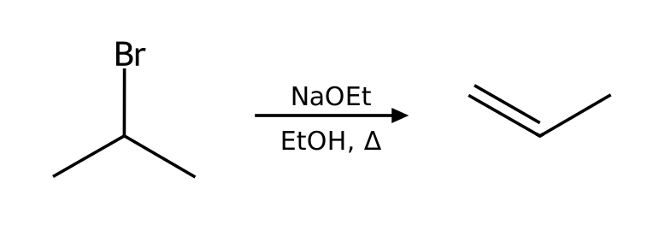
Why: Substrate: secondary (2°) alkyl halide; Leaving group: good leaving group (Br); Nucleophile/base: ethoxide is a strong nucleophile and a strong base; Solvent: EtOH is protic. These favor E2. Competing pathway: SN1/E1 do not compete under strongly basic conditions.
59. What reagent(s) and solvent would convert 2-bromobutane into (E)-but-2-ene? Name the mechanism and justify your choice with the four factors (substrate, nucleophile, leaving group, solvent). [P008, Basic]
Answer: NaOEt in EtOH with heat (E2).
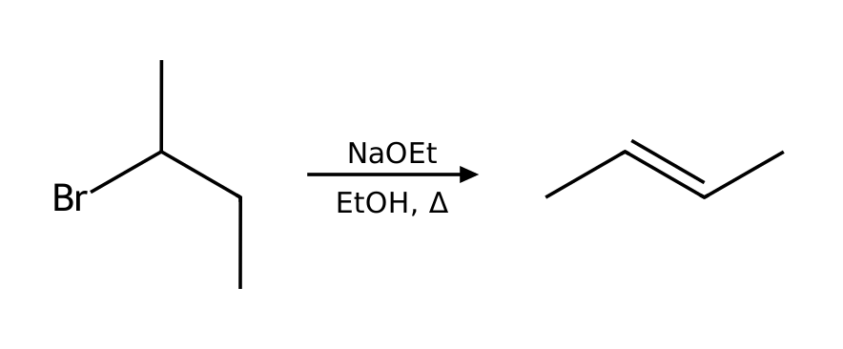
Why: Substrate: secondary (2°) alkyl halide; Leaving group: good leaving group (Br); Nucleophile/base: ethoxide is a strong nucleophile and a strong base; Solvent: EtOH is protic. These favor E2. Competing pathway: SN1/E1 do not compete under strongly basic conditions.
60. What reagent(s) and solvent would convert 2-bromo-2-methylbutane into 2-methylbut-1-ene? Name the mechanism and justify your choice with the four factors (substrate, nucleophile, leaving group, solvent). [P009, Basic]
Answer: KOtBu in tBuOH with heat (E2).
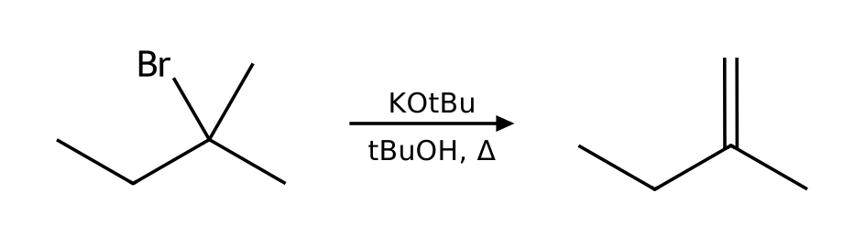
Why: Substrate: tertiary (3°) alkyl halide; Leaving group: good leaving group (Br); Nucleophile/base: tert-butoxide is a strong nucleophile and a strong base (bulky); Solvent: tBuOH is protic. These favor E2. Competing pathway: SN1/E1 do not compete under strongly basic conditions.
61. What reagent(s) and solvent would convert 2-iodobutane into but-1-ene? Name the mechanism and justify your choice with the four factors (substrate, nucleophile, leaving group, solvent). [P010, Basic]
Answer: KOtBu in tBuOH with heat (E2).
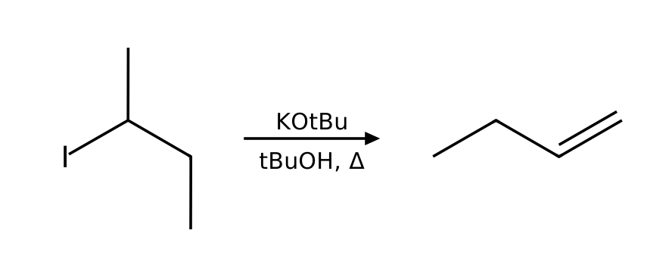
Why: Substrate: secondary (2°) alkyl halide; Leaving group: excellent leaving group (I); Nucleophile/base: tert-butoxide is a strong nucleophile and a strong base (bulky); Solvent: tBuOH is protic. These favor E2. Competing pathway: SN1/E1 do not compete under strongly basic conditions.
62. Predict the major organic product of 2-bromopentane with NaOH in EtOH. State the mechanism and any minor pathway. [P018, Basic]
Answer: (E)-pent-2-ene via E2. Minor: SN1/E1 do not compete under strongly basic conditions.
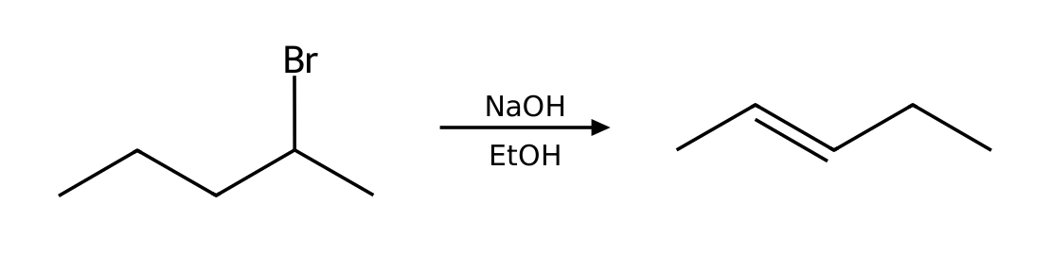
Why: Substrate: secondary (2°) alkyl halide; Leaving group: good leaving group (Br); Nucleophile/base: hydroxide is a strong nucleophile and a strong base; Solvent: EtOH is protic. These favor E2. Competing pathway: SN1/E1 do not compete under strongly basic conditions.
63. Predict the major organic product of bromocyclohexane with NaOEt in EtOH. State the mechanism and any minor pathway. [P019, Basic]
Answer: cyclohexene via E2. Minor: SN1/E1 do not compete under strongly basic conditions.
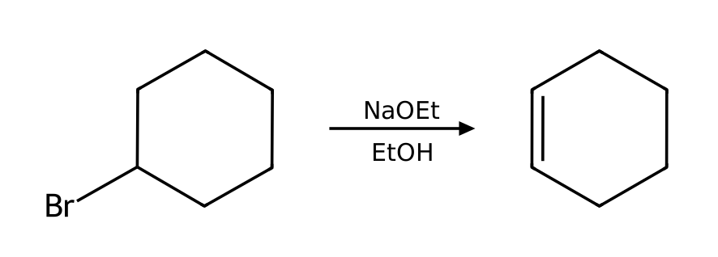
Why: Substrate: secondary (2°) alkyl halide; Leaving group: good leaving group (Br); Nucleophile/base: ethoxide is a strong nucleophile and a strong base; Solvent: EtOH is protic. These favor E2. Competing pathway: SN1/E1 do not compete under strongly basic conditions.
64. Predict the major organic product of 1-bromo-1-methylcyclohexane with KOtBu in tBuOH. State the mechanism and any minor pathway. [P020, Basic]
Answer: methylenecyclohexane via E2. Minor: SN1/E1 do not compete under strongly basic conditions.
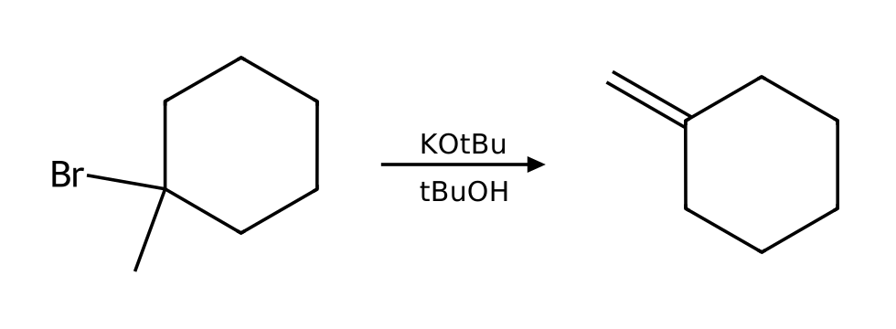
Why: Substrate: tertiary (3°) alkyl halide; Leaving group: good leaving group (Br); Nucleophile/base: tert-butoxide is a strong nucleophile and a strong base (bulky); Solvent: tBuOH is protic. These favor E2. Competing pathway: SN1/E1 do not compete under strongly basic conditions.
65. Which mechanism (SN1, SN2, E1 or E2) predominates when 2-bromopentane reacts with NaOH in EtOH? List the factors that support your answer and give the major product. [P025, Basic]
Answer: E2. Major product: (E)-pent-2-ene.
Why: Substrate: secondary (2°) alkyl halide; Leaving group: good leaving group (Br); Nucleophile/base: hydroxide is a strong nucleophile and a strong base; Solvent: EtOH is protic. These favor E2. Competing pathway: SN1/E1 do not compete under strongly basic conditions.
66. Which mechanism (SN1, SN2, E1 or E2) predominates when 1-bromopropane reacts with KOtBu in tBuOH? List the factors that support your answer and give the major product. [P026, Basic]
Answer: E2. Major product: prop-1-ene.
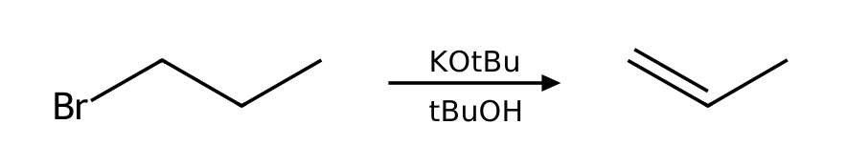
Why: Substrate: primary (1°) alkyl halide; Leaving group: good leaving group (Br); Nucleophile/base: tert-butoxide is a strong nucleophile and a strong base (bulky); Solvent: tBuOH is protic. These favor E2. Competing pathway: SN2 (minor).
67. Which mechanism (SN1, SN2, E1 or E2) predominates when 3-bromo-3-methylpentane reacts with NaOMe in MeOH? List the factors that support your answer and give the major product. [P027, Basic]
Answer: E2. Major product: 3-methylpent-2-ene.
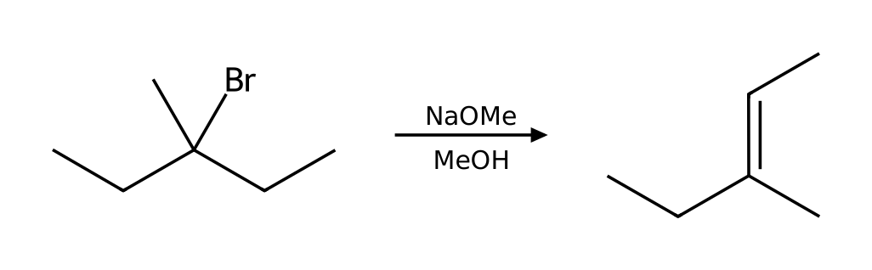
Why: Substrate: tertiary (3°) alkyl halide; Leaving group: good leaving group (Br); Nucleophile/base: methoxide is a strong nucleophile and a strong base; Solvent: MeOH is protic. These favor E2. Competing pathway: SN1/E1 do not compete under strongly basic conditions.
68. Which mechanism (SN1, SN2, E1 or E2) predominates when 2-bromo-2-methylbutane reacts with NaOEt in EtOH? List the factors that support your answer and give the major product. [P029, Basic]
Answer: E2. Major product: 2-methylbut-2-ene.
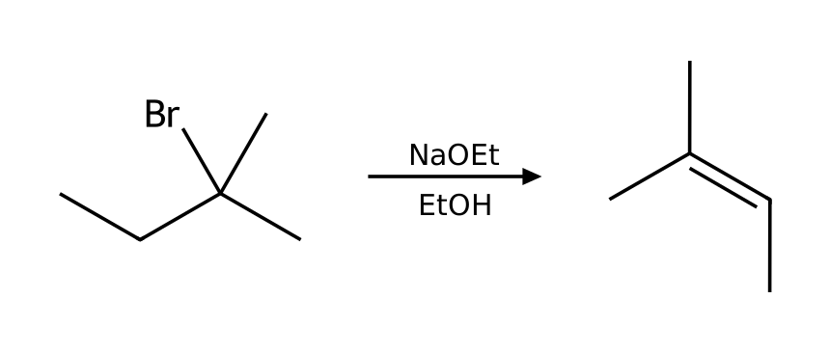
Why: Substrate: tertiary (3°) alkyl halide; Leaving group: good leaving group (Br); Nucleophile/base: ethoxide is a strong nucleophile and a strong base; Solvent: EtOH is protic. These favor E2. Competing pathway: SN1/E1 do not compete under strongly basic conditions.
69. Describe the complete mechanism (list each step and the curved arrows) for the reaction of 2-bromobutane with NaOEt in EtOH. How many steps are there? [P042, Moderate]
Answer: (1) One concerted step: the base removes a β hydrogen (anti to the leaving group) as the π bond forms and the leaving group departs.
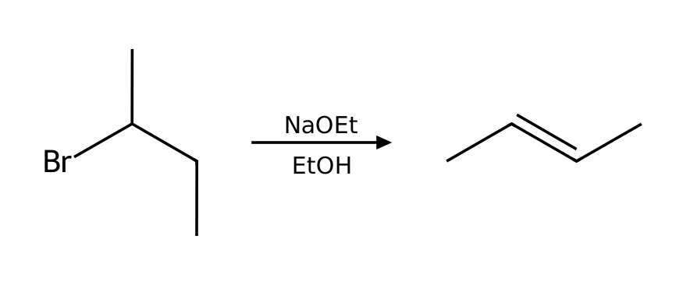
Why: Each ionic mechanism is built from nucleophilic attack, loss of a leaving group, proton transfer and rearrangement. Substrate: secondary (2°) alkyl halide; Leaving group: good leaving group (Br); Nucleophile/base: ethoxide is a strong nucleophile and a strong base; Solvent: EtOH is protic. These favor E2. Competing pathway: SN1/E1 do not compete under strongly basic conditions.
70. The reaction of 2-bromobutane with NaOEt in EtOH follows the mechanism predicted for these conditions. Write the rate law. What happens to the rate if (a) [substrate] is doubled and [ethoxide] is unchanged, and (b) [ethoxide] is tripled and [substrate] is unchanged? [P094, Basic]
Answer: E2: rate = k[substrate][base]. (a) Rate doubles. (b) Rate triples.
Why: The rate law reflects the species in the rate-determining step.

7.6 Stability of Alkenes and Cycloalkenes
71. Which alkene is most stable? [C07M26, Easy]
Answer: A) The most substituted alkene
Why: Hyperconjugation stabilises substituted alkenes.
72. Which is the most stable alkene? [C07M27, Basic]
Answer: B) 2-Methylbut-2-ene
Why: The trisubstituted alkene is more stable than the di- or monosubstituted ones.
73. Which is more stable: cis- or trans-but-2-ene, and why? [C07M28, Moderate]
Answer: A) trans, because the methyl groups are farther apart and there is less steric strain
Why: Steric strain destabilizes the cis isomer.
74. Which cycloalkene is least able to contain a trans double bond? [C07M29, Moderate]
Answer: A) Cyclohexene
Why: A trans double bond in a small ring would be too strained.

7.7 Regiochemical and Stereochemical Outcomes of E2
75. In an E2 reaction of 2-bromo-2-methylbutane with sodium ethoxide, the major product is: [C07M30, Basic]
Answer: B) 2-Methylbut-2-ene
Why: The Zaitsev (more substituted) alkene is favored with a small base.
76. Using potassium tert-butoxide instead of ethoxide on 2-bromo-2-methylbutane gives mostly: [C07M31, Moderate]
Answer: B) 2-Methylbut-1-ene
Why: A bulky base removes the less hindered β proton, giving the less substituted (Hofmann) alkene.
77. An E2 reaction produces a new stereogenic alkene. Which isomer is typically major? [C07M32, Moderate]
Answer: C) The trans (E) isomer
Why: The more stable alkene forms faster.
78. Which β hydrogens of a cyclohexyl bromide can undergo E2 elimination? [C07M33, Hard]
Answer: C) Only those anti-coplanar to the bromine (axial-axial)
Why: In a chair, the leaving group and the hydrogen must both be axial.
79. (S)-2-bromobutane is treated with NaOEt in EtOH. What is the major product? Does the stereocenter of the starting material appear in the product? [P037, Moderate]
Answer: (E)-but-2-ene (Zaitsev, trans); the product has no stereocenter, so the configuration of the substrate is lost.
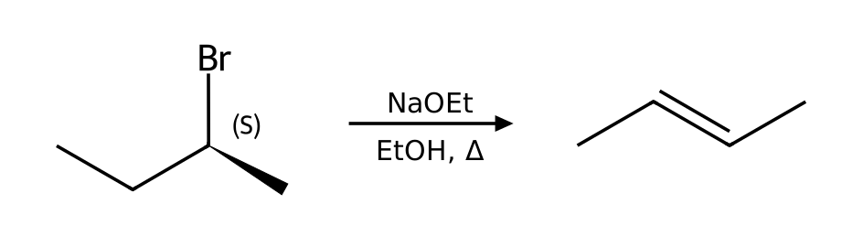
Why: Substrate: secondary (2°) alkyl halide; Leaving group: good leaving group (Br); Nucleophile/base: ethoxide is a strong nucleophile and a strong base; Solvent: EtOH is protic. These favor E2. Competing pathway: SN1/E1 do not compete under strongly basic conditions. Anti-periplanar elimination; the more stable trans (E) alkene predominates.
80. Starting from 2-bromo-2-methylbutane, choose reagents to make (a) the more substituted alkene and (b) the less substituted alkene. Give both products. [P074, Moderate]
Answer: (a) NaOEt/EtOH (small base, Zaitsev): 2-methylbut-2-ene. (b) KOtBu/tBuOH (bulky base, Hofmann): 2-methylbut-1-ene.
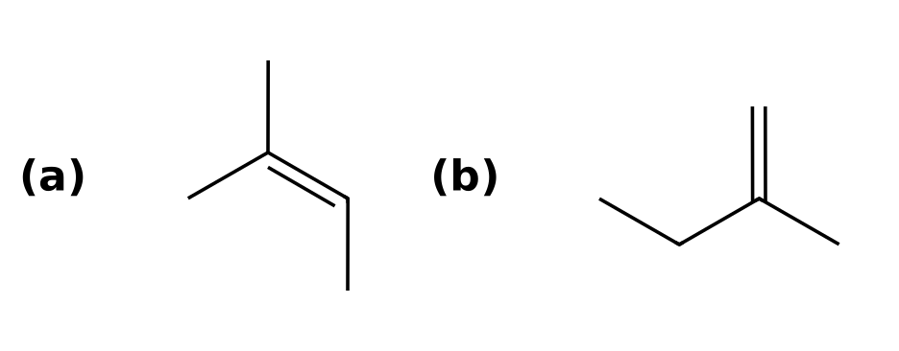
Why: A small base removes the β hydrogen that leads to the more stable, more substituted alkene (Zaitsev). A bulky base removes the more accessible, less hindered hydrogen (Hofmann).
81. Starting from 2-bromobutane, choose reagents to make (a) the more substituted alkene and (b) the less substituted alkene. Give both products. [P075, Moderate]
Answer: (a) NaOEt/EtOH (small base, Zaitsev): (E)-but-2-ene. (b) KOtBu/tBuOH (bulky base, Hofmann): but-1-ene.
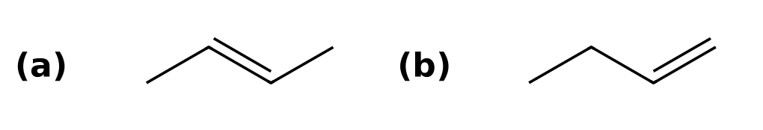
Why: A small base removes the β hydrogen that leads to the more stable, more substituted alkene (Zaitsev). A bulky base removes the more accessible, less hindered hydrogen (Hofmann).
82. Starting from 2-bromopentane, choose reagents to make (a) the more substituted alkene and (b) the less substituted alkene. Give both products. [P076, Moderate]
Answer: (a) NaOEt/EtOH (small base, Zaitsev): (E)-pent-2-ene. (b) KOtBu/tBuOH (bulky base, Hofmann): pent-1-ene.
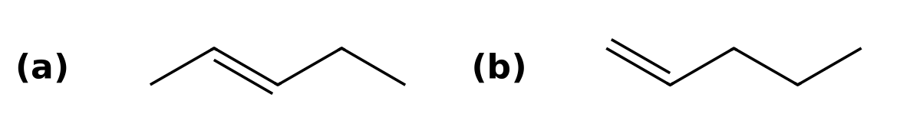
Why: A small base removes the β hydrogen that leads to the more stable, more substituted alkene (Zaitsev). A bulky base removes the more accessible, less hindered hydrogen (Hofmann).
83. Starting from 1-bromo-1-methylcyclohexane, choose reagents to make (a) the more substituted alkene and (b) the less substituted alkene. Give both products. [P077, Moderate]
Answer: (a) NaOEt/EtOH (small base, Zaitsev): 1-methylcyclohexene. (b) KOtBu/tBuOH (bulky base, Hofmann): methylenecyclohexane.
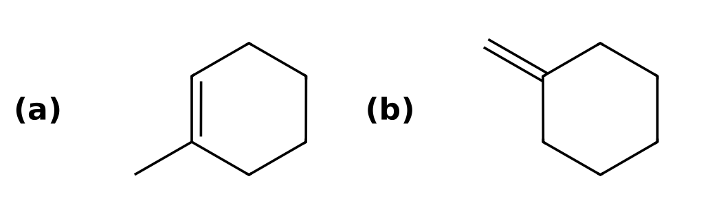
Why: A small base removes the β hydrogen that leads to the more stable, more substituted alkene (Zaitsev). A bulky base removes the more accessible, less hindered hydrogen (Hofmann).
84. Starting from 3-bromo-3-methylpentane, choose reagents to make (a) the more substituted alkene and (b) the less substituted alkene. Give both products. [P078, Moderate]
Answer: (a) NaOEt/EtOH (small base, Zaitsev): 3-methylpent-2-ene. (b) KOtBu/tBuOH (bulky base, Hofmann): 2-ethylbut-1-ene.
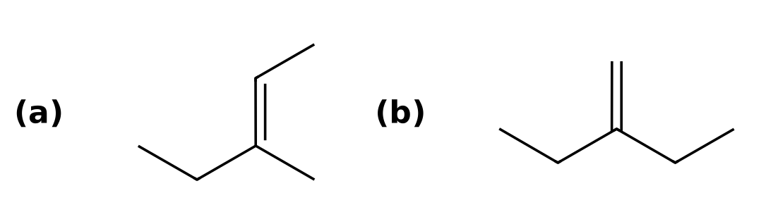
Why: A small base removes the β hydrogen that leads to the more stable, more substituted alkene (Zaitsev). A bulky base removes the more accessible, less hindered hydrogen (Hofmann).

7.8 Unimolecular Reactions (SN1 and E1)
85. What does SN1 stand for? [C07M34, Easy]
Answer: A) Substitution, nucleophilic, unimolecular
Why: The slow step involves only the substrate.
86. In an SN1 reaction, the rate-determining step is: [C07M35, Basic]
Answer: C) Loss of the leaving group to give a carbocation
Why: The first step has the highest barrier.
87. Which substrate reacts fastest by SN1? [C07M36, Basic]
Answer: A) tert-Butyl bromide
Why: A tertiary carbocation is the most stable.
88. A chirality center undergoes SN1 substitution. The product is typically: [C07M37, Moderate]
Answer: B) A mixture of enantiomers (racemic)
Why: The planar carbocation can be attacked from either face.
89. Which species is an intermediate in E1 and SN1 reactions? [C07M38, Moderate]
Answer: D) A carbocation
Why: Both mechanisms start with loss of the leaving group.
90. What reagent(s) and solvent would convert 2-bromo-2-methylpropane into 2-methylpropan-2-ol? Name the mechanism and justify your choice with the four factors (substrate, nucleophile, leaving group, solvent). [P006, Basic]
Answer: H₂o as the solvent (SN1).
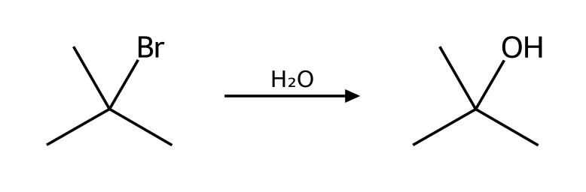
Why: Substrate: tertiary (3°) alkyl halide; Leaving group: good leaving group (Br); Nucleophile/base: water is a weak nucleophile and a weak base; Solvent: H2O is protic. These favor SN1. Competing pathway: E1 (minor; favored by heat).
91. Predict the major organic product of 2-chloro-2-methylbutane with EtOH as the solvent. State the mechanism and any minor pathway. [P016, Basic]
Answer: 2-ethoxy-2-methylbutane via SN1. Minor: E1 (minor; favored by heat).
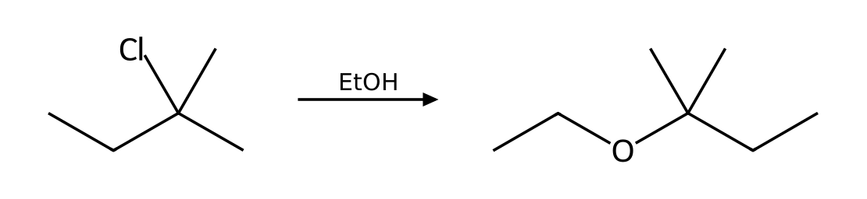
Why: Substrate: tertiary (3°) alkyl halide; Leaving group: good leaving group (Cl); Nucleophile/base: ethanol is a weak nucleophile and a weak base; Solvent: EtOH is protic. These favor SN1. Competing pathway: E1 (minor; favored by heat).
92. Predict the major organic product of 1-bromo-1-methylcyclohexane with MeOH as the solvent. State the mechanism and any minor pathway. [P017, Basic]
Answer: 1-methoxy-1-methylcyclohexane via SN1. Minor: E1 (minor; favored by heat).
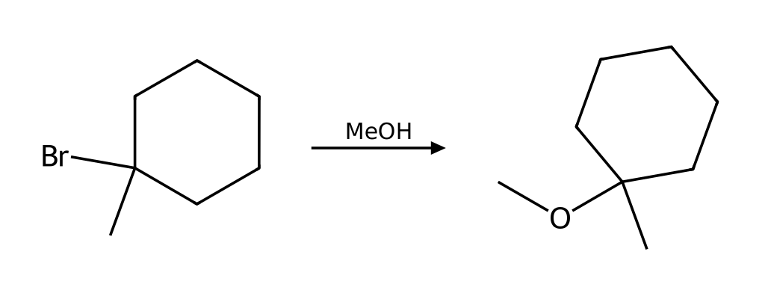
Why: Substrate: tertiary (3°) alkyl halide; Leaving group: good leaving group (Br); Nucleophile/base: methanol is a weak nucleophile and a weak base; Solvent: MeOH is protic. These favor SN1. Competing pathway: E1 (minor; favored by heat).
93. Which mechanism (SN1, SN2, E1 or E2) predominates when 3-bromo-3-methylpentane reacts with EtOH as the solvent? List the factors that support your answer and give the major product. [P023, Basic]
Answer: SN1. Major product: 3-ethoxy-3-methylpentane.
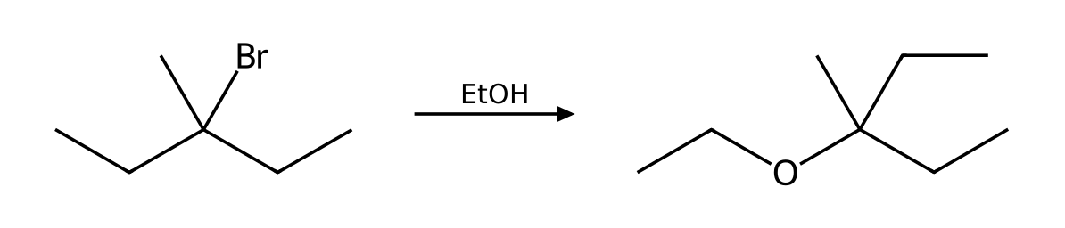
Why: Substrate: tertiary (3°) alkyl halide; Leaving group: good leaving group (Br); Nucleophile/base: ethanol is a weak nucleophile and a weak base; Solvent: EtOH is protic. These favor SN1. Competing pathway: E1 (minor; favored by heat).
94. Which mechanism (SN1, SN2, E1 or E2) predominates when 2-iodo-2-methylpropane reacts with CH₃CO₂H as the solvent? List the factors that support your answer and give the major product. [P024, Basic]
Answer: SN1. Major product: tert-butyl ethanoate.
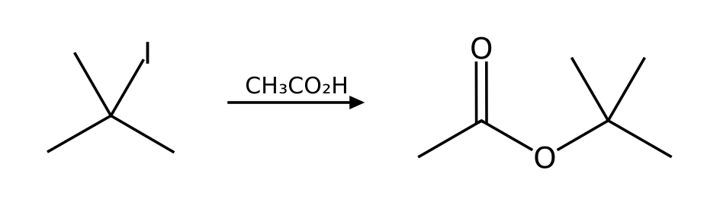
Why: Substrate: tertiary (3°) alkyl halide; Leaving group: excellent leaving group (I); Nucleophile/base: acetic acid is a weak nucleophile and a weak base; Solvent: AcOH is protic. These favor SN1. Competing pathway: E1 (minor; favored by heat).
95. (R)-3-bromo-3-methylhexane reacts with MeOH as the solvent. Draw the product(s), including stereochemistry, and explain why the result differs from an SN2 reaction. [P034, Moderate]
Answer: Both enantiomers form: (S)-3-methoxy-3-methylhexane (inversion, slightly in excess because of ion pairing) and (R)-3-methoxy-3-methylhexane (retention).
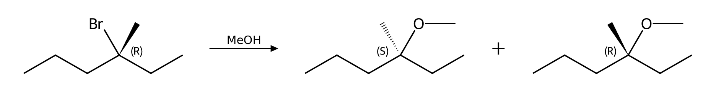
Why: The leaving group departs first to give a planar carbocation, which the solvent attacks from either face, so the stereocenter racemizes. Substrate: tertiary (3°) alkyl halide; Leaving group: good leaving group (Br); Nucleophile/base: methanol is a weak nucleophile and a weak base; Solvent: MeOH is protic. These favor SN1. Competing pathway: E1 (minor; favored by heat).
96. (S)-3-chloro-3-methylhexane reacts with EtOH as the solvent. Draw the product(s), including stereochemistry, and explain why the result differs from an SN2 reaction. [P035, Moderate]
Answer: Both enantiomers form: (R)-3-ethoxy-3-methylhexane (inversion, slightly in excess because of ion pairing) and (S)-3-ethoxy-3-methylhexane (retention).
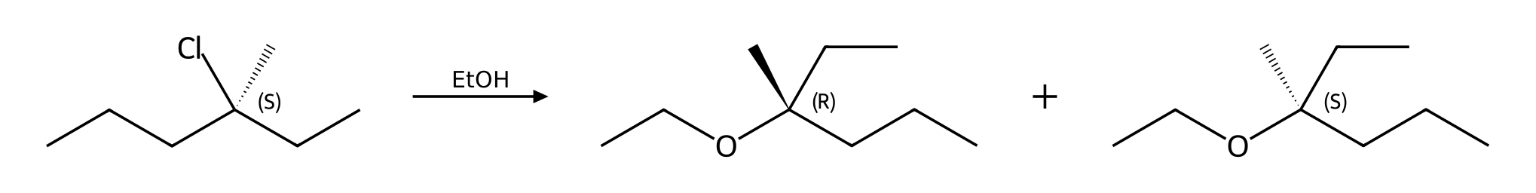
Why: The leaving group departs first to give a planar carbocation, which the solvent attacks from either face, so the stereocenter racemizes. Substrate: tertiary (3°) alkyl halide; Leaving group: good leaving group (Cl); Nucleophile/base: ethanol is a weak nucleophile and a weak base; Solvent: EtOH is protic. These favor SN1. Competing pathway: E1 (minor; favored by heat).
97. (S)-3-bromo-3-methylhexane reacts with H₂O as the solvent. Draw the product(s), including stereochemistry, and explain why the result differs from an SN2 reaction. [P036, Moderate]
Answer: Both enantiomers form: (R)-3-methylhexan-3-ol (inversion, slightly in excess because of ion pairing) and (S)-3-methylhexan-3-ol (retention).
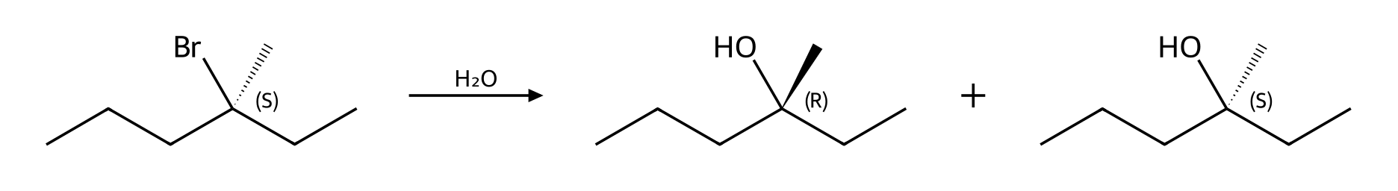
Why: The leaving group departs first to give a planar carbocation, which the solvent attacks from either face, so the stereocenter racemizes. Substrate: tertiary (3°) alkyl halide; Leaving group: good leaving group (Br); Nucleophile/base: water is a weak nucleophile and a weak base; Solvent: H2O is protic. These favor SN1. Competing pathway: E1 (minor; favored by heat).
98. Describe the complete mechanism (list each step and the curved arrows) for the reaction of 2-bromo-2-methylpropane with H₂O as the solvent. How many steps are there? [P040, Moderate]
Answer: (1) Loss of the leaving group gives a planar carbocation (rate-determining step). (2) Nucleophilic attack on the carbocation (either face). (3) Proton transfer removes the positive charge from the oxonium ion.
Why: Each ionic mechanism is built from nucleophilic attack, loss of a leaving group, proton transfer and rearrangement. Substrate: tertiary (3°) alkyl halide; Leaving group: good leaving group (Br); Nucleophile/base: water is a weak nucleophile and a weak base; Solvent: H2O is protic. These favor SN1. Competing pathway: E1 (minor; favored by heat).
99. Describe the complete mechanism (list each step and the curved arrows) for the reaction of 2-chloro-2-methylbutane with EtOH as the solvent. How many steps are there? [P041, Moderate]
Answer: (1) Loss of the leaving group gives a planar carbocation (rate-determining step). (2) Nucleophilic attack on the carbocation (either face). (3) Proton transfer removes the positive charge from the oxonium ion.
Why: Each ionic mechanism is built from nucleophilic attack, loss of a leaving group, proton transfer and rearrangement. Substrate: tertiary (3°) alkyl halide; Leaving group: good leaving group (Cl); Nucleophile/base: ethanol is a weak nucleophile and a weak base; Solvent: EtOH is protic. These favor SN1. Competing pathway: E1 (minor; favored by heat).
100. Describe the complete mechanism (list each step and the curved arrows) for the reaction of 2-bromo-2-methylbutane with MeOH as the solvent. How many steps are there? [P045, Moderate]
Answer: (1) Loss of the leaving group gives a planar carbocation (rate-determining step). (2) Nucleophilic attack on the carbocation (either face). (3) Proton transfer removes the positive charge from the oxonium ion.
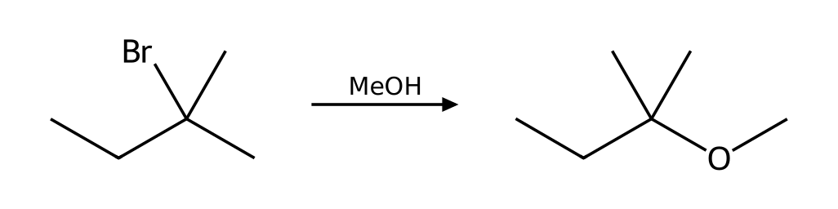
Why: Each ionic mechanism is built from nucleophilic attack, loss of a leaving group, proton transfer and rearrangement. Substrate: tertiary (3°) alkyl halide; Leaving group: good leaving group (Br); Nucleophile/base: methanol is a weak nucleophile and a weak base; Solvent: MeOH is protic. These favor SN1. Competing pathway: E1 (minor; favored by heat).
101. Will 2-bromo-3-methylbutane rearrange when heated in EtOH? Show the carbocation that forms, the shift involved, and the major substitution product. [P065, Moderate]
Answer: Yes: hydride shift converts the initial cation into a more stable tertiary cation; major product 2-ethoxy-2-methylbutane.
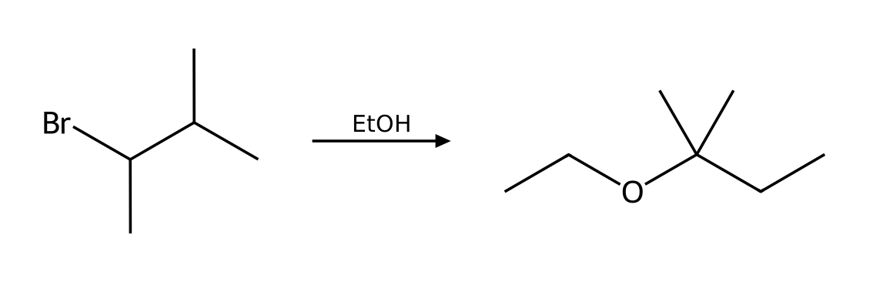
Why: (1) Loss of the leaving group gives a planar carbocation (rate-determining step). (2) Carbocation rearrangement (hydride shift) gives a more stable carbocation. (3) Nucleophilic attack on the carbocation (either face). (4) Proton transfer removes the positive charge from the oxonium ion. Substrate: secondary (2°) alkyl halide; Leaving group: good leaving group (Br); Nucleophile/base: ethanol is a weak nucleophile and a weak base; Solvent: EtOH is protic. These favor SN1.
102. Will 1-bromo-2,2-dimethylpropane rearrange when heated in EtOH? Show the carbocation that forms, the shift involved, and the major substitution product. [P066, Moderate]
Answer: Yes: methyl shift converts the initial cation into a more stable tertiary cation; major product 1-ethoxy-2,2-dimethylpropane.
Why: (1) One concerted step: the nucleophile attacks the α carbon from the back side while the leaving group departs (inversion). (2) Proton transfer: a base removes the proton from the positively charged nucleophile atom. Substrate: primary (1°) alkyl halide; Leaving group: good leaving group (Br); Nucleophile/base: ethanol is a weak nucleophile and a weak base; Solvent: EtOH is protic. These favor SN2.
103. Will 3-bromo-2,2-dimethylbutane rearrange when heated in MeOH? Show the carbocation that forms, the shift involved, and the major substitution product. [P067, Moderate]
Answer: Yes: methyl shift converts the initial cation into a more stable tertiary cation; major product 2-methoxy-2,3-dimethylbutane.
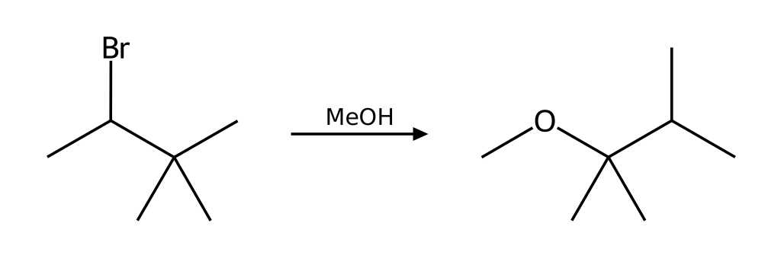
Why: (1) Loss of the leaving group gives a planar carbocation (rate-determining step). (2) Carbocation rearrangement (methyl shift) gives a more stable carbocation. (3) Nucleophilic attack on the carbocation (either face). (4) Proton transfer removes the positive charge from the oxonium ion. Substrate: secondary (2°) alkyl halide; Leaving group: good leaving group (Br); Nucleophile/base: methanol is a weak nucleophile and a weak base; Solvent: MeOH is protic. These favor SN1.
104. Will 2-bromo-3-methylpentane rearrange when heated in MeOH? Show the carbocation that forms, the shift involved, and the major substitution product. [P068, Moderate]
Answer: Yes: hydride shift converts the initial cation into a more stable tertiary cation; major product 3-methoxy-3-methylpentane.
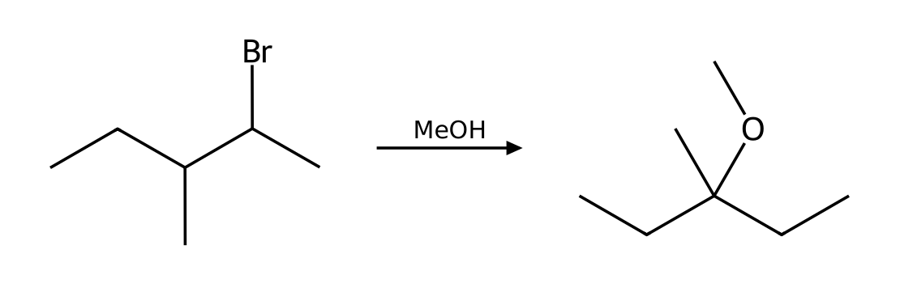
Why: (1) Loss of the leaving group gives a planar carbocation (rate-determining step). (2) Carbocation rearrangement (hydride shift) gives a more stable carbocation. (3) Nucleophilic attack on the carbocation (either face). (4) Proton transfer removes the positive charge from the oxonium ion. Substrate: secondary (2°) alkyl halide; Leaving group: good leaving group (Br); Nucleophile/base: methanol is a weak nucleophile and a weak base; Solvent: MeOH is protic. These favor SN1.
105. Predict the major alkene from heating 3-methylbutan-2-ol with H₂SO₄. Explain the rearrangement. [P069, Moderate]
Answer: 2-methylbut-2-ene via E1 after a hydride shift.
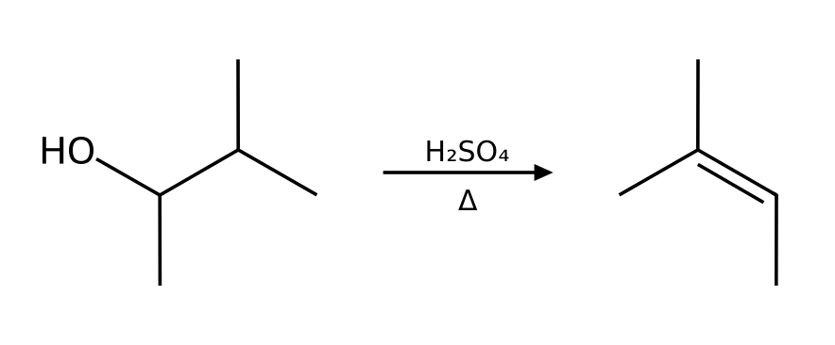
Why: (1) Proton transfer: the acid protonates the OH group. (2) Loss of water gives a carbocation (rate-determining step). (3) Carbocation rearrangement (hydride shift) gives a more stable carbocation. (4) A base (water or HSO₄⁻) removes a β hydrogen next to the cation, forming the alkene. Zaitsev elimination from the rearranged tertiary cation.
106. What happens when 2-methylpropan-2-ol is heated with concentrated H₂SO₄? Give the major product, name the mechanism and explain why the OH must be protonated first. [P070, Basic]
Answer: 2-methylprop-1-ene via E1.
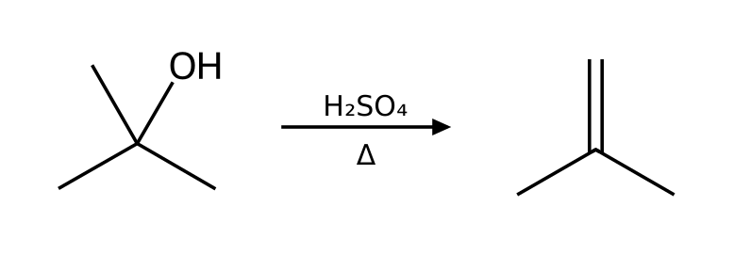
Why: (1) Proton transfer: the acid protonates the OH group. (2) Loss of water gives a carbocation (rate-determining step). (3) A base (water or HSO₄⁻) removes a β hydrogen next to the cation, forming the alkene.
107. What happens when 2-methylbutan-2-ol is heated with concentrated H₂SO₄? Give the major product, name the mechanism and explain why the OH must be protonated first. [P071, Basic]
Answer: 2-methylbut-2-ene via E1 (Zaitsev).
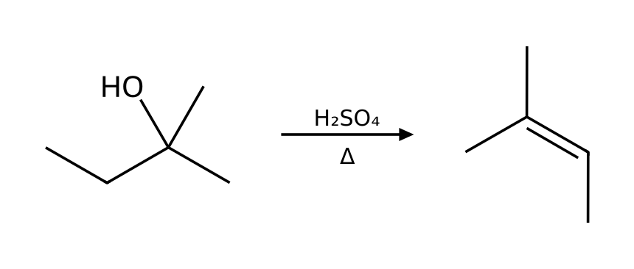
Why: (1) Proton transfer: the acid protonates the OH group. (2) Loss of water gives a carbocation (rate-determining step). (3) A base (water or HSO₄⁻) removes a β hydrogen next to the cation, forming the alkene.
108. What happens when 1-methylcyclohexan-1-ol is heated with concentrated H₂SO₄? Give the major product, name the mechanism and explain why the OH must be protonated first. [P072, Basic]
Answer: 1-methylcyclohexene via E1 (Zaitsev).
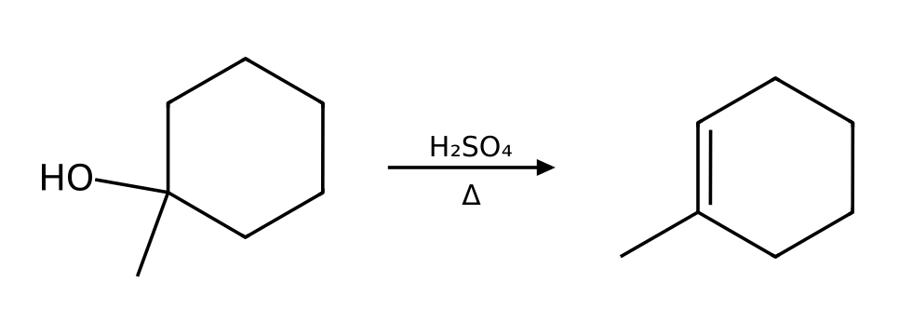
Why: (1) Proton transfer: the acid protonates the OH group. (2) Loss of water gives a carbocation (rate-determining step). (3) A base (water or HSO₄⁻) removes a β hydrogen next to the cation, forming the alkene.
109. What happens when butan-2-ol is heated with concentrated H₂SO₄? Give the major product, name the mechanism and explain why the OH must be protonated first. [P073, Basic]
Answer: (E)-but-2-ene via E1 (Zaitsev).
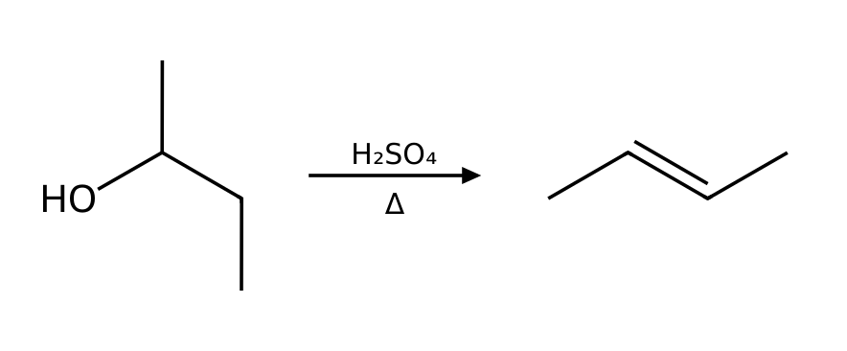
Why: (1) Proton transfer: the acid protonates the OH group. (2) Loss of water gives a carbocation (rate-determining step). (3) A base (water or HSO₄⁻) removes a β hydrogen next to the cation, forming the alkene.
110. The reaction of 2-chloro-2-methylbutane with EtOH as the solvent follows the mechanism predicted for these conditions. Write the rate law. What happens to the rate if (a) [substrate] is doubled and [ethanol] is unchanged, and (b) [ethanol] is tripled and [substrate] is unchanged? [P093, Basic]
Answer: SN1: rate = k[substrate]. (a) Rate doubles. (b) No change.
Why: The rate law reflects the species in the rate-determining step.

7.9 Predicting Products: Substitution vs. Elimination
111. A tertiary alkyl halide with a strong base (NaOEt) gives mainly: [C07M39, Basic]
Answer: C) E2 elimination
Why: A strong base with a hindered substrate favors elimination.
112. A primary alkyl halide with a strong nucleophile that is a weak base (NaCN) gives mainly: [C07M40, Basic]
Answer: A) SN2 substitution
Why: Unhindered substrate plus good nucleophile gives SN2.
113. A tertiary alkyl halide in warm ethanol (no strong base) gives: [C07M41, Moderate]
Answer: D) A mixture of SN1 and E1 products
Why: The solvent is a weak nucleophile and weak base.
114. Which conditions favor E2 over SN2 for a secondary alkyl halide? [C07M42, Moderate]
Answer: B) A strong, bulky base and heat
Why: Heat and strong or bulky bases favor elimination.
115. Which substrate/reagent pair gives mainly the SN2 product? [C07M43, Hard]
Answer: D) CH₃CH₂CH₂Br with NaN₃
Why: Only the primary halide with a nucleophile that is a weak base gives SN2.
116. A student predicts an SN2 reaction to give a nitrile. Reaction: 2-bromo-2-methylpropane + NaCN in DMSO. Explain what is wrong and give the correct outcome. [P046, Basic]
Answer: No SN2: a tertiary carbon is too hindered for back-side attack. Cyanide is a weak base but the only feasible path is E2, giving 2-methylpropene (isobutylene).
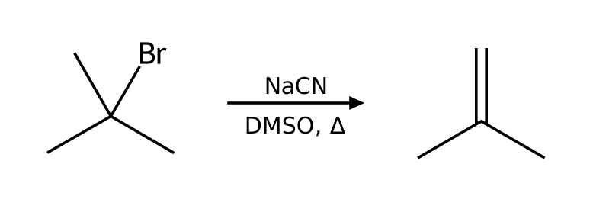
Why: Apply the four factors in order: substrate, nucleophile/base, leaving group, solvent.
117. A student says a primary halide always reacts quickly by SN2. Reaction: 1-bromo-2,2-dimethylpropane + NaOH in DMSO. Explain what is wrong and give the correct outcome. [P047, Basic]
Answer: Neopentyl bromide is primary but the three β methyl groups block back-side attack; SN2 is extremely slow (like a tertiary substrate). The primary carbocation is also too unstable for SN1.
Why: Apply the four factors in order: substrate, nucleophile/base, leaving group, solvent.
118. A student predicts substitution to give vinyl alcohol. Reaction: bromoethene (vinyl bromide) + NaOH in DMSO. Explain what is wrong and give the correct outcome. [P048, Basic]
Answer: Vinyl halides do not react by SN2 (sp² carbon, back side blocked) or SN1 (unstable vinyl cation). No substitution occurs.
Why: Apply the four factors in order: substrate, nucleophile/base, leaving group, solvent.
119. A student predicts benzonitrile. Reaction: bromobenzene + NaCN in DMSO. Explain what is wrong and give the correct outcome. [P049, Basic]
Answer: Aryl halides do not undergo SN2 or SN1: back-side attack is impossible and the phenyl cation is unstable. No reaction under these conditions.
Why: Apply the four factors in order: substrate, nucleophile/base, leaving group, solvent.
120. A student predicts 1-bromobutane. Reaction: butan-1-ol + NaBr in DMF. Explain what is wrong and give the correct outcome. [P050, Basic]
Answer: Hydroxide is a poor leaving group (strong base), so bromide cannot displace it. The OH must first be protonated (HBr) or converted to a tosylate or bromide with PBr₃.
Why: Apply the four factors in order: substrate, nucleophile/base, leaving group, solvent.
121. A student predicts the ether 2-ethoxybutane by SN2. Reaction: 2-bromobutane + NaOEt in EtOH. Explain what is wrong and give the correct outcome. [P051, Basic]
Answer: Ethoxide is a strong base and the substrate is secondary, so E2 predominates: (E)-but-2-ene is the major product with some but-1-ene.
Why: Apply the four factors in order: substrate, nucleophile/base, leaving group, solvent.
122. A student predicts butanenitrile. Reaction: 1-fluoropropane + NaCN in DMSO. Explain what is wrong and give the correct outcome. [P052, Basic]
Answer: Fluoride is a poor leaving group (conjugate base of a weak acid, HF), so no SN2 reaction occurs at a useful rate.
Why: Apply the four factors in order: substrate, nucleophile/base, leaving group, solvent.
123. 2-bromopropane is treated under two different conditions: (a) NaCN in DMSO; (b) NaOEt in EtOH with heat. For each, name the mechanism and the major product. [P053, Moderate]
Answer: (a) SN2: 2-methylpropanenitrile. (b) E2: prop-1-ene.
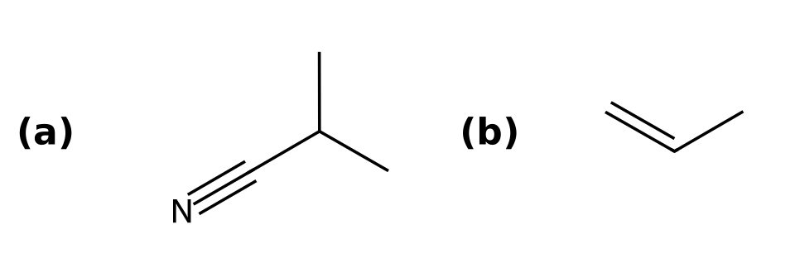
Why: (a) Substrate: secondary (2°) alkyl halide; Leaving group: good leaving group (Br); Nucleophile/base: cyanide is a strong nucleophile and a weak base; Solvent: DMSO is aprotic. These favor SN2. (b) Substrate: secondary (2°) alkyl halide; Leaving group: good leaving group (Br); Nucleophile/base: ethoxide is a strong nucleophile and a strong base; Solvent: EtOH is protic. These favor E2.
124. 2-bromo-2-methylbutane is treated under two different conditions: (a) EtOH in EtOH; (b) NaOEt in EtOH with heat. For each, name the mechanism and the major product. [P054, Moderate]
Answer: (a) SN1: 2-ethoxy-2-methylbutane. (b) E2: 2-methylbut-2-ene.
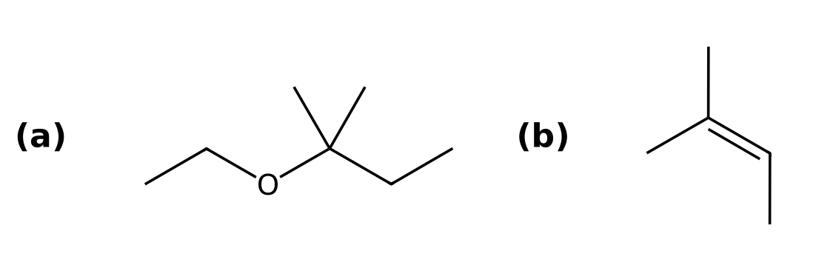
Why: (a) Substrate: tertiary (3°) alkyl halide; Leaving group: good leaving group (Br); Nucleophile/base: ethanol is a weak nucleophile and a weak base; Solvent: EtOH is protic. These favor SN1. (b) Substrate: tertiary (3°) alkyl halide; Leaving group: good leaving group (Br); Nucleophile/base: ethoxide is a strong nucleophile and a strong base; Solvent: EtOH is protic. These favor E2.
125. 1-bromopropane is treated under two different conditions: (a) NaOEt in EtOH; (b) KOtBu in tBuOH. For each, name the mechanism and the major product. [P055, Moderate]
Answer: (a) SN2: 1-ethoxypropane. (b) E2: prop-1-ene.
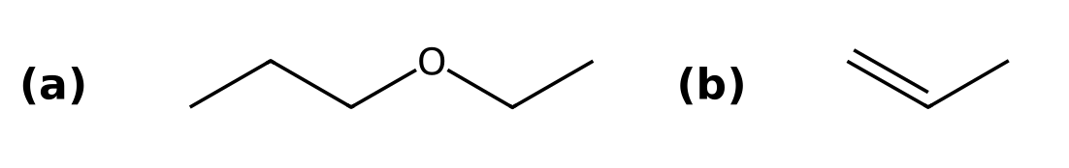
Why: (a) Substrate: primary (1°) alkyl halide; Leaving group: good leaving group (Br); Nucleophile/base: ethoxide is a strong nucleophile and a strong base; Solvent: EtOH is protic. These favor SN2. (b) Substrate: primary (1°) alkyl halide; Leaving group: good leaving group (Br); Nucleophile/base: tert-butoxide is a strong nucleophile and a strong base (bulky); Solvent: tBuOH is protic. These favor E2.
126. 2-bromobutane is treated under two different conditions: (a) NaN₃ in DMF; (b) KOtBu in tBuOH. For each, name the mechanism and the major product. [P056, Moderate]
Answer: (a) SN2: 2-azidobutane. (b) E2: but-1-ene.
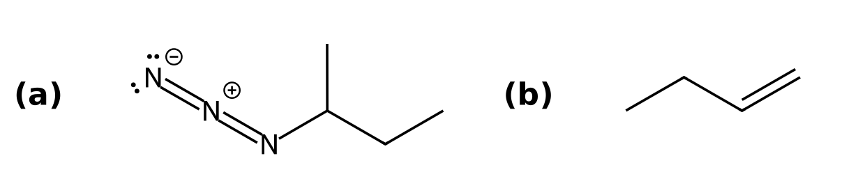
Why: (a) Substrate: secondary (2°) alkyl halide; Leaving group: good leaving group (Br); Nucleophile/base: azide is a strong nucleophile and a weak base; Solvent: DMF is aprotic. These favor SN2. (b) Substrate: secondary (2°) alkyl halide; Leaving group: good leaving group (Br); Nucleophile/base: tert-butoxide is a strong nucleophile and a strong base (bulky); Solvent: tBuOH is protic. These favor E2.
127. 2-bromo-2-methylpropane is treated under two different conditions: (a) H₂O in H2O; (b) NaOH in EtOH with heat. For each, name the mechanism and the major product. [P057, Moderate]
Answer: (a) SN1: 2-methylpropan-2-ol. (b) E2: 2-methylprop-1-ene.
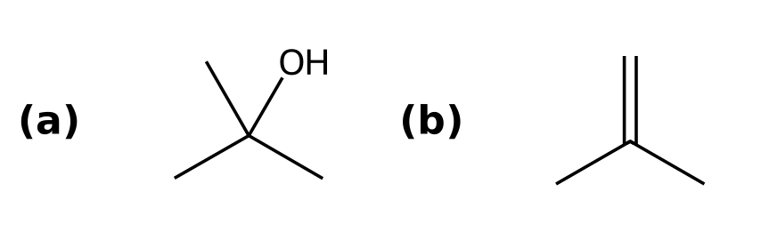
Why: (a) Substrate: tertiary (3°) alkyl halide; Leaving group: good leaving group (Br); Nucleophile/base: water is a weak nucleophile and a weak base; Solvent: H2O is protic. These favor SN1. (b) Substrate: tertiary (3°) alkyl halide; Leaving group: good leaving group (Br); Nucleophile/base: hydroxide is a strong nucleophile and a strong base; Solvent: EtOH is protic. These favor E2.
128. bromocyclohexane is treated under two different conditions: (a) NaSH in DMSO; (b) NaOMe in MeOH with heat. For each, name the mechanism and the major product. [P058, Moderate]
Answer: (a) SN2: SC1CCCCC1. (b) E2: cyclohexene.
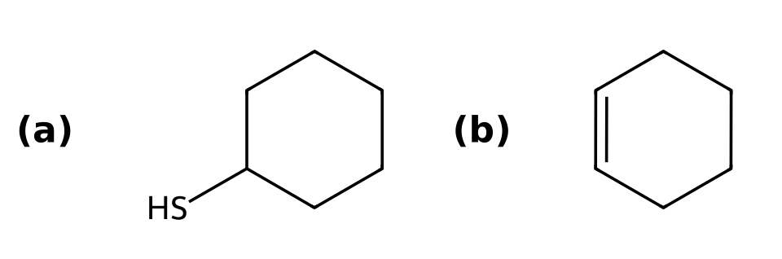
Why: (a) Substrate: secondary (2°) alkyl halide; Leaving group: good leaving group (Br); Nucleophile/base: hydrosulfide is a strong nucleophile and a weak base; Solvent: DMSO is aprotic. These favor SN2. (b) Substrate: secondary (2°) alkyl halide; Leaving group: good leaving group (Br); Nucleophile/base: methoxide is a strong nucleophile and a strong base; Solvent: MeOH is protic. These favor E2.
129. For each substrate, classify the α carbon (methyl, 1°, 2° or 3°), identify the leaving group, and state whether SN2, SN1, both or neither is feasible: (I) iodoethane (II) 2-bromo-2-methylbutane (III) 2-chlorobutane (IV) bromobenzene. [P096, Basic]
Answer: I: 1°, I⁻, SN2 only. II: 3°, Br⁻, SN1 (SN2 impossible). III: 2°, Cl⁻, either (conditions decide). IV: aryl halide, Br⁻, neither.
Why: Methyl/primary favor SN2, tertiary favors SN1, secondary can go either way, and aryl/vinyl halides do not react.
130. Label each carbon bearing a leaving group as 1°, 2° or 3° and say which substitution mechanism is favored by the substrate alone: (I) 1-bromobutane (II) 3-bromo-3-methylpentane (III) iodocyclohexane. [P097, Basic]
Answer: I: 1°, SN2. II: 3°, SN1. III: 2°, either.
Why: This is the first of the four factors; secondary substrates need the nucleophile and solvent to decide.

7.10 Substitution and Elimination with Other Substrates
131. Why is the OH group of an alcohol a poor leaving group? [C07M44, Basic]
Answer: A) HO⁻ is a strong base
Why: Strong bases are poor leaving groups.
132. What converts an alcohol into a good leaving group for substitution? [C07M45, Moderate]
Answer: C) Protonation with a strong acid or conversion to a tosylate
Why: Water (after protonation) and TsO⁻ are good leaving groups.
133. Propose reagents to convert (S)-butan-2-ol into (R)-2-bromobutane. Explain why the OH group cannot simply be displaced, and state the stereochemical outcome if there is a stereocenter. [P059, Basic]
Answer: PBr3 (SN2). Inversion at the stereocenter.
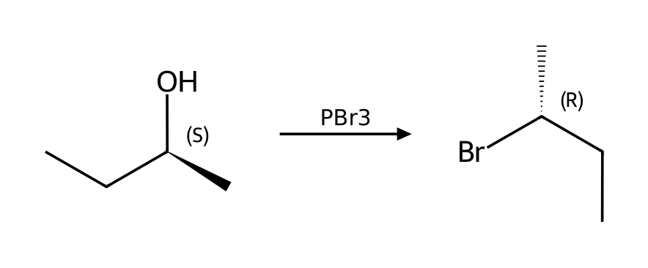
Why: Hydroxide is a bad leaving group, so the OH must be activated first: protonated by HX (SN1 for tertiary, SN2 for primary), or converted to a tosylate (TsCl/pyridine) or halide (PBr₃, SOCl₂) for SN2. Tosylate formation does not touch the stereocenter, so one inversion occurs in the substitution step.
134. Propose reagents to convert 2-methylpropan-2-ol into 2-bromo-2-methylpropane. Explain why the OH group cannot simply be displaced, and state the stereochemical outcome if there is a stereocenter. [P060, Basic]
Answer: HBr (SN1).
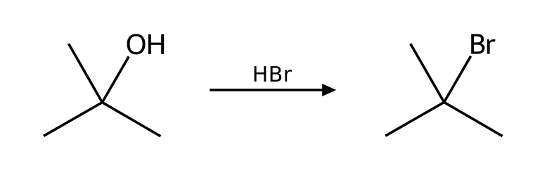
Why: Hydroxide is a bad leaving group, so the OH must be activated first: protonated by HX (SN1 for tertiary, SN2 for primary), or converted to a tosylate (TsCl/pyridine) or halide (PBr₃, SOCl₂) for SN2. Tosylate formation does not touch the stereocenter, so one inversion occurs in the substitution step.
135. Propose reagents to convert butan-1-ol into 1-bromobutane. Explain why the OH group cannot simply be displaced, and state the stereochemical outcome if there is a stereocenter. [P061, Basic]
Answer: HBr (SN2).
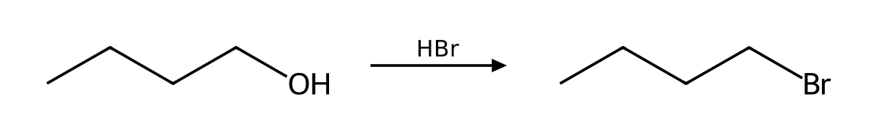
Why: Hydroxide is a bad leaving group, so the OH must be activated first: protonated by HX (SN1 for tertiary, SN2 for primary), or converted to a tosylate (TsCl/pyridine) or halide (PBr₃, SOCl₂) for SN2. Tosylate formation does not touch the stereocenter, so one inversion occurs in the substitution step.
136. Propose reagents to convert propan-2-ol into 2-chloropropane. Explain why the OH group cannot simply be displaced, and state the stereochemical outcome if there is a stereocenter. [P062, Basic]
Answer: SOCl2, pyridine (SN2).
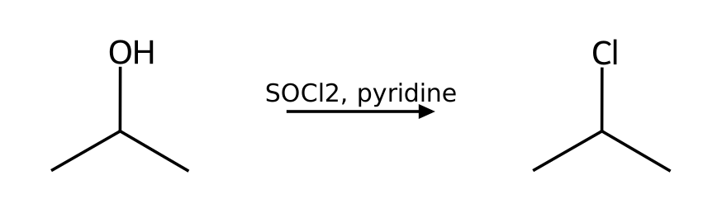
Why: Hydroxide is a bad leaving group, so the OH must be activated first: protonated by HX (SN1 for tertiary, SN2 for primary), or converted to a tosylate (TsCl/pyridine) or halide (PBr₃, SOCl₂) for SN2. Tosylate formation does not touch the stereocenter, so one inversion occurs in the substitution step.
137. Propose reagents to convert (R)-pentan-2-ol into (S)-2-methylpentanenitrile. Explain why the OH group cannot simply be displaced, and state the stereochemical outcome if there is a stereocenter. [P063, Basic]
Answer: TsCl, pyridine; then NaCN, DMSO (SN2). Inversion at the stereocenter.
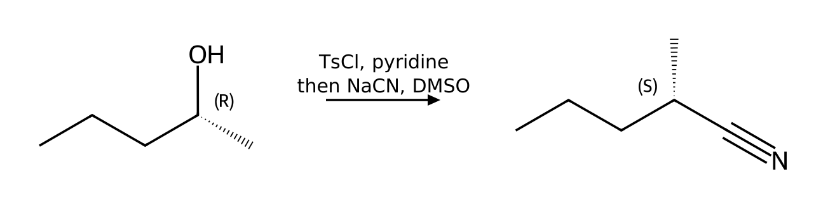
Why: Hydroxide is a bad leaving group, so the OH must be activated first: protonated by HX (SN1 for tertiary, SN2 for primary), or converted to a tosylate (TsCl/pyridine) or halide (PBr₃, SOCl₂) for SN2. Tosylate formation does not touch the stereocenter, so one inversion occurs in the substitution step.
138. Propose reagents to convert butan-1-ol into 1-azidobutane. Explain why the OH group cannot simply be displaced, and state the stereochemical outcome if there is a stereocenter. [P064, Basic]
Answer: TsCl, pyridine; then NaN3, DMF (SN2).
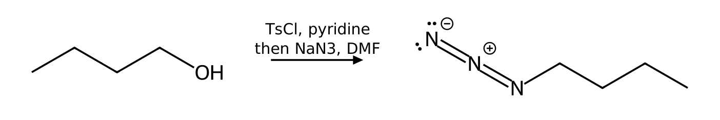
Why: Hydroxide is a bad leaving group, so the OH must be activated first: protonated by HX (SN1 for tertiary, SN2 for primary), or converted to a tosylate (TsCl/pyridine) or halide (PBr₃, SOCl₂) for SN2. Tosylate formation does not touch the stereocenter, so one inversion occurs in the substitution step.

7.11 Synthesis Strategies
139. To convert 1-bromobutane into butan-1-ol with high yield, which reagent is best? [C07M46, Moderate]
Answer: A) NaOH in a polar solvent (SN2)
Why: A primary halide with a good nucleophile gives SN2.
140. To make 2-methylbut-1-ene from 2-bromo-2-methylbutane the best reagent is: [C07M47, Hard]
Answer: B) Potassium tert-butoxide
Why: A bulky base gives the Hofmann product.
141. Design a synthesis of 2-methoxy-2-methylpropane from an alkyl halide and an alkoxide. Which combination works, and why does the other combination fail? [P079, Moderate]
Answer: Use iodomethane with sodium tert-butoxide. The alternative, tert-butyl bromide with sodium methoxide, fails because it gives E2 elimination instead of substitution.
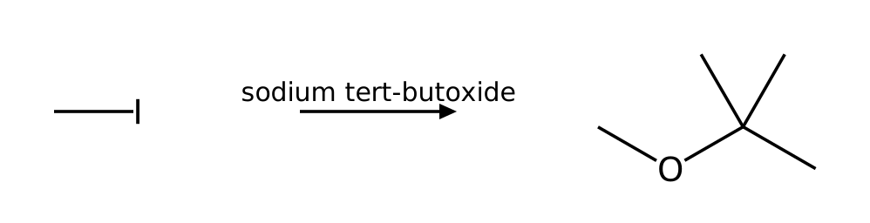
Why: The Williamson ether synthesis is an SN2 reaction, so the halide must be methyl or primary. A secondary or tertiary halide with a strongly basic alkoxide gives E2 elimination.
142. Design a synthesis of 2-ethoxypropane from an alkyl halide and an alkoxide. Which combination works, and why does the other combination fail? [P080, Moderate]
Answer: Use bromoethane with sodium isopropoxide. The alternative, 2-bromopropane with sodium ethoxide, fails because it gives E2 elimination instead of substitution.
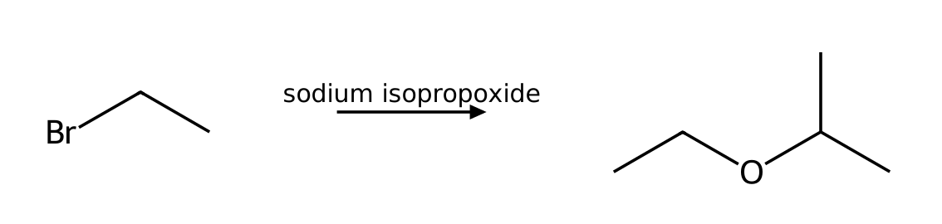
Why: The Williamson ether synthesis is an SN2 reaction, so the halide must be methyl or primary. A secondary or tertiary halide with a strongly basic alkoxide gives E2 elimination.
143. Design a synthesis of 2-ethoxy-2-methylpropane from an alkyl halide and an alkoxide. Which combination works, and why does the other combination fail? [P081, Moderate]
Answer: Use iodoethane with sodium tert-butoxide. The alternative, tert-butyl bromide with sodium ethoxide, fails because it gives E2 elimination instead of substitution.
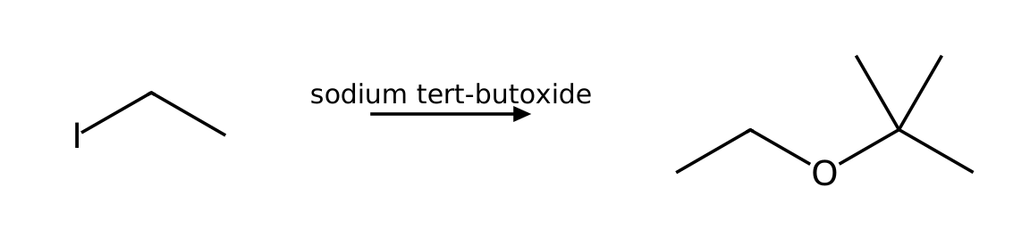
Why: The Williamson ether synthesis is an SN2 reaction, so the halide must be methyl or primary. A secondary or tertiary halide with a strongly basic alkoxide gives E2 elimination.

7.12 Solvent Effects in Substitution Reactions
144. Which is a polar protic solvent? [C07M48, Easy]
Answer: A) Ethanol
Why: Protic solvents have an O-H or N-H group.
145. SN2 reactions are generally fastest in: [C07M49, Basic]
Answer: D) Polar aprotic solvents
Why: Aprotic solvents do not hydrogen-bond to the nucleophile.
146. Which solvent favors SN1 reactions by stabilizing the carbocation and leaving group? [C07M50, Moderate]
Answer: A) A polar protic solvent
Why: Protic solvents solvate ions through hydrogen bonding and ion-dipole interactions.
147. Classify each solvent as protic or polar aprotic and say which substitution mechanism it favors: DMSO, methanol, acetonitrile, water, DMF, acetic acid. [P090, Basic]
Answer: Polar aprotic (favor SN2): DMSO, acetonitrile, DMF. Protic (favor SN1): methanol, water, acetic acid.
Why: Protic solvents have an H on an electronegative atom; they stabilize ions and intermediates (SN1) but solvate and weaken anionic nucleophiles. Polar aprotic solvents leave the nucleophile unsolvated.
148. The SN2 reaction of 1-bromobutane with azide is about 1300 times faster in DMSO than in methanol. Explain. [P091, Basic]
Answer: In methanol the azide ion is hydrogen-bonded to the solvent, which lowers its energy and raises the barrier. DMSO solvates the cation but not the anion, so the nucleophile is higher in energy and reacts faster.
Why: See the effect of polar aprotic solvents on nucleophile energy in the SN2 energy diagram.

