Chapter 5: Stereoisomerism
Organic chemistry questions. Multiple choice first within each textbook section.
Name: ______________________________ Date: ______________

5.1 Overview of Isomerism
1. Which term describes two compounds with the same molecular formula but different connectivity of atoms? [C05M01, Easy]
A) Stereoisomers
B) Enantiomers
C) Constitutional isomers
D) Conformers
2. Which term describes two compounds with the same connectivity but a different spatial arrangement of atoms? [C05M02, Easy]
A) Constitutional isomers
B) Stereoisomers
C) Structural isomers
D) Functional isomers
3. What is the relationship between the two compounds shown? [C05M03, Basic]
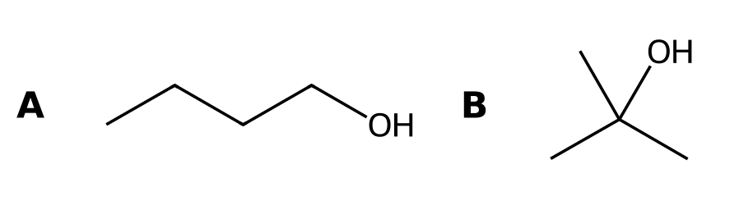
A) Stereoisomers
B) Identical compounds
C) Constitutional isomers
D) Different molecular formulas
4. What is the relationship between cis- and trans-but-2-ene? [C05M04, Basic]
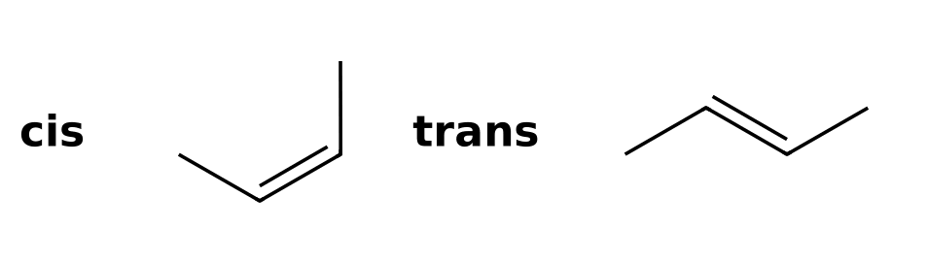
A) Constitutional isomers
B) Identical compounds
C) Stereoisomers
D) Different molecular formulas
5. Define constitutional isomers and give an example pair. [C05F01, Easy]

6. Define stereoisomers. [C05F02, Easy]

7. Are the two compounds shown constitutional isomers or stereoisomers? Explain. [C05F03, Basic]
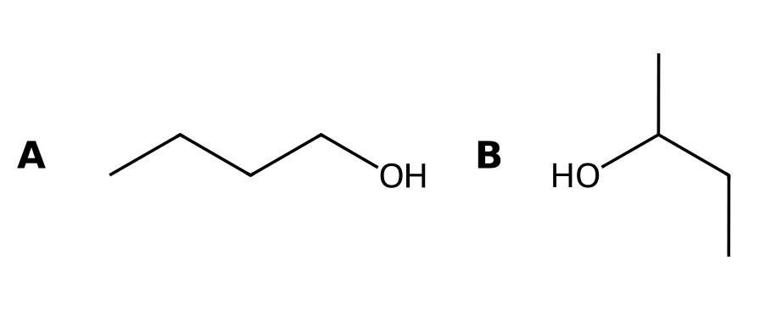

8. Draw the two stereoisomers of but-2-ene and label each as cis or trans. [C05F04, Basic]

9. Draw all constitutional isomers of C₄H₁₀ and state how many there are. [C05F05, Moderate]

10. Are cis- and trans-1,2-dimethylcyclohexane constitutional isomers or stereoisomers? Explain. [C05F06, Moderate]

5.2 Introduction to Stereoisomerism
11. What is a chirality center (stereocenter) in an organic compound? [C05M05, Easy]
A) A carbon bonded to four different groups
B) Any carbon with four bonds
C) A carbon in a double bond
D) Any carbon bonded to a heteroatom
12. A compound with one chirality center has how many stereoisomers? [C05M06, Easy]
A) Two
B) One
C) Three
D) Four
13. How many chirality centers are in the compound shown? [C05M07, Basic]
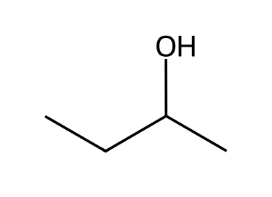
A) 0
B) 2
C) 3
D) 1
14. Which compound contains a chirality center? [C05M08, Basic]
A) Propan-2-ol
B) Butan-1-ol
C) Butan-2-ol
D) 2-Methylpropan-2-ol
15. How many chirality centers are in the compound shown? [C05M09, Moderate]
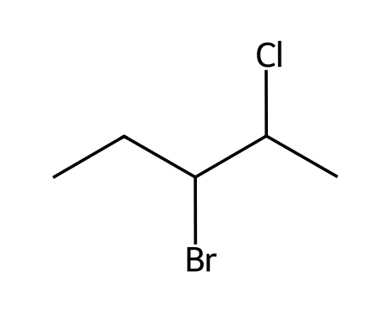
A) 1
B) 3
C) 4
D) 2
16. Identify the chirality center in the compound shown and list its four groups. [C05F07, Basic]

17. Explain why propan-2-ol does not have a chirality center. [C05F08, Basic]
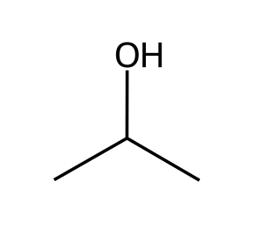

18. How many chirality centers does 3-methylhexane have, and where? [C05F09, Basic]
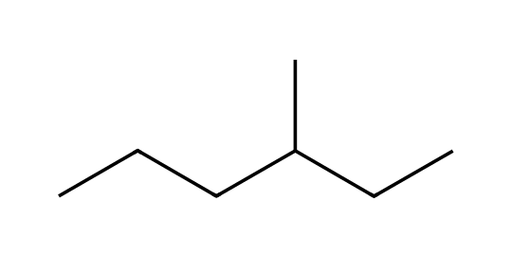

19. Circle the chirality centers in the compound shown by naming their carbon numbers. [C05F10, Moderate]

20. Draw a molecule of formula C₄H₉Br that has a chirality center. [C05F11, Moderate]

5.3 Designating Configuration (Cahn-Ingold-Prelog, R/S)
21. In the Cahn-Ingold-Prelog system, priorities are first assigned according to what? [C05M10, Easy]
A) Atomic mass
B) Size of the group
C) Number of carbons in the group
D) Atomic number of the atoms directly attached to the center
22. With priority 4 on a dash, going 1 → 2 → 3 clockwise gives which designation? [C05M11, Easy]
A) S
B) E
C) Z
D) R
23. Rank the groups on a chirality center from highest to lowest priority: -OH, -CH₃, -H, -NH₂. [C05M12, Basic]
A) -NH₂ > -OH > -CH₃ > -H
B) -OH > -CH₃ > -NH₂ > -H
C) -H > -CH₃ > -NH₂ > -OH
D) -OH > -NH₂ > -CH₃ > -H
24. Which of the following is the correct priority order for -CH₂OH, -CH₃, -CH₂CH₃, -H? [C05M13, Hard]
A) -CH₂CH₃ > -CH₂OH > -CH₃ > -H
B) -CH₂OH > -CH₂CH₃ > -CH₃ > -H
C) -CH₃ > -CH₂CH₃ > -CH₂OH > -H
D) -CH₂OH > -CH₃ > -CH₂CH₃ > -H
25. What is the configuration of the chirality center in butan-2-ol? [C05M14, Basic]
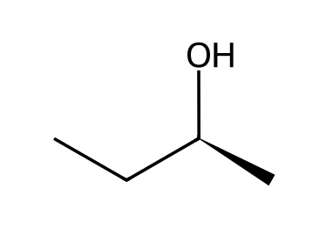
A) S
B) R
C) E
D) Z
26. What is the configuration of the chirality center in butan-2-ol? [C05M15, Basic]
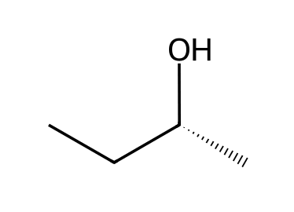
A) S
B) E
C) Z
D) R
27. What is the configuration of the chirality center in 2-chlorobutane? [C05M16, Basic]
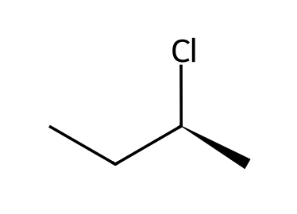
A) R
B) S
C) E
D) Z
28. What is the configuration of the chirality center in 2-bromobutane? [C05M17, Basic]
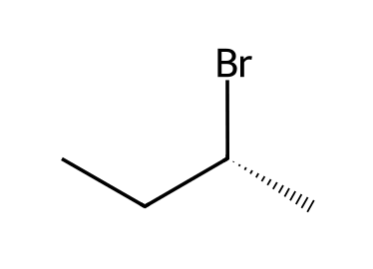
A) S
B) E
C) R
D) Z
29. What is the configuration of the chirality center in this sample of alanine? [C05M18, Moderate]
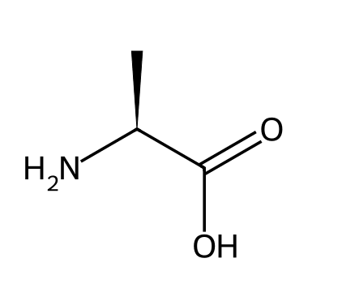
A) R
B) S
C) Meso
D) Cannot be determined
30. What is the configuration of the chirality center in this sample of alanine? [C05M19, Moderate]
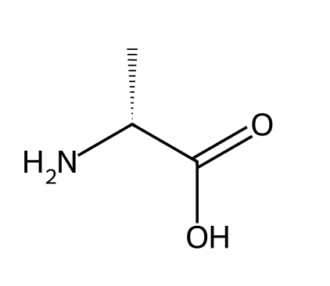
A) S
B) Meso
C) Cannot be determined
D) R
31. If the lowest priority group is on a wedge and 1 → 2 → 3 appears clockwise, what is the configuration? [C05M20, Moderate]
A) S
B) R
C) E
D) Meso
32. A chirality center is drawn with the lowest priority group on a wedge and 1 → 2 → 3 counterclockwise. What is the configuration? [C05M21, Hard]
A) S
B) R
C) E
D) Z
33. Assign R or S to the chirality center in the compound shown. List the priorities. [C05F12, Basic]

34. Assign R or S to the chirality center in the compound shown. List the priorities. [C05F13, Basic]

35. Assign R or S to the chirality center in the compound shown. List the priorities. [C05F14, Basic]
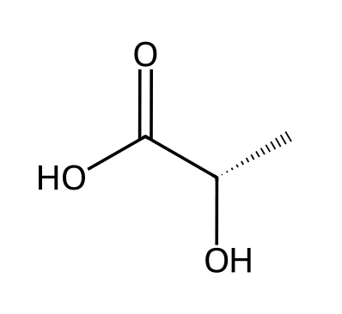

36. Assign R or S to the chirality center in the compound shown. List the priorities. [C05F15, Moderate]

37. What do R and S stand for, and what do they describe? [C05F16, Easy]

38. Explain how to assign priorities when two attached atoms are the same. [C05F17, Basic]

39. Rank the groups -CH₂OH, -CH₂CH₃, -CH₃ and -H on a chirality center. [C05F18, Moderate]

40. The lowest priority group is on a wedge and 1 → 2 → 3 looks clockwise. What is the configuration and why? [C05F19, Hard]

5.4 Optical Activity
41. What instrument measures the rotation of plane-polarized light? [C05M22, Easy]
A) A spectrometer
B) A calorimeter
C) A polarimeter
D) A chromatograph
42. What is a racemic mixture? [C05M23, Easy]
A) A pure single enantiomer
B) A mixture of constitutional isomers
C) A mixture of diastereomers
D) An equal mixture of two enantiomers
43. Two enantiomers rotate plane-polarized light: [C05M24, Basic]
A) By equal amounts in the same direction
B) By different amounts in opposite directions
C) Not at all
D) By equal amounts in opposite directions
44. An enantiomer has a specific rotation of +20°. What is the specific rotation of its enantiomer? [C05M25, Moderate]
A) -20°
B) +20°
C) 0°
D) -40°
45. A sample contains 75% of one enantiomer and 25% of the other. What is the enantiomeric excess? [C05M26, Hard]
A) 25%
B) 75%
C) 50%
D) 100%
46. What is the difference between dextrorotatory and levorotatory? [C05F20, Easy]

47. Explain why a racemic mixture is optically inactive. [C05F21, Basic]

48. What is a racemic mixture, and how is it written? [C05F22, Basic]

49. A sample contains 80% of the (+) enantiomer and 20% of the (−) enantiomer. Calculate the enantiomeric excess. [C05F23, Moderate]

50. The (R) enantiomer of a compound is dextrorotatory. What can you say about the rotation of the (S) enantiomer? [C05F24, Moderate]

5.5 Enantiomers and Diastereomers
51. Enantiomers are best described as: [C05M27, Easy]
A) Stereoisomers that are nonsuperimposable mirror images
B) Stereoisomers that are not mirror images
C) Constitutional isomers
D) Identical compounds
52. Diastereomers are best described as: [C05M28, Easy]
A) Mirror-image stereoisomers
B) Stereoisomers that are not mirror images
C) Constitutional isomers
D) Compounds with different formulas
53. What is the relationship between the two compounds shown? [C05M29, Basic]
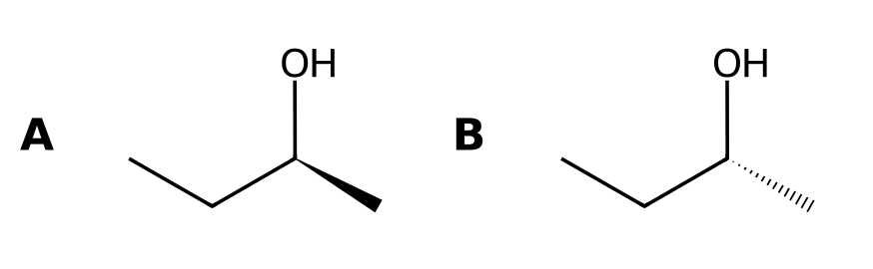
A) Diastereomers
B) Enantiomers
C) Identical compounds
D) Constitutional isomers
54. What is the relationship between the two compounds shown? [C05M30, Basic]
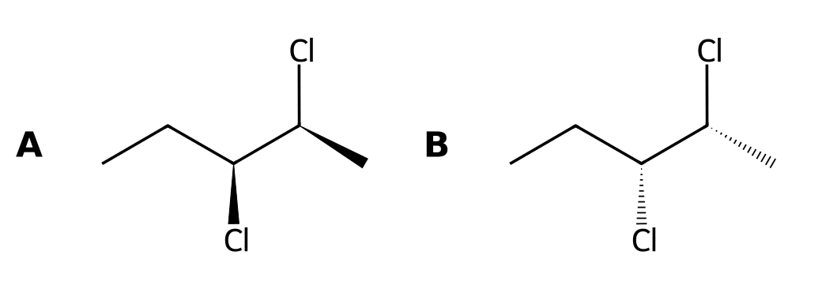
A) Diastereomers
B) Identical compounds
C) Enantiomers
D) Constitutional isomers
55. What is the relationship between the two compounds shown? [C05M31, Moderate]
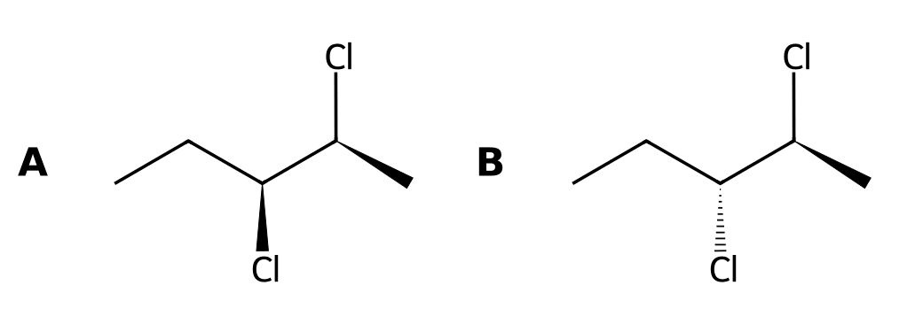
A) Enantiomers
B) Identical compounds
C) Constitutional isomers
D) Diastereomers
56. What is the relationship between the two compounds shown? [C05M32, Moderate]
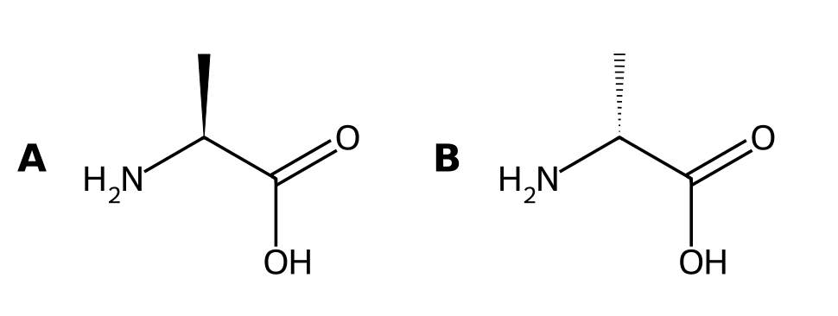
A) Diastereomers
B) Identical compounds
C) Enantiomers
D) Constitutional isomers
57. A compound has two chirality centers with configurations (2R,3S). Which stereoisomer is its enantiomer? [C05M33, Moderate]
A) (2S,3R)
B) (2R,3R)
C) (2S,3S)
D) (2R,3S)
58. A compound has two chirality centers with configurations (2R,3S). Which stereoisomer is a diastereomer? [C05M34, Moderate]
A) (2R,3R)
B) (2S,3R)
C) Its mirror image
D) Itself
59. Are these two compounds enantiomers, diastereomers or identical? Explain. [C05F25, Basic]

60. Are these two compounds enantiomers, diastereomers or identical? Explain. [C05F26, Basic]

61. Are these two compounds enantiomers, diastereomers or identical? Explain. [C05F27, Moderate]

62. Are these two compounds enantiomers, diastereomers or identical? Explain. [C05F28, Moderate]

63. State one physical property that differs between diastereomers but not between enantiomers. [C05F29, Easy]

64. Draw the enantiomer of the compound shown. [C05F30, Basic]

65. For a compound with three chirality centers, how many stereoisomers are possible (no meso)? [C05F31, Basic]

5.6 Symmetry and Chirality
66. A compound with a plane of symmetry is: [C05M35, Easy]
A) Chiral
B) Achiral
C) Always optically active
D) Always a racemic mixture
67. Which describes a meso compound? [C05M36, Basic]
A) Contains chirality centers but is achiral
B) Contains no chirality centers
C) Is chiral and optically active
D) Is a racemic mixture
68. Is the compound shown chiral? [C05M37, Basic]
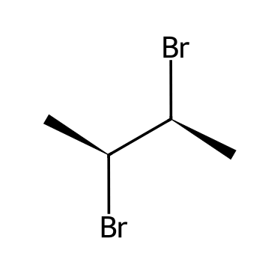
A) Yes, it has two chirality centers
B) No, it is meso
C) Yes, it is optically active
D) It cannot be determined
69. How many stereoisomers does 2,3-dibromobutane have? [C05M38, Hard]
A) 3
B) 2
C) 4
D) 1
70. Which compound is meso? [C05M39, Moderate]
A) trans-1,2-dimethylcyclohexane
B) Butan-2-ol
C) 2-Chlorobutane
D) cis-1,2-dimethylcyclohexane
71. What kind of symmetry element makes a compound achiral? [C05F32, Easy]

72. Explain why 2,3-dibromobutane has three stereoisomers rather than four. [C05F33, Hard]

73. Is the compound shown chiral or meso? Identify the plane of symmetry. [C05F34, Moderate]

74. Is the compound shown chiral? Explain. [C05F35, Moderate]
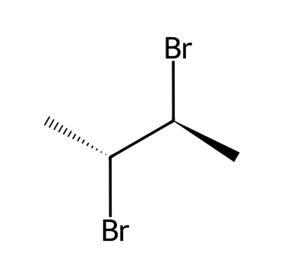

5.7 Fischer Projections
75. In a Fischer projection, horizontal bonds point: [C05M40, Easy]
A) Away from the viewer
B) Within the plane of the page
C) Toward the viewer (out of the page)
D) Up the page
76. Rotating a Fischer projection by 180° in the plane of the page changes the configuration of the chirality center: [C05M41, Moderate]
A) Not at all
B) From R to S
C) From S to R
D) To a diastereomer
77. In a Fischer projection, what do the horizontal and vertical lines mean? [C05F36, Easy]

78. Describe how to assign R or S from a Fischer projection when the lowest priority group is on a horizontal bond. [C05F37, Basic]

79. Describe what happens to the configuration if you rotate a Fischer projection by 90° in the plane of the page. [C05F38, Hard]

5.8 Conformationally Mobile Systems
80. Why is butane achiral even though some of its conformations lack a mirror plane? [C05M42, Basic]
A) It has a chirality center
B) It contains no hydrogens
C) Its conformations interconvert rapidly by bond rotation
D) It has a double bond
81. Explain why butane, which has chiral conformations, is not optically active. [C05F39, Basic]

5.9 Chiral Compounds that Lack a Chiral Center
82. Which statement is true? [C05M43, Hard]
A) Every chiral compound has a chirality center
B) A compound can be chiral without having a chirality center
C) Every compound with a chirality center is chiral
D) Chirality only occurs in carbon compounds
83. Can a compound be chiral without containing a chirality center? Give a reason. [C05F40, Hard]

5.10 Resolution of Enantiomers
84. What is the purpose of resolution? [C05M44, Basic]
A) To convert one enantiomer into the other
B) To separate a racemic mixture into its enantiomers
C) To make a racemic mixture
D) To change a compound into a constitutional isomer
85. Why are diastereomers helpful in resolving a racemic mixture? [C05M45, Moderate]
A) Diastereomers have different physical properties and can be separated
B) Diastereomers are mirror images
C) Diastereomers rotate light equally
D) Diastereomers have identical solubilities
86. Explain why reacting a racemic acid with one pure enantiomer of a chiral base allows the acid enantiomers to be separated. [C05F41, Hard]

5.11 E and Z Designations for Alkenes
87. In the E/Z system, a Z alkene has the highest priority groups: [C05M46, Easy]
A) On opposite sides
B) On the same side of the double bond
C) On the same carbon
D) In a ring
88. What is the configuration of the double bond in pent-2-ene? [C05M47, Basic]
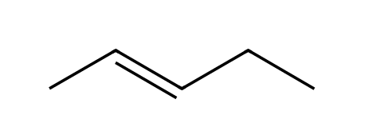
A) Z
B) R
C) E
D) S
89. What is the configuration of the double bond in 1-chloro-2-fluoroethene? [C05M48, Basic]
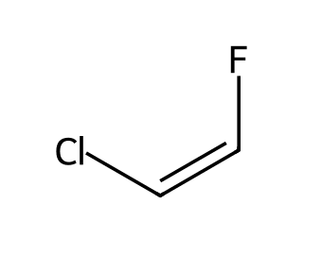
A) E
B) Z
C) R
D) S
90. What is the configuration of the double bond in 3-chloropent-2-ene? [C05M49, Basic]
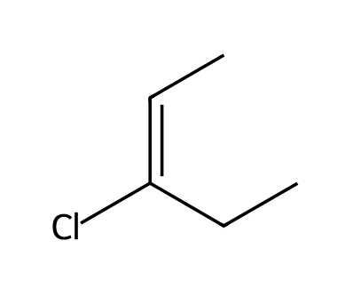
A) E
B) Z
C) R
D) S
91. Which alkene cannot show E/Z isomerism? [C05M50, Moderate]
A) But-2-ene
B) Pent-2-ene
C) 1,2-Dichloroethene
D) 2-Methylbut-2-ene
92. Assign E or Z to the double bond in the compound shown. [C05F42, Basic]

93. Assign E or Z to the double bond in the compound shown. [C05F43, Basic]

94. Assign E or Z to the double bond in the compound shown. [C05F44, Basic]

95. Assign E or Z to the double bond in the compound shown. [C05F45, Moderate]
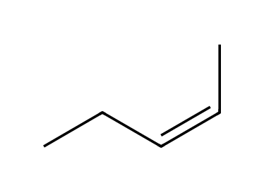

96. Assign E or Z to the double bond in the compound shown. [C05F46, Moderate]
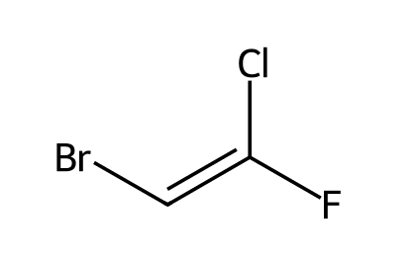

97. What do E and Z mean in alkene nomenclature? [C05F47, Easy]

98. Draw (Z)-but-2-ene. [C05F48, Basic]

99. Explain why propene has no E or Z designation. [C05F49, Moderate]

100. Draw (E)-pent-2-ene and (Z)-pent-2-ene. [C05F50, Moderate]

