Chapter 7: Alkyl Halides: Substitution and Elimination
Organic chemistry questions. Multiple choice first within each textbook section.
Name: ______________________________ Date: ______________

7.1 Introduction to Substitution and Elimination
1. In a substitution reaction, what happens? [C07M01, Easy]
A) A π bond is formed and a leaving group is lost
B) Two molecules add across a double bond
C) A leaving group is replaced by another group
D) A radical is formed
2. In an elimination reaction of an alkyl halide, what is formed? [C07M02, Easy]
A) An alkane
B) An alcohol
C) An alkene
D) An alkyne only
3. Which is a good leaving group? [C07M03, Basic]
A) HO⁻
B) H⁻
C) CH₃⁻
D) Br⁻
4. Which is the better leaving group in each pair, and why? (a) Cl⁻ or I⁻ (b) HO⁻ or H₂O (c) CH₃O⁻ or TsO⁻. [P088, Basic]

5. Rank 1-chlorobutane, 1-bromobutane and 1-iodobutane by their rate of reaction with NaCN in DMSO, and explain. [P089, Basic]

7.2 Nomenclature and Uses of Alkyl Halides
6. What is the IUPAC name of CH₃CH₂CH₂Br? [C07M04, Easy]
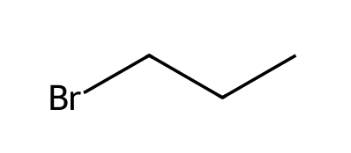
A) 2-Bromopropane
B) Propyl bromine
C) 3-Bromopropane
D) 1-Bromopropane
7. What is the IUPAC name of the compound shown? [C07M05, Basic]
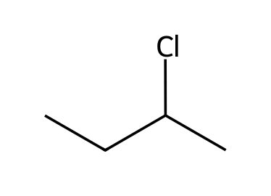
A) 1-chlorobutane
B) 2-chlorobutane
C) 2-chloro-2-methylpropane
D) 2-chloro-3-methylbutane
8. What is the IUPAC name of the compound shown? [C07M06, Moderate]
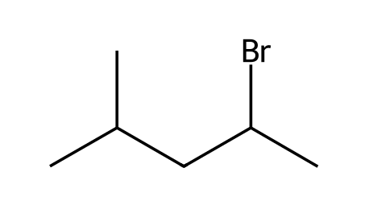
A) 3-bromo-4-methylpentane
B) 2-bromo-2-methylpentane
C) 3-bromo-2-methylbutane
D) 2-bromo-4-methylpentane
9. Classify the alkyl halide 2-bromo-2-methylpropane. [C07M07, Basic]
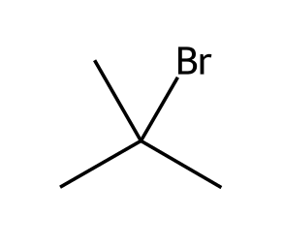
A) Primary
B) Secondary
C) Tertiary
D) Quaternary
10. Classify the alkyl halide shown. [C07M08, Basic]
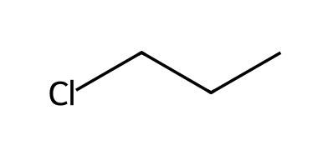
A) Secondary
B) Primary
C) Tertiary
D) Quaternary

7.3 SN2 Reactions
11. What does SN2 stand for? [C07M09, Easy]
A) Substitution, nucleophilic, unimolecular
B) Substitution, neutral, bimolecular
C) Single-step nucleophile, 2 products
D) Substitution, nucleophilic, bimolecular
12. The SN2 mechanism proceeds: [C07M10, Easy]
A) In one concerted step
B) In two steps through a carbocation
C) In three steps
D) Through a radical
13. From which direction does the nucleophile attack in an SN2 reaction? [C07M11, Basic]
A) From the side opposite the leaving group (back-side attack)
B) From the same side as the leaving group
C) From either side equally
D) In the plane of the molecule
14. What is the stereochemical outcome of an SN2 reaction at a chirality center? [C07M12, Basic]
A) Retention of configuration
B) Racemization
C) No change
D) Inversion of configuration
15. Which substrate reacts fastest by SN2? [C07M13, Basic]
A) Isopropyl bromide
B) Methyl bromide
C) tert-Butyl bromide
D) Neopentyl bromide
16. Rank the alkyl bromides from fastest to slowest SN2: 1° , 2°, 3°, methyl. [C07M14, Moderate]
A) Methyl > 1° > 2° > 3°
B) 3° > 2° > 1° > methyl
C) 1° > methyl > 2° > 3°
D) Methyl > 2° > 1° > 3°
17. The (S)-2-bromobutane shown reacts with NaOH in an SN2 reaction. What is the configuration of the butan-2-ol formed? [C07M15, Moderate]
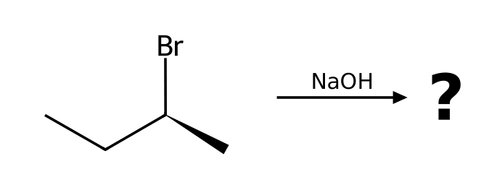
A) S
B) Racemic mixture
C) R
D) No reaction
18. In the SN2 reaction of 1-bromobutane with NaCN, what is the product? [C07M16, Moderate]
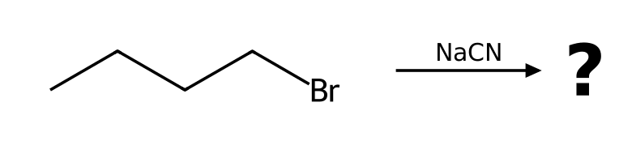
A) Butanenitrile
B) Pentanenitrile
C) Pent-1-ene
D) Butan-1-ol
19. Which factor does NOT speed up an SN2 reaction? [C07M17, Hard]
A) A better leaving group
B) A stronger nucleophile
C) Making the substrate more substituted at the reacting carbon
D) A less hindered substrate
20. What reagent(s) and solvent would convert iodomethane into ethanenitrile? Name the mechanism and justify your choice with the four factors (substrate, nucleophile, leaving group, solvent). [P001, Easy]
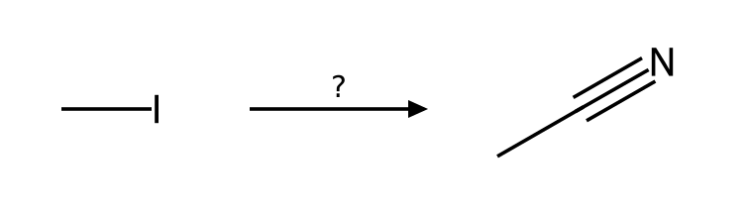

21. What reagent(s) and solvent would convert bromoethane into azidoethane? Name the mechanism and justify your choice with the four factors (substrate, nucleophile, leaving group, solvent). [P002, Easy]
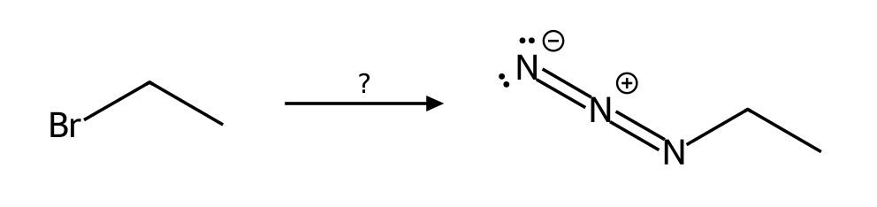

22. What reagent(s) and solvent would convert 1-bromopropane into propane-1-thiol? Name the mechanism and justify your choice with the four factors (substrate, nucleophile, leaving group, solvent). [P003, Easy]
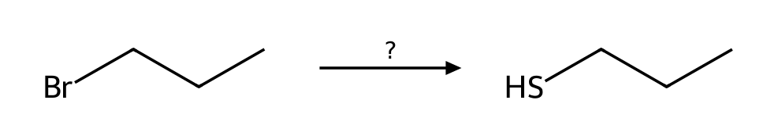

23. What reagent(s) and solvent would convert 2-bromopropane into 2-methylpropanenitrile? Name the mechanism and justify your choice with the four factors (substrate, nucleophile, leaving group, solvent). [P004, Easy]
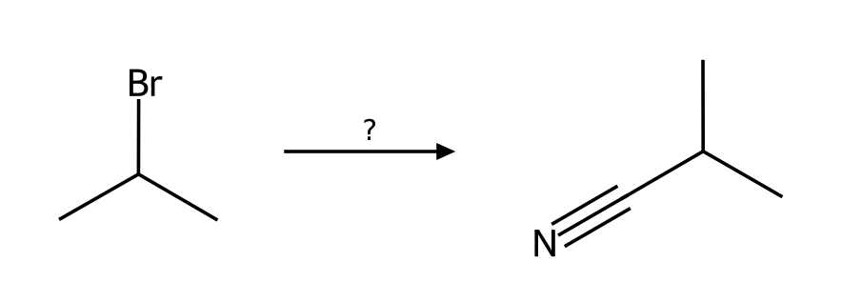

24. What reagent(s) and solvent would convert 2-bromobutane into butane-2-thiol? Name the mechanism and justify your choice with the four factors (substrate, nucleophile, leaving group, solvent). [P005, Easy]
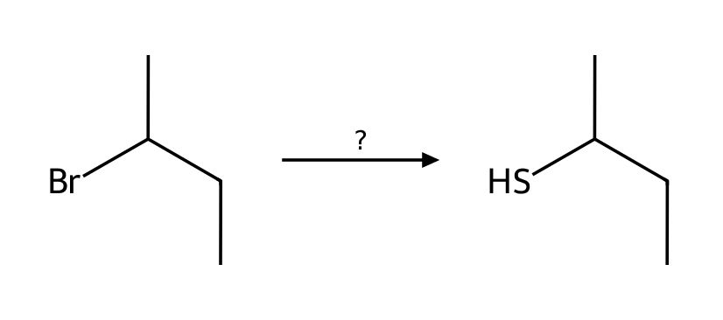

25. Predict the major organic product of 1-iodobutane with NaCN in CH3CN. State the mechanism and any minor pathway. [P011, Basic]
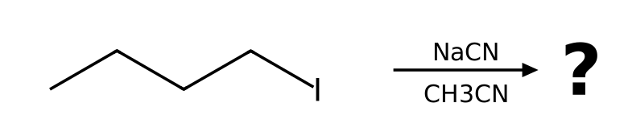

26. Predict the major organic product of 1-chlorobutane with NaI in acetone. State the mechanism and any minor pathway. [P012, Basic]
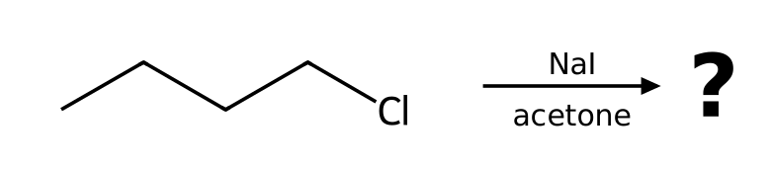

27. Predict the major organic product of 1-bromopropane with NaOMe in MeOH. State the mechanism and any minor pathway. [P013, Basic]
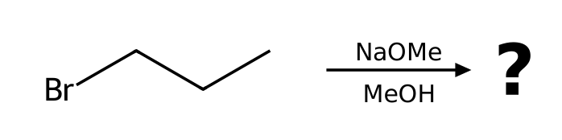

28. Predict the major organic product of 2-iodobutane with NaN₃ in DMF. State the mechanism and any minor pathway. [P014, Basic]
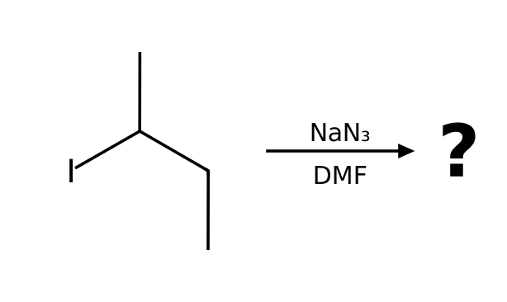

29. Predict the major organic product of bromocyclohexane with NaN₃ in DMF. State the mechanism and any minor pathway. [P015, Basic]
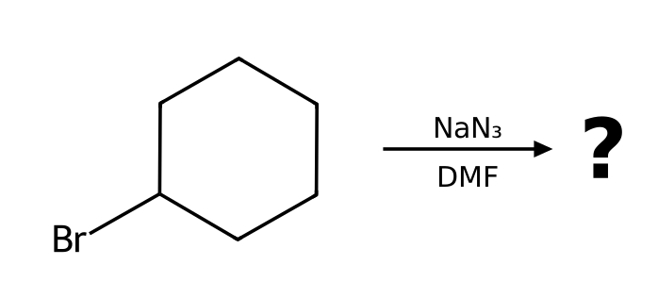

30. Which mechanism (SN1, SN2, E1 or E2) predominates when bromoethane reacts with NaN₃ in DMF? List the factors that support your answer and give the major product. [P021, Basic]
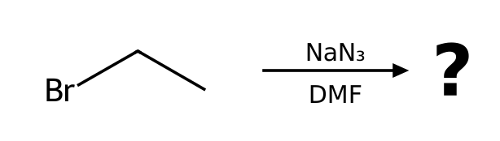

31. Which mechanism (SN1, SN2, E1 or E2) predominates when 1-bromobutane reacts with NaOAc in DMF? List the factors that support your answer and give the major product. [P022, Basic]
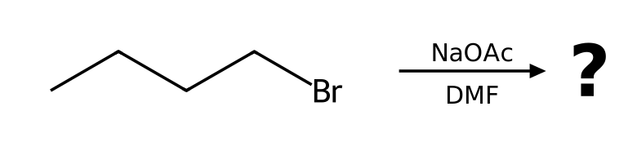

32. Which mechanism (SN1, SN2, E1 or E2) predominates when 1-chlorobutane reacts with NaI in acetone? List the factors that support your answer and give the major product. [P028, Basic]

33. Draw the product of (S)-2-bromobutane with NaSH in DMSO. Give the configuration (R or S) of the substrate and the product and explain the stereochemical outcome. [P030, Basic]
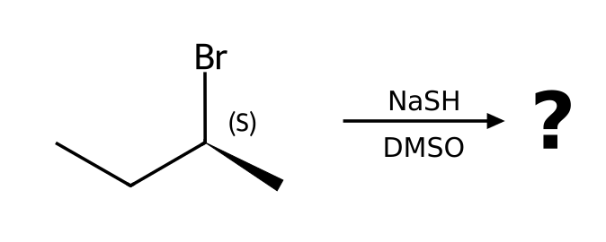

34. Draw the product of (S)-2-chloropentane with NaCN in DMSO. Give the configuration (R or S) of the substrate and the product and explain the stereochemical outcome. [P031, Basic]
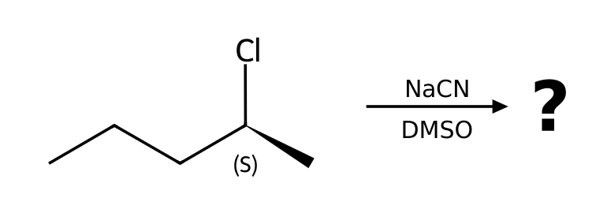

35. Draw the product of (R)-3-iodohexane with NaN₃ in DMF. Give the configuration (R or S) of the substrate and the product and explain the stereochemical outcome. [P032, Basic]
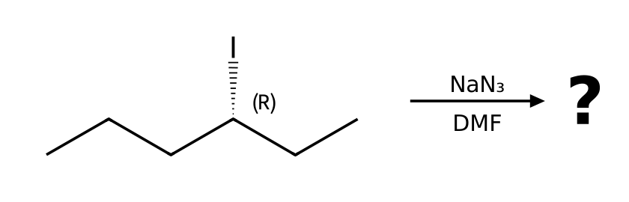

36. Draw the product of (R)-2-bromohexane with NaI in acetone. Give the configuration (R or S) of the substrate and the product and explain the stereochemical outcome. [P033, Basic]
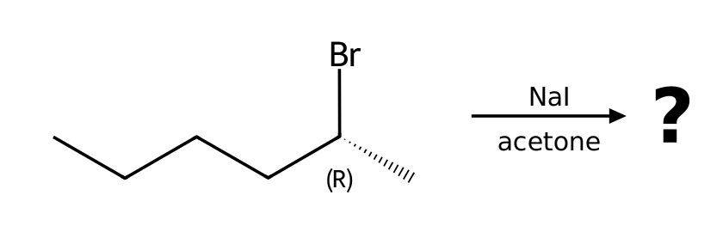

37. Describe the complete mechanism (list each step and the curved arrows) for the reaction of bromoethane with NaN₃ in DMF. How many steps are there? [P038, Moderate]

38. Describe the complete mechanism (list each step and the curved arrows) for the reaction of 1-bromopropane with NaOMe in MeOH. How many steps are there? [P039, Moderate]

39. Describe the complete mechanism (list each step and the curved arrows) for the reaction of 2-bromobutane with NaSH in DMSO. How many steps are there? [P043, Moderate]
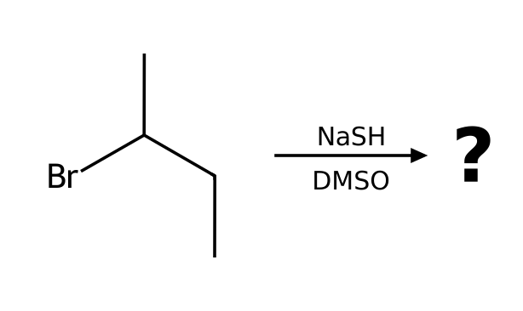

40. Describe the complete mechanism (list each step and the curved arrows) for the reaction of 1-bromo-2,2-dimethylpropane with EtOH as the solvent. How many steps are there? [P044, Moderate]
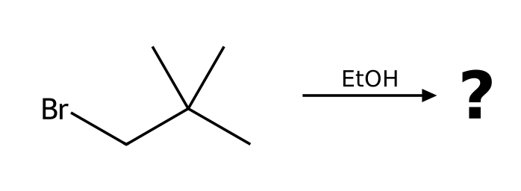

41. Treatment of 4-bromobutan-1-ol with NaOH gives a cyclic ether, tetrahydrofuran (oxolane). Explain the mechanism and why a ring forms. [P082, Moderate]
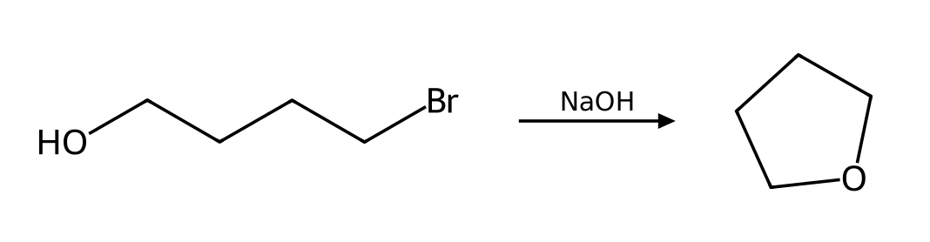

42. Treatment of 5-bromopentan-1-ol with NaOH gives a cyclic ether, tetrahydropyran (oxane). Explain the mechanism and why a ring forms. [P083, Moderate]
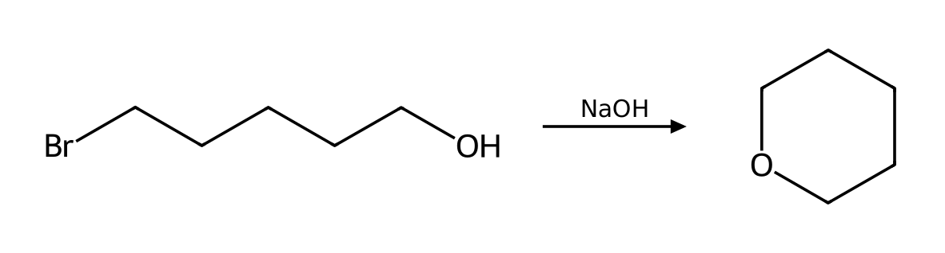

43. Rank bromomethane, 1-bromopropane, 2-bromopropane and 2-bromo-2-methylpropane from fastest to slowest toward SN2. Then give the order for SN1. [P086, Basic]
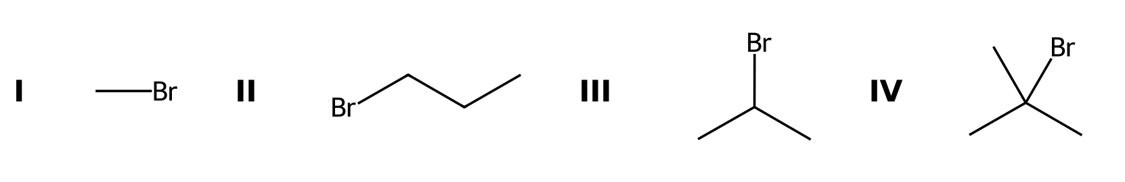

44. Neopentyl bromide, (CH₃)₃CCH₂Br, is a primary alkyl halide. Predict whether it reacts well by SN2 or by SN1 and explain. [P087, Moderate]
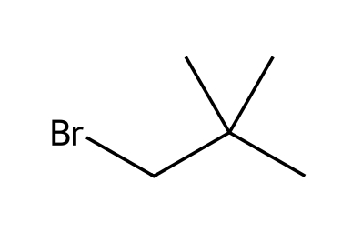

45. The reaction of 2-bromobutane with NaSH in DMSO follows the mechanism predicted for these conditions. Write the rate law. What happens to the rate if (a) [substrate] is doubled and [hydrosulfide] is unchanged, and (b) [hydrosulfide] is tripled and [substrate] is unchanged? [P092, Basic]

46. The reaction of 1-chlorobutane with NaI in acetone follows the mechanism predicted for these conditions. Write the rate law. What happens to the rate if (a) [substrate] is doubled and [iodide] is unchanged, and (b) [iodide] is tripled and [substrate] is unchanged? [P095, Basic]

47. Which compound reacts faster with NaN₃ in DMF, 1-bromobutane or 2-bromobutane? Which reacts faster with ethanol (solvolysis), 2-bromo-2-methylpropane or 2-bromopropane? [P098, Basic]

7.4 Nucleophilic Strength in SN2 Reactions
48. Which is the stronger nucleophile in a polar protic solvent: I⁻ or F⁻? [C07M18, Easy]
A) F⁻
B) They are equal
C) Neither is a nucleophile
D) I⁻
49. Which is the stronger nucleophile: CH₃O⁻ or CH₃OH? [C07M19, Basic]
A) CH₃OH
B) They are equal
C) Neither
D) CH₃O⁻
50. Which reagent is both a strong nucleophile and a weak base? [C07M20, Basic]
A) HO⁻
B) NaH
C) t-BuOK
D) I⁻
51. Which reagent is a strong base but a poor nucleophile because of its size? [C07M21, Moderate]
A) Sodium iodide
B) Potassium tert-butoxide
C) Sodium cyanide
D) Sodium azide
52. Rank the halide ions F⁻, Cl⁻, Br⁻, I⁻ by nucleophilicity (a) in methanol (a protic solvent) and (b) in DMSO (a polar aprotic solvent). Explain the reversal. [P084, Basic]

53. Classify each as a strong or weak nucleophile and state whether it favors SN2 or SN1: (a) HS⁻ (b) H₂O (c) CH₃CH₂O⁻ (d) CH₃CH₂OH (e) I⁻ (f) CN⁻. [P085, Basic]

7.5 Introduction to E2 Reactions
54. What does E2 stand for? [C07M22, Easy]
A) Elimination, unimolecular
B) Electrophilic, two-step
C) Elimination, bimolecular
D) Equilibrium, two-step
55. In an E2 reaction, which pattern of arrows applies? [C07M23, Basic]
A) Nucleophilic attack and carbocation rearrangement
B) Loss of a leaving group only
C) Proton transfer and loss of the leaving group at the same time
D) Two separate steps
56. In E2, the β hydrogen and the leaving group must be: [C07M24, Moderate]
A) Gauche
B) Anti-coplanar
C) Eclipsed
D) On the same side
57. What is the major organic product of 2-bromopropane with sodium ethoxide in ethanol (heat)? [C07M25, Moderate]
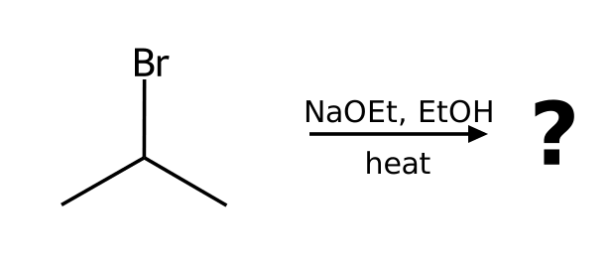
A) Propan-2-ol
B) Propene
C) Ethyl isopropyl ether
D) Propane
58. What reagent(s) and solvent would convert 2-bromopropane into prop-1-ene? Name the mechanism and justify your choice with the four factors (substrate, nucleophile, leaving group, solvent). [P007, Basic]
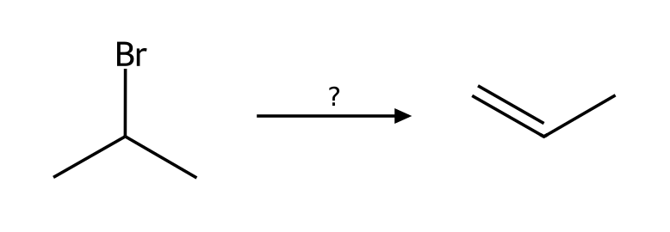

59. What reagent(s) and solvent would convert 2-bromobutane into (E)-but-2-ene? Name the mechanism and justify your choice with the four factors (substrate, nucleophile, leaving group, solvent). [P008, Basic]
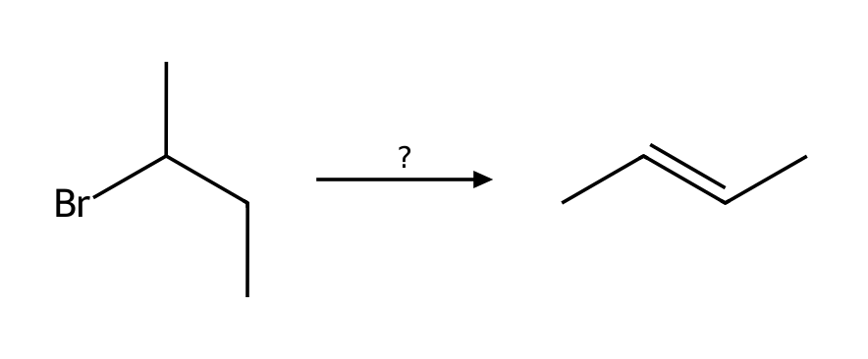

60. What reagent(s) and solvent would convert 2-bromo-2-methylbutane into 2-methylbut-1-ene? Name the mechanism and justify your choice with the four factors (substrate, nucleophile, leaving group, solvent). [P009, Basic]
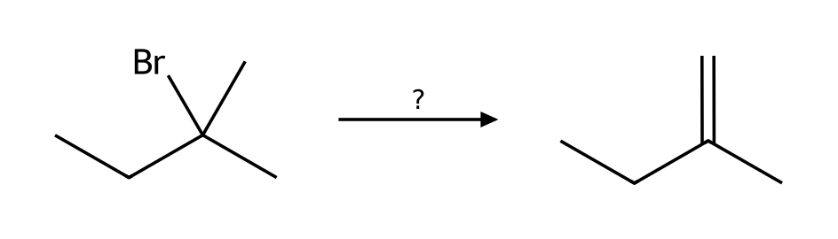

61. What reagent(s) and solvent would convert 2-iodobutane into but-1-ene? Name the mechanism and justify your choice with the four factors (substrate, nucleophile, leaving group, solvent). [P010, Basic]
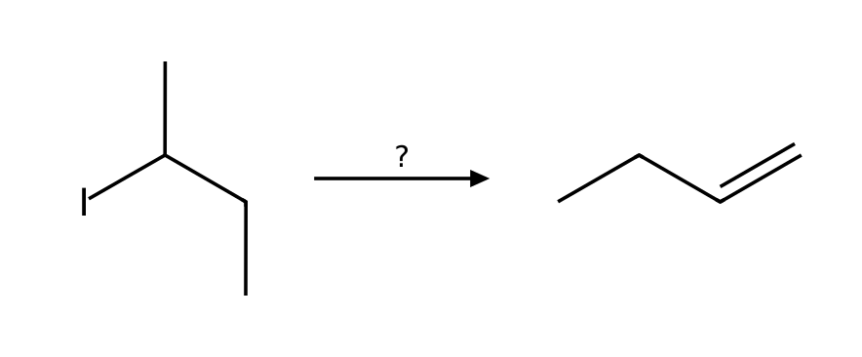

62. Predict the major organic product of 2-bromopentane with NaOH in EtOH. State the mechanism and any minor pathway. [P018, Basic]
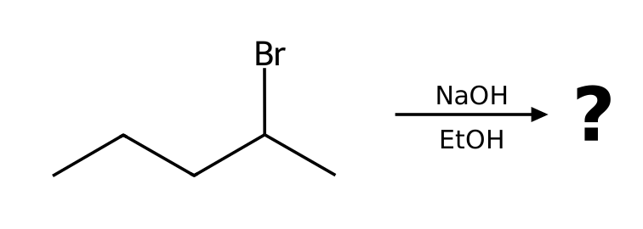

63. Predict the major organic product of bromocyclohexane with NaOEt in EtOH. State the mechanism and any minor pathway. [P019, Basic]
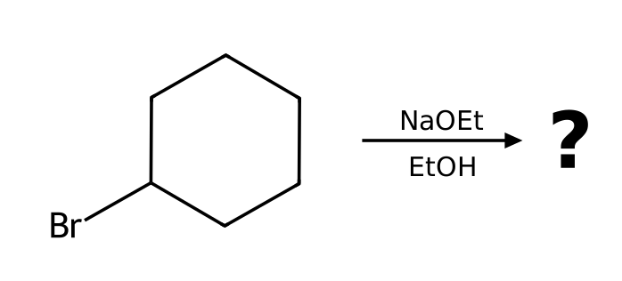

64. Predict the major organic product of 1-bromo-1-methylcyclohexane with KOtBu in tBuOH. State the mechanism and any minor pathway. [P020, Basic]
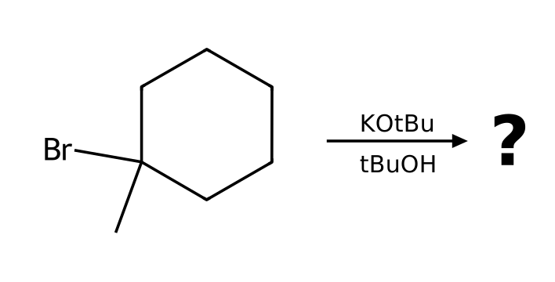

65. Which mechanism (SN1, SN2, E1 or E2) predominates when 2-bromopentane reacts with NaOH in EtOH? List the factors that support your answer and give the major product. [P025, Basic]

66. Which mechanism (SN1, SN2, E1 or E2) predominates when 1-bromopropane reacts with KOtBu in tBuOH? List the factors that support your answer and give the major product. [P026, Basic]
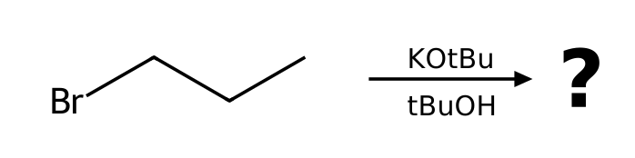

67. Which mechanism (SN1, SN2, E1 or E2) predominates when 3-bromo-3-methylpentane reacts with NaOMe in MeOH? List the factors that support your answer and give the major product. [P027, Basic]
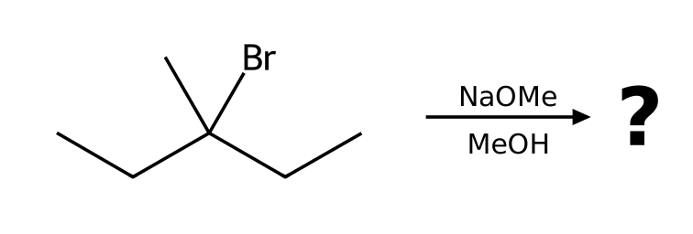

68. Which mechanism (SN1, SN2, E1 or E2) predominates when 2-bromo-2-methylbutane reacts with NaOEt in EtOH? List the factors that support your answer and give the major product. [P029, Basic]
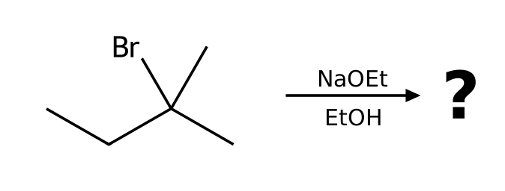

69. Describe the complete mechanism (list each step and the curved arrows) for the reaction of 2-bromobutane with NaOEt in EtOH. How many steps are there? [P042, Moderate]
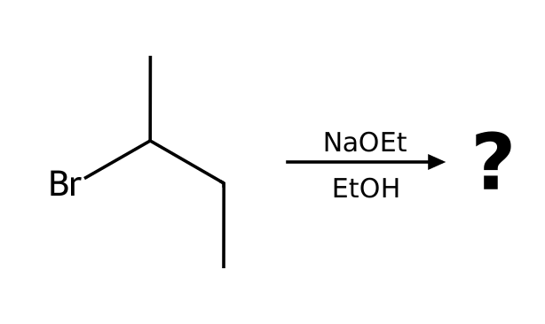

70. The reaction of 2-bromobutane with NaOEt in EtOH follows the mechanism predicted for these conditions. Write the rate law. What happens to the rate if (a) [substrate] is doubled and [ethoxide] is unchanged, and (b) [ethoxide] is tripled and [substrate] is unchanged? [P094, Basic]

7.6 Stability of Alkenes and Cycloalkenes
71. Which alkene is most stable? [C07M26, Easy]
A) The most substituted alkene
B) The least substituted alkene
C) A terminal alkene
D) A cis alkene
72. Which is the most stable alkene? [C07M27, Basic]
A) 2-Methylbut-1-ene
B) 2-Methylbut-2-ene
C) 3-Methylbut-1-ene
D) Pent-1-ene
73. Which is more stable: cis- or trans-but-2-ene, and why? [C07M28, Moderate]
A) trans, because the methyl groups are farther apart and there is less steric strain
B) cis, because the dipole is larger
C) They are equally stable
D) cis, because of hydrogen bonding
74. Which cycloalkene is least able to contain a trans double bond? [C07M29, Moderate]
A) Cyclohexene
B) Cyclodecene
C) Cyclooctene
D) Cyclododecene

7.7 Regiochemical and Stereochemical Outcomes of E2
75. In an E2 reaction of 2-bromo-2-methylbutane with sodium ethoxide, the major product is: [C07M30, Basic]
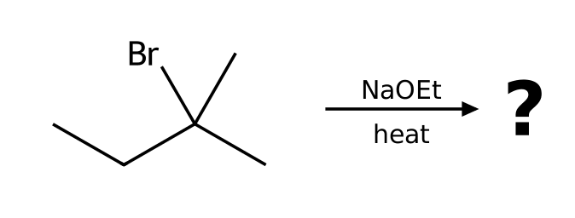
A) 2-Methylbut-1-ene
B) 2-Methylbut-2-ene
C) tert-Pentyl ethyl ether
D) 2-Methylbutan-2-ol
76. Using potassium tert-butoxide instead of ethoxide on 2-bromo-2-methylbutane gives mostly: [C07M31, Moderate]
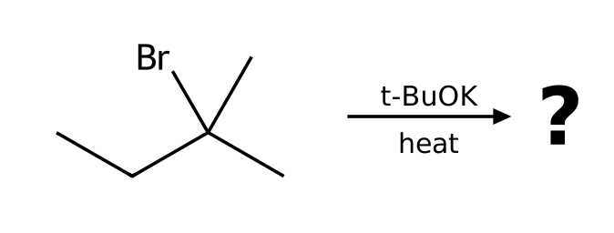
A) 2-Methylbut-2-ene
B) 2-Methylbut-1-ene
C) tert-Pentyl tert-butyl ether
D) 2-Methylbutan-2-ol
77. An E2 reaction produces a new stereogenic alkene. Which isomer is typically major? [C07M32, Moderate]
A) The cis (Z) isomer
B) A 1:1 mixture
C) The trans (E) isomer
D) Neither
78. Which β hydrogens of a cyclohexyl bromide can undergo E2 elimination? [C07M33, Hard]
A) Any β hydrogen
B) Only equatorial hydrogens
C) Only those anti-coplanar to the bromine (axial-axial)
D) Only hydrogens on the same face as Br
79. (S)-2-bromobutane is treated with NaOEt in EtOH. What is the major product? Does the stereocenter of the starting material appear in the product? [P037, Moderate]
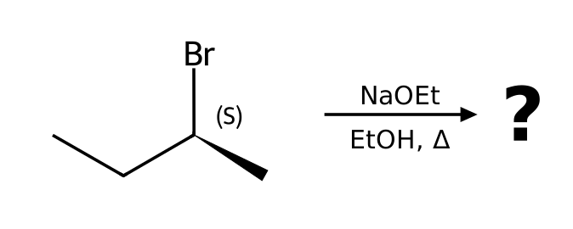

80. Starting from 2-bromo-2-methylbutane, choose reagents to make (a) the more substituted alkene and (b) the less substituted alkene. Give both products. [P074, Moderate]
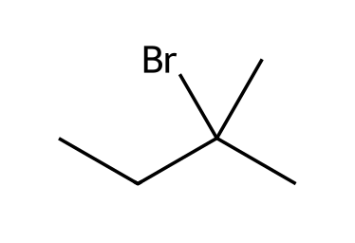

81. Starting from 2-bromobutane, choose reagents to make (a) the more substituted alkene and (b) the less substituted alkene. Give both products. [P075, Moderate]
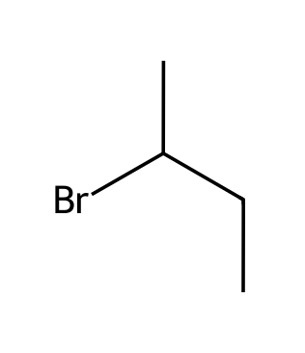

82. Starting from 2-bromopentane, choose reagents to make (a) the more substituted alkene and (b) the less substituted alkene. Give both products. [P076, Moderate]
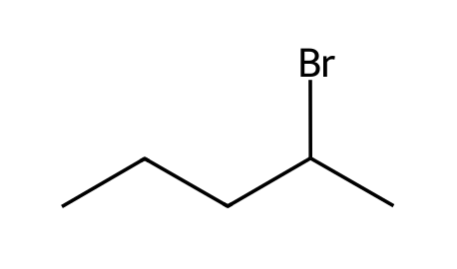

83. Starting from 1-bromo-1-methylcyclohexane, choose reagents to make (a) the more substituted alkene and (b) the less substituted alkene. Give both products. [P077, Moderate]
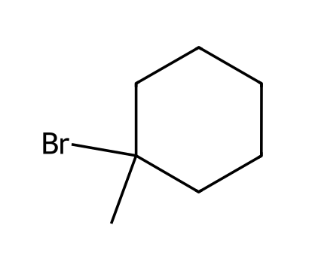

84. Starting from 3-bromo-3-methylpentane, choose reagents to make (a) the more substituted alkene and (b) the less substituted alkene. Give both products. [P078, Moderate]
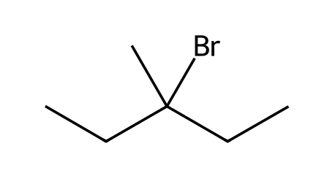

7.8 Unimolecular Reactions (SN1 and E1)
85. What does SN1 stand for? [C07M34, Easy]
A) Substitution, nucleophilic, unimolecular
B) Substitution, nucleophilic, bimolecular
C) Single nucleophile, one step
D) Substitution, neutral, one-step
86. In an SN1 reaction, the rate-determining step is: [C07M35, Basic]
A) Attack of the nucleophile
B) Proton transfer
C) Loss of the leaving group to give a carbocation
D) Loss of a proton
87. Which substrate reacts fastest by SN1? [C07M36, Basic]
A) tert-Butyl bromide
B) Isopropyl bromide
C) Ethyl bromide
D) Methyl bromide
88. A chirality center undergoes SN1 substitution. The product is typically: [C07M37, Moderate]
A) Pure inversion
B) A mixture of enantiomers (racemic)
C) Pure retention
D) No product
89. Which species is an intermediate in E1 and SN1 reactions? [C07M38, Moderate]
A) A carbanion
B) A radical
C) A carbene
D) A carbocation
90. What reagent(s) and solvent would convert 2-bromo-2-methylpropane into 2-methylpropan-2-ol? Name the mechanism and justify your choice with the four factors (substrate, nucleophile, leaving group, solvent). [P006, Basic]
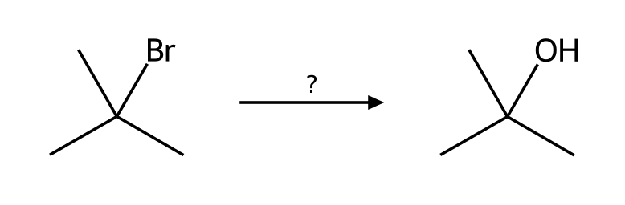

91. Predict the major organic product of 2-chloro-2-methylbutane with EtOH as the solvent. State the mechanism and any minor pathway. [P016, Basic]
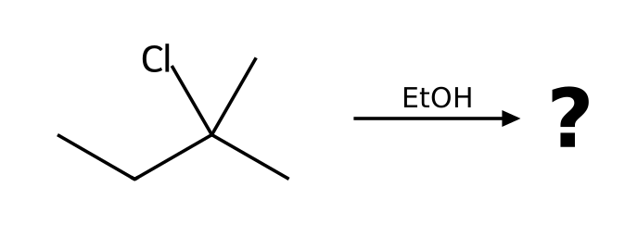

92. Predict the major organic product of 1-bromo-1-methylcyclohexane with MeOH as the solvent. State the mechanism and any minor pathway. [P017, Basic]
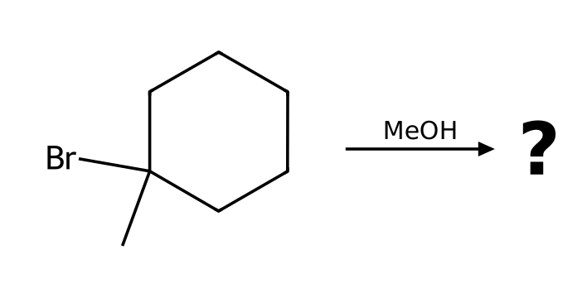

93. Which mechanism (SN1, SN2, E1 or E2) predominates when 3-bromo-3-methylpentane reacts with EtOH as the solvent? List the factors that support your answer and give the major product. [P023, Basic]
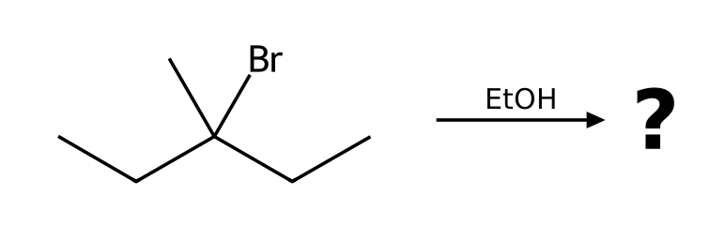

94. Which mechanism (SN1, SN2, E1 or E2) predominates when 2-iodo-2-methylpropane reacts with CH₃CO₂H as the solvent? List the factors that support your answer and give the major product. [P024, Basic]
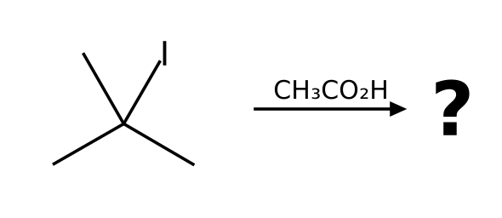

95. (R)-3-bromo-3-methylhexane reacts with MeOH as the solvent. Draw the product(s), including stereochemistry, and explain why the result differs from an SN2 reaction. [P034, Moderate]
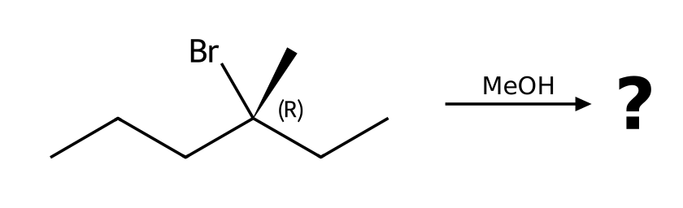

96. (S)-3-chloro-3-methylhexane reacts with EtOH as the solvent. Draw the product(s), including stereochemistry, and explain why the result differs from an SN2 reaction. [P035, Moderate]
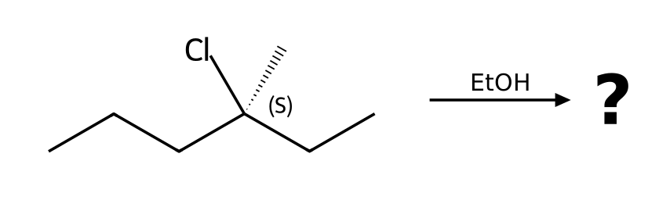

97. (S)-3-bromo-3-methylhexane reacts with H₂O as the solvent. Draw the product(s), including stereochemistry, and explain why the result differs from an SN2 reaction. [P036, Moderate]
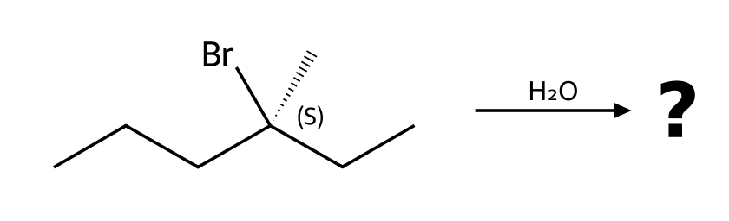

98. Describe the complete mechanism (list each step and the curved arrows) for the reaction of 2-bromo-2-methylpropane with H₂O as the solvent. How many steps are there? [P040, Moderate]
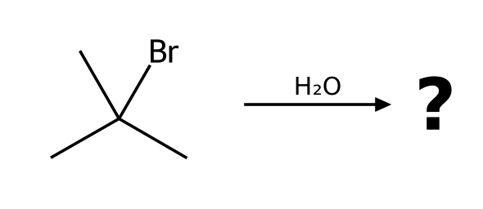

99. Describe the complete mechanism (list each step and the curved arrows) for the reaction of 2-chloro-2-methylbutane with EtOH as the solvent. How many steps are there? [P041, Moderate]

100. Describe the complete mechanism (list each step and the curved arrows) for the reaction of 2-bromo-2-methylbutane with MeOH as the solvent. How many steps are there? [P045, Moderate]
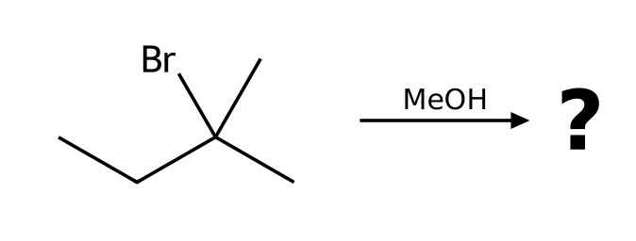

101. Will 2-bromo-3-methylbutane rearrange when heated in EtOH? Show the carbocation that forms, the shift involved, and the major substitution product. [P065, Moderate]
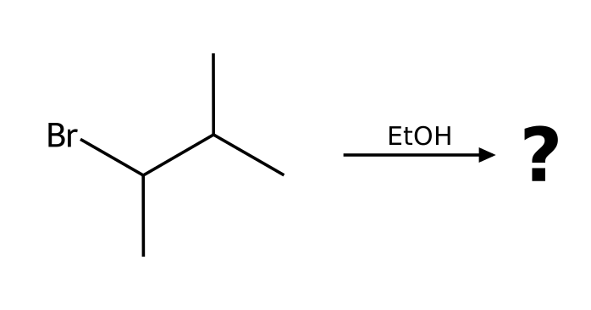

102. Will 1-bromo-2,2-dimethylpropane rearrange when heated in EtOH? Show the carbocation that forms, the shift involved, and the major substitution product. [P066, Moderate]

103. Will 3-bromo-2,2-dimethylbutane rearrange when heated in MeOH? Show the carbocation that forms, the shift involved, and the major substitution product. [P067, Moderate]
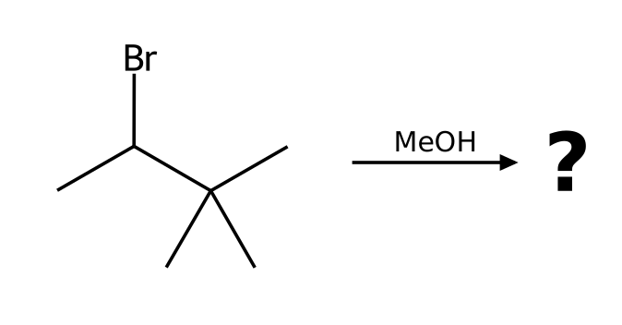

104. Will 2-bromo-3-methylpentane rearrange when heated in MeOH? Show the carbocation that forms, the shift involved, and the major substitution product. [P068, Moderate]
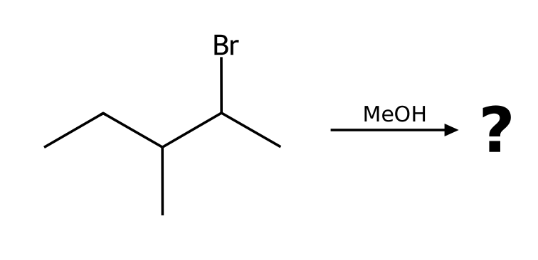

105. Predict the major alkene from heating 3-methylbutan-2-ol with H₂SO₄. Explain the rearrangement. [P069, Moderate]
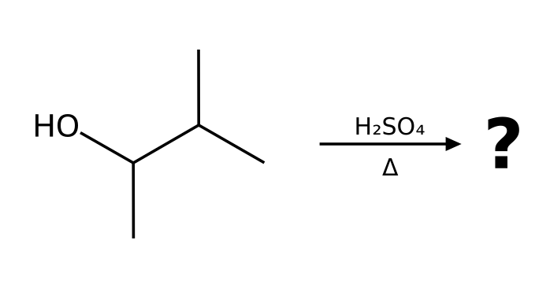

106. What happens when 2-methylpropan-2-ol is heated with concentrated H₂SO₄? Give the major product, name the mechanism and explain why the OH must be protonated first. [P070, Basic]
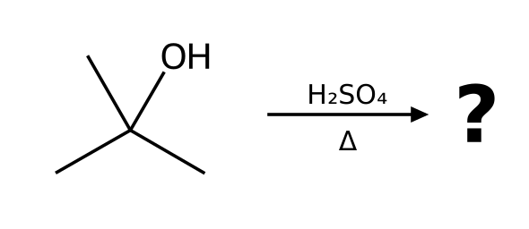

107. What happens when 2-methylbutan-2-ol is heated with concentrated H₂SO₄? Give the major product, name the mechanism and explain why the OH must be protonated first. [P071, Basic]
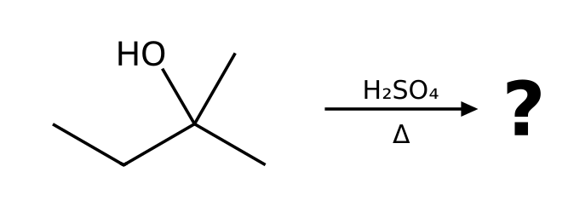

108. What happens when 1-methylcyclohexan-1-ol is heated with concentrated H₂SO₄? Give the major product, name the mechanism and explain why the OH must be protonated first. [P072, Basic]
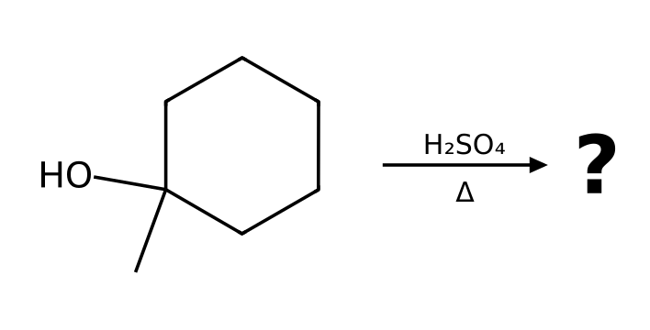

109. What happens when butan-2-ol is heated with concentrated H₂SO₄? Give the major product, name the mechanism and explain why the OH must be protonated first. [P073, Basic]
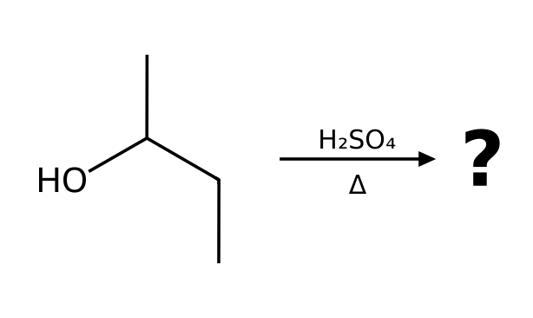

110. The reaction of 2-chloro-2-methylbutane with EtOH as the solvent follows the mechanism predicted for these conditions. Write the rate law. What happens to the rate if (a) [substrate] is doubled and [ethanol] is unchanged, and (b) [ethanol] is tripled and [substrate] is unchanged? [P093, Basic]

7.9 Predicting Products: Substitution vs. Elimination
111. A tertiary alkyl halide with a strong base (NaOEt) gives mainly: [C07M39, Basic]
A) SN2 substitution
B) SN1 substitution
C) E2 elimination
D) No reaction
112. A primary alkyl halide with a strong nucleophile that is a weak base (NaCN) gives mainly: [C07M40, Basic]
A) SN2 substitution
B) E2 elimination
C) SN1 substitution
D) E1 elimination
113. A tertiary alkyl halide in warm ethanol (no strong base) gives: [C07M41, Moderate]
A) Only SN2 product
B) Only E2 product
C) No reaction
D) A mixture of SN1 and E1 products
114. Which conditions favor E2 over SN2 for a secondary alkyl halide? [C07M42, Moderate]
A) A weak base, room temperature
B) A strong, bulky base and heat
C) A good nucleophile that is a weak base
D) A polar protic solvent with no base
115. Which substrate/reagent pair gives mainly the SN2 product? [C07M43, Hard]
A) (CH₃)₃CBr with NaOEt
B) (CH₃)₂CHBr with t-BuOK, heat
C) (CH₃)₃CBr in ethanol
D) CH₃CH₂CH₂Br with NaN₃
116. A student predicts an SN2 reaction to give a nitrile. Reaction: 2-bromo-2-methylpropane + NaCN in DMSO. Explain what is wrong and give the correct outcome. [P046, Basic]
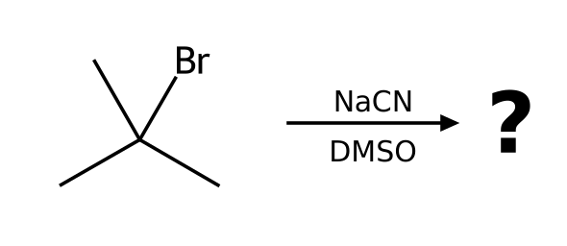

117. A student says a primary halide always reacts quickly by SN2. Reaction: 1-bromo-2,2-dimethylpropane + NaOH in DMSO. Explain what is wrong and give the correct outcome. [P047, Basic]
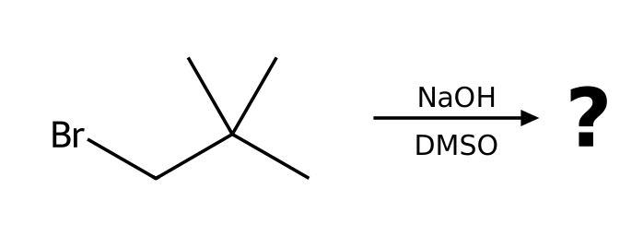

118. A student predicts substitution to give vinyl alcohol. Reaction: bromoethene (vinyl bromide) + NaOH in DMSO. Explain what is wrong and give the correct outcome. [P048, Basic]
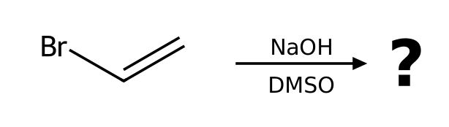

119. A student predicts benzonitrile. Reaction: bromobenzene + NaCN in DMSO. Explain what is wrong and give the correct outcome. [P049, Basic]
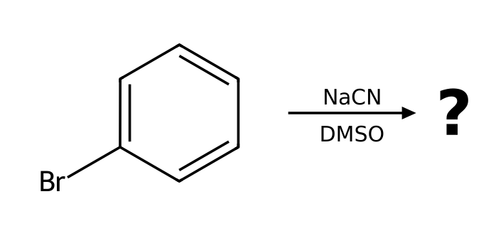

120. A student predicts 1-bromobutane. Reaction: butan-1-ol + NaBr in DMF. Explain what is wrong and give the correct outcome. [P050, Basic]
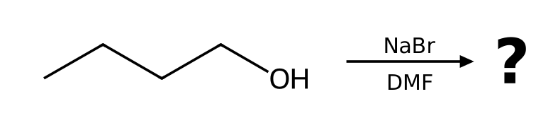

121. A student predicts the ether 2-ethoxybutane by SN2. Reaction: 2-bromobutane + NaOEt in EtOH. Explain what is wrong and give the correct outcome. [P051, Basic]

122. A student predicts butanenitrile. Reaction: 1-fluoropropane + NaCN in DMSO. Explain what is wrong and give the correct outcome. [P052, Basic]
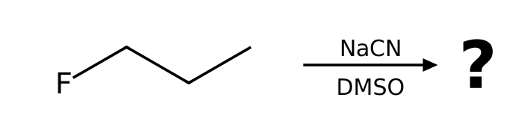

123. 2-bromopropane is treated under two different conditions: (a) NaCN in DMSO; (b) NaOEt in EtOH with heat. For each, name the mechanism and the major product. [P053, Moderate]
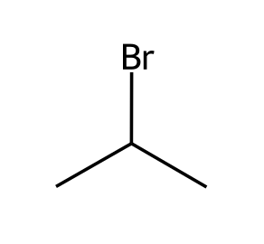

124. 2-bromo-2-methylbutane is treated under two different conditions: (a) EtOH in EtOH; (b) NaOEt in EtOH with heat. For each, name the mechanism and the major product. [P054, Moderate]

125. 1-bromopropane is treated under two different conditions: (a) NaOEt in EtOH; (b) KOtBu in tBuOH. For each, name the mechanism and the major product. [P055, Moderate]
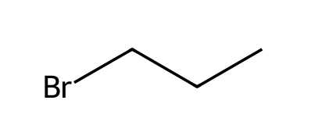

126. 2-bromobutane is treated under two different conditions: (a) NaN₃ in DMF; (b) KOtBu in tBuOH. For each, name the mechanism and the major product. [P056, Moderate]

127. 2-bromo-2-methylpropane is treated under two different conditions: (a) H₂O in H2O; (b) NaOH in EtOH with heat. For each, name the mechanism and the major product. [P057, Moderate]
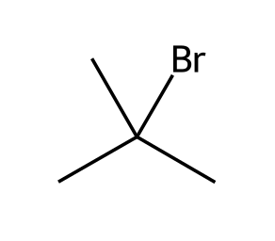

128. bromocyclohexane is treated under two different conditions: (a) NaSH in DMSO; (b) NaOMe in MeOH with heat. For each, name the mechanism and the major product. [P058, Moderate]
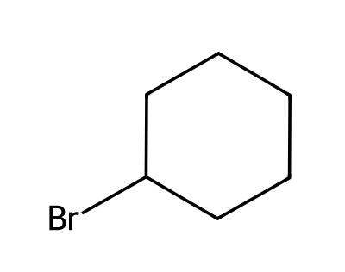

129. For each substrate, classify the α carbon (methyl, 1°, 2° or 3°), identify the leaving group, and state whether SN2, SN1, both or neither is feasible: (I) iodoethane (II) 2-bromo-2-methylbutane (III) 2-chlorobutane (IV) bromobenzene. [P096, Basic]
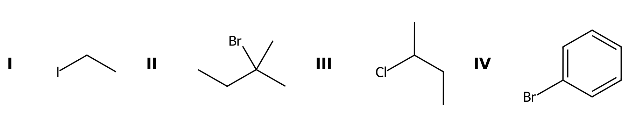

130. Label each carbon bearing a leaving group as 1°, 2° or 3° and say which substitution mechanism is favored by the substrate alone: (I) 1-bromobutane (II) 3-bromo-3-methylpentane (III) iodocyclohexane. [P097, Basic]
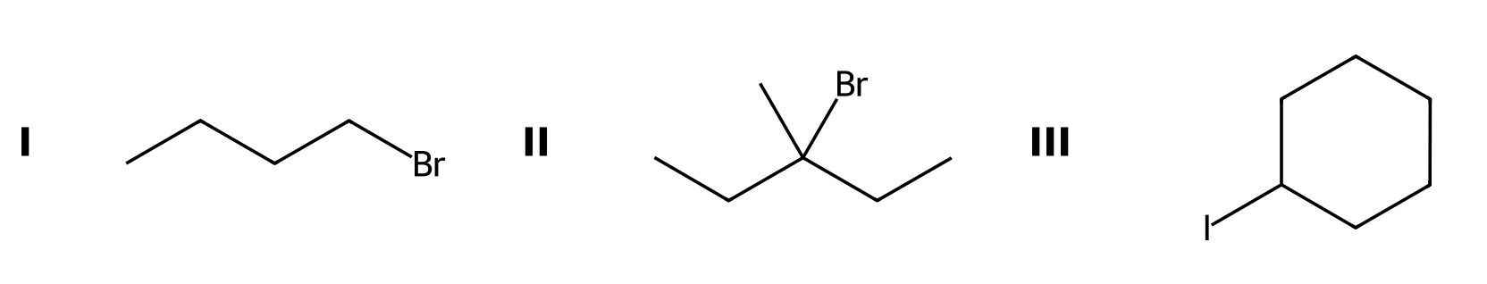

7.10 Substitution and Elimination with Other Substrates
131. Why is the OH group of an alcohol a poor leaving group? [C07M44, Basic]
A) HO⁻ is a strong base
B) HO⁻ is too large
C) It has no lone pairs
D) It is not polar
132. What converts an alcohol into a good leaving group for substitution? [C07M45, Moderate]
A) Treating it with NaOH
B) Treating it with a base only
C) Protonation with a strong acid or conversion to a tosylate
D) Reducing it
133. Propose reagents to convert (S)-butan-2-ol into (R)-2-bromobutane. Explain why the OH group cannot simply be displaced, and state the stereochemical outcome if there is a stereocenter. [P059, Basic]
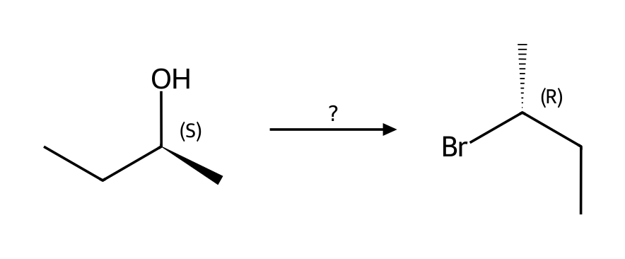

134. Propose reagents to convert 2-methylpropan-2-ol into 2-bromo-2-methylpropane. Explain why the OH group cannot simply be displaced, and state the stereochemical outcome if there is a stereocenter. [P060, Basic]
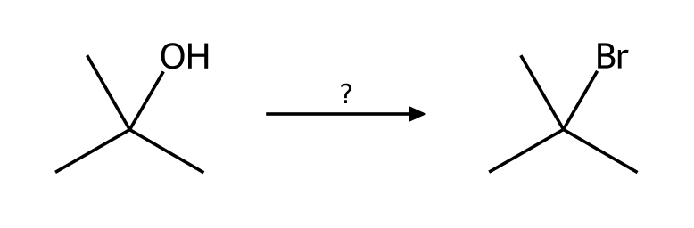

135. Propose reagents to convert butan-1-ol into 1-bromobutane. Explain why the OH group cannot simply be displaced, and state the stereochemical outcome if there is a stereocenter. [P061, Basic]
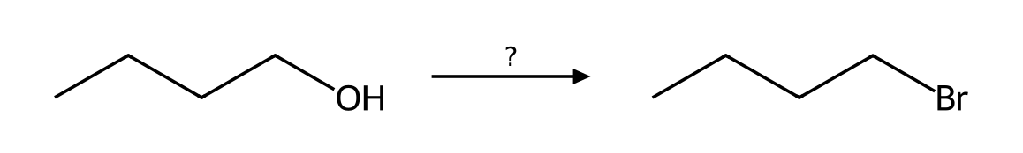

136. Propose reagents to convert propan-2-ol into 2-chloropropane. Explain why the OH group cannot simply be displaced, and state the stereochemical outcome if there is a stereocenter. [P062, Basic]
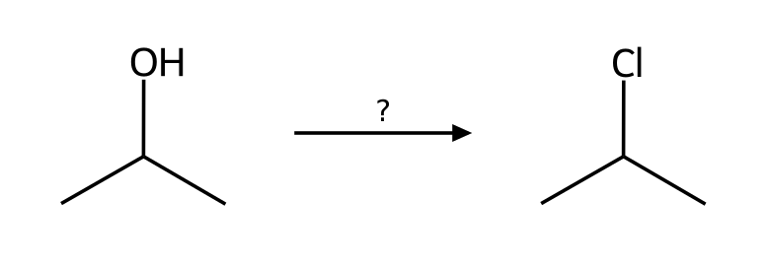

137. Propose reagents to convert (R)-pentan-2-ol into (S)-2-methylpentanenitrile. Explain why the OH group cannot simply be displaced, and state the stereochemical outcome if there is a stereocenter. [P063, Basic]
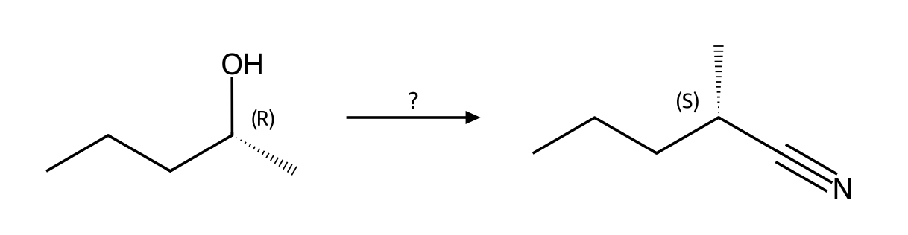

138. Propose reagents to convert butan-1-ol into 1-azidobutane. Explain why the OH group cannot simply be displaced, and state the stereochemical outcome if there is a stereocenter. [P064, Basic]
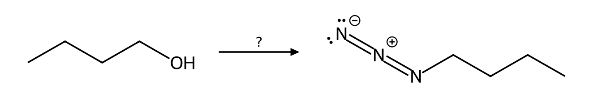

7.11 Synthesis Strategies
139. To convert 1-bromobutane into butan-1-ol with high yield, which reagent is best? [C07M46, Moderate]
A) NaOH in a polar solvent (SN2)
B) t-BuOK
C) H₂O, heat
D) HBr
140. To make 2-methylbut-1-ene from 2-bromo-2-methylbutane the best reagent is: [C07M47, Hard]
A) Sodium ethoxide
B) Potassium tert-butoxide
C) Water
D) Sodium iodide
141. Design a synthesis of 2-methoxy-2-methylpropane from an alkyl halide and an alkoxide. Which combination works, and why does the other combination fail? [P079, Moderate]
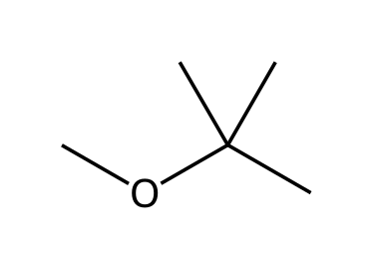

142. Design a synthesis of 2-ethoxypropane from an alkyl halide and an alkoxide. Which combination works, and why does the other combination fail? [P080, Moderate]
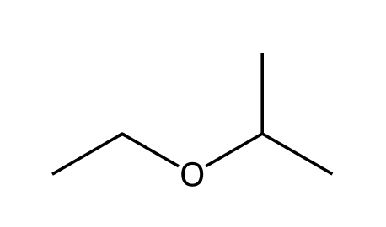

143. Design a synthesis of 2-ethoxy-2-methylpropane from an alkyl halide and an alkoxide. Which combination works, and why does the other combination fail? [P081, Moderate]
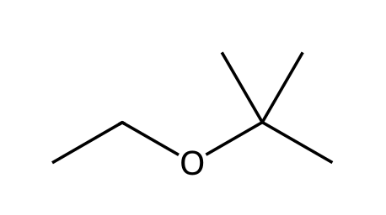

7.12 Solvent Effects in Substitution Reactions
144. Which is a polar protic solvent? [C07M48, Easy]
A) Ethanol
B) Acetone
C) DMSO
D) DMF
145. SN2 reactions are generally fastest in: [C07M49, Basic]
A) Polar protic solvents
B) Nonpolar solvents
C) Water only
D) Polar aprotic solvents
146. Which solvent favors SN1 reactions by stabilizing the carbocation and leaving group? [C07M50, Moderate]
A) A polar protic solvent
B) A nonpolar solvent
C) A polar aprotic solvent
D) Hexane
147. Classify each solvent as protic or polar aprotic and say which substitution mechanism it favors: DMSO, methanol, acetonitrile, water, DMF, acetic acid. [P090, Basic]

148. The SN2 reaction of 1-bromobutane with azide is about 1300 times faster in DMSO than in methanol. Explain. [P091, Basic]

