Chapter 2: Molecular Representations
Organic chemistry questions. Multiple choice first within each textbook section.
Name: ______________________________ Date: ______________

2.1 Molecular Representations
1. A partially condensed structure is CH₃CH₂CH₂OH. What is its molecular formula? [C02M01, Easy]
A) C₃H₆O
B) C₃H₈O
C) C₃H₇O
D) C₃H₈O₂
2. Which statement about molecular formulas is correct? [C02M02, Basic]
A) A molecular formula shows which atoms are bonded to each other
B) Every molecular formula corresponds to exactly one compound
C) A molecular formula does not show how the atoms are connected, so C₄H₁₀O fits several different compounds
D) A molecular formula shows the lone pairs on each atom
3. Which bond-line structure is the same compound as the condensed structure (CH₃)₂CHCH₂CH₃? [C02M03, Basic]
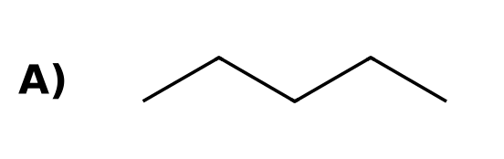 | 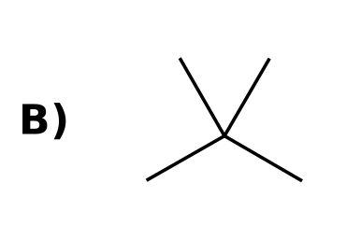
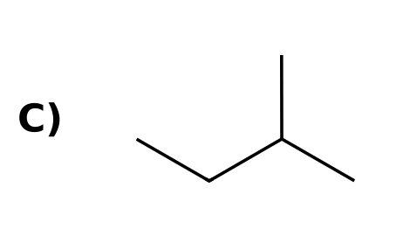 | 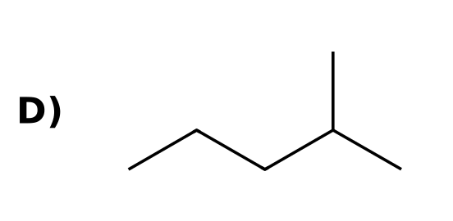
4. Write the molecular formula for CH₃CH₂COCH₃. [C02F01, Easy]

5. Draw the complete Lewis structure of CH₃OCH₃ (dimethyl ether), showing every lone pair. How many lone pairs are there in total? [C02F02, Basic]

6. Give two different compounds with the molecular formula C₂H₆O as condensed structures. [C02F03, Basic]

7. The bond-line structure of 2-methylbutane is shown. Write its partially condensed structure and its molecular formula. [C02F04, Moderate]
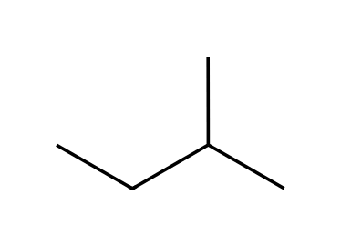

2.2 Drawing Bond-Line Structures
8. How many carbon atoms are in the compound shown? [C02M04, Easy]
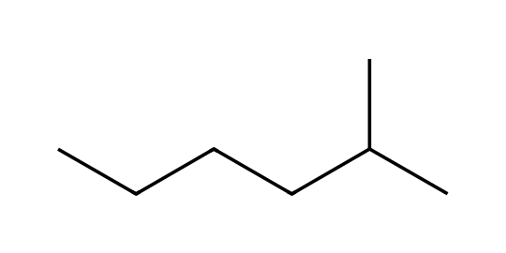
A) 6
B) 8
C) 7
D) 9
9. What is the molecular formula of the compound shown? [C02M05, Basic]
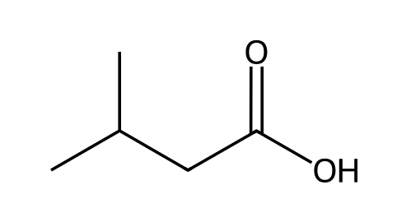
A) C₅H₁₂O₂
B) C₅H₁₀O₂
C) C₅H₈O₂
D) C₄H₈O₂
10. Which statement about bond-line structures is correct? [C02M06, Basic]
A) Carbon atoms are at each bend and line end, and hydrogen atoms bonded to carbon are not drawn
B) Every hydrogen atom must be drawn
C) Carbon atoms are written as the letter C
D) Lone pairs on oxygen must always be drawn
11. How many hydrogen atoms are bonded to the carbon that bears the OH group? [C02M07, Basic]
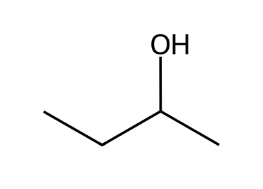
A) 0
B) 1
C) 2
D) 3
12. Which compound has the molecular formula C₆H₁₂O? [C02M08, Moderate]
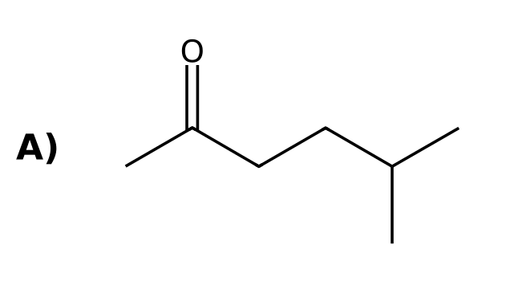 | 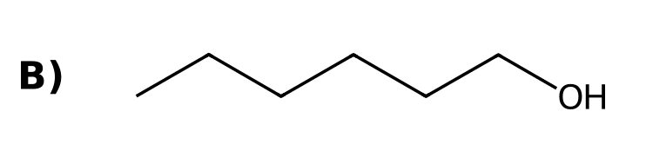
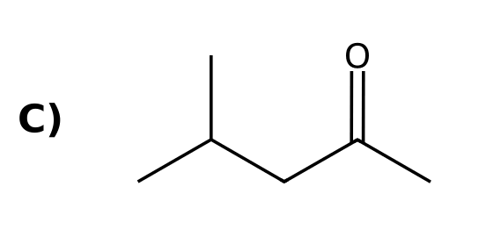 | 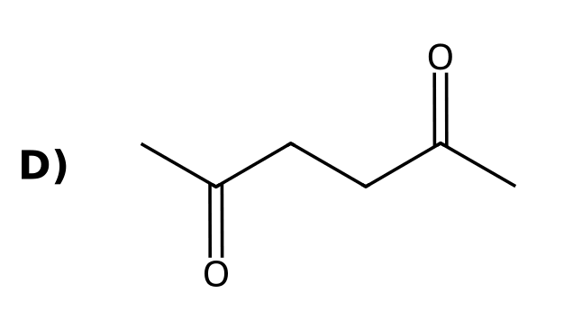
13. Draw the bond-line structure of (CH₃)₂CHCH₂CH₃. [C02F05, Easy]

14. Draw the bond-line structure of CH₃CH₂CH(OH)CH₃. [C02F06, Basic]

15. What is the molecular formula of the compound shown? [C02F07, Basic]
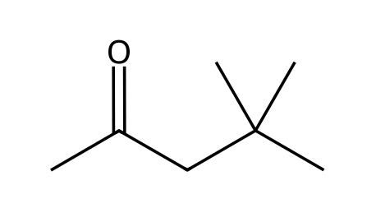

16. Draw bond-line structures of all constitutional isomers of C₄H₁₀. [C02F08, Moderate]

17. For the compound shown, give the molecular formula and identify the carbon atom that bears no hydrogen atoms. [C02F09, Moderate]
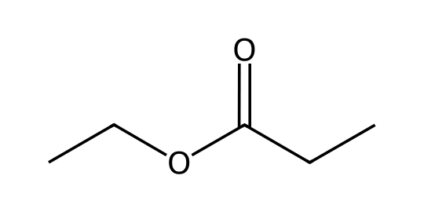

2.3 Identifying Functional Groups
18. Which functional group is present in this compound? [C02M09, Easy]
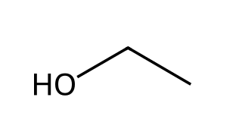
A) An alcohol
B) An ether
C) An aldehyde
D) An amine
19. Which functional group is present in this compound? [C02M10, Easy]
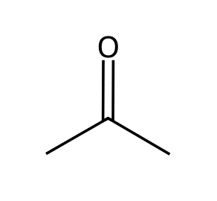
A) A ketone
B) An aldehyde
C) An ester
D) A carboxylic acid
20. Which functional group is present in this compound? [C02M11, Basic]
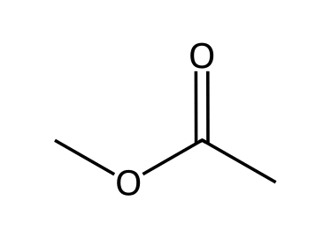
A) A carboxylic acid
B) An ester
C) An ether
D) A ketone
21. Which functional group is present in this compound? [C02M12, Basic]
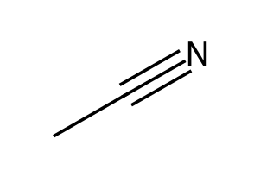
A) An alkyne
B) A nitrile
C) An amine
D) An imine
22. Which functional group is present in this compound? [C02M13, Basic]
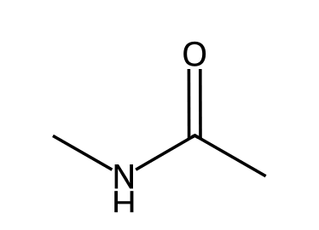
A) An ester
B) An amine
C) A nitrile
D) An amide
23. Which pair of functional groups (besides the aromatic ring) is present in aspirin? [C02M14, Moderate]
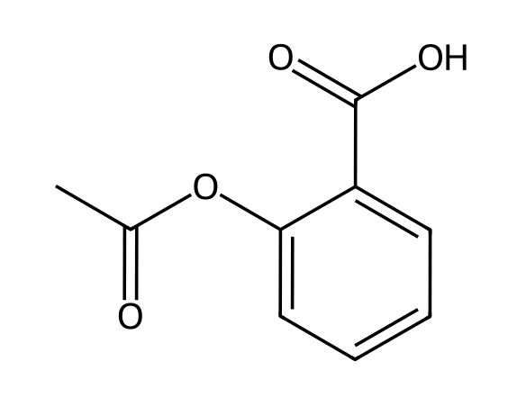
A) An ester and a carboxylic acid
B) A ketone and a carboxylic acid
C) An ester and an aldehyde
D) An ether and a carboxylic acid
24. Name the functional group in CH₃CH₂CHO. [C02F10, Easy]

25. Identify the functional group and classify it as primary, secondary or tertiary. [C02F11, Basic]
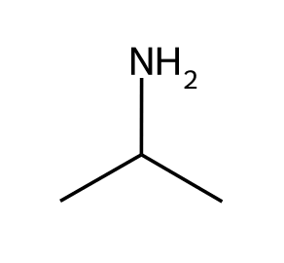

26. Identify the two functional groups in this compound. [C02F12, Basic]
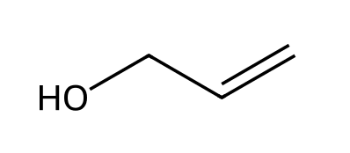

27. Identify the two carbonyl-containing functional groups in this compound. [C02F13, Moderate]
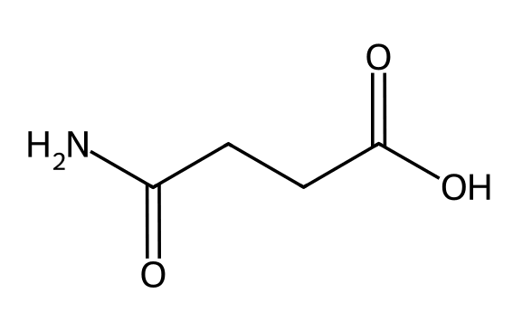

28. Draw one aldehyde and one ketone, each with the molecular formula C₃H₆O. [C02F14, Moderate]

29. Is the compound shown an amine or an amide? Explain. [C02F15, Moderate]
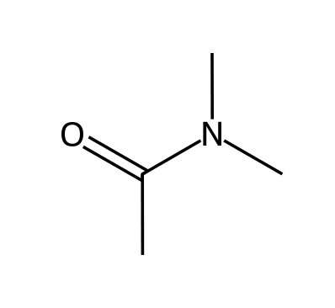

2.4 Carbon Atoms with Formal Charges
30. A carbon atom with a positive formal charge and no lone pair (a carbocation) has how many bonds? [C02M15, Easy]
A) 2
B) 4
C) 1
D) 3
31. A carbon atom has three bonds and one lone pair. What is its formal charge? [C02M16, Basic]
A) Positive (+1)
B) Neutral
C) -2
D) Negative (-1)
32. Which structure contains a carbocation? [C02M17, Basic]
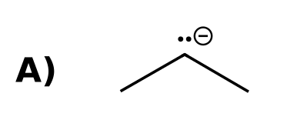 | 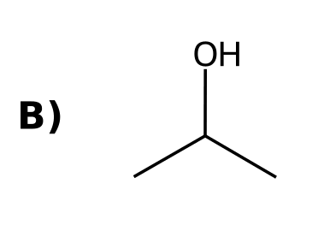
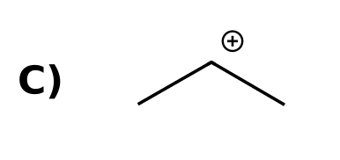 | 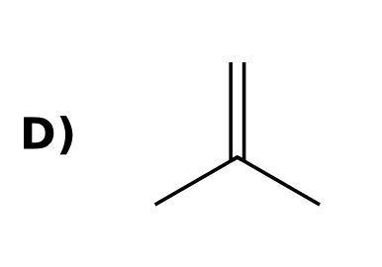
33. How many hydrogen atoms are bonded to the charged carbon in this ion? [C02M18, Moderate]
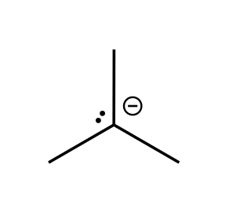
A) 1
B) 2
C) 0
D) 3
34. Draw the methyl cation. How many bonds and lone pairs does the carbon have? [C02F16, Easy]

35. A carbon atom with three bonds can be either positive or negative. How can you tell which? [C02F17, Basic]

36. State the formal charge on the terminal CH₂ carbon of this ion and the number of lone pairs on it. [C02F18, Moderate]
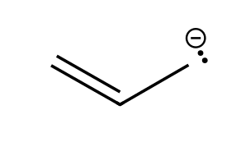

2.5 Identifying Lone Pairs
37. How many lone pairs are on the oxygen atom of an alcohol (R-OH)? [C02M19, Easy]
A) 0
B) 1
C) 3
D) 2
38. How many lone pairs does the nitrogen atom of a neutral amine (R₃N) have? [C02M20, Basic]
A) 1
B) 0
C) 2
D) 3
39. Which atom in this compound has two lone pairs? [C02M21, Basic]
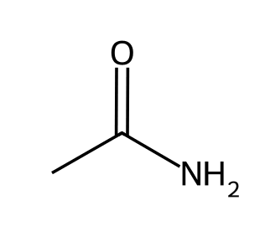
A) The nitrogen
B) The carbonyl carbon
C) The oxygen
D) Both the oxygen and the nitrogen
40. How many lone pairs are on all the atoms of acetic acid, CH₃CO₂H? [C02M22, Moderate]
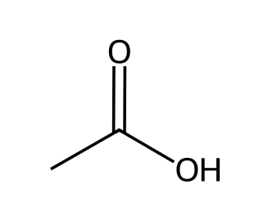
A) 2
B) 3
C) 6
D) 4
41. How many lone pairs does the chlorine atom in CH₃Cl have? [C02F19, Easy]

42. Redraw the compound showing all lone pairs. How many are there? [C02F20, Basic]
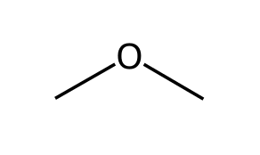

43. How many lone pairs are on all the heteroatoms of the compound shown? [C02F21, Moderate]

44. Lone pairs are usually not drawn in bond-line structures. Why is it still important to recognize them? [C02F22, Moderate]

2.6 Three-Dimensional Bond-Line Structures
45. In a bond-line drawing, what does a dashed bond indicate? [C02M23, Easy]
A) The group is in front of the plane of the page
B) The group is behind the plane of the page
C) The bond is a double bond
D) The bond is very weak
46. In a bond-line drawing, what does a solid wedge indicate? [C02M24, Easy]
A) The group is in front of the plane of the page
B) The group is behind the plane of the page
C) The bond is a triple bond
D) The group is lone-pair bearing
47. A tetrahedral carbon is drawn with two bonds in the plane, one on a wedge and one on a dash. Where are the groups on the wedge and the dash? [C02M25, Moderate]
A) The wedge group points toward the viewer and the dash group points away
B) Both point toward the viewer
C) Both point away from the viewer
D) Both lie in the plane of the page
48. In the drawing shown, the methyl group is drawn on a wedge. Where is that group relative to the plane of the page? [C02M26, Basic]
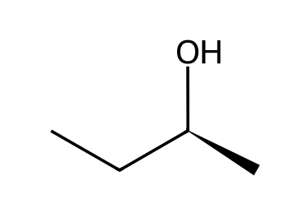
A) Behind the page
B) Toward the viewer (in front of the page)
C) In the plane of the page
D) It cannot be determined
49. What do a plain bond, a solid wedge and a dashed bond mean in a three-dimensional bond-line structure? [C02F23, Easy]

50. Describe the position of the methyl group in the drawing shown, relative to the plane of the page. [C02F24, Basic]
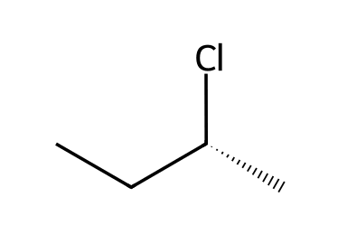

51. One student draws CH₃CH(OH)CH₂CH₃ with the OH group on a wedge; another draws it on a dash. Are these the same molecule? Explain. [C02F25, Moderate]
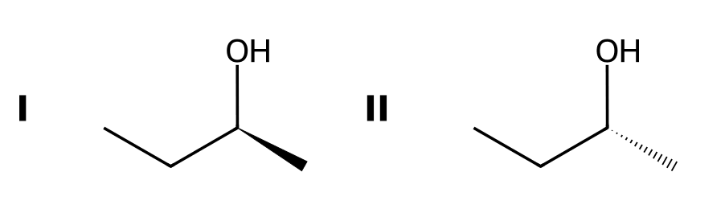

52. Name two drawing styles other than wedge-and-dash that show three-dimensional structure. [C02F26, Easy]

2.7 Introduction to Resonance
53. Which arrow is placed between resonance structures? [C02M27, Easy]
A) A double-headed arrow (↔)
B) An equilibrium arrow (⇌)
C) A single reaction arrow (→)
D) A curved arrow
54. Which statement about a resonance hybrid is correct? [C02M28, Basic]
A) The molecule rapidly flips between the resonance structures
B) It is a single species that is a combination of all the resonance structures
C) Only the most stable resonance structure actually exists
D) Each resonance structure is a separate isomer
55. Why is a single bond-line structure inadequate for acetate, CH₃CO₂⁻? [C02M29, Moderate]
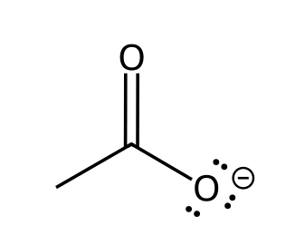
A) It does not show the carbon atoms
B) It shows one C=O and one C-O⁻ bond, but the two carbon-oxygen bonds are actually equivalent
C) It shows too many hydrogens
D) It places the negative charge on carbon
56. What do the brackets and the double-headed arrow mean when they surround a set of structures? [C02F27, Easy]

57. Is resonance an equilibrium between the resonance structures? Explain. [C02F28, Basic]

58. Define resonance stabilization. [C02F29, Basic]

2.8 Curved Arrows
59. In resonance structures, curved arrows show the movement of what? [C02M30, Easy]
A) A pair of electrons
B) An atom
C) A proton
D) A positive charge only
60. Where should the tail of a curved arrow start? [C02M31, Basic]
A) On the nucleus of an atom
B) On a lone pair or a π bond
C) On a formal charge
D) On any hydrogen atom
61. Which is NOT allowed when drawing resonance arrows? [C02M32, Basic]
A) Breaking a single bond
B) Moving a lone pair to form a π bond
C) Moving a π bond onto an adjacent atom
D) Moving a π bond to become a lone pair
62. Which set of curved arrows correctly converts this resonance structure of acetate into the other one? [C02M33, Moderate]
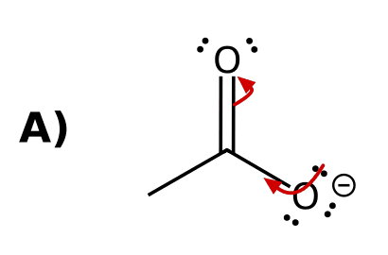 | 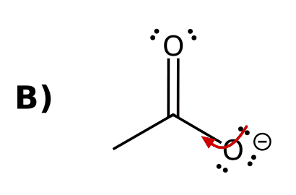
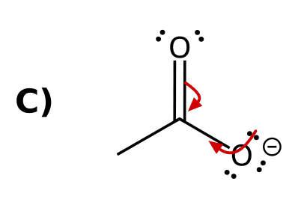 | 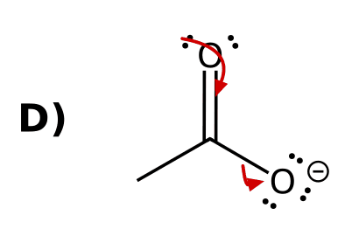
63. Draw curved arrow(s) to convert the allyl cation resonance structure shown into the other one. [C02F30, Basic]
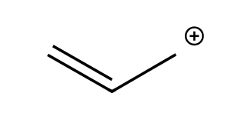

64. Why can a curved arrow not be drawn starting from a single bond in resonance? [C02F31, Basic]

65. How many curved arrows are needed to convert one resonance structure of acetate into the other? Describe where each starts and ends. [C02F32, Moderate]

66. A curved arrow starts on the π bond of a C=O group and points to oxygen. Describe the resulting structure. [C02F33, Moderate]

2.9 Formal Charges in Resonance Structures
67. What is the formal charge on the oxygen atom that has one single bond and three lone pairs? [C02M34, Easy]
A) 0
B) +1
C) -2
D) -1
68. What is the formal charge on nitrogen in the ammonium ion, NH₄⁺? [C02M35, Basic]
A) 0
B) -1
C) +1
D) +4
69. The ion CH₂=CH-O⁻ has a second resonance structure. On which atom is the negative charge in it? [C02M36, Moderate]
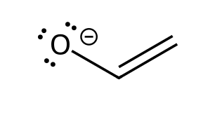
A) The oxygen
B) The middle carbon
C) Neither; the second structure is neutral
D) The terminal carbon
70. What is the formal charge on an oxygen atom that has three bonds and one lone pair? [C02F34, Easy]

71. Draw the second resonance structure of the ion shown, including formal charges. [C02F35, Basic]

72. Must the total charge be the same in every resonance structure of an ion? Explain. [C02F36, Basic]

2.10 Drawing Resonance Structures via Pattern Recognition
73. Which of these is NOT one of the five patterns used to find resonance structures? [C02M37, Basic]
A) An isolated double bond with no adjacent lone pair or charge
B) An allylic carbocation
C) An allylic lone pair
D) Conjugated π bonds in a ring
74. Which anion has an allylic lone pair and can therefore be drawn with resonance? [C02M38, Basic]
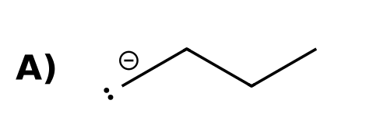 | 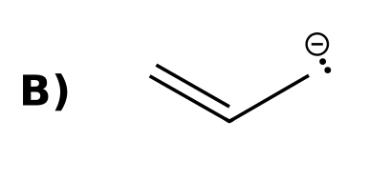
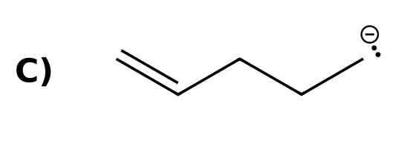 | 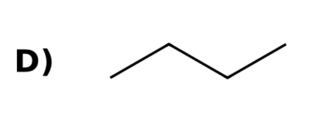
75. How many resonance structures (including the one drawn) are there for the allyl cation, CH₂=CH-CH₂⁺? [C02M39, Basic]
A) 1
B) 2
C) 3
D) 4
76. How many resonance structures with alternating double bonds can be drawn for benzene? [C02M40, Basic]
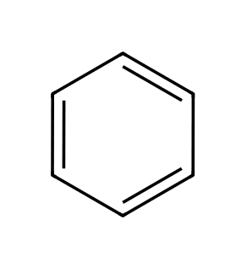
A) 1
B) 3
C) 2
D) 6
77. Which resonance pattern applies to acetate? [C02M41, Moderate]
A) An allylic lone pair (a lone pair next to a π bond)
B) An allylic carbocation
C) A lone pair adjacent to a carbocation
D) Conjugated π bonds in a ring
78. Draw both resonance structures of the allyl anion. [C02F37, Basic]

79. Draw the second resonance structure of the allyl cation. [C02F38, Basic]

80. Draw a resonance structure of acrolein, CH₂=CH-CH=O, in which oxygen carries a negative charge. [C02F39, Moderate]
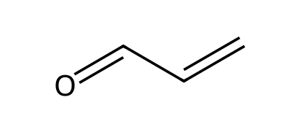

81. Draw the resonance structure of CH₃-O-CH₂⁺ that places the positive charge on oxygen. Which pattern is this? [C02F40, Moderate]
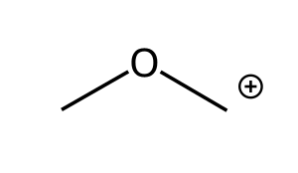

82. How many resonance structures can be drawn for the phenoxide ion (including both Kekulé forms)? On which atoms can the negative charge be placed? [C02F41, Hard]
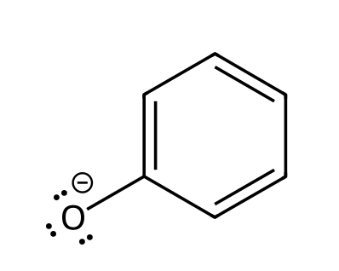

2.11 Assessing the Relative Importance of Resonance Structures
83. Which resonance structures contribute equally to the resonance hybrid? [C02M42, Easy]
A) Structures with the most charges
B) Structures with the fewest filled octets
C) Structures that are equally good Lewis structures (equivalent)
D) The first structure drawn
84. Which resonance structure is the more significant contributor? [C02M43, Basic]
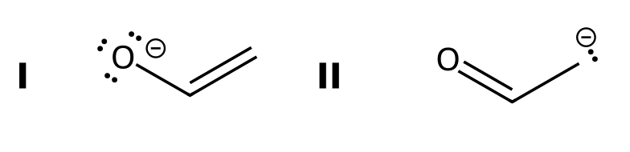
A) II, because the negative charge is on carbon
B) They contribute equally
C) I, because the negative charge is on the more electronegative atom (oxygen)
D) II, because it has fewer formal charges
85. Are the two resonance structures of acetate equivalent? [C02M44, Basic]
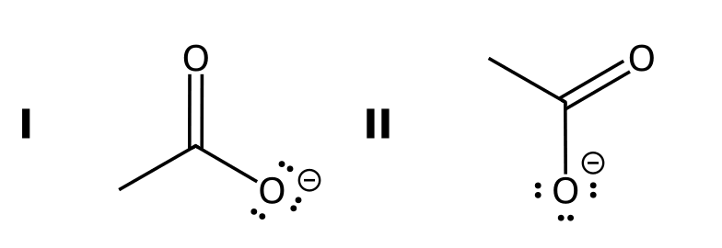
A) No, one has a negative charge on carbon
B) Yes, both have a negative charge on one oxygen and a C=O on the other
C) No, one has no formal charge
D) No, one has an incomplete octet
86. Which resonance structure of the methoxymethyl cation is more significant? [C02M45, Moderate]
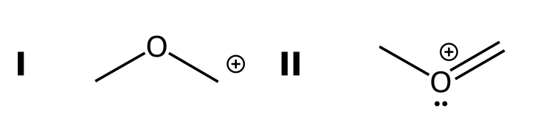
A) I, because the positive charge is on carbon
B) I, because it has fewer bonds
C) They are equivalent
D) II, because every atom has a complete octet
87. State the first and second rules used to decide which resonance structure is more significant. [C02F42, Basic]

88. Why is a resonance structure with separated positive and negative charges usually less significant than one without charges? [C02F43, Basic]

89. Of the two resonance structures of the enolate shown, which contributes more to the hybrid and why? [C02F44, Moderate]

90. List the four guidelines for judging the significance of resonance structures. [C02F45, Moderate]

2.12 The Resonance Hybrid
91. How is a resonance hybrid drawn? [C02M46, Basic]
A) With two structures and an equilibrium arrow
B) With the most stable structure only
C) With a double bond on each side
D) With dashed (partial) bonds and partial charges (δ)
92. What is the carbon-oxygen bond order in each C-O bond of acetate? [C02M47, Basic]
A) 1
B) 2
C) 1 and 2 alternating
D) 1.5
93. Describe how the resonance hybrid of the allyl cation is drawn. [C02F46, Basic]

94. In the resonance hybrid of acetate, what is the charge on each oxygen? [C02F47, Basic]

2.13 Delocalized and Localized Lone Pairs
95. In an amide, the lone pair on nitrogen is: [C02M48, Basic]
A) Localized, because nitrogen is electronegative
B) Delocalized, because it is in an s orbital
C) Delocalized, because it is adjacent to the C=O π bond
D) Not present
96. Compare the nitrogen lone pair in CH₃CH₂NH₂ and in CH₂=CHNH₂. [C02M49, Moderate]
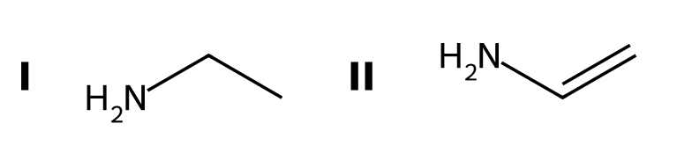
A) Delocalized in both
B) Localized in both
C) Delocalized in the first and localized in the second
D) Localized in the first and delocalized in the second
97. A carbonyl oxygen has a π bond and lone pairs. Which statement is correct? [C02M50, Moderate]
A) The lone pairs and the π bond both participate in resonance
B) Neither the lone pairs nor the π bond can participate
C) The lone pairs participate but the π bond does not
D) The π bond can participate in resonance but the lone pairs on that oxygen do not
98. In the ester shown, identify the oxygen lone pair that is delocalized and say why. [C02F48, Basic]

99. Is the nitrogen lone pair in aniline localized or delocalized? Explain. [C02F49, Moderate]
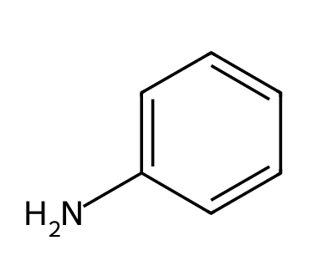

100. Draw the resonance structure of the amide shown that results from delocalizing the nitrogen lone pair. [C02F50, Moderate]

