Chapter 3: Acids and Bases: Answer Key
Answers and explanations.
Name: ______________________________ Date: ______________

3.1 Introduction to Brønsted-Lowry Acids and Bases
1. In the reaction HCl + H₂O ⇌ Cl⁻ + H₃O⁺, which species is the conjugate base of HCl? [C03M01, Easy]
Answer: D) Cl⁻
Why: The conjugate base is what remains after the acid loses a proton.
2. In which reaction does water act as an acid? [C03M02, Basic]
Answer: B) CH₃CH₂O⁻ + H₂O ⇌ CH₃CH₂OH + HO⁻
Why: Only in the first reaction does water donate a proton (becoming HO⁻); in the others it accepts one.
3. Define a Brønsted-Lowry acid and a Brønsted-Lowry base. [C03F01, Easy]
Answer: An acid is a proton (H⁺) donor and a base is a proton acceptor.
Why: The definition is based on the transfer of a proton.
4. In NH₃ + HCl → NH₄⁺ + Cl⁻, identify the acid, base, conjugate acid and conjugate base. [C03F02, Easy]
Answer: Acid: HCl; base: NH₃; conjugate acid: NH₄⁺; conjugate base: Cl⁻.
Why: HCl donates the proton to NH₃.
5. Water can act as an acid or as a base. Write one reaction for each and name the conjugate partner formed. [C03F03, Basic]
Answer: As a base: HCl + H₂O → Cl⁻ + H₃O⁺ (conjugate acid H₃O⁺). As an acid: CH₃O⁻ + H₂O → CH₃OH + HO⁻ (conjugate base HO⁻).
Why: Water is amphoteric.
6. Give the conjugate acid of CH₃NH₂ and the conjugate base of CH₃OH. [C03F04, Basic]
Answer: The conjugate acid of CH₃NH₂ is CH₃NH₃⁺; the conjugate base of CH₃OH is CH₃O⁻.
Why: Add a proton to the base; remove a proton from the acid.

3.2 Flow of Electron Density: Curved-Arrow Notation
7. What is the minimum number of curved arrows needed to show a proton transfer? [C03M03, Basic]
Answer: D) Two
Why: One arrow shows the base attacking the proton and a second shows the X-H bond breaking.
8. Which curved arrows correctly show hydroxide removing a proton from HCl? [C03M04, Moderate]
Answer: D
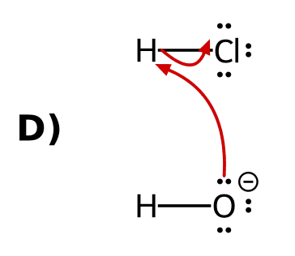
Why: Arrow 1 starts on a lone pair of the base and ends on the proton; arrow 2 starts on the H-Cl bond and ends on chlorine.
9. Draw the curved arrows for the reaction of hydroxide with HCl. [C03F05, Basic]
Answer: Arrow 1: from a lone pair on HO⁻ to the hydrogen of HCl. Arrow 2: from the H-Cl bond to the chlorine atom, giving H₂O and Cl⁻.
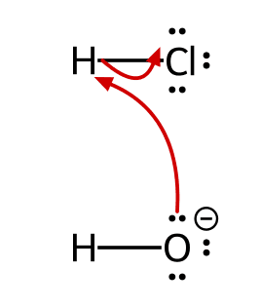
Why: Tail on the electron source, head on where the electrons go.
10. Why does every proton transfer need at least two curved arrows? [C03F06, Basic]
Answer: One arrow shows the base forming a bond to the proton and a second shows the bond to the proton breaking, so the proton is never left with two bonds.
Why: A hydrogen cannot hold more than one bond.
11. Describe the curved arrows for CH₃CO₂H reacting with hydroxide, including where each arrow starts and ends. [C03F07, Moderate]
Answer: Arrow 1: from a lone pair on HO⁻ to the acidic hydrogen. Arrow 2: from the O-H bond of the acid to its oxygen atom, forming CH₃CO₂⁻ and H₂O.
Why: The base attacks the proton and the O-H bond electrons move onto oxygen.
12. For NH₃ + HBr, state where the tail and head of each curved arrow are placed. [C03F08, Moderate]
Answer: Arrow 1 starts on the nitrogen lone pair and ends on the H of HBr. Arrow 2 starts on the H-Br bond and ends on bromine, forming NH₄⁺ and Br⁻.
Why: Lone pair attacks the proton; the H-Br bond leaves with its electrons.

3.3 Comparing pKa Values
13. Which acid is stronger: one with pKa 4.75 or one with pKa 15.7? [C03M05, Easy]
Answer: C) The one with pKa 4.75
Why: A lower pKa means a stronger acid.
14. Acid A has pKa 5 and acid B has pKa 9. How many times more acidic is A than B? [C03M06, Basic]
Answer: A) 10,000 times
Why: Each pKa unit is a factor of ten, so four units is 10⁴.
15. For CH₃CO₂H + HO⁻ ⇌ CH₃CO₂⁻ + H₂O (pKa of CH₃CO₂H = 4.75; pKa of H₂O = 15.7), which side is favored? [C03M07, Basic]
Answer: A) The products
Why: Equilibrium favors the weaker acid, water (higher pKa).
16. Which is more acidic, ethanol (pKa 16) or acetic acid (pKa 4.75)? By about how many orders of magnitude? [C03F09, Easy]
Answer: Acetic acid is more acidic, by about 11 orders of magnitude.
Why: 16 - 4.75 is roughly 11 pKa units.
17. Use pKa values to rank from weakest to strongest acid: NH₃ (38), HC≡CH (25), H₂O (15.7). [C03F10, Basic]
Answer: NH₃ < HC≡CH < H₂O.
Why: The higher the pKa, the weaker the acid.
18. Predict the position of the equilibrium HC≡CH + NH₂⁻ ⇌ HC≡C⁻ + NH₃ (pKa of HC≡CH = 25; pKa of NH₃ = 38). [C03F11, Basic]
Answer: The products are favored, because NH₃ (pKa 38) is the weaker acid.
Why: Equilibrium favors the weaker acid.
19. Rank HO⁻, CH₃CO₂⁻ and NH₂⁻ from weakest to strongest base. (Conjugate acid pKa values: H₂O 15.7, CH₃CO₂H 4.75, NH₃ 38.) [C03F12, Basic]
Answer: CH₃CO₂⁻ < HO⁻ < NH₂⁻.
Why: The weaker the conjugate acid, the stronger the base.
20. The pKa of H₃O⁺ is -1.74 and that of NH₄⁺ is 9.3. Which is the stronger base, H₂O or NH₃? Explain. [C03F13, Moderate]
Answer: NH₃ is the stronger base, because its conjugate acid (NH₄⁺) is the weaker acid.
Why: A weak acid has a strong conjugate base.
21. HA has pKa 15 and HB has pKa 5. Which side is favored in A⁻ + HB ⇌ HA + B⁻? Explain. [C03F14, Moderate]
Answer: The products. HB is the stronger acid, so the equilibrium favors the weaker acid (HA) and the weaker base (B⁻).
Why: The stronger acid reacts with the stronger base.

3.4 Anion stability: Atom
22. Which is the stronger acid, HF or HCl? [C03M08, Basic]
Answer: D) HCl, because Cl⁻ is larger and spreads the charge over more space
Why: Within a column, size beats electronegativity.
23. Ethanolamine has three different kinds of hydrogen, labeled below. Which labeled H is the most acidic? [Q01, Easy]
Answer: C) H₃ (the O–H)
Why: Each conjugate base has its charge on a different atom: C, N or O. These are in the same row, so electronegativity decides. O is the most electronegative, so RO⁻ is the most stable base and the O–H is the most acidic.
24. Which labeled hydrogen in 3-mercaptopropan-1-ol is the most acidic? [Q02, Basic]
Answer: B) H₂ (the S–H), because S is larger than O and spreads the charge over a larger volume
Why: Compare RS⁻ with RO⁻. O and S are in the same column, so size is the dominant effect, not electronegativity. The larger S⁻ is more stable, so the S–H is more acidic.
25. Acetaminophen (Tylenol) is shown below. Which labeled H is the most acidic? [Q03, Basic]
Answer: A) H₁ (the phenol O–H), because O is more electronegative than N
Why: H₁ and H₂ both give resonance-stabilized bases, so look at factor 1 first: the charge is on O in one and on N in the other. Same row, so the more electronegative O wins. H₃ and H₄ are C–H bonds, which is the weakest factor 1 outcome.
26. Two anions are shown. Which is the stronger base, and why? [Q04, Easy]
Answer: B) II, because N is less electronegative than O, so the negative charge on N is less stable
Why: Both charges are in the same row of the periodic table, so electronegativity decides. N is less electronegative than O, so N⁻ is less stable (stronger base).
27. Which is more acidic, H₂O or H₂S? Explain. [C03F15, Easy]
Answer: H₂S, because S is larger than O, so HS⁻ spreads its charge over a larger volume.
Why: Compare atoms in the same column by size.
28. Which is more acidic, NH₃ or H₂O? Explain. [C03F16, Basic]
Answer: H₂O, because oxygen is more electronegative than nitrogen and stabilizes the negative charge of HO⁻ better.
Why: Same row: electronegativity decides.
29. Which is more acidic, CH₃OH or CH₃SH? Explain. [C03F17, Basic]
Answer: CH₃SH, because CH₃S⁻ is larger than CH₃O⁻ and stabilizes charge better (size dominates within a column).
Why: O and S are in the same column.

3.4 Anion stability: Resonance
30. 4-Hydroxybutanoic acid has the labeled hydrogens shown. Which is the most acidic? [Q05, Easy]
Answer: D) H₁ (the carboxylic acid O–H), because its conjugate base is resonance stabilized
Why: H₁ and H₂ both put the charge on O, so atom does not decide. The carboxylate is delocalized over two oxygens by resonance; the alkoxide is localized. H₃ is a C–H (atom favors O).
31. Which labeled hydrogen in the following compound is the most acidic? [Q06, Basic]
Answer: C) H₂ (the amide N–H)
Why: H₁ and H₂ are both N–H, so factor 1 ties. Deprotonating the amide N–H gives a base whose charge is delocalized onto the carbonyl O by resonance; the amine N⁻ is localized. H₃ and H₄ are C–H bonds and lose on factor 1.
32. Which labeled hydrogen is the most acidic? [Q07, Easy]
Answer: A) H₁ (the phenol O–H), because the phenoxide charge is delocalized into the ring
Why: H₁ and H₂ both give O⁻, so factor 1 does not decide (H₃ is a C–H, which loses). Only the phenoxide is resonance stabilized; the benzylic alkoxide is not.
33. Ethyl acetoacetate has the labeled hydrogens shown. Which one is the most acidic? [Q08, Basic]
Answer: B) H₂ (the CH₂ between the two C=O groups)
Why: All four are C–H bonds, so factor 1 is a tie. Only removing H₂ gives a base whose charge is delocalized onto two carbonyl oxygens. H₁ gives a base delocalized onto only one.
34. Acetate is shown. Which set of curved arrows correctly converts this resonance structure into the other one? [Q09, Basic]
Answer: A
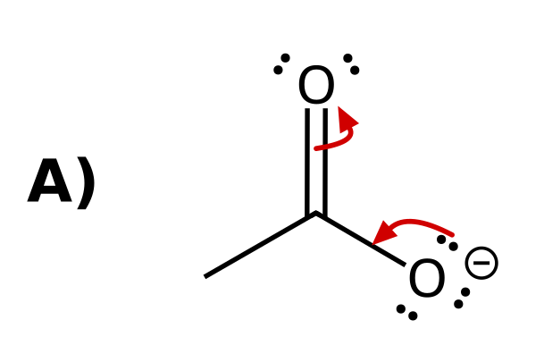
Why: Arrow 1 starts on a lone pair of O⁻ and ends between O and C (forming the C=O π bond). Arrow 2 starts on the C=O π bond and ends on the other O (becoming a lone pair). Every arrow goes from electrons to where the electrons end up.
35. Which set of curved arrows correctly shows the charge of phenoxide moving onto an ortho carbon? [Q10, Basic]
Answer: C
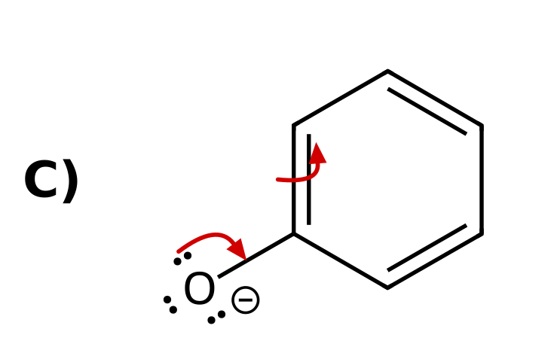
Why: Arrow 1: lone pair on O⁻ forms the C=O π bond. Arrow 2: the adjacent ring C=C π bond moves onto the ortho carbon as a lone pair. A single arrow leaves the ipso carbon with five bonds, and moving the electrons to a meta carbon is not a valid resonance shift. The delocalization of charge into the ring is why phenol is more acidic than an alcohol.
36. Cyclopentadiene is shown. Which labeled hydrogen is the most acidic? [Q11, Basic]
Answer: D) H₁ (the CH₂ hydrogen)
Why: All are C–H bonds. Removing H₁ gives the cyclopentadienyl anion, with the charge delocalized over five carbons by resonance. Removing a vinyl H (H₂ or H₃) puts the charge in an sp² orbital that does not overlap with the π system, so there is no resonance.
37. Which is more acidic, ethanol or acetic acid? Explain using the conjugate bases. [C03F18, Basic]
Answer: Acetic acid; the acetate ion is stabilized by resonance (charge on two oxygens), but ethoxide has a localized charge.
Why: Both charges are on oxygen, so compare resonance.
38. Which N-H is more acidic, the amide N-H or the amine N-H? Explain. [C03F19, Basic]
Answer: The amide N-H; its conjugate base has the charge delocalized onto the carbonyl oxygen by resonance.
Why: Both charges are on nitrogen, so compare resonance.
39. Phenol is a stronger acid than cyclohexanol. Explain using the conjugate bases. [C03F20, Moderate]
Answer: Phenoxide is stabilized by resonance (the negative charge delocalizes onto ortho and para carbons), but cyclohexoxide has a localized charge.
Why: Both anions have the charge on oxygen.

3.4 Anion stability: Induction
40. Which compound is the stronger acid? [C03M09, Basic]
Answer: C) CF₃CH₂OH, because the fluorines stabilize the alkoxide by induction
Why: The electron-withdrawing CF₃ group stabilizes the negative charge of the conjugate base.
41. Rank the carboxylic acids from LEAST acidic to MOST acidic. [Q12, Basic]
Answer: B) I < II < III
Why: All three have the same atom and resonance. Cl withdraws electron density by induction and stabilizes the carboxylate. The effect weakens with distance: III (Cl on the α carbon) > II (Cl on the γ carbon) > I (no Cl).
42. Which labeled hydrogen is the most acidic? [Q13, Basic]
Answer: A) H₁, because the CF₃ groups stabilize the nearby alkoxide by induction
Why: Both conjugate bases have the charge on O with no resonance. The three F atoms on each CF₃ pull electron density through the σ bonds and stabilize the nearby O⁻. The other alkoxide is too far away to feel it.
43. Which acid is the strongest? [Q14, Basic]
Answer: D
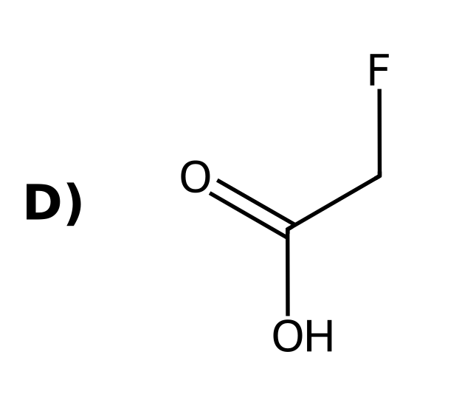
Why: Same atom, no change in resonance. The halogen on the α carbon withdraws electron density by induction. F is the most electronegative, so FCH₂CO₂⁻ is the most stabilized.
44. Which is the stronger acid, CH₃CO₂H or ClCH₂CO₂H? Explain. [C03F21, Basic]
Answer: ClCH₂CO₂H; the electronegative chlorine withdraws electron density through the σ bonds (induction) and stabilizes the carboxylate.
Why: Same atom and resonance; induction differs.
45. Which is the stronger acid: 2-chlorobutanoic acid or 4-chlorobutanoic acid? Explain. [C03F22, Basic]
Answer: 2-Chlorobutanoic acid, because the chlorine is closer to the carboxylate and the inductive effect weakens with distance.
Why: Induction decreases as the number of bonds between Cl and the acid group increases.
46. Which O-H is more acidic in this compound? Explain. [C03F23, Moderate]
Answer: The O-H on the carbon bearing the two CF₃ groups; the six fluorines stabilize that alkoxide by induction.
Why: Compare the inductive effect near each alkoxide.

3.4 Anion stability: Orbitals
47. Which hydrogen is the most acidic? [C03M10, Basic]
Answer: A) The H on the sp carbon (the alkyne C-H)
Why: An sp orbital holds the negative charge closer to the nucleus.
48. Which labeled hydrogen in the following compound is the most acidic? [Q15, Easy]
Answer: C) H₁ (the alkyne H)
Why: All are C–H bonds, with no resonance or induction available. Only the orbital differs: sp (alkyne) > sp² (vinyl) > sp³ (alkyl). The sp orbital has the most s character, holding the lone pair closest to the nucleus.
49. Which of these anions is the strongest base? [Q16, Easy]
Answer: C
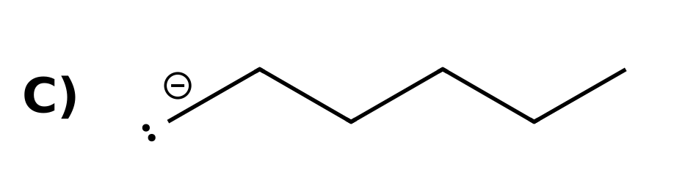
Why: The charge is on carbon in all three, with no resonance or induction. The orbital differs: the alkyl anion has the charge in an sp³ orbital (highest energy, least stable, strongest base). The alkynide is in an sp orbital (most stable, weakest base).
50. A terminal alkyne C–H is more acidic than an alkene C–H. Which statement best explains why? [Q17, Easy]
Answer: B) The electron pair in the sp orbital is held closer to the nucleus, so the alkynide ion is more stable
Why: This is factor 4 (orbitals). An sp orbital is 50% s character, which is closer to the nucleus than the 33% s character of an sp² orbital, so the lone pair in an sp orbital is lower in energy.
51. Which is more acidic, ethane or ethyne? Explain. [C03F24, Easy]
Answer: Ethyne; its conjugate base has the charge in an sp orbital, which is closer to the nucleus and more stable.
Why: sp > sp² > sp³ for stabilizing a negative charge.
52. In 1-butene-3-yne only one hydrogen is much more acidic than the others. Which hydrogen is it and why? [C03F25, Basic]
Answer: The alkyne hydrogen on the sp carbon; the conjugate base has its charge in an sp orbital.
Why: Compare sp, sp² and sp³ carbon-hydrogen bonds.
53. Explain why an sp orbital stabilizes a negative charge better than an sp³ orbital. [C03F26, Moderate]
Answer: An sp orbital has 50% s character, and s electrons are held closer to the nucleus than p electrons, so the lone pair is lower in energy.
Why: More s character means the electrons are closer to the positive nucleus.

3.4 Anion stability: Ranking the factors (ARIO)
54. Which of the labeled hydrogens is more acidic? [Q18, Hard]
Answer: D) H₁ in I (ethanol), because the atom (O vs. C) outranks resonance
Why: Propene's CH₃ gives a resonance-stabilized allyl anion, but the charge is on carbon. Ethoxide has the charge on O. The atom (factor 1) takes priority over resonance (factor 2).
55. Which labeled hydrogen is the most acidic? [Q19, Hard]
Answer: A) H₁, because resonance outranks induction
Why: Both put the charge on O, so factor 1 ties. The carboxylate is resonance stabilized (factor 2); the alkoxide only has the inductive effect of CF₃ (factor 3). Resonance beats induction.
56. Which labeled hydrogen is more acidic? [Q20, Hard]
Answer: C) H₂, because the atom (O vs. C) outranks the orbital
Why: H₁ gives a carbanion on an sp carbon; H₂ gives an alkoxide. Atom comes before orbital: O⁻ is more stable than C⁻ even in an sp orbital.
57. Rank these from LEAST acidic to MOST acidic. [Q21, Hard]
Answer: D) I < II < III
Why: All three have the charge on O. III is resonance stabilized (factor 2), the strongest effect here. II has the inductive effect of three F atoms (factor 3), and I has neither.
58. Aspirin is shown. Which labeled hydrogen is the most acidic? [Q22, Basic]
Answer: B) H₁ (the carboxylic acid O–H)
Why: H₁ puts the charge on O (factor 1) and the carboxylate is resonance stabilized. H₂ and H₃ put the charge on carbon, which loses on factor 1.
59. Which is more acidic, the O-H of propan-1-ol or the C-H of propyne (on the sp carbon)? Name the factor that decides. [C03F27, Moderate]
Answer: The O-H, because the atom (O versus C) takes priority over the orbital effect.
Why: Order of priority: atom, resonance, induction, orbital.
60. Which O-H is more acidic in this compound? Explain which factor wins. [C03F28, Moderate]
Answer: The carboxylic acid O-H; resonance (a delocalized carboxylate) is more important than the inductive effect of the nearby CCl₃ group.
Why: Atom ties; resonance outranks induction.
61. Which C-H is more acidic: the CH₂ between two carbonyls in CH₃COCH₂COCH₃, or the terminal alkyne C-H in HC≡CH? Explain. [C03F29, Moderate]
Answer: The CH₂ between the carbonyls; its conjugate base is resonance stabilized (charge on two oxygens), which outranks the orbital effect.
Why: Both are carbon acids; resonance outranks orbitals.
62. Rank from least to most acidic and explain: I = HC≡CH, II = CH₃CH₂OH, III = CH₃COCH₂COCH₃ (central CH₂). [C03F30, Hard]
Answer: I < II < III. Acetylene is a carbon acid (an sp carbanion); ethanol puts the charge on oxygen (atom beats orbital); the diketone anion is resonance stabilized (charge on two oxygens), which outranks atom alone.
Why: Compare the conjugate bases using atom, resonance, induction and orbital in order.

3.5 Relative Acidity of Cationic Acids
63. Which is the stronger acid, NH₄⁺ or H₃O⁺? [C03M11, Basic]
Answer: B) H₃O⁺, because oxygen is less able than nitrogen to stabilize a positive charge
Why: A positive charge is more stable on the less electronegative atom.
64. Which is the stronger base, CH₃NH₂ or CH₃OH? [C03M12, Basic]
Answer: B) CH₃NH₂
Why: Nitrogen holds a positive charge better than oxygen, so the amine is more easily protonated.
65. Aniline is a weaker base than methylamine because: [C03M13, Moderate]
Answer: A) The nitrogen lone pair of aniline is delocalized into the ring
Why: A delocalized lone pair is less available to accept a proton.
66. Draw the conjugate acid of CH₃CH₂NH₂. Which atom carries the positive charge? [C03F31, Basic]
Answer: CH₃CH₂NH₃⁺; the nitrogen carries the positive charge.
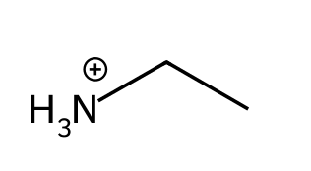
Why: Protonate the nitrogen lone pair.
67. Why are amines stronger bases than alcohols? [C03F32, Basic]
Answer: Nitrogen is less electronegative than oxygen, so a positive charge on nitrogen (the conjugate acid) is more stable than on oxygen.
Why: Compare the stability of the conjugate acids.
68. Explain why amides are extremely poor bases. [C03F33, Moderate]
Answer: The nitrogen lone pair is delocalized onto the carbonyl oxygen by resonance, so it is not available to accept a proton.
Why: A delocalized lone pair is a weak base.
69. Which is the stronger acid, CH₃NH₃⁺ (pKa 10.6) or C₆H₅NH₃⁺ (pKa 4.6)? Explain using the conjugate bases. [C03F34, Moderate]
Answer: C₆H₅NH₃⁺; its conjugate base (aniline) has a lone pair delocalized into the ring, making it the weaker base.
Why: Strong acid means weak conjugate base.
70. Draw the product of protonating pyridine and state which atom is protonated. [C03F35, Basic]
Answer: The nitrogen is protonated, giving the pyridinium ion.
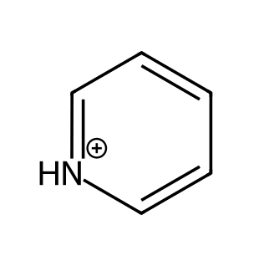
Why: The nitrogen lone pair lies in the plane of the ring, not in the π system.

3.6 Position of Equilibrium and Choice of Reagents
71. Which side is favored in NH₂⁻ + CH₃OH ⇌ NH₃ + CH₃O⁻? [C03M14, Basic]
Answer: A) The products
Why: Equilibrium favors the more stable anion: O⁻ is more stable than N⁻ (same row).
72. Is water a suitable proton source to convert the acetate ion into acetic acid? [C03M15, Moderate]
Answer: D) No; the equilibrium favors acetate because it is a resonance-stabilized, weaker base than HO⁻
Why: H₂O + CH₃CO₂⁻ → CH₃CO₂H + HO⁻ is uphill; a stronger acid such as H₃O⁺ is needed.
73. Which side of the equilibrium is favored? [Q23, Basic]
Answer: A) The products, because acetate is resonance stabilized and is the more stable anion
Why: The equilibrium favors the more stable ion. Both anions have O⁻, so compare resonance: acetate is delocalized over two O atoms, ethoxide is not. Acetate is the weaker base, so the products are favored.
74. Which side of the equilibrium is favored? [Q24, Basic]
Answer: D) The products, because the larger S atom stabilizes the charge better
Why: Compare HO⁻ with RS⁻. O and S are in the same column, so size decides. The larger RS⁻ is more stable (weaker base), so the equilibrium favors the products.
75. Which side of the equilibrium is favored? [Q25, Hard]
Answer: B) The reactants, because ethoxide (O⁻) is more stable than the sp carbanion (C⁻)
Why: Compare RO⁻ with the alkynide. Atom (factor 1) before orbital (factor 4): O is more electronegative than C, so ethoxide is more stable. The reactants are favored.
76. Which side of the equilibrium is favored? [Q26, Basic]
Answer: C) The reactants, because phenoxide is resonance stabilized
Why: Both anions have O⁻, so compare resonance. Phenoxide is delocalized into the ring; ethoxide is not. The more stable anion (phenoxide) is on the reactant side, so the reactants are favored.
77. Which side of the equilibrium is favored? [Q27, Hard]
Answer: D) The reactants, because CF₃CO₂⁻ is stabilized by induction
Why: Both anions are carboxylates, so atom and resonance tie. The three F atoms stabilize CF₃CO₂⁻ by induction (factor 3), so CF₃CO₂⁻ is more stable and the reactant side is favored.
78. Hydroxide deprotonates phenol. Which set of curved arrows correctly shows the proton transfer? [Q28, Basic]
Answer: C
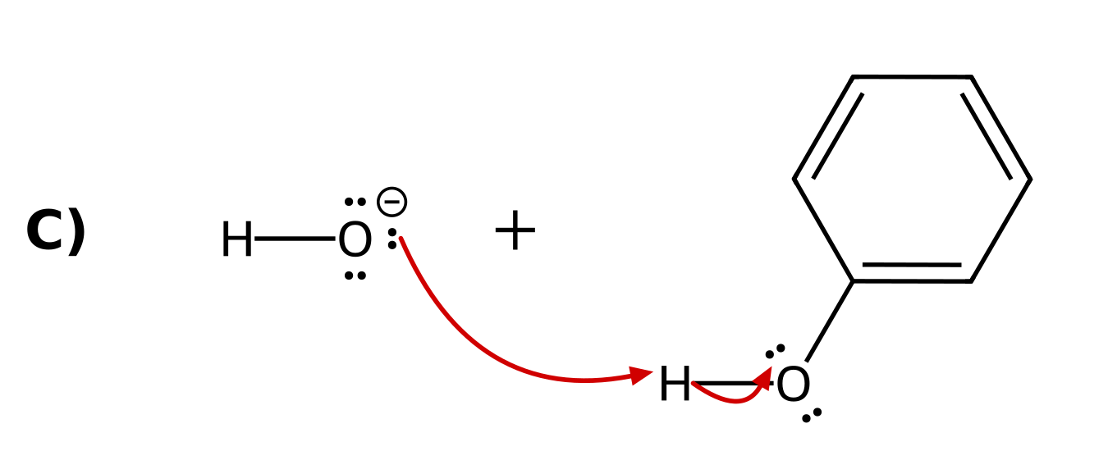
Why: A proton transfer always uses at least two arrows. Arrow 1 starts on a lone pair of the base (HO⁻) and ends on the H. Arrow 2 starts on the O–H bond and ends on the O of the acid, which becomes the conjugate base.
79. Which side of the equilibrium is favored? [Q29, Basic]
Answer: A) The reactants, because the alkynide (charge in an sp orbital) is more stable than the vinyl anion (charge in an sp² orbital)
Why: Both ions have the charge on carbon, with no resonance and no inductive effects, so only the orbital differs (factor 4). An sp orbital (50% s character) holds the lone pair closer to the nucleus than an sp² orbital (33% s), so the alkynide is more stable. The more stable ion is on the reactant side, so the reactants are favored.
80. Which anion is a strong enough base to deprotonate ethanol so that the equilibrium favors the products? [Q30, Hard]
Answer: B
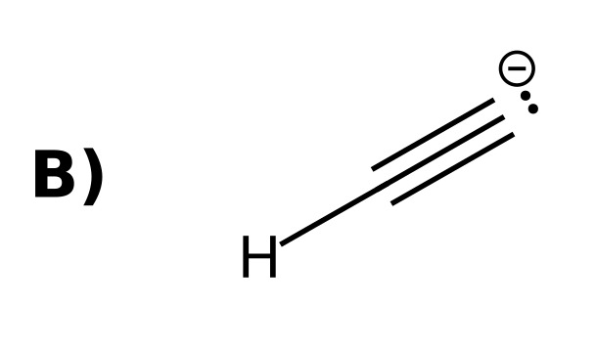
Why: Ethanol deprotonates to give ethoxide, so the base must be a less stable (stronger) base than ethoxide. Acetate (resonance), phenoxide (resonance), and CH₃S⁻ (larger atom) are all more stable than ethoxide. The alkynide ion has the charge on C and is less stable.
81. Predict the position of equilibrium: CH₃CO₂⁻ + HCl ⇌ CH₃CO₂H + Cl⁻. [C03F36, Basic]
Answer: The products are favored, because Cl⁻ is a much weaker base than acetate.
Why: HCl is the stronger acid.
82. Is hydroxide a strong enough base to deprotonate phenol? Explain. [C03F37, Basic]
Answer: Yes. Phenoxide is resonance stabilized, so phenol (pKa 9.9) is a stronger acid than water (15.7) and the equilibrium favors phenoxide.
Why: The equilibrium favors the more stable anion.
83. A student wants to convert CH₃CH₂OH completely into its alkoxide. Is NaOH or NaNH₂ the better choice? Explain. [C03F38, Moderate]
Answer: NaNH₂. Ethanol (pKa 16) and water (15.7) have similar acidity, so NaOH gives only a partial equilibrium, whereas NH₂⁻ is a far stronger base (NH₃ pKa 38) and deprotonates ethanol completely.
Why: Compare the conjugate acids of the two bases.
84. Is water a suitable proton source to protonate CH₃CH₂O⁻? Explain. [C03F39, Moderate]
Answer: Yes. Water (pKa 15.7) is about as acidic as ethanol (16), so the equilibrium lies roughly in balance and favors the alcohol with excess water.
Why: Compare the acidities of water and ethanol.
85. Is hydroxide a suitable base to deprotonate acetylene? Explain. [C03F40, Moderate]
Answer: No. Acetylene (pKa 25) is far less acidic than water (15.7), so the equilibrium favors the reactants. A base such as NH₂⁻ is needed.
Why: Equilibrium favors the weaker acid.

3.7 Leveling Effect
86. What is the strongest base that can exist in water? [C03M16, Basic]
Answer: C) HO⁻
Why: Any base stronger than HO⁻ reacts with water to give HO⁻ (the leveling effect).
87. What happens when sodium amide (NaNH₂) is added to water? [C03M17, Basic]
Answer: C) It reacts with water to give NH₃ and HO⁻
Why: NH₂⁻ is a stronger base than HO⁻, so it is destroyed by the solvent.
88. State the leveling effect for bases in a solvent. [C03F41, Basic]
Answer: The strongest base that can exist in a solvent is the conjugate base of the solvent; any stronger base reacts with the solvent.
Why: In water the limit is HO⁻.
89. Why can NaNH₂ not be used as a base in water, and what solvent could be used instead? [C03F42, Moderate]
Answer: NH₂⁻ deprotonates water, giving HO⁻. Liquid ammonia (or a solvent such as THF) can be used because it is not deprotonated.
Why: Choose a solvent whose conjugate base is at least as strong as the base.
90. What is the strongest acid that can exist in water? [C03F43, Basic]
Answer: H₃O⁺; a stronger acid such as HCl simply protonates water to form H₃O⁺.
Why: The leveling effect applies to acids as well.

3.8 Solvating Effects
91. Why is the tert-butoxide ion less stable than the ethoxide ion in solution? [C03M18, Basic]
Answer: B) It is bulky, so solvent molecules cannot approach and stabilize the negative oxygen as well
Why: Steric hindrance reduces solvation.
92. Ethanol (pKa 16) is slightly more acidic than tert-butanol (pKa 18). Explain. [C03F44, Basic]
Answer: Ethoxide is better solvated than the sterically hindered tert-butoxide, so it is more stable and ethanol is the stronger acid.
Why: Solvation depends on how well solvent molecules reach the charge.
93. Predict which is the stronger base, CH₃O⁻ or (CH₃)₃CO⁻, and explain how solvation contributes. [C03F45, Moderate]
Answer: (CH₃)₃CO⁻ is stronger, because the bulky groups hinder solvation of its negative charge, leaving it less stabilized.
Why: Less stabilized means a stronger base.

3.9 Counterions
94. In the reagent NaOH, which ion acts as the base? [C03M19, Easy]
Answer: C) HO⁻
Why: The sodium counterion is a spectator.
95. What is a counterion? [C03F46, Easy]
Answer: A positively charged species (such as Na⁺, K⁺, Li⁺) that accompanies a negatively charged base; it usually does not take part in the reaction.
Why: It is also called a spectator ion.
96. Rewrite NaNH₂ + H₂O → NH₃ + NaOH without the counterion. [C03F47, Basic]
Answer: NH₂⁻ + H₂O → NH₃ + HO⁻
Why: Na⁺ is a spectator.

3.10 Lewis Acids and Bases
97. Which species is a Lewis acid? [C03M20, Basic]
Answer: B) BF₃
Why: BF₃ has an empty p orbital and accepts an electron pair.
98. In BF₃ + O(CH₃)₂ → F₃B⁻-O⁺(CH₃)₂, identify the Lewis acid and the Lewis base. [C03F48, Basic]
Answer: BF₃ is the Lewis acid (electron-pair acceptor); dimethyl ether is the Lewis base (electron-pair donor).
Why: The oxygen lone pair is donated to boron.
99. BF₃ has no hydrogens. Explain how it can still be an acid. [C03F49, Basic]
Answer: It is a Lewis acid: boron has an empty p orbital and accepts an electron pair.
Why: Lewis acidity is defined by electron-pair acceptance, not proton donation.
100. How many curved arrows are needed for NH₃ + BF₃ → H₃N⁺-B⁻F₃? Draw it. [C03F50, Moderate]
Answer: One: from the nitrogen lone pair to boron.
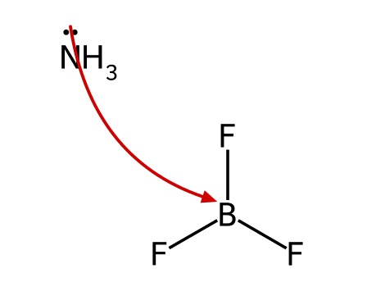
Why: A Lewis acid-base reaction forms one new bond, so one arrow is enough.

