Chapter 3: Acids and Bases
Organic chemistry questions. Multiple choice first within each textbook section.
Name: ______________________________ Date: ______________

3.1 Introduction to Brønsted-Lowry Acids and Bases
1. In the reaction HCl + H₂O ⇌ Cl⁻ + H₃O⁺, which species is the conjugate base of HCl? [C03M01, Easy]
A) H₃O⁺
B) H₂O
C) HO⁻
D) Cl⁻
2. In which reaction does water act as an acid? [C03M02, Basic]
A) HBr + H₂O → Br⁻ + H₃O⁺
B) CH₃CH₂O⁻ + H₂O ⇌ CH₃CH₂OH + HO⁻
C) CH₃CO₂H + H₂O ⇌ CH₃CO₂⁻ + H₃O⁺
D) H₂SO₄ + H₂O → HSO₄⁻ + H₃O⁺
3. Define a Brønsted-Lowry acid and a Brønsted-Lowry base. [C03F01, Easy]

4. In NH₃ + HCl → NH₄⁺ + Cl⁻, identify the acid, base, conjugate acid and conjugate base. [C03F02, Easy]

5. Water can act as an acid or as a base. Write one reaction for each and name the conjugate partner formed. [C03F03, Basic]

6. Give the conjugate acid of CH₃NH₂ and the conjugate base of CH₃OH. [C03F04, Basic]

3.2 Flow of Electron Density: Curved-Arrow Notation
7. What is the minimum number of curved arrows needed to show a proton transfer? [C03M03, Basic]
A) One
B) Three
C) Four
D) Two
8. Which curved arrows correctly show hydroxide removing a proton from HCl? [C03M04, Moderate]
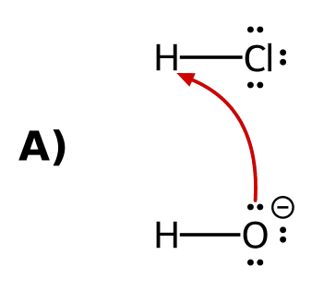 | 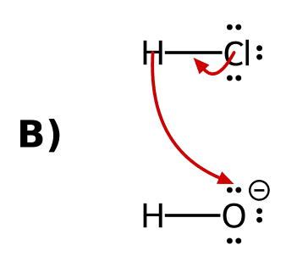
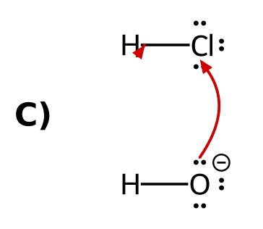 | 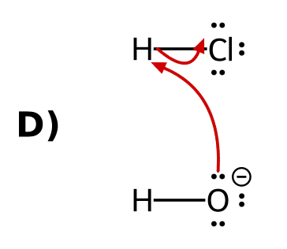
9. Draw the curved arrows for the reaction of hydroxide with HCl. [C03F05, Basic]

10. Why does every proton transfer need at least two curved arrows? [C03F06, Basic]

11. Describe the curved arrows for CH₃CO₂H reacting with hydroxide, including where each arrow starts and ends. [C03F07, Moderate]
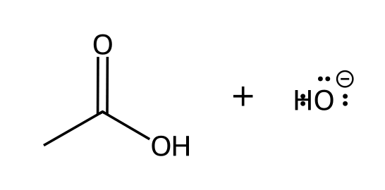

12. For NH₃ + HBr, state where the tail and head of each curved arrow are placed. [C03F08, Moderate]

3.3 Comparing pKa Values
13. Which acid is stronger: one with pKa 4.75 or one with pKa 15.7? [C03M05, Easy]
A) The one with pKa 15.7
B) They are equally strong
C) The one with pKa 4.75
D) It depends on the solvent only
14. Acid A has pKa 5 and acid B has pKa 9. How many times more acidic is A than B? [C03M06, Basic]
A) 10,000 times
B) 4 times
C) 40 times
D) 1,000 times
15. For CH₃CO₂H + HO⁻ ⇌ CH₃CO₂⁻ + H₂O (pKa of CH₃CO₂H = 4.75; pKa of H₂O = 15.7), which side is favored? [C03M07, Basic]
A) The products
B) The reactants
C) Neither side
D) It cannot be predicted
16. Which is more acidic, ethanol (pKa 16) or acetic acid (pKa 4.75)? By about how many orders of magnitude? [C03F09, Easy]

17. Use pKa values to rank from weakest to strongest acid: NH₃ (38), HC≡CH (25), H₂O (15.7). [C03F10, Basic]

18. Predict the position of the equilibrium HC≡CH + NH₂⁻ ⇌ HC≡C⁻ + NH₃ (pKa of HC≡CH = 25; pKa of NH₃ = 38). [C03F11, Basic]

19. Rank HO⁻, CH₃CO₂⁻ and NH₂⁻ from weakest to strongest base. (Conjugate acid pKa values: H₂O 15.7, CH₃CO₂H 4.75, NH₃ 38.) [C03F12, Basic]

20. The pKa of H₃O⁺ is -1.74 and that of NH₄⁺ is 9.3. Which is the stronger base, H₂O or NH₃? Explain. [C03F13, Moderate]

21. HA has pKa 15 and HB has pKa 5. Which side is favored in A⁻ + HB ⇌ HA + B⁻? Explain. [C03F14, Moderate]

3.4 Anion stability: Atom
22. Which is the stronger acid, HF or HCl? [C03M08, Basic]
A) HF, because F is more electronegative
B) They are equally acidic
C) HF, because F⁻ is smaller
D) HCl, because Cl⁻ is larger and spreads the charge over more space
23. Ethanolamine has three different kinds of hydrogen, labeled below. Which labeled H is the most acidic? [Q01, Easy]
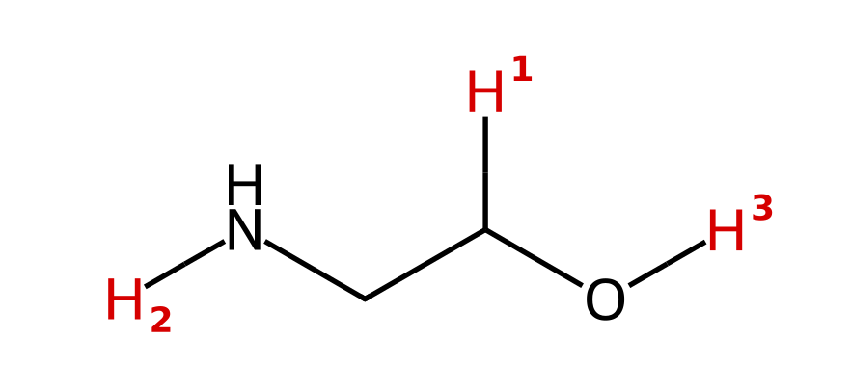
A) H₁ (the C–H on the carbon bearing O)
B) H₂ (the N–H)
C) H₃ (the O–H)
D) All three are about equally acidic
24. Which labeled hydrogen in 3-mercaptopropan-1-ol is the most acidic? [Q02, Basic]
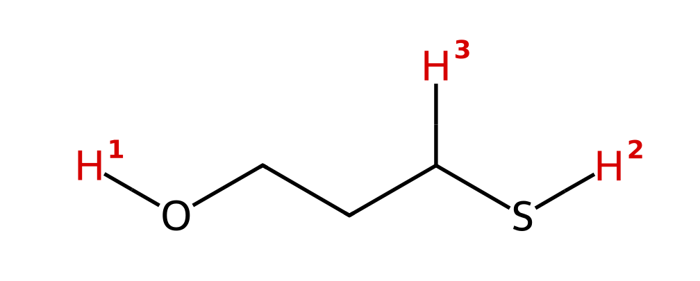
A) H₁ (the O–H), because O is more electronegative than S
B) H₂ (the S–H), because S is larger than O and spreads the charge over a larger volume
C) H₃ (the C–H next to S), because it is closest to the large S atom
D) H₁ and H₂ are equally acidic because O and S are in the same column
25. Acetaminophen (Tylenol) is shown below. Which labeled H is the most acidic? [Q03, Basic]
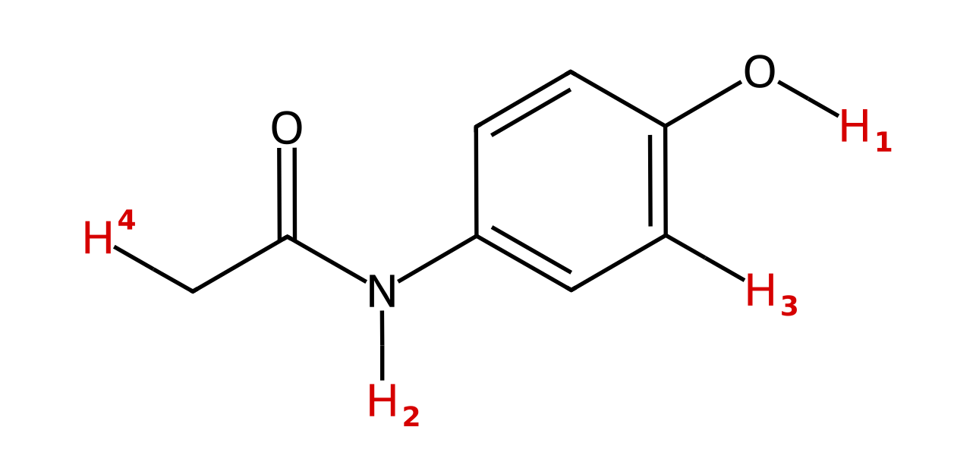
A) H₁ (the phenol O–H), because O is more electronegative than N
B) H₂ (the amide N–H), because the N⁻ charge is delocalized onto the carbonyl O
C) H₃ (the aromatic C–H), because it is on an sp²-hybridized carbon
D) H₄ (the CH₃ hydrogen), because it is next to a C=O
26. Two anions are shown. Which is the stronger base, and why? [Q04, Easy]
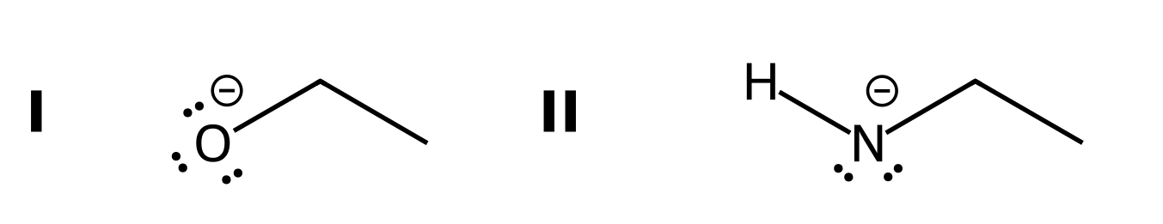
A) I, because O is more electronegative, so its charge is held more tightly
B) II, because N is less electronegative than O, so the negative charge on N is less stable
C) I, because O is larger than N
D) They are equally basic because both anions have a lone pair
27. Which is more acidic, H₂O or H₂S? Explain. [C03F15, Easy]

28. Which is more acidic, NH₃ or H₂O? Explain. [C03F16, Basic]

29. Which is more acidic, CH₃OH or CH₃SH? Explain. [C03F17, Basic]

3.4 Anion stability: Resonance
30. 4-Hydroxybutanoic acid has the labeled hydrogens shown. Which is the most acidic? [Q05, Easy]
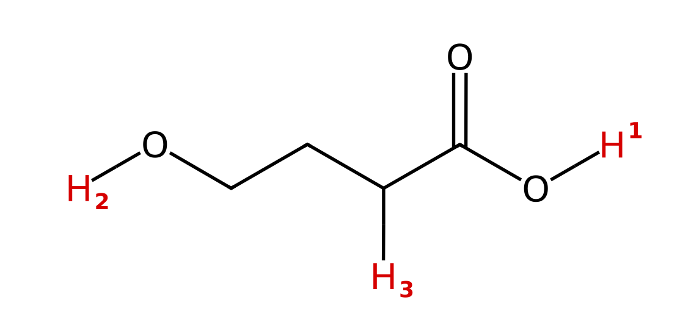
A) H₂ (the alcohol O–H), because alcohols are more acidic than carboxylic acids
B) H₃ (the C–H next to C=O), because it is next to a carbonyl
C) H₁ and H₂ are equally acidic because both are on oxygen
D) H₁ (the carboxylic acid O–H), because its conjugate base is resonance stabilized
31. Which labeled hydrogen in the following compound is the most acidic? [Q06, Basic]
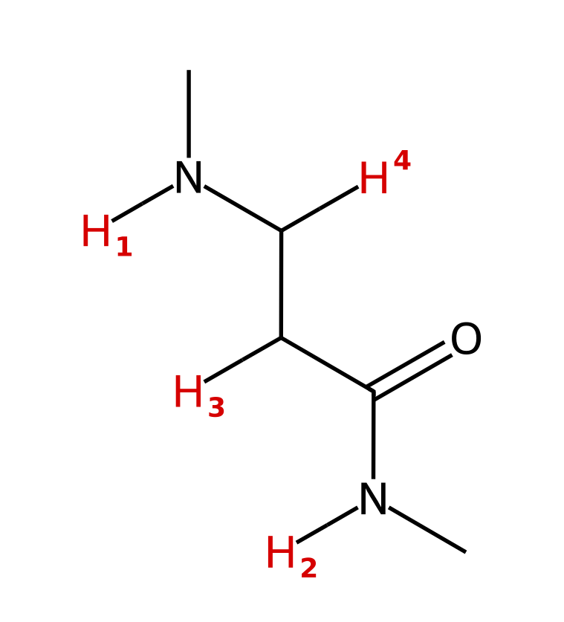
A) H₁ (the amine N–H)
B) H₃ (the C–H next to C=O)
C) H₂ (the amide N–H)
D) H₄ (the C–H next to the amine N)
32. Which labeled hydrogen is the most acidic? [Q07, Easy]
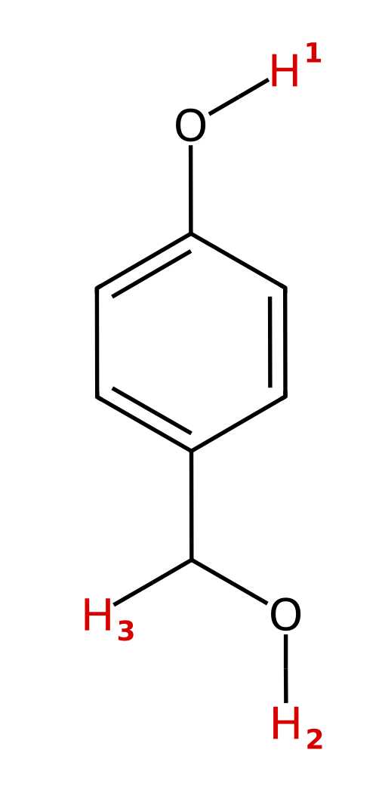
A) H₁ (the phenol O–H), because the phenoxide charge is delocalized into the ring
B) H₂ (the benzylic alcohol O–H), because the alkoxide is more electronegative
C) H₃ (the benzylic C–H), because the carbanion is next to a ring
D) All three are equally acidic
33. Ethyl acetoacetate has the labeled hydrogens shown. Which one is the most acidic? [Q08, Basic]
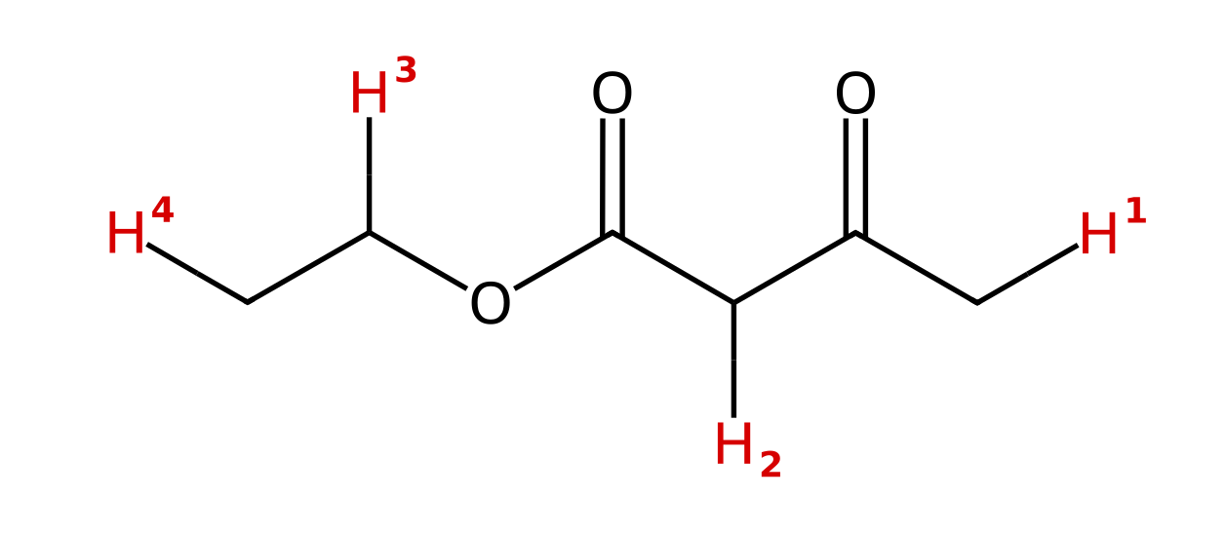
A) H₁ (the CH₃ next to the ketone)
B) H₂ (the CH₂ between the two C=O groups)
C) H₃ (the OCH₂ hydrogen)
D) H₄ (the CH₃ of the ethyl group)
34. Acetate is shown. Which set of curved arrows correctly converts this resonance structure into the other one? [Q09, Basic]
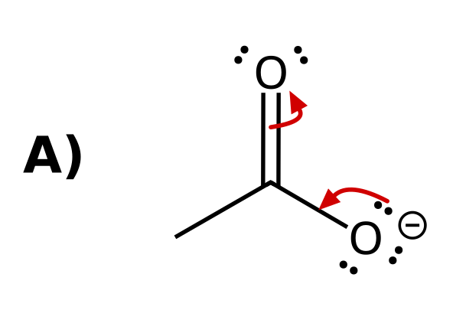 | 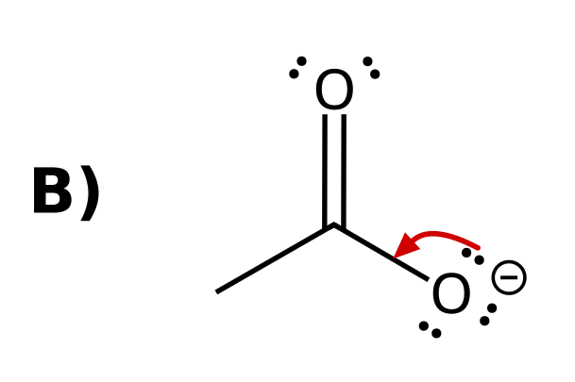
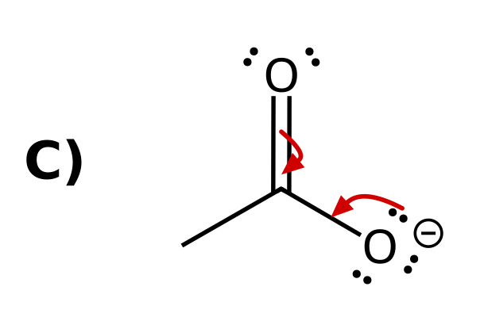 | 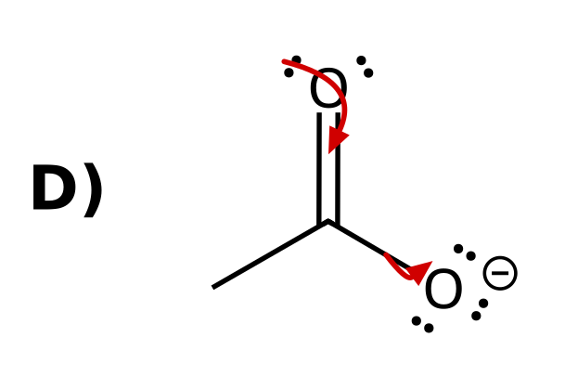
35. Which set of curved arrows correctly shows the charge of phenoxide moving onto an ortho carbon? [Q10, Basic]
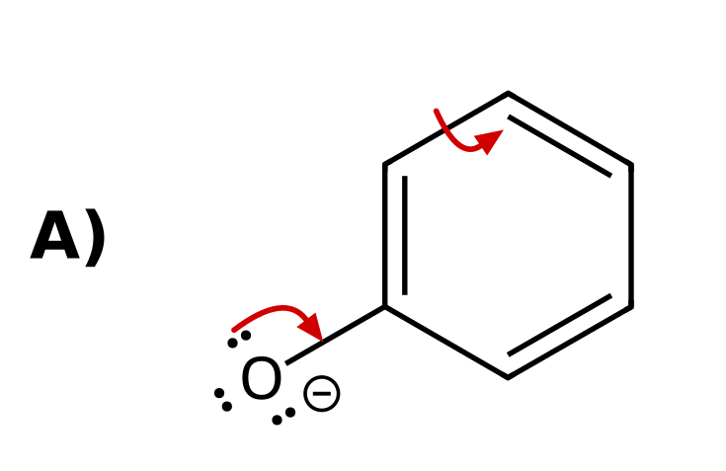 | 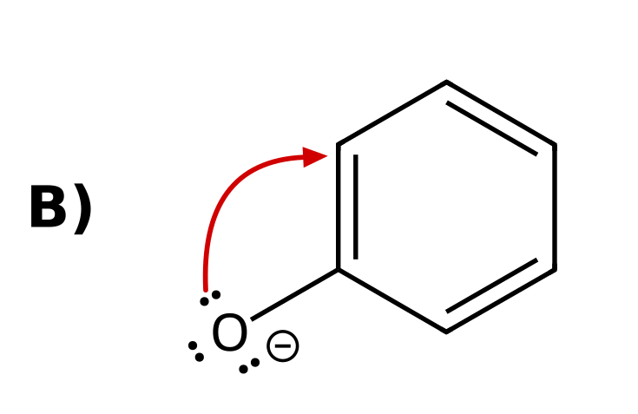
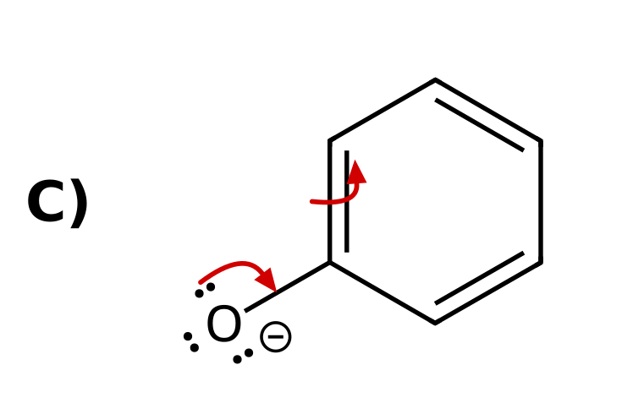 | 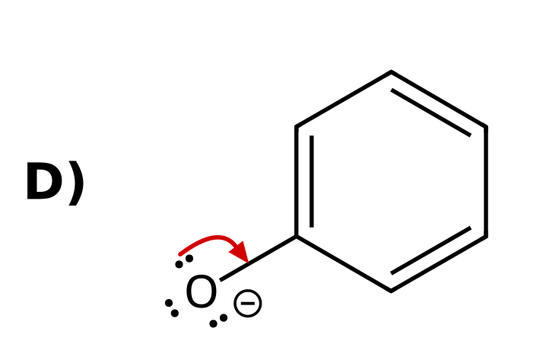
36. Cyclopentadiene is shown. Which labeled hydrogen is the most acidic? [Q11, Basic]
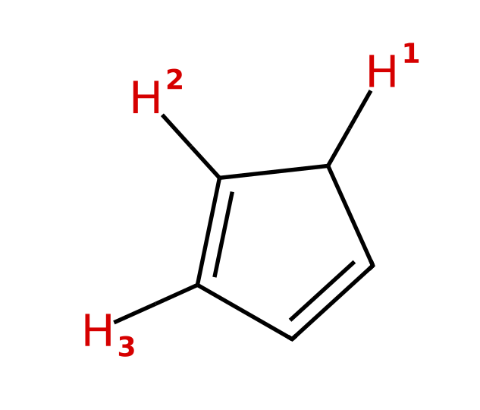
A) H₂ (the vinyl H next to the CH₂)
B) H₃ (the other vinyl H)
C) All three are equally acidic
D) H₁ (the CH₂ hydrogen)
37. Which is more acidic, ethanol or acetic acid? Explain using the conjugate bases. [C03F18, Basic]
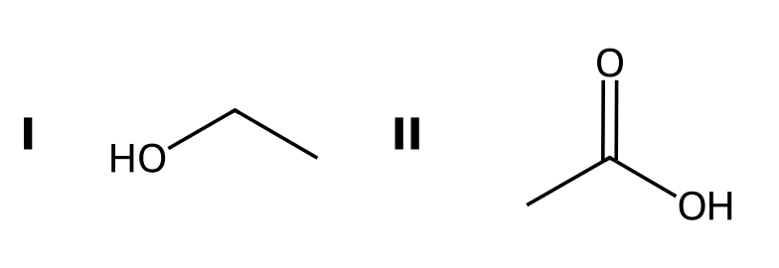

38. Which N-H is more acidic, the amide N-H or the amine N-H? Explain. [C03F19, Basic]
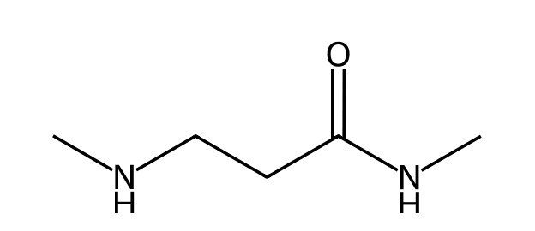

39. Phenol is a stronger acid than cyclohexanol. Explain using the conjugate bases. [C03F20, Moderate]
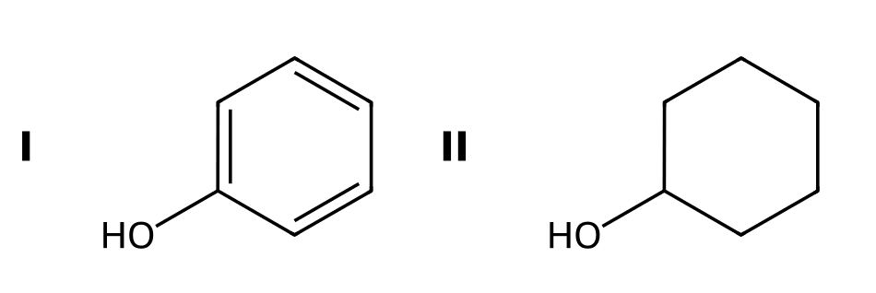

3.4 Anion stability: Induction
40. Which compound is the stronger acid? [C03M09, Basic]
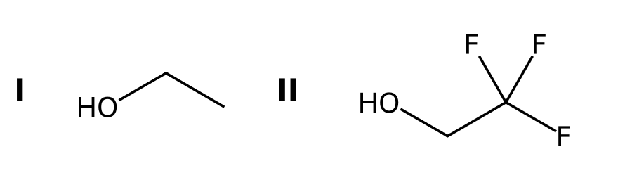
A) CH₃CH₂OH, because it has fewer halogens
B) They are equally acidic
C) CF₃CH₂OH, because the fluorines stabilize the alkoxide by induction
D) CH₃CH₂OH, because its oxygen is more electronegative
41. Rank the carboxylic acids from LEAST acidic to MOST acidic. [Q12, Basic]
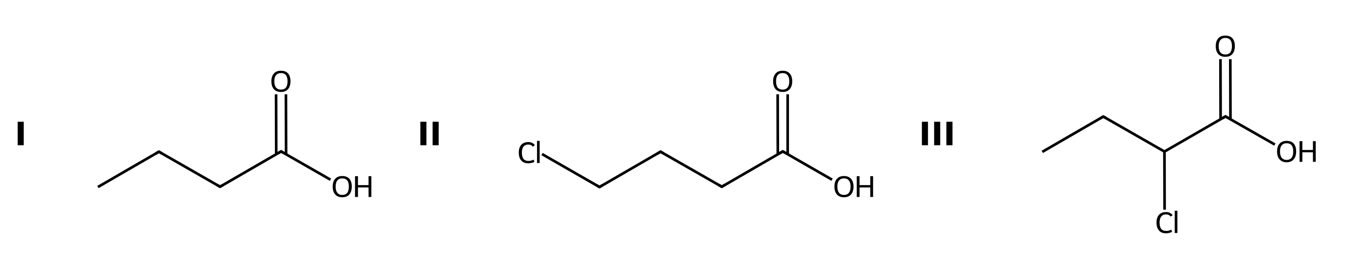
A) III < II < I
B) I < II < III
C) II < I < III
D) I < III < II
42. Which labeled hydrogen is the most acidic? [Q13, Basic]
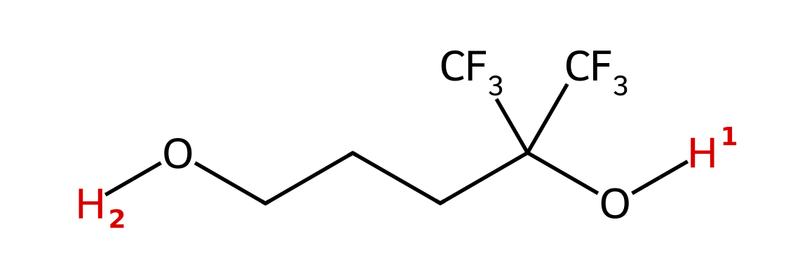
A) H₁, because the CF₃ groups stabilize the nearby alkoxide by induction
B) H₂, because primary alcohols are less hindered
C) H₂, because it is far from the electron-withdrawing groups
D) H₁ and H₂ are equally acidic
43. Which acid is the strongest? [Q14, Basic]
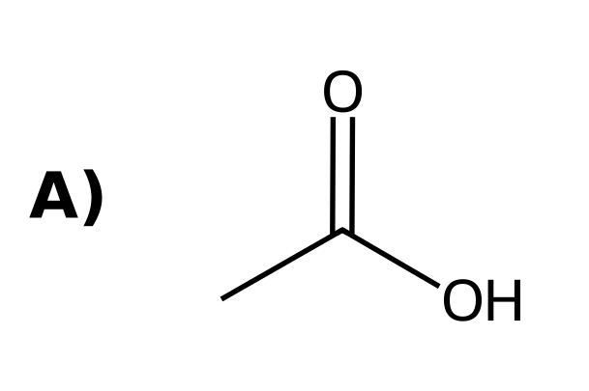 | 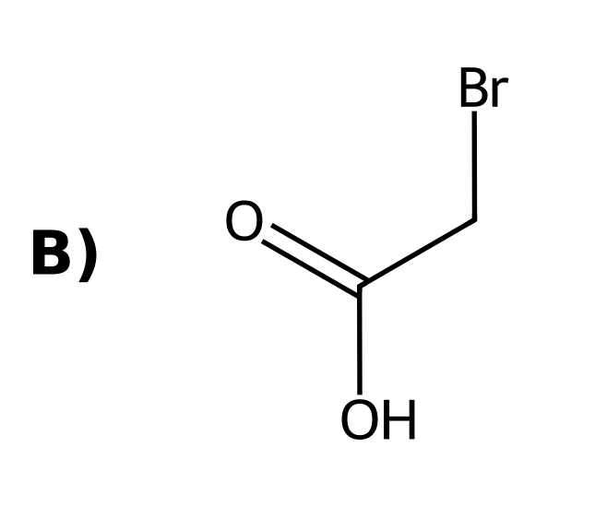
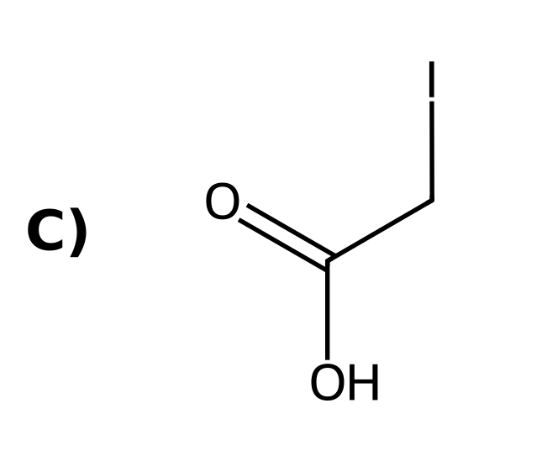 | 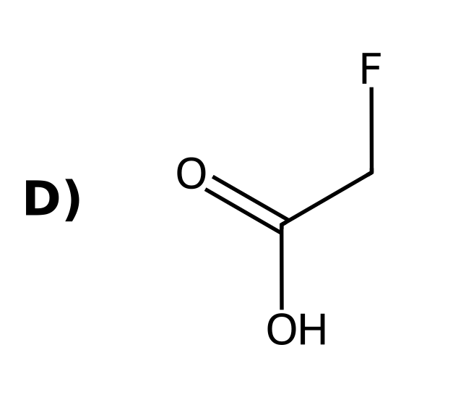
44. Which is the stronger acid, CH₃CO₂H or ClCH₂CO₂H? Explain. [C03F21, Basic]
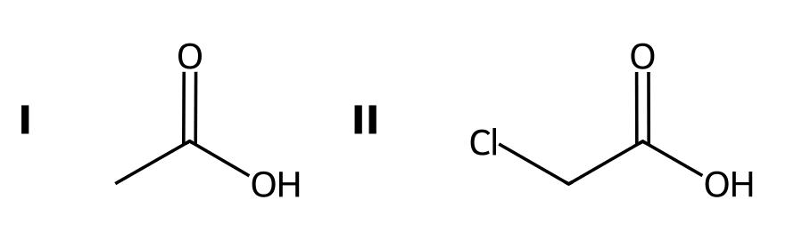

45. Which is the stronger acid: 2-chlorobutanoic acid or 4-chlorobutanoic acid? Explain. [C03F22, Basic]
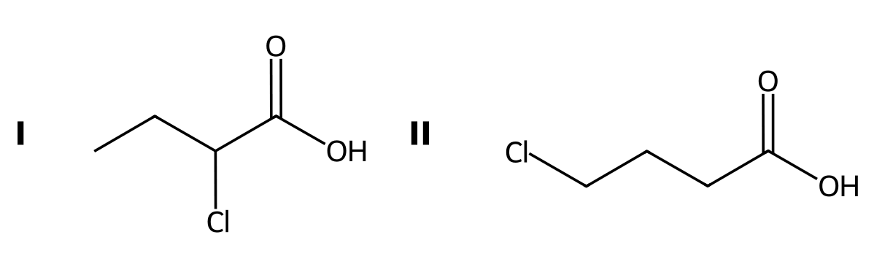

46. Which O-H is more acidic in this compound? Explain. [C03F23, Moderate]
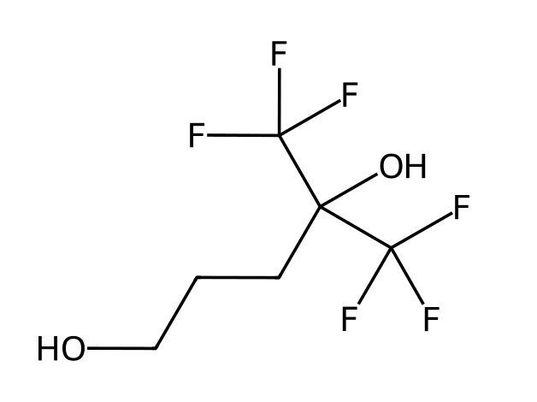

3.4 Anion stability: Orbitals
47. Which hydrogen is the most acidic? [C03M10, Basic]
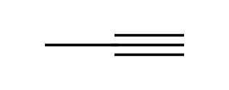
A) The H on the sp carbon (the alkyne C-H)
B) The H on the sp² carbon
C) A H on the CH₃ group
D) They are equally acidic
48. Which labeled hydrogen in the following compound is the most acidic? [Q15, Easy]
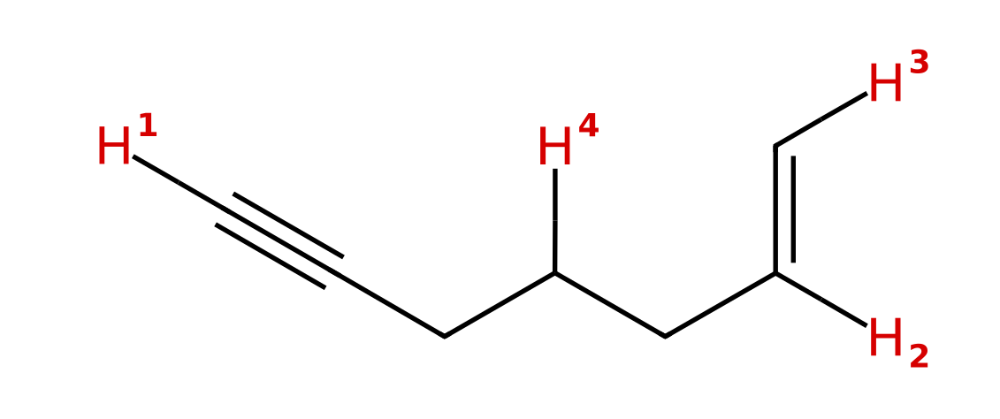
A) H₂ (the internal vinyl H)
B) H₃ (the terminal vinyl H)
C) H₁ (the alkyne H)
D) H₄ (the CH₂)
49. Which of these anions is the strongest base? [Q16, Easy]
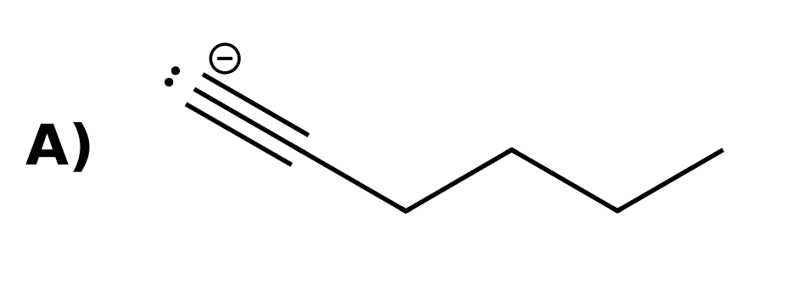 | 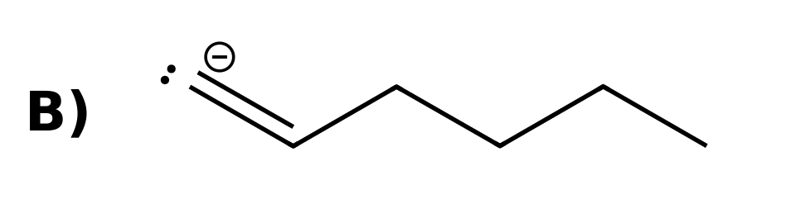
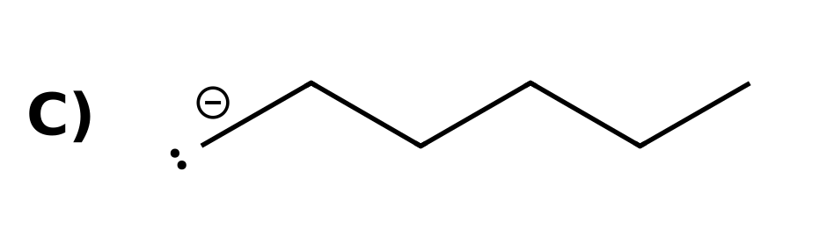
50. A terminal alkyne C–H is more acidic than an alkene C–H. Which statement best explains why? [Q17, Easy]
A) The sp carbon has more p character, so it is more electronegative
B) The electron pair in the sp orbital is held closer to the nucleus, so the alkynide ion is more stable
C) The alkynide ion has resonance structures that spread out the charge
D) The triple bond withdraws electron density from the C–H bond by induction
51. Which is more acidic, ethane or ethyne? Explain. [C03F24, Easy]
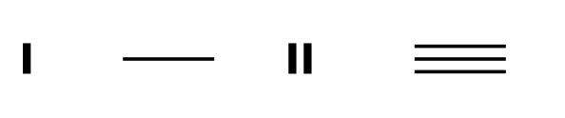

52. In 1-butene-3-yne only one hydrogen is much more acidic than the others. Which hydrogen is it and why? [C03F25, Basic]
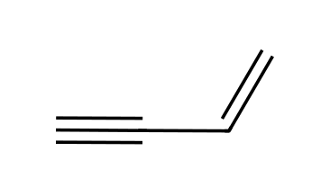

53. Explain why an sp orbital stabilizes a negative charge better than an sp³ orbital. [C03F26, Moderate]

3.4 Anion stability: Ranking the factors (ARIO)
54. Which of the labeled hydrogens is more acidic? [Q18, Hard]
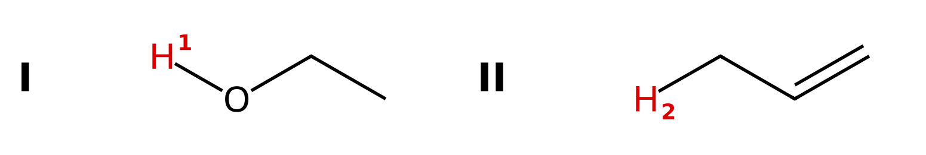
A) H₂ in II (propene), because the allyl anion is resonance stabilized
B) H₂ in II (propene), because the carbon is sp² hybridized
C) They are about equal
D) H₁ in I (ethanol), because the atom (O vs. C) outranks resonance
55. Which labeled hydrogen is the most acidic? [Q19, Hard]
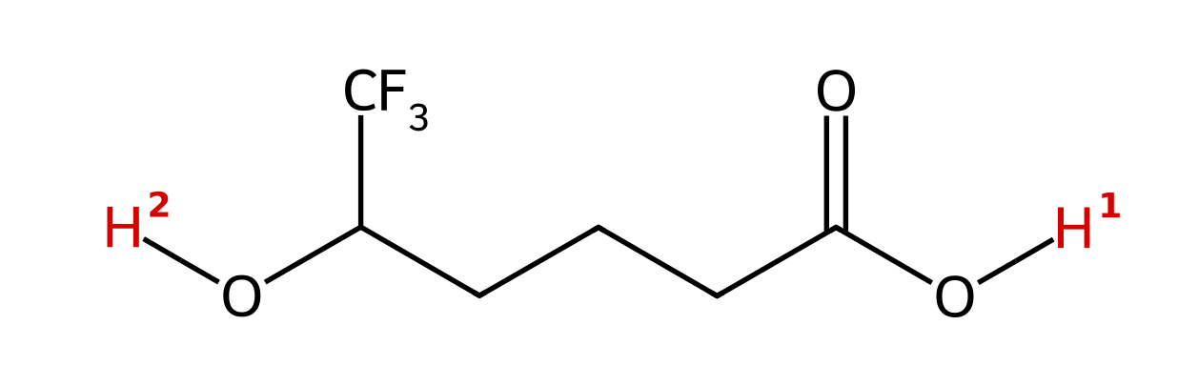
A) H₁, because resonance outranks induction
B) H₂, because the CF₃ group stabilizes the alkoxide by induction
C) H₂, because alcohols are more acidic than carboxylic acids
D) They are equally acidic
56. Which labeled hydrogen is more acidic? [Q20, Hard]
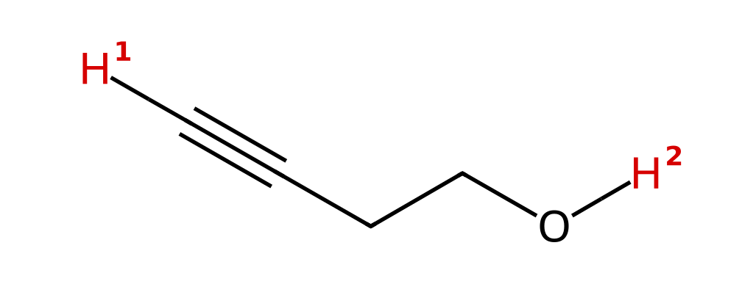
A) H₁, because an sp carbanion is the most stable
B) H₁, because the alkynide ion is resonance stabilized
C) H₂, because the atom (O vs. C) outranks the orbital
D) They are about equal
57. Rank these from LEAST acidic to MOST acidic. [Q21, Hard]
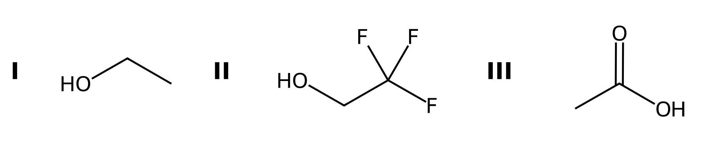
A) III < II < I
B) II < I < III
C) I < III < II
D) I < II < III
58. Aspirin is shown. Which labeled hydrogen is the most acidic? [Q22, Basic]
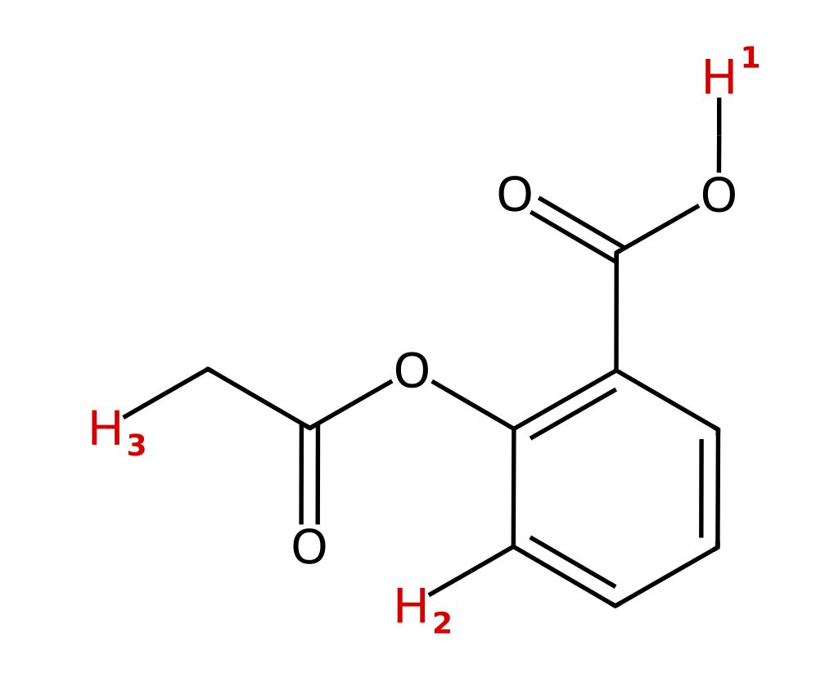
A) H₂ (the aromatic C–H)
B) H₁ (the carboxylic acid O–H)
C) H₃ (the CH₃ on the acetyl group)
D) All three are about equally acidic
59. Which is more acidic, the O-H of propan-1-ol or the C-H of propyne (on the sp carbon)? Name the factor that decides. [C03F27, Moderate]
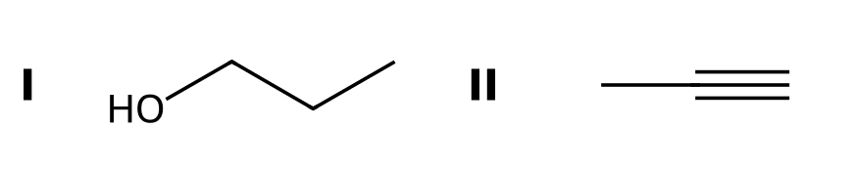

60. Which O-H is more acidic in this compound? Explain which factor wins. [C03F28, Moderate]
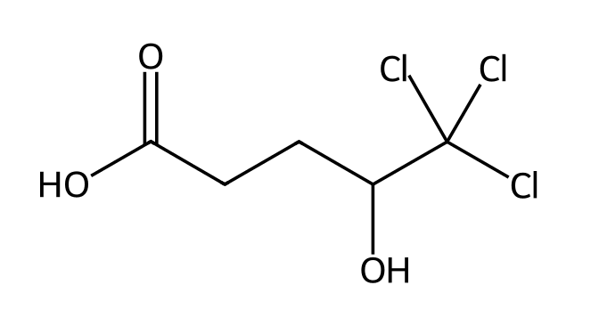

61. Which C-H is more acidic: the CH₂ between two carbonyls in CH₃COCH₂COCH₃, or the terminal alkyne C-H in HC≡CH? Explain. [C03F29, Moderate]
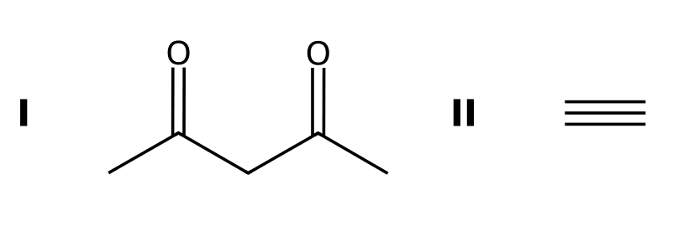

62. Rank from least to most acidic and explain: I = HC≡CH, II = CH₃CH₂OH, III = CH₃COCH₂COCH₃ (central CH₂). [C03F30, Hard]
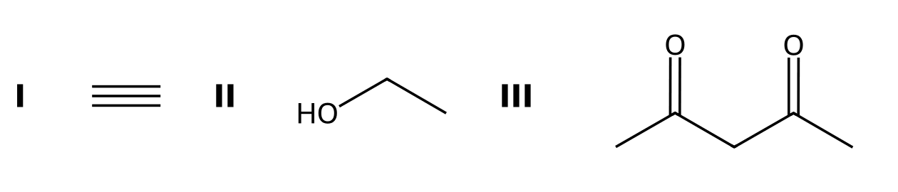

3.5 Relative Acidity of Cationic Acids
63. Which is the stronger acid, NH₄⁺ or H₃O⁺? [C03M11, Basic]
A) NH₄⁺, because nitrogen is less electronegative
B) H₃O⁺, because oxygen is less able than nitrogen to stabilize a positive charge
C) They are equally strong
D) NH₄⁺, because it has more hydrogens
64. Which is the stronger base, CH₃NH₂ or CH₃OH? [C03M12, Basic]
A) CH₃OH
B) CH₃NH₂
C) They are equally basic
D) Neither is basic
65. Aniline is a weaker base than methylamine because: [C03M13, Moderate]
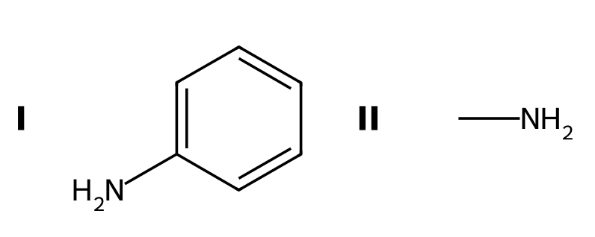
A) The nitrogen lone pair of aniline is delocalized into the ring
B) Nitrogen in aniline is less electronegative
C) Aniline has no lone pair
D) The ring is electron donating by induction only
66. Draw the conjugate acid of CH₃CH₂NH₂. Which atom carries the positive charge? [C03F31, Basic]

67. Why are amines stronger bases than alcohols? [C03F32, Basic]

68. Explain why amides are extremely poor bases. [C03F33, Moderate]
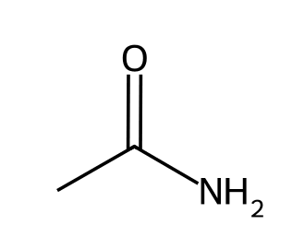

69. Which is the stronger acid, CH₃NH₃⁺ (pKa 10.6) or C₆H₅NH₃⁺ (pKa 4.6)? Explain using the conjugate bases. [C03F34, Moderate]

70. Draw the product of protonating pyridine and state which atom is protonated. [C03F35, Basic]
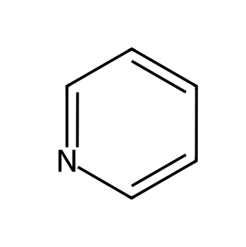

3.6 Position of Equilibrium and Choice of Reagents
71. Which side is favored in NH₂⁻ + CH₃OH ⇌ NH₃ + CH₃O⁻? [C03M14, Basic]
A) The products
B) The reactants
C) Neither side
D) Cannot be predicted
72. Is water a suitable proton source to convert the acetate ion into acetic acid? [C03M15, Moderate]
A) Yes; water is a strong acid
B) Yes; the equilibrium favors acetic acid
C) No, because water has no protons
D) No; the equilibrium favors acetate because it is a resonance-stabilized, weaker base than HO⁻
73. Which side of the equilibrium is favored? [Q23, Basic]
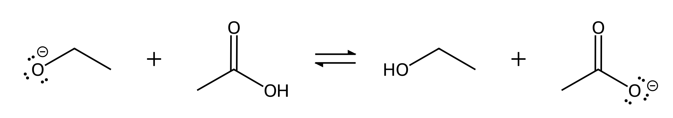
A) The products, because acetate is resonance stabilized and is the more stable anion
B) The reactants, because ethoxide is more stable
C) Neither side, because both anions have the charge on O
D) The products, because ethanol is a stronger acid than acetic acid
74. Which side of the equilibrium is favored? [Q24, Basic]
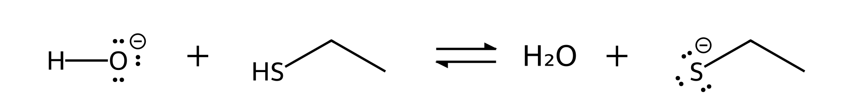
A) The reactants, because O is more electronegative than S
B) Neither side, because O and S are both in group 16
C) The reactants, because hydroxide is the smaller anion
D) The products, because the larger S atom stabilizes the charge better
75. Which side of the equilibrium is favored? [Q25, Hard]
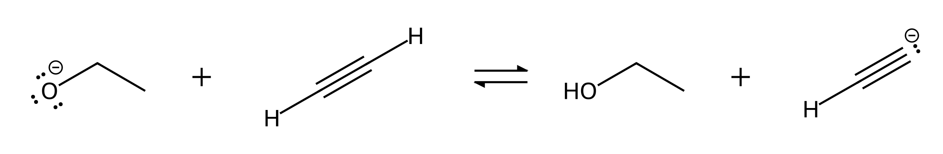
A) The products, because the sp carbanion is the most stable carbanion
B) The reactants, because ethoxide (O⁻) is more stable than the sp carbanion (C⁻)
C) The products, because the alkynide ion has resonance structures
D) Neither side, because both anions have lone pairs
76. Which side of the equilibrium is favored? [Q26, Basic]
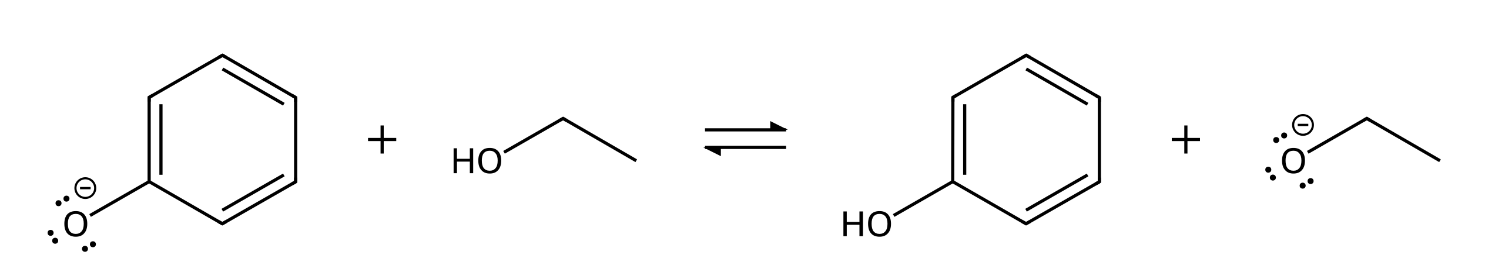
A) The products, because ethanol is the more acidic reactant
B) The products, because ethoxide is more stable
C) The reactants, because phenoxide is resonance stabilized
D) Neither side, because both anions have the charge on O
77. Which side of the equilibrium is favored? [Q27, Hard]
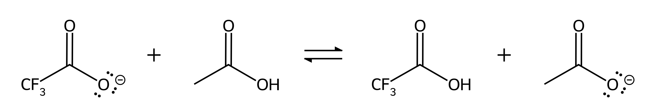
A) The products, because acetate is resonance stabilized
B) The products, because CH₃ donates electron density to the carboxylate
C) Neither side, because both anions are resonance stabilized
D) The reactants, because CF₃CO₂⁻ is stabilized by induction
78. Hydroxide deprotonates phenol. Which set of curved arrows correctly shows the proton transfer? [Q28, Basic]
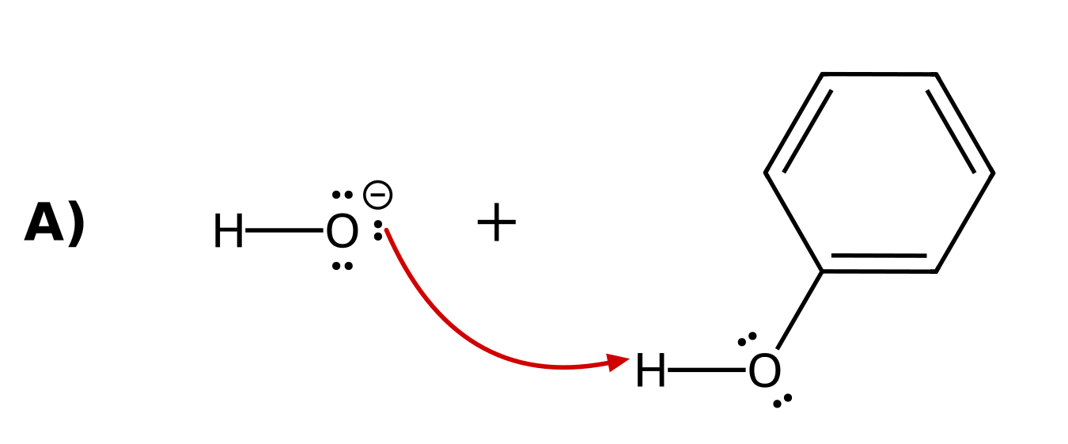 | 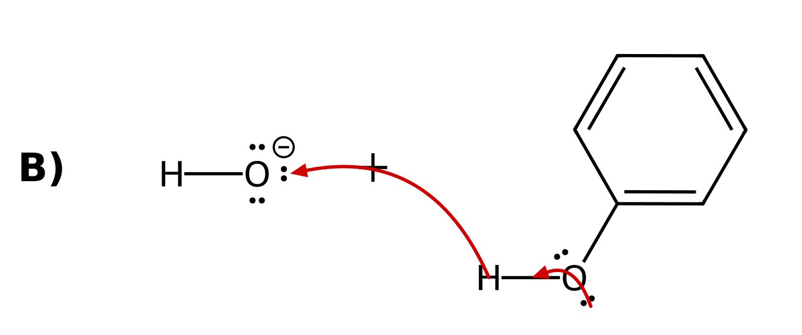
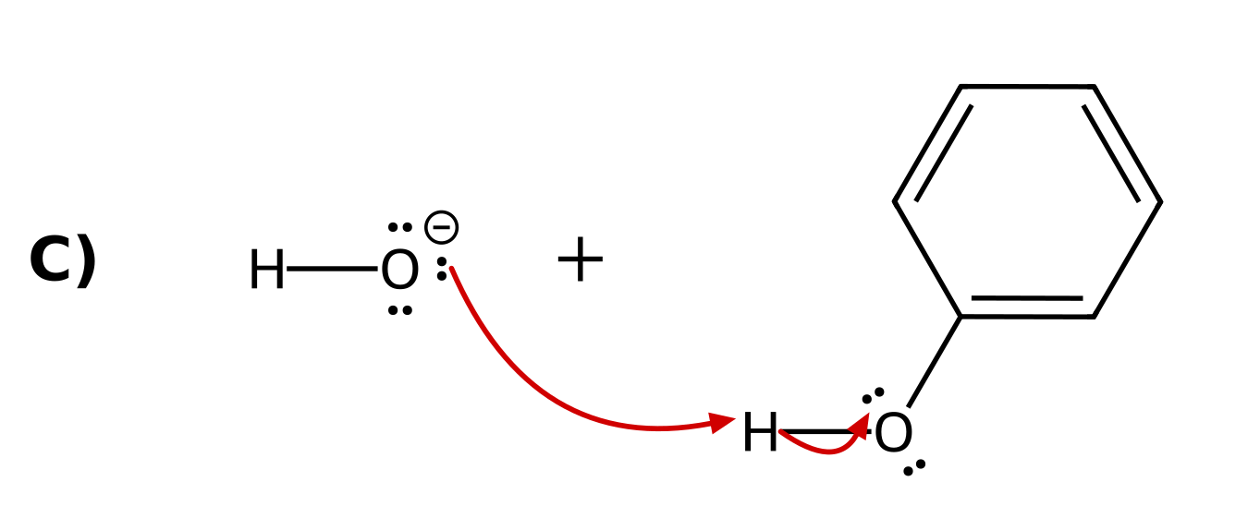 | 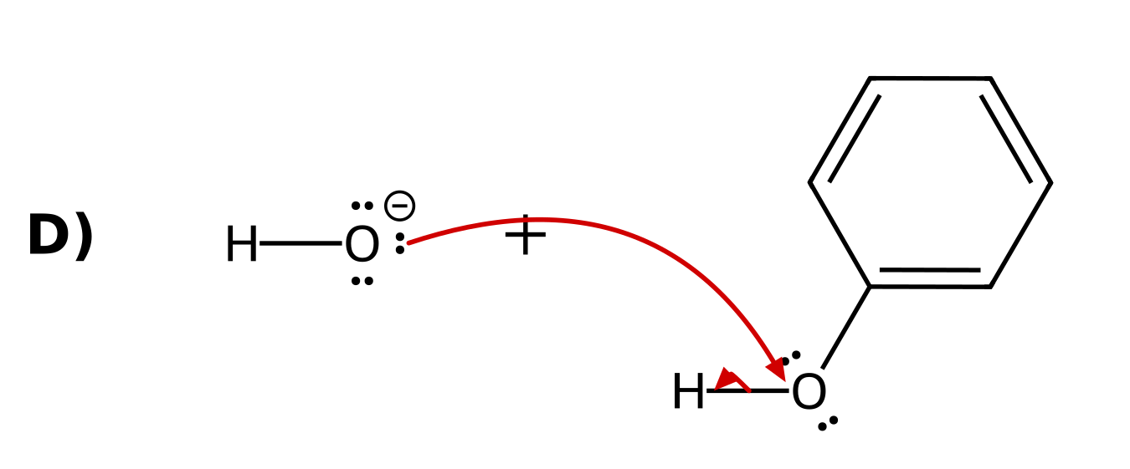
79. Which side of the equilibrium is favored? [Q29, Basic]
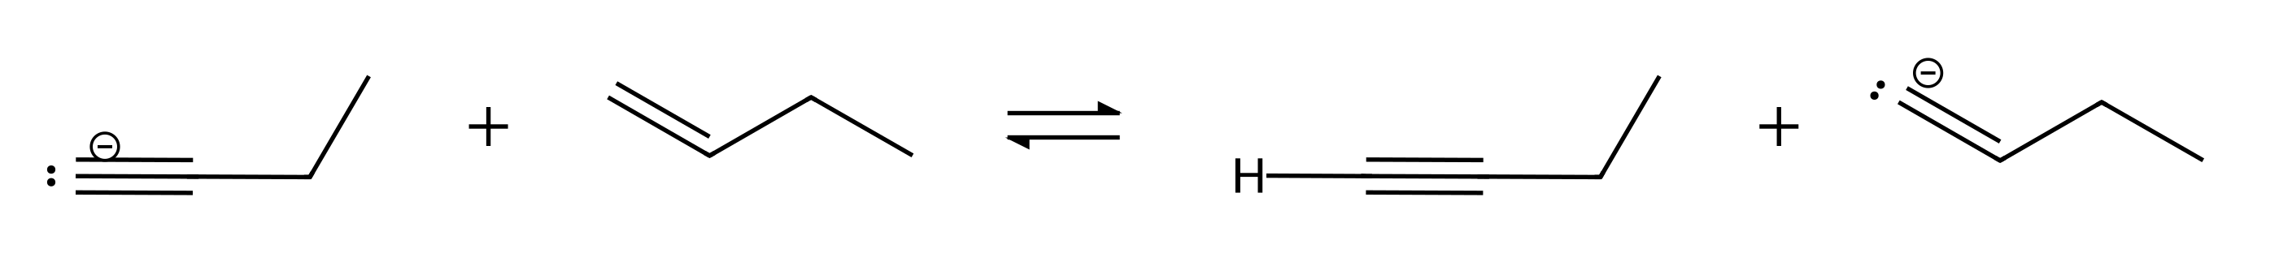
A) The reactants, because the alkynide (charge in an sp orbital) is more stable than the vinyl anion (charge in an sp² orbital)
B) The products, because the vinyl anion is resonance stabilized
C) The products, because an sp² orbital is closer to the nucleus than an sp orbital
D) Neither side, because both anions have the charge on carbon
80. Which anion is a strong enough base to deprotonate ethanol so that the equilibrium favors the products? [Q30, Hard]
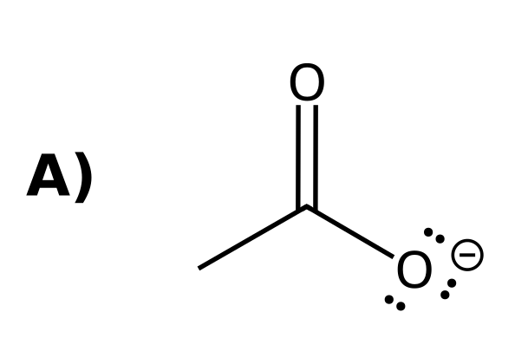 | 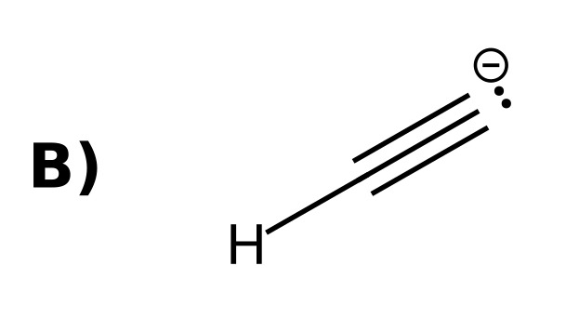
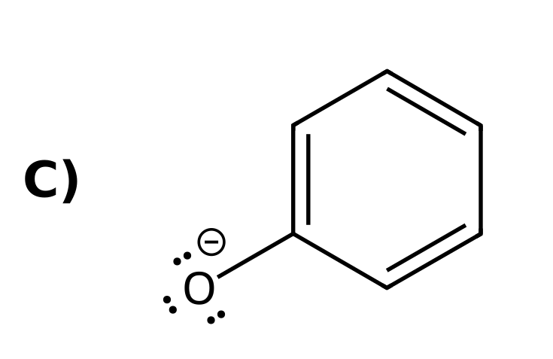 | 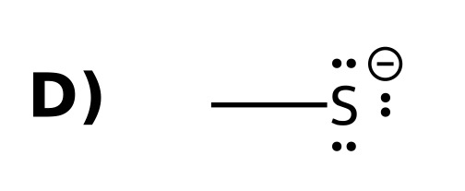
81. Predict the position of equilibrium: CH₃CO₂⁻ + HCl ⇌ CH₃CO₂H + Cl⁻. [C03F36, Basic]

82. Is hydroxide a strong enough base to deprotonate phenol? Explain. [C03F37, Basic]

83. A student wants to convert CH₃CH₂OH completely into its alkoxide. Is NaOH or NaNH₂ the better choice? Explain. [C03F38, Moderate]

84. Is water a suitable proton source to protonate CH₃CH₂O⁻? Explain. [C03F39, Moderate]

85. Is hydroxide a suitable base to deprotonate acetylene? Explain. [C03F40, Moderate]

3.7 Leveling Effect
86. What is the strongest base that can exist in water? [C03M16, Basic]
A) NH₂⁻
B) CH₃CH₂⁻
C) HO⁻
D) H⁻
87. What happens when sodium amide (NaNH₂) is added to water? [C03M17, Basic]
A) It dissolves unchanged as NH₂⁻
B) It forms NH₄⁺
C) It reacts with water to give NH₃ and HO⁻
D) Nothing; amide is not basic
88. State the leveling effect for bases in a solvent. [C03F41, Basic]

89. Why can NaNH₂ not be used as a base in water, and what solvent could be used instead? [C03F42, Moderate]

90. What is the strongest acid that can exist in water? [C03F43, Basic]

3.8 Solvating Effects
91. Why is the tert-butoxide ion less stable than the ethoxide ion in solution? [C03M18, Basic]
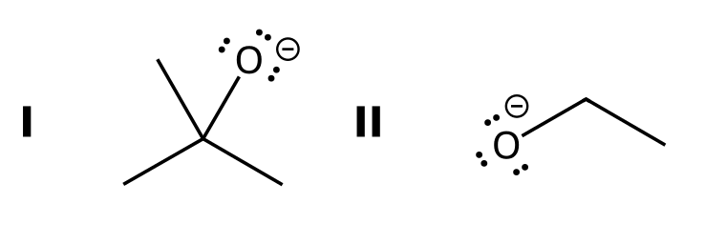
A) It has a smaller negative charge
B) It is bulky, so solvent molecules cannot approach and stabilize the negative oxygen as well
C) It has resonance structures
D) It has fewer carbon atoms
92. Ethanol (pKa 16) is slightly more acidic than tert-butanol (pKa 18). Explain. [C03F44, Basic]

93. Predict which is the stronger base, CH₃O⁻ or (CH₃)₃CO⁻, and explain how solvation contributes. [C03F45, Moderate]

3.9 Counterions
94. In the reagent NaOH, which ion acts as the base? [C03M19, Easy]
A) Na⁺
B) Both ions equally
C) HO⁻
D) Neither ion
95. What is a counterion? [C03F46, Easy]

96. Rewrite NaNH₂ + H₂O → NH₃ + NaOH without the counterion. [C03F47, Basic]

3.10 Lewis Acids and Bases
97. Which species is a Lewis acid? [C03M20, Basic]
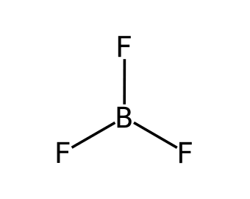
A) NH₃
B) BF₃
C) H₂O
D) CH₃O⁻
98. In BF₃ + O(CH₃)₂ → F₃B⁻-O⁺(CH₃)₂, identify the Lewis acid and the Lewis base. [C03F48, Basic]

99. BF₃ has no hydrogens. Explain how it can still be an acid. [C03F49, Basic]

100. How many curved arrows are needed for NH₃ + BF₃ → H₃N⁺-B⁻F₃? Draw it. [C03F50, Moderate]

