Chapter 5: Stereoisomerism: Answer Key
Answers and explanations.
Name: ______________________________ Date: ______________

5.1 Overview of Isomerism
1. Which term describes two compounds with the same molecular formula but different connectivity of atoms? [C05M01, Easy]
Answer: C) Constitutional isomers
Why: Constitutional isomers differ in which atoms are bonded to which.
2. Which term describes two compounds with the same connectivity but a different spatial arrangement of atoms? [C05M02, Easy]
Answer: B) Stereoisomers
Why: Same connectivity, different arrangement in space.
3. What is the relationship between the two compounds shown? [C05M03, Basic]
Answer: C) Constitutional isomers
Why: Both are C₄H₁₀O, but the atoms are connected differently.
4. What is the relationship between cis- and trans-but-2-ene? [C05M04, Basic]
Answer: C) Stereoisomers
Why: The atoms are connected in the same order; only the arrangement across the double bond differs.
5. Define constitutional isomers and give an example pair. [C05F01, Easy]
Answer: Constitutional isomers have the same molecular formula but different connectivity, for example butan-1-ol and diethyl ether (both C₄H₁₀O).
Why: Different connectivity is the key.
6. Define stereoisomers. [C05F02, Easy]
Answer: Stereoisomers have the same connectivity of atoms but differ in the arrangement of the atoms in space.
Why: Same connectivity, different 3D arrangement.
7. Are the two compounds shown constitutional isomers or stereoisomers? Explain. [C05F03, Basic]
Answer: Constitutional isomers: the formula C₄H₁₀O is shared but the oxygen sits at a different carbon.
Why: Compare the connectivity, not the 3D shape.
8. Draw the two stereoisomers of but-2-ene and label each as cis or trans. [C05F04, Basic]
Answer: cis-But-2-ene has both CH₃ groups on the same side of the double bond; trans-but-2-ene has them on opposite sides.
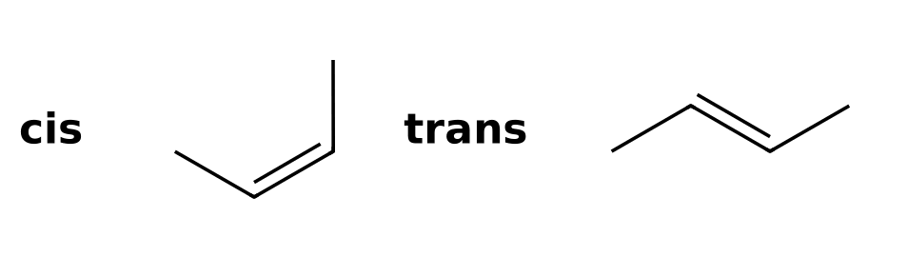
Why: The groups are cis if they are on the same side.
9. Draw all constitutional isomers of C₄H₁₀ and state how many there are. [C05F05, Moderate]
Answer: Two: butane and 2-methylpropane (isobutane).
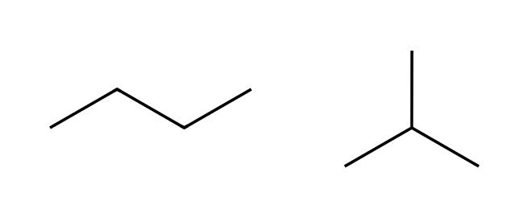
Why: Try a straight chain and a branched chain.
10. Are cis- and trans-1,2-dimethylcyclohexane constitutional isomers or stereoisomers? Explain. [C05F06, Moderate]
Answer: Stereoisomers: both have the same connectivity but the methyl groups are on the same face in cis and opposite faces in trans.
Why: Check the connectivity first.

5.2 Introduction to Stereoisomerism
11. What is a chirality center (stereocenter) in an organic compound? [C05M05, Easy]
Answer: A) A carbon bonded to four different groups
Why: Four different groups make the mirror image nonsuperimposable.
12. A compound with one chirality center has how many stereoisomers? [C05M06, Easy]
Answer: A) Two
Why: The two stereoisomers are enantiomers of one another.
13. How many chirality centers are in the compound shown? [C05M07, Basic]
Answer: D) 1
Why: Only C2, bonded to H, OH, CH₃ and CH₂CH₃, has four different groups.
14. Which compound contains a chirality center? [C05M08, Basic]
Answer: C) Butan-2-ol
Why: In butan-2-ol, C2 bears H, OH, CH₃ and C₂H₅.
15. How many chirality centers are in the compound shown? [C05M09, Moderate]
Answer: D) 2
Why: C2 and C3 each have four different groups.
16. Identify the chirality center in the compound shown and list its four groups. [C05F07, Basic]
Answer: The chirality center is C2; its groups are H, OH, CH₃ and CH₂CH₃.
Why: The carbon bearing the OH has four different groups.
17. Explain why propan-2-ol does not have a chirality center. [C05F08, Basic]
Answer: C2 bears two identical methyl groups, so only three different groups are attached.
Why: Two methyl groups are identical.
18. How many chirality centers does 3-methylhexane have, and where? [C05F09, Basic]
Answer: One, at C3 (bonded to H, CH₃, CH₂CH₃ and CH₂CH₂CH₃).
Why: Look for a carbon with four different groups.
19. Circle the chirality centers in the compound shown by naming their carbon numbers. [C05F10, Moderate]
Answer: C2 and C3 are chirality centers; each carbon has four different groups.
Why: Count carbons from the end nearest the first branch.
20. Draw a molecule of formula C₄H₉Br that has a chirality center. [C05F11, Moderate]
Answer: 2-Bromobutane, CH₃CHBrCH₂CH₃, has a chirality center at C2.
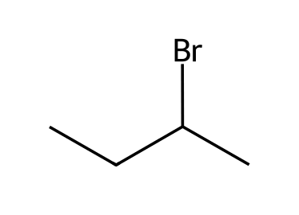
Why: Put the Br on an internal carbon of the straight chain.

5.3 Designating Configuration (Cahn-Ingold-Prelog, R/S)
21. In the Cahn-Ingold-Prelog system, priorities are first assigned according to what? [C05M10, Easy]
Answer: D) Atomic number of the atoms directly attached to the center
Why: Higher atomic number gets higher priority.
22. With priority 4 on a dash, going 1 → 2 → 3 clockwise gives which designation? [C05M11, Easy]
Answer: D) R
Why: Clockwise is R (rectus) and counterclockwise is S (sinister).
23. Rank the groups on a chirality center from highest to lowest priority: -OH, -CH₃, -H, -NH₂. [C05M12, Basic]
Answer: D) -OH > -NH₂ > -CH₃ > -H
Why: Atomic numbers: O 8, N 7, C 6, H 1.
24. Which of the following is the correct priority order for -CH₂OH, -CH₃, -CH₂CH₃, -H? [C05M13, Hard]
Answer: B) -CH₂OH > -CH₂CH₃ > -CH₃ > -H
Why: All three carbons tie at the first point; compare their substituents: (O,H,H) beats (C,H,H) beats (H,H,H).
25. What is the configuration of the chirality center in butan-2-ol? [C05M14, Basic]
Answer: A) S
Why: Rank the four groups, point the lowest priority away from you and trace 1 → 2 → 3.
26. What is the configuration of the chirality center in butan-2-ol? [C05M15, Basic]
Answer: D) R
Why: Rank the four groups, point the lowest priority away from you and trace 1 → 2 → 3.
27. What is the configuration of the chirality center in 2-chlorobutane? [C05M16, Basic]
Answer: B) S
Why: Rank the four groups, point the lowest priority away from you and trace 1 → 2 → 3.
28. What is the configuration of the chirality center in 2-bromobutane? [C05M17, Basic]
Answer: C) R
Why: Rank the four groups, point the lowest priority away from you and trace 1 → 2 → 3.
29. What is the configuration of the chirality center in this sample of alanine? [C05M18, Moderate]
Answer: B) S
Why: Rank by atomic number (N or O above C above H), then trace 1 → 2 → 3 with H pointing away.
30. What is the configuration of the chirality center in this sample of alanine? [C05M19, Moderate]
Answer: D) R
Why: Rank by atomic number (N or O above C above H), then trace 1 → 2 → 3 with H pointing away.
31. If the lowest priority group is on a wedge and 1 → 2 → 3 appears clockwise, what is the configuration? [C05M20, Moderate]
Answer: A) S
Why: Looking from the front puts the lowest priority group toward you, so the apparent direction is reversed.
32. A chirality center is drawn with the lowest priority group on a wedge and 1 → 2 → 3 counterclockwise. What is the configuration? [C05M21, Hard]
Answer: B) R
Why: Reverse the apparent direction because the lowest priority group points toward the viewer.
33. Assign R or S to the chirality center in the compound shown. List the priorities. [C05F12, Basic]
Answer: The configuration is S. Priorities are assigned by atomic number, the lowest priority group (H) is pointed away, and the 1 → 2 → 3 direction is read.
Why: Rank groups, put 4 on a dash, trace 1 to 2 to 3.
34. Assign R or S to the chirality center in the compound shown. List the priorities. [C05F13, Basic]
Answer: The configuration is R. Priorities are assigned by atomic number, the lowest priority group (H) is pointed away, and the 1 → 2 → 3 direction is read.
Why: Rank groups, put 4 on a dash, trace 1 to 2 to 3.
35. Assign R or S to the chirality center in the compound shown. List the priorities. [C05F14, Basic]
Answer: The configuration is S. Priorities are assigned by atomic number, the lowest priority group (H) is pointed away, and the 1 → 2 → 3 direction is read.
Why: Rank groups, put 4 on a dash, trace 1 to 2 to 3.
36. Assign R or S to the chirality center in the compound shown. List the priorities. [C05F15, Moderate]
Answer: The configuration is R. Priorities are assigned by atomic number, the lowest priority group (H) is pointed away, and the 1 → 2 → 3 direction is read.
Why: Rank groups, put 4 on a dash, trace 1 to 2 to 3.
37. What do R and S stand for, and what do they describe? [C05F16, Easy]
Answer: R is rectus (clockwise) and S is sinister (counterclockwise); they describe the configuration of a chirality center.
Why: Latin for right and left.
38. Explain how to assign priorities when two attached atoms are the same. [C05F17, Basic]
Answer: Move outward to the next atoms and compare their substituents in order until a first difference is found.
Why: Compare sets of atoms, atom by atom.
39. Rank the groups -CH₂OH, -CH₂CH₃, -CH₃ and -H on a chirality center. [C05F18, Moderate]
Answer: -CH₂OH > -CH₂CH₃ > -CH₃ > -H
Why: The first atoms are all C, so look at what the carbons carry: (O,H,H), (C,H,H), (H,H,H).
40. The lowest priority group is on a wedge and 1 → 2 → 3 looks clockwise. What is the configuration and why? [C05F19, Hard]
Answer: S, because the apparent direction is reversed when the lowest priority group points toward you.
Why: View from the opposite side.

5.4 Optical Activity
41. What instrument measures the rotation of plane-polarized light? [C05M22, Easy]
Answer: C) A polarimeter
Why: The polarimeter reports the observed rotation.
42. What is a racemic mixture? [C05M23, Easy]
Answer: D) An equal mixture of two enantiomers
Why: Equal amounts mean the rotations cancel.
43. Two enantiomers rotate plane-polarized light: [C05M24, Basic]
Answer: D) By equal amounts in opposite directions
Why: Enantiomers share all physical properties except the sign of rotation.
44. An enantiomer has a specific rotation of +20°. What is the specific rotation of its enantiomer? [C05M25, Moderate]
Answer: A) -20°
Why: Enantiomers have equal magnitudes and opposite signs.
45. A sample contains 75% of one enantiomer and 25% of the other. What is the enantiomeric excess? [C05M26, Hard]
Answer: C) 50%
Why: Enantiomeric excess is the major percentage minus the minor percentage.
46. What is the difference between dextrorotatory and levorotatory? [C05F20, Easy]
Answer: Dextrorotatory (+) rotates plane-polarized light clockwise; levorotatory (−) rotates it counterclockwise.
Why: Based on the direction of rotation.
47. Explain why a racemic mixture is optically inactive. [C05F21, Basic]
Answer: The two enantiomers rotate light by equal amounts in opposite directions, so the rotations cancel.
Why: Equal and opposite.
48. What is a racemic mixture, and how is it written? [C05F22, Basic]
Answer: An equal mixture of two enantiomers, written as (±) or racemic.
Why: Equal amounts of each enantiomer.
49. A sample contains 80% of the (+) enantiomer and 20% of the (−) enantiomer. Calculate the enantiomeric excess. [C05F23, Moderate]
Answer: 60% ee (80% − 20%).
Why: ee is the major minus the minor.
50. The (R) enantiomer of a compound is dextrorotatory. What can you say about the rotation of the (S) enantiomer? [C05F24, Moderate]
Answer: It is levorotatory with the same magnitude, because enantiomers rotate light equally in opposite directions.
Why: Equal and opposite.

5.5 Enantiomers and Diastereomers
51. Enantiomers are best described as: [C05M27, Easy]
Answer: A) Stereoisomers that are nonsuperimposable mirror images
Why: Mirror images that cannot be superimposed.
52. Diastereomers are best described as: [C05M28, Easy]
Answer: B) Stereoisomers that are not mirror images
Why: Diastereomers are stereoisomers that are not enantiomers.
53. What is the relationship between the two compounds shown? [C05M29, Basic]
Answer: B) Enantiomers
Why: Compare every chirality center: all inverted gives enantiomers; some inverted gives diastereomers.
54. What is the relationship between the two compounds shown? [C05M30, Basic]
Answer: C) Enantiomers
Why: Compare every chirality center: all inverted gives enantiomers; some inverted gives diastereomers.
55. What is the relationship between the two compounds shown? [C05M31, Moderate]
Answer: D) Diastereomers
Why: Compare every chirality center: all inverted gives enantiomers; some inverted gives diastereomers.
56. What is the relationship between the two compounds shown? [C05M32, Moderate]
Answer: C) Enantiomers
Why: Compare every chirality center: all inverted gives enantiomers; some inverted gives diastereomers.
57. A compound has two chirality centers with configurations (2R,3S). Which stereoisomer is its enantiomer? [C05M33, Moderate]
Answer: A) (2S,3R)
Why: An enantiomer inverts every center.
58. A compound has two chirality centers with configurations (2R,3S). Which stereoisomer is a diastereomer? [C05M34, Moderate]
Answer: A) (2R,3R)
Why: Inverting only one center gives a diastereomer.
59. Are these two compounds enantiomers, diastereomers or identical? Explain. [C05F25, Basic]
Answer: Enantiomers: compare the configuration at each chirality center.
Why: All inverted = enantiomers; some inverted = diastereomers; none inverted = identical.
60. Are these two compounds enantiomers, diastereomers or identical? Explain. [C05F26, Basic]
Answer: Enantiomers: compare the configuration at each chirality center.
Why: All inverted = enantiomers; some inverted = diastereomers; none inverted = identical.
61. Are these two compounds enantiomers, diastereomers or identical? Explain. [C05F27, Moderate]
Answer: Diastereomers: compare the configuration at each chirality center.
Why: All inverted = enantiomers; some inverted = diastereomers; none inverted = identical.
62. Are these two compounds enantiomers, diastereomers or identical? Explain. [C05F28, Moderate]
Answer: Enantiomers: compare the configuration at each chirality center.
Why: All inverted = enantiomers; some inverted = diastereomers; none inverted = identical.
63. State one physical property that differs between diastereomers but not between enantiomers. [C05F29, Easy]
Answer: Melting point (or boiling point, solubility): diastereomers have different physical properties while enantiomers have identical ones (apart from the sign of rotation).
Why: Enantiomers share nearly all properties.
64. Draw the enantiomer of the compound shown. [C05F30, Basic]
Answer: Reflect the structure so that the chirality center is inverted (wedge ↔ dash).
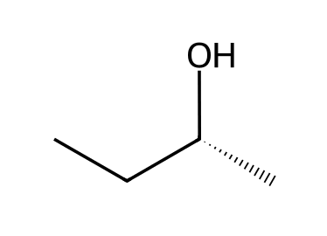
Why: A mirror image.
65. For a compound with three chirality centers, how many stereoisomers are possible (no meso)? [C05F31, Basic]
Answer: 2³ = 8
Why: Use 2ⁿ.

5.6 Symmetry and Chirality
66. A compound with a plane of symmetry is: [C05M35, Easy]
Answer: B) Achiral
Why: A mirror plane makes the molecule identical to its mirror image.
67. Which describes a meso compound? [C05M36, Basic]
Answer: A) Contains chirality centers but is achiral
Why: A plane of symmetry cancels the chirality of its centers.
68. Is the compound shown chiral? [C05M37, Basic]
Answer: B) No, it is meso
Why: The halves are mirror images across a plane in the middle of the C2-C3 bond.
69. How many stereoisomers does 2,3-dibromobutane have? [C05M38, Hard]
Answer: A) 3
Why: Two enantiomers plus one meso compound, because the meso form is its own mirror image.
70. Which compound is meso? [C05M39, Moderate]
Answer: D) cis-1,2-dimethylcyclohexane
Why: The cis isomer has an internal mirror plane; the trans isomer exists as a pair of enantiomers.
71. What kind of symmetry element makes a compound achiral? [C05F32, Easy]
Answer: A plane of symmetry (reflectional symmetry).
Why: A mirror plane inside the molecule.
72. Explain why 2,3-dibromobutane has three stereoisomers rather than four. [C05F33, Hard]
Answer: One of the four possible combinations, (2R,3S), is meso and identical to its mirror image; the other two form an enantiomeric pair.
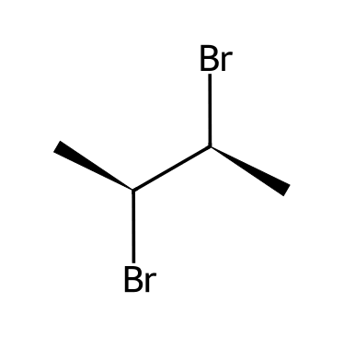
Why: Use symmetry.
73. Is the compound shown chiral or meso? Identify the plane of symmetry. [C05F34, Moderate]
Answer: Meso: a plane of symmetry passes through the middle of the C2-C3 bond, so the molecule is achiral despite two chirality centers.
Why: Compare the two halves.
74. Is the compound shown chiral? Explain. [C05F35, Moderate]
Answer: Yes. It has two chirality centers and no plane of symmetry.
Why: Look for a mirror plane.

5.7 Fischer Projections
75. In a Fischer projection, horizontal bonds point: [C05M40, Easy]
Answer: C) Toward the viewer (out of the page)
Why: Horizontal lines are wedges and vertical lines are dashes.
76. Rotating a Fischer projection by 180° in the plane of the page changes the configuration of the chirality center: [C05M41, Moderate]
Answer: A) Not at all
Why: A 180° turn in the plane is the same molecule; a 90° turn would invert the picture.
77. In a Fischer projection, what do the horizontal and vertical lines mean? [C05F36, Easy]
Answer: Horizontal lines are bonds coming out of the page (wedges); vertical lines are bonds going behind the page (dashes).
Why: Think of the bow-tie shape.
78. Describe how to assign R or S from a Fischer projection when the lowest priority group is on a horizontal bond. [C05F37, Basic]
Answer: Trace 1 → 2 → 3 and then reverse the answer, because the lowest priority group points toward the viewer.
Why: A horizontal group is on a wedge.
79. Describe what happens to the configuration if you rotate a Fischer projection by 90° in the plane of the page. [C05F38, Hard]
Answer: The drawing now represents the enantiomer, because the horizontal and vertical roles swap.
Why: Horizontal bonds point out of the page.

5.8 Conformationally Mobile Systems
80. Why is butane achiral even though some of its conformations lack a mirror plane? [C05M42, Basic]
Answer: C) Its conformations interconvert rapidly by bond rotation
Why: The mirror-image conformations are constantly interconverting.
81. Explain why butane, which has chiral conformations, is not optically active. [C05F39, Basic]
Answer: The mirror-image conformations interconvert rapidly through single-bond rotation, so the sample contains equal amounts and is achiral overall.
Why: Think about rapid rotation.

5.9 Chiral Compounds that Lack a Chiral Center
82. Which statement is true? [C05M43, Hard]
Answer: B) A compound can be chiral without having a chirality center
Why: Some allenes, biaryls and helices are chiral without stereocenters.
83. Can a compound be chiral without containing a chirality center? Give a reason. [C05F40, Hard]
Answer: Yes. A compound lacking a plane of symmetry is chiral even without a stereocenter, for example some allenes or helical molecules.
Why: Chirality depends on overall symmetry.

5.10 Resolution of Enantiomers
84. What is the purpose of resolution? [C05M44, Basic]
Answer: B) To separate a racemic mixture into its enantiomers
Why: Resolution separates the two enantiomers of a racemate.
85. Why are diastereomers helpful in resolving a racemic mixture? [C05M45, Moderate]
Answer: A) Diastereomers have different physical properties and can be separated
Why: Enantiomers cannot be separated by ordinary means; diastereomeric salts can.
86. Explain why reacting a racemic acid with one pure enantiomer of a chiral base allows the acid enantiomers to be separated. [C05F41, Hard]
Answer: The products are diastereomeric salts, which have different physical properties and can be separated, for example by crystallisation.
Why: Enantiomer + pure chiral reagent gives diastereomers.

5.11 E and Z Designations for Alkenes
87. In the E/Z system, a Z alkene has the highest priority groups: [C05M46, Easy]
Answer: B) On the same side of the double bond
Why: Z is from the German zusammen (together).
88. What is the configuration of the double bond in pent-2-ene? [C05M47, Basic]
Answer: C) E
Why: Rank the two groups on each end of the double bond, then compare their sides.
89. What is the configuration of the double bond in 1-chloro-2-fluoroethene? [C05M48, Basic]
Answer: B) Z
Why: Rank the two groups on each end of the double bond, then compare their sides.
90. What is the configuration of the double bond in 3-chloropent-2-ene? [C05M49, Basic]
Answer: A) E
Why: Rank the two groups on each end of the double bond, then compare their sides.
91. Which alkene cannot show E/Z isomerism? [C05M50, Moderate]
Answer: D) 2-Methylbut-2-ene
Why: One alkene carbon of 2-methylbut-2-ene has two identical methyl groups.
92. Assign E or Z to the double bond in the compound shown. [C05F42, Basic]
Answer: E: rank the groups on each alkene carbon by CIP priority and check whether the higher priority groups are on the same side (Z) or opposite sides (E).
Why: Compare priorities at each end.
93. Assign E or Z to the double bond in the compound shown. [C05F43, Basic]
Answer: Z: rank the groups on each alkene carbon by CIP priority and check whether the higher priority groups are on the same side (Z) or opposite sides (E).
Why: Compare priorities at each end.
94. Assign E or Z to the double bond in the compound shown. [C05F44, Basic]
Answer: E: rank the groups on each alkene carbon by CIP priority and check whether the higher priority groups are on the same side (Z) or opposite sides (E).
Why: Compare priorities at each end.
95. Assign E or Z to the double bond in the compound shown. [C05F45, Moderate]
Answer: Z: rank the groups on each alkene carbon by CIP priority and check whether the higher priority groups are on the same side (Z) or opposite sides (E).
Why: Compare priorities at each end.
96. Assign E or Z to the double bond in the compound shown. [C05F46, Moderate]
Answer: Z: rank the groups on each alkene carbon by CIP priority and check whether the higher priority groups are on the same side (Z) or opposite sides (E).
Why: Compare priorities at each end.
97. What do E and Z mean in alkene nomenclature? [C05F47, Easy]
Answer: E (entgegen) means the higher priority groups are on opposite sides; Z (zusammen) means they are on the same side.
Why: German for opposite and together.
98. Draw (Z)-but-2-ene. [C05F48, Basic]
Answer: Both methyl groups are on the same side of the double bond.
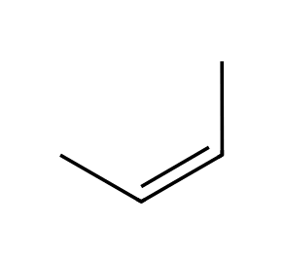
Why: Z = together.
99. Explain why propene has no E or Z designation. [C05F49, Moderate]
Answer: One alkene carbon (CH₂) carries two identical hydrogens, so the two arrangements are the same compound.
Why: Each alkene carbon needs two different groups.
100. Draw (E)-pent-2-ene and (Z)-pent-2-ene. [C05F50, Moderate]
Answer: In E the CH₃ and CH₂CH₃ groups are on opposite sides; in Z they are on the same side.
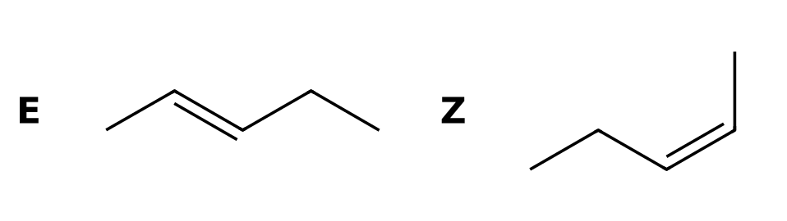
Why: Higher priority on each carbon: CH₃CH₂ on C3 and CH₃ on C2.

