Chapter 6: Chemical Reactivity and Mechanisms
Organic chemistry questions. Multiple choice first within each textbook section.
Name: ______________________________ Date: ______________

6.1 Enthalpy
1. What does a negative ΔH indicate? [C06M01, Easy]
A) The reaction is endothermic
B) The reaction is very slow
C) The reaction is exothermic (heat is released)
D) The reaction has no energy change
2. Breaking a bond is a(n) ______ process, and forming a bond is a(n) ______ process. [C06M02, Easy]
A) exothermic; endothermic
B) endothermic; endothermic
C) exothermic; exothermic
D) endothermic; exothermic
3. In a reaction, the bonds broken are stronger overall than the bonds formed. What is the sign of ΔH? [C06M03, Basic]
A) Negative
B) Zero
C) Positive
D) It cannot be determined
4. Which pair of bond strengths (kJ/mol) is correct for the reaction CH₄ + Cl₂ → CH₃Cl + HCl (C-H 414, Cl-Cl 243, C-Cl 339, H-Cl 431)? [C06M04, Basic]
A) ΔH = −113 kJ/mol
B) ΔH = +113 kJ/mol
C) ΔH = −770 kJ/mol
D) ΔH = +770 kJ/mol
5. A reaction breaks bonds totalling 850 kJ/mol and forms bonds totalling 920 kJ/mol. What is ΔH? [C06M05, Moderate]
A) −70 kJ/mol
B) +70 kJ/mol
C) −1770 kJ/mol
D) +1770 kJ/mol
6. Define exothermic and endothermic. [C06F01, Easy]

7. Explain why bond breaking is endothermic and bond making is exothermic. [C06F02, Basic]

8. Estimate ΔH for CH₄ + Cl₂ → CH₃Cl + HCl using C-H 414, Cl-Cl 243, C-Cl 339 and H-Cl 431 kJ/mol. [C06F03, Basic]

9. A reaction breaks bonds totalling 1000 kJ/mol and forms bonds totalling 880 kJ/mol. Calculate ΔH and say whether the reaction is exothermic or endothermic. [C06F04, Moderate]

6.2 Entropy
10. Entropy (S) is best described as a measure of: [C06M06, Easy]
A) Heat released
B) Disorder (the number of ways energy can be distributed)
C) Rate of reaction
D) Bond strength
11. In which reaction does the system gain entropy (ΔS > 0)? [C06M07, Basic]
A) One molecule splits into two molecules
B) Two molecules combine into one
C) A liquid freezes
D) A gas dissolves in a liquid
12. What is the sign of ΔS for A + B → C? [C06M08, Basic]
A) Negative
B) Positive
C) Zero
D) It depends on ΔH
13. Which change has the largest positive ΔS? [C06M09, Moderate]
A) A gas condensing to a liquid
B) A solid dissolving to give many gas molecules
C) A liquid freezing to a solid
D) Two molecules forming a ring
14. What does entropy measure? [C06F05, Easy]

15. Predict the sign of ΔS for the reaction A → B + C and explain. [C06F06, Basic]

16. Predict the sign of ΔS for the formation of a ring from a long chain. Explain. [C06F07, Basic]

17. Explain why an elimination reaction that makes two molecules from one is favored by high temperature. [C06F08, Moderate]

6.3 Gibbs Free Energy
18. Which equation relates free energy, enthalpy and entropy? [C06M10, Easy]
A) ΔG = ΔH − TΔS
B) ΔG = ΔH + TΔS
C) ΔG = TΔH − ΔS
D) ΔG = ΔS − ΔH
19. A reaction with ΔG < 0 is: [C06M11, Easy]
A) Always fast
B) Thermodynamically favorable
C) Not thermodynamically favorable
D) At equilibrium
20. For a reaction, ΔH = -40 kJ/mol, T = 300 K and ΔS = +0.1 kJ/(mol·K). What is ΔG? [C06M12, Basic]
A) -10.0 kJ/mol
B) -40.1 kJ/mol
C) +70.0 kJ/mol
D) -70.0 kJ/mol
21. For a reaction, ΔH = +30 kJ/mol, T = 300 K and ΔS = -0.05 kJ/(mol·K). What is ΔG? [C06M13, Basic]
A) 15.0 kJ/mol
B) +45.0 kJ/mol
C) +30.05 kJ/mol
D) +0.0 kJ/mol
22. A reaction has ΔH < 0 and ΔS > 0. At what temperatures is it thermodynamically favorable? [C06M14, Basic]
A) All temperatures
B) Only high temperatures
C) Only low temperatures
D) No temperature
23. A reaction has ΔH > 0 and ΔS > 0. It is thermodynamically favorable only: [C06M15, Moderate]
A) At low temperature
B) At high temperature
C) At all temperatures
D) At no temperature
24. A reaction has ΔH < 0 and ΔS < 0. It is thermodynamically favorable only: [C06M16, Moderate]
A) At high temperature
B) At low temperature
C) At all temperatures
D) At no temperature
25. Write the equation for Gibbs free energy and name each term. [C06F09, Easy]

26. Calculate ΔG for a reaction with ΔH = −50 kJ/mol, ΔS = −0.10 kJ/(mol·K) at 300 K. [C06F10, Basic]

27. Calculate ΔG for a reaction with ΔH = +20 kJ/mol, ΔS = +0.20 kJ/(mol·K) at 400 K. [C06F11, Basic]

28. A reaction has ΔH < 0 and ΔS < 0. Explain how the temperature affects whether it is thermodynamically favorable. [C06F12, Moderate]

29. Calculate the temperature (in K) at which a reaction with ΔH = +60 kJ/mol and ΔS = +0.15 kJ/(mol·K) becomes thermodynamically favorable. [C06F13, Moderate]

6.4 Equilibria
30. If ΔG° is negative, the equilibrium constant K is: [C06M17, Easy]
A) Less than 1
B) Equal to 1
C) Greater than 1
D) Zero
31. If K = 1 for a reaction, what is ΔG°? [C06M18, Basic]
A) Positive
B) Zero
C) Negative
D) Infinite
32. A reaction has a large positive ΔG°. What is true at equilibrium? [C06M19, Basic]
A) Products are favored
B) Reactants are favored
C) Equal amounts of reactants and products are present
D) The reaction is exothermic
33. Which change in ΔG° corresponds to the largest K? [C06M20, Moderate]
A) −10 kJ/mol
B) 0 kJ/mol
C) −40 kJ/mol
D) +10 kJ/mol
34. A reaction has ΔG° = +10 kJ/mol. Which statement is correct? [C06M49, Moderate]
A) K is greater than 1
B) K is exactly 1
C) K is less than 1
D) The reaction is exothermic
35. What does K > 1 say about the equilibrium position? [C06F14, Easy]

36. Explain the relationship between the sign of ΔG° and the size of K. [C06F15, Basic]

37. Two reactions have ΔG° = −20 and −5 kJ/mol. Which has the larger K and why? [C06F16, Moderate]

38. A reaction has ΔG° = +15 kJ/mol. Are reactants or products favored at equilibrium? [C06F48, Basic]

6.5 Kinetics
39. What does the activation energy (Eₐ) represent? [C06M21, Easy]
A) The energy released by the reaction
B) The energy barrier that must be overcome for the reaction to proceed
C) The difference in energy between products and reactants
D) The equilibrium constant
40. A smaller activation energy gives a reaction that is: [C06M22, Easy]
A) Slower
B) More exothermic
C) Less favorable thermodynamically
D) Faster
41. Increasing the temperature of a reaction mixture usually makes the reaction faster because: [C06M23, Basic]
A) More molecules have enough energy to overcome Eₐ
B) Eₐ becomes smaller
C) ΔG becomes more negative
D) The products become more stable
42. A reaction is thermodynamically favorable (ΔG < 0). Does this mean it is fast? [C06M24, Basic]
A) Yes, it is always fast
B) Yes, but only at high temperature
C) No, because ΔG controls only enthalpy
D) No, speed depends on the activation energy
43. In a one-step reaction the rate depends on the concentration of both reactants. This is a: [C06M25, Moderate]
A) First-order reaction
B) Zero-order reaction
C) Second-order (bimolecular) reaction
D) Reaction with no rate law
44. Doubling the concentration of the only species in the rate law of a first-order reaction changes the rate by what factor? [C06M26, Moderate]
A) 2
B) 4
C) 1
D) 0.5
45. Define activation energy. [C06F17, Easy]

46. Explain why a reaction can be thermodynamically favorable but extremely slow. [C06F18, Basic]

47. Explain why raising the temperature increases the rate of a reaction. [C06F19, Basic]

48. Rate = k[A][B] for a one-step reaction. What happens to the rate if [A] is tripled and [B] is halved? [C06F20, Moderate]

49. For a first-order reaction Rate = k[A], what happens to the rate when [A] is tripled? [C06F21, Moderate]

50. Which has the higher rate: a reaction with Eₐ = 40 kJ/mol or one with Eₐ = 80 kJ/mol at the same temperature? Explain. [C06F50, Basic]

6.6 Reading Energy Diagrams
51. On an energy diagram, the highest point between reactants and products is the: [C06M27, Easy]
A) Intermediate
B) Product
C) Transition state
D) Catalyst
52. On an energy diagram, a valley between two peaks represents: [C06M28, Basic]
A) An intermediate
B) A transition state
C) A catalyst
D) The products
53. A reaction with two peaks and one valley between them is a: [C06M29, Basic]
A) One-step reaction
B) Two-step reaction
C) Three-step reaction
D) Reaction with no intermediate
54. On a two-step energy diagram, which step is rate-determining? [C06M30, Moderate]
A) The step with the lowest-energy transition state
B) The first step always
C) The step with the highest-energy transition state
D) The last step always
55. If the products are lower in energy than the reactants on an energy diagram, then the reaction is: [C06M31, Moderate]
A) Endergonic
B) Always fast
C) Exergonic
D) Always slow
56. Which feature of an energy diagram represents the activation energy? [C06M50, Basic]
A) The height from reactants to products
B) The depth of a valley
C) The width of the peak
D) The height from the reactants to the top of the peak
57. On an energy diagram, what do the peaks and the valleys represent? [C06F22, Easy]

58. Describe the energy diagram of a one-step, exergonic reaction. [C06F23, Basic]

59. Describe the energy diagram of an endergonic reaction. [C06F24, Basic]

60. A two-step reaction has transition states at 80 and 60 kJ/mol above the reactants and an intermediate at 30 kJ/mol. Which step is rate-determining, and what is its activation energy? [C06F25, Moderate]

61. Why is the intermediate in a two-step reaction not an isolable product in most cases? [C06F26, Moderate]

62. Sketch in words an energy diagram for a two-step SN1 reaction, naming the intermediate and the rate-determining step. [C06F47, Hard]

63. Sketch the reaction energy diagram for the SN1 solvolysis of 2-bromo-2-methylpropane in water. How many transition states and intermediates are there, and which step is rate-determining? [P099, Moderate]

64. How does the energy diagram of an SN2 reaction differ from that of an SN1 reaction? Include the number of steps, transition states and intermediates. [P100, Basic]

6.7 Nucleophiles and Electrophiles
65. A nucleophile is a species that: [C06M32, Easy]
A) Donates a pair of electrons to form a bond
B) Accepts a pair of electrons
C) Donates a proton
D) Is always positively charged
66. An electrophile is a species that: [C06M33, Easy]
A) Donates a pair of electrons
B) Always carries a negative charge
C) Accepts a pair of electrons
D) Is a solvent
67. Which species is most likely to act as a nucleophile? [C06M34, Basic]
A) H₃O⁺
B) CH₃⁺
C) BF₃
D) HO⁻
68. Which species is most likely to act as an electrophile? [C06M35, Basic]
A) HO⁻
B) NH₃
C) The carbocation (CH₃)₃C⁺
D) Br⁻
69. In the reaction of hydroxide with (CH₃)₃C⁺, which is the electrophile? [C06M36, Moderate]
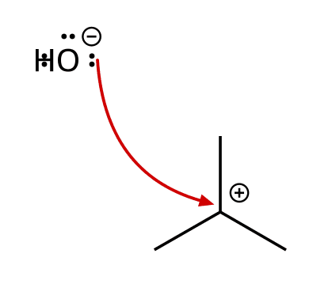
A) Hydroxide
B) Neither
C) Both
D) The carbocation
70. Define nucleophile and electrophile. [C06F27, Easy]

71. Identify the nucleophile and the electrophile in the reaction shown. [C06F28, Basic]

72. Which is the better nucleophile, HO⁻ or H₂O? Explain. [C06F29, Basic]

73. Can a species act as both a nucleophile and a base? Explain the difference in what they attack. [C06F30, Moderate]

74. Classify each as a nucleophile or an electrophile: NH₃, (CH₃)₃C⁺, Br⁻, H₃O⁺. [C06F49, Moderate]

6.8 Mechanisms and Arrow Pushing
75. Which is NOT one of the four arrow-pushing patterns? [C06M37, Easy]
A) Nucleophilic attack
B) Nucleophilic substitution of a hydride
C) Loss of a leaving group
D) Proton transfer
76. Which pattern is shown by the curved arrow? [C06M38, Basic]
A) Nucleophilic attack
B) Loss of a leaving group
C) Proton transfer
D) Carbocation rearrangement
77. Which pattern is shown by the curved arrow? [C06M39, Basic]
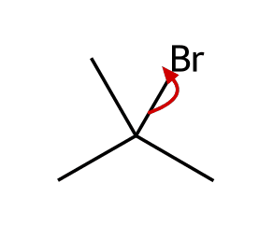
A) Nucleophilic attack
B) Proton transfer
C) Loss of a leaving group
D) Carbocation rearrangement
78. Which pattern is shown by the curved arrow? [C06M40, Moderate]
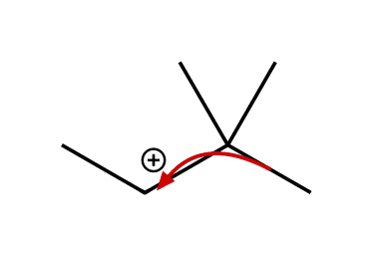
A) Loss of a leaving group
B) Proton transfer
C) Nucleophilic attack
D) Carbocation rearrangement
79. List the four patterns of arrow pushing. [C06F31, Easy]

80. Which arrow-pushing pattern is shown? Draw the product. [C06F32, Basic]

81. Draw the curved arrow(s) for hydroxide attacking the carbocation and draw the product. [C06F33, Basic]
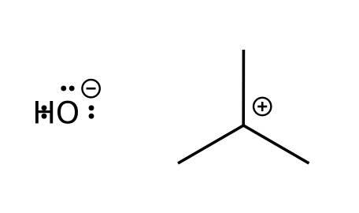

82. Describe how nucleophilic attack and loss of a leaving group are related to each other, using the SN1 mechanism as an example. [C06F34, Moderate]

6.9 Combining the Patterns of Arrow Pushing
83. Why does proton transfer typically precede nucleophilic attack on a neutral alcohol in acid? [C06M43, Moderate]
A) It adds a negative charge
B) It makes the alcohol more nucleophilic
C) It forms a carbanion
D) Protonation turns the OH into a better leaving group (water)
84. Why does protonating an alcohol allow it to undergo substitution? [C06F35, Basic]

85. Describe the steps of an acid-catalyzed substitution of an alcohol by bromide through a carbocation intermediate. [C06F36, Moderate]

86. Why do arrow-pushing steps in a mechanism usually combine two patterns in one step (for example, E2)? [C06F37, Moderate]

6.10 Drawing Curved Arrows
87. Where does a curved arrow start? [C06M41, Basic]
A) At the atom that will become positive
B) At the source of the electrons (a lone pair or bond)
C) At an atom that gains a proton
D) At the product
88. A curved arrow is used to show hydroxide attacking a carbocation. Which arrow is correct? [C06M42, Moderate]
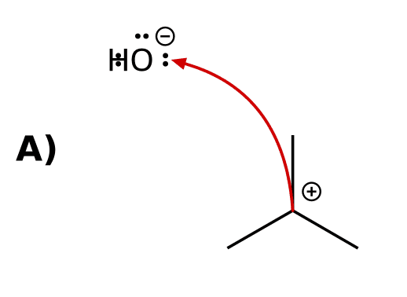 | 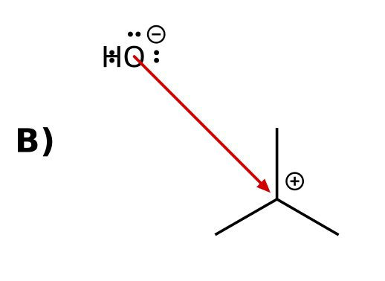
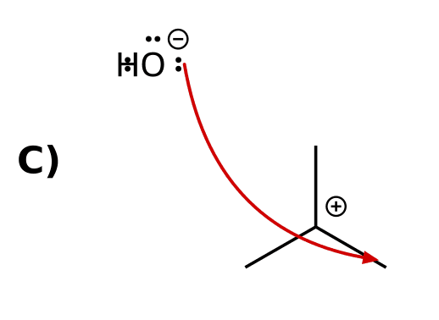 | 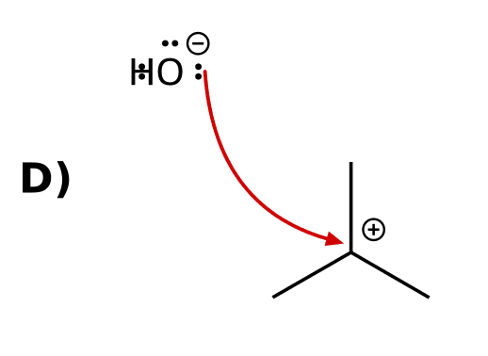
89. In a hydride shift the curved arrow starts at: [C06M48, Hard]
A) The cationic carbon
B) A lone pair on hydrogen
C) The positive charge
D) The C-H bond
90. State two rules for drawing curved arrows. [C06F38, Basic]

91. A student draws a curved arrow starting at a carbocation. What is wrong? [C06F39, Basic]

92. Show the curved arrow(s) for loss of the leaving group in the substrate shown. [C06F40, Moderate]
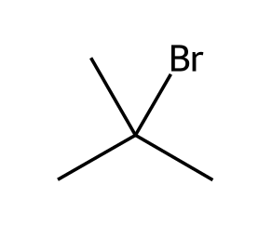

93. Draw the curved arrow for the methyl shift that converts the secondary carbocation shown into a tertiary carbocation. [C06F41, Moderate]
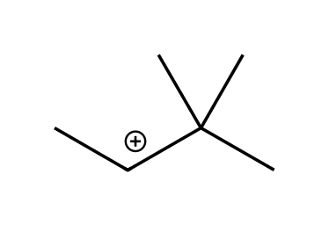

6.11 Carbocation Rearrangements
94. Carbocation rearrangements occur to form: [C06M44, Easy]
A) A less stable carbocation
B) A radical
C) A carbanion
D) A more stable carbocation
95. Which carbocation is the most stable? [C06M45, Basic]
A) Secondary
B) Tertiary
C) Primary
D) Methyl
96. A secondary carbocation next to a quaternary carbon rearranges by a methyl shift. What is the new carbocation? [C06M46, Moderate]
A) Tertiary
B) Primary
C) Secondary
D) Methyl
97. A secondary carbocation has a tertiary neighbour carbon bearing an H. After a hydride shift, what is the new cation? [C06M47, Hard]
A) A tertiary carbocation
B) A primary carbocation
C) A secondary carbocation
D) A radical
98. Why do carbocations rearrange? [C06F42, Easy]

99. Rank the carbocations methyl, primary, secondary and tertiary by stability. [C06F43, Basic]

100. Explain what is moving in a hydride shift and where it goes. [C06F44, Basic]

101. A secondary carbocation is adjacent to a tertiary carbon bearing one hydrogen. Draw the possible rearrangement and name the product cation type. [C06F45, Moderate]

102. Explain why a primary carbocation adjacent to a quaternary carbon will rearrange by a methyl shift, but one adjacent to a CH₂ group with no branching will not give a more stable cation. [C06F46, Hard]

