Chapter 8: Addition Reactions to Alkenes
Organic chemistry questions. Multiple choice first within each textbook section.
Name: ______________________________ Date: ______________

8.1 Introduction to Addition Reactions
1. In an addition reaction to an alkene, what happens? [C08M01, Easy]
A) A leaving group is replaced
B) Two groups add across the double bond and the π bond is lost
C) A proton and a leaving group are lost
D) The σ bond is broken
2. Define an addition reaction and give an example. [C08F01, Easy]

3. What kind of bond is broken and what is formed in an addition to an alkene? [C08F02, Basic]

8.2 Alkenes in Nature and in Industry
4. Which small alkene is the largest-volume starting material of the chemical industry? [C08M02, Easy]
A) Ethylene
B) Methane
C) Benzene
D) Acetylene
5. Name two alkenes produced industrially by cracking petroleum. [C08F03, Easy]

8.3 Nomenclature of Alkenes
6. What is the degree of substitution of the double bond in 2-methylbut-2-ene? [C08M03, Easy]
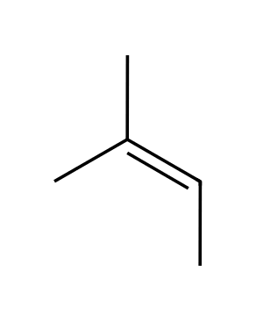
A) Monosubstituted
B) Trisubstituted
C) Disubstituted
D) Tetrasubstituted
7. What is the degree of substitution of the double bond in 2,3-dimethylbut-2-ene? [C08M04, Basic]
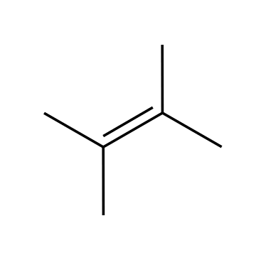
A) Trisubstituted
B) Tetrasubstituted
C) Disubstituted
D) Monosubstituted
8. What is the IUPAC name of the alkene shown? [C08M05, Basic]
A) 3-methylbut-1-ene
B) 2-methylbut-2-ene
C) 2-methylbut-3-ene
D) 2-methylbut-1-ene
9. How many carbon atoms are in the longest chain containing the double bond of 2-methylbut-2-ene? [C08M48, Easy]
A) 3
B) 4
C) 5
D) 2
10. Classify the double bond of 2-methylbut-2-ene as mono-, di-, tri- or tetrasubstituted. [C08F04, Basic]

11. Draw 3-methylcyclohexene. [C08F05, Basic]

12. Name the compound shown, giving its E/Z descriptor. [C08F06, Moderate]
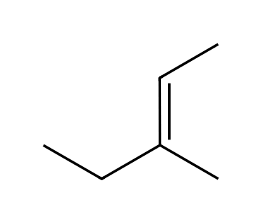

8.4 Addition vs. Elimination: A Thermodynamic Perspective
13. Why are addition reactions disfavored at high temperature? [C08M06, Moderate]
A) ΔH is positive
B) The π bond becomes stronger
C) ΔS is negative, so −TΔS opposes the reaction at high T
D) The reaction is always exothermic
14. Explain why alkene hydrogenation is thermodynamically favorable at room temperature. [C08F07, Basic]

15. Explain why elimination becomes more favorable relative to addition as temperature increases. [C08F08, Moderate]

8.5 Hydrohalogenation
16. What is the major product of the reaction of propene with HBr? [C08M07, Basic]
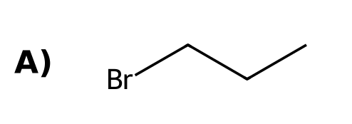 | 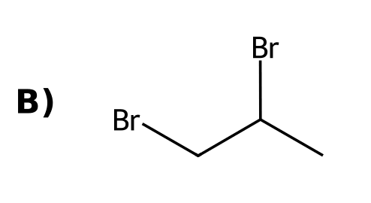
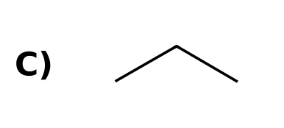 | 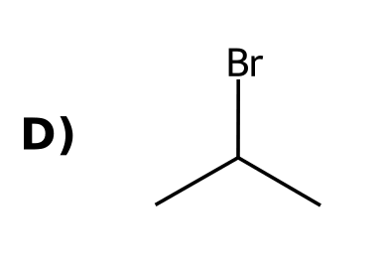
17. Markovnikov addition of HX puts the halogen on: [C08M08, Easy]
A) The less substituted carbon
B) A carbon next to the double bond
C) The more substituted carbon of the double bond
D) Both carbons
18. What is the intermediate in the addition of HBr to an alkene? [C08M09, Basic]
A) A carbanion
B) A carbocation
C) A radical
D) A bromonium ion
19. What is the major product when 2-methylpropene reacts with HBr? [C08M10, Moderate]
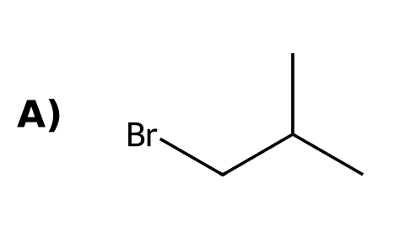 | 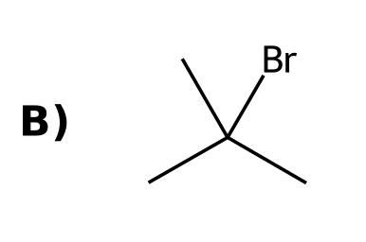
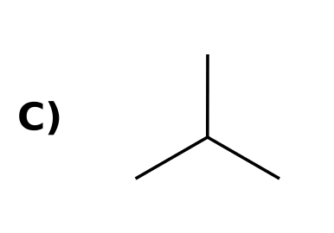 | 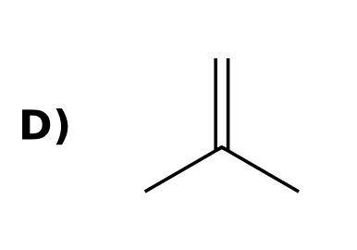
20. What is the major product when propene reacts with HBr in the presence of peroxides (ROOR)? [C08M11, Moderate]
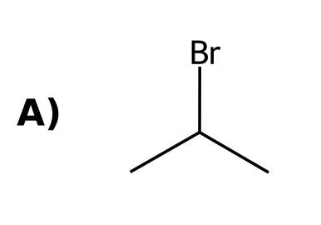
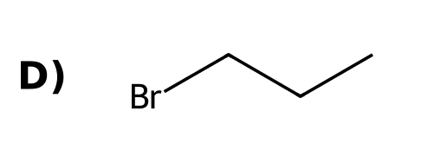
21. The addition of HBr to 3-methylbut-1-ene gives mainly 2-bromo-2-methylbutane. This is because: [C08M12, Moderate]
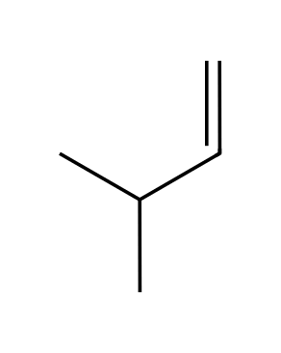
A) A hydride shift converts a secondary carbocation to a tertiary one
B) HBr adds in an anti-Markovnikov sense
C) A radical intermediate forms
D) The alkene rearranges before protonation
22. Adding HCl to 1-methylcyclohexene gives a product with how many stereoisomers? [C08M13, Moderate]
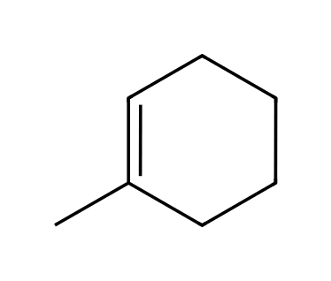
A) Two
B) Four
C) One (the product has no chirality center)
D) Three
23. Hydrohalogenation of but-1-ene gives 2-bromobutane. What is the stereochemical result? [C08M14, Hard]
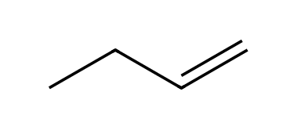
A) A racemic mixture
B) Only the R enantiomer
C) Only the S enantiomer
D) A meso compound
24. In the addition of HBr to an alkene, which species acts as the electrophile in the first step? [C08M49, Basic]
A) Br⁻
B) The alkene carbon
C) H⁺ (the proton of HBr)
D) The carbocation
25. Draw the major product of 2-methylbut-2-ene with HCl. [C08F09, Basic]
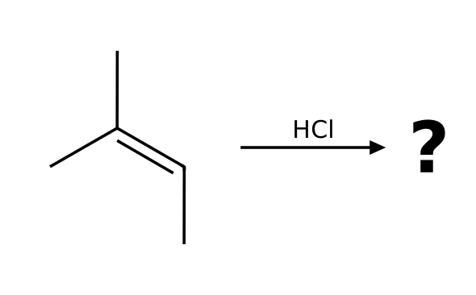

26. Draw the major product of propene with HBr in the presence of peroxides and state the regiochemistry. [C08F10, Basic]
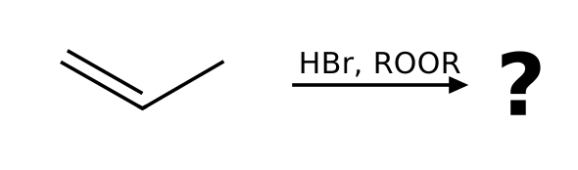

27. Explain why HBr adds to propene to give 2-bromopropane rather than 1-bromopropane. [C08F11, Moderate]

28. Show the first step of the mechanism of HBr with propene using curved arrows. [C08F12, Moderate]

29. Predict the product of 3,3-dimethylbut-1-ene with HCl and explain why it is not the direct Markovnikov product. [C08F13, Moderate]
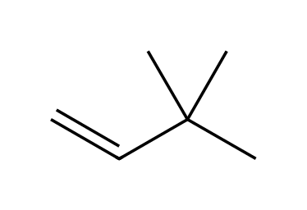

30. When HBr adds to but-1-ene, how many stereoisomers are formed, and in what ratio? [C08F14, Hard]

31. Why does HBr add to an alkene faster than HCl typically? [C08F48, Basic]

8.6 Acid-Catalyzed Hydration
32. What is the major product when 2-methylpropene is treated with H₂O and H₂SO₄? [C08M15, Basic]
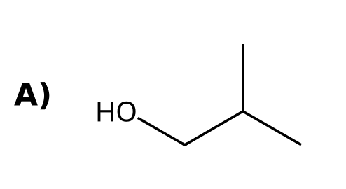 | 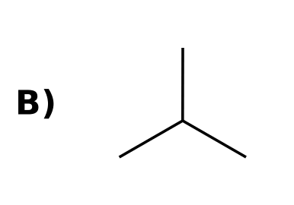
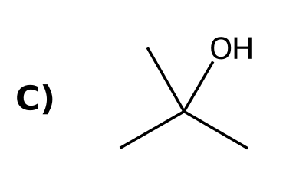 | 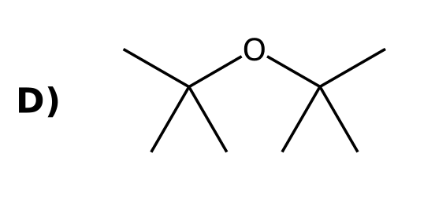
33. Which reaction conditions give an alkene from an alcohol? [C08M16, Basic]
A) Concentrated acid and heat
B) Dilute acid at room temperature
C) NaOH
D) H₂, Pt
34. Why is acid-catalyzed hydration of 3-methylbut-1-ene a poor way to make 3-methylbutan-2-ol? [C08M17, Moderate]
A) A carbocation rearrangement gives a different alcohol
B) The alkene is unreactive
C) Water is a poor nucleophile
D) Anti-Markovnikov addition occurs
35. What reagents add water to an alkene with Markovnikov regiochemistry? [C08F15, Easy]

36. Draw the product of 1-methylcyclohexene with H₂O, H₂SO₄. [C08F16, Basic]
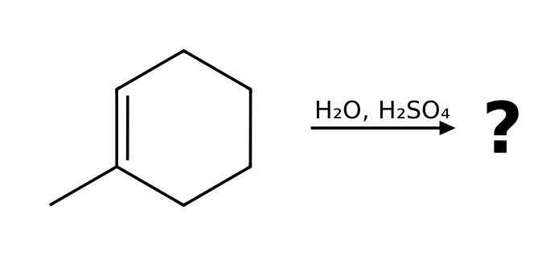

37. Describe the three steps of the mechanism of acid-catalyzed hydration of propene. [C08F17, Moderate]

38. How do you favor the alkene when converting an alcohol to an alkene and the alcohol when hydrating an alkene? [C08F18, Moderate]

8.7 Oxymercuration-Demercuration
39. Oxymercuration-demercuration is the addition of: [C08M18, Easy]
A) H and Br across a double bond
B) Two OH groups to the same face
C) H and OH across a double bond without carbocation rearrangements
D) H₂ across a double bond
40. What is the product of 3-methylbut-1-ene with (1) Hg(OAc)₂, H₂O; (2) NaBH₄? [C08M19, Moderate]
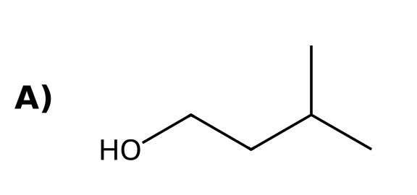 | 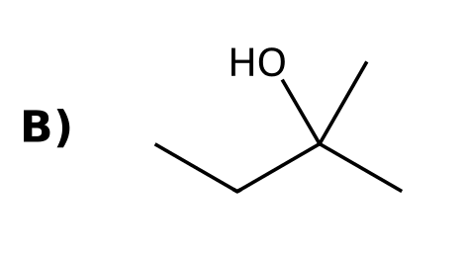
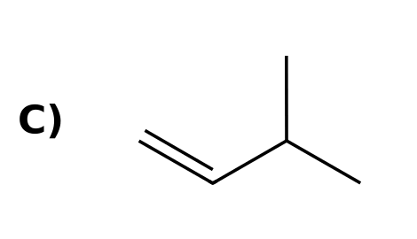 | 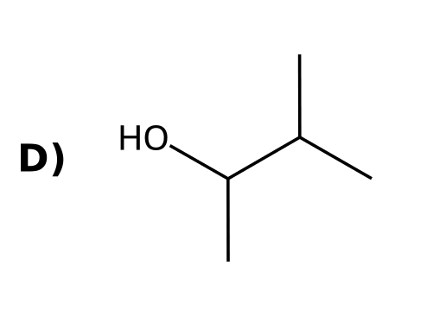
41. What advantage does oxymercuration-demercuration have over acid-catalyzed hydration? [C08F19, Basic]

42. Draw the product of 3-methylbut-1-ene with (1) Hg(OAc)₂, H₂O; (2) NaBH₄. [C08F20, Moderate]

8.8 Hydroboration-Oxidation
43. What is the major product of propene with (1) BH₃·THF; (2) H₂O₂, NaOH? [C08M20, Basic]
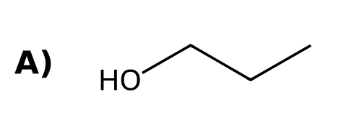 | 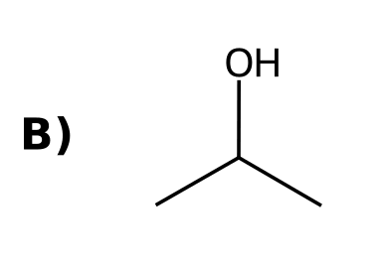
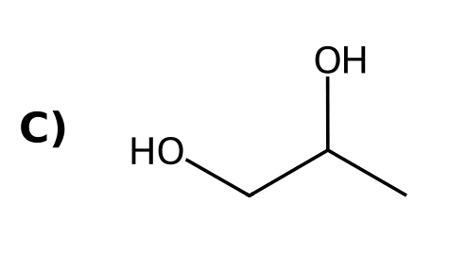 | 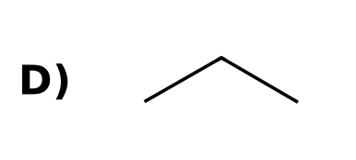
44. Hydroboration-oxidation proceeds with which stereochemistry? [C08M21, Basic]
A) Anti addition of H and OH
B) Syn addition of H and OH
C) Both syn and anti equally
D) Radical addition
45. Hydroboration-oxidation of 1-methylcyclohexene gives which product? [C08M22, Moderate]
A) cis-2-Methylcyclohexan-1-ol
B) trans-2-Methylcyclohexan-1-ol
C) 1-Methylcyclohexan-1-ol
D) 2-Methylcyclohexene
46. Which statement about BH₃ addition is correct? [C08M23, Moderate]
A) Boron attaches to the less hindered carbon and H adds to the more substituted carbon
B) Boron attaches to the more substituted carbon
C) A carbocation is formed
D) The reaction is stepwise
47. What reagents add H and OH to an alkene with anti-Markovnikov regiochemistry? [C08F21, Easy]

48. Draw the product of 2-methylpropene with (1) BH₃·THF; (2) H₂O₂, NaOH. [C08F22, Basic]
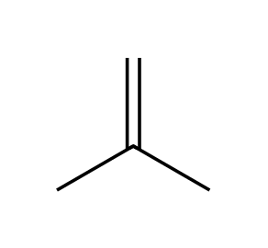

49. Explain the stereochemical outcome of hydroboration-oxidation of 1-methylcyclohexene. [C08F23, Moderate]

50. Why is no carbocation rearrangement observed in hydroboration? [C08F24, Moderate]

8.9 Catalytic Hydrogenation
51. Which reagents hydrogenate an alkene? [C08M24, Easy]
A) H₂O and H₂SO₄
B) BH₃ then H₂O₂
C) H₂ with Pt, Pd or Ni
D) O₃ then DMS
52. Catalytic hydrogenation proceeds with: [C08M25, Basic]
A) Anti addition of H₂
B) Markovnikov addition
C) Radical addition
D) Syn addition of H₂
53. Which product is formed when 1,2-dimethylcyclohexene is hydrogenated with H₂, Pt? [C08M26, Moderate]
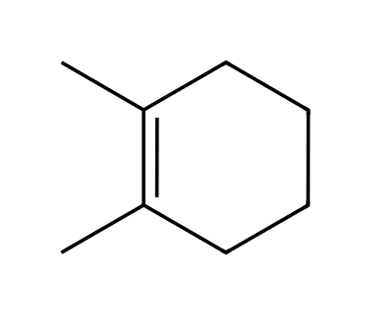
A) trans-1,2-Dimethylcyclohexane
B) 1,1-Dimethylcyclohexane
C) Methylcyclohexane
D) cis-1,2-Dimethylcyclohexane
54. A homogeneous catalyst is one that: [C08M27, Basic]
A) Is a solid not soluble in the solvent
B) Is not used up
C) Is always chiral
D) Is soluble in the reaction mixture
55. What is the product of 2-methylpropene with H₂, Pt? [C08M50, Basic]
A) Isobutane (2-methylpropane)
B) Butane
C) 2-Methylpropan-2-ol
D) 2-Bromo-2-methylpropane
56. What reagents are needed to hydrogenate an alkene? [C08F25, Easy]

57. Draw the product of 1,2-dimethylcyclohexene with H₂, Pt and state the stereochemistry. [C08F26, Basic]

58. Explain the difference between a homogeneous and a heterogeneous catalyst. [C08F27, Moderate]

59. Draw the product of 2-methylpropene with H₂, Pt. [C08F49, Basic]

8.10 Halogenation and Halohydrin Formation
60. What is the intermediate in the bromination of an alkene with Br₂? [C08M28, Easy]
A) A bromonium ion
B) A carbocation
C) A carbanion
D) A radical
61. What is the product of cyclohexene with Br₂ in CH₂Cl₂? [C08M29, Moderate]
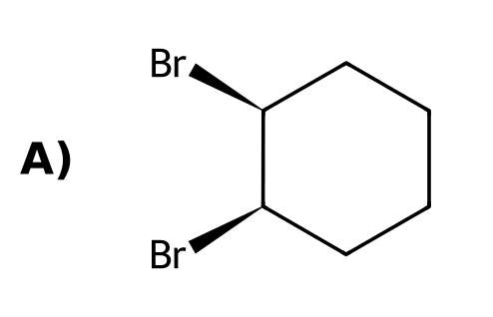 | 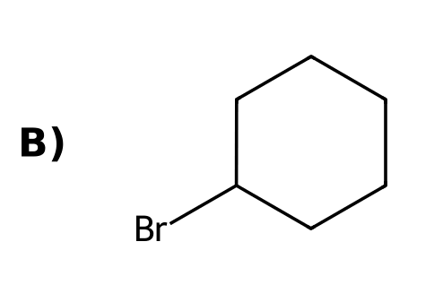
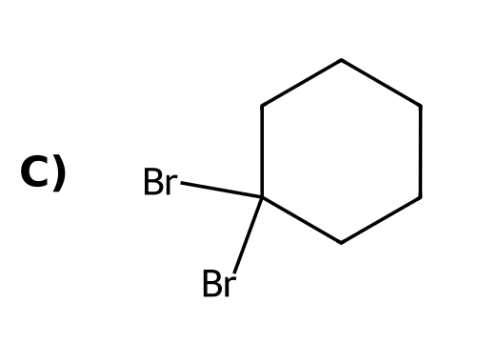 | 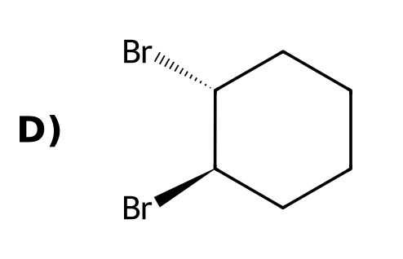
62. The addition of Br₂ to an alkene is: [C08M30, Basic]
A) Anti
B) Syn
C) Markovnikov
D) Radical only
63. When Br₂ is added to an alkene in water, where does OH end up? [C08M31, Moderate]
A) On the less substituted carbon
B) On both carbons
C) It does not add
D) On the more substituted carbon
64. What is the product of Br₂ and H₂O with propene? [C08M32, Moderate]
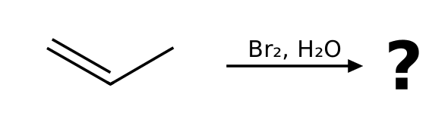
A) 2-Bromopropan-1-ol
B) 1,2-Dibromopropane
C) 1-Bromopropan-2-ol
D) Propane-1,2-diol
65. Draw the product of cyclohexene with Br₂ and state the stereochemistry. [C08F28, Basic]
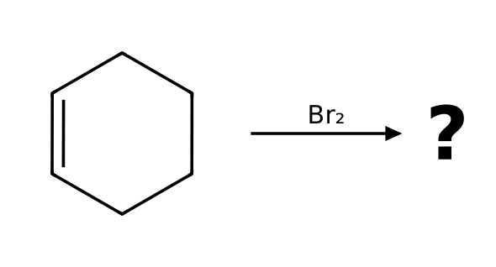

66. Explain why bromination of an alkene gives anti addition. [C08F29, Moderate]

67. Draw the product of propene with Br₂ in water and name it. [C08F30, Moderate]

68. Explain why water attacks the more substituted carbon of the bromonium ion in halohydrin formation. [C08F31, Hard]

8.11 Anti Dihydroxylation
69. What is the product of cyclohexene with (1) mCPBA; (2) H₃O⁺? [C08M33, Moderate]
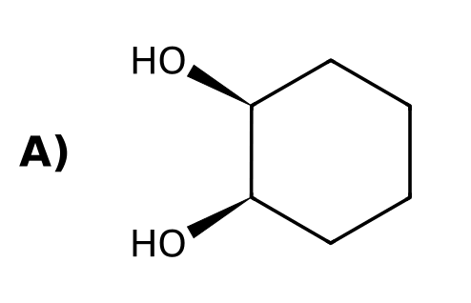 | 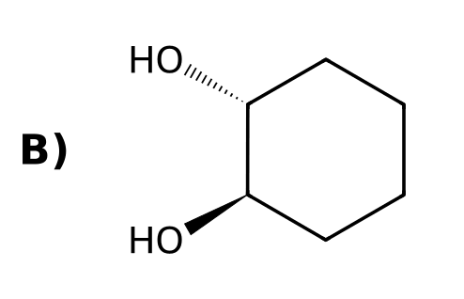
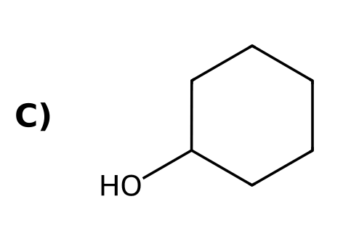 | 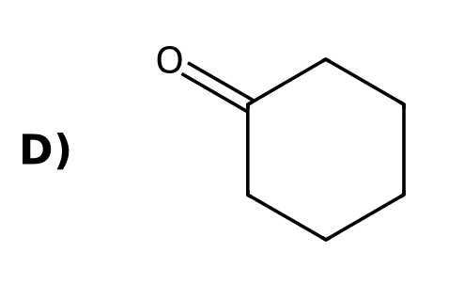
70. What is formed first from an alkene and mCPBA? [C08M36, Basic]
A) An epoxide
B) A diol
C) A carbocation
D) An alkyl halide
71. Draw the product of cyclohexene with (1) mCPBA; (2) H₃O⁺. [C08F32, Basic]
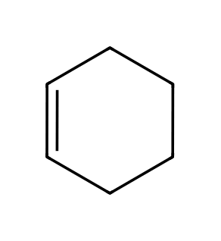

8.12 Syn Dihydroxylation
72. What is the product of cyclohexene with OsO₄ then NaHSO₃/H₂O? [C08M34, Moderate]
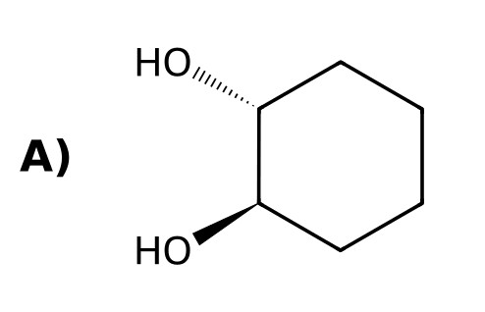 | 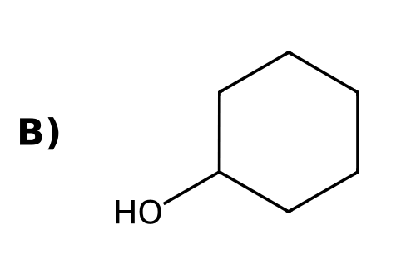
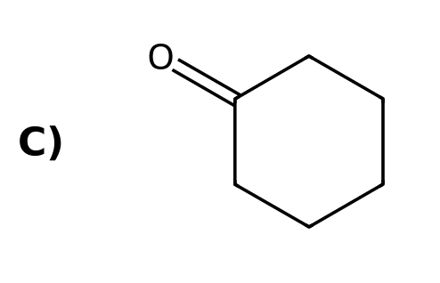 | 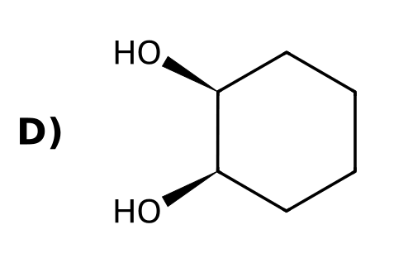
73. Which reagent can convert an alkene to a syn diol? [C08M35, Easy]
A) O₃
B) OsO₄
C) mCPBA, then H₃O⁺
D) HBr
74. Draw the product of cyclohexene with OsO₄, then NaHSO₃/H₂O. [C08F33, Basic]

75. Compare how to make cis and trans cyclohexane-1,2-diol from cyclohexene. [C08F34, Moderate]

76. Why does syn dihydroxylation with OsO₄ give only the cis diol from cyclohexene? [C08F50, Basic]

8.13 Oxidative Cleavage
77. Ozonolysis of an alkene followed by DMS cleaves the double bond to give: [C08M37, Easy]
A) Two alcohols
B) An epoxide
C) A diol
D) Two carbonyl compounds
78. Which compounds form from 2-methylbut-2-ene with (1) O₃; (2) DMS? [C08M38, Moderate]
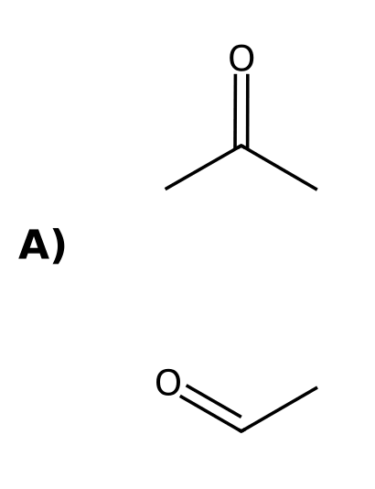 | 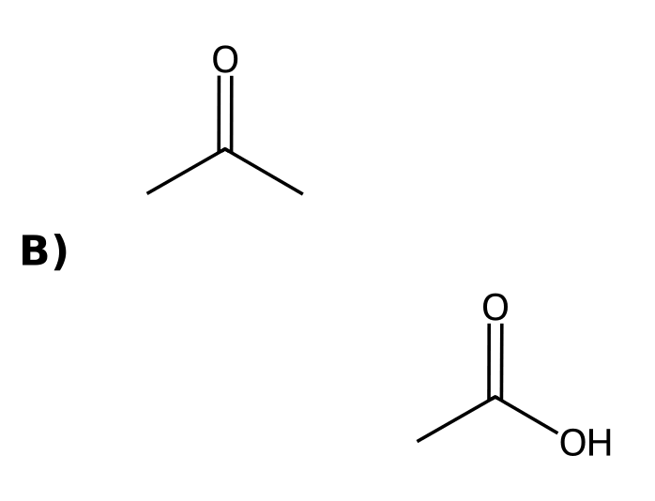
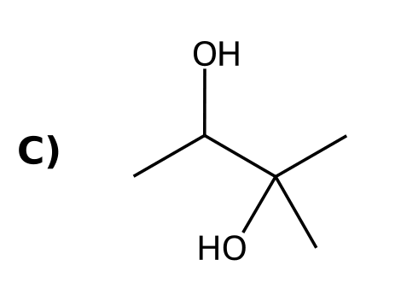 | 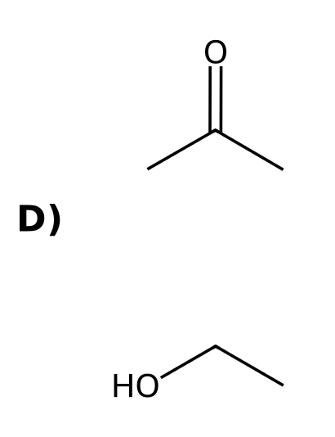
79. Ozonolysis of cyclohexene (O₃ then DMS) gives: [C08M39, Moderate]
A) Cyclohexane-1,2-diol
B) Two molecules of ethanal
C) Cyclohexanone
D) Hexanedial
80. Which alkene gives a single product (propanal) when treated with O₃ then DMS? [C08M40, Hard]
A) Hex-1-ene
B) Hex-3-ene
C) Hex-2-ene
D) 2-Methylhex-2-ene
81. What two carbon-containing groups does ozonolysis (O₃; DMS) produce from an alkene? [C08F35, Easy]

82. Draw the products of 2-methylbut-2-ene with (1) O₃; (2) DMS. [C08F36, Basic]

83. An alkene gives only one product, acetone, on ozonolysis with DMS workup. Identify the alkene. [C08F37, Moderate]

84. Draw the product of cyclopentene with (1) O₃; (2) DMS. [C08F38, Moderate]
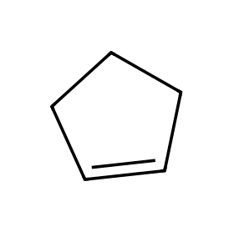

8.14 Predicting the Products of an Addition Reaction
85. Which reagent adds H and OH to an alkene with anti-Markovnikov regiochemistry? [C08M41, Basic]
A) H₂O, H₂SO₄
B) Hg(OAc)₂, H₂O then NaBH₄
C) BH₃·THF, then H₂O₂, NaOH
D) OsO₄
86. Which of these does NOT proceed through a carbocation intermediate? [C08M42, Moderate]
A) HBr addition (no peroxides)
B) Acid-catalyzed hydration
C) Hydroboration-oxidation
D) Hydrochlorination
87. What three questions help you predict an addition product? [C08M43, Moderate]
A) Solvent, temperature and pressure
B) Number of carbons, rings and π bonds
C) Which groups add, regiochemistry and stereochemistry
D) Rate, yield and cost
88. List the three questions used to predict the product of an addition reaction. [C08F39, Basic]

89. Which reagent would you use to convert 1-methylcyclohexene to 1-methylcyclohexan-1-ol and which to 2-methylcyclohexan-1-ol? [C08F40, Moderate]

90. Draw the product of propene with (1) BH₃·THF; (2) H₂O₂, NaOH and the product of propene with H₂O, H₂SO₄. How are they related? [C08F41, Moderate]

91. Design reagents to convert 1-methylcyclohexene into trans-2-methylcyclohexan-1-ol and explain each feature of the outcome. [C08F42, Hard]

8.15 Synthesis Strategies
92. What sequence converts 1-bromopropane into 2-bromopropane? [C08M44, Basic]
A) (1) HBr; (2) NaOEt
B) (1) NaOEt, heat; (2) HBr
C) (1) H₂, Pt; (2) HBr
D) (1) O₃; (2) DMS
93. To convert cyclohexene into cis-cyclohexane-1,2-diol, use: [C08M45, Moderate]
A) mCPBA then H₃O⁺
B) Br₂ then NaOH
C) OsO₄ then NaHSO₃
D) BH₃ then H₂O₂
94. To convert 1-methylcyclohexene to 2-methylcyclohexan-1-ol (trans), use: [C08M46, Hard]
A) H₂O, H₂SO₄
B) HBr then NaOH
C) Hg(OAc)₂, H₂O; then NaBH₄
D) BH₃·THF; then H₂O₂, NaOH
95. To convert 2-bromo-2-methylpropane into 2-methylpropan-1-ol, a good route is: [C08M47, Hard]
A) (1) t-BuOK; (2) BH₃·THF; (3) H₂O₂, NaOH
B) (1) NaOH
C) (1) H₂O, heat
D) (1) HBr; (2) NaOH
96. How can you change the position of a halogen using elimination and addition? [C08F43, Basic]

97. Propose a synthesis of 1-bromopropane from 2-bromopropane. [C08F44, Moderate]
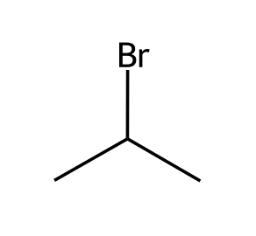

98. Propose a synthesis of cis-cyclohexane-1,2-diol from cyclohexanol. [C08F45, Moderate]
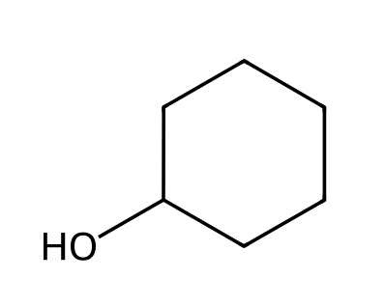

99. Propose a synthesis of 2-methylpropan-1-ol from 2-methylpropan-2-ol. [C08F46, Hard]
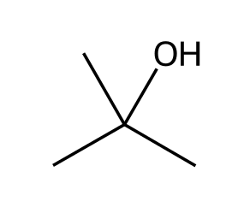

100. Propose a synthesis of acetone and formaldehyde from 2-methylpropene. [C08F47, Hard]

