Chapter 2: Molecular Representations: Answer Key
Answers and explanations.
Name: ______________________________ Date: ______________

2.1 Molecular Representations
1. A partially condensed structure is CH₃CH₂CH₂OH. What is its molecular formula? [C02M01, Easy]
Answer: B) C₃H₈O
Why: Count the carbons (3), the hydrogens (3 + 2 + 2 + 1 = 8) and the oxygen (1).
2. Which statement about molecular formulas is correct? [C02M02, Basic]
Answer: C) A molecular formula does not show how the atoms are connected, so C₄H₁₀O fits several different compounds
Why: The molecular formula gives only the number of each kind of atom. Constitutional isomers share a formula.
3. Which bond-line structure is the same compound as the condensed structure (CH₃)₂CHCH₂CH₃? [C02M03, Basic]
Answer: C
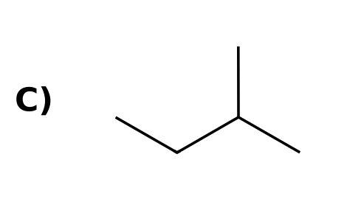
Why: (CH₃)₂CH- is a carbon with two methyl groups; attached to CH₂CH₃ it gives 2-methylbutane.
4. Write the molecular formula for CH₃CH₂COCH₃. [C02F01, Easy]
Answer: C₄H₈O
Why: Four carbons, 3 + 2 + 0 + 3 = 8 hydrogens, one oxygen.
5. Draw the complete Lewis structure of CH₃OCH₃ (dimethyl ether), showing every lone pair. How many lone pairs are there in total? [C02F02, Basic]
Answer: Two lone pairs, both on the oxygen atom.
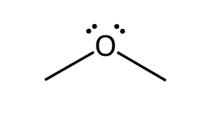
Why: Each carbon has four bonds and no lone pairs. Oxygen forms two bonds and keeps two lone pairs.
6. Give two different compounds with the molecular formula C₂H₆O as condensed structures. [C02F03, Basic]
Answer: CH₃CH₂OH (ethanol) and CH₃OCH₃ (dimethyl ether).
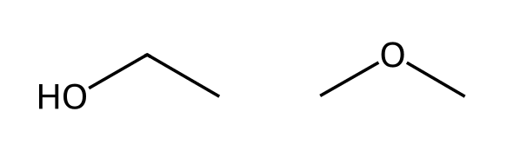
Why: They are constitutional isomers: the same formula with different connectivity.
7. The bond-line structure of 2-methylbutane is shown. Write its partially condensed structure and its molecular formula. [C02F04, Moderate]
Answer: CH₃CH(CH₃)CH₂CH₃ (or (CH₃)₂CHCH₂CH₃); C₅H₁₂.
Why: Each vertex and line end is a carbon. The branch point carbon bears one hydrogen; the CH₂ has two and each CH₃ has three: 3 + 1 + 3 + 2 + 3 = 12.

2.2 Drawing Bond-Line Structures
8. How many carbon atoms are in the compound shown? [C02M04, Easy]
Answer: C) 7
Why: Count each vertex and line end: the chain has 6 carbons plus one methyl branch.
9. What is the molecular formula of the compound shown? [C02M05, Basic]
Answer: B) C₅H₁₀O₂
Why: Five carbons; the CH₃, CH₃, CH, CH₂ carbons carry 3 + 3 + 1 + 2 = 9 hydrogens, plus the acid O-H = 10.
10. Which statement about bond-line structures is correct? [C02M06, Basic]
Answer: A) Carbon atoms are at each bend and line end, and hydrogen atoms bonded to carbon are not drawn
Why: Bond-line structures omit carbon labels and C-H hydrogens; each carbon is assumed to have enough hydrogens for four bonds.
11. How many hydrogen atoms are bonded to the carbon that bears the OH group? [C02M07, Basic]
Answer: B) 1
Why: That carbon has bonds to OH, CH₃ and CH₂ (three bonds), so one hydrogen completes four bonds.
12. Which compound has the molecular formula C₆H₁₂O? [C02M08, Moderate]
Answer: C
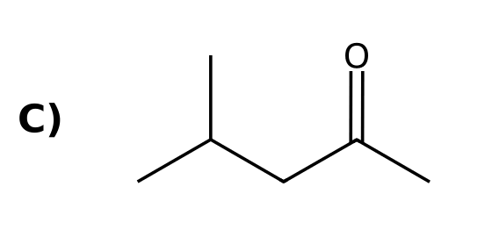
Why: Only 4-methyl-2-pentanone gives six carbons and twelve hydrogens with one oxygen (the others are C₇H₁₄O, C₆H₁₄O and C₆H₁₀O₂).
13. Draw the bond-line structure of (CH₃)₂CHCH₂CH₃. [C02F05, Easy]
Answer: The bond-line structure is a four-carbon chain with a methyl branch on the second carbon (2-methylbutane).
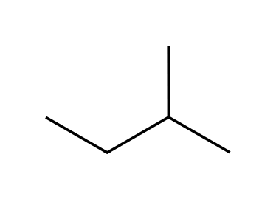
Why: Each vertex is a carbon; the CH branch carries one methyl group.
14. Draw the bond-line structure of CH₃CH₂CH(OH)CH₃. [C02F06, Basic]
Answer: A four-carbon chain with an OH group on carbon 2 (2-butanol).
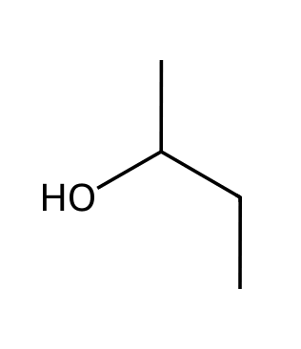
Why: Draw the zigzag chain and attach OH to the second carbon.
15. What is the molecular formula of the compound shown? [C02F07, Basic]
Answer: C₇H₁₄O
Why: Seven carbons; hydrogens: 3 + 3 + 3 + 0 + 2 + 3 = 14 (the quaternary carbon has none); one oxygen.
16. Draw bond-line structures of all constitutional isomers of C₄H₁₀. [C02F08, Moderate]
Answer: Two isomers: butane (an unbranched chain) and 2-methylpropane (isobutane).
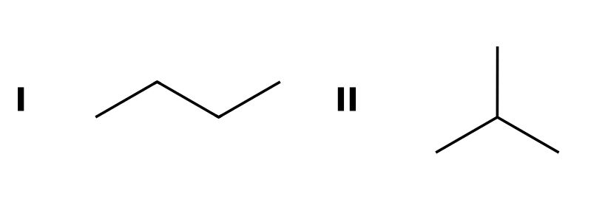
Why: Only these two carbon skeletons are possible with four carbons.
17. For the compound shown, give the molecular formula and identify the carbon atom that bears no hydrogen atoms. [C02F09, Moderate]
Answer: C₅H₁₀O₂; the carbonyl (C=O) carbon has no hydrogens.
Why: Carbon atoms: CH₃ (3), CH₂ (2), C=O (0), O-CH₂ (2), CH₃ (3): ten hydrogens in total.

2.3 Identifying Functional Groups
18. Which functional group is present in this compound? [C02M09, Easy]
Answer: A) An alcohol
Why: The OH group on a carbon atom is an alcohol.
19. Which functional group is present in this compound? [C02M10, Easy]
Answer: A) A ketone
Why: A carbonyl group bonded to two carbons is a ketone.
20. Which functional group is present in this compound? [C02M11, Basic]
Answer: B) An ester
Why: C(=O)-O-C: a carbonyl carbon bonded to an OR group.
21. Which functional group is present in this compound? [C02M12, Basic]
Answer: B) A nitrile
Why: The C≡N group is a nitrile.
22. Which functional group is present in this compound? [C02M13, Basic]
Answer: D) An amide
Why: A carbonyl group bonded directly to nitrogen is an amide.
23. Which pair of functional groups (besides the aromatic ring) is present in aspirin? [C02M14, Moderate]
Answer: A) An ester and a carboxylic acid
Why: The acetyl group is attached through oxygen (an ester), and the other substituent is CO₂H.
24. Name the functional group in CH₃CH₂CHO. [C02F10, Easy]
Answer: An aldehyde.
Why: A carbonyl group with at least one hydrogen attached to the carbonyl carbon.
25. Identify the functional group and classify it as primary, secondary or tertiary. [C02F11, Basic]
Answer: An amine; it is primary because nitrogen is bonded to one carbon.
Why: Count the carbon atoms bonded to nitrogen: one.
26. Identify the two functional groups in this compound. [C02F12, Basic]
Answer: An alkene (C=C) and an alcohol (OH).
Why: The C=C is an alkene; the OH on an sp³ carbon is an alcohol.
27. Identify the two carbonyl-containing functional groups in this compound. [C02F13, Moderate]
Answer: A carboxylic acid and an amide.
Why: CO₂H is a carboxylic acid; C(=O)N is an amide.
28. Draw one aldehyde and one ketone, each with the molecular formula C₃H₆O. [C02F14, Moderate]
Answer: Propanal (CH₃CH₂CHO) is the aldehyde and acetone (CH₃COCH₃) is the ketone.
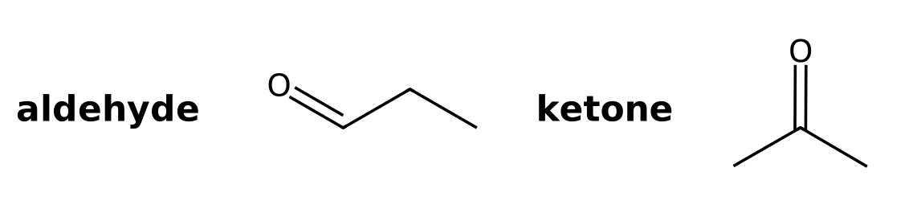
Why: Both are constitutional isomers with the carbonyl group in different positions.
29. Is the compound shown an amine or an amide? Explain. [C02F15, Moderate]
Answer: It is an amide, because nitrogen is bonded directly to the carbonyl carbon.
Why: An amine has nitrogen bonded only to carbon and hydrogen atoms that are not part of a carbonyl group.

2.4 Carbon Atoms with Formal Charges
30. A carbon atom with a positive formal charge and no lone pair (a carbocation) has how many bonds? [C02M15, Easy]
Answer: D) 3
Why: It has only six valence electrons around it: three bonds.
31. A carbon atom has three bonds and one lone pair. What is its formal charge? [C02M16, Basic]
Answer: D) Negative (-1)
Why: Three bonds plus a lone pair gives five valence electrons, one more than neutral carbon.
32. Which structure contains a carbocation? [C02M17, Basic]
Answer: C
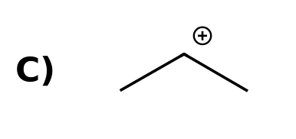
Why: Only the first has a carbon with three bonds and no lone pair (positive charge).
33. How many hydrogen atoms are bonded to the charged carbon in this ion? [C02M18, Moderate]
Answer: C) 0
Why: The charged carbon is bonded to three methyl groups and a lone pair, so it has no hydrogens.
34. Draw the methyl cation. How many bonds and lone pairs does the carbon have? [C02F16, Easy]
Answer: Three bonds and no lone pairs; formal charge +1.
Why: A carbocation carbon has three bonds and an empty p orbital.
35. A carbon atom with three bonds can be either positive or negative. How can you tell which? [C02F17, Basic]
Answer: Count the lone pairs: three bonds and no lone pair is positive (+1); three bonds and one lone pair is negative (-1).
Why: Formal charge depends on the electrons assigned to the carbon.
36. State the formal charge on the terminal CH₂ carbon of this ion and the number of lone pairs on it. [C02F18, Moderate]
Answer: Negative (-1) with one lone pair.
Why: It has three bonds (two to H, one to C) and a lone pair.

2.5 Identifying Lone Pairs
37. How many lone pairs are on the oxygen atom of an alcohol (R-OH)? [C02M19, Easy]
Answer: D) 2
Why: Oxygen has six valence electrons: two shared in bonds and four as two lone pairs.
38. How many lone pairs does the nitrogen atom of a neutral amine (R₃N) have? [C02M20, Basic]
Answer: A) 1
Why: Nitrogen has five valence electrons: three form bonds and two remain as one lone pair.
39. Which atom in this compound has two lone pairs? [C02M21, Basic]
Answer: C) The oxygen
Why: The carbonyl oxygen has two lone pairs; the nitrogen has one.
40. How many lone pairs are on all the atoms of acetic acid, CH₃CO₂H? [C02M22, Moderate]
Answer: D) 4
Why: The carbonyl oxygen has two lone pairs and the hydroxyl oxygen has two.
41. How many lone pairs does the chlorine atom in CH₃Cl have? [C02F19, Easy]
Answer: Three.
Why: Chlorine has seven valence electrons: one forms the bond and six form three lone pairs.
42. Redraw the compound showing all lone pairs. How many are there? [C02F20, Basic]
Answer: Two lone pairs, both on the oxygen.
Why: Ether oxygen forms two bonds and keeps two lone pairs.
43. How many lone pairs are on all the heteroatoms of the compound shown? [C02F21, Moderate]
Answer: Four: two on the carbonyl oxygen and two on the other oxygen.
Why: Each neutral oxygen with two bonds (or a double bond) has two lone pairs.
44. Lone pairs are usually not drawn in bond-line structures. Why is it still important to recognize them? [C02F22, Moderate]
Answer: Lone pairs make atoms basic and nucleophilic and take part in resonance, so they must be known when predicting reactivity.
Why: They determine how the molecule reacts even when not drawn.

2.6 Three-Dimensional Bond-Line Structures
45. In a bond-line drawing, what does a dashed bond indicate? [C02M23, Easy]
Answer: B) The group is behind the plane of the page
Why: A dash points away from the viewer.
46. In a bond-line drawing, what does a solid wedge indicate? [C02M24, Easy]
Answer: A) The group is in front of the plane of the page
Why: A wedge points toward the viewer.
47. A tetrahedral carbon is drawn with two bonds in the plane, one on a wedge and one on a dash. Where are the groups on the wedge and the dash? [C02M25, Moderate]
Answer: A) The wedge group points toward the viewer and the dash group points away
Why: Wedge: toward; dash: away; two plain bonds lie in the plane of the page.
48. In the drawing shown, the methyl group is drawn on a wedge. Where is that group relative to the plane of the page? [C02M26, Basic]
Answer: B) Toward the viewer (in front of the page)
Why: A solid wedge means toward the viewer.
49. What do a plain bond, a solid wedge and a dashed bond mean in a three-dimensional bond-line structure? [C02F23, Easy]
Answer: A plain bond lies in the plane of the page, a wedge comes toward the viewer, and a dash goes away from the viewer.
Why: These three bond types let a flat drawing show tetrahedral geometry.
50. Describe the position of the methyl group in the drawing shown, relative to the plane of the page. [C02F24, Basic]
Answer: It is drawn on a dash, so it points away from the viewer.
Why: Wedge means toward and dash means away from the viewer.
51. One student draws CH₃CH(OH)CH₂CH₃ with the OH group on a wedge; another draws it on a dash. Are these the same molecule? Explain. [C02F25, Moderate]
Answer: No. They are mirror images that cannot be superimposed (enantiomers).
Why: Swapping the wedge and dash at the only stereocenter gives the mirror-image arrangement.
52. Name two drawing styles other than wedge-and-dash that show three-dimensional structure. [C02F26, Easy]
Answer: Fischer projections and Haworth projections.
Why: Both are covered in Section 2.6 of the text.

2.7 Introduction to Resonance
53. Which arrow is placed between resonance structures? [C02M27, Easy]
Answer: A) A double-headed arrow (↔)
Why: Resonance structures are connected by a double-headed straight arrow and enclosed in brackets.
54. Which statement about a resonance hybrid is correct? [C02M28, Basic]
Answer: B) It is a single species that is a combination of all the resonance structures
Why: Resonance structures are drawing tools; the real molecule is one hybrid.
55. Why is a single bond-line structure inadequate for acetate, CH₃CO₂⁻? [C02M29, Moderate]
Answer: B) It shows one C=O and one C-O⁻ bond, but the two carbon-oxygen bonds are actually equivalent
Why: The charge and double bond are delocalized over both oxygens, so resonance is needed.
56. What do the brackets and the double-headed arrow mean when they surround a set of structures? [C02F27, Easy]
Answer: The structures are resonance structures of one species, not different molecules in equilibrium.
Why: The double-headed arrow is reserved for resonance.
57. Is resonance an equilibrium between the resonance structures? Explain. [C02F28, Basic]
Answer: No. The molecule is a single hybrid; resonance structures do not interconvert.
Why: Equilibrium involves different species converting; resonance describes one species.
58. Define resonance stabilization. [C02F29, Basic]
Answer: The lowering of energy that comes from delocalizing electrons over more than one atom through resonance.
Why: Delocalized electrons are more stable than localized ones.

2.8 Curved Arrows
59. In resonance structures, curved arrows show the movement of what? [C02M30, Easy]
Answer: A) A pair of electrons
Why: Each curved arrow shows the movement of one electron pair.
60. Where should the tail of a curved arrow start? [C02M31, Basic]
Answer: B) On a lone pair or a π bond
Why: The tail marks the source electrons.
61. Which is NOT allowed when drawing resonance arrows? [C02M32, Basic]
Answer: A) Breaking a single bond
Why: Resonance moves lone pairs and π bonds, never σ bonds, and never exceeds an octet for second-row elements.
62. Which set of curved arrows correctly converts this resonance structure of acetate into the other one? [C02M33, Moderate]
Answer: A
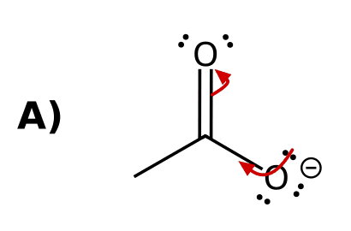
Why: Arrow 1 moves a lone pair of O⁻ to form the C=O π bond; arrow 2 moves the old π bond onto the other oxygen as a lone pair.
63. Draw curved arrow(s) to convert the allyl cation resonance structure shown into the other one. [C02F30, Basic]
Answer: One curved arrow from the C=C π bond to the space between the C⁺ and its neighbouring carbon, forming a new π bond and moving the positive charge.
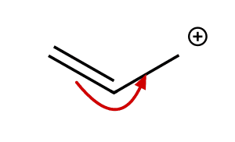
Why: The π bond moves toward the cation, forming a new π bond and leaving a cation at the other end.
64. Why can a curved arrow not be drawn starting from a single bond in resonance? [C02F31, Basic]
Answer: Resonance moves only π bonds and lone pairs. Breaking a single (σ) bond would change the connectivity of the atoms, which is not resonance.
Why: Resonance structures differ only in electron positions, not atom positions.
65. How many curved arrows are needed to convert one resonance structure of acetate into the other? Describe where each starts and ends. [C02F32, Moderate]
Answer: Two: a lone pair on the O⁻ forms a C=O π bond, and the original C=O π bond becomes a lone pair on the other oxygen.
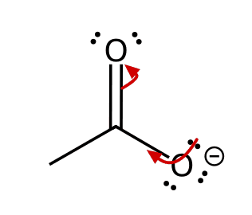
Why: One arrow forms a new π bond and the other pushes the old π bond onto oxygen.
66. A curved arrow starts on the π bond of a C=O group and points to oxygen. Describe the resulting structure. [C02F33, Moderate]
Answer: Oxygen gains a lone pair (becoming O⁻) and the carbon loses the π bond (becoming C⁺).
Why: The two π electrons move onto the more electronegative oxygen.

2.9 Formal Charges in Resonance Structures
67. What is the formal charge on the oxygen atom that has one single bond and three lone pairs? [C02M34, Easy]
Answer: D) -1
Why: Six valence electrons minus seven assigned electrons gives -1.
68. What is the formal charge on nitrogen in the ammonium ion, NH₄⁺? [C02M35, Basic]
Answer: C) +1
Why: Four bonds and no lone pair gives five minus four electrons: +1.
69. The ion CH₂=CH-O⁻ has a second resonance structure. On which atom is the negative charge in it? [C02M36, Moderate]
Answer: D) The terminal carbon
Why: The oxygen lone pair forms a C=O bond and the C=C π electrons end up as a lone pair on the terminal carbon.
70. What is the formal charge on an oxygen atom that has three bonds and one lone pair? [C02F34, Easy]
Answer: +1
Why: Six valence electrons minus (2 + 3) = +1, as in H₃O⁺.
71. Draw the second resonance structure of the ion shown, including formal charges. [C02F35, Basic]
Answer: The negative charge moves to the terminal carbon: ⁻CH₂-CH=O.
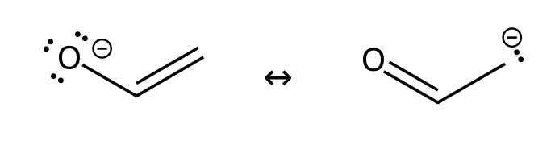
Why: Use two curved arrows: a lone pair from O forms C=O and the C=C π bond moves to carbon.
72. Must the total charge be the same in every resonance structure of an ion? Explain. [C02F36, Basic]
Answer: Yes. Resonance only moves electrons, so the overall charge is unchanged; the individual formal charges may move.
Why: Electrons are moved, not added or removed.

2.10 Drawing Resonance Structures via Pattern Recognition
73. Which of these is NOT one of the five patterns used to find resonance structures? [C02M37, Basic]
Answer: A) An isolated double bond with no adjacent lone pair or charge
Why: Without a lone pair, positive charge or conjugated π system next to it, a double bond cannot delocalize.
74. Which anion has an allylic lone pair and can therefore be drawn with resonance? [C02M38, Basic]
Answer: B
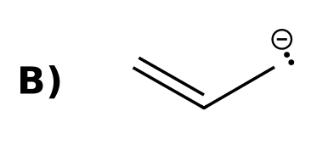
Why: The lone pair on carbon is adjacent to the C=C π bond.
75. How many resonance structures (including the one drawn) are there for the allyl cation, CH₂=CH-CH₂⁺? [C02M39, Basic]
Answer: B) 2
Why: Moving the π bond swaps the positions of the double bond and the positive charge.
76. How many resonance structures with alternating double bonds can be drawn for benzene? [C02M40, Basic]
Answer: C) 2
Why: Two Kekulé structures differ in the placement of the three double bonds.
77. Which resonance pattern applies to acetate? [C02M41, Moderate]
Answer: A) An allylic lone pair (a lone pair next to a π bond)
Why: The lone pair on O⁻ is adjacent to the C=O π bond.
78. Draw both resonance structures of the allyl anion. [C02F37, Basic]
Answer: CH₂=CH-CH₂⁻ ↔ ⁻CH₂-CH=CH₂ (the two forms are equivalent).
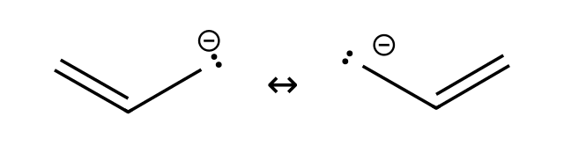
Why: Pattern 1: an allylic lone pair; one curved arrow from the lone pair and one from the π bond.
79. Draw the second resonance structure of the allyl cation. [C02F38, Basic]
Answer: CH₂=CH-CH₂⁺ ↔ ⁺CH₂-CH=CH₂
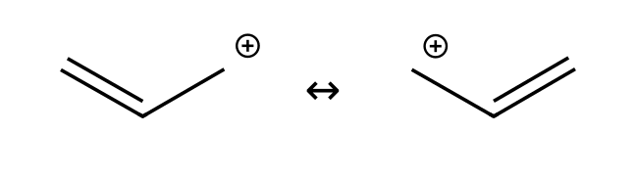
Why: Pattern 2: an allylic carbocation; the π bond shifts toward the positive carbon.
80. Draw a resonance structure of acrolein, CH₂=CH-CH=O, in which oxygen carries a negative charge. [C02F39, Moderate]
Answer: ⁺CH₂-CH=CH-O⁻
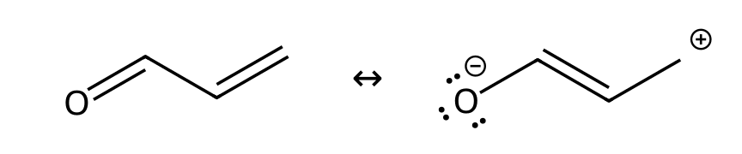
Why: Pattern 4 (a π bond between atoms of different electronegativity) combined with conjugation: the π electrons move onto oxygen.
81. Draw the resonance structure of CH₃-O-CH₂⁺ that places the positive charge on oxygen. Which pattern is this? [C02F40, Moderate]
Answer: CH₃-O⁺=CH₂; pattern 3, a lone pair adjacent to a carbocation.
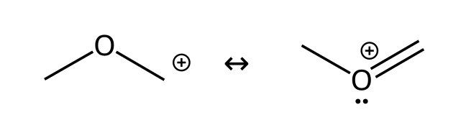
Why: The oxygen lone pair forms a π bond to the carbon.
82. How many resonance structures can be drawn for the phenoxide ion (including both Kekulé forms)? On which atoms can the negative charge be placed? [C02F41, Hard]
Answer: Five structures: the negative charge can be on the oxygen, on either ortho carbon, or on the para carbon; the oxygen form can be drawn with either Kekulé arrangement.
Why: The oxygen lone pair is adjacent to the ring π system, so charge moves to the ortho and para positions (not meta).

2.11 Assessing the Relative Importance of Resonance Structures
83. Which resonance structures contribute equally to the resonance hybrid? [C02M42, Easy]
Answer: C) Structures that are equally good Lewis structures (equivalent)
Why: Equivalent resonance forms have identical charge placement and bonding patterns.
84. Which resonance structure is the more significant contributor? [C02M43, Basic]
Answer: C) I, because the negative charge is on the more electronegative atom (oxygen)
Why: Other things being equal, a negative charge is better on oxygen than on carbon.
85. Are the two resonance structures of acetate equivalent? [C02M44, Basic]
Answer: B) Yes, both have a negative charge on one oxygen and a C=O on the other
Why: Each oxygen carries the charge in one structure and the double bond in the other.
86. Which resonance structure of the methoxymethyl cation is more significant? [C02M45, Moderate]
Answer: D) II, because every atom has a complete octet
Why: The carbon in structure I has only six electrons; in II all atoms have octets (the first rule).
87. State the first and second rules used to decide which resonance structure is more significant. [C02F42, Basic]
Answer: First, the structure with the greatest number of filled octets is more significant. Second, the structure with fewer formal charges is more significant.
Why: These are two of the four rules in Section 2.11.
88. Why is a resonance structure with separated positive and negative charges usually less significant than one without charges? [C02F43, Basic]
Answer: Charge separation costs energy, and structures with fewer formal charges are more significant.
Why: Rule 2: fewer formal charges.
89. Of the two resonance structures of the enolate shown, which contributes more to the hybrid and why? [C02F44, Moderate]
Answer: The one with the negative charge on oxygen (I), because oxygen is more electronegative than carbon.
Why: A negative charge is more stable on the more electronegative atom.
90. List the four guidelines for judging the significance of resonance structures. [C02F45, Moderate]
Answer: (1) Most filled octets; (2) fewest formal charges; (3) negative charge on the more electronegative atom (positive on the less); (4) equally good structures contribute equally.
Why: These are the rules in Section 2.11.

2.12 The Resonance Hybrid
91. How is a resonance hybrid drawn? [C02M46, Basic]
Answer: D) With dashed (partial) bonds and partial charges (δ)
Why: Partial bonds and partial charges show the delocalization.
92. What is the carbon-oxygen bond order in each C-O bond of acetate? [C02M47, Basic]
Answer: D) 1.5
Why: The two oxygens are equivalent: each C-O bond is between a single and a double bond.
93. Describe how the resonance hybrid of the allyl cation is drawn. [C02F46, Basic]
Answer: Both carbon-carbon bonds are drawn as dashed partial double bonds, and each terminal carbon carries a partial positive charge (δ+).
Why: The positive charge is shared equally by the two terminal carbons.
94. In the resonance hybrid of acetate, what is the charge on each oxygen? [C02F47, Basic]
Answer: Each oxygen carries half of the negative charge (about -1/2, written δ⁻).
Why: The one negative charge is shared by two equivalent oxygens.

2.13 Delocalized and Localized Lone Pairs
95. In an amide, the lone pair on nitrogen is: [C02M48, Basic]
Answer: C) Delocalized, because it is adjacent to the C=O π bond
Why: A lone pair next to a π bond can participate in resonance and occupies a p orbital.
96. Compare the nitrogen lone pair in CH₃CH₂NH₂ and in CH₂=CHNH₂. [C02M49, Moderate]
Answer: D) Localized in the first and delocalized in the second
Why: Only the vinyl amine has a lone pair adjacent to a π bond.
97. A carbonyl oxygen has a π bond and lone pairs. Which statement is correct? [C02M50, Moderate]
Answer: D) The π bond can participate in resonance but the lone pairs on that oxygen do not
Why: An atom with both a π bond and a lone pair uses only one of them in resonance (the π bond).
98. In the ester shown, identify the oxygen lone pair that is delocalized and say why. [C02F48, Basic]
Answer: The lone pair on the single-bonded oxygen is delocalized because it is adjacent to the C=O π bond.
Why: The carbonyl oxygen lone pairs are localized (in sp² orbitals).
99. Is the nitrogen lone pair in aniline localized or delocalized? Explain. [C02F49, Moderate]
Answer: Delocalized: it is adjacent to the π system of the ring, so it participates in resonance.
Why: The lone pair occupies a p orbital that overlaps with the ring π bonds.
100. Draw the resonance structure of the amide shown that results from delocalizing the nitrogen lone pair. [C02F50, Moderate]
Answer: CH₃C(O⁻)=NH₂⁺: the nitrogen lone pair forms a C=N π bond and the C=O π electrons move onto oxygen.
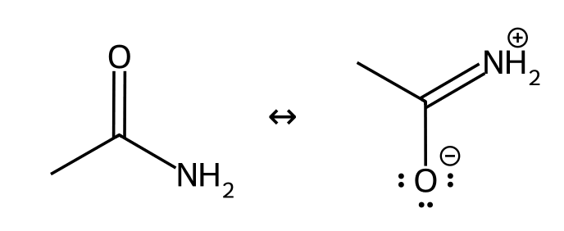
Why: This is pattern 1 combined with the polarized C=O.

