Chapter 8: Addition Reactions to Alkenes: Answer Key
Answers and explanations.
Name: ______________________________ Date: ______________

8.1 Introduction to Addition Reactions
1. In an addition reaction to an alkene, what happens? [C08M01, Easy]
Answer: B) Two groups add across the double bond and the π bond is lost
Why: The π bond breaks and two new σ bonds form.
2. Define an addition reaction and give an example. [C08F01, Easy]
Answer: Two groups add across a double bond; for example CH₂=CH₂ + HBr → CH₃CH₂Br.
Why: The π bond is converted into two σ bonds.
3. What kind of bond is broken and what is formed in an addition to an alkene? [C08F02, Basic]
Answer: The π bond is broken and two new σ bonds are formed.
Why: π to two σ.

8.2 Alkenes in Nature and in Industry
4. Which small alkene is the largest-volume starting material of the chemical industry? [C08M02, Easy]
Answer: A) Ethylene
Why: Ethylene is made by cracking petroleum.
5. Name two alkenes produced industrially by cracking petroleum. [C08F03, Easy]
Answer: Ethylene (ethene) and propylene (propene).
Why: Smallest alkenes.

8.3 Nomenclature of Alkenes
6. What is the degree of substitution of the double bond in 2-methylbut-2-ene? [C08M03, Easy]
Answer: B) Trisubstituted
Why: Three alkyl groups are attached to the double bond carbons.
7. What is the degree of substitution of the double bond in 2,3-dimethylbut-2-ene? [C08M04, Basic]
Answer: B) Tetrasubstituted
Why: Four alkyl groups are attached to the alkene carbons.
8. What is the IUPAC name of the alkene shown? [C08M05, Basic]
Answer: B) 2-methylbut-2-ene
Why: Number to give the double bond the lowest locant, then name the substituent.
9. How many carbon atoms are in the longest chain containing the double bond of 2-methylbut-2-ene? [C08M48, Easy]
Answer: B) 4
Why: But- means four carbons; the methyl is a substituent.
10. Classify the double bond of 2-methylbut-2-ene as mono-, di-, tri- or tetrasubstituted. [C08F04, Basic]
Answer: Trisubstituted: three alkyl groups are on the double bond carbons.
Why: Count the alkyl groups on the double bond.
11. Draw 3-methylcyclohexene. [C08F05, Basic]
Answer: A six-membered ring with a double bond between C1 and C2 and a methyl group on C3.
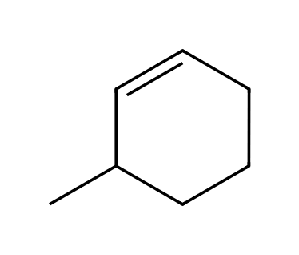
Why: The double bond gets locants 1 and 2.
12. Name the compound shown, giving its E/Z descriptor. [C08F06, Moderate]
Answer: (E)-3-Methylpent-2-ene
Why: Rank the groups on each alkene carbon.

8.4 Addition vs. Elimination: A Thermodynamic Perspective
13. Why are addition reactions disfavored at high temperature? [C08M06, Moderate]
Answer: C) ΔS is negative, so −TΔS opposes the reaction at high T
Why: Two molecules become one, so entropy decreases.
14. Explain why alkene hydrogenation is thermodynamically favorable at room temperature. [C08F07, Basic]
Answer: A weak π bond and an H-H bond are converted into two stronger C-H σ bonds, so ΔH is strongly negative.
Why: Bond energies.
15. Explain why elimination becomes more favorable relative to addition as temperature increases. [C08F08, Moderate]
Answer: Elimination increases the number of molecules (ΔS > 0), so the −TΔS term makes ΔG more negative at high temperature.
Why: Entropy.

8.5 Hydrohalogenation
16. What is the major product of the reaction of propene with HBr? [C08M07, Basic]
Answer: D
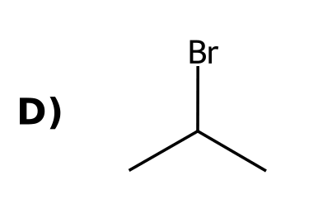
Why: Markovnikov addition puts Br on the more substituted carbon.
17. Markovnikov addition of HX puts the halogen on: [C08M08, Easy]
Answer: C) The more substituted carbon of the double bond
Why: The more stable carbocation forms first.
18. What is the intermediate in the addition of HBr to an alkene? [C08M09, Basic]
Answer: B) A carbocation
Why: Protonation of the alkene gives a carbocation, which Br⁻ then attacks.
19. What is the major product when 2-methylpropene reacts with HBr? [C08M10, Moderate]
Answer: B
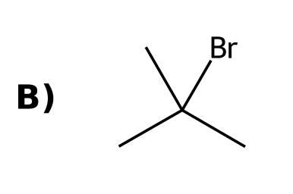
Why: The tertiary carbocation is the intermediate.
20. What is the major product when propene reacts with HBr in the presence of peroxides (ROOR)? [C08M11, Moderate]
Answer: D
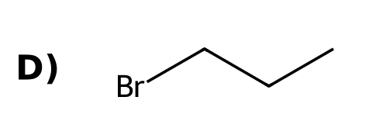
Why: Peroxides lead to a radical mechanism and anti-Markovnikov addition.
21. The addition of HBr to 3-methylbut-1-ene gives mainly 2-bromo-2-methylbutane. This is because: [C08M12, Moderate]
Answer: A) A hydride shift converts a secondary carbocation to a tertiary one
Why: A carbocation rearrangement gives the more stable cation.
22. Adding HCl to 1-methylcyclohexene gives a product with how many stereoisomers? [C08M13, Moderate]
Answer: C) One (the product has no chirality center)
Why: The tertiary chloride is achiral because the ring is symmetric.
23. Hydrohalogenation of but-1-ene gives 2-bromobutane. What is the stereochemical result? [C08M14, Hard]
Answer: A) A racemic mixture
Why: The planar carbocation is attacked from either face.
24. In the addition of HBr to an alkene, which species acts as the electrophile in the first step? [C08M49, Basic]
Answer: C) H⁺ (the proton of HBr)
Why: The π bond attacks the proton of HBr.
25. Draw the major product of 2-methylbut-2-ene with HCl. [C08F09, Basic]
Answer: 2-Chloro-2-methylbutane (tertiary chloride).
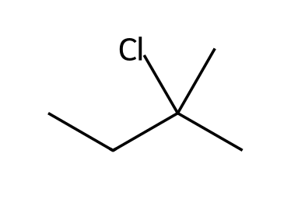
Why: Markovnikov.
26. Draw the major product of propene with HBr in the presence of peroxides and state the regiochemistry. [C08F10, Basic]
Answer: 1-Bromopropane; anti-Markovnikov addition (radical mechanism).
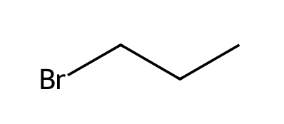
Why: Peroxides change the mechanism.
27. Explain why HBr adds to propene to give 2-bromopropane rather than 1-bromopropane. [C08F11, Moderate]
Answer: Protonation at the terminal carbon gives a secondary carbocation, more stable than the primary cation from the other orientation; Br⁻ then attacks the secondary carbocation.
Why: Stability of the intermediate decides.
28. Show the first step of the mechanism of HBr with propene using curved arrows. [C08F12, Moderate]
Answer: One arrow from the π bond to the H of HBr and one from the H-Br bond to Br, giving a secondary carbocation and Br⁻.
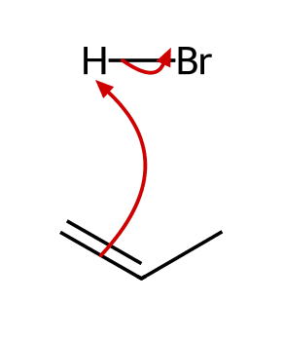
Why: Two arrows.
29. Predict the product of 3,3-dimethylbut-1-ene with HCl and explain why it is not the direct Markovnikov product. [C08F13, Moderate]
Answer: 2-Chloro-2,3-dimethylbutane: the secondary carbocation rearranges by a methyl shift to a tertiary carbocation before chloride attacks.
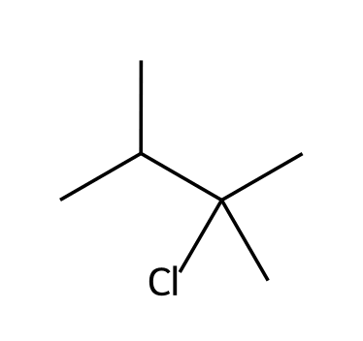
Why: Look for a rearrangement.
30. When HBr adds to but-1-ene, how many stereoisomers are formed, and in what ratio? [C08F14, Hard]
Answer: Two: the R and S enantiomers of 2-bromobutane in a 1:1 (racemic) ratio, because the planar carbocation is attacked equally from both faces.
Why: Planar intermediate.
31. Why does HBr add to an alkene faster than HCl typically? [C08F48, Basic]
Answer: HBr is the stronger acid, so protonating the π bond is easier.
Why: Compare acidities of the hydrogen halides.

8.6 Acid-Catalyzed Hydration
32. What is the major product when 2-methylpropene is treated with H₂O and H₂SO₄? [C08M15, Basic]
Answer: C
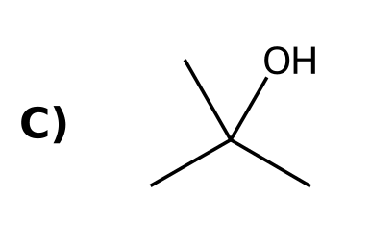
Why: Markovnikov hydration gives the tertiary alcohol.
33. Which reaction conditions give an alkene from an alcohol? [C08M16, Basic]
Answer: A) Concentrated acid and heat
Why: Concentrated acid favors elimination; dilute acid favors hydration.
34. Why is acid-catalyzed hydration of 3-methylbut-1-ene a poor way to make 3-methylbutan-2-ol? [C08M17, Moderate]
Answer: A) A carbocation rearrangement gives a different alcohol
Why: The secondary cation rearranges to a tertiary cation.
35. What reagents add water to an alkene with Markovnikov regiochemistry? [C08F15, Easy]
Answer: H₂O with H₂SO₄ or H₃O⁺ (acid-catalyzed hydration).
Why: Aqueous acid.
36. Draw the product of 1-methylcyclohexene with H₂O, H₂SO₄. [C08F16, Basic]
Answer: 1-Methylcyclohexan-1-ol.
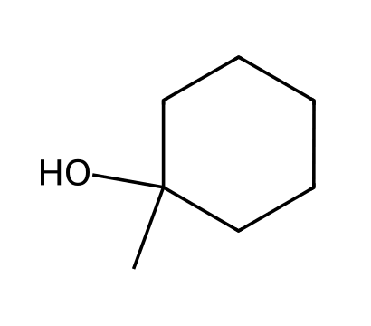
Why: Markovnikov: OH on the more substituted carbon.
37. Describe the three steps of the mechanism of acid-catalyzed hydration of propene. [C08F17, Moderate]
Answer: 1) Protonation of the alkene gives a secondary carbocation. 2) Water attacks the carbocation, giving an oxonium ion. 3) Deprotonation by water gives propan-2-ol.
Why: Protonate, attack, deprotonate.
38. How do you favor the alkene when converting an alcohol to an alkene and the alcohol when hydrating an alkene? [C08F18, Moderate]
Answer: Use concentrated acid and heat to favor the alkene; dilute acid (excess water) to favor the alcohol.
Why: Le Chatelier.

8.7 Oxymercuration-Demercuration
39. Oxymercuration-demercuration is the addition of: [C08M18, Easy]
Answer: C) H and OH across a double bond without carbocation rearrangements
Why: The mercurinium ion prevents rearrangement.
40. What is the product of 3-methylbut-1-ene with (1) Hg(OAc)₂, H₂O; (2) NaBH₄? [C08M19, Moderate]
Answer: D
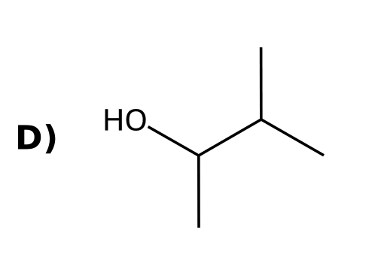
Why: Markovnikov hydration without rearrangement gives the secondary alcohol.
41. What advantage does oxymercuration-demercuration have over acid-catalyzed hydration? [C08F19, Basic]
Answer: It does not involve a free carbocation, so no rearrangement occurs.
Why: The mercurinium ion.
42. Draw the product of 3-methylbut-1-ene with (1) Hg(OAc)₂, H₂O; (2) NaBH₄. [C08F20, Moderate]
Answer: 3-Methylbutan-2-ol (Markovnikov, no rearrangement).
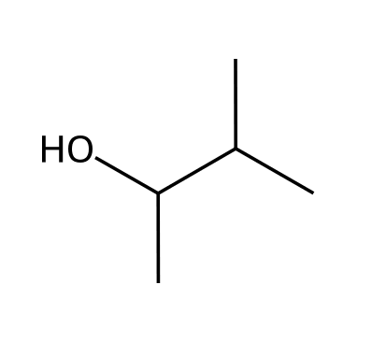
Why: No carbocation rearrangement.

8.8 Hydroboration-Oxidation
43. What is the major product of propene with (1) BH₃·THF; (2) H₂O₂, NaOH? [C08M20, Basic]
Answer: A
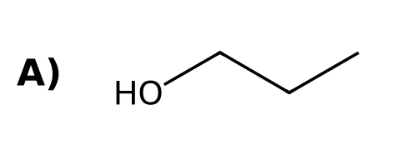
Why: Hydroboration-oxidation gives anti-Markovnikov hydration.
44. Hydroboration-oxidation proceeds with which stereochemistry? [C08M21, Basic]
Answer: B) Syn addition of H and OH
Why: H and B add to the same face in a concerted step.
45. Hydroboration-oxidation of 1-methylcyclohexene gives which product? [C08M22, Moderate]
Answer: B) trans-2-Methylcyclohexan-1-ol
Why: OH goes to the less substituted carbon and syn addition of H and OH places H and OH on the same face, leaving CH₃ and OH trans.
46. Which statement about BH₃ addition is correct? [C08M23, Moderate]
Answer: A) Boron attaches to the less hindered carbon and H adds to the more substituted carbon
Why: The addition is concerted with boron on the less substituted carbon.
47. What reagents add H and OH to an alkene with anti-Markovnikov regiochemistry? [C08F21, Easy]
Answer: (1) BH₃·THF; (2) H₂O₂, NaOH.
Why: Hydroboration-oxidation.
48. Draw the product of 2-methylpropene with (1) BH₃·THF; (2) H₂O₂, NaOH. [C08F22, Basic]
Answer: 2-Methylpropan-1-ol.
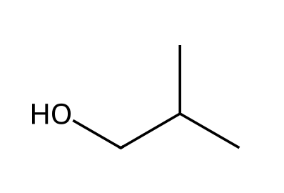
Why: OH goes to the less substituted carbon.
49. Explain the stereochemical outcome of hydroboration-oxidation of 1-methylcyclohexene. [C08F23, Moderate]
Answer: H and OH add to the same face (syn), so the product is trans-2-methylcyclohexan-1-ol (CH₃ and OH trans), formed as a racemate.
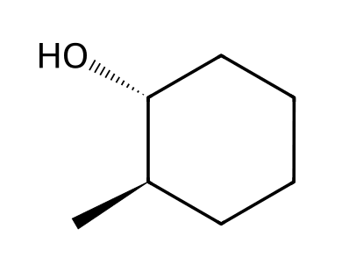
Why: Syn addition of H and B.
50. Why is no carbocation rearrangement observed in hydroboration? [C08F24, Moderate]
Answer: The reaction is concerted: no carbocation is formed, so there is nothing to rearrange.
Why: One step, no cation.

8.9 Catalytic Hydrogenation
51. Which reagents hydrogenate an alkene? [C08M24, Easy]
Answer: C) H₂ with Pt, Pd or Ni
Why: A metal catalyst is required.
52. Catalytic hydrogenation proceeds with: [C08M25, Basic]
Answer: D) Syn addition of H₂
Why: Both H atoms are delivered from the catalyst surface to the same face.
53. Which product is formed when 1,2-dimethylcyclohexene is hydrogenated with H₂, Pt? [C08M26, Moderate]
Answer: D) cis-1,2-Dimethylcyclohexane
Why: Syn addition of H₂ puts both methyl groups on the same face.
54. A homogeneous catalyst is one that: [C08M27, Basic]
Answer: D) Is soluble in the reaction mixture
Why: Homogeneous means the same phase as the reactants.
55. What is the product of 2-methylpropene with H₂, Pt? [C08M50, Basic]
Answer: A) Isobutane (2-methylpropane)
Why: Hydrogenation converts C=C to C-C.
56. What reagents are needed to hydrogenate an alkene? [C08F25, Easy]
Answer: H₂ and a metal catalyst (Pd, Pt or Ni).
Why: Heterogeneous catalysts.
57. Draw the product of 1,2-dimethylcyclohexene with H₂, Pt and state the stereochemistry. [C08F26, Basic]
Answer: cis-1,2-Dimethylcyclohexane, because both H atoms add to the same face (syn).
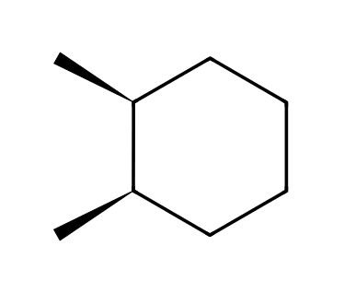
Why: Syn addition.
58. Explain the difference between a homogeneous and a heterogeneous catalyst. [C08F27, Moderate]
Answer: A homogeneous catalyst dissolves in the reaction mixture; a heterogeneous catalyst is a solid that does not (for example Pd/C).
Why: Phases.
59. Draw the product of 2-methylpropene with H₂, Pt. [C08F49, Basic]
Answer: 2-Methylpropane.
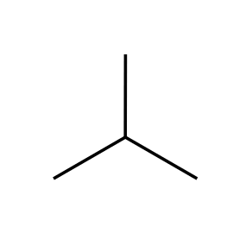
Why: The double bond becomes a single bond.

8.10 Halogenation and Halohydrin Formation
60. What is the intermediate in the bromination of an alkene with Br₂? [C08M28, Easy]
Answer: A) A bromonium ion
Why: A bridged three-membered ring forms.
61. What is the product of cyclohexene with Br₂ in CH₂Cl₂? [C08M29, Moderate]
Answer: D
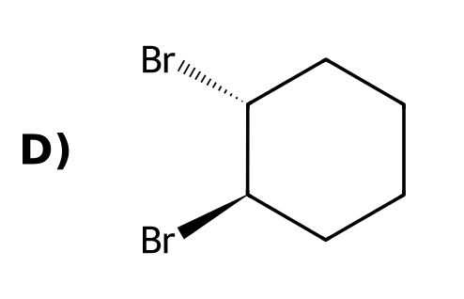
Why: The bromonium ion is opened from the opposite face, so the addition is anti.
62. The addition of Br₂ to an alkene is: [C08M30, Basic]
Answer: A) Anti
Why: The bromide attacks the bromonium ion from the side opposite the Br bridge.
63. When Br₂ is added to an alkene in water, where does OH end up? [C08M31, Moderate]
Answer: D) On the more substituted carbon
Why: The more substituted carbon of the bromonium ion carries more positive charge.
64. What is the product of Br₂ and H₂O with propene? [C08M32, Moderate]
Answer: C) 1-Bromopropan-2-ol
Why: OH adds to the more substituted carbon; Br adds to the terminal carbon.
65. Draw the product of cyclohexene with Br₂ and state the stereochemistry. [C08F28, Basic]
Answer: trans-1,2-Dibromocyclohexane (as a racemate), from anti addition.
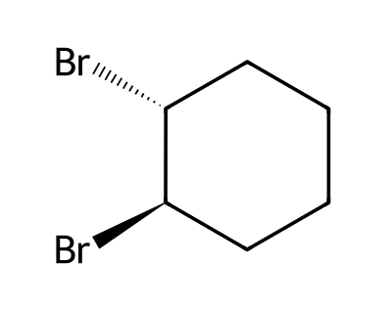
Why: Anti addition via a bromonium ion.
66. Explain why bromination of an alkene gives anti addition. [C08F29, Moderate]
Answer: The alkene forms a bridged bromonium ion; bromide must attack from the side opposite the bridge (SN2-like), so the two Br atoms end up on opposite faces.
Why: Back-side attack on a three-membered ring.
67. Draw the product of propene with Br₂ in water and name it. [C08F30, Moderate]
Answer: 1-Bromopropan-2-ol; OH adds to the more substituted carbon.
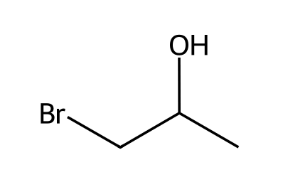
Why: Halohydrin formation.
68. Explain why water attacks the more substituted carbon of the bromonium ion in halohydrin formation. [C08F31, Hard]
Answer: The more substituted carbon bears a larger partial positive charge because it better stabilizes the charge, so the nucleophile attacks it.
Why: Partial carbocation character.

8.11 Anti Dihydroxylation
69. What is the product of cyclohexene with (1) mCPBA; (2) H₃O⁺? [C08M33, Moderate]
Answer: B
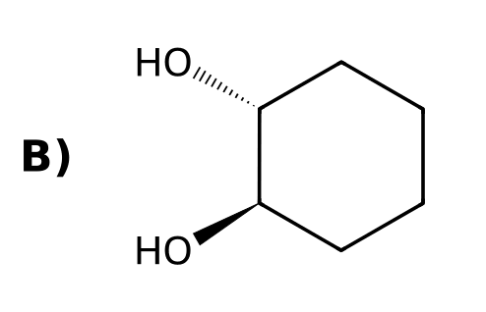
Why: Epoxidation followed by acid-catalyzed opening gives anti dihydroxylation.
70. What is formed first from an alkene and mCPBA? [C08M36, Basic]
Answer: A) An epoxide
Why: The peroxy acid transfers an oxygen atom to the alkene.
71. Draw the product of cyclohexene with (1) mCPBA; (2) H₃O⁺. [C08F32, Basic]
Answer: trans-Cyclohexane-1,2-diol (anti dihydroxylation).
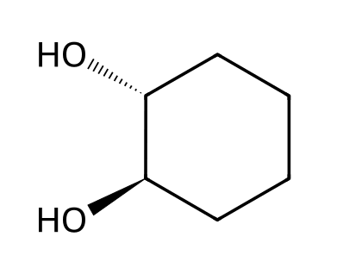
Why: Epoxide, then ring opening.

8.12 Syn Dihydroxylation
72. What is the product of cyclohexene with OsO₄ then NaHSO₃/H₂O? [C08M34, Moderate]
Answer: D
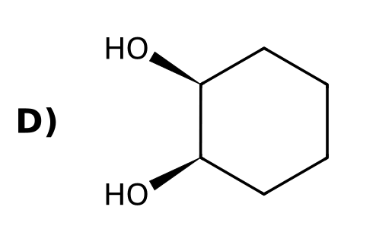
Why: OsO₄ adds both oxygens to the same face: syn dihydroxylation.
73. Which reagent can convert an alkene to a syn diol? [C08M35, Easy]
Answer: B) OsO₄
Why: OsO₄ (or cold, dilute KMnO₄) gives syn dihydroxylation.
74. Draw the product of cyclohexene with OsO₄, then NaHSO₃/H₂O. [C08F33, Basic]
Answer: cis-Cyclohexane-1,2-diol (syn dihydroxylation).
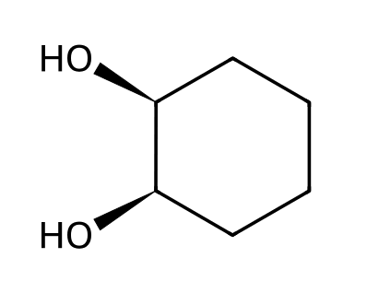
Why: Both OH groups add to the same face.
75. Compare how to make cis and trans cyclohexane-1,2-diol from cyclohexene. [C08F34, Moderate]
Answer: cis: OsO₄ (or cold, dilute KMnO₄) in a syn addition. trans: mCPBA followed by H₃O⁺ (epoxide opening, anti addition).
Why: Syn vs anti.
76. Why does syn dihydroxylation with OsO₄ give only the cis diol from cyclohexene? [C08F50, Basic]
Answer: The two oxygens are delivered together from OsO₄ to the same face of the double bond in a cyclic osmate ester.
Why: A cyclic intermediate delivers both oxygens at once.

8.13 Oxidative Cleavage
77. Ozonolysis of an alkene followed by DMS cleaves the double bond to give: [C08M37, Easy]
Answer: D) Two carbonyl compounds
Why: Each alkene carbon becomes a C=O.
78. Which compounds form from 2-methylbut-2-ene with (1) O₃; (2) DMS? [C08M38, Moderate]
Answer: A
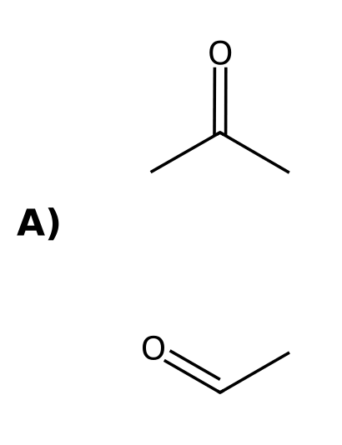
Why: Cleavage of the double bond gives acetaldehyde and acetone.
79. Ozonolysis of cyclohexene (O₃ then DMS) gives: [C08M39, Moderate]
Answer: D) Hexanedial
Why: The ring is opened to a dialdehyde.
80. Which alkene gives a single product (propanal) when treated with O₃ then DMS? [C08M40, Hard]
Answer: B) Hex-3-ene
Why: A symmetrical alkene gives two identical carbonyl compounds.
81. What two carbon-containing groups does ozonolysis (O₃; DMS) produce from an alkene? [C08F35, Easy]
Answer: Two carbonyl groups (aldehydes and/or ketones).
Why: The double bond is cleaved.
82. Draw the products of 2-methylbut-2-ene with (1) O₃; (2) DMS. [C08F36, Basic]
Answer: Acetone and acetaldehyde.
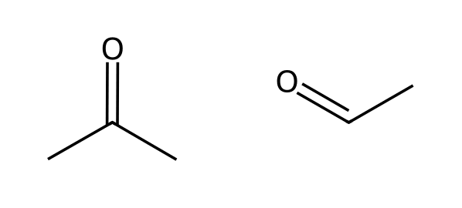
Why: Each alkene carbon becomes a C=O.
83. An alkene gives only one product, acetone, on ozonolysis with DMS workup. Identify the alkene. [C08F37, Moderate]
Answer: 2,3-Dimethylbut-2-ene.
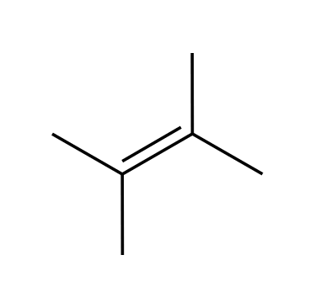
Why: Two identical halves.
84. Draw the product of cyclopentene with (1) O₃; (2) DMS. [C08F38, Moderate]
Answer: Pentanedial (glutaraldehyde), OHC-CH₂CH₂CH₂-CHO.
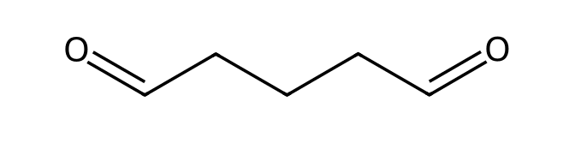
Why: The ring is cleaved.

8.14 Predicting the Products of an Addition Reaction
85. Which reagent adds H and OH to an alkene with anti-Markovnikov regiochemistry? [C08M41, Basic]
Answer: C) BH₃·THF, then H₂O₂, NaOH
Why: Hydroboration-oxidation gives the anti-Markovnikov alcohol.
86. Which of these does NOT proceed through a carbocation intermediate? [C08M42, Moderate]
Answer: C) Hydroboration-oxidation
Why: Hydroboration is concerted.
87. What three questions help you predict an addition product? [C08M43, Moderate]
Answer: C) Which groups add, regiochemistry and stereochemistry
Why: These are the questions listed in Klein section 8.14.
88. List the three questions used to predict the product of an addition reaction. [C08F39, Basic]
Answer: Which groups are added, what regiochemistry (Markovnikov or anti-Markovnikov), and what stereochemistry (syn or anti).
Why: Klein 8.14.
89. Which reagent would you use to convert 1-methylcyclohexene to 1-methylcyclohexan-1-ol and which to 2-methylcyclohexan-1-ol? [C08F40, Moderate]
Answer: H₂O, H₂SO₄ (or oxymercuration) for the 1-ol (Markovnikov); BH₃ then H₂O₂, NaOH for the 2-ol (anti-Markovnikov).
Why: Choose by regiochemistry.
90. Draw the product of propene with (1) BH₃·THF; (2) H₂O₂, NaOH and the product of propene with H₂O, H₂SO₄. How are they related? [C08F41, Moderate]
Answer: Propan-1-ol and propan-2-ol, which are constitutional (regio) isomers.
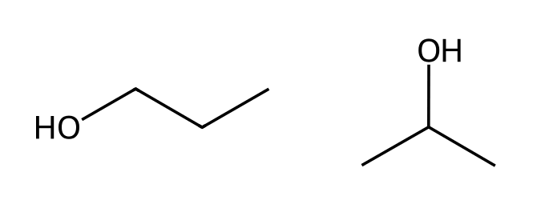
Why: Opposite regiochemistry.
91. Design reagents to convert 1-methylcyclohexene into trans-2-methylcyclohexan-1-ol and explain each feature of the outcome. [C08F42, Hard]
Answer: BH₃·THF then H₂O₂, NaOH: anti-Markovnikov (OH on the less substituted carbon) and syn addition of H and OH, so CH₃ and OH end up trans.
Why: Hydroboration-oxidation.

8.15 Synthesis Strategies
92. What sequence converts 1-bromopropane into 2-bromopropane? [C08M44, Basic]
Answer: B) (1) NaOEt, heat; (2) HBr
Why: Eliminate to propene, then add HBr in a Markovnikov sense.
93. To convert cyclohexene into cis-cyclohexane-1,2-diol, use: [C08M45, Moderate]
Answer: C) OsO₄ then NaHSO₃
Why: Syn dihydroxylation.
94. To convert 1-methylcyclohexene to 2-methylcyclohexan-1-ol (trans), use: [C08M46, Hard]
Answer: D) BH₃·THF; then H₂O₂, NaOH
Why: Anti-Markovnikov hydration (syn addition).
95. To convert 2-bromo-2-methylpropane into 2-methylpropan-1-ol, a good route is: [C08M47, Hard]
Answer: A) (1) t-BuOK; (2) BH₃·THF; (3) H₂O₂, NaOH
Why: Eliminate to the alkene, then add water anti-Markovnikov.
96. How can you change the position of a halogen using elimination and addition? [C08F43, Basic]
Answer: Eliminate HX to form an alkene (E2), then add HX in the desired orientation (Markovnikov or anti-Markovnikov with peroxides).
Why: Eliminate then add.
97. Propose a synthesis of 1-bromopropane from 2-bromopropane. [C08F44, Moderate]
Answer: (1) NaOEt, heat (E2) to give propene; (2) HBr, ROOR (anti-Markovnikov).
Why: Eliminate, then radical addition.
98. Propose a synthesis of cis-cyclohexane-1,2-diol from cyclohexanol. [C08F45, Moderate]
Answer: (1) H₂SO₄, heat (dehydration) to cyclohexene; (2) OsO₄, then NaHSO₃.
Why: Eliminate, then syn dihydroxylation.
99. Propose a synthesis of 2-methylpropan-1-ol from 2-methylpropan-2-ol. [C08F46, Hard]
Answer: (1) H₂SO₄, heat to give 2-methylpropene; (2) BH₃·THF; (3) H₂O₂, NaOH.
Why: Dehydrate, then hydroboration-oxidation.
100. Propose a synthesis of acetone and formaldehyde from 2-methylpropene. [C08F47, Hard]
Answer: Treat 2-methylpropene with (1) O₃; (2) DMS.
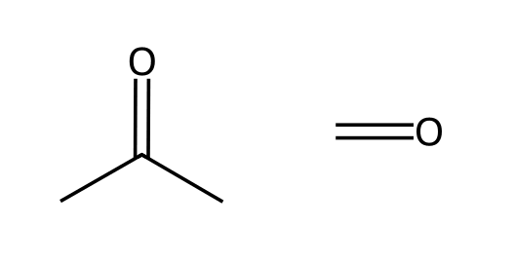
Why: Ozonolysis splits the double bond.

