Chapter 9: Alkynes: Answer Key
Answers and explanations.
Name: ______________________________ Date: ______________

9.1 Introduction to Alkynes
1. How many σ and π bonds make up a carbon-carbon triple bond? [C09M01, Easy]
Answer: D) One σ and two π
Why: A triple bond is one σ bond plus two π bonds.
2. What is the geometry around each carbon of a triple bond? [C09M02, Easy]
Answer: A) Linear (180°)
Why: sp hybridization gives a linear arrangement.
3. What is the hybridization of the carbons of an alkyne triple bond? [C09M03, Basic]
Answer: D) sp
Why: Two sp orbitals form two σ bonds; two p orbitals form the two π bonds.
4. Which compound has a C-C-C bond angle of 180°? [C09M04, Basic]
Answer: A) Propyne
Why: The sp carbons of propyne are linear with their neighbours.
5. Describe the bonds in a carbon-carbon triple bond. [C09F01, Easy]
Answer: One σ bond and two π bonds, formed by sp hybridized carbons.
Why: Three bonds in total.
6. What is the geometry around the carbons of an alkyne, and why? [C09F02, Basic]
Answer: Linear (180°); each carbon is sp hybridised with two σ bonds spread as far apart as possible.
Why: Two electron regions.
7. Draw the structural formula of propyne and label the bond angle at the central carbon. [C09F03, Basic]
Answer: CH₃-C≡CH with a 180° C-C≡C angle.
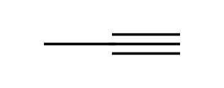
Why: Linear.

9.2 Nomenclature of Alkynes
8. What is the IUPAC name of the compound shown? [C09M05, Easy]
Answer: B) but-1-yne
Why: The chain has four carbons with the triple bond starting at C1.
9. What is the IUPAC name of the compound shown? [C09M06, Basic]
Answer: C) but-2-yne
Why: The triple bond is in the middle of a four-carbon chain.
10. What is the IUPAC name of the compound shown? [C09M07, Basic]
Answer: C) 4-methylpent-2-yne
Why: Number from the end nearest the triple bond.
11. What is the IUPAC name of the compound shown? [C09M08, Moderate]
Answer: A) 2,5-dimethylhept-3-yne
Why: The triple bond gets the lowest locant (3), then the substituents.
12. A terminal alkyne has the triple bond: [C09M09, Easy]
Answer: D) At the end of the chain
Why: A terminal alkyne has an H on a triple-bond carbon.
13. Which is an internal alkyne? [C09M10, Basic]
Answer: B) Pent-2-yne
Why: Both triple-bond carbons are bonded to other carbons.
14. Define terminal and internal alkynes. [C09F04, Easy]
Answer: A terminal alkyne has its triple bond at the end of a chain (with an acidic C-H); an internal alkyne has the triple bond within the chain.
Why: Position of the triple bond.
15. Name the compound shown. [C09F05, Basic]
Answer: 4-Methylpent-2-yne
Why: Number from the end nearest the triple bond.
16. Draw pent-1-yne and pent-2-yne. [C09F06, Basic]
Answer: Pent-1-yne: HC≡C-CH₂CH₂CH₃. Pent-2-yne: CH₃-C≡C-CH₂CH₃.
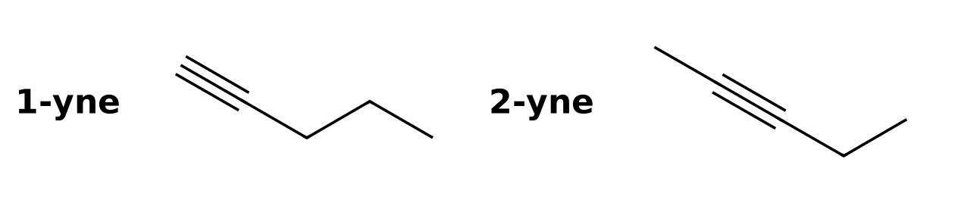
Why: Same formula, different triple bond position.
17. Name the compound shown. [C09F07, Moderate]
Answer: 2,5-Dimethylhept-3-yne
Why: The triple bond must receive the lowest locant.
18. Draw all acyclic alkynes of formula C₅H₈ and name them. [C09F08, Moderate]
Answer: Pent-1-yne, pent-2-yne and 3-methylbut-1-yne.
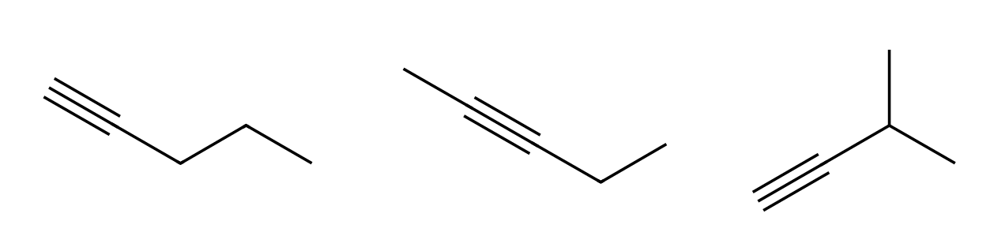
Why: Check the positions of the triple bond and branching.
19. Draw ethyne (acetylene) and give its common name. [C09F09, Easy]
Answer: HC≡CH; the common name is acetylene.
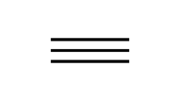
Why: Simplest alkyne.
20. How many carbons are in hex-2-yne, and where is the triple bond? [C09F49, Basic]
Answer: Six carbons; the triple bond is between C2 and C3.
Why: The locant gives the first carbon of the triple bond.

9.3 Acidity of Acetylene and Terminal Alkynes
21. Which hydrogen is the most acidic? [C09M11, Easy]
Answer: B) The terminal alkyne C-H
Why: The sp carbon holds its lone pair closest to the nucleus.
22. Why is the conjugate base of a terminal alkyne relatively stable? [C09M12, Basic]
Answer: B) The lone pair is in an sp orbital, which has high s character
Why: Electrons in an sp orbital are held close to the nucleus.
23. Which base is strong enough to deprotonate a terminal alkyne completely? [C09M13, Basic]
Answer: C) NaNH₂
Why: The amide ion is a stronger base than the alkynide ion that forms.
24. Which compound cannot be deprotonated by NaNH₂ at a triple-bond carbon? [C09M14, Moderate]
Answer: A) But-2-yne
Why: An internal alkyne has no acidic C-H on the triple bond.
25. The reaction of propyne with NaNH₂ gives: [C09M15, Moderate]
Answer: A) The propynide ion (an alkynide) and NH₃
Why: The base removes the acidic proton.
26. Which C-H bond of a hydrocarbon is the most acidic: alkane, alkene or terminal alkyne? [C09F10, Easy]
Answer: The terminal alkyne C-H.
Why: sp carbon is the most electron-withdrawing.
27. Explain why a terminal alkyne is more acidic than an alkene. [C09F11, Basic]
Answer: The conjugate base has its lone pair in an sp orbital (50% s character), which holds electrons closer to the nucleus and stabilises the anion.
Why: Orbital hybridization.
28. Write the reaction of propyne with NaNH₂. [C09F12, Basic]
Answer: CH₃C≡CH + NaNH₂ → CH₃C≡C⁻ Na⁺ + NH₃.
Why: The amide removes the acidic proton.
29. Why can NaOH not be used to deprotonate a terminal alkyne completely? [C09F13, Moderate]
Answer: Hydroxide is a weaker base than the alkynide ion, so the equilibrium lies on the side of the reactants.
Why: Compare base strengths.
30. Which compound will react with NaNH₂ to form an alkynide, but-1-yne or but-2-yne? Explain. [C09F14, Moderate]
Answer: But-1-yne has an acidic hydrogen on the terminal sp carbon; but-2-yne has none.
Why: Look for a hydrogen on the triple bond carbon.

9.4 Preparation of Alkynes
31. An alkyne can be prepared from a dihalide by: [C09M16, Easy]
Answer: C) Two successive E2 reactions
Why: Each E2 removes one HX.
32. Which is a suitable starting material to make propyne by double elimination? [C09M17, Basic]
Answer: D) 1,2-Dibromopropane
Why: A vicinal dihalide loses two HBr.
33. Why is excess (three equivalents of) NaNH₂ needed when making a terminal alkyne from a dihalide? [C09M18, Moderate]
Answer: D) The terminal alkyne product is deprotonated by the base, and water workup restores it
Why: The third equivalent deprotonates the terminal alkyne; protonation on workup gives the alkyne.
34. Give the starting material and reagents to prepare propyne by double elimination. [C09F15, Basic]
Answer: 1,2-Dibromopropane (or 2,2-dibromopropane) with excess NaNH₂, then H₂O.
Why: Two E2 reactions.
35. Why are three equivalents of NaNH₂ used when making a terminal alkyne from a dihalide? [C09F16, Moderate]
Answer: Two eliminate HX; the third deprotonates the terminal alkyne (it is acidic), and a water workup restores the alkyne.
Why: The product is acidic.
36. Show how to prepare but-2-yne from 2,3-dibromobutane. [C09F17, Moderate]
Answer: Treat with excess NaNH₂ (or NaOH at high T): two successive E2 reactions.
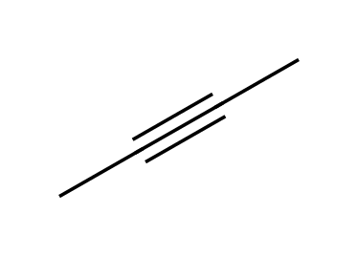
Why: Vicinal dihalide.

9.5 Reduction of Alkynes
37. What is the major product of but-2-yne with H₂ and Lindlar's catalyst? [C09M20, Basic]
Answer: C
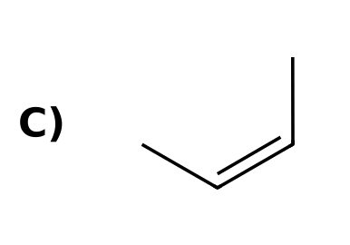
Why: A poisoned catalyst stops at the alkene and adds H₂ syn, giving the cis alkene.
38. What is the major product of but-2-yne with Na in liquid NH₃? [C09M21, Basic]
Answer: C
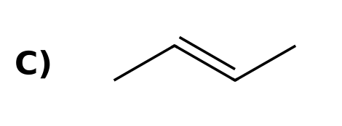
Why: Dissolving-metal reduction gives the trans alkene.
39. What is the product of but-2-yne with excess H₂ and Pt? [C09M22, Easy]
Answer: C
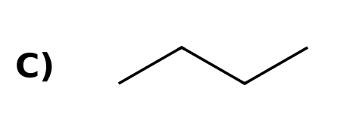
Why: Without a poison the alkene is also hydrogenated to the alkane.
40. Which reagent converts an internal alkyne into a cis alkene? [C09M23, Basic]
Answer: A) H₂, Lindlar catalyst
Why: Lindlar catalyst is poisoned Pd.
41. The Na/NH₃ reduction of an alkyne involves which kind of arrow? [C09M24, Moderate]
Answer: A) Fishhook (single-electron) arrows
Why: Electrons are transferred one at a time through a radical anion.
42. Which reagent converts pent-2-yne into trans-pent-2-ene? [C09M25, Moderate]
Answer: C) Na, NH₃(l)
Why: Dissolving-metal reduction gives trans alkenes.
43. What does H₂ with Pt do to an alkyne? [C09F18, Easy]
Answer: It reduces it fully to an alkane.
Why: Two additions of H₂.
44. Draw the product of but-2-yne with H₂ and Lindlar catalyst. [C09F19, Basic]
Answer: cis-But-2-ene (syn addition of H₂).
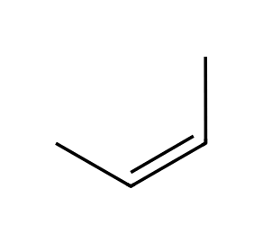
Why: Poisoned catalyst, syn.
45. Draw the product of but-2-yne with Na, NH₃(l). [C09F20, Basic]
Answer: trans-But-2-ene.
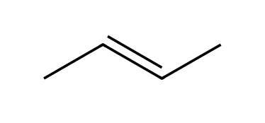
Why: Dissolving-metal reduction.
46. What type of arrow is used in the mechanism of the dissolving-metal reduction, and why? [C09F21, Moderate]
Answer: Fishhook (single-headed) arrows, because only one electron moves at a time (from sodium to the alkyne).
Why: Radical anion intermediate.
47. Propose reagents to convert pent-2-yne to cis-pent-2-ene, and to trans-pent-2-ene. [C09F22, Moderate]
Answer: cis: H₂, Lindlar catalyst. trans: Na, NH₃(l).
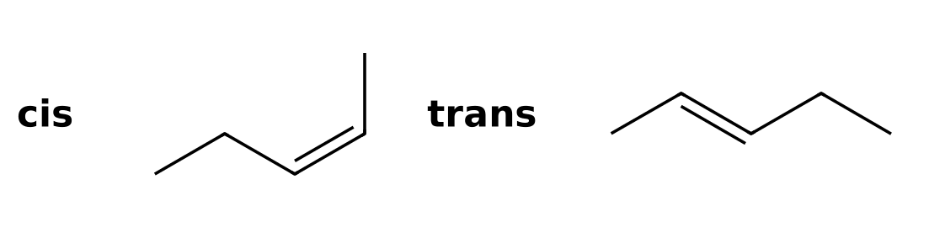
Why: Syn vs dissolving metal.
48. Explain why an alkyne can be stopped at the alkene stage with Lindlar catalyst but not with Pd/C. [C09F23, Hard]
Answer: The poisoned catalyst is too unreactive to hydrogenate the alkene once formed, while unpoisoned Pd/C hydrogenates the alkene to an alkane.
Why: Catalyst activity.
49. Why is a trans alkene formed in the dissolving-metal reduction? [C09F48, Moderate]
Answer: The intermediate vinylic radical prefers the more stable trans arrangement, which places the large groups far apart before the second reduction and protonation.
Why: Stability of the intermediate.

9.6 Hydrohalogenation of Alkynes
50. What is the product of propyne with one equivalent of HBr? [C09M26, Basic]
Answer: D
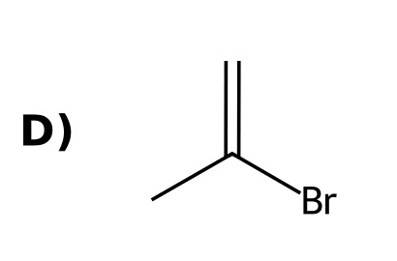
Why: Markovnikov: bromine on the more substituted alkyne carbon.
51. What is the product of propyne with two equivalents of HBr? [C09M27, Moderate]
Answer: B
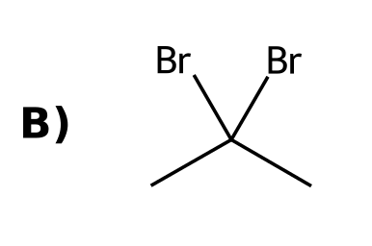
Why: The second HBr adds to the same carbon, giving a geminal dibromide.
52. What is the product of propyne with HBr in the presence of peroxides? [C09M28, Moderate]
Answer: A
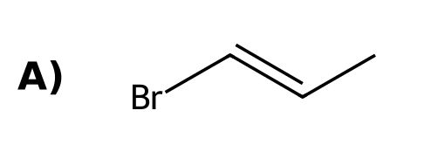
Why: Peroxides give anti-Markovnikov addition.
53. Two equivalents of HX add to a terminal alkyne. Where are the two halogens in the product? [C09M29, Moderate]
Answer: B) On the same carbon (geminal)
Why: Both additions are Markovnikov.
54. State the regiochemistry for the addition of HBr to a terminal alkyne. [C09F24, Easy]
Answer: Markovnikov: bromine ends up on the internal (more substituted) carbon.
Why: More stable cationic character.
55. Draw the product of propyne with one equivalent of HBr. [C09F25, Basic]
Answer: 2-Bromopropene.
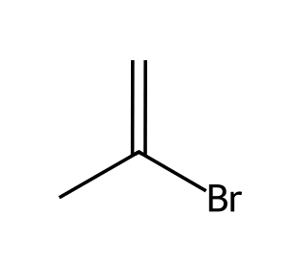
Why: Markovnikov.
56. Draw the product of propyne with two equivalents of HBr. [C09F26, Basic]
Answer: 2,2-Dibromopropane (geminal dibromide).
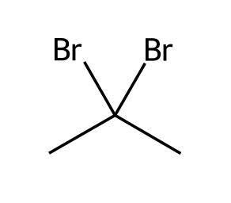
Why: Both Br on the same carbon.
57. Draw the product of propyne with HBr and peroxides and state the regiochemistry. [C09F27, Moderate]
Answer: 1-Bromopropene; anti-Markovnikov (radical addition).
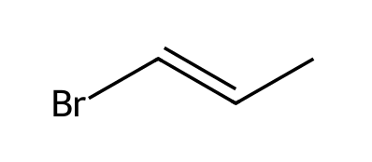
Why: Peroxides.

9.7 Hydration of Alkynes
58. What is the product of but-1-yne with H₂O, H₂SO₄, HgSO₄? [C09M30, Moderate]
Answer: B
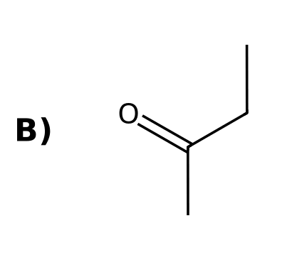
Why: Markovnikov hydration gives an enol that tautomerizes to a ketone.
59. What is the product of but-1-yne with (1) Sia₂BH; (2) H₂O₂, NaOH? [C09M31, Moderate]
Answer: A
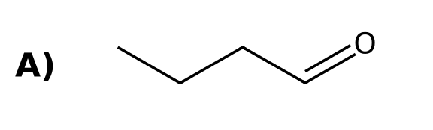
Why: Anti-Markovnikov hydration of a terminal alkyne gives an aldehyde.
60. Enols and ketones that interconvert are called: [C09M32, Easy]
Answer: B) Tautomers
Why: Tautomers are constitutional isomers that interconvert by moving a proton.
61. What functional group does an enol contain? [C09M33, Basic]
Answer: A) A C=C double bond bearing an OH group
Why: Enol means ene + ol.
62. Hydration of an internal symmetrical alkyne such as but-2-yne gives: [C09M34, Basic]
Answer: D) A single ketone
Why: Both carbons give the same product.
63. Hydration of pent-2-yne (HgSO₄, H₂SO₄, H₂O) gives: [C09M35, Moderate]
Answer: C) A mixture of two ketones
Why: Water can add to either alkyne carbon with similar preference.
64. The tautomerization of an enol to a ketone in base proceeds through: [C09M36, Hard]
Answer: D) An enolate ion
Why: Deprotonation of the enol gives a resonance-stabilised enolate, which is protonated on carbon.
65. What is tautomerism? [C09F28, Easy]
Answer: The rapid interconversion of constitutional isomers by movement of a proton, such as an enol and a ketone.
Why: Keto-enol.
66. Draw the enol and ketone formed from propyne with H₂O, H₂SO₄, HgSO₄. [C09F29, Basic]
Answer: Enol: CH₃C(OH)=CH₂; it tautomerizes to acetone, CH₃C(=O)CH₃.
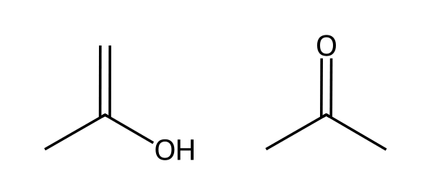
Why: Markovnikov hydration.
67. Draw the product of but-1-yne with (1) Sia₂BH; (2) H₂O₂, NaOH. [C09F30, Basic]
Answer: Butanal (an aldehyde).
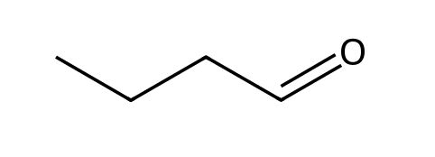
Why: Anti-Markovnikov, then tautomerization.
68. Explain why hydration of but-1-yne gives a ketone but hydroboration-oxidation gives an aldehyde. [C09F31, Moderate]
Answer: Acid-catalyzed hydration is Markovnikov (OH on C2, giving a ketone); hydroboration is anti-Markovnikov (OH on C1, giving an aldehyde).
Why: Regiochemistry.
69. Why does hydration of pent-2-yne give two products? [C09F32, Moderate]
Answer: The alkyne is unsymmetrical with similar substituents on each side, so water adds to either carbon, giving pentan-2-one and pentan-3-one.
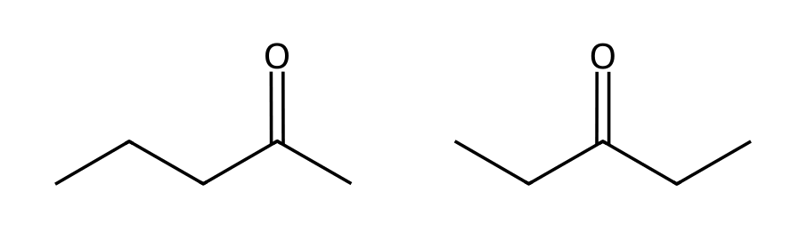
Why: Compare the two sides.
70. Describe the base-catalyzed tautomerization of an enol to a ketone. [C09F33, Hard]
Answer: Hydroxide removes the enol O-H proton, forming a resonance-stabilised enolate; the carbon of the enolate then takes a proton from water to give the ketone.
Why: Enolate intermediate.

9.8 Halogenation of Alkynes
71. What is the product of propyne with excess Br₂? [C09M37, Basic]
Answer: A
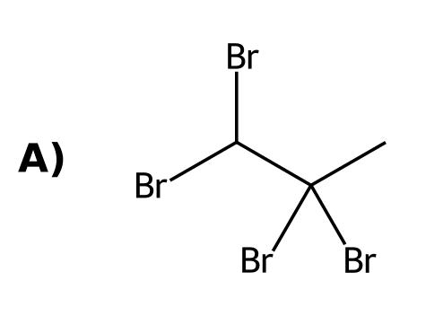
Why: Each π bond adds one Br₂, giving a tetrabromide.
72. How many moles of Br₂ add to one mole of an alkyne to give a tetrabromide? [C09M38, Moderate]
Answer: C) 2
Why: Each of the two π bonds adds one Br₂.
73. What is the stereochemistry of the addition of one equivalent of Br₂ to an alkyne? [C09M50, Basic]
Answer: B) Anti
Why: A bromonium ion is opened from the opposite face.
74. Draw the product of propyne with excess Br₂. [C09F34, Basic]
Answer: 1,1,2,2-Tetrabromopropane.
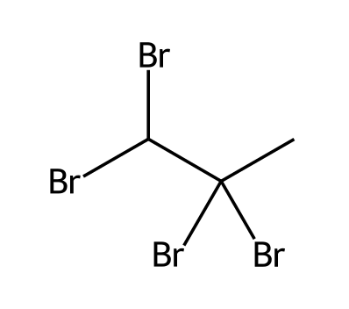
Why: Two Br₂ add.
75. How many equivalents of Br₂ are needed to convert an alkyne to a tetrabromide, and why? [C09F35, Moderate]
Answer: Two, since each of the two π bonds adds one Br₂.
Why: Two π bonds.
76. Draw the product of but-2-yne with one equivalent of Br₂ and state the stereochemistry of addition. [C09F50, Basic]
Answer: (E)-2,3-Dibromobut-2-ene, formed by anti addition.
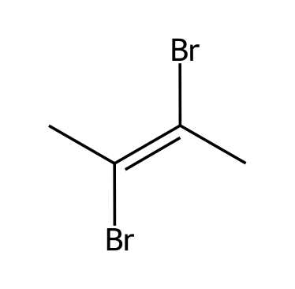
Why: Bromination of an alkyne is anti, like an alkene.

9.9 Ozonolysis of Alkynes
77. Ozonolysis of an internal alkyne (O₃; H₂O) gives: [C09M39, Easy]
Answer: D) Two carboxylic acids
Why: Each alkyne carbon becomes a carboxylic acid carbon.
78. What is formed from but-2-yne with (1) O₃; (2) H₂O? [C09M40, Basic]
Answer: D
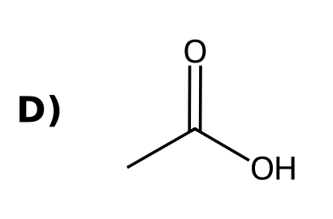
Why: Two molecules of acetic acid form.
79. Ozonolysis of a terminal alkyne converts the terminal carbon into: [C09M41, Moderate]
Answer: D) CO₂
Why: The terminal CH becomes carbon dioxide.
80. Draw the products of but-2-yne with (1) O₃; (2) H₂O. [C09F36, Basic]
Answer: Two molecules of acetic acid.
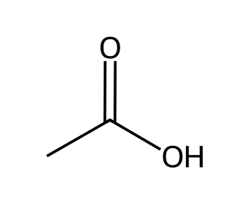
Why: Internal alkynes give carboxylic acids.
81. Draw the products of but-1-yne with (1) O₃; (2) H₂O. [C09F37, Moderate]
Answer: Propanoic acid and carbon dioxide.
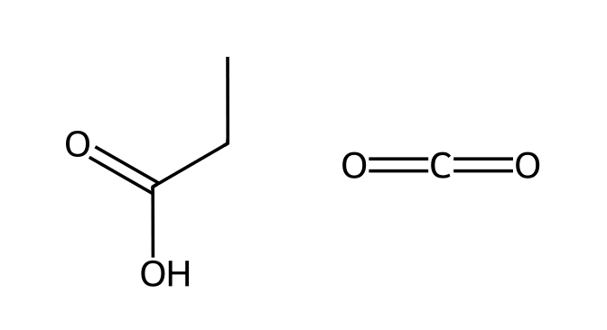
Why: The terminal carbon becomes CO₂.
82. An alkyne gives acetic acid and propanoic acid on ozonolysis with water workup. Identify it. [C09F38, Hard]
Answer: Pent-2-yne.
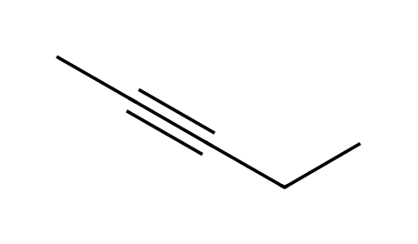
Why: Join the two acid carbons.

9.10 Alkylation of Terminal Alkynes
83. In the alkylation of a terminal alkyne, the nucleophile is: [C09M42, Easy]
Answer: A) The alkynide ion
Why: The anion attacks the alkyl halide in an SN2 reaction.
84. What is the product of but-1-yne with (1) NaNH₂; (2) CH₃CH₂Br? [C09M43, Moderate]
Answer: B
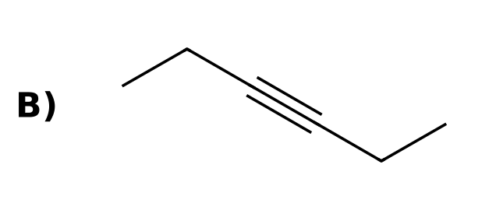
Why: The alkynide attacks the primary halide in an SN2 reaction, adding two carbons.
85. Which alkyl halide gives the best yield of alkylation with an alkynide? [C09M44, Moderate]
Answer: B) Methyl or primary
Why: The alkynide is also a strong base, so only SN2-reactive halides work.
86. What is the main product when an alkynide reacts with tert-butyl bromide? [C09M45, Hard]
Answer: A) The alkene from E2 elimination
Why: A strong base with a tertiary halide gives elimination.
87. What is alkylation of a terminal alkyne? [C09F39, Easy]
Answer: Formation of a new C-C bond by reacting an alkynide with an alkyl halide in an SN2 reaction.
Why: Alkynide as nucleophile.
88. Draw the product of propyne with (1) NaNH₂; (2) CH₃CH₂Br. [C09F40, Basic]
Answer: Pent-2-yne.
Why: SN2 on a primary halide.
89. Explain why tertiary alkyl halides cannot be used in alkynide alkylation. [C09F41, Moderate]
Answer: The alkynide is a strong base, so with a tertiary halide E2 elimination occurs instead of SN2.
Why: Strong base, hindered halide.
90. Show how to make hex-3-yne from acetylene. [C09F42, Moderate]
Answer: (1) NaNH₂; (2) CH₃CH₂Br; (3) NaNH₂; (4) CH₃CH₂Br.
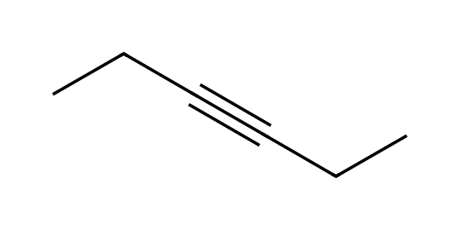
Why: Alkylate twice.

9.11 Synthesis Strategies
91. Which two-step sequence converts but-1-ene into but-1-yne? [C09M19, Moderate]
Answer: C) (1) Br₂; (2) excess NaNH₂, then H₂O
Why: Bromination makes a vicinal dibromide, which eliminates twice.
92. To make hex-3-yne from acetylene, you need: [C09M46, Moderate]
Answer: C) Two alkylations with ethyl bromide
Why: NaNH₂ then CH₃CH₂Br, repeated twice.
93. To convert but-2-yne to butan-2-one, use: [C09M47, Moderate]
Answer: B) H₂O, H₂SO₄, HgSO₄
Why: Hydration of an alkyne gives a ketone through an enol.
94. To convert 1-butyne into 2-pentyne (chain extension), which sequence is best? [C09M48, Hard]
Answer: D) (1) NaNH₂; (2) CH₃I
Why: Deprotonate the terminal alkyne and alkylate with methyl iodide.
95. To convert 1-bromopropane into propyne, the best sequence is: [C09M49, Hard]
Answer: B) (1) NaOEt; (2) Br₂; (3) excess NaNH₂, then H₂O
Why: Eliminate to propene, brominate, then double elimination.
96. Propose a synthesis of but-1-yne from but-1-ene. [C09F43, Moderate]
Answer: (1) Br₂; (2) excess NaNH₂; (3) H₂O.
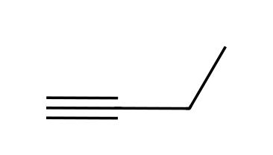
Why: Add Br₂, then eliminate twice.
97. Propose a synthesis of butan-2-one from but-1-yne. [C09F44, Moderate]
Answer: H₂O, H₂SO₄, HgSO₄ (Markovnikov hydration, then tautomerization).
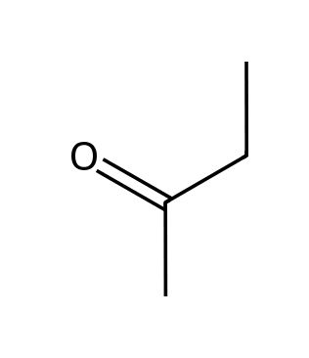
Why: Ketone.
98. Propose a synthesis of cis-pent-2-ene from propyne and ethyl bromide. [C09F45, Hard]
Answer: (1) NaNH₂; (2) CH₃CH₂Br to give pent-2-yne; (3) H₂, Lindlar catalyst to give cis-pent-2-ene.
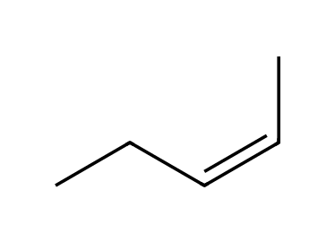
Why: Alkylate, then partially reduce.
99. Propose a synthesis of trans-hex-3-ene from acetylene and ethyl bromide. [C09F46, Hard]
Answer: (1) NaNH₂; (2) CH₃CH₂Br; (3) NaNH₂; (4) CH₃CH₂Br to give hex-3-yne; (5) Na, NH₃(l) to give the trans alkene.
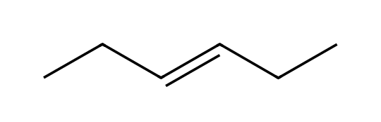
Why: Build then dissolving-metal reduction.
100. Propose a synthesis of 2,2-dibromopropane from propene. [C09F47, Hard]
Answer: (1) Br₂; (2) excess NaNH₂, then H₂O to give propyne; (3) 2 HBr.
Why: Alkyne then double HBr addition.

