Chapter 11: Multi-Step Synthesis: Answer Key
Answers and explanations.
Name: ______________________________ Date: ______________

11.1 One-Step Syntheses
1. What is the product of propene with H₂ and Pt? [C11M01, Easy]
Answer: D
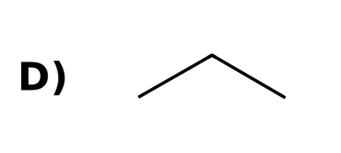
Why: Catalytic hydrogenation converts C=C to C-C.
2. What is the product of cyclohexene with Br₂? [C11M02, Basic]
Answer: A
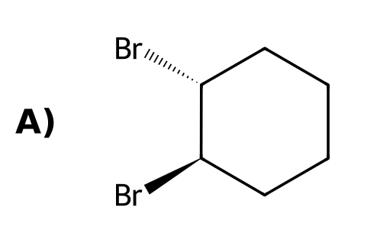
Why: Addition of Br₂ across the π bond gives trans-1,2-dibromocyclohexane.
3. What is the product of 2-bromopropane with NaOEt and heat? [C11M03, Basic]
Answer: B
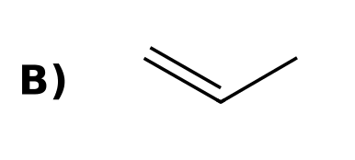
Why: A strong base with a secondary halide favors E2.
4. What is the product of 1-bromobutane with NaCN? [C11M04, Basic]
Answer: C
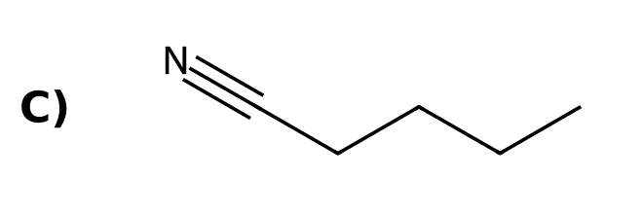
Why: Cyanide is a good nucleophile and a weak base: SN2.
5. Which reagents convert an alkene into an alcohol with Markovnikov regiochemistry? [C11M05, Easy]
Answer: D) H₂O, H₂SO₄
Why: Acid-catalyzed hydration is Markovnikov.
6. Which reagent converts a terminal alkyne into a methyl ketone? [C11M06, Easy]
Answer: C) H₂O, H₂SO₄, HgSO₄
Why: Hydration of an alkyne gives a ketone through an enol.
7. Which reagent converts an alkene into an epoxide? [C11M07, Basic]
Answer: A) mCPBA
Why: A peroxy acid transfers an oxygen to the alkene.
8. Which reagent converts an alkene into an alkane? [C11M45, Easy]
Answer: A) H₂, Pt
Why: Catalytic hydrogenation.
9. Which reagents cleave an alkene into two carbonyl compounds? [C11M46, Easy]
Answer: C) O₃, then DMS
Why: Ozonolysis.
10. Which reagent adds Br across a double bond? [C11M47, Basic]
Answer: B) Br₂
Why: Halogenation of an alkene.
11. Give the reagents to convert propene into propane. [C11F01, Easy]
Answer: H₂ with Pt (or Pd or Ni).
Why: Catalytic hydrogenation.
12. Give the reagents to convert cyclohexene into trans-1,2-dibromocyclohexane. [C11F02, Basic]
Answer: Br₂ in CH₂Cl₂ (or CCl₄).
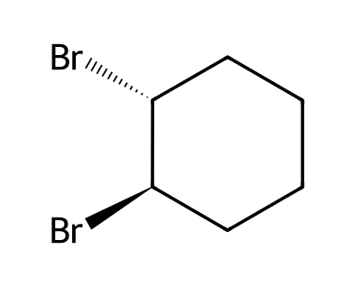
Why: Anti addition.
13. Give the reagents to convert but-2-yne into trans-but-2-ene. [C11F03, Basic]
Answer: Na, NH₃(l).
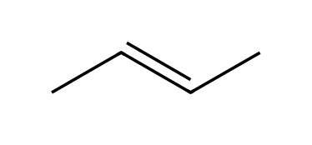
Why: Dissolving-metal reduction.
14. Give the reagents to convert but-2-yne into cis-but-2-ene. [C11F04, Basic]
Answer: H₂, Lindlar catalyst.
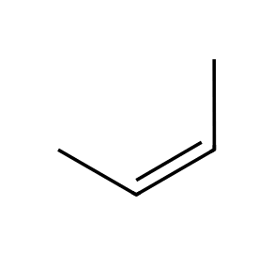
Why: Poisoned catalyst.
15. Give the reagents to convert 1-methylcyclohexene into 1-methylcyclohexan-1-ol and into trans-2-methylcyclohexan-1-ol. [C11F05, Moderate]
Answer: H₂O, H₂SO₄ (Markovnikov) for the first; BH₃·THF then H₂O₂, NaOH (anti-Markovnikov, syn addition) for the second.
Why: Regiochemistry controls the choice.
16. Give the product of 3-methylbut-1-ene with (1) Hg(OAc)₂, H₂O; (2) NaBH₄, and explain why this reagent is used instead of H₂SO₄/H₂O. [C11F06, Moderate]
Answer: 3-Methylbutan-2-ol; oxymercuration avoids a carbocation rearrangement.
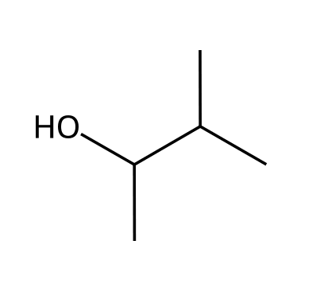
Why: No free carbocation.
17. Give the reagents to convert propyne into propene. [C11F48, Easy]
Answer: H₂ with Lindlar catalyst.
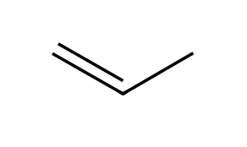
Why: Partial reduction.

11.2 Functional Group Transformations
18. How can the position of a halogen be changed? [C11M08, Basic]
Answer: B) Elimination followed by addition
Why: Eliminate HX to form an alkene, then add HX in the other orientation.
19. How can the position of a π bond be changed? [C11M09, Basic]
Answer: D) Addition followed by elimination
Why: Add HX across the alkene, then eliminate in the other direction.
20. Which sequence converts 1-bromopropane into 2-bromopropane? [C11M10, Moderate]
Answer: A) (1) NaOEt, heat; (2) HBr
Why: Eliminate to propene, then add HBr in a Markovnikov sense.
21. Which sequence converts 1-pentene into 2-pentene? [C11M11, Moderate]
Answer: A) (1) HBr; (2) NaOEt, heat
Why: Add HBr to give 2-bromopentane, then eliminate toward the more substituted alkene.
22. Which sequence converts an alkane into an alkene? [C11M12, Moderate]
Answer: B) (1) Br₂, hν; (2) NaOEt, heat
Why: Radical bromination, then E2 elimination.
23. Which sequence converts but-1-ene into but-1-yne? [C11M13, Moderate]
Answer: D) (1) Br₂; (2) excess NaNH₂; (3) H₂O
Why: Bromination, double elimination, then protonation.
24. Which sequence converts an alkyne into a trans alkene? [C11M14, Moderate]
Answer: B) Na, NH₃(l)
Why: Dissolving-metal reduction.
25. Which sequence converts cyclohexane into trans-cyclohexane-1,2-diol? [C11M15, Hard]
Answer: C) (1) Br₂, hν; (2) NaOEt; (3) mCPBA; (4) H₃O⁺
Why: Halogenate, eliminate, then anti dihydroxylation through the epoxide.
26. To convert propene into 1,2-dibromopropane use: [C11M42, Moderate]
Answer: C) Br₂
Why: Addition of Br₂ across the double bond.
27. To convert cyclohexene into cis-cyclohexane-1,2-diol use: [C11M43, Moderate]
Answer: D) OsO₄, then NaHSO₃
Why: Syn dihydroxylation.
28. Which sequence converts 2-bromo-2-methylpropane into 2-methylpropan-1-ol? [C11M44, Hard]
Answer: D) (1) t-BuOK; (2) BH₃·THF; (3) H₂O₂, NaOH
Why: Eliminate, then anti-Markovnikov hydration.
29. Which reagent brominates the allylic position of an alkene? [C11M48, Basic]
Answer: B) NBS with light
Why: Allylic bromination.
30. Which reagent converts a vicinal dibromide into an alkyne? [C11M49, Basic]
Answer: A) Excess NaNH₂
Why: Two successive E2 reactions.
31. Propose a synthesis of 2-bromopropane from 1-bromopropane. [C11F07, Basic]
Answer: (1) NaOEt, heat (E2) to propene; (2) HBr (Markovnikov).
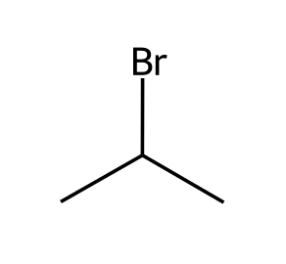
Why: Eliminate, then add.
32. Show how to convert 2-bromopropane into 1-bromopropane in two steps. [C11F08, Basic]
Answer: (1) NaOEt, heat (E2); (2) HBr, ROOR (anti-Markovnikov).
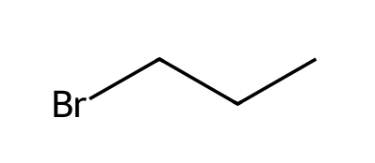
Why: Radical addition.
33. Propose a synthesis of pent-2-ene from pent-1-ene. [C11F09, Moderate]
Answer: (1) HBr (Markovnikov, gives 2-bromopentane); (2) NaOEt, heat (E2, Zaitsev product).
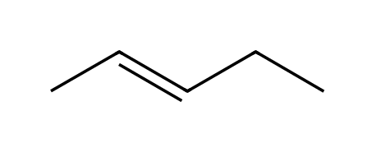
Why: Add then eliminate.
34. Propose a synthesis of cyclohexene from cyclohexane. [C11F10, Moderate]
Answer: (1) Br₂, hν; (2) NaOEt, heat.
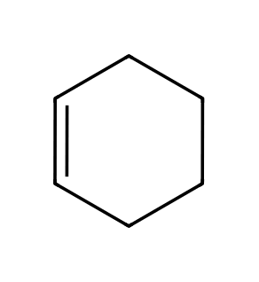
Why: Radical bromination then E2.
35. Propose a synthesis of 3-bromocyclohexene from cyclohexane. [C11F11, Moderate]
Answer: (1) Br₂, hν; (2) NaOEt, heat to give cyclohexene; (3) NBS, hν (allylic bromination).
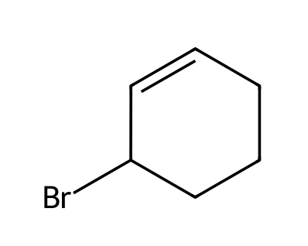
Why: Make the alkene, then brominate the allylic position.
36. Give a three-step route from but-1-ene to but-1-yne. [C11F12, Moderate]
Answer: (1) Br₂; (2) excess NaNH₂; (3) H₂O.
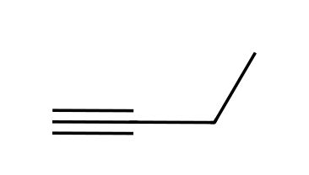
Why: Bromination, then double elimination.
37. Propose a synthesis of propane-1,2-diol (cis addition irrelevant) from 2-bromopropane. [C11F13, Moderate]
Answer: (1) NaOEt, heat to propene; (2) OsO₄, then NaHSO₃ (or mCPBA, then H₃O⁺).
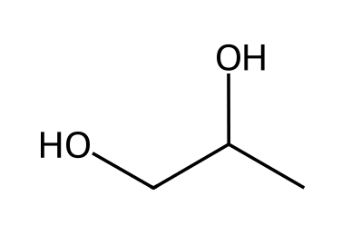
Why: Eliminate, then dihydroxylate.
38. Propose a synthesis of trans-cyclohexane-1,2-diol from cyclohexanol. [C11F14, Hard]
Answer: (1) H₂SO₄, heat (dehydration) to cyclohexene; (2) mCPBA; (3) H₃O⁺.
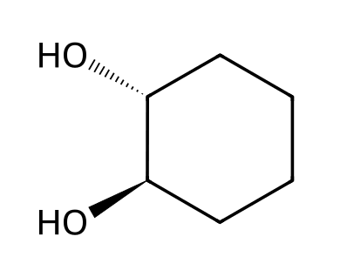
Why: Alkene first, then anti dihydroxylation.
39. Propose a synthesis of 2-methylpropan-1-ol from 2-bromo-2-methylpropane. [C11F15, Hard]
Answer: (1) t-BuOK, heat (E2, gives 2-methylpropene); (2) BH₃·THF; (3) H₂O₂, NaOH.
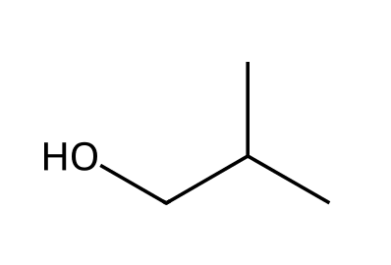
Why: Eliminate then anti-Markovnikov hydration.
40. Propose a synthesis of butanal from but-1-yne. [C11F16, Moderate]
Answer: (1) Sia₂BH (or 9-BBN); (2) H₂O₂, NaOH; the enol tautomerizes to butanal.
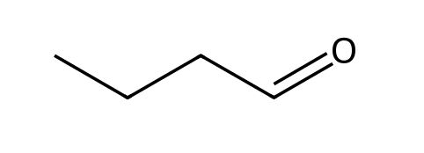
Why: Anti-Markovnikov hydration of a terminal alkyne.
41. Propose a synthesis of 2-bromopropane from propyne. [C11F45, Hard]
Answer: (1) H₂, Pt (to propane or use Lindlar to propene); (2) with propene, HBr. Using Lindlar: H₂, Lindlar gives propene, then HBr gives 2-bromopropane.
Why: Reduce the alkyne to the alkene, then add HBr.
42. Propose a synthesis of 1,2-dibromocyclohexane from cyclohexane. [C11F46, Moderate]
Answer: (1) Br₂, hν; (2) NaOEt, heat; (3) Br₂.
Why: Make the alkene, then add Br₂.
43. Give the reagents to convert propene into 1,2-dibromopropane. [C11F49, Basic]
Answer: Br₂.
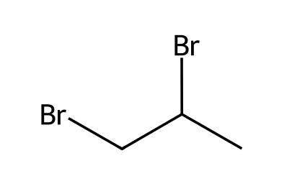
Why: Halogenation.

11.3 Reactions That Change the Carbon Skeleton
44. If the carbon skeleton gets larger, which kind of reaction is needed? [C11M16, Easy]
Answer: A) A C-C bond-forming reaction
Why: New carbons must be attached.
45. If the carbon skeleton gets smaller, which kind of reaction is needed? [C11M17, Easy]
Answer: B) A C-C bond cleavage such as ozonolysis
Why: Ozonolysis splits C=C or C≡C bonds.
46. Which reaction forms a new C-C bond? [C11M18, Basic]
Answer: C) An alkynide reacting with a primary alkyl halide
Why: Alkylation of alkynides is the Klein C-C bond-forming reaction in these chapters.
47. What is the product of propyne with (1) NaNH₂; (2) CH₃CH₂Br? [C11M19, Moderate]
Answer: B
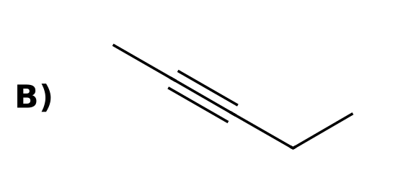
Why: Two carbons are added to the alkyne.
48. Which reagent sequence converts hex-3-yne into propanoic acid? [C11M20, Moderate]
Answer: C) (1) O₃; (2) H₂O
Why: Ozonolysis of an internal alkyne gives two carboxylic acids.
49. Which sequence converts acetylene into hex-3-yne? [C11M21, Moderate]
Answer: D) (1) NaNH₂; (2) EtBr; (3) NaNH₂; (4) EtBr
Why: Alkylate both terminal hydrogens.
50. Which compound is made from cyclohexene by (1) O₃; (2) DMS? [C11M22, Hard]
Answer: C) Hexanedial
Why: The ring is cleaved to a dialdehyde.
51. Which sequence makes pent-2-yne from propyne? [C11M23, Hard]
Answer: D) (1) NaNH₂; (2) CH₃CH₂Br
Why: Alkylation of the alkynide.
52. How do you decide whether a synthesis needs C-C bond formation or cleavage? [C11F17, Easy]
Answer: Compare the number of carbons in the starting material and the product: more carbons needs bond formation, fewer needs bond cleavage.
Why: Count the carbons.
53. Propose a synthesis of pent-2-yne from propyne. [C11F18, Basic]
Answer: (1) NaNH₂; (2) CH₃CH₂Br.
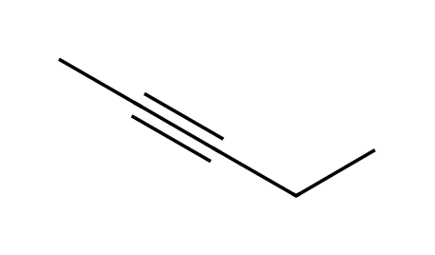
Why: Alkylate the alkynide.
54. Propose a synthesis of hex-3-yne from acetylene. [C11F19, Moderate]
Answer: (1) NaNH₂; (2) CH₃CH₂Br; (3) NaNH₂; (4) CH₃CH₂Br.
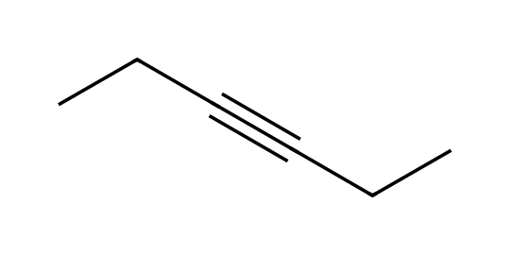
Why: Two alkylations.
55. Propose a synthesis of acetic acid from but-2-yne. [C11F20, Moderate]
Answer: (1) O₃; (2) H₂O. Two equivalents of acetic acid form.
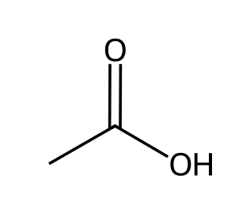
Why: Cleavage of the triple bond.
56. Propose a synthesis of acetone from 2-methylbut-2-ene. [C11F21, Moderate]
Answer: (1) O₃; (2) DMS (the other product is acetaldehyde).
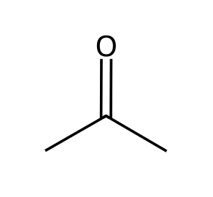
Why: Ozonolysis.
57. Propose a synthesis of hexanedial from cyclohexene. [C11F22, Moderate]
Answer: (1) O₃; (2) DMS.
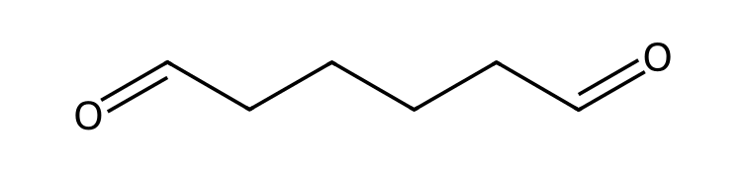
Why: Cleaves the ring.
58. Propose a synthesis of cis-pent-2-ene from propyne and bromoethane. [C11F23, Hard]
Answer: (1) NaNH₂; (2) CH₃CH₂Br; (3) H₂, Lindlar catalyst.
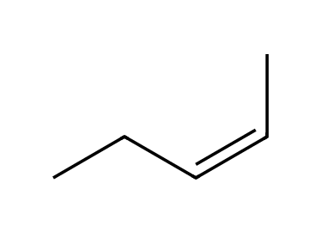
Why: Alkylate, then reduce to cis.
59. Propose a synthesis of trans-hex-3-ene from acetylene and bromoethane. [C11F24, Hard]
Answer: (1) NaNH₂; (2) CH₃CH₂Br; (3) NaNH₂; (4) CH₃CH₂Br; (5) Na, NH₃(l).
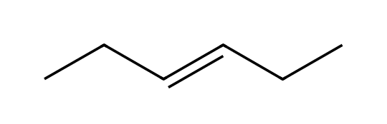
Why: Build hex-3-yne, then dissolving-metal reduction.
60. Propose a synthesis of butan-2-one from acetylene and bromoethane. [C11F25, Hard]
Answer: (1) NaNH₂; (2) CH₃CH₂Br to give but-1-yne; (3) H₂O, H₂SO₄, HgSO₄.
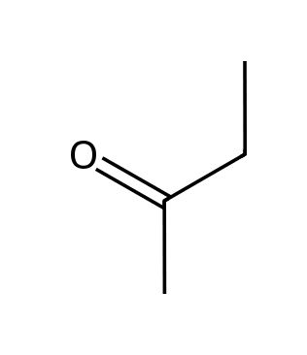
Why: Extend, then hydrate.
61. Propose a synthesis of propanoic acid from hex-3-yne. [C11F47, Moderate]
Answer: (1) O₃; (2) H₂O (two equivalents of propanoic acid form).
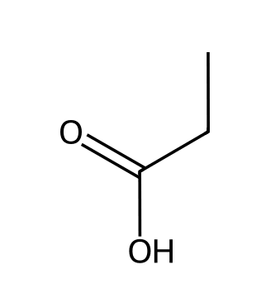
Why: Cleavage of an internal alkyne.
62. Give the reagents to convert 2-butene into two molecules of acetaldehyde. [C11F50, Basic]
Answer: (1) O₃; (2) DMS.
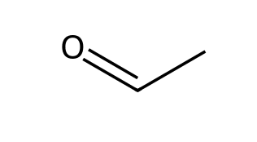
Why: Ozonolysis.

11.4 How to Approach a Synthesis Problem
63. What two questions should be asked first in a synthesis problem? [C11M24, Easy]
Answer: C) Does the carbon skeleton change? Does the functional group change identity or position?
Why: Klein section 11.3 states these two questions.
64. Comparing a starting material with a product, the product has two more carbon atoms. What is needed? [C11M25, Basic]
Answer: D) A C-C bond-forming step
Why: The skeleton must be extended.
65. Which transformation changes only the location of a functional group? [C11M26, Basic]
Answer: A) 1-Bromopropane → 2-bromopropane
Why: Both compounds have three carbons and a bromine, but the bromine moves.
66. The synthesis of butanal from but-1-yne requires: [C11M27, Moderate]
Answer: A) Anti-Markovnikov hydration (Sia₂BH; H₂O₂, NaOH)
Why: The carbonyl must end up at the terminal carbon.
67. Which change requires C-C bond cleavage? [C11M50, Moderate]
Answer: D) Cyclohexene to hexanedial
Why: The ring is broken open, so the skeleton changes by cleavage.
68. List the two questions to ask when approaching a synthesis problem. [C11F26, Basic]
Answer: Is there any change in the carbon skeleton? Is there any change in the identity and/or location of the functional group?
Why: Klein 11.3.
69. Does converting 1-butene into 1-butyne change the skeleton or only the functional group? [C11F27, Basic]
Answer: Only the functional group; both have four carbons.
Why: Count carbons.
70. Does converting propyne into pent-2-yne change the skeleton? What type of reaction is needed? [C11F28, Moderate]
Answer: Yes, it gains two carbons; a C-C bond-forming reaction (alkylation of the alkynide) is needed.
Why: Compare carbon counts.

11.5 Multi-Step Synthesis and Retrosynthetic Analysis
71. What is a retrosynthetic analysis? [C11M28, Easy]
Answer: B) Working backward from the product to the starting material
Why: The last step is identified first.
72. In a retrosynthetic analysis of 2-bromopropane from propane, what is the immediate precursor? [C11M29, Basic]
Answer: B) Propene
Why: Propene + HBr → 2-bromopropane.
73. A retrosynthesis of cis-hex-3-ene from acetylene and ethyl bromide ends with which last step? [C11M30, Moderate]
Answer: C) H₂, Lindlar catalyst on hex-3-yne
Why: The cis alkene is made by partial hydrogenation of the alkyne.
74. A retrosynthesis of 2-methylpropan-1-ol from 2-methylpropene ends with which last step? [C11M31, Moderate]
Answer: A) BH₃·THF; H₂O₂, NaOH
Why: Anti-Markovnikov hydration.
75. Which is the best precursor for a final step of anti-dihydroxylation giving trans-cyclohexane-1,2-diol? [C11M32, Hard]
Answer: D) Cyclohexene
Why: mCPBA then H₃O⁺ on the alkene.
76. A target is 2,2-dibromopropane. Which is the best immediate precursor? [C11M33, Hard]
Answer: B) Propyne
Why: Two equivalents of HBr add to propyne at the same carbon.
77. Define retrosynthetic analysis. [C11F29, Easy]
Answer: Working backward from the target molecule, identifying the last step first and the preceding compounds in turn until a simple starting material is reached.
Why: Backwards.
78. Write the retrosynthesis (last two steps) for 1-bromopropane from propane. [C11F30, Basic]
Answer: Target ⇒ propene (add HBr, ROOR) ⇒ 2-bromopropane (E2) ⇒ propane (Br₂, hν).
Why: Work backward.
79. Write the retrosynthesis for trans-cyclohexane-1,2-diol starting from cyclohexane. [C11F31, Moderate]
Answer: Target ⇐ epoxide/cyclohexene (mCPBA, H₃O⁺) ⇐ bromocyclohexane (NaOEt) ⇐ cyclohexane (Br₂, hν).
Why: Last step first.
80. Write the retrosynthesis for hex-3-yne from acetylene and bromoethane. [C11F32, Moderate]
Answer: Hex-3-yne ⇐ but-1-yne + ethyl bromide ⇐ acetylene + ethyl bromide, each time via an alkynide.
Why: Two alkylations.
81. Write the retrosynthesis for 2,2-dibromopropane from propane. [C11F33, Hard]
Answer: 2,2-Dibromopropane ⇐ propyne (2 HBr) ⇐ 1,2-dibromopropane (excess NaNH₂) ⇐ propene (Br₂) ⇐ 2-bromopropane (NaOEt) ⇐ propane (Br₂, hν).
Why: Work back through the alkyne.
82. Write the retrosynthesis for cis-pent-2-ene starting from acetylene and bromoalkanes. [C11F34, Hard]
Answer: cis-Pent-2-ene ⇐ pent-2-yne (H₂, Lindlar) ⇐ propyne + CH₃CH₂Br (NaNH₂) ⇐ acetylene + CH₃Br (NaNH₂).
Why: Build the alkyne then reduce.
83. Write the retrosynthesis for 2-methylpropan-1-ol starting from 2-methylpropane. [C11F35, Hard]
Answer: Target ⇐ 2-methylpropene (BH₃; H₂O₂, NaOH) ⇐ 2-bromo-2-methylpropane (t-BuOK or NaOEt) ⇐ 2-methylpropane (Br₂, hν).
Why: Radical bromination is selective for the tertiary C-H.

11.6 Green Chemistry
84. What is green chemistry? [C11M34, Easy]
Answer: A) Designing reactions that minimize negative impacts on the environment
Why: It aims to reduce waste and hazards.
85. What does a high atom economy mean? [C11M35, Basic]
Answer: D) Most atoms of the reactants end up in the desired product
Why: Less waste is produced.
86. Atom economy of CH₃CH=CH₂ + HBr → CH₃CHBrCH₃ is: [C11M36, Moderate]
Answer: A) 100%
Why: An addition uses all atoms of both reactants.
87. Which has the lower atom economy? [C11M37, Hard]
Answer: B) Elimination of HBr from 2-bromopropane with NaOEt
Why: Eliminations produce a byproduct (salt plus alcohol).
88. Define green chemistry in your own words. [C11F36, Easy]
Answer: Designing chemical reactions and processes to minimize their negative effects on the environment.
Why: Reduce waste and hazard.
89. Calculate the atom economy of CH₃CH=CH₂ + HBr → CH₃CHBrCH₃. [C11F37, Basic]
Answer: 100%, since all atoms of both reactants appear in the product.
Why: Addition reactions use all atoms.
90. Estimate the atom economy of CH₃CHBrCH₃ + NaOCH₂CH₃ → CH₃CH=CH₂ + NaBr + CH₃CH₂OH. (Molar masses: product 42.1; reactants 123.0 + 68.1.) [C11F38, Moderate]
Answer: About 22% (42.1/191.1); the rest is wasted as NaBr and ethanol.
Why: Product mass divided by total reactant mass.
91. Explain why an addition reaction is typically greener than an elimination reaction. [C11F39, Moderate]
Answer: Addition incorporates every atom of the reactants in the product (100% atom economy), whereas elimination releases a byproduct such as a salt and an alcohol.
Why: Atom economy.
92. Give two ways a chemist can make a synthesis greener. [C11F40, Moderate]
Answer: Use fewer steps and reagents, choose safer solvents, use catalysts instead of stoichiometric reagents, or choose routes with higher atom economy.
Why: Many answers are possible.

11.7 Practical Tips for Increasing Proficiency
93. Which is generally the best approach to a synthesis problem? [C11M38, Easy]
Answer: B) Use the fewest reliable steps
Why: Efficiency matters.
94. Why is learning the reagents from Chapters 7 to 10 essential for synthesis? [C11M39, Basic]
Answer: C) Each synthesis is built from those known reactions
Why: Mastery of reactions is the foundation.
95. Which is NOT a good strategy when planning a synthesis? [C11M40, Moderate]
Answer: A) Ignoring regiochemistry and stereochemistry
Why: You must control where and how groups are added.
96. Several different routes give the same correct product. How should you choose? [C11M41, Moderate]
Answer: C) Prefer the route with fewer steps and better selectivity
Why: Efficiency and selectivity are priorities.
97. Why might two correct synthesis routes differ in quality? [C11F41, Basic]
Answer: One may use fewer steps, higher-yielding reactions or more selective reagents; shorter, selective routes are preferred.
Why: Efficiency.
98. Why must regiochemistry be considered when planning an alkene-to-alcohol step? [C11F42, Moderate]
Answer: Acid-catalyzed hydration (or oxymercuration) puts OH on the more substituted carbon, hydroboration on the less substituted carbon, so the reagent determines which constitutional isomer forms.
Why: Markovnikov vs anti-Markovnikov.
99. Why does the stereochemistry of an addition step matter in synthesis? [C11F43, Moderate]
Answer: Syn and anti additions give different stereoisomers (for example, cis vs trans diols), so the reagent must be chosen to give the required stereoisomer.
Why: Syn vs anti.
100. Propose a synthesis of cis-cyclohexane-1,2-diol from bromocyclohexane. [C11F44, Hard]
Answer: (1) NaOEt, heat (E2) to give cyclohexene; (2) OsO₄, then NaHSO₃/H₂O.
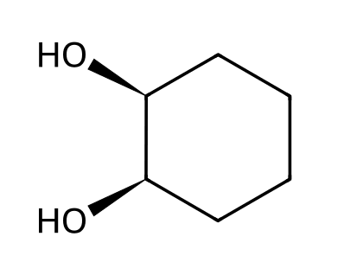
Why: Eliminate then syn dihydroxylation.

