Chapter 10: Radical Reactions
Organic chemistry questions. Multiple choice first within each textbook section.
Name: ______________________________ Date: ______________

10.1 Radicals
1. What is a radical? [C10M01, Easy]
A) A species with a positive charge on carbon
B) A species with a lone pair and a negative charge
C) A species with an unpaired electron
D) A species with an empty p orbital only
2. What kind of arrow shows the movement of a single electron? [C10M02, Easy]
A) A full-headed curved arrow
B) An equilibrium arrow
C) A fishhook (half-headed) arrow
D) A straight arrow
3. Which radical is the most stable? [C10M03, Basic]
A) Secondary
B) Primary
C) Methyl
D) Tertiary
4. Which radical is stabilised by resonance? [C10M04, Basic]
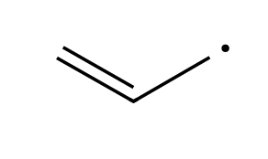
A) The vinyl radical, CH₂=CH•
B) The methyl radical
C) The allyl radical, CH₂=CH-CH₂•
D) The ethyl radical
5. Rank these radicals from most stable to least stable: methyl, primary, secondary, allylic. [C10M05, Moderate]
A) Secondary > allylic > primary > methyl
B) Allylic > secondary > primary > methyl
C) Methyl > primary > secondary > allylic
D) Allylic > methyl > primary > secondary
6. How many resonance structures does the allyl radical have? [C10M06, Moderate]
A) 1
B) 3
C) 2
D) 4
7. What is a radical, and what arrow shows its reactions? [C10F01, Easy]

8. Rank the radicals methyl, primary, secondary and tertiary by stability. [C10F02, Basic]

9. Explain why the allyl radical is more stable than a primary alkyl radical. [C10F03, Basic]

10. Draw the two resonance structures of the allyl radical. [C10F04, Moderate]

11. Why is a vinylic radical not stabilised by resonance? [C10F05, Moderate]

12. Which is more stable, a secondary radical or a primary radical? Give the reason. [C10F48, Basic]

10.2 Common Patterns in Radical Mechanisms
13. A step in which a bond breaks and each atom keeps one electron is called: [C10M07, Easy]
A) Heterolytic cleavage
B) Hydride shift
C) Proton transfer
D) Homolytic cleavage
14. The three stages of a radical chain reaction are: [C10M08, Easy]
A) Initiation, propagation and termination
B) Addition, elimination and substitution
C) Protonation, attack and deprotonation
D) Reduction, oxidation and hydrolysis
15. Which step type consumes one radical and produces one radical? [C10M09, Basic]
A) Initiation
B) Termination
C) Propagation
D) Homolysis of an initiator
16. A step in which two radicals combine to form a stable molecule is: [C10M10, Basic]
A) Initiation
B) Termination
C) Propagation
D) Homolysis
17. A step that creates radicals from a molecule with no radicals present is: [C10M11, Basic]
A) Propagation
B) Termination
C) Chain transfer
D) Initiation
18. Cl• + CH₄ → HCl + CH₃• is which type of radical step? [C10M12, Moderate]
A) Homolytic cleavage (initiation)
B) Hydrogen abstraction (propagation)
C) Coupling (termination)
D) Addition to a π bond
19. CH₃• + Cl₂ → CH₃Cl + Cl• is which type of radical step? [C10M13, Moderate]
A) Hydrogen abstraction (propagation)
B) Coupling (termination)
C) Halogen abstraction (propagation)
D) Homolytic cleavage (initiation)
20. Name the three stages of a radical chain mechanism. [C10F06, Easy]

21. List the six kinds of radical steps. [C10F07, Basic]

22. Classify Cl• + CH₄ → HCl + CH₃• as initiation, propagation or termination, and as a step type. [C10F08, Basic]

23. Explain why a termination step ends the chain. [C10F09, Moderate]

10.3 Chlorination of Methane
24. What conditions start the chlorination of methane? [C10M14, Easy]
A) Light (hν) or heat
B) A strong base
C) A strong acid
D) A metal catalyst only
25. What is the initiation step in the chlorination of methane? [C10M15, Basic]
A) Cl-Cl → 2 Cl•
B) CH₄ → CH₃• + H•
C) Cl• + CH₄ → HCl + CH₃•
D) CH₃• + Cl• → CH₃Cl
26. Why is the chlorination of methane called a chain reaction? [C10M16, Basic]
A) It forms long polymers
B) It needs many catalysts
C) The two propagation steps regenerate the radical that starts the cycle
D) It runs in many solvents
27. Which compound is formed in a termination step of methane chlorination? [C10M17, Moderate]
A) Chloroform
B) Ethane
C) Methanol
D) Hydrogen
28. What is the net reaction of the two propagation steps of methane chlorination? [C10M18, Moderate]
A) CH₄ + Cl₂ → CH₃Cl + HCl
B) CH₄ + 2 Cl₂ → CH₂Cl₂ + 2 HCl
C) CH₄ + Cl• → CH₃Cl + H•
D) 2 CH₄ → C₂H₆ + H₂
29. Write the initiation step of the chlorination of methane. [C10F10, Basic]

30. Write both propagation steps of the chlorination of methane. [C10F11, Basic]

31. Show that the two propagation steps add up to the net reaction. [C10F12, Moderate]

32. Give three possible termination steps in the chlorination of methane. [C10F13, Moderate]

33. Why is a small amount of light enough to convert a large amount of methane to chloromethane? [C10F14, Moderate]

34. What does hν mean in a reaction scheme? [C10F49, Easy]

10.4 Thermodynamic Considerations
35. Bromination of an alkane is generally ______ chlorination. [C10M19, Basic]
A) Faster than
B) Slower than
C) Identical in rate to
D) Not possible, unlike
36. Use C-H 414, Cl-Cl 243, C-Cl 339 and H-Cl 431 kJ/mol. What is ΔH for CH₃• + Cl₂ → CH₃Cl + Cl•? [C10M20, Moderate]
A) +96 kJ/mol
B) −17 kJ/mol
C) +17 kJ/mol
D) −96 kJ/mol
37. Use C-H 414 and H-Cl 431 kJ/mol. What is ΔH for Cl• + CH₄ → HCl + CH₃•? [C10M21, Moderate]
A) +17 kJ/mol
B) −845 kJ/mol
C) +845 kJ/mol
D) −17 kJ/mol
38. Use C-H 414, Cl-Cl 243, C-Cl 339 and H-Cl 431 kJ/mol to calculate ΔH for each propagation step of methane chlorination. [C10F15, Moderate]

39. Which is more practical in the laboratory: radical chlorination or radical iodination? Explain briefly. [C10F16, Basic]

10.5 Selectivity of Halogenation
40. Radical halogenation occurs more readily at which kind of hydrogen? [C10M22, Easy]
A) Tertiary C-H
B) Primary C-H
C) Methyl C-H
D) All equally
41. Which halogen is more selective in radical halogenation? [C10M23, Basic]
A) Chlorine
B) They are equally selective
C) Neither
D) Bromine
42. What is the major product of isobutane (2-methylpropane) with Br₂, hν? [C10M24, Moderate]
A)  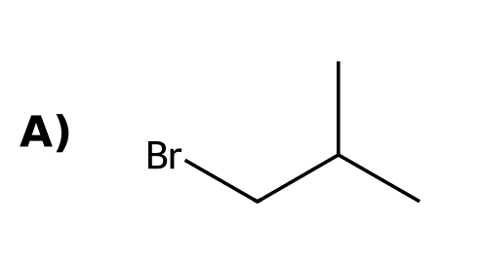 | B)  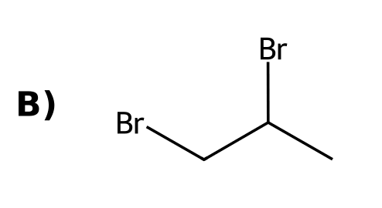
C)  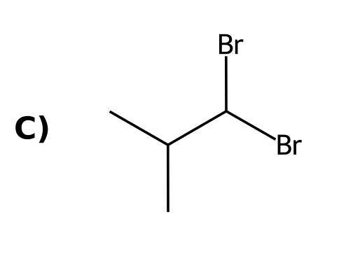 | D)  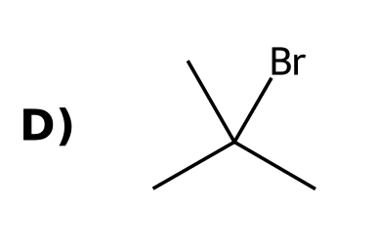
43. How many different monochlorination products (constitutional isomers) can propane give? [C10M25, Moderate]
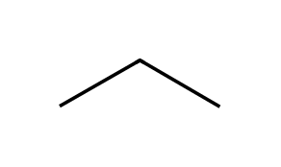
A) 2
B) 1
C) 3
D) 4
44. How many monochlorination products (constitutional isomers) can 2-methylpropane give? [C10M26, Moderate]
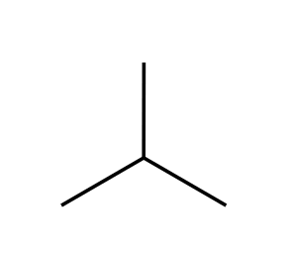
A) 1
B) 3
C) 2
D) 4
45. In the chlorination of 2-methylbutane, the monochloro product ratio is not simply 9:2:1 because: [C10M27, Hard]
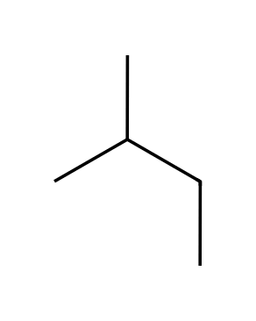
A) Tertiary hydrogens are more reactive per hydrogen
B) Primary hydrogens are more reactive
C) Chlorine is very selective
D) All hydrogens are equally reactive
46. Explain why radical halogenation occurs more readily at tertiary hydrogens. [C10F17, Basic]

47. Which is more selective, bromination or chlorination, and why? [C10F18, Basic]

48. Draw the major product of isobutane with Br₂, hν and explain. [C10F19, Moderate]

49. Draw all monochlorination products of propane. [C10F20, Moderate]

50. Chlorination of 2-methylbutane gives four monochloro constitutional isomers. Draw them. [C10F21, Hard]

10.6 Stereochemistry of Halogenation
51. Radical bromination creates a new chirality center in a molecule. What is the stereochemical outcome? [C10M28, Basic]
A) Only one enantiomer
B) Inversion only
C) Retention only
D) Both stereoisomers form in equal amounts
52. (R)-3-Methylhexane undergoes radical bromination at C3. What is the product? [C10M29, Moderate]
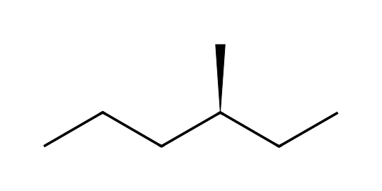
A) (R)-3-Bromo-3-methylhexane only
B) (S)-3-Bromo-3-methylhexane only
C) A racemic mixture of 3-bromo-3-methylhexane
D) No reaction
53. Why does halogenation at a chirality center give a racemic mixture? [C10M30, Hard]
A) The reaction proceeds by SN2 inversion
B) The intermediate radical is planar and is attacked equally from both faces
C) The halogen adds only from one side
D) The chirality center is destroyed in a carbocation
54. Radical bromination of butane at C2 creates a chirality center. What is the stereochemical result? [C10F22, Basic]
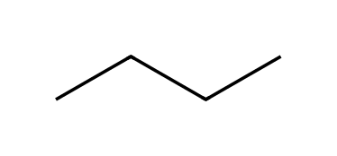

55. Explain why bromination of optically pure (R)-3-methylhexane at C3 gives an optically inactive product. [C10F23, Moderate]

56. Why does the chirality of a starting material not control the outcome of a radical substitution at that center? [C10F24, Moderate]

10.7 Allylic Bromination
57. Which reagent is used for allylic bromination? [C10M31, Easy]
A) HBr
B) Br₂ in the dark
C) NaBr
D) NBS
58. What is the major product of cyclohexene with NBS, hν? [C10M32, Basic]
A)  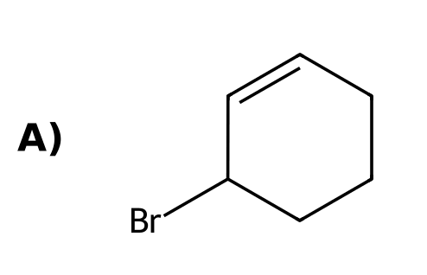 | B)  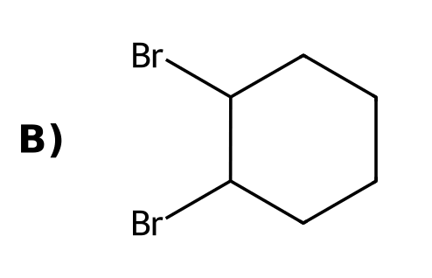
C)  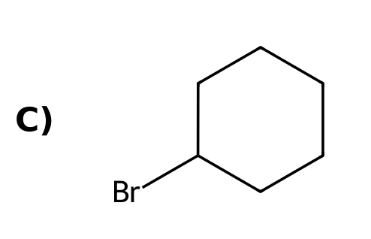 | D)  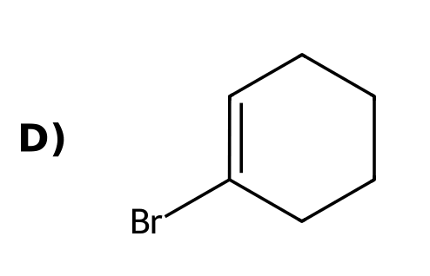
59. Why is NBS used instead of Br₂ for allylic bromination of an alkene? [C10M33, Basic]
A) To speed up the ionic addition
B) To make the alkene more reactive
C) To keep Br₂ concentration low and avoid ionic addition to the double bond
D) To make HBr
60. Which hydrogen of 1-butene is removed in allylic bromination? [C10M34, Moderate]
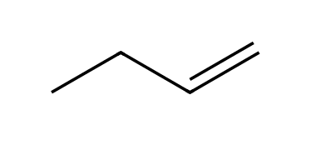
A) A hydrogen on C1
B) A hydrogen on C3
C) A hydrogen on C2
D) A hydrogen on C4
61. Why does allylic bromination of an unsymmetrical alkene often give two products? [C10M35, Moderate]
A) Two initiation steps occur
B) The allylic radical has two resonance structures
C) The ring opens
D) Bromine adds twice
62. What reagent is used for allylic bromination? [C10F25, Easy]

63. Draw the product of cyclohexene with NBS, hν. [C10F26, Basic]
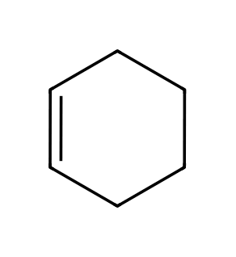

64. Draw the product of propene with NBS, hν. [C10F27, Basic]
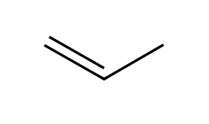

65. Why does Br₂ at high concentration add to alkenes but NBS gives allylic substitution? [C10F28, Moderate]

66. Explain why allylic bromination of 1-butene can give two products. [C10F29, Moderate]

67. Outline the mechanism of allylic bromination of cyclohexene with NBS: name the two propagation steps. [C10F30, Hard]

10.8 Atmospheric Chemistry and the Ozone Layer
68. Which compounds were responsible for depleting stratospheric ozone? [C10M36, Easy]
A) CFCs (chlorofluorocarbons)
B) HFCs
C) Alkanes
D) Alkenes
69. What replaced CFCs as refrigerants? [C10M37, Basic]
A) Hydrofluorocarbons (HFCs)
B) Freons
C) Chloroform
D) Carbon tetrachloride
70. What are CFCs, and what problem did they cause? [C10F31, Easy]

71. Why were HFCs introduced as replacements for CFCs? [C10F32, Basic]

10.9 Autooxidation and Antioxidants
72. What is autooxidation? [C10M38, Easy]
A) Reaction with a strong acid
B) Reaction of an organic compound with atmospheric oxygen via radicals to give hydroperoxides
C) Reaction with water
D) A reduction by hydrogen
73. What does an antioxidant such as BHT do? [C10M39, Basic]
A) Creates radicals
B) Adds oxygen to alkenes
C) Catalyses polymerisation
D) Traps radicals and stops the chain reaction
74. Which is a natural antioxidant? [C10M40, Basic]
A) Freon
B) Peroxide
C) Chloroform
D) Vitamin E
75. Which compound is a radical initiator? [C10M41, Moderate]
A) Hydroquinone
B) A peroxide (such as ROOR)
C) BHT
D) O₂
76. What is autooxidation? [C10F33, Easy]

77. Explain how BHT preserves foods. [C10F34, Basic]

78. Name two natural antioxidants. [C10F35, Moderate]

79. What is a radical inhibitor? Give one example. [C10F50, Basic]

10.10 Radical Addition of HBr: Anti-Markovnikov
80. What is the major product of 1-butene with HBr in the presence of peroxides? [C10M42, Basic]
A)  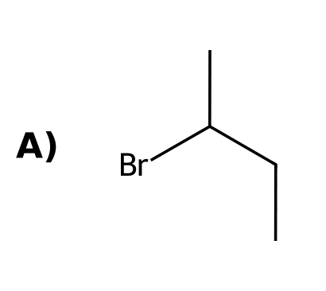 | B)  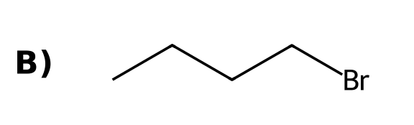
C)  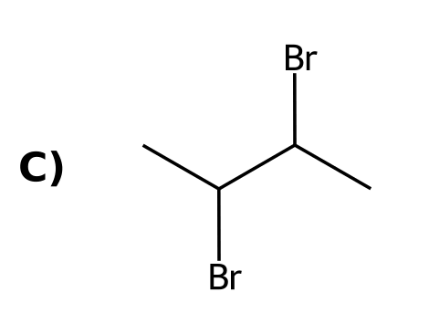 | D)  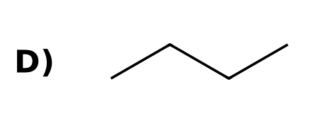
81. In radical addition of HBr to propene, which radical does Br• create? [C10M43, Moderate]
A) A primary radical (Br adds to C2)
B) A carbocation
C) A secondary radical (Br adds to the terminal carbon)
D) A carbanion
82. HCl adds to alkenes with peroxides in an anti-Markovnikov sense. [C10M44, Moderate]
A) True
B) False: only HBr works well in the radical chain
C) True, only for tertiary alkenes
D) True, only for rings
83. What conditions cause HBr to add to an alkene in an anti-Markovnikov sense? [C10F36, Easy]

84. Draw the product of propene with HBr in the presence of peroxides. [C10F37, Basic]

85. Explain the regiochemistry of radical addition of HBr to propene. [C10F38, Moderate]

86. Why does radical addition work for HBr but not for HCl or HI? [C10F39, Moderate]

10.11 Radical Polymerization
87. What is the repeating unit of polyethylene made from? [C10M45, Easy]
A) Propylene
B) Styrene
C) Ethylene (ethene)
D) Vinyl chloride
88. PVC is made by polymerizing: [C10M46, Basic]
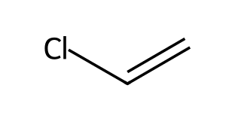
A) Chloroethane
B) Ethylene
C) Chlorobenzene
D) Vinyl chloride
89. Which type of step grows the polymer chain in radical polymerisation? [C10M47, Moderate]
A) Addition of a radical to a π bond
B) Hydrogen abstraction
C) Termination
D) Homolysis of an initiator
90. What monomer gives polyvinyl chloride (PVC)? [C10F40, Easy]

91. Explain why polymerisation of ethylene through a radical process gives chain branching. [C10F41, Basic]

92. Draw the repeating unit of polyvinyl chloride and the monomer it comes from. [C10F42, Moderate]

10.12 Radical Processes in the Petrochemical Industry
93. What is cracking in the petrochemical industry? [C10M48, Basic]
A) Breaking large hydrocarbons into smaller ones
B) Joining small molecules
C) Adding oxygen
D) Removing hydrogen from rings
94. What is cracking? [C10F43, Basic]

10.13 Halogenation as a Synthetic Technique
95. To convert 2-methylbutane into 2-methylbut-2-ene, a good route is: [C10M49, Moderate]
A) (1) NBS; (2) H₂O
B) (1) Br₂, hν; (2) NaOEt, heat
C) (1) HBr; (2) Mg
D) (1) H₂, Pt; (2) Br₂
96. To convert propane into propene, which two steps are best? [C10M50, Hard]
A) (1) Br₂, hν; (2) NaOEt, heat
B) (1) Cl₂, hν; (2) NaOH, cold
C) (1) NBS; (2) H₂O
D) (1) HBr; (2) KOH
97. Propose a synthesis of 2-methylbut-2-ene from 2-methylbutane. [C10F44, Moderate]

98. Propose a synthesis of trans-cyclohexane-1,2-diol from cyclohexane. [C10F45, Hard]
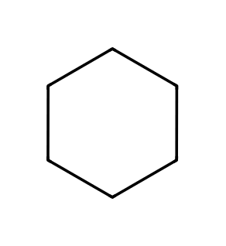

99. Propose a synthesis of 1-bromopropane from propane. [C10F46, Hard]

100. Why is radical bromination preferred over chlorination when a single product is wanted? [C10F47, Moderate]

