Chapter 11: Multi-Step Synthesis
Organic chemistry questions. Multiple choice first within each textbook section.
Name: ______________________________ Date: ______________

11.1 One-Step Syntheses
1. What is the product of propene with H₂ and Pt? [C11M01, Easy]
A)  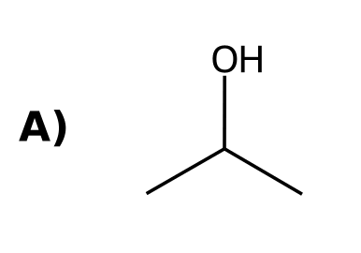 | B)  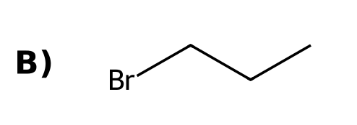
C)  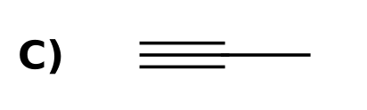 | D)  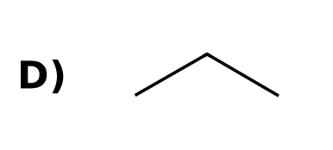
2. What is the product of cyclohexene with Br₂? [C11M02, Basic]
A)  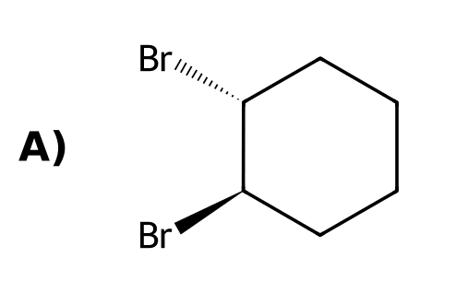 | B)  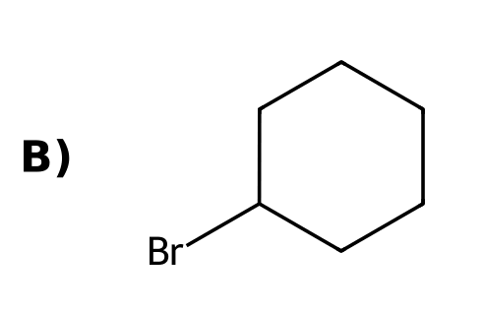
C)  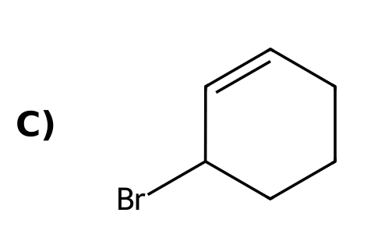 | D)  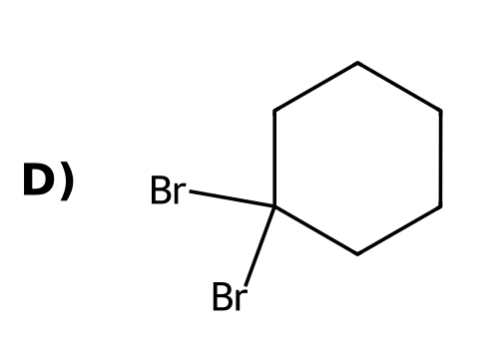
3. What is the product of 2-bromopropane with NaOEt and heat? [C11M03, Basic]
A)  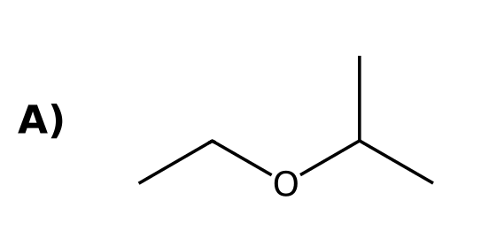 | B)  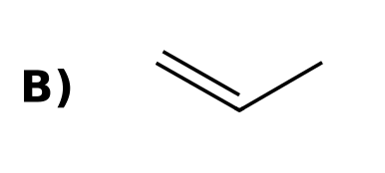
C)  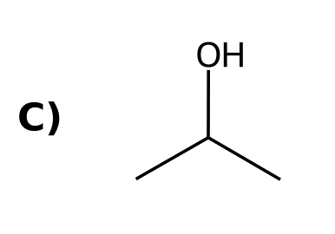 | D)
4. What is the product of 1-bromobutane with NaCN? [C11M04, Basic]
A)  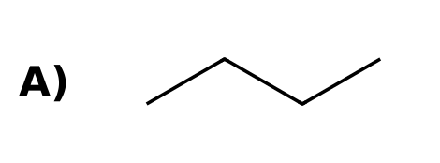 | B)  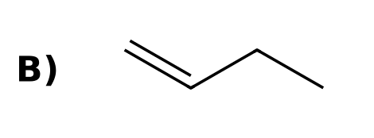
C)  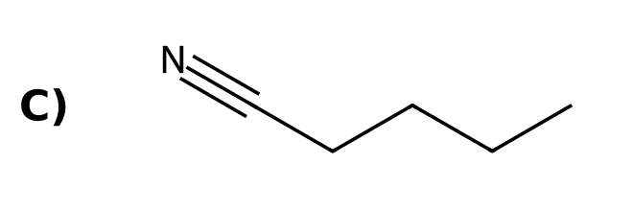 | D)  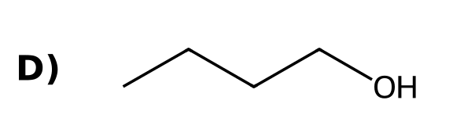
5. Which reagents convert an alkene into an alcohol with Markovnikov regiochemistry? [C11M05, Easy]
A) BH₃·THF; H₂O₂, NaOH
B) H₂, Pt
C) O₃; DMS
D) H₂O, H₂SO₄
6. Which reagent converts a terminal alkyne into a methyl ketone? [C11M06, Easy]
A) H₂, Lindlar
B) NaNH₂
C) H₂O, H₂SO₄, HgSO₄
D) O₃, DMS
7. Which reagent converts an alkene into an epoxide? [C11M07, Basic]
A) mCPBA
B) OsO₄
C) BH₃
D) NBS
8. Which reagent converts an alkene into an alkane? [C11M45, Easy]
A) H₂, Pt
B) HBr
C) Br₂
D) O₃
9. Which reagents cleave an alkene into two carbonyl compounds? [C11M46, Easy]
A) H₂, Pt
B) BH₃, then H₂O₂
C) O₃, then DMS
D) NBS
10. Which reagent adds Br across a double bond? [C11M47, Basic]
A) NBS
B) Br₂
C) NaBr
D) HBr with peroxides
11. Give the reagents to convert propene into propane. [C11F01, Easy]
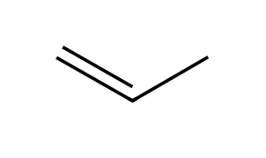

12. Give the reagents to convert cyclohexene into trans-1,2-dibromocyclohexane. [C11F02, Basic]
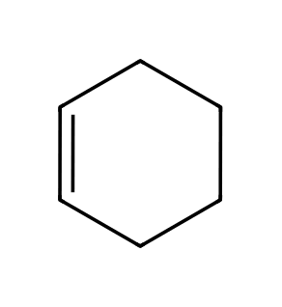

13. Give the reagents to convert but-2-yne into trans-but-2-ene. [C11F03, Basic]
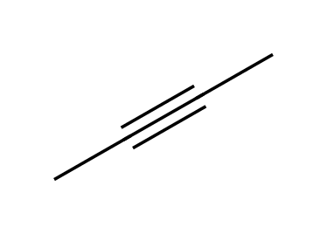

14. Give the reagents to convert but-2-yne into cis-but-2-ene. [C11F04, Basic]

15. Give the reagents to convert 1-methylcyclohexene into 1-methylcyclohexan-1-ol and into trans-2-methylcyclohexan-1-ol. [C11F05, Moderate]
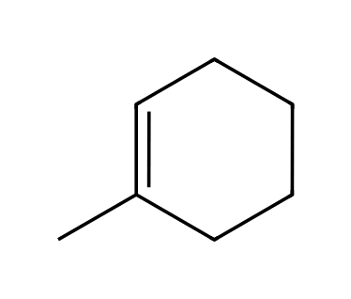

16. Give the product of 3-methylbut-1-ene with (1) Hg(OAc)₂, H₂O; (2) NaBH₄, and explain why this reagent is used instead of H₂SO₄/H₂O. [C11F06, Moderate]
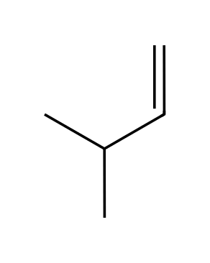

17. Give the reagents to convert propyne into propene. [C11F48, Easy]
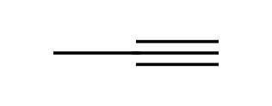

11.2 Functional Group Transformations
18. How can the position of a halogen be changed? [C11M08, Basic]
A) Addition followed by hydrogenation
B) Elimination followed by addition
C) Ozonolysis
D) Substitution twice
19. How can the position of a π bond be changed? [C11M09, Basic]
A) Elimination followed by addition
B) Hydrogenation
C) Ozonolysis
D) Addition followed by elimination
20. Which sequence converts 1-bromopropane into 2-bromopropane? [C11M10, Moderate]
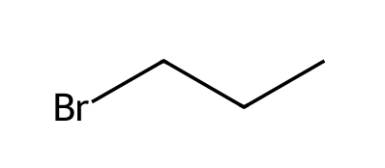
A) (1) NaOEt, heat; (2) HBr
B) (1) HBr; (2) NaOEt
C) (1) H₂O; (2) HBr
D) (1) NBS; (2) HBr
21. Which sequence converts 1-pentene into 2-pentene? [C11M11, Moderate]
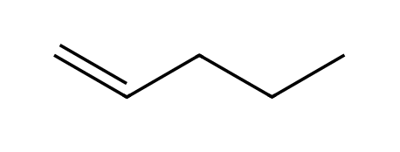
A) (1) HBr; (2) NaOEt, heat
B) (1) H₂, Pt; (2) Br₂
C) (1) BH₃; (2) H₂O₂
D) (1) O₃; (2) DMS
22. Which sequence converts an alkane into an alkene? [C11M12, Moderate]
A) (1) HBr; (2) NaOH
B) (1) Br₂, hν; (2) NaOEt, heat
C) (1) H₂, Pt; (2) NBS
D) (1) O₃; (2) DMS
23. Which sequence converts but-1-ene into but-1-yne? [C11M13, Moderate]
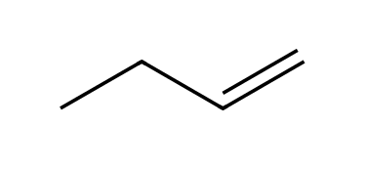
A) (1) HBr; (2) NaNH₂
B) (1) H₂, Pt; (2) NaNH₂
C) (1) O₃; (2) DMS
D) (1) Br₂; (2) excess NaNH₂; (3) H₂O
24. Which sequence converts an alkyne into a trans alkene? [C11M14, Moderate]
A) H₂, Lindlar
B) Na, NH₃(l)
C) H₂, Pt
D) BH₃; H₂O₂
25. Which sequence converts cyclohexane into trans-cyclohexane-1,2-diol? [C11M15, Hard]
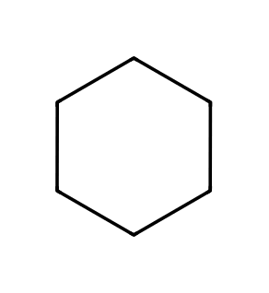
A) (1) Br₂, hν; (2) NaOEt; (3) OsO₄; (4) NaHSO₃
B) (1) HBr; (2) NaOEt; (3) H₂O
C) (1) Br₂, hν; (2) NaOEt; (3) mCPBA; (4) H₃O⁺
D) (1) Cl₂, hν; (2) NaOH; (3) OsO₄
26. To convert propene into 1,2-dibromopropane use: [C11M42, Moderate]
A) HBr
B) NBS
C) Br₂
D) H₂, Pt
27. To convert cyclohexene into cis-cyclohexane-1,2-diol use: [C11M43, Moderate]
A) mCPBA, then H₃O⁺
B) Br₂, then NaOH
C) H₂, Pt
D) OsO₄, then NaHSO₃
28. Which sequence converts 2-bromo-2-methylpropane into 2-methylpropan-1-ol? [C11M44, Hard]
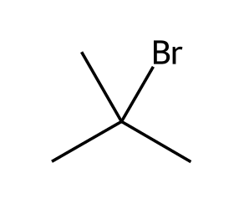
A) (1) NaOH
B) (1) HBr; (2) NaOH
C) (1) H₂O, heat
D) (1) t-BuOK; (2) BH₃·THF; (3) H₂O₂, NaOH
29. Which reagent brominates the allylic position of an alkene? [C11M48, Basic]
A) Br₂ in the dark
B) NBS with light
C) HBr
D) NaBr
30. Which reagent converts a vicinal dibromide into an alkyne? [C11M49, Basic]
A) Excess NaNH₂
B) H₂, Pt
C) NaOH, cold
D) HBr
31. Propose a synthesis of 2-bromopropane from 1-bromopropane. [C11F07, Basic]

32. Show how to convert 2-bromopropane into 1-bromopropane in two steps. [C11F08, Basic]
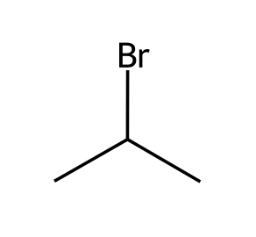

33. Propose a synthesis of pent-2-ene from pent-1-ene. [C11F09, Moderate]

34. Propose a synthesis of cyclohexene from cyclohexane. [C11F10, Moderate]

35. Propose a synthesis of 3-bromocyclohexene from cyclohexane. [C11F11, Moderate]

36. Give a three-step route from but-1-ene to but-1-yne. [C11F12, Moderate]

37. Propose a synthesis of propane-1,2-diol (cis addition irrelevant) from 2-bromopropane. [C11F13, Moderate]

38. Propose a synthesis of trans-cyclohexane-1,2-diol from cyclohexanol. [C11F14, Hard]
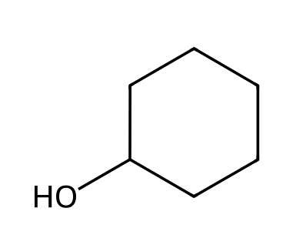

39. Propose a synthesis of 2-methylpropan-1-ol from 2-bromo-2-methylpropane. [C11F15, Hard]

40. Propose a synthesis of butanal from but-1-yne. [C11F16, Moderate]
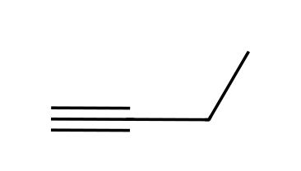

41. Propose a synthesis of 2-bromopropane from propyne. [C11F45, Hard]

42. Propose a synthesis of 1,2-dibromocyclohexane from cyclohexane. [C11F46, Moderate]

43. Give the reagents to convert propene into 1,2-dibromopropane. [C11F49, Basic]

11.3 Reactions That Change the Carbon Skeleton
44. If the carbon skeleton gets larger, which kind of reaction is needed? [C11M16, Easy]
A) A C-C bond-forming reaction
B) A C-C bond cleavage
C) An elimination
D) A hydrogenation
45. If the carbon skeleton gets smaller, which kind of reaction is needed? [C11M17, Easy]
A) Alkylation of an alkyne
B) A C-C bond cleavage such as ozonolysis
C) Hydrogenation
D) Hydroboration
46. Which reaction forms a new C-C bond? [C11M18, Basic]
A) Hydration of an alkene
B) Hydrogenation of an alkene
C) An alkynide reacting with a primary alkyl halide
D) Bromination of an alkene
47. What is the product of propyne with (1) NaNH₂; (2) CH₃CH₂Br? [C11M19, Moderate]
A)  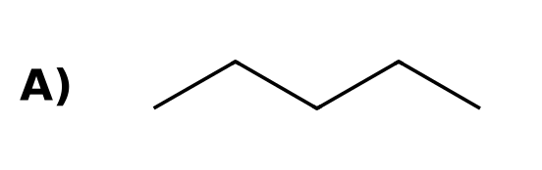 | B)  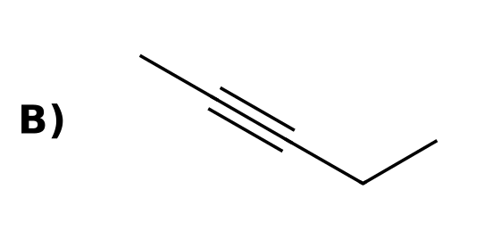
C)  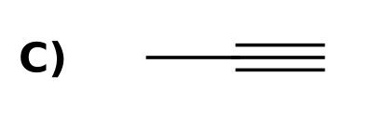 | D)  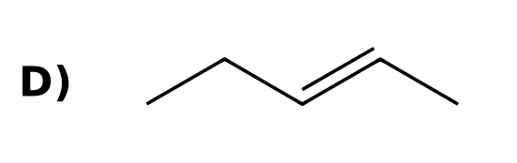
48. Which reagent sequence converts hex-3-yne into propanoic acid? [C11M20, Moderate]
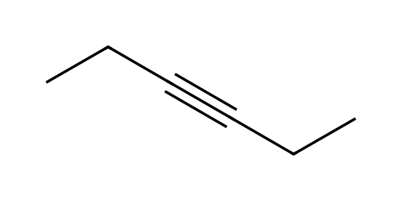
A) (1) H₂, Lindlar
B) (1) NaNH₂; (2) CH₃I
C) (1) O₃; (2) H₂O
D) (1) Br₂
49. Which sequence converts acetylene into hex-3-yne? [C11M21, Moderate]
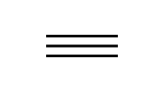
A) (1) H₂O, HgSO₄; (2) EtBr
B) (1) NaOH; (2) EtBr
C) (1) Br₂; (2) EtBr
D) (1) NaNH₂; (2) EtBr; (3) NaNH₂; (4) EtBr
50. Which compound is made from cyclohexene by (1) O₃; (2) DMS? [C11M22, Hard]
A) Cyclohexane-1,2-diol
B) Hexanedioic acid
C) Hexanedial
D) Cyclohexanone
51. Which sequence makes pent-2-yne from propyne? [C11M23, Hard]
A) (1) NaOH; (2) CH₃CH₂Br
B) (1) H₂O, HgSO₄
C) (1) HBr; (2) CH₃CH₂Br
D) (1) NaNH₂; (2) CH₃CH₂Br
52. How do you decide whether a synthesis needs C-C bond formation or cleavage? [C11F17, Easy]

53. Propose a synthesis of pent-2-yne from propyne. [C11F18, Basic]

54. Propose a synthesis of hex-3-yne from acetylene. [C11F19, Moderate]

55. Propose a synthesis of acetic acid from but-2-yne. [C11F20, Moderate]

56. Propose a synthesis of acetone from 2-methylbut-2-ene. [C11F21, Moderate]
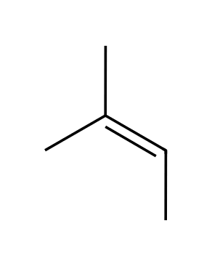

57. Propose a synthesis of hexanedial from cyclohexene. [C11F22, Moderate]

58. Propose a synthesis of cis-pent-2-ene from propyne and bromoethane. [C11F23, Hard]

59. Propose a synthesis of trans-hex-3-ene from acetylene and bromoethane. [C11F24, Hard]

60. Propose a synthesis of butan-2-one from acetylene and bromoethane. [C11F25, Hard]

61. Propose a synthesis of propanoic acid from hex-3-yne. [C11F47, Moderate]

62. Give the reagents to convert 2-butene into two molecules of acetaldehyde. [C11F50, Basic]
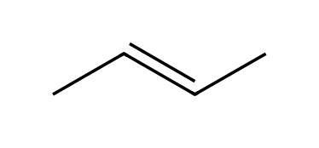

11.4 How to Approach a Synthesis Problem
63. What two questions should be asked first in a synthesis problem? [C11M24, Easy]
A) What is the yield? What is the cost?
B) What is the solvent? What is the temperature?
C) Does the carbon skeleton change? Does the functional group change identity or position?
D) How many steps? How many reagents?
64. Comparing a starting material with a product, the product has two more carbon atoms. What is needed? [C11M25, Basic]
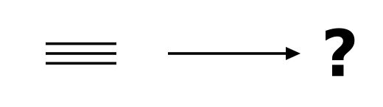
A) A hydrogenation
B) An elimination only
C) A hydration
D) A C-C bond-forming step
65. Which transformation changes only the location of a functional group? [C11M26, Basic]
A) 1-Bromopropane → 2-bromopropane
B) Propene → propane
C) Propyne → propanone
D) Propene → ethanal
66. The synthesis of butanal from but-1-yne requires: [C11M27, Moderate]
A) Anti-Markovnikov hydration (Sia₂BH; H₂O₂, NaOH)
B) Markovnikov hydration (HgSO₄, H₂SO₄)
C) Ozonolysis
D) NaNH₂
67. Which change requires C-C bond cleavage? [C11M50, Moderate]
A) Propyne to pent-2-yne
B) Propene to propane
C) Propene to 2-bromopropane
D) Cyclohexene to hexanedial
68. List the two questions to ask when approaching a synthesis problem. [C11F26, Basic]

69. Does converting 1-butene into 1-butyne change the skeleton or only the functional group? [C11F27, Basic]

70. Does converting propyne into pent-2-yne change the skeleton? What type of reaction is needed? [C11F28, Moderate]

11.5 Multi-Step Synthesis and Retrosynthetic Analysis
71. What is a retrosynthetic analysis? [C11M28, Easy]
A) Working forward from the starting material
B) Working backward from the product to the starting material
C) Testing the reaction in the lab
D) Predicting the yield
72. In a retrosynthetic analysis of 2-bromopropane from propane, what is the immediate precursor? [C11M29, Basic]
A) Propyne
B) Propene
C) 1-Bromopropane only
D) Propan-2-ol only
73. A retrosynthesis of cis-hex-3-ene from acetylene and ethyl bromide ends with which last step? [C11M30, Moderate]
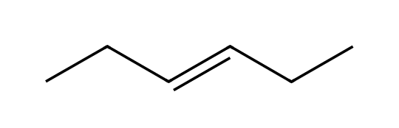
A) Na, NH₃ on hex-3-yne
B) H₂, Pt on hex-3-yne
C) H₂, Lindlar catalyst on hex-3-yne
D) O₃ on hex-3-yne
74. A retrosynthesis of 2-methylpropan-1-ol from 2-methylpropene ends with which last step? [C11M31, Moderate]
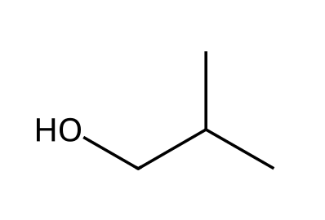
A) BH₃·THF; H₂O₂, NaOH
B) H₂O, H₂SO₄
C) Hg(OAc)₂, H₂O; NaBH₄
D) O₃; DMS
75. Which is the best precursor for a final step of anti-dihydroxylation giving trans-cyclohexane-1,2-diol? [C11M32, Hard]
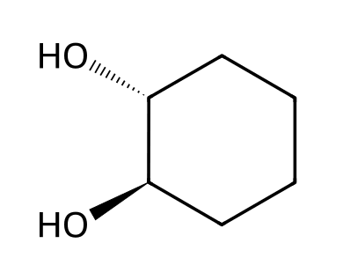
A) Cyclohexane
B) Benzene
C) Cyclohexanone
D) Cyclohexene
76. A target is 2,2-dibromopropane. Which is the best immediate precursor? [C11M33, Hard]
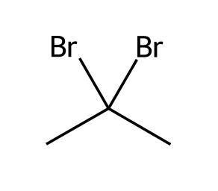
A) Propene
B) Propyne
C) Propane
D) 1,2-dibromopropane
77. Define retrosynthetic analysis. [C11F29, Easy]

78. Write the retrosynthesis (last two steps) for 1-bromopropane from propane. [C11F30, Basic]

79. Write the retrosynthesis for trans-cyclohexane-1,2-diol starting from cyclohexane. [C11F31, Moderate]

80. Write the retrosynthesis for hex-3-yne from acetylene and bromoethane. [C11F32, Moderate]

81. Write the retrosynthesis for 2,2-dibromopropane from propane. [C11F33, Hard]

82. Write the retrosynthesis for cis-pent-2-ene starting from acetylene and bromoalkanes. [C11F34, Hard]
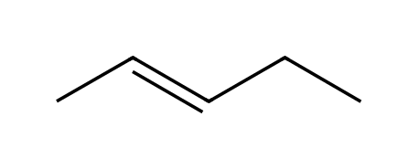

83. Write the retrosynthesis for 2-methylpropan-1-ol starting from 2-methylpropane. [C11F35, Hard]

11.6 Green Chemistry
84. What is green chemistry? [C11M34, Easy]
A) Designing reactions that minimize negative impacts on the environment
B) Chemistry of plants
C) Chemistry using only water
D) Reactions that are always faster
85. What does a high atom economy mean? [C11M35, Basic]
A) The reaction is fast
B) The reaction uses little energy
C) The reaction gives high yield only
D) Most atoms of the reactants end up in the desired product
86. Atom economy of CH₃CH=CH₂ + HBr → CH₃CHBrCH₃ is: [C11M36, Moderate]
A) 100%
B) 75%
C) 50%
D) 25%
87. Which has the lower atom economy? [C11M37, Hard]
A) Addition of HBr to propene
B) Elimination of HBr from 2-bromopropane with NaOEt
C) Hydrogenation of propene
D) Addition of Br₂ to propene
88. Define green chemistry in your own words. [C11F36, Easy]

89. Calculate the atom economy of CH₃CH=CH₂ + HBr → CH₃CHBrCH₃. [C11F37, Basic]

90. Estimate the atom economy of CH₃CHBrCH₃ + NaOCH₂CH₃ → CH₃CH=CH₂ + NaBr + CH₃CH₂OH. (Molar masses: product 42.1; reactants 123.0 + 68.1.) [C11F38, Moderate]

91. Explain why an addition reaction is typically greener than an elimination reaction. [C11F39, Moderate]

92. Give two ways a chemist can make a synthesis greener. [C11F40, Moderate]

11.7 Practical Tips for Increasing Proficiency
93. Which is generally the best approach to a synthesis problem? [C11M38, Easy]
A) Use as many steps as possible
B) Use the fewest reliable steps
C) Use rare reagents
D) Start from the product only
94. Why is learning the reagents from Chapters 7 to 10 essential for synthesis? [C11M39, Basic]
A) Synthesis uses only new reactions
B) Reagents are never repeated
C) Each synthesis is built from those known reactions
D) They are all identical
95. Which is NOT a good strategy when planning a synthesis? [C11M40, Moderate]
A) Ignoring regiochemistry and stereochemistry
B) Working backward from the target
C) Checking the carbon skeleton first
D) Looking for the fewest steps
96. Several different routes give the same correct product. How should you choose? [C11M41, Moderate]
A) Choose the one with the most steps
B) Choose the longest route
C) Prefer the route with fewer steps and better selectivity
D) Choose any route with radicals
97. Why might two correct synthesis routes differ in quality? [C11F41, Basic]

98. Why must regiochemistry be considered when planning an alkene-to-alcohol step? [C11F42, Moderate]

99. Why does the stereochemistry of an addition step matter in synthesis? [C11F43, Moderate]

100. Propose a synthesis of cis-cyclohexane-1,2-diol from bromocyclohexane. [C11F44, Hard]
