Substitution and Elimination (SN1, SN2, E1, E2): 100 Problems
Free response. For each problem, show structures clearly. Where asked, justify your answer with the four factors: substrate, nucleophile/base, leaving group and solvent.
1. [Choose the reagents] What reagent(s) and solvent would convert iodomethane into ethanenitrile? Name the mechanism and justify your choice with the four factors (substrate, nucleophile, leaving group, solvent).
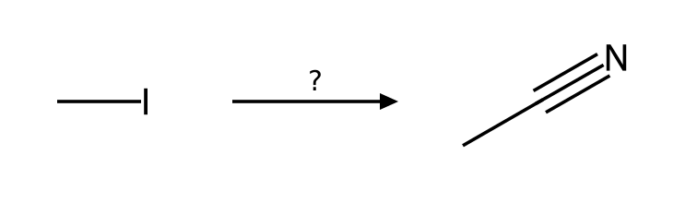
______________________________________________________________________________________
______________________________________________________________________________________
______________________________________________________________________________________
2. [Choose the reagents] What reagent(s) and solvent would convert bromoethane into azidoethane? Name the mechanism and justify your choice with the four factors (substrate, nucleophile, leaving group, solvent).
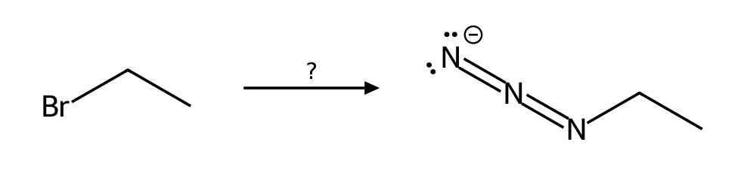
______________________________________________________________________________________
______________________________________________________________________________________
______________________________________________________________________________________
3. [Choose the reagents] What reagent(s) and solvent would convert 1-bromopropane into propane-1-thiol? Name the mechanism and justify your choice with the four factors (substrate, nucleophile, leaving group, solvent).
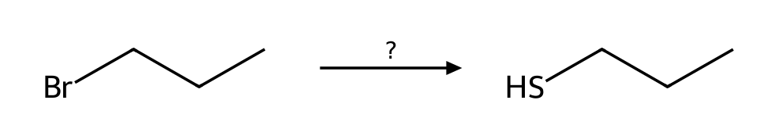
______________________________________________________________________________________
______________________________________________________________________________________
______________________________________________________________________________________
4. [Choose the reagents] What reagent(s) and solvent would convert 2-bromopropane into 2-methylpropanenitrile? Name the mechanism and justify your choice with the four factors (substrate, nucleophile, leaving group, solvent).
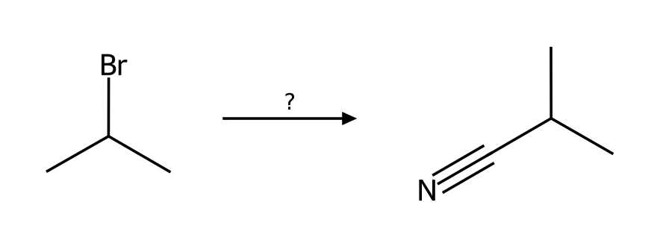
______________________________________________________________________________________
______________________________________________________________________________________
______________________________________________________________________________________
5. [Choose the reagents] What reagent(s) and solvent would convert 2-bromobutane into butane-2-thiol? Name the mechanism and justify your choice with the four factors (substrate, nucleophile, leaving group, solvent).
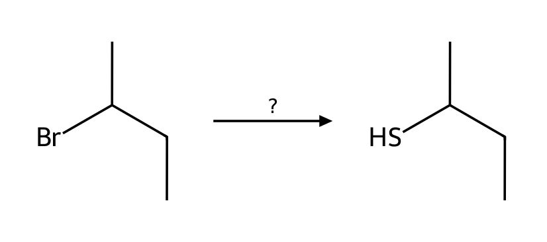
______________________________________________________________________________________
______________________________________________________________________________________
______________________________________________________________________________________
6. [Choose the reagents] What reagent(s) and solvent would convert 2-bromo-2-methylpropane into 2-methylpropan-2-ol? Name the mechanism and justify your choice with the four factors (substrate, nucleophile, leaving group, solvent).
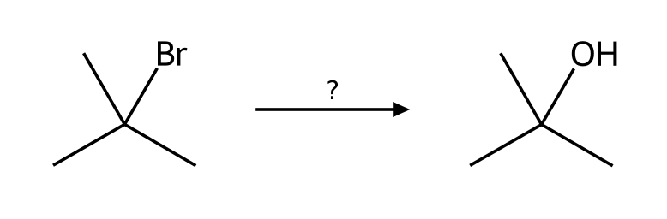
______________________________________________________________________________________
______________________________________________________________________________________
______________________________________________________________________________________
7. [Choose the reagents] What reagent(s) and solvent would convert 2-bromopropane into prop-1-ene? Name the mechanism and justify your choice with the four factors (substrate, nucleophile, leaving group, solvent).
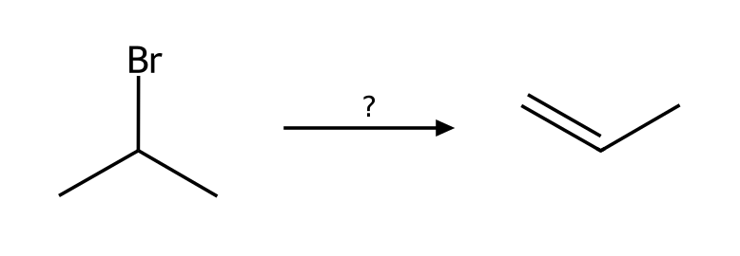
______________________________________________________________________________________
______________________________________________________________________________________
______________________________________________________________________________________
8. [Choose the reagents] What reagent(s) and solvent would convert 2-bromobutane into (E)-but-2-ene? Name the mechanism and justify your choice with the four factors (substrate, nucleophile, leaving group, solvent).
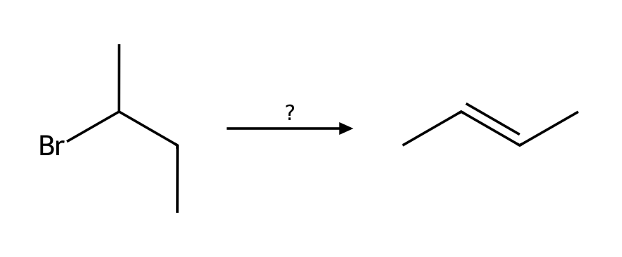
______________________________________________________________________________________
______________________________________________________________________________________
______________________________________________________________________________________
9. [Choose the reagents] What reagent(s) and solvent would convert 2-bromo-2-methylbutane into 2-methylbut-1-ene? Name the mechanism and justify your choice with the four factors (substrate, nucleophile, leaving group, solvent).
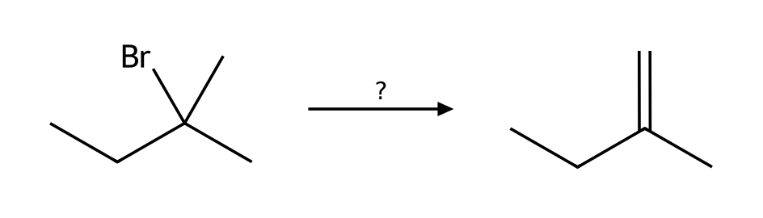
______________________________________________________________________________________
______________________________________________________________________________________
______________________________________________________________________________________
10. [Choose the reagents] What reagent(s) and solvent would convert 2-iodobutane into but-1-ene? Name the mechanism and justify your choice with the four factors (substrate, nucleophile, leaving group, solvent).
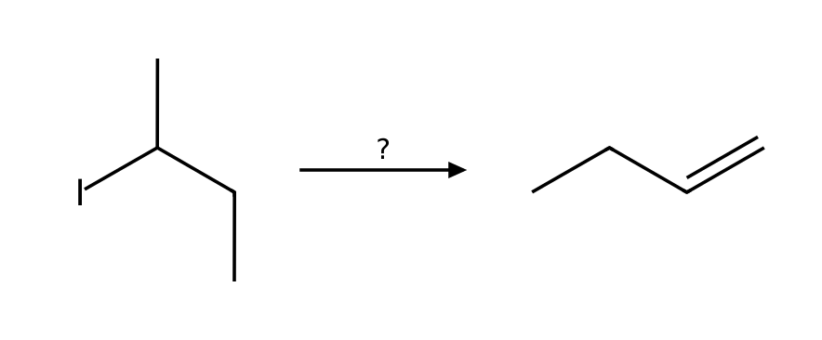
______________________________________________________________________________________
______________________________________________________________________________________
______________________________________________________________________________________
11. [Predict the product] Predict the major organic product of 1-iodobutane with NaCN in CH3CN. State the mechanism and any minor pathway.
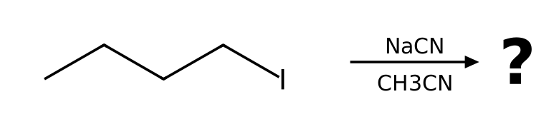
______________________________________________________________________________________
______________________________________________________________________________________
______________________________________________________________________________________
12. [Predict the product] Predict the major organic product of 1-chlorobutane with NaI in acetone. State the mechanism and any minor pathway.
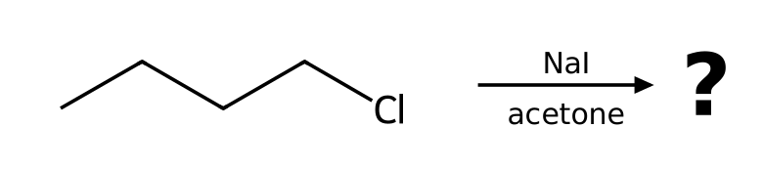
______________________________________________________________________________________
______________________________________________________________________________________
______________________________________________________________________________________
13. [Predict the product] Predict the major organic product of 1-bromopropane with NaOMe in MeOH. State the mechanism and any minor pathway.
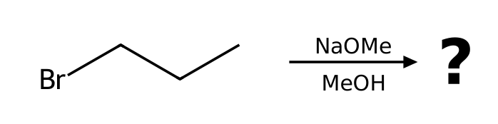
______________________________________________________________________________________
______________________________________________________________________________________
______________________________________________________________________________________
14. [Predict the product] Predict the major organic product of 2-iodobutane with NaN₃ in DMF. State the mechanism and any minor pathway.
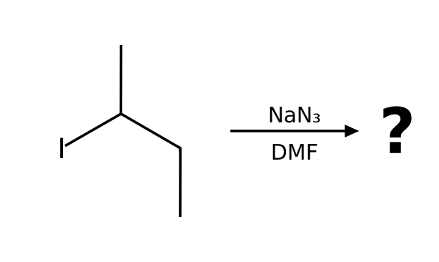
______________________________________________________________________________________
______________________________________________________________________________________
______________________________________________________________________________________
15. [Predict the product] Predict the major organic product of bromocyclohexane with NaN₃ in DMF. State the mechanism and any minor pathway.
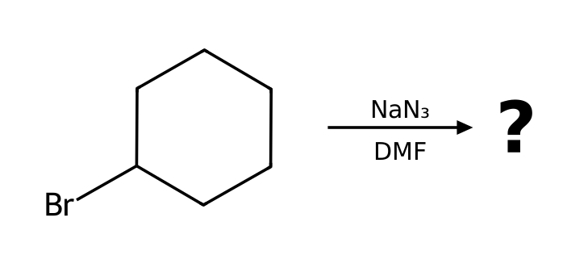
______________________________________________________________________________________
______________________________________________________________________________________
______________________________________________________________________________________
16. [Predict the product] Predict the major organic product of 2-chloro-2-methylbutane with EtOH as the solvent. State the mechanism and any minor pathway.
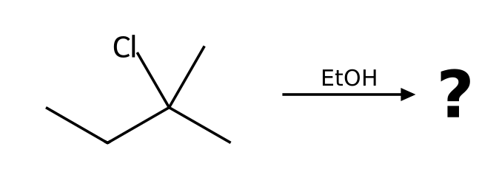
______________________________________________________________________________________
______________________________________________________________________________________
______________________________________________________________________________________
17. [Predict the product] Predict the major organic product of 1-bromo-1-methylcyclohexane with MeOH as the solvent. State the mechanism and any minor pathway.
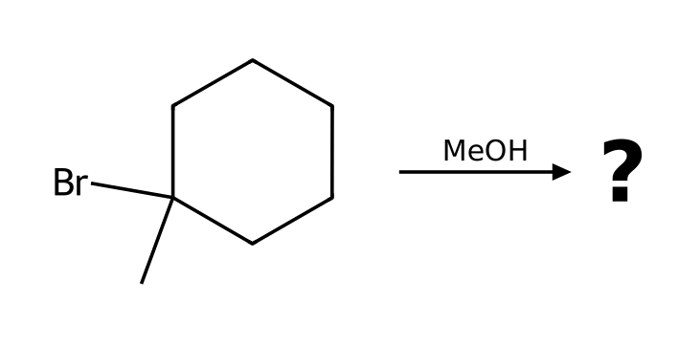
______________________________________________________________________________________
______________________________________________________________________________________
______________________________________________________________________________________
18. [Predict the product] Predict the major organic product of 2-bromopentane with NaOH in EtOH. State the mechanism and any minor pathway.
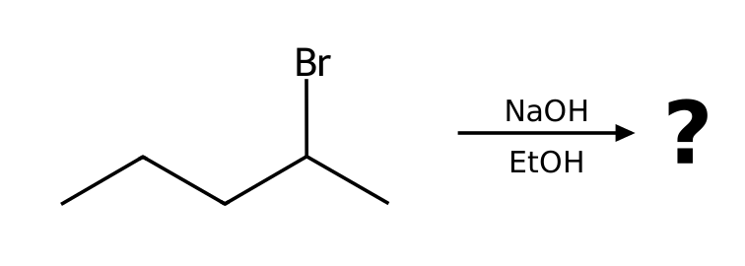
______________________________________________________________________________________
______________________________________________________________________________________
______________________________________________________________________________________
19. [Predict the product] Predict the major organic product of bromocyclohexane with NaOEt in EtOH. State the mechanism and any minor pathway.
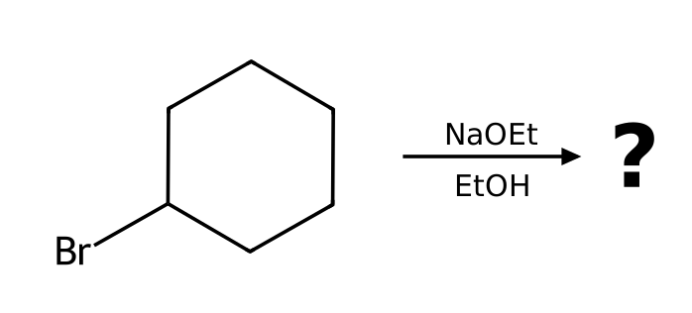
______________________________________________________________________________________
______________________________________________________________________________________
______________________________________________________________________________________
20. [Predict the product] Predict the major organic product of 1-bromo-1-methylcyclohexane with KOtBu in tBuOH. State the mechanism and any minor pathway.
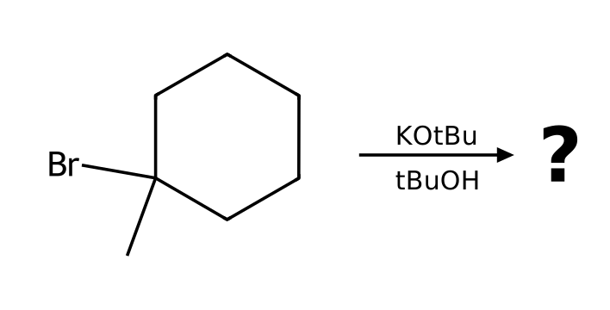
______________________________________________________________________________________
______________________________________________________________________________________
______________________________________________________________________________________
21. [Identify the mechanism] Which mechanism (SN1, SN2, E1 or E2) predominates when bromoethane reacts with NaN₃ in DMF? List the factors that support your answer and give the major product.
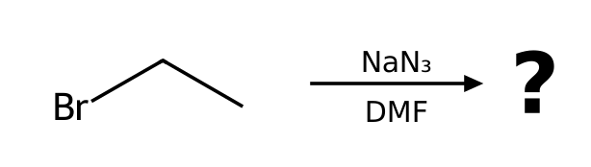
______________________________________________________________________________________
______________________________________________________________________________________
______________________________________________________________________________________
22. [Identify the mechanism] Which mechanism (SN1, SN2, E1 or E2) predominates when 1-bromobutane reacts with NaOAc in DMF? List the factors that support your answer and give the major product.
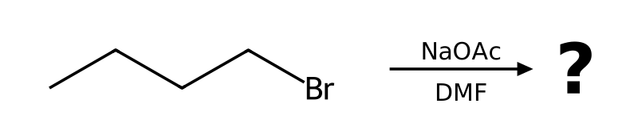
______________________________________________________________________________________
______________________________________________________________________________________
______________________________________________________________________________________
23. [Identify the mechanism] Which mechanism (SN1, SN2, E1 or E2) predominates when 3-bromo-3-methylpentane reacts with EtOH as the solvent? List the factors that support your answer and give the major product.
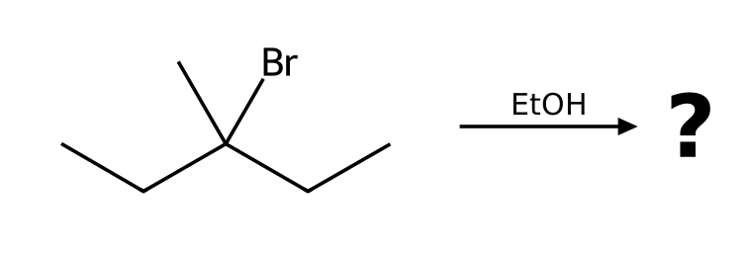
______________________________________________________________________________________
______________________________________________________________________________________
______________________________________________________________________________________
24. [Identify the mechanism] Which mechanism (SN1, SN2, E1 or E2) predominates when 2-iodo-2-methylpropane reacts with CH₃CO₂H as the solvent? List the factors that support your answer and give the major product.
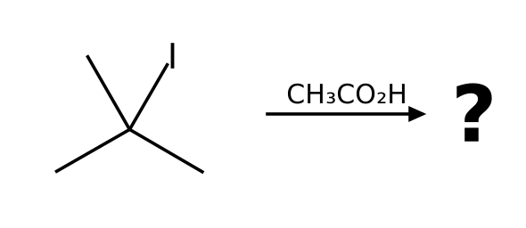
______________________________________________________________________________________
______________________________________________________________________________________
______________________________________________________________________________________
25. [Identify the mechanism] Which mechanism (SN1, SN2, E1 or E2) predominates when 2-bromopentane reacts with NaOH in EtOH? List the factors that support your answer and give the major product.
______________________________________________________________________________________
______________________________________________________________________________________
______________________________________________________________________________________
26. [Identify the mechanism] Which mechanism (SN1, SN2, E1 or E2) predominates when 1-bromopropane reacts with KOtBu in tBuOH? List the factors that support your answer and give the major product.
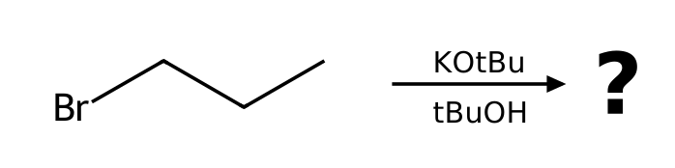
______________________________________________________________________________________
______________________________________________________________________________________
______________________________________________________________________________________
27. [Identify the mechanism] Which mechanism (SN1, SN2, E1 or E2) predominates when 3-bromo-3-methylpentane reacts with NaOMe in MeOH? List the factors that support your answer and give the major product.
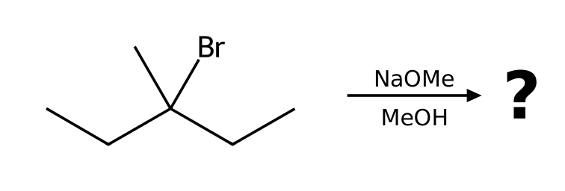
______________________________________________________________________________________
______________________________________________________________________________________
______________________________________________________________________________________
28. [Identify the mechanism] Which mechanism (SN1, SN2, E1 or E2) predominates when 1-chlorobutane reacts with NaI in acetone? List the factors that support your answer and give the major product.
______________________________________________________________________________________
______________________________________________________________________________________
______________________________________________________________________________________
29. [Identify the mechanism] Which mechanism (SN1, SN2, E1 or E2) predominates when 2-bromo-2-methylbutane reacts with NaOEt in EtOH? List the factors that support your answer and give the major product.
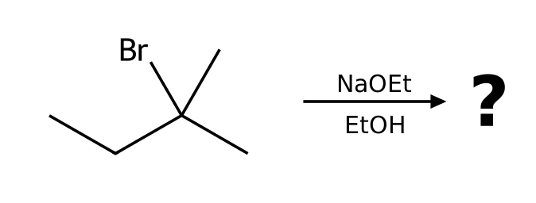
______________________________________________________________________________________
______________________________________________________________________________________
______________________________________________________________________________________
30. [Stereochemistry] Draw the product of (S)-2-bromobutane with NaSH in DMSO. Give the configuration (R or S) of the substrate and the product and explain the stereochemical outcome.
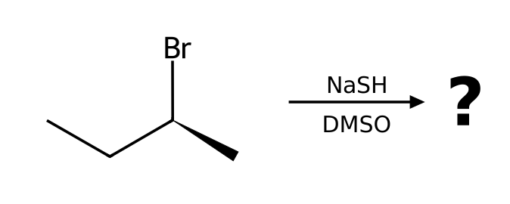
______________________________________________________________________________________
______________________________________________________________________________________
______________________________________________________________________________________
31. [Stereochemistry] Draw the product of (S)-2-chloropentane with NaCN in DMSO. Give the configuration (R or S) of the substrate and the product and explain the stereochemical outcome.
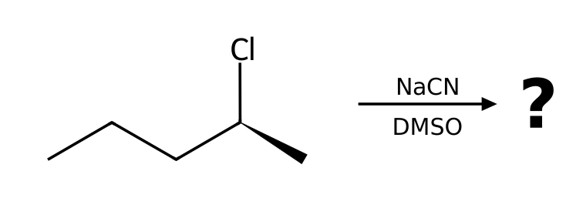
______________________________________________________________________________________
______________________________________________________________________________________
______________________________________________________________________________________
32. [Stereochemistry] Draw the product of (R)-3-iodohexane with NaN₃ in DMF. Give the configuration (R or S) of the substrate and the product and explain the stereochemical outcome.
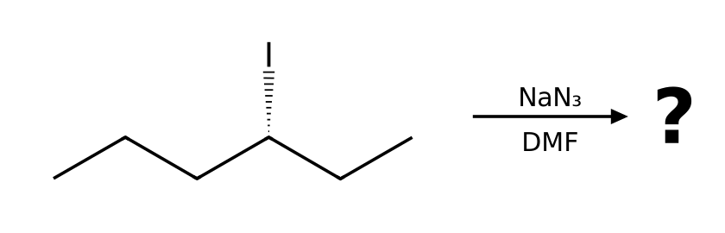
______________________________________________________________________________________
______________________________________________________________________________________
______________________________________________________________________________________
33. [Stereochemistry] Draw the product of (R)-2-bromohexane with NaI in acetone. Give the configuration (R or S) of the substrate and the product and explain the stereochemical outcome.
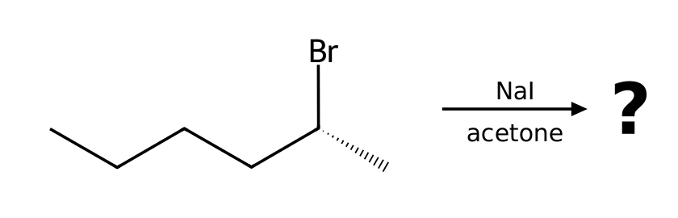
______________________________________________________________________________________
______________________________________________________________________________________
______________________________________________________________________________________
34. [Stereochemistry] (R)-3-bromo-3-methylhexane reacts with MeOH as the solvent. Draw the product(s), including stereochemistry, and explain why the result differs from an SN2 reaction.
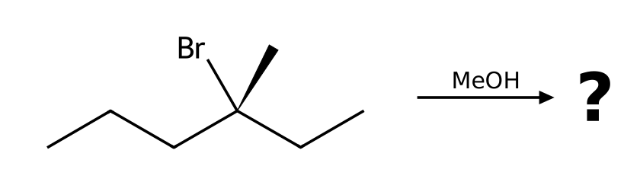
______________________________________________________________________________________
______________________________________________________________________________________
______________________________________________________________________________________
35. [Stereochemistry] (S)-3-chloro-3-methylhexane reacts with EtOH as the solvent. Draw the product(s), including stereochemistry, and explain why the result differs from an SN2 reaction.
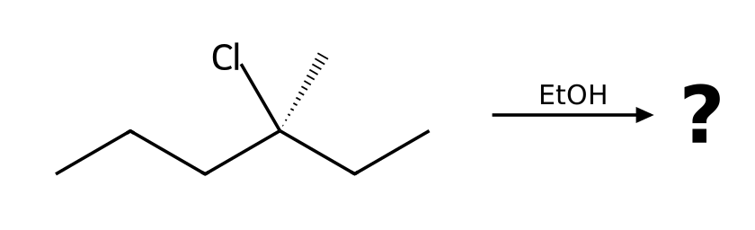
______________________________________________________________________________________
______________________________________________________________________________________
______________________________________________________________________________________
36. [Stereochemistry] (S)-3-bromo-3-methylhexane reacts with H₂O as the solvent. Draw the product(s), including stereochemistry, and explain why the result differs from an SN2 reaction.
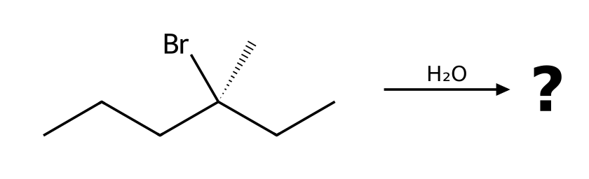
______________________________________________________________________________________
______________________________________________________________________________________
______________________________________________________________________________________
37. [Stereochemistry] (S)-2-bromobutane is treated with NaOEt in EtOH. What is the major product? Does the stereocenter of the starting material appear in the product?
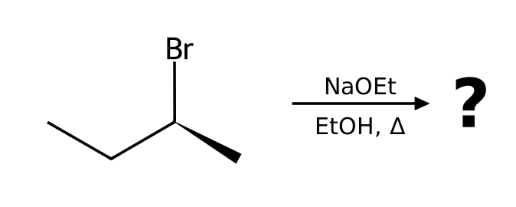
______________________________________________________________________________________
______________________________________________________________________________________
______________________________________________________________________________________
38. [Draw the mechanism] Describe the complete mechanism (list each step and the curved arrows) for the reaction of bromoethane with NaN₃ in DMF. How many steps are there?
______________________________________________________________________________________
______________________________________________________________________________________
______________________________________________________________________________________
39. [Draw the mechanism] Describe the complete mechanism (list each step and the curved arrows) for the reaction of 1-bromopropane with NaOMe in MeOH. How many steps are there?
______________________________________________________________________________________
______________________________________________________________________________________
______________________________________________________________________________________
40. [Draw the mechanism] Describe the complete mechanism (list each step and the curved arrows) for the reaction of 2-bromo-2-methylpropane with H₂O as the solvent. How many steps are there?
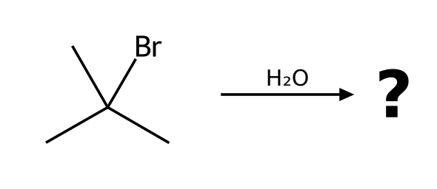
______________________________________________________________________________________
______________________________________________________________________________________
______________________________________________________________________________________
41. [Draw the mechanism] Describe the complete mechanism (list each step and the curved arrows) for the reaction of 2-chloro-2-methylbutane with EtOH as the solvent. How many steps are there?
______________________________________________________________________________________
______________________________________________________________________________________
______________________________________________________________________________________
42. [Draw the mechanism] Describe the complete mechanism (list each step and the curved arrows) for the reaction of 2-bromobutane with NaOEt in EtOH. How many steps are there?
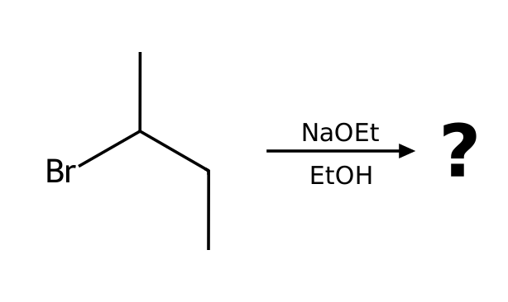
______________________________________________________________________________________
______________________________________________________________________________________
______________________________________________________________________________________
43. [Draw the mechanism] Describe the complete mechanism (list each step and the curved arrows) for the reaction of 2-bromobutane with NaSH in DMSO. How many steps are there?
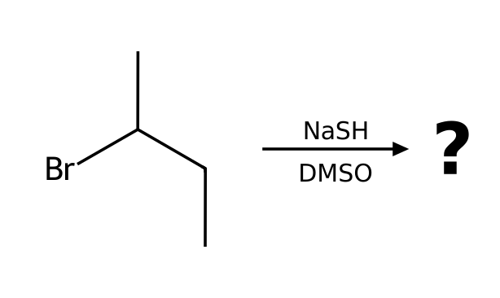
______________________________________________________________________________________
______________________________________________________________________________________
______________________________________________________________________________________
44. [Draw the mechanism] Describe the complete mechanism (list each step and the curved arrows) for the reaction of 1-bromo-2,2-dimethylpropane with EtOH as the solvent. How many steps are there?
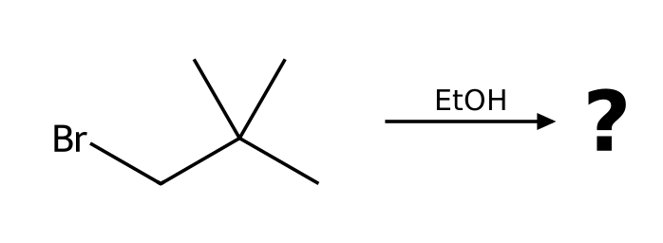
______________________________________________________________________________________
______________________________________________________________________________________
______________________________________________________________________________________
45. [Draw the mechanism] Describe the complete mechanism (list each step and the curved arrows) for the reaction of 2-bromo-2-methylbutane with MeOH as the solvent. How many steps are there?
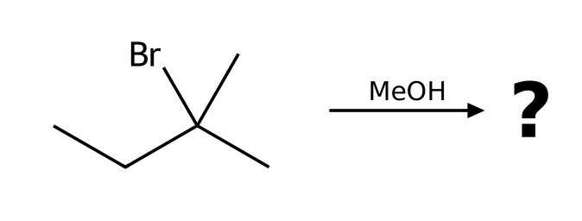
______________________________________________________________________________________
______________________________________________________________________________________
______________________________________________________________________________________
46. [What went wrong] A student predicts an SN2 reaction to give a nitrile. Reaction: 2-bromo-2-methylpropane + NaCN in DMSO. Explain what is wrong and give the correct outcome.
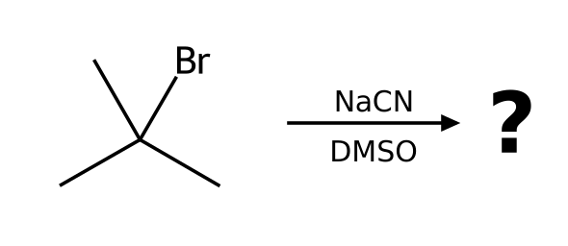
______________________________________________________________________________________
______________________________________________________________________________________
______________________________________________________________________________________
47. [What went wrong] A student says a primary halide always reacts quickly by SN2. Reaction: 1-bromo-2,2-dimethylpropane + NaOH in DMSO. Explain what is wrong and give the correct outcome.
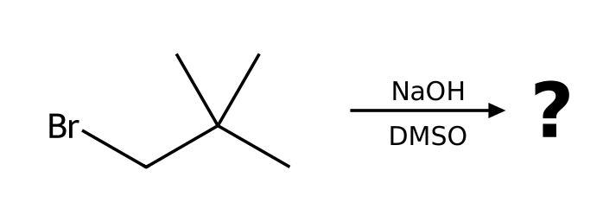
______________________________________________________________________________________
______________________________________________________________________________________
______________________________________________________________________________________
48. [What went wrong] A student predicts substitution to give vinyl alcohol. Reaction: bromoethene (vinyl bromide) + NaOH in DMSO. Explain what is wrong and give the correct outcome.
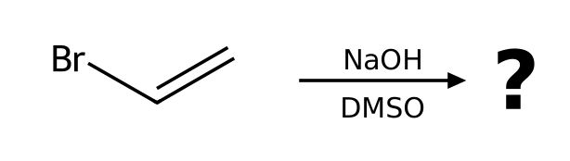
______________________________________________________________________________________
______________________________________________________________________________________
______________________________________________________________________________________
49. [What went wrong] A student predicts benzonitrile. Reaction: bromobenzene + NaCN in DMSO. Explain what is wrong and give the correct outcome.
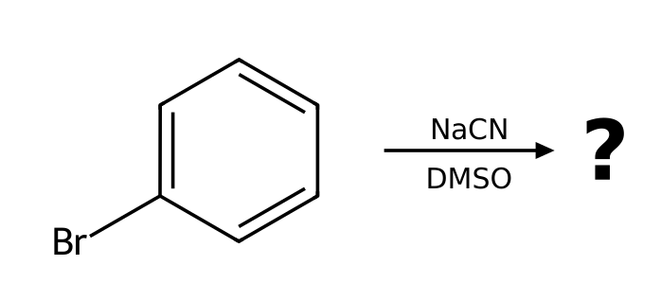
______________________________________________________________________________________
______________________________________________________________________________________
______________________________________________________________________________________
50. [What went wrong] A student predicts 1-bromobutane. Reaction: butan-1-ol + NaBr in DMF. Explain what is wrong and give the correct outcome.
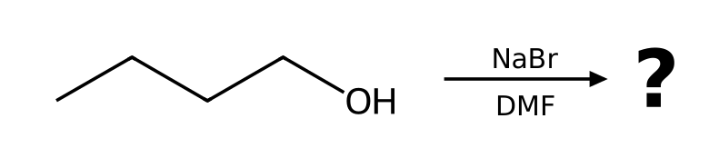
______________________________________________________________________________________
______________________________________________________________________________________
______________________________________________________________________________________
51. [What went wrong] A student predicts the ether 2-ethoxybutane by SN2. Reaction: 2-bromobutane + NaOEt in EtOH. Explain what is wrong and give the correct outcome.
______________________________________________________________________________________
______________________________________________________________________________________
______________________________________________________________________________________
52. [What went wrong] A student predicts butanenitrile. Reaction: 1-fluoropropane + NaCN in DMSO. Explain what is wrong and give the correct outcome.
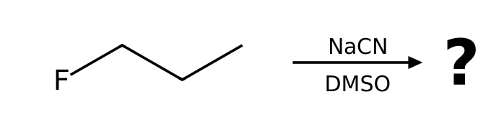
______________________________________________________________________________________
______________________________________________________________________________________
______________________________________________________________________________________
53. [Compare two conditions] 2-bromopropane is treated under two different conditions: (a) NaCN in DMSO; (b) NaOEt in EtOH with heat. For each, name the mechanism and the major product.
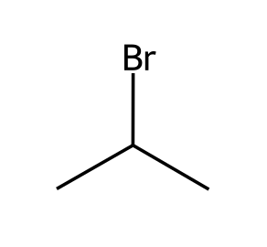
______________________________________________________________________________________
______________________________________________________________________________________
______________________________________________________________________________________
54. [Compare two conditions] 2-bromo-2-methylbutane is treated under two different conditions: (a) EtOH in EtOH; (b) NaOEt in EtOH with heat. For each, name the mechanism and the major product.
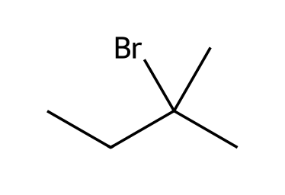
______________________________________________________________________________________
______________________________________________________________________________________
______________________________________________________________________________________
55. [Compare two conditions] 1-bromopropane is treated under two different conditions: (a) NaOEt in EtOH; (b) KOtBu in tBuOH. For each, name the mechanism and the major product.
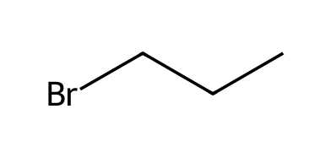
______________________________________________________________________________________
______________________________________________________________________________________
______________________________________________________________________________________
56. [Compare two conditions] 2-bromobutane is treated under two different conditions: (a) NaN₃ in DMF; (b) KOtBu in tBuOH. For each, name the mechanism and the major product.
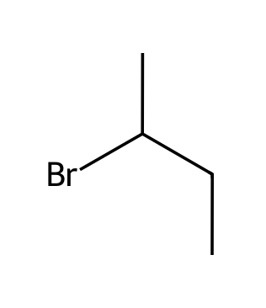
______________________________________________________________________________________
______________________________________________________________________________________
______________________________________________________________________________________
57. [Compare two conditions] 2-bromo-2-methylpropane is treated under two different conditions: (a) H₂O in H2O; (b) NaOH in EtOH with heat. For each, name the mechanism and the major product.
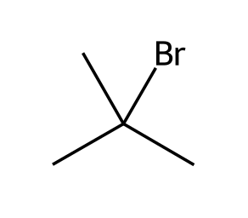
______________________________________________________________________________________
______________________________________________________________________________________
______________________________________________________________________________________
58. [Compare two conditions] bromocyclohexane is treated under two different conditions: (a) NaSH in DMSO; (b) NaOMe in MeOH with heat. For each, name the mechanism and the major product.
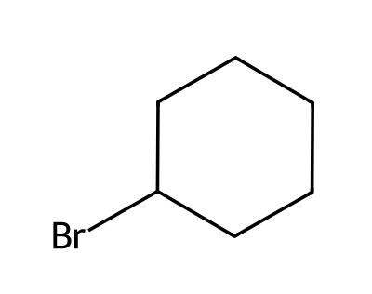
______________________________________________________________________________________
______________________________________________________________________________________
______________________________________________________________________________________
59. [Functional group conversion] Propose reagents to convert (S)-butan-2-ol into (R)-2-bromobutane. Explain why the OH group cannot simply be displaced, and state the stereochemical outcome if there is a stereocenter.
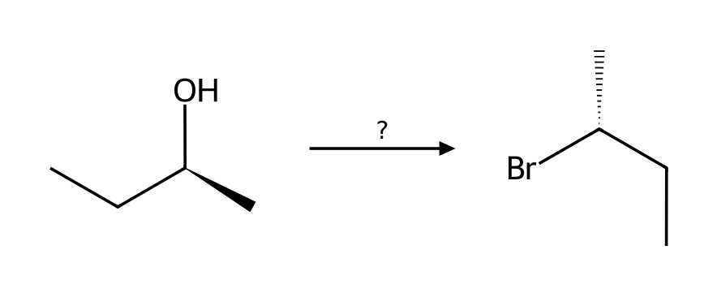
______________________________________________________________________________________
______________________________________________________________________________________
______________________________________________________________________________________
60. [Functional group conversion] Propose reagents to convert 2-methylpropan-2-ol into 2-bromo-2-methylpropane. Explain why the OH group cannot simply be displaced, and state the stereochemical outcome if there is a stereocenter.
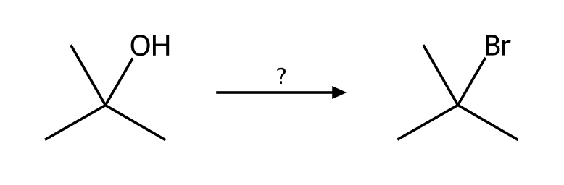
______________________________________________________________________________________
______________________________________________________________________________________
______________________________________________________________________________________
61. [Functional group conversion] Propose reagents to convert butan-1-ol into 1-bromobutane. Explain why the OH group cannot simply be displaced, and state the stereochemical outcome if there is a stereocenter.
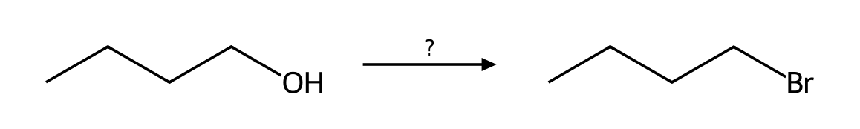
______________________________________________________________________________________
______________________________________________________________________________________
______________________________________________________________________________________
62. [Functional group conversion] Propose reagents to convert propan-2-ol into 2-chloropropane. Explain why the OH group cannot simply be displaced, and state the stereochemical outcome if there is a stereocenter.
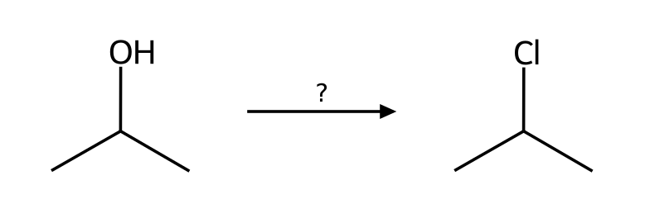
______________________________________________________________________________________
______________________________________________________________________________________
______________________________________________________________________________________
63. [Functional group conversion] Propose reagents to convert (R)-pentan-2-ol into (S)-2-methylpentanenitrile. Explain why the OH group cannot simply be displaced, and state the stereochemical outcome if there is a stereocenter.
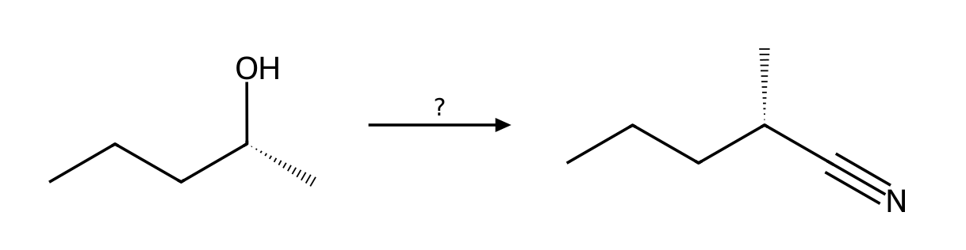
______________________________________________________________________________________
______________________________________________________________________________________
______________________________________________________________________________________
64. [Functional group conversion] Propose reagents to convert butan-1-ol into 1-azidobutane. Explain why the OH group cannot simply be displaced, and state the stereochemical outcome if there is a stereocenter.
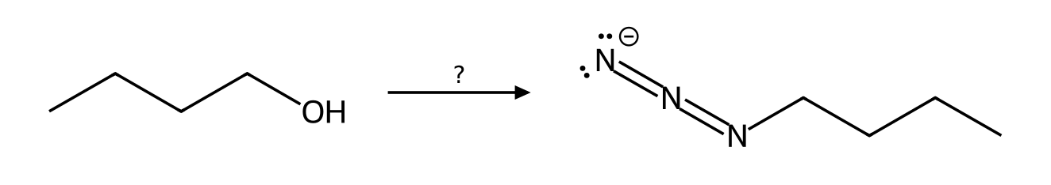
______________________________________________________________________________________
______________________________________________________________________________________
______________________________________________________________________________________
65. [Carbocation rearrangement] Will 2-bromo-3-methylbutane rearrange when heated in EtOH? Show the carbocation that forms, the shift involved, and the major substitution product.
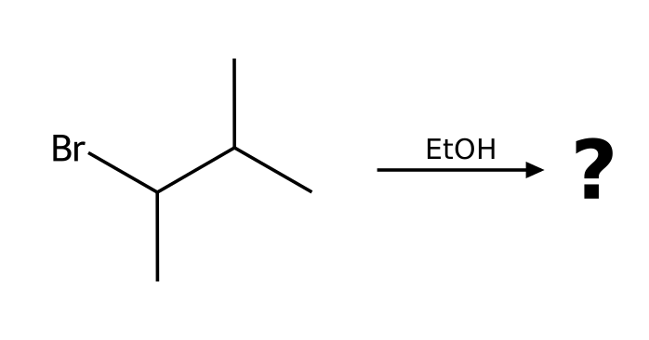
______________________________________________________________________________________
______________________________________________________________________________________
______________________________________________________________________________________
66. [Carbocation rearrangement] Will 1-bromo-2,2-dimethylpropane rearrange when heated in EtOH? Show the carbocation that forms, the shift involved, and the major substitution product.
______________________________________________________________________________________
______________________________________________________________________________________
______________________________________________________________________________________
67. [Carbocation rearrangement] Will 3-bromo-2,2-dimethylbutane rearrange when heated in MeOH? Show the carbocation that forms, the shift involved, and the major substitution product.
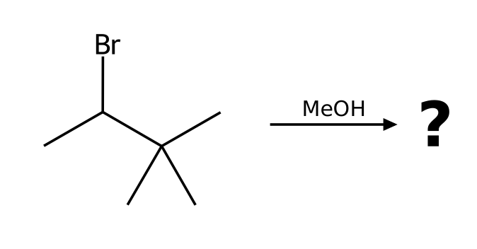
______________________________________________________________________________________
______________________________________________________________________________________
______________________________________________________________________________________
68. [Carbocation rearrangement] Will 2-bromo-3-methylpentane rearrange when heated in MeOH? Show the carbocation that forms, the shift involved, and the major substitution product.
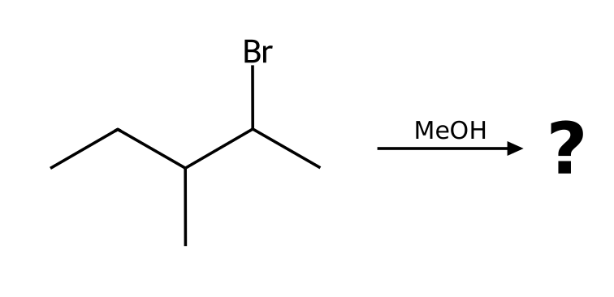
______________________________________________________________________________________
______________________________________________________________________________________
______________________________________________________________________________________
69. [Carbocation rearrangement] Predict the major alkene from heating 3-methylbutan-2-ol with H₂SO₄. Explain the rearrangement.
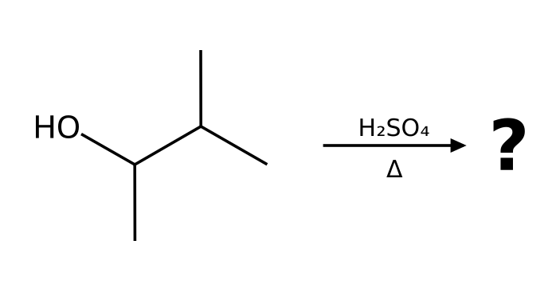
______________________________________________________________________________________
______________________________________________________________________________________
______________________________________________________________________________________
70. [Elimination (E1)] What happens when 2-methylpropan-2-ol is heated with concentrated H₂SO₄? Give the major product, name the mechanism and explain why the OH must be protonated first.
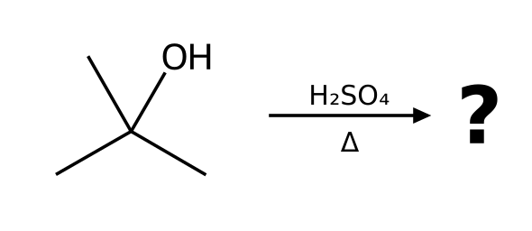
______________________________________________________________________________________
______________________________________________________________________________________
______________________________________________________________________________________
71. [Elimination (E1)] What happens when 2-methylbutan-2-ol is heated with concentrated H₂SO₄? Give the major product, name the mechanism and explain why the OH must be protonated first.
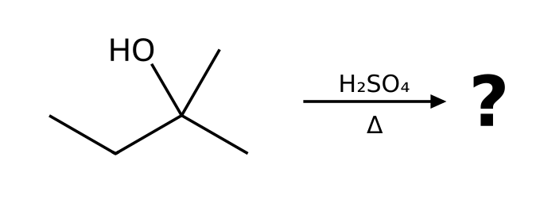
______________________________________________________________________________________
______________________________________________________________________________________
______________________________________________________________________________________
72. [Elimination (E1)] What happens when 1-methylcyclohexan-1-ol is heated with concentrated H₂SO₄? Give the major product, name the mechanism and explain why the OH must be protonated first.
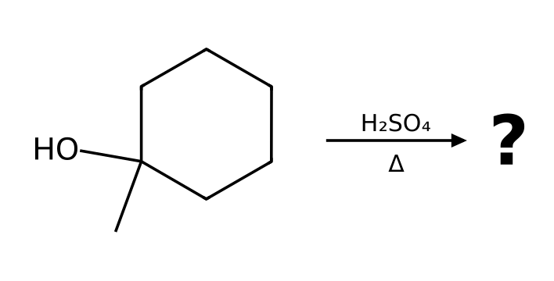
______________________________________________________________________________________
______________________________________________________________________________________
______________________________________________________________________________________
73. [Elimination (E1)] What happens when butan-2-ol is heated with concentrated H₂SO₄? Give the major product, name the mechanism and explain why the OH must be protonated first.
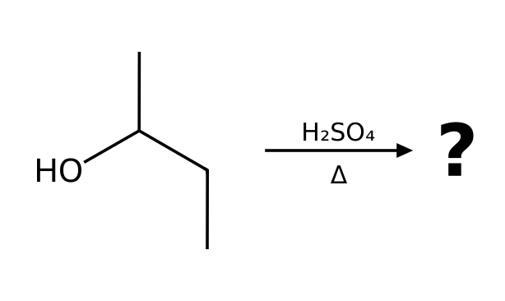
______________________________________________________________________________________
______________________________________________________________________________________
______________________________________________________________________________________
74. [Regiochemistry of elimination] Starting from 2-bromo-2-methylbutane, choose reagents to make (a) the more substituted alkene and (b) the less substituted alkene. Give both products.
______________________________________________________________________________________
______________________________________________________________________________________
______________________________________________________________________________________
75. [Regiochemistry of elimination] Starting from 2-bromobutane, choose reagents to make (a) the more substituted alkene and (b) the less substituted alkene. Give both products.
______________________________________________________________________________________
______________________________________________________________________________________
______________________________________________________________________________________
76. [Regiochemistry of elimination] Starting from 2-bromopentane, choose reagents to make (a) the more substituted alkene and (b) the less substituted alkene. Give both products.
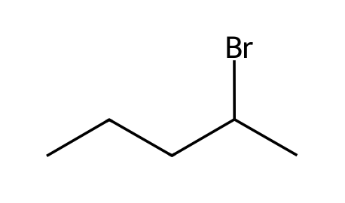
______________________________________________________________________________________
______________________________________________________________________________________
______________________________________________________________________________________
77. [Regiochemistry of elimination] Starting from 1-bromo-1-methylcyclohexane, choose reagents to make (a) the more substituted alkene and (b) the less substituted alkene. Give both products.
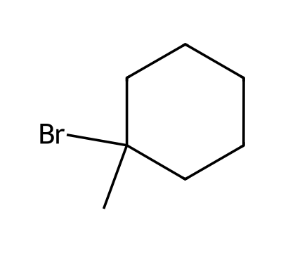
______________________________________________________________________________________
______________________________________________________________________________________
______________________________________________________________________________________
78. [Regiochemistry of elimination] Starting from 3-bromo-3-methylpentane, choose reagents to make (a) the more substituted alkene and (b) the less substituted alkene. Give both products.
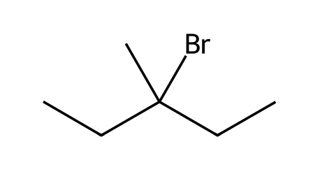
______________________________________________________________________________________
______________________________________________________________________________________
______________________________________________________________________________________
79. [Synthesis design] Design a synthesis of 2-methoxy-2-methylpropane from an alkyl halide and an alkoxide. Which combination works, and why does the other combination fail?
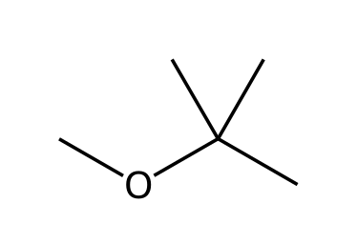
______________________________________________________________________________________
______________________________________________________________________________________
______________________________________________________________________________________
80. [Synthesis design] Design a synthesis of 2-ethoxypropane from an alkyl halide and an alkoxide. Which combination works, and why does the other combination fail?
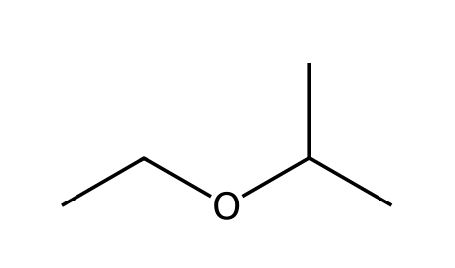
______________________________________________________________________________________
______________________________________________________________________________________
______________________________________________________________________________________
81. [Synthesis design] Design a synthesis of 2-ethoxy-2-methylpropane from an alkyl halide and an alkoxide. Which combination works, and why does the other combination fail?
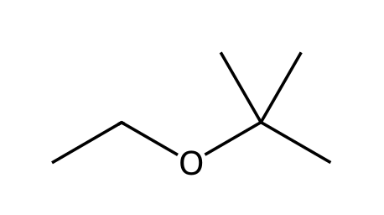
______________________________________________________________________________________
______________________________________________________________________________________
______________________________________________________________________________________
82. [Intramolecular substitution] Treatment of 4-bromobutan-1-ol with NaOH gives a cyclic ether, tetrahydrofuran (oxolane). Explain the mechanism and why a ring forms.
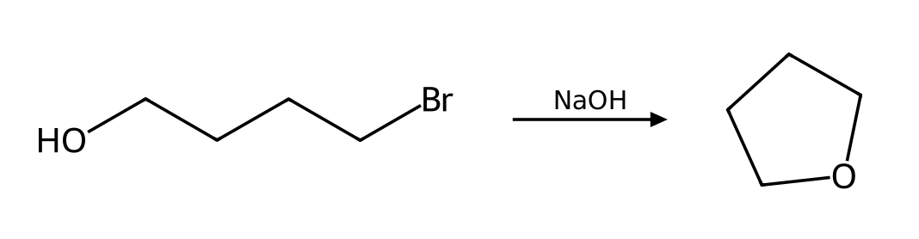
______________________________________________________________________________________
______________________________________________________________________________________
______________________________________________________________________________________
83. [Intramolecular substitution] Treatment of 5-bromopentan-1-ol with NaOH gives a cyclic ether, tetrahydropyran (oxane). Explain the mechanism and why a ring forms.
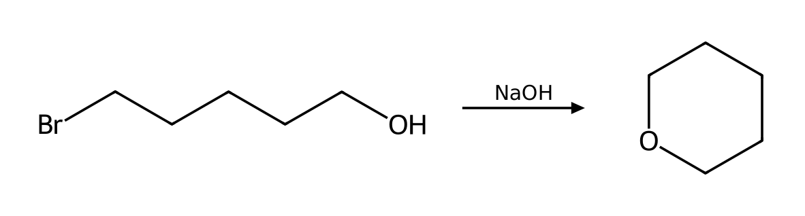
______________________________________________________________________________________
______________________________________________________________________________________
______________________________________________________________________________________
84. [Nucleophile strength] Rank the halide ions F⁻, Cl⁻, Br⁻, I⁻ by nucleophilicity (a) in methanol (a protic solvent) and (b) in DMSO (a polar aprotic solvent). Explain the reversal.
______________________________________________________________________________________
______________________________________________________________________________________
______________________________________________________________________________________
85. [Nucleophile strength] Classify each as a strong or weak nucleophile and state whether it favors SN2 or SN1: (a) HS⁻ (b) H₂O (c) CH₃CH₂O⁻ (d) CH₃CH₂OH (e) I⁻ (f) CN⁻.
______________________________________________________________________________________
______________________________________________________________________________________
______________________________________________________________________________________
86. [Substrate reactivity] Rank bromomethane, 1-bromopropane, 2-bromopropane and 2-bromo-2-methylpropane from fastest to slowest toward SN2. Then give the order for SN1.
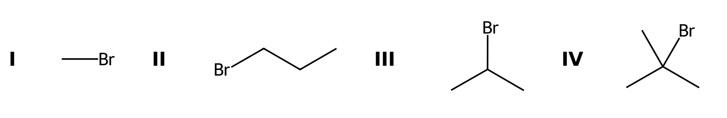
______________________________________________________________________________________
______________________________________________________________________________________
______________________________________________________________________________________
87. [Substrate reactivity] Neopentyl bromide, (CH₃)₃CCH₂Br, is a primary alkyl halide. Predict whether it reacts well by SN2 or by SN1 and explain.
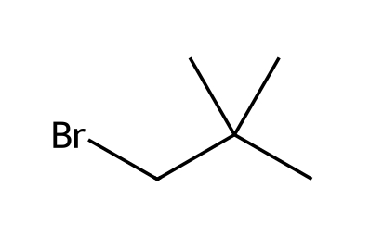
______________________________________________________________________________________
______________________________________________________________________________________
______________________________________________________________________________________
88. [Leaving groups] Which is the better leaving group in each pair, and why? (a) Cl⁻ or I⁻ (b) HO⁻ or H₂O (c) CH₃O⁻ or TsO⁻.
______________________________________________________________________________________
______________________________________________________________________________________
______________________________________________________________________________________
89. [Leaving groups] Rank 1-chlorobutane, 1-bromobutane and 1-iodobutane by their rate of reaction with NaCN in DMSO, and explain.
______________________________________________________________________________________
______________________________________________________________________________________
______________________________________________________________________________________
90. [Solvent effects] Classify each solvent as protic or polar aprotic and say which substitution mechanism it favors: DMSO, methanol, acetonitrile, water, DMF, acetic acid.
______________________________________________________________________________________
______________________________________________________________________________________
______________________________________________________________________________________
91. [Solvent effects] The SN2 reaction of 1-bromobutane with azide is about 1300 times faster in DMSO than in methanol. Explain.
______________________________________________________________________________________
______________________________________________________________________________________
______________________________________________________________________________________
92. [Kinetics] The reaction of 2-bromobutane with NaSH in DMSO follows the mechanism predicted for these conditions. Write the rate law. What happens to the rate if (a) [substrate] is doubled and [hydrosulfide] is unchanged, and (b) [hydrosulfide] is tripled and [substrate] is unchanged?
______________________________________________________________________________________
______________________________________________________________________________________
______________________________________________________________________________________
93. [Kinetics] The reaction of 2-chloro-2-methylbutane with EtOH as the solvent follows the mechanism predicted for these conditions. Write the rate law. What happens to the rate if (a) [substrate] is doubled and [ethanol] is unchanged, and (b) [ethanol] is tripled and [substrate] is unchanged?
______________________________________________________________________________________
______________________________________________________________________________________
______________________________________________________________________________________
94. [Kinetics] The reaction of 2-bromobutane with NaOEt in EtOH follows the mechanism predicted for these conditions. Write the rate law. What happens to the rate if (a) [substrate] is doubled and [ethoxide] is unchanged, and (b) [ethoxide] is tripled and [substrate] is unchanged?
______________________________________________________________________________________
______________________________________________________________________________________
______________________________________________________________________________________
95. [Kinetics] The reaction of 1-chlorobutane with NaI in acetone follows the mechanism predicted for these conditions. Write the rate law. What happens to the rate if (a) [substrate] is doubled and [iodide] is unchanged, and (b) [iodide] is tripled and [substrate] is unchanged?
______________________________________________________________________________________
______________________________________________________________________________________
______________________________________________________________________________________
96. [Classify the substrate] For each substrate, classify the α carbon (methyl, 1°, 2° or 3°), identify the leaving group, and state whether SN2, SN1, both or neither is feasible: (I) iodoethane (II) 2-bromo-2-methylbutane (III) 2-chlorobutane (IV) bromobenzene.
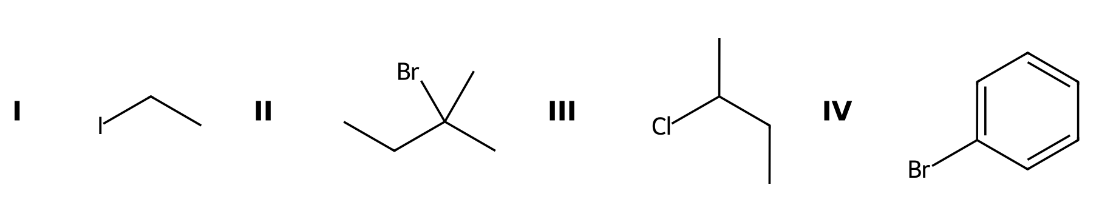
______________________________________________________________________________________
______________________________________________________________________________________
______________________________________________________________________________________
97. [Classify the substrate] Label each carbon bearing a leaving group as 1°, 2° or 3° and say which substitution mechanism is favored by the substrate alone: (I) 1-bromobutane (II) 3-bromo-3-methylpentane (III) iodocyclohexane.
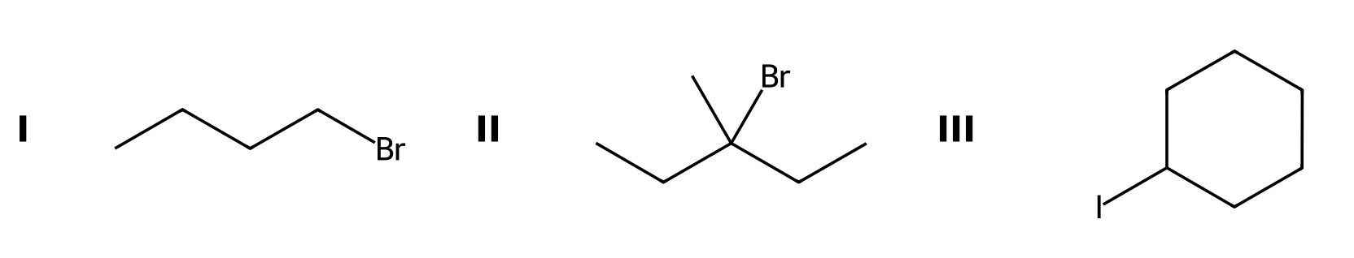
______________________________________________________________________________________
______________________________________________________________________________________
______________________________________________________________________________________
98. [Which reacts faster?] Which compound reacts faster with NaN₃ in DMF, 1-bromobutane or 2-bromobutane? Which reacts faster with ethanol (solvolysis), 2-bromo-2-methylpropane or 2-bromopropane?
______________________________________________________________________________________
______________________________________________________________________________________
______________________________________________________________________________________
99. [Energy diagrams] Sketch the reaction energy diagram for the SN1 solvolysis of 2-bromo-2-methylpropane in water. How many transition states and intermediates are there, and which step is rate-determining?
______________________________________________________________________________________
______________________________________________________________________________________
______________________________________________________________________________________
100. [Energy diagrams] How does the energy diagram of an SN2 reaction differ from that of an SN1 reaction? Include the number of steps, transition states and intermediates.
______________________________________________________________________________________
______________________________________________________________________________________
______________________________________________________________________________________

