Chapter 9: Alkynes
Organic chemistry questions. Multiple choice first within each textbook section.
Name: ______________________________ Date: ______________

9.1 Introduction to Alkynes
1. How many σ and π bonds make up a carbon-carbon triple bond? [C09M01, Easy]
A) Two σ and one π
B) Three σ
C) Three π
D) One σ and two π
2. What is the geometry around each carbon of a triple bond? [C09M02, Easy]
A) Linear (180°)
B) Trigonal planar (120°)
C) Tetrahedral (109.5°)
D) Bent
3. What is the hybridization of the carbons of an alkyne triple bond? [C09M03, Basic]
A) sp²
B) sp³
C) p
D) sp
4. Which compound has a C-C-C bond angle of 180°? [C09M04, Basic]
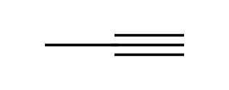
A) Propyne
B) Propene
C) Propane
D) Cyclopropane
5. Describe the bonds in a carbon-carbon triple bond. [C09F01, Easy]

6. What is the geometry around the carbons of an alkyne, and why? [C09F02, Basic]

7. Draw the structural formula of propyne and label the bond angle at the central carbon. [C09F03, Basic]

9.2 Nomenclature of Alkynes
8. What is the IUPAC name of the compound shown? [C09M05, Easy]
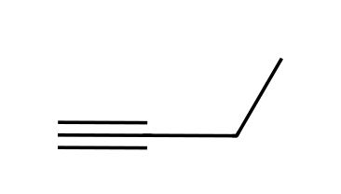
A) but-2-yne
B) but-1-yne
C) propyne
D) pent-1-yne
9. What is the IUPAC name of the compound shown? [C09M06, Basic]
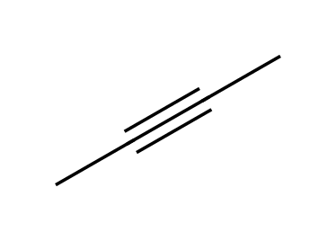
A) but-1-yne
B) butyne
C) but-2-yne
D) dimethylethene
10. What is the IUPAC name of the compound shown? [C09M07, Basic]
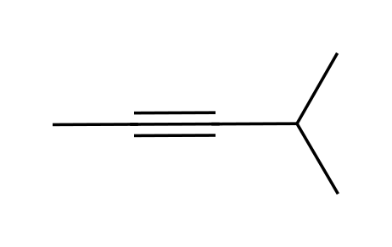
A) 2-methylpent-2-yne
B) 3-methylpent-1-yne
C) 4-methylpent-2-yne
D) 4-methylpent-1-yne
11. What is the IUPAC name of the compound shown? [C09M08, Moderate]
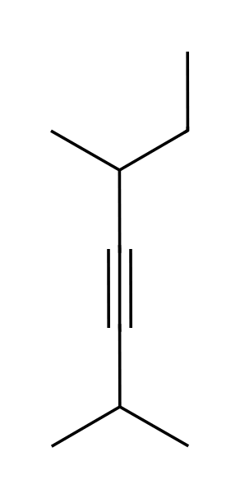
A) 2,5-dimethylhept-3-yne
B) 2,6-dimethylhept-3-yne
C) 2,5-dimethyloct-3-yne
D) 3,5-dimethylhept-1-yne
12. A terminal alkyne has the triple bond: [C09M09, Easy]
A) In the middle of the chain
B) In a ring
C) Next to a double bond
D) At the end of the chain
13. Which is an internal alkyne? [C09M10, Basic]
A) Pent-1-yne
B) Pent-2-yne
C) Ethyne
D) Propyne
14. Define terminal and internal alkynes. [C09F04, Easy]

15. Name the compound shown. [C09F05, Basic]

16. Draw pent-1-yne and pent-2-yne. [C09F06, Basic]

17. Name the compound shown. [C09F07, Moderate]

18. Draw all acyclic alkynes of formula C₅H₈ and name them. [C09F08, Moderate]

19. Draw ethyne (acetylene) and give its common name. [C09F09, Easy]

20. How many carbons are in hex-2-yne, and where is the triple bond? [C09F49, Basic]

9.3 Acidity of Acetylene and Terminal Alkynes
21. Which hydrogen is the most acidic? [C09M11, Easy]
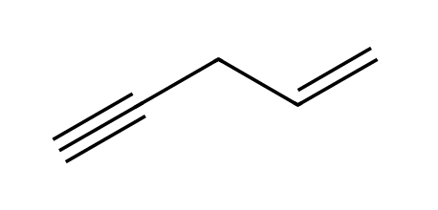
A) An alkene C-H
B) The terminal alkyne C-H
C) An alkane C-H
D) They are equally acidic
22. Why is the conjugate base of a terminal alkyne relatively stable? [C09M12, Basic]
A) The lone pair is in a p orbital
B) The lone pair is in an sp orbital, which has high s character
C) The anion is delocalised by resonance
D) The anion is a radical
23. Which base is strong enough to deprotonate a terminal alkyne completely? [C09M13, Basic]
A) NaOH
B) NaOCH₃
C) NaNH₂
D) NaHCO₃
24. Which compound cannot be deprotonated by NaNH₂ at a triple-bond carbon? [C09M14, Moderate]
A) But-2-yne
B) Propyne
C) But-1-yne
D) Acetylene
25. The reaction of propyne with NaNH₂ gives: [C09M15, Moderate]
A) The propynide ion (an alkynide) and NH₃
B) Propene and NaNH
C) A vinyl anion
D) Propane
26. Which C-H bond of a hydrocarbon is the most acidic: alkane, alkene or terminal alkyne? [C09F10, Easy]

27. Explain why a terminal alkyne is more acidic than an alkene. [C09F11, Basic]

28. Write the reaction of propyne with NaNH₂. [C09F12, Basic]

29. Why can NaOH not be used to deprotonate a terminal alkyne completely? [C09F13, Moderate]

30. Which compound will react with NaNH₂ to form an alkynide, but-1-yne or but-2-yne? Explain. [C09F14, Moderate]

9.4 Preparation of Alkynes
31. An alkyne can be prepared from a dihalide by: [C09M16, Easy]
A) Two SN2 reactions
B) Hydrogenation
C) Two successive E2 reactions
D) Ozonolysis
32. Which is a suitable starting material to make propyne by double elimination? [C09M17, Basic]
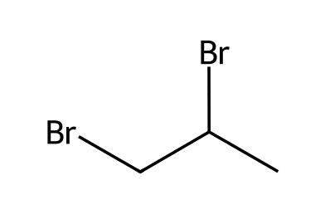
A) 1-Bromopropane
B) 2-Bromopropane
C) Propane
D) 1,2-Dibromopropane
33. Why is excess (three equivalents of) NaNH₂ needed when making a terminal alkyne from a dihalide? [C09M18, Moderate]
A) The first E2 is very slow
B) NaNH₂ is destroyed by the solvent
C) A radical must be generated
D) The terminal alkyne product is deprotonated by the base, and water workup restores it
34. Give the starting material and reagents to prepare propyne by double elimination. [C09F15, Basic]

35. Why are three equivalents of NaNH₂ used when making a terminal alkyne from a dihalide? [C09F16, Moderate]

36. Show how to prepare but-2-yne from 2,3-dibromobutane. [C09F17, Moderate]
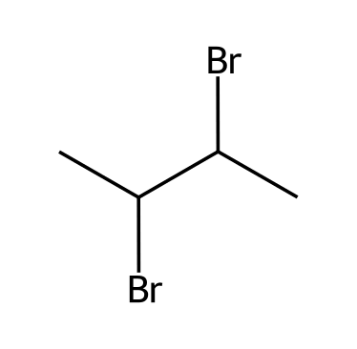

9.5 Reduction of Alkynes
37. What is the major product of but-2-yne with H₂ and Lindlar's catalyst? [C09M20, Basic]
A)  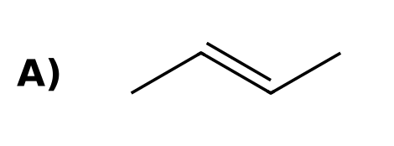 | B)  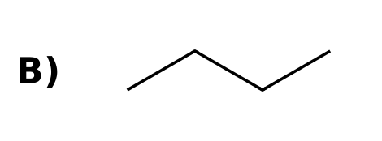
C)  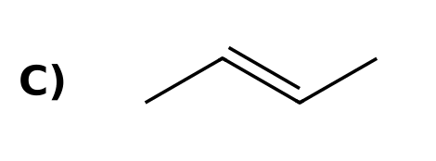 | D)  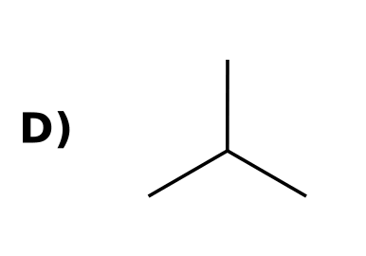
38. What is the major product of but-2-yne with Na in liquid NH₃? [C09M21, Basic]
A) | B)
C) | D)  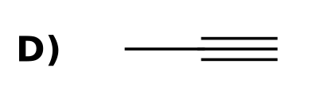
39. What is the product of but-2-yne with excess H₂ and Pt? [C09M22, Easy]
A) | B)  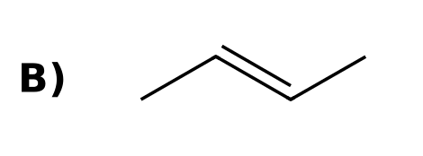
C)  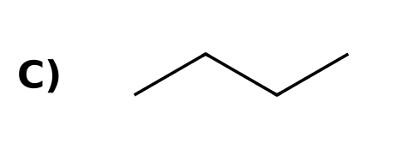 | D)
40. Which reagent converts an internal alkyne into a cis alkene? [C09M23, Basic]
A) H₂, Lindlar catalyst
B) Na, NH₃(l)
C) H₂, Pt
D) O₃, then H₂O
41. The Na/NH₃ reduction of an alkyne involves which kind of arrow? [C09M24, Moderate]
A) Fishhook (single-electron) arrows
B) Only full-headed arrows
C) No arrows
D) Equilibrium arrows
42. Which reagent converts pent-2-yne into trans-pent-2-ene? [C09M25, Moderate]
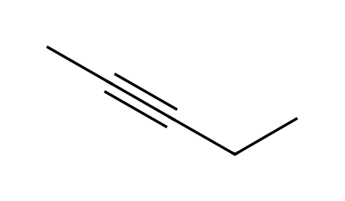
A) H₂, Lindlar
B) H₂ (excess), Pd/C
C) Na, NH₃(l)
D) BH₃ then H₂O₂
43. What does H₂ with Pt do to an alkyne? [C09F18, Easy]

44. Draw the product of but-2-yne with H₂ and Lindlar catalyst. [C09F19, Basic]

45. Draw the product of but-2-yne with Na, NH₃(l). [C09F20, Basic]

46. What type of arrow is used in the mechanism of the dissolving-metal reduction, and why? [C09F21, Moderate]

47. Propose reagents to convert pent-2-yne to cis-pent-2-ene, and to trans-pent-2-ene. [C09F22, Moderate]

48. Explain why an alkyne can be stopped at the alkene stage with Lindlar catalyst but not with Pd/C. [C09F23, Hard]

49. Why is a trans alkene formed in the dissolving-metal reduction? [C09F48, Moderate]

9.6 Hydrohalogenation of Alkynes
50. What is the product of propyne with one equivalent of HBr? [C09M26, Basic]
A)  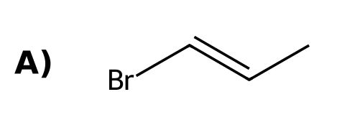 | B)  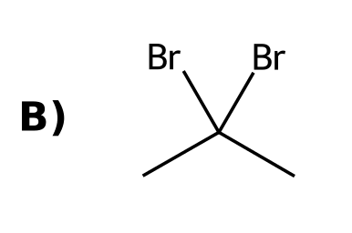
C)  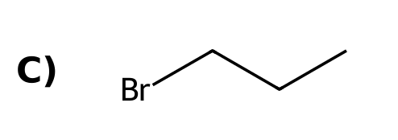 | D)  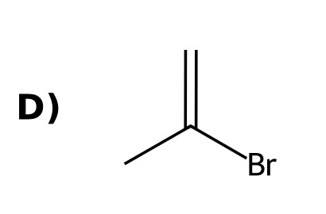
51. What is the product of propyne with two equivalents of HBr? [C09M27, Moderate]
A)  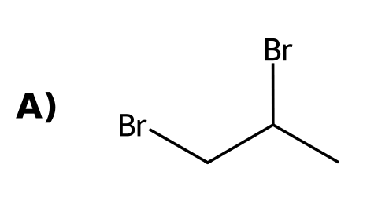 | B)
C)  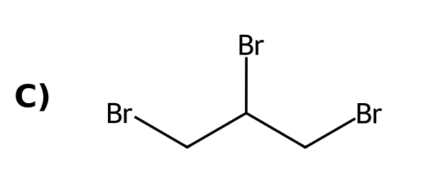 | D)
52. What is the product of propyne with HBr in the presence of peroxides? [C09M28, Moderate]
A) | B)  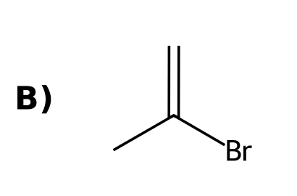
C)  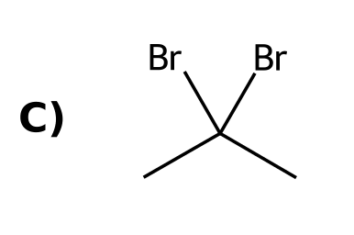 | D)  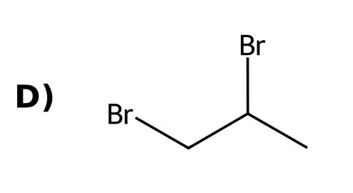
53. Two equivalents of HX add to a terminal alkyne. Where are the two halogens in the product? [C09M29, Moderate]
A) On adjacent carbons
B) On the same carbon (geminal)
C) On the terminal carbon only
D) On carbons 1 and 3
54. State the regiochemistry for the addition of HBr to a terminal alkyne. [C09F24, Easy]

55. Draw the product of propyne with one equivalent of HBr. [C09F25, Basic]

56. Draw the product of propyne with two equivalents of HBr. [C09F26, Basic]

57. Draw the product of propyne with HBr and peroxides and state the regiochemistry. [C09F27, Moderate]

9.7 Hydration of Alkynes
58. What is the product of but-1-yne with H₂O, H₂SO₄, HgSO₄? [C09M30, Moderate]
A)  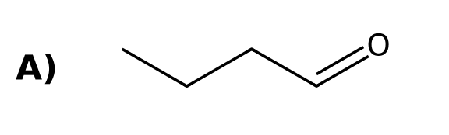 | B)  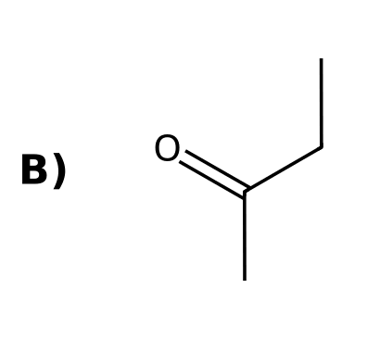
C)  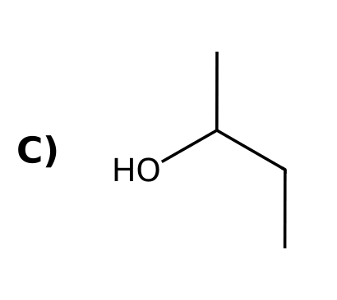 | D)  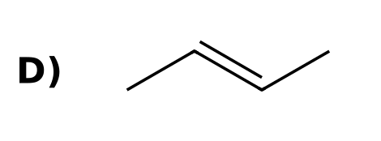
59. What is the product of but-1-yne with (1) Sia₂BH; (2) H₂O₂, NaOH? [C09M31, Moderate]
A) | B)
C)  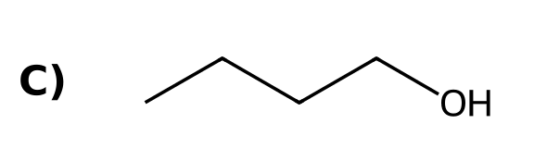 | D)  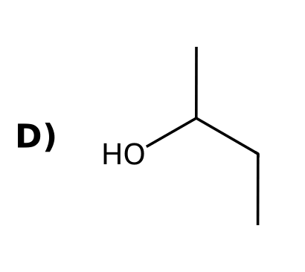
60. Enols and ketones that interconvert are called: [C09M32, Easy]
A) Enantiomers
B) Tautomers
C) Resonance structures
D) Diastereomers
61. What functional group does an enol contain? [C09M33, Basic]
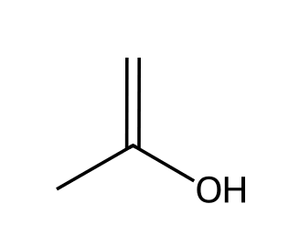
A) A C=C double bond bearing an OH group
B) A C=O and an OH
C) A C≡C and an OH
D) Two OH groups
62. Hydration of an internal symmetrical alkyne such as but-2-yne gives: [C09M34, Basic]
A) An aldehyde
B) A mixture of two ketones
C) A carboxylic acid
D) A single ketone
63. Hydration of pent-2-yne (HgSO₄, H₂SO₄, H₂O) gives: [C09M35, Moderate]
A) A single ketone
B) An aldehyde
C) A mixture of two ketones
D) An alcohol
64. The tautomerization of an enol to a ketone in base proceeds through: [C09M36, Hard]
A) A carbocation
B) A radical
C) A carbene
D) An enolate ion
65. What is tautomerism? [C09F28, Easy]

66. Draw the enol and ketone formed from propyne with H₂O, H₂SO₄, HgSO₄. [C09F29, Basic]

67. Draw the product of but-1-yne with (1) Sia₂BH; (2) H₂O₂, NaOH. [C09F30, Basic]

68. Explain why hydration of but-1-yne gives a ketone but hydroboration-oxidation gives an aldehyde. [C09F31, Moderate]

69. Why does hydration of pent-2-yne give two products? [C09F32, Moderate]

70. Describe the base-catalyzed tautomerization of an enol to a ketone. [C09F33, Hard]

9.8 Halogenation of Alkynes
71. What is the product of propyne with excess Br₂? [C09M37, Basic]
A)  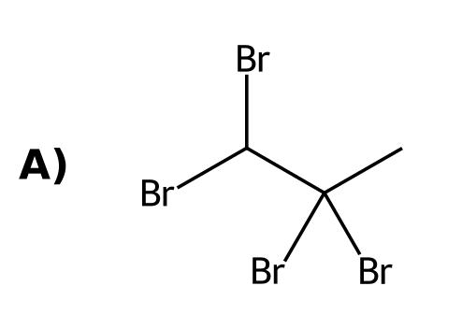 | B)  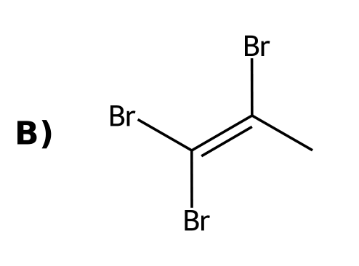
C)  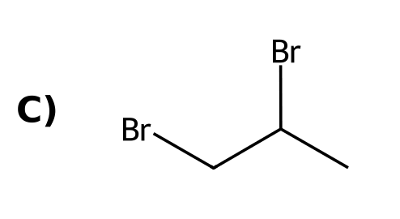 | D)  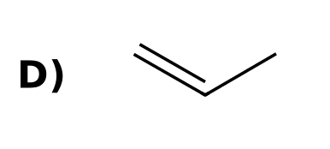
72. How many moles of Br₂ add to one mole of an alkyne to give a tetrabromide? [C09M38, Moderate]
A) 1
B) 3
C) 2
D) 4
73. What is the stereochemistry of the addition of one equivalent of Br₂ to an alkyne? [C09M50, Basic]
A) Syn
B) Anti
C) Markovnikov
D) Radical only
74. Draw the product of propyne with excess Br₂. [C09F34, Basic]

75. How many equivalents of Br₂ are needed to convert an alkyne to a tetrabromide, and why? [C09F35, Moderate]

76. Draw the product of but-2-yne with one equivalent of Br₂ and state the stereochemistry of addition. [C09F50, Basic]

9.9 Ozonolysis of Alkynes
77. Ozonolysis of an internal alkyne (O₃; H₂O) gives: [C09M39, Easy]
A) Two aldehydes
B) Two ketones
C) Two alcohols
D) Two carboxylic acids
78. What is formed from but-2-yne with (1) O₃; (2) H₂O? [C09M40, Basic]
A)  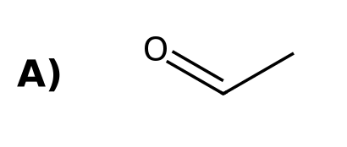 | B)  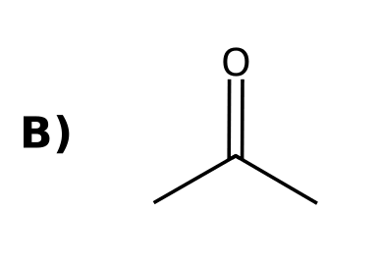
C)  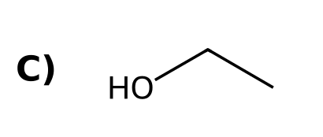 | D)  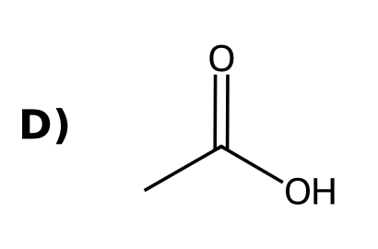
79. Ozonolysis of a terminal alkyne converts the terminal carbon into: [C09M41, Moderate]
A) A methyl group
B) An aldehyde
C) An alcohol
D) CO₂
80. Draw the products of but-2-yne with (1) O₃; (2) H₂O. [C09F36, Basic]

81. Draw the products of but-1-yne with (1) O₃; (2) H₂O. [C09F37, Moderate]

82. An alkyne gives acetic acid and propanoic acid on ozonolysis with water workup. Identify it. [C09F38, Hard]

9.10 Alkylation of Terminal Alkynes
83. In the alkylation of a terminal alkyne, the nucleophile is: [C09M42, Easy]
A) The alkynide ion
B) The alkyl halide
C) The alkyne itself
D) NaNH₂
84. What is the product of but-1-yne with (1) NaNH₂; (2) CH₃CH₂Br? [C09M43, Moderate]
A)  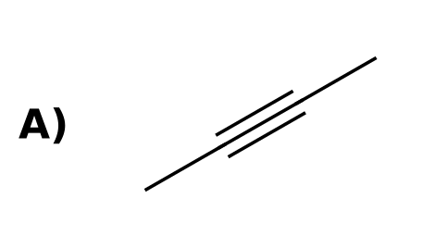 | B)  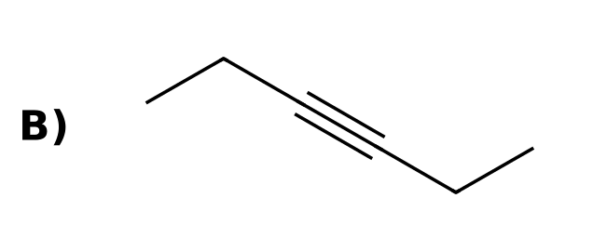
C)  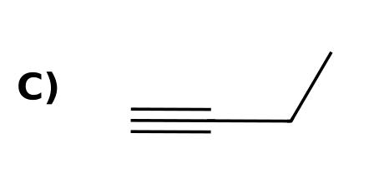 | D)  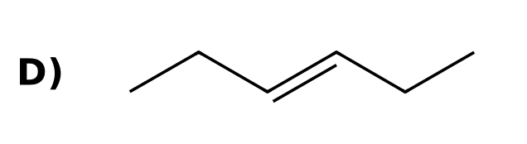
85. Which alkyl halide gives the best yield of alkylation with an alkynide? [C09M44, Moderate]
A) Tertiary
B) Methyl or primary
C) Secondary
D) Vinylic
86. What is the main product when an alkynide reacts with tert-butyl bromide? [C09M45, Hard]
A) The alkene from E2 elimination
B) The alkylated alkyne
C) A ketone
D) The alkane
87. What is alkylation of a terminal alkyne? [C09F39, Easy]

88. Draw the product of propyne with (1) NaNH₂; (2) CH₃CH₂Br. [C09F40, Basic]

89. Explain why tertiary alkyl halides cannot be used in alkynide alkylation. [C09F41, Moderate]

90. Show how to make hex-3-yne from acetylene. [C09F42, Moderate]
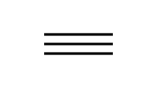

9.11 Synthesis Strategies
91. Which two-step sequence converts but-1-ene into but-1-yne? [C09M19, Moderate]
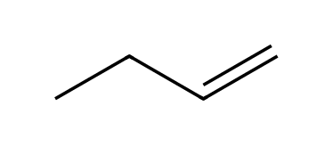
A) (1) HBr; (2) NaOH
B) (1) H₂, Pt; (2) NaNH₂
C) (1) Br₂; (2) excess NaNH₂, then H₂O
D) (1) O₃; (2) DMS
92. To make hex-3-yne from acetylene, you need: [C09M46, Moderate]
A) Two hydrations
B) One hydrogenation
C) Two alkylations with ethyl bromide
D) Ozonolysis
93. To convert but-2-yne to butan-2-one, use: [C09M47, Moderate]
A) H₂, Lindlar
B) H₂O, H₂SO₄, HgSO₄
C) Na, NH₃
D) O₃, H₂O
94. To convert 1-butyne into 2-pentyne (chain extension), which sequence is best? [C09M48, Hard]
A) (1) H₂, Lindlar; (2) CH₃I
B) (1) HBr; (2) NaNH₂
C) (1) Br₂; (2) CH₃I
D) (1) NaNH₂; (2) CH₃I
95. To convert 1-bromopropane into propyne, the best sequence is: [C09M49, Hard]
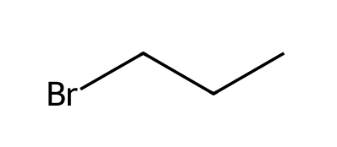
A) (1) NaNH₂; (2) H₂O
B) (1) NaOEt; (2) Br₂; (3) excess NaNH₂, then H₂O
C) (1) Br₂; (2) H₂O
D) (1) H₂, Pt; (2) NaNH₂
96. Propose a synthesis of but-1-yne from but-1-ene. [C09F43, Moderate]

97. Propose a synthesis of butan-2-one from but-1-yne. [C09F44, Moderate]

98. Propose a synthesis of cis-pent-2-ene from propyne and ethyl bromide. [C09F45, Hard]

99. Propose a synthesis of trans-hex-3-ene from acetylene and ethyl bromide. [C09F46, Hard]

100. Propose a synthesis of 2,2-dibromopropane from propene. [C09F47, Hard]
