Chapter 10: Radical Reactions: Answer Key
Answers and explanations.
Name: ______________________________ Date: ______________

10.1 Radicals
1. What is a radical? [C10M01, Easy]
Answer: C) A species with an unpaired electron
Why: Radicals have one unpaired electron and are usually highly reactive.
2. What kind of arrow shows the movement of a single electron? [C10M02, Easy]
Answer: C) A fishhook (half-headed) arrow
Why: A full arrow moves a pair of electrons.
3. Which radical is the most stable? [C10M03, Basic]
Answer: D) Tertiary
Why: Radical stability follows the same trend as carbocation stability.
4. Which radical is stabilised by resonance? [C10M04, Basic]
Answer: C) The allyl radical, CH₂=CH-CH₂•
Why: The unpaired electron of the allyl radical is delocalised over two carbons.
5. Rank these radicals from most stable to least stable: methyl, primary, secondary, allylic. [C10M05, Moderate]
Answer: B) Allylic > secondary > primary > methyl
Why: Resonance stabilisation outweighs substitution.
6. How many resonance structures does the allyl radical have? [C10M06, Moderate]
Answer: C) 2
Why: The radical can sit on either terminal carbon.
7. What is a radical, and what arrow shows its reactions? [C10F01, Easy]
Answer: A radical has an unpaired electron; its reactions are drawn with fishhook (single-headed) arrows.
Why: One electron per arrow.
8. Rank the radicals methyl, primary, secondary and tertiary by stability. [C10F02, Basic]
Answer: Tertiary > secondary > primary > methyl.
Why: More alkyl groups stabilise the radical.
9. Explain why the allyl radical is more stable than a primary alkyl radical. [C10F03, Basic]
Answer: The unpaired electron is delocalised over two carbons through resonance.
Why: Draw both resonance structures.
10. Draw the two resonance structures of the allyl radical. [C10F04, Moderate]
Answer: CH₂=CH-CH₂• ↔ •CH₂-CH=CH₂; the radical is shared by the two terminal carbons.
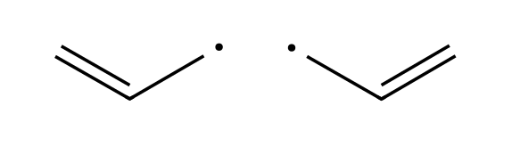
Why: Move one electron with fishhook arrows.
11. Why is a vinylic radical not stabilised by resonance? [C10F05, Moderate]
Answer: The unpaired electron is in an sp² orbital in the plane of the molecule, perpendicular to the π system, so it cannot overlap with the π bond.
Why: Consider orbital alignment.
12. Which is more stable, a secondary radical or a primary radical? Give the reason. [C10F48, Basic]
Answer: The secondary radical; its extra alkyl group stabilises the unpaired electron by hyperconjugation, the same trend seen for carbocations.
Why: More alkyl groups, more stable.

10.2 Common Patterns in Radical Mechanisms
13. A step in which a bond breaks and each atom keeps one electron is called: [C10M07, Easy]
Answer: D) Homolytic cleavage
Why: Homolytic cleavage produces two radicals.
14. The three stages of a radical chain reaction are: [C10M08, Easy]
Answer: A) Initiation, propagation and termination
Why: Every step of a radical mechanism fits one of these.
15. Which step type consumes one radical and produces one radical? [C10M09, Basic]
Answer: C) Propagation
Why: The number of radicals stays the same, so the chain continues.
16. A step in which two radicals combine to form a stable molecule is: [C10M10, Basic]
Answer: B) Termination
Why: Coupling removes two radicals from the reaction.
17. A step that creates radicals from a molecule with no radicals present is: [C10M11, Basic]
Answer: D) Initiation
Why: Initiation produces the first radicals, often by light or heat.
18. Cl• + CH₄ → HCl + CH₃• is which type of radical step? [C10M12, Moderate]
Answer: B) Hydrogen abstraction (propagation)
Why: A hydrogen atom is removed from methane by the chlorine radical.
19. CH₃• + Cl₂ → CH₃Cl + Cl• is which type of radical step? [C10M13, Moderate]
Answer: C) Halogen abstraction (propagation)
Why: The methyl radical takes a chlorine atom from Cl₂.
20. Name the three stages of a radical chain mechanism. [C10F06, Easy]
Answer: Initiation, propagation and termination.
Why: Start, continue, end.
21. List the six kinds of radical steps. [C10F07, Basic]
Answer: Homolytic cleavage, addition to a π bond, hydrogen abstraction, halogen abstraction, elimination and coupling.
Why: Klein section 10.2.
22. Classify Cl• + CH₄ → HCl + CH₃• as initiation, propagation or termination, and as a step type. [C10F08, Basic]
Answer: Propagation; hydrogen abstraction.
Why: One radical consumed, one produced.
23. Explain why a termination step ends the chain. [C10F09, Moderate]
Answer: Two radicals combine into a stable molecule, so no radical is left to continue the cycle.
Why: Radicals are consumed.

10.3 Chlorination of Methane
24. What conditions start the chlorination of methane? [C10M14, Easy]
Answer: A) Light (hν) or heat
Why: Light breaks the Cl-Cl bond homolytically.
25. What is the initiation step in the chlorination of methane? [C10M15, Basic]
Answer: A) Cl-Cl → 2 Cl•
Why: The weakest bond, Cl-Cl, breaks first.
26. Why is the chlorination of methane called a chain reaction? [C10M16, Basic]
Answer: C) The two propagation steps regenerate the radical that starts the cycle
Why: One Cl• can cause many cycles.
27. Which compound is formed in a termination step of methane chlorination? [C10M17, Moderate]
Answer: B) Ethane
Why: Two methyl radicals can couple to make ethane.
28. What is the net reaction of the two propagation steps of methane chlorination? [C10M18, Moderate]
Answer: A) CH₄ + Cl₂ → CH₃Cl + HCl
Why: Add the two propagation steps; the radicals cancel.
29. Write the initiation step of the chlorination of methane. [C10F10, Basic]
Answer: Cl-Cl → 2 Cl• (homolytic cleavage by light or heat).
Why: Weakest bond.
30. Write both propagation steps of the chlorination of methane. [C10F11, Basic]
Answer: Cl• + CH₄ → HCl + CH₃•; CH₃• + Cl₂ → CH₃Cl + Cl•.
Why: Hydrogen abstraction then halogen abstraction.
31. Show that the two propagation steps add up to the net reaction. [C10F12, Moderate]
Answer: Cl• + CH₄ + CH₃• + Cl₂ → HCl + CH₃• + CH₃Cl + Cl•; cancelling Cl• and CH₃• leaves CH₄ + Cl₂ → CH₃Cl + HCl.
Why: Add and cancel the radicals.
32. Give three possible termination steps in the chlorination of methane. [C10F13, Moderate]
Answer: Cl• + Cl• → Cl₂; CH₃• + Cl• → CH₃Cl; CH₃• + CH₃• → CH₃CH₃.
Why: Two radicals combine.
33. Why is a small amount of light enough to convert a large amount of methane to chloromethane? [C10F14, Moderate]
Answer: The propagation steps form a chain reaction in which each chlorine radical regenerates itself and can cause many cycles.
Why: Chain reaction.
34. What does hν mean in a reaction scheme? [C10F49, Easy]
Answer: Light (a photon of energy hν) used to start the reaction, here by breaking a weak bond homolytically.
Why: Light as the initiator.

10.4 Thermodynamic Considerations
35. Bromination of an alkane is generally ______ chlorination. [C10M19, Basic]
Answer: B) Slower than
Why: The hydrogen abstraction step for Br• is endothermic.
36. Use C-H 414, Cl-Cl 243, C-Cl 339 and H-Cl 431 kJ/mol. What is ΔH for CH₃• + Cl₂ → CH₃Cl + Cl•? [C10M20, Moderate]
Answer: D) −96 kJ/mol
Why: Bonds broken: 243. Bonds formed: 339. ΔH = 243 − 339.
37. Use C-H 414 and H-Cl 431 kJ/mol. What is ΔH for Cl• + CH₄ → HCl + CH₃•? [C10M21, Moderate]
Answer: D) −17 kJ/mol
Why: Bonds broken: 414. Bonds formed: 431. ΔH = 414 − 431.
38. Use C-H 414, Cl-Cl 243, C-Cl 339 and H-Cl 431 kJ/mol to calculate ΔH for each propagation step of methane chlorination. [C10F15, Moderate]
Answer: Step 1: 414 − 431 = −17 kJ/mol. Step 2: 243 − 339 = −96 kJ/mol. Overall −113 kJ/mol.
Why: Bonds broken minus bonds formed.
39. Which is more practical in the laboratory: radical chlorination or radical iodination? Explain briefly. [C10F16, Basic]
Answer: Chlorination, since the iodination propagation step is too unfavorable (only chlorination and bromination are practical).
Why: Only Cl and Br are useful.

10.5 Selectivity of Halogenation
40. Radical halogenation occurs more readily at which kind of hydrogen? [C10M22, Easy]
Answer: A) Tertiary C-H
Why: The more substituted radical is more stable.
41. Which halogen is more selective in radical halogenation? [C10M23, Basic]
Answer: D) Bromine
Why: Bromine abstracts hydrogen in an endothermic step with a late transition state.
42. What is the major product of isobutane (2-methylpropane) with Br₂, hν? [C10M24, Moderate]
Answer: D
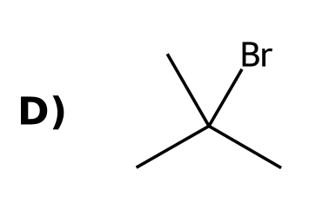
Why: Bromine is highly selective for the tertiary hydrogen.
43. How many different monochlorination products (constitutional isomers) can propane give? [C10M25, Moderate]
Answer: A) 2
Why: 1-Chloropropane and 2-chloropropane.
44. How many monochlorination products (constitutional isomers) can 2-methylpropane give? [C10M26, Moderate]
Answer: C) 2
Why: 1-chloro-2-methylpropane and 2-chloro-2-methylpropane.
45. In the chlorination of 2-methylbutane, the monochloro product ratio is not simply 9:2:1 because: [C10M27, Hard]
Answer: A) Tertiary hydrogens are more reactive per hydrogen
Why: You must weigh the number of hydrogens by their relative reactivity.
46. Explain why radical halogenation occurs more readily at tertiary hydrogens. [C10F17, Basic]
Answer: Abstracting a tertiary hydrogen forms the most stable (tertiary) radical, with the lowest energy transition state.
Why: Radical stability.
47. Which is more selective, bromination or chlorination, and why? [C10F18, Basic]
Answer: Bromination; its hydrogen abstraction step is endothermic with a late transition state, which resembles the radical and magnifies stability differences.
Why: Late transition state.
48. Draw the major product of isobutane with Br₂, hν and explain. [C10F19, Moderate]
Answer: 2-Bromo-2-methylpropane; bromine is highly selective for the tertiary hydrogen.
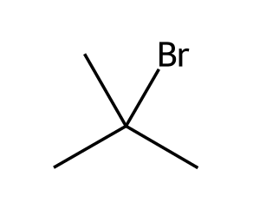
Why: Selectivity of Br•.
49. Draw all monochlorination products of propane. [C10F20, Moderate]
Answer: 1-Chloropropane and 2-chloropropane.
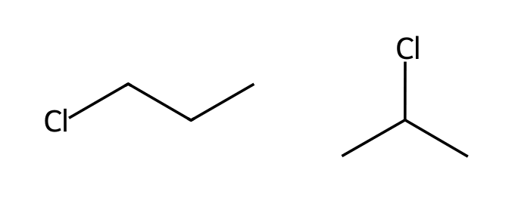
Why: Two types of hydrogen.
50. Chlorination of 2-methylbutane gives four monochloro constitutional isomers. Draw them. [C10F21, Hard]
Answer: 1-Chloro-2-methylbutane, 2-chloro-2-methylbutane, 2-chloro-3-methylbutane and 1-chloro-3-methylbutane.
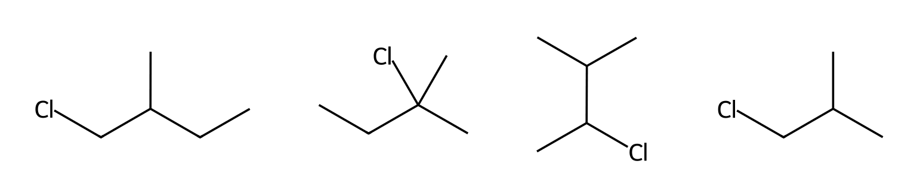
Why: Count the types of hydrogens.

10.6 Stereochemistry of Halogenation
51. Radical bromination creates a new chirality center in a molecule. What is the stereochemical outcome? [C10M28, Basic]
Answer: D) Both stereoisomers form in equal amounts
Why: The radical carbon is planar, so the halogen adds to either face.
52. (R)-3-Methylhexane undergoes radical bromination at C3. What is the product? [C10M29, Moderate]
Answer: C) A racemic mixture of 3-bromo-3-methylhexane
Why: The planar radical intermediate loses stereochemical information.
53. Why does halogenation at a chirality center give a racemic mixture? [C10M30, Hard]
Answer: B) The intermediate radical is planar and is attacked equally from both faces
Why: A trigonal planar radical has no preferred face.
54. Radical bromination of butane at C2 creates a chirality center. What is the stereochemical result? [C10F22, Basic]
Answer: A racemic mixture of (R)- and (S)-2-bromobutane, because the radical is planar and Br₂ attacks either face.
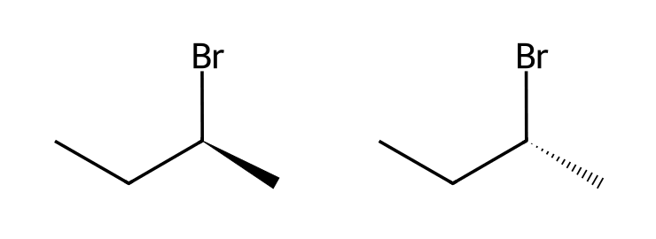
Why: Planar radical.
55. Explain why bromination of optically pure (R)-3-methylhexane at C3 gives an optically inactive product. [C10F23, Moderate]
Answer: The radical at C3 is planar and achiral, and Br₂ attacks either face equally, giving a racemic mixture.
Why: Radical intermediate.
56. Why does the chirality of a starting material not control the outcome of a radical substitution at that center? [C10F24, Moderate]
Answer: Because the intermediate radical is planar, so the original configuration is lost.
Why: Planar radical.

10.7 Allylic Bromination
57. Which reagent is used for allylic bromination? [C10M31, Easy]
Answer: D) NBS
Why: N-bromosuccinimide provides a low concentration of Br₂.
58. What is the major product of cyclohexene with NBS, hν? [C10M32, Basic]
Answer: A
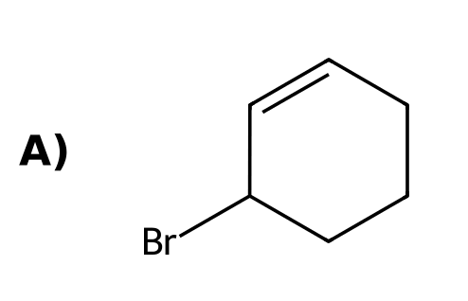
Why: Bromination occurs at the allylic position.
59. Why is NBS used instead of Br₂ for allylic bromination of an alkene? [C10M33, Basic]
Answer: C) To keep Br₂ concentration low and avoid ionic addition to the double bond
Why: Low Br₂ concentration prevents the competing addition.
60. Which hydrogen of 1-butene is removed in allylic bromination? [C10M34, Moderate]
Answer: B) A hydrogen on C3
Why: The allylic position is the carbon next to the double bond.
61. Why does allylic bromination of an unsymmetrical alkene often give two products? [C10M35, Moderate]
Answer: B) The allylic radical has two resonance structures
Why: Br can attach to either end of the allylic radical.
62. What reagent is used for allylic bromination? [C10F25, Easy]
Answer: N-Bromosuccinimide (NBS) with light or a radical initiator.
Why: NBS.
63. Draw the product of cyclohexene with NBS, hν. [C10F26, Basic]
Answer: 3-Bromocyclohexene.
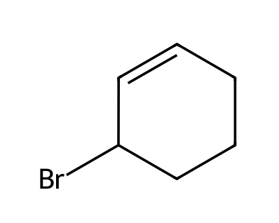
Why: Allylic position.
64. Draw the product of propene with NBS, hν. [C10F27, Basic]
Answer: 3-Bromopropene (allyl bromide).
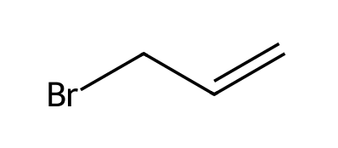
Why: Allylic bromination.
65. Why does Br₂ at high concentration add to alkenes but NBS gives allylic substitution? [C10F28, Moderate]
Answer: NBS keeps the concentration of Br₂ very low, so the ionic addition via a bromonium ion is slow compared with the radical chain substitution.
Why: Concentration of Br₂.
66. Explain why allylic bromination of 1-butene can give two products. [C10F29, Moderate]
Answer: The allylic radical is resonance-stabilised, so Br₂ can attack either end, giving 3-bromobut-1-ene and 1-bromobut-2-ene.
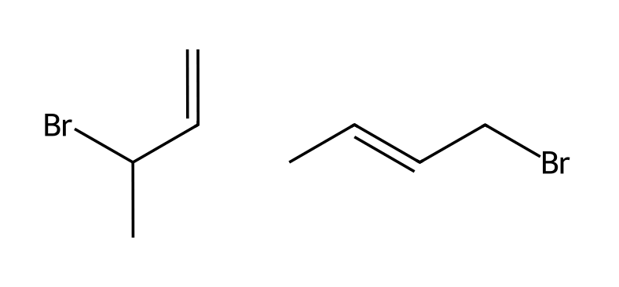
Why: Two resonance structures.
67. Outline the mechanism of allylic bromination of cyclohexene with NBS: name the two propagation steps. [C10F30, Hard]
Answer: Br• abstracts an allylic hydrogen to give a resonance-stabilised allylic radical and HBr; the radical abstracts a Br from Br₂ to give 3-bromocyclohexene and Br•.
Why: Hydrogen abstraction then halogen abstraction.

10.8 Atmospheric Chemistry and the Ozone Layer
68. Which compounds were responsible for depleting stratospheric ozone? [C10M36, Easy]
Answer: A) CFCs (chlorofluorocarbons)
Why: CFCs release chlorine radicals in the stratosphere.
69. What replaced CFCs as refrigerants? [C10M37, Basic]
Answer: A) Hydrofluorocarbons (HFCs)
Why: HFCs contain no chlorine.
70. What are CFCs, and what problem did they cause? [C10F31, Easy]
Answer: Chlorofluorocarbons; they release chlorine radicals in the stratosphere that destroy the ozone layer.
Why: Ozone depletion.
71. Why were HFCs introduced as replacements for CFCs? [C10F32, Basic]
Answer: HFCs contain no chlorine, so they do not generate chlorine radicals that destroy ozone.
Why: No chlorine.

10.9 Autooxidation and Antioxidants
72. What is autooxidation? [C10M38, Easy]
Answer: B) Reaction of an organic compound with atmospheric oxygen via radicals to give hydroperoxides
Why: Autooxidation is a radical chain process.
73. What does an antioxidant such as BHT do? [C10M39, Basic]
Answer: D) Traps radicals and stops the chain reaction
Why: It is a radical scavenger.
74. Which is a natural antioxidant? [C10M40, Basic]
Answer: D) Vitamin E
Why: Vitamins E and C are natural antioxidants.
75. Which compound is a radical initiator? [C10M41, Moderate]
Answer: B) A peroxide (such as ROOR)
Why: Its weak O-O bond breaks homolytically.
76. What is autooxidation? [C10F33, Easy]
Answer: A radical chain reaction of organic compounds with atmospheric oxygen that forms hydroperoxides.
Why: Oxidation by O₂ in air.
77. Explain how BHT preserves foods. [C10F34, Basic]
Answer: BHT is a radical scavenger: it donates a hydrogen atom to peroxy radicals, forming a stable radical that does not continue the chain.
Why: Radical trap.
78. Name two natural antioxidants. [C10F35, Moderate]
Answer: Vitamin E and vitamin C.
Why: Protect cell membranes.
79. What is a radical inhibitor? Give one example. [C10F50, Basic]
Answer: A compound that stops a radical chain by reacting with radicals to form stable products; examples include oxygen and hydroquinone.
Why: Radical scavenger.

10.10 Radical Addition of HBr: Anti-Markovnikov
80. What is the major product of 1-butene with HBr in the presence of peroxides? [C10M42, Basic]
Answer: B
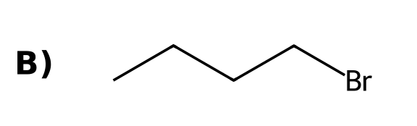
Why: Anti-Markovnikov addition through the more stable secondary radical.
81. In radical addition of HBr to propene, which radical does Br• create? [C10M43, Moderate]
Answer: C) A secondary radical (Br adds to the terminal carbon)
Why: The Br atom adds so that the more stable radical forms.
82. HCl adds to alkenes with peroxides in an anti-Markovnikov sense. [C10M44, Moderate]
Answer: B) False: only HBr works well in the radical chain
Why: The propagation steps are only favorable for HBr.
83. What conditions cause HBr to add to an alkene in an anti-Markovnikov sense? [C10F36, Easy]
Answer: HBr with peroxides (ROOR) or light.
Why: Radical mechanism.
84. Draw the product of propene with HBr in the presence of peroxides. [C10F37, Basic]
Answer: 1-Bromopropane.
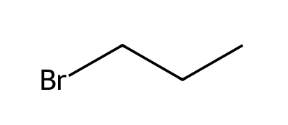
Why: Anti-Markovnikov.
85. Explain the regiochemistry of radical addition of HBr to propene. [C10F38, Moderate]
Answer: Br• adds to the terminal carbon, forming the more stable secondary radical; this radical then abstracts H from HBr, giving 1-bromopropane.
Why: More stable radical.
86. Why does radical addition work for HBr but not for HCl or HI? [C10F39, Moderate]
Answer: For HCl the hydrogen abstraction step is too endothermic; for HI the addition of I• to the alkene is too unfavorable.
Why: One of the propagation steps is unfavorable.

10.11 Radical Polymerization
87. What is the repeating unit of polyethylene made from? [C10M45, Easy]
Answer: C) Ethylene (ethene)
Why: Polyethylene is made by polymerisation of ethene.
88. PVC is made by polymerizing: [C10M46, Basic]
Answer: D) Vinyl chloride
Why: Vinyl chloride is CH₂=CHCl.
89. Which type of step grows the polymer chain in radical polymerisation? [C10M47, Moderate]
Answer: A) Addition of a radical to a π bond
Why: Each propagation step adds one more monomer.
90. What monomer gives polyvinyl chloride (PVC)? [C10F40, Easy]
Answer: Vinyl chloride (chloroethene).
Why: CH₂=CHCl.
91. Explain why polymerisation of ethylene through a radical process gives chain branching. [C10F41, Basic]
Answer: A growing chain radical can abstract a hydrogen from within its own chain (backbiting), creating a new radical site from which a branch grows.
Why: Hydrogen abstraction.
92. Draw the repeating unit of polyvinyl chloride and the monomer it comes from. [C10F42, Moderate]
Answer: Monomer CH₂=CHCl; repeating unit -CH₂-CHCl-.
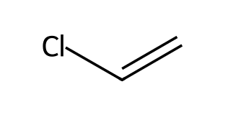
Why: The π bond opens.

10.12 Radical Processes in the Petrochemical Industry
93. What is cracking in the petrochemical industry? [C10M48, Basic]
Answer: A) Breaking large hydrocarbons into smaller ones
Why: Cracking breaks C-C bonds by radical processes at high temperature.
94. What is cracking? [C10F43, Basic]
Answer: Breaking larger hydrocarbons into smaller ones, such as gasoline-range alkanes and alkenes, at high temperature.
Why: Radical process.

10.13 Halogenation as a Synthetic Technique
95. To convert 2-methylbutane into 2-methylbut-2-ene, a good route is: [C10M49, Moderate]
Answer: B) (1) Br₂, hν; (2) NaOEt, heat
Why: Selective radical bromination, then E2 elimination.
96. To convert propane into propene, which two steps are best? [C10M50, Hard]
Answer: A) (1) Br₂, hν; (2) NaOEt, heat
Why: Brominate (mostly at C2), then eliminate with a strong base.
97. Propose a synthesis of 2-methylbut-2-ene from 2-methylbutane. [C10F44, Moderate]
Answer: (1) Br₂, hν (selective at the tertiary C-H) to give 2-bromo-2-methylbutane; (2) NaOEt, heat (E2).
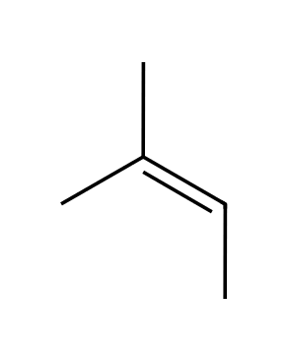
Why: Brominate, then eliminate.
98. Propose a synthesis of trans-cyclohexane-1,2-diol from cyclohexane. [C10F45, Hard]
Answer: (1) Br₂, hν; (2) NaOEt, heat to give cyclohexene; (3) mCPBA; (4) H₃O⁺.
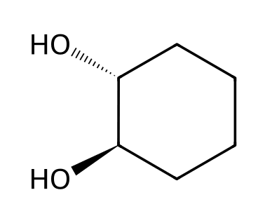
Why: Radical bromination, elimination, anti dihydroxylation.
99. Propose a synthesis of 1-bromopropane from propane. [C10F46, Hard]
Answer: (1) Br₂, hν gives mostly 2-bromopropane; (2) NaOEt, heat gives propene; (3) HBr, ROOR gives 1-bromopropane.
Why: Anti-Markovnikov radical addition.
100. Why is radical bromination preferred over chlorination when a single product is wanted? [C10F47, Moderate]
Answer: Bromine is much more selective, so it reacts mostly at the most substituted (tertiary) C-H and gives one major product.
Why: Selectivity.

