**Database Design Assignment**

Question 1 : Physical Entity Relationship diagram of database.

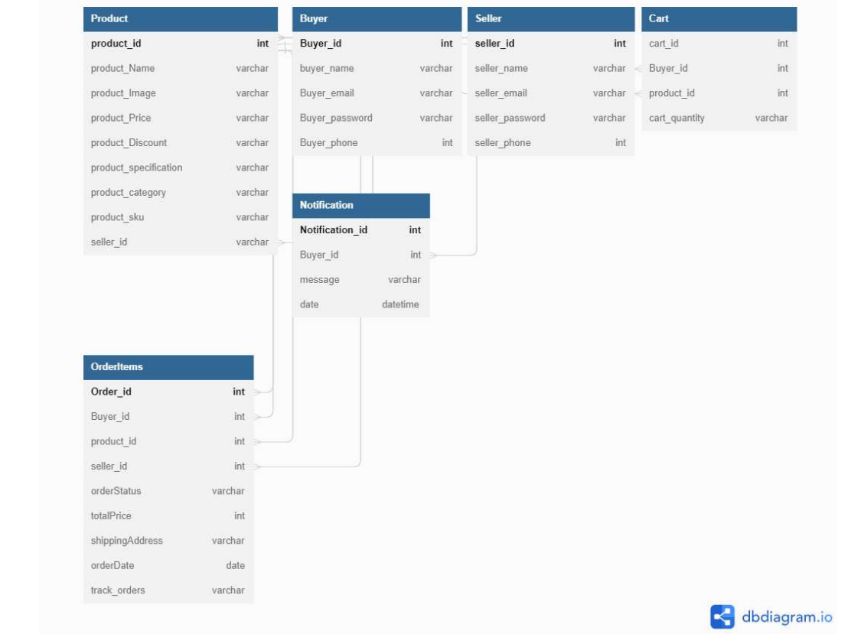

Question 2: Explain about searching performance. How will you handle replication in SQL for searching & Reporting?

Answer:

Achieving fast and accurate search results is crucial for the optimal performance of an e-commerce application. When it comes to handling replication in SQL for searching and reporting, there are several considerations to ensure efficiency. Here's an explanation of search performance and approaches to handle replication:

**Search Performance:**

The speed and accuracy of search operations depend on various factors, including data volume, indexing strategy, query complexity, hardware infrastructure, and optimization techniques.

To enhance search performance, it is important to have an efficient database design, appropriate indexing, and optimized queries.

Techniques such as full-text search, relevance ranking, and attribute-based filtering can improve the speed and accuracy of searches.

Caching mechanisms can be utilized to store frequently accessed data in memory, reducing the need for repetitive database queries and improving response times.

**Replication in SQL:**

Replication in SQL involves creating and maintaining multiple copies of a database or its subsets across different servers or locations.

Replication serves purposes like improving availability, fault tolerance, scalability, and performance.

In the context of searching and reporting in an e-commerce application, replication can be used to distribute the read load across multiple replicated databases.

Read-intensive operations, such as search queries and reporting, can be directed to these replicas, reducing the load on the primary database and enhancing overall performance.

Approaches to Handle Replication for Searching and Reporting:

**Load Balancing:**

Implement load balancing techniques to evenly distribute search and reporting requests across multiple replicas.

Load balancers can route incoming requests to available replicas using algorithms like round-robin, least connections, or session-based routing.

**Asynchronous Replication:**

Utilize asynchronous replication to minimize the impact on write operations and allow the replicas to slightly lag behind the primary database.

This approach reduces write operation latency and ensures that search and reporting operations are unaffected by the replication process.

**Indexing Strategy**:

Implement indexes on the replicated databases to optimize search queries and reporting operations.

Depending on specific requirements, indexes can be created on columns frequently used for searching, filtering, or sorting.

It's important to consider the trade-offs and potential challenges associated with replication, such as increased complexity, data consistency, and management overhead. The implementation details may vary based on the chosen database management system and available replication mechanisms. Therefore, it is recommended to refer to the documentation and best practices provided by the specific database technology being used.

Question 3: Explain what major factors are taken into consideration for performance.

Answer :

It is important to take into account several key factors that can significantly impact its performance. Here are some major factors to consider:

**Database Design and Indexing:**

Efficient database design, including proper normalization and suitable indexing, can enhance the application's search and retrieval performance.

Identifying the appropriate columns for indexing based on search frequency and optimizing query execution plans can help minimize query response times.

**Query Optimization:**

Well-optimized SQL queries that leverage indexes, join techniques, and appropriate query plans can improve search performance.

Analyzing and fine-tuning query execution plans, utilizing suitable indexes, and avoiding unnecessary or redundant operations can have a substantial impact on performance.

**Caching:**

Implementing caching mechanisms, such as in-memory databases or caching solutions like Redis, can reduce the need for repetitive database queries and improve response times for frequently accessed data.

Caching is particularly effective for static or slowly changing data, such as product details, categories, or promotional information.

**Scaling and Load Balancing:**

Planning for horizontal scaling by adding more servers or utilizing cloud-based solutions can accommodate increased user load and search demands.

Implementing load balancing techniques to distribute search requests across multiple servers ensures optimal resource utilization and prevents bottlenecks.

**Hardware and Infrastructure:**

Ensuring that the hardware infrastructure, including servers, storage, and network components, is properly configured and optimized for performance.

Choosing appropriate hardware specifications based on anticipated workload and scaling requirements helps meet performance goals.

**Monitoring and Performance Testing:**

Regularly monitoring the application's performance using tools such as query profiling, server monitoring, and load testing.

Identifying and addressing performance bottlenecks, optimizing resource usage, and fine-tuning configurations based on real-world usage patterns can continuously improve performance.

It is essential to conduct comprehensive performance testing, measure performance metrics, and analyze the application's behavior under different load conditions to identify areas for improvement and ensure performance goals are met. By considering and optimizing these factors, you can enhance the overall performance and user experience of your e-commerce application.

Question 4 : Mention about Indexing, Normalization and Denormalization .

Answer: Indexing, normalization, and denormalization are fundamental database concepts that have a significant impact on the design and performance of an e-commerce application. Here's a summary of each concept and its relevance in the context of an e-commerce application:

**1. Indexing:**

- Indexing involves creating data structures (indexes) to enhance the speed and efficiency of data retrieval operations, such as searching and filtering.

- In an e-commerce application, indexing plays a crucial role in optimizing search operations, allowing users to quickly find products based on various criteria like names, SKUs, or attributes.

- By creating indexes on frequently searched columns, the need for time-consuming full-table scans is reduced, resulting in faster and more efficient search queries.

- However, it's important to consider that indexing increases storage requirements and introduces overhead during data modification operations such as inserts, updates, and deletes.

**2. Normalization:**

- Normalization is a database design technique that aims to eliminate data redundancy and improve data integrity by organizing data into multiple related tables.

- By decomposing a single table into multiple tables, each serving a specific purpose with minimal redundancy, normalization reduces the risk of data inconsistencies and update anomalies.

- In an e-commerce application, normalization can be applied to entities like products, sellers, buyers, orders, and cart items.

- Normalization ensures that each piece of information is stored in only one place, enhancing data integrity and providing a flexible foundation for managing complex relationships between entities.

**3. Denormalization:** - Denormalization, in contrast to normalization, involves combining or duplicating data across tables to optimize query performance.

- In an e-commerce application, denormalization is used to improve read/query performance, particularly for data that is frequently accessed together or involves complex joins.

- Denormalization is selectively applied to specific tables or columns where performance gains are crucial.

- By duplicating data, denormalization avoids expensive join operations and minimizes the need for accessing multiple tables during read operations.

- However, denormalization introduces the risk of data redundancy and requires careful maintenance to ensure data consistency and prevent update anomalies.

In an e-commerce application, finding a balance between normalization and denormalization is often sought. Normalization is typically employed to ensure data integrity and flexibility, while selective denormalization is used to optimize specific performance-critical queries or operations. The choice of normalization and denormalization techniques depends on the specific requirements, performance goals, and trade-offs of the application. It's crucial to analyze the data model carefully and consider factors like query patterns, data modification frequency, and scalability needs to determine the appropriate level of normalization and denormalization for the e-commerce application.

Question 5: How will you handle scaling, if required at any point of time.

Answer : Managing scalability in an e-commerce application is crucial to accommodate growing traffic, user demand, and data volume. Below are several approaches to handle scalability when needed:

**1. Horizontal Scaling:**

- Horizontal scaling involves adding more servers or instances to distribute the workload and handle increased traffic.

- Load balancers can be utilized to evenly distribute incoming requests across multiple servers, optimizing resource utilization.

- Horizontal scaling enables the application to handle a larger number of concurrent users, enhancing responsiveness and availability.

**2. Database Scaling:**

- Scaling the database is vital to handle expanding data volume and query load.

- Vertical scaling involves upgrading the hardware and resources of the database server to increase its capacity and performance.

- Horizontal scaling for databases can be achieved through techniques like database sharding, which partitions and distributes data across multiple database instances or clusters.

- Sharding can be based on criteria such as customer IDs, product categories, or geographical regions.

**3. Caching and Content Delivery Networks (CDNs):**

- Caching mechanisms like in-memory databases or caching solutions such as Redis can cache frequently accessed data, reducing the load on the primary database.

- Implementing a content delivery network (CDN) helps serve static content, like product images and CSS files, from geographically distributed servers, improving performance by reducing the load on application servers.

**4. Asynchronous Processing and Message Queues:**

- Asynchronous processing and message queues can offload resource-intensive tasks and decouple components of the application.

- For instance, order processing, email notifications, and image processing can be moved to separate worker processes or queues, allowing the main application to focus on user interactions and requests.

- This approach enhances scalability and responsiveness by separating critical and time-sensitive tasks from the main application flow.

**5. Cloud Services:**

- Leveraging cloud services such as Infrastructure as a Service (IaaS) or Platform as a Service (PaaS) provides on-demand scalability.

- Cloud platforms like AWS, Google Cloud, or Microsoft Azure offer auto-scaling features that automatically adjust resources based on demand.

- Managed database services provided by these platforms handle scalability and replication, reducing administrative overhead in managing scaling operations.

It is essential to plan for scalability from the early stages of application development, considering factors like projected user load, growth expectations, and scalability requirements. Scalability should be integrated into the architecture and validated through load testing and performance optimization. By combining horizontal scaling, database scaling, caching, asynchronous processing, and cloud services, an e-commerce application can effectively handle increased traffic, user demand, and data growth

Question 6: Mention all the assumptions you are taking for solutions

Answer: 1. Technology Stack: The e-commerce application is built using modern web development frameworks, relevant libraries, and tools, along with a relational database management system (RDBMS).

2. Scalability: The application is designed to handle a significant number of users and concurrent requests. The solutions provided prioritize scalability and performance optimization.

3. Relational Database: It is assumed that a relational database is utilized to store and manage data related to products, inventory, orders, and users. SQL queries and indexing techniques are employed for data retrieval and manipulation.

4. User Authentication and Authorization: The application includes mechanisms for user authentication and authorization to ensure secure access to buyer and seller accounts. Login options include email/password and phone number with OTP.

5. Image Storage: Product images are assumed to be stored in a suitable storage solution, such as a file system or a cloud-based storage service.

6. Mobile Application: While not explicitly mentioned, the solutions can be adapted for both web and mobile applications, aiming for a seamless experience across different devices.

7. Payment Processing: The solutions provided do not cover the intricacies of payment processing, including integration with payment gateways or third-party payment providers.

8. Security: While security is recognized as crucial, specific details regarding encryption, secure communication protocols, and data protection mechanisms are not extensively discussed in the solutions.

9. User Interface and Design: The solutions primarily focus on the backend functionality of the application. Aspects like user interface design, layout, and user experience considerations are not addressed in detail.

10. Third-Party Services: The integration of third-party services such as email notifications, SMS gateways, or analytics tools is not explicitly explored in the provided solutions.